Setting up the server

Keep the default settings. Refer to the client virtual machine setup if in doubt.

sudo apt update
sudo apt upgrade

#search for your IP. You’re going to need it to configure the right range in your dhcp

ip a
#The address IP will be displayed after ‘inet’ you’ll probably get 2 block with an address. Don’t use the link//loopback one. Use the link/ether one. Mine is 10.0.2.15 in this case.

#enter the dhcpd.conf file to configure your dhcp.

Use:
sudo vi /etc/dhcp/dhcpd.conf
or
sudo nano /etc/dhcp/dhcpd.conf

#depending on which you’re more comfortable using and insert something similar to this:

subnet 10.0.2.0 netmask 255.255.255.0 { #♦your network and subnet mask
range 10.0.2.20 10.0.2.200; #The range of IP addresses you’re willing to give
option routers 10.0.2.1; #The ip address of the router
option domain-name-servers 10.0.2.15; #the address of your DNS server. 8.8.8.8 by default
option domain-name "ubuntu-server.com"; #The default domain name given to computers
}
#Then go to /etc/default/isc-dhcp-server using

sudo vi /etc/default/isc-dhcp-server
or:
sudo nano /etc/default/isc-dhcp-server

#Next is configuring which interface the DHCP server should listen to.
#Then go and change to following line,uncomment it if needed(remove #), and change

INTERFACESv4=””
to
INTERFACESv4=”enp0s3”

or whichever interface you’re using. When using the ip a command it should be the first word written on the first line. In the loopback block it would be ‘lo’.

#Restart the DHCP service to apply the configuration

sudo systemctl restart isc-dhcp-server
#Check if it works

sudo systemctl stats isc-dhcp-server

#Install openssh

sudo apt install openssh-server

#We’ll still have to configure the ssh connection rules

sudo nano /etc/ssh/sshd_config
or
sudo vi /etc/ssh/sshd_config
Uncomment the PermitRootLogin and change whatever follows it to yes

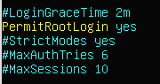
#Now save it and check the service status

sudo systemctl restart ssh

sudo systemctl status ssh

Setting up the client

Give your machine any name you would recognize and select in .iso image the latest stable version of ubuntu. The click next.

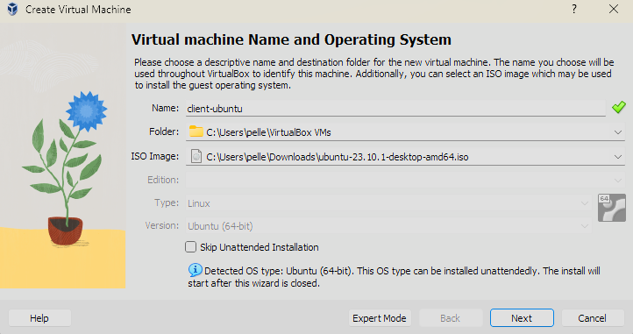
Select an username as well as a password. In this case I will simply use UbClient with ubuntu as password. Then go next.
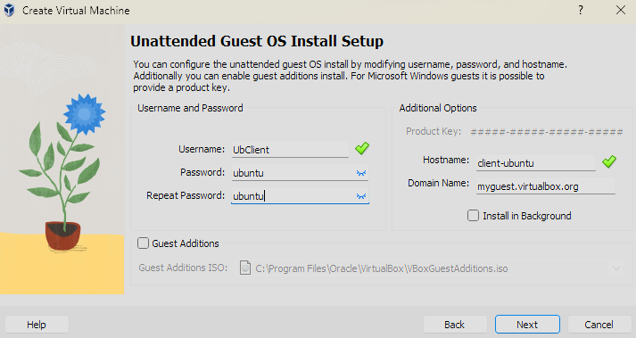
Now we have to select the hardware ressources we’ll allocate the computer. The base settings should be sufficient but I’ll double them for convenience. Go next.

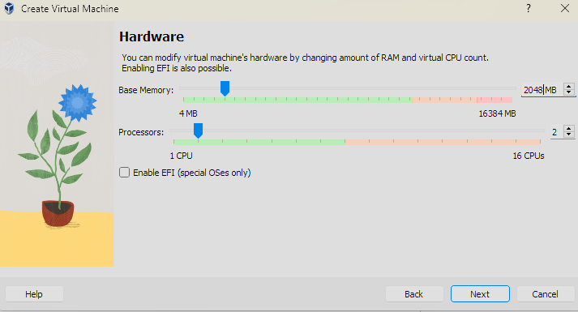
The base settings are fine here too so go next then you’ll arrive on the summary where you should clic on Finish.

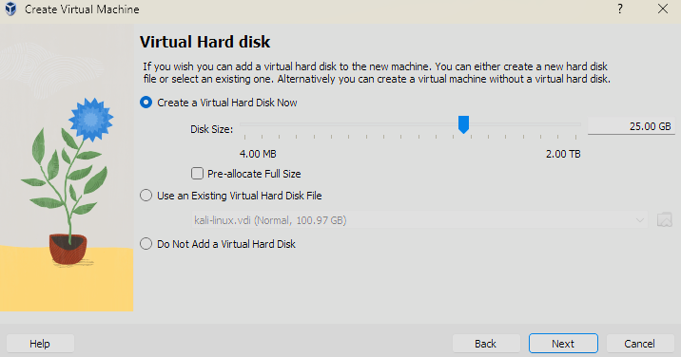
Your Virtual Machine should be starting up automatically. You don’t need to do anything before arriving to similar screen:
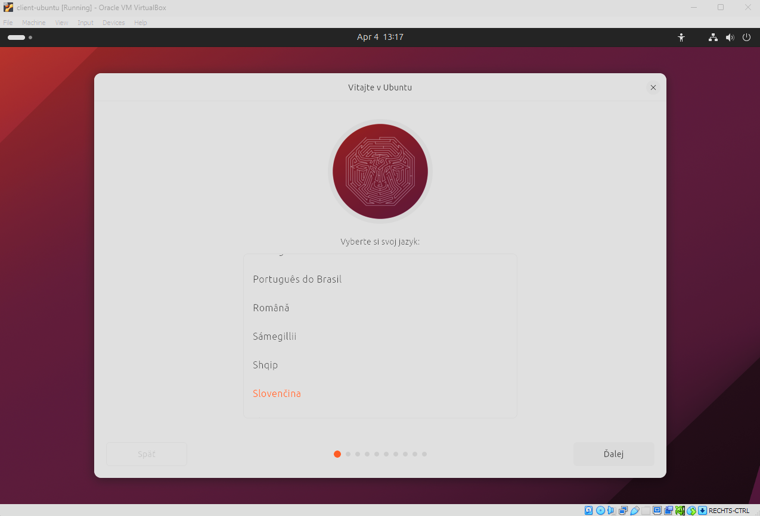
Select your preferred language then select install Ubuntu.

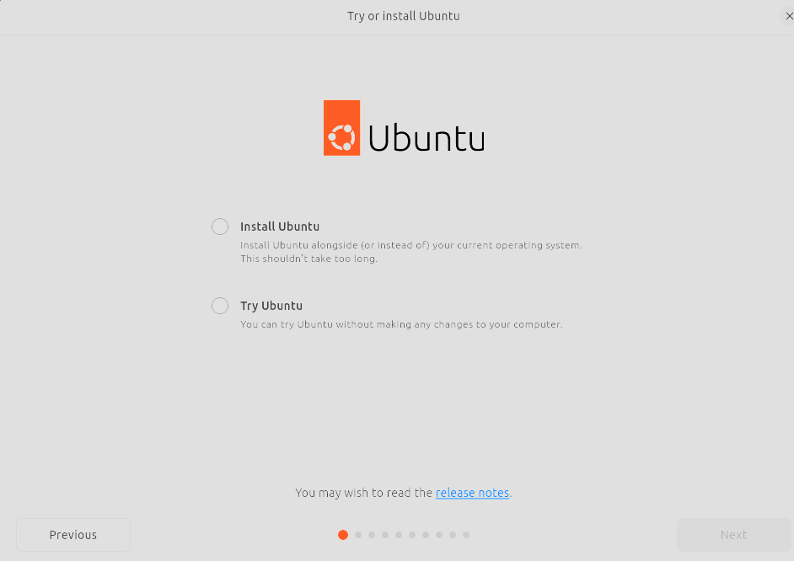
Select a keyboard of your choosing then select “Use wired connection”.

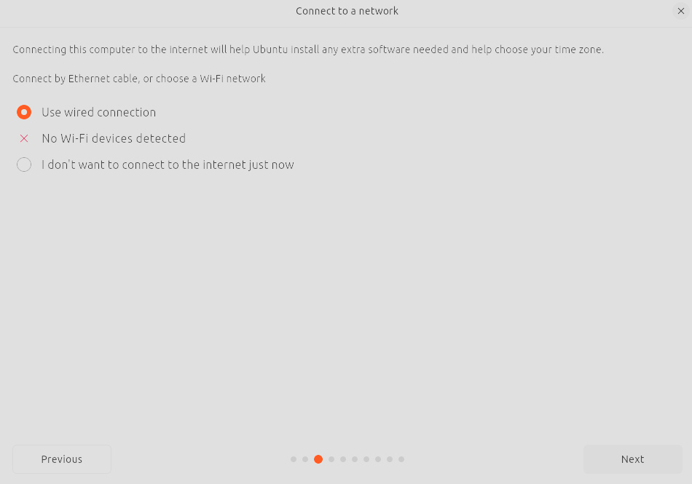
Go for the full installation before going Next.

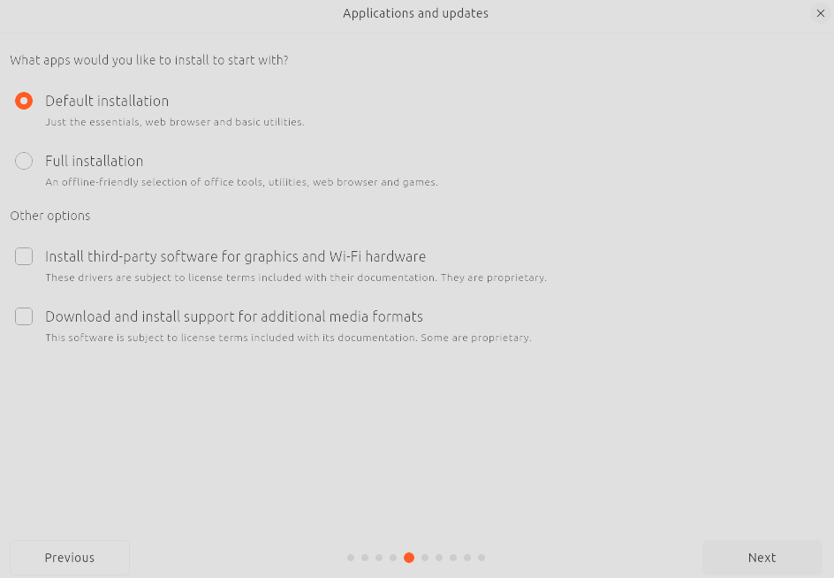
Select “Manual partitioning”.

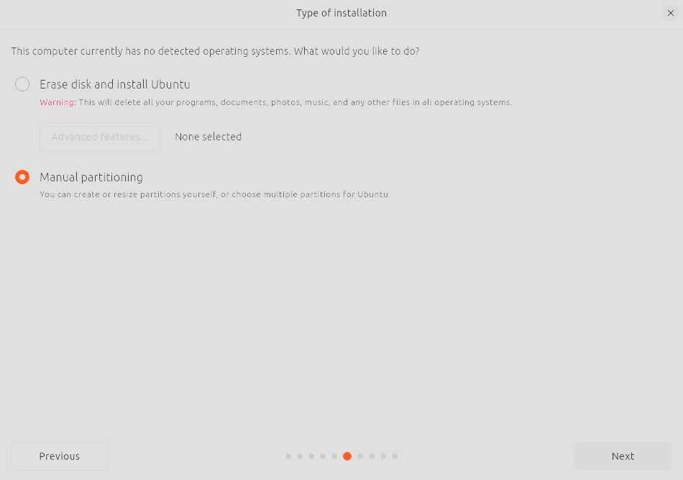
You’ll access this page. Click on Free Space then on the ‘+’ below to add a partition.

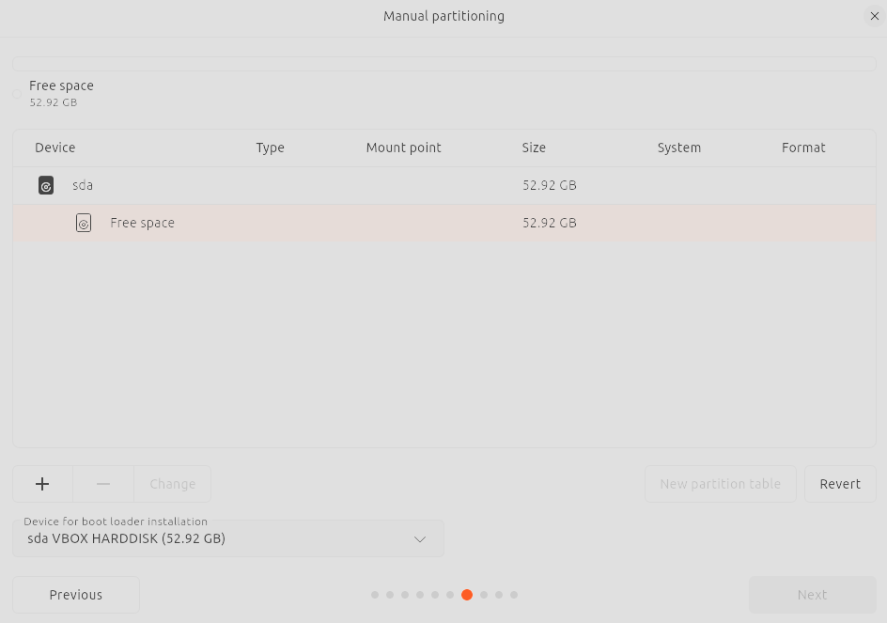
Then you should land on something similar to this:

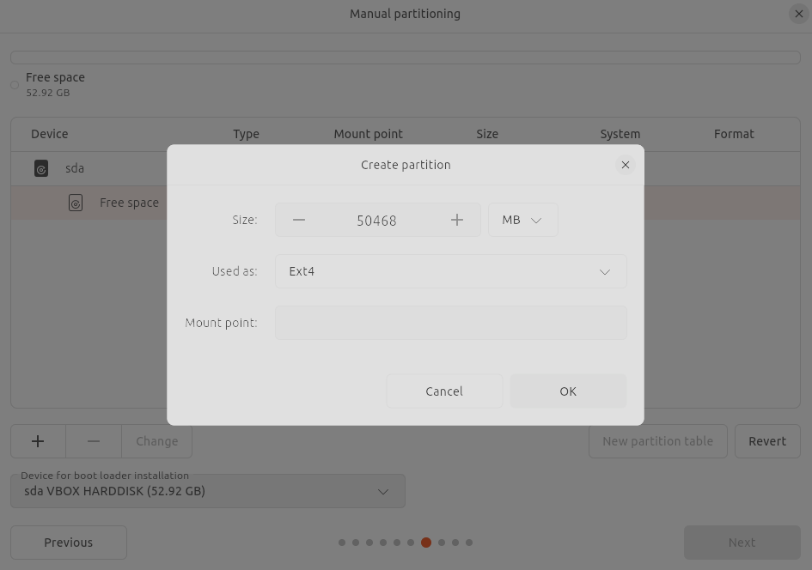
Allocate sufficient space for your requirements, ensuring there is enough room for user files and data.
Select the file system type. For ubuntu, the default is usually Ext4.
And Select ‘/home’ as a mount point

Then create a new one with (/) as a mount point only when all your memory will have been allocated will you be able to click on Next.
You’ll then get a summary of how your disk will be partitioned. Click install.
Now you have to select your timezone the click next.

Then you’ll have to choose a username and a password. Continue and reboot when prompted to.

After the reboot your software update might start updating. Once it is over it will ask you to restart now or later. Restart now.

Now your VM is set up open a terminal and use the following commands:

sudo apt update

sudo apt upgrade

You can now start installing

sudo apt install libreoffice

sudo apt install gimp

wget --content-disposition https://mullvad.net/en/download/browser/linux-x86_64/latest -P ~/Downloads

cd ~/Downloads

tar -xvf mullvad-browser-linux-x86_64-X.X.tar.xz
cd ~/Downloads/mullvad-browser

./start-mullvad-browser.desktop
The .xz file which you have to decompress may find itself in the home directory instead of downloads. If it does apply the same steps while being mindful of where the file is located.

If the start command succesfully launches the mullvad browser that means you were succesful.
Just type
libreoffice
and
gimp

As commands to launch them and check if they’re properly installed.

#Install ssh and check whether or not it listens to port 22

sudo apt-get install openssh-server

sudo netstat -tuln | grep 22

if you can’t use the netstat command install net-tools with

sudo apt install net-tools

#We’ll now create a virtual internal server in order to connect both machines and enable ssh connection. First turn of the machines and go back to the VirtualBox Manager.

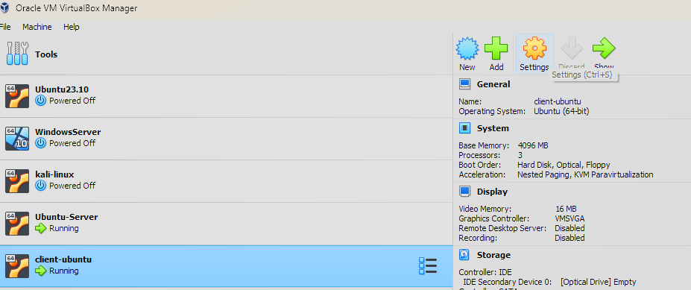
Go into the settings of one of the machines you wish to add to the internal network. And go into the network subcategory.

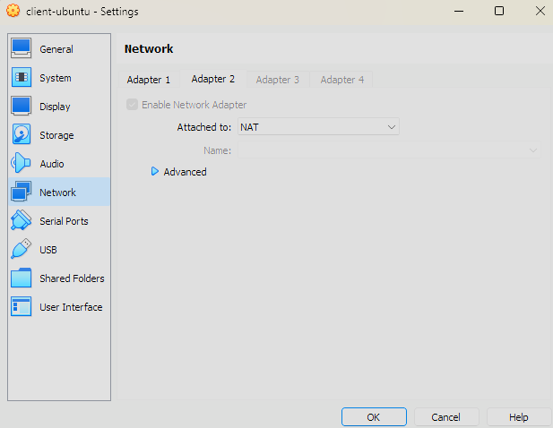
Go to Adapter 1. You will probably be attached to NAT by default. Change that to Internal network.
Then change give the internal server another name than the default name (You won’t be able to do this if the machine is still running). Then click okay to save the changes.

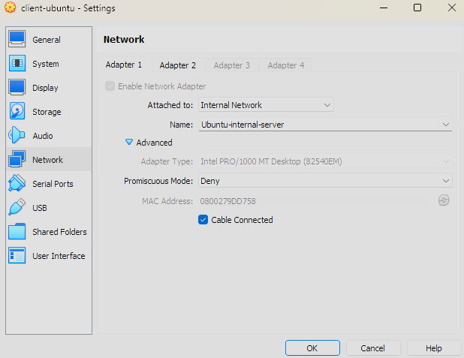
Then repeat this operation on all the other machines which you’d like to add to the network, using the same internal network name.

You machines are now on a same isolated network which is rather safe. This being said you won’t be able to connect to the internet. If you’d still like to be able to connect to the internet go to the second Adapter, enable it and attach it to NAT.

#Now launch the machines again.
#Before continuing if it’s not done already you should set up the ubuntu server up until the dhcp set-up.
#Open a terminal on the client machine and use

ip a

#To check whether your dhcp indeed did assign an address within the pool you previously prepared

ssh <username>@<ip address>

#The username being the one of the user of the server you want to log to and the IP address being the one of the server. Then if asked insert the password of the user you are trying to connect to. Then use:

whoami

#To confirm you have succesfully logged into the server as the right user.

You are now done with the client machine. You can either continue configuring the server from the server’s machine or you can keep working from the client machine via ssh.

