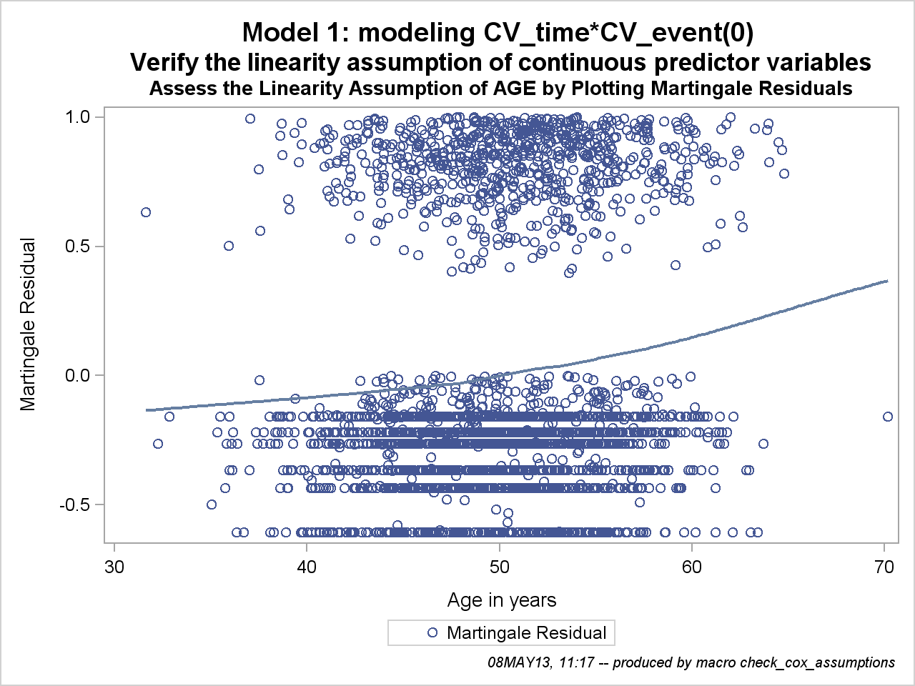

To use the Martingale residuals to assess the linearity assumption, first fit a model that excludes the predictor variable of interest. Then plot the Martingale residuals by the values of the excluded predictor variable of interest. Finally, fit a smoothed line (that is, a loess smooth) in the plot. The shape of the smoothed line provides an estimate of the functional form of the predictor variable in the model (Therneau, Grambsch, and Fleming 1990).

The MEANS Procedure

Analysis Variable : age Age in years
Rank for Variable age | N Obs | Minimum | Maximum
0 | 593 | 31.63 | 45.63
1 | 594 | 45.64 | 48.66
2 | 593 | 48.67 | 51.22
3 | 594 | 51.22 | 54.27
4 | 593 | 54.28 | 70.18

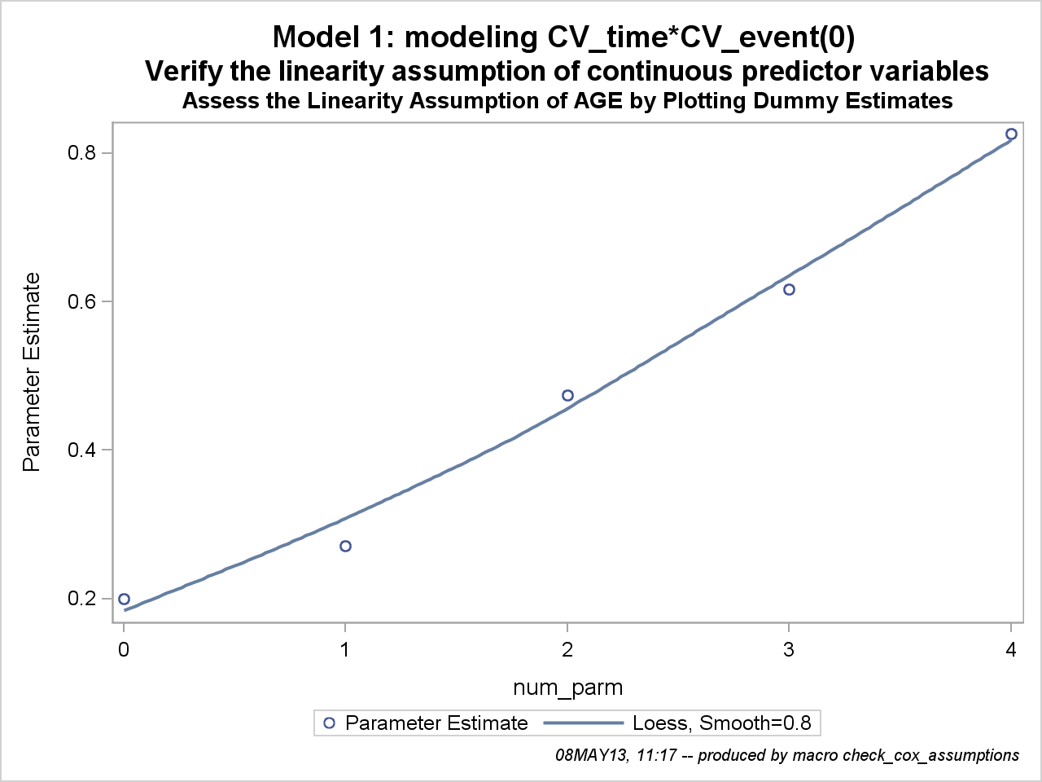

One method to check for linearity is to replace the predictor variable of interest with several dummy variables. Then fit the model with the new dummy variables and plot the parameter estimates of the dummy variables, with a point at zero representing the reference group. If the correct scale is linear in the log hazard, then a smoothed line is fairly linear. If the smoothed line departs substantially from a linear trend, then its form is used to decide how to model the predictor variable (Hosmer and Lemeshow 1999).

The LIFETEST Procedure

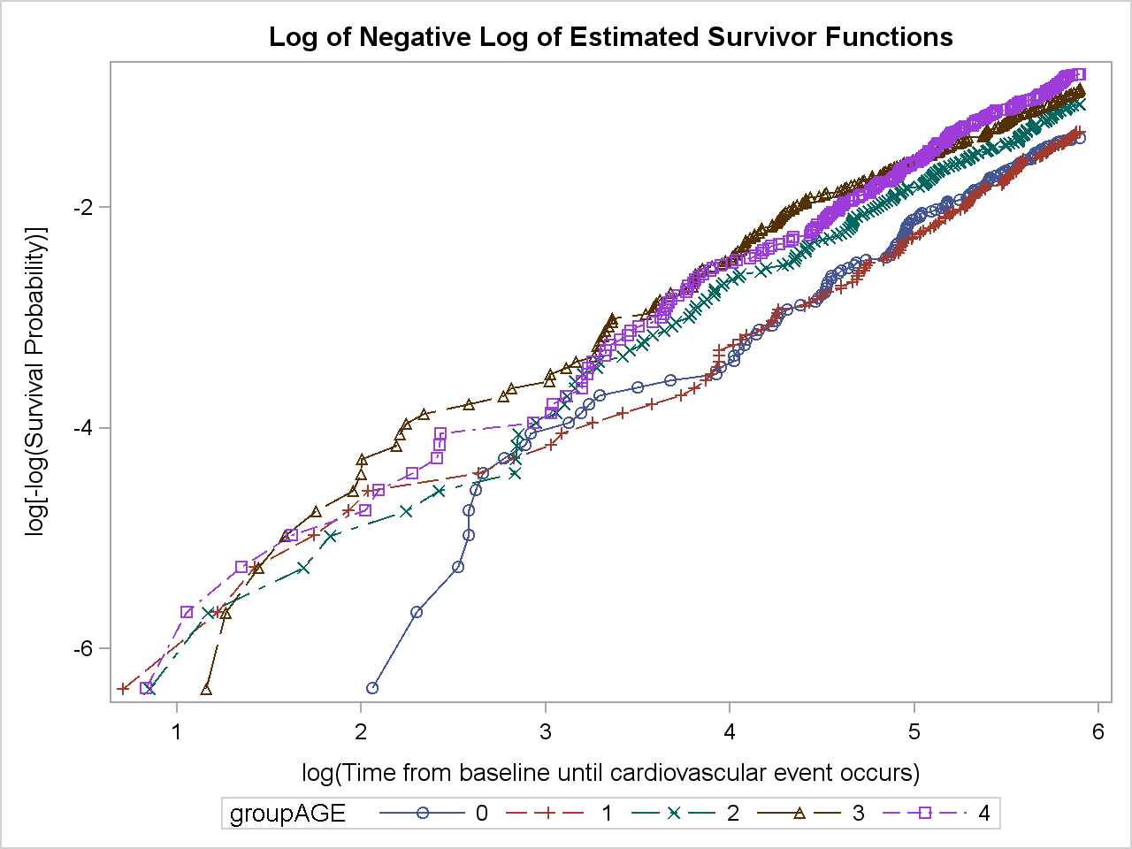

One method to assess the proportional hazards assumption is to plot thelog-negative-log of the Kaplan-Meier estimates of the survival function versus the log of time. If the hazard ratios are constant, the plot has parallel lines.

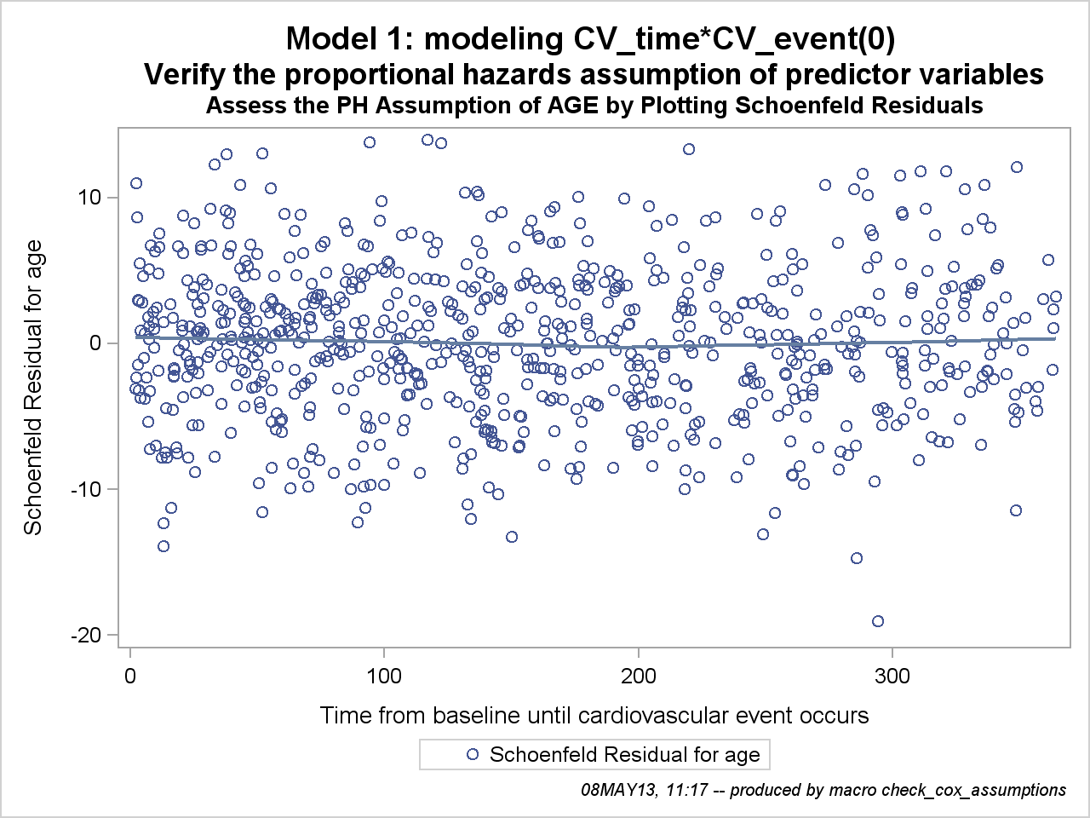

Because Schoenfeld residuals are based on the effects of the predictor variables that are assumed to be independent of time, a plot of the residuals by time could be used to visually assess whether the effect of the predictor variable changes over the period of follow-up. A smoothed line fit to the plot ofthe residuals should have an intercept and a slope of approximately 0 (Hosmer and Lemeshow 1999).

parameter | Label | Parameter Estimate | Standard Error | Chi-Square | Pr > ChiSq | flag
age*treatment | Treatment 1 * Age in years | -0.02037 | 0.01475 | 1.9070 | 0.1673
age*activity | Physical activity alevel high | -0.00878 | 0.02058 | 0.1818 | 0.6698
age*activity | Physical activity alevel low | 0.02092 | 0.01685 | 1.5399 | 0.2146

Results of a partial likelihood ratio test that compares the model with only the main effects to the model with the main effects and all two-way interactions. P-values less than 0.05 are marked

Parameter | Label | Crude Estimate (Error) | Crude Hazard Ratio (95% CI) | Adjusted Estimate (Error) | Adjusted Hazard Ratio (95% CI) | change | flag
activity | Physical activity alevel high | -0.51 ( 0.10) | 0.60 ( 0.49- 0.74) | -0.55 ( 0.10) | 0.57 ( 0.47- 0.71) | ( 9%)
activity | Physical activity alevel low | 0.50 ( 0.08) | 1.65 ( 1.40- 1.95) | 0.49 ( 0.08) | 1.62 ( 1.38- 1.91) | 4%
treatment | Treatment 1 | 0.33 ( 0.07) | 1.40 ( 1.21- 1.61) | 0.35 ( 0.07) | 1.42 ( 1.23- 1.64) | ( 5%)

Estimating change between Parameter Estimates for Other variables varies significantly for model without (crude) or with (adjusted) variable of interest. Variables for which parameter estimates varies by more than 20 are flaged.Variables are flaged only if at least one of the estimates is larger then 0.01.

The LIFETEST Procedure

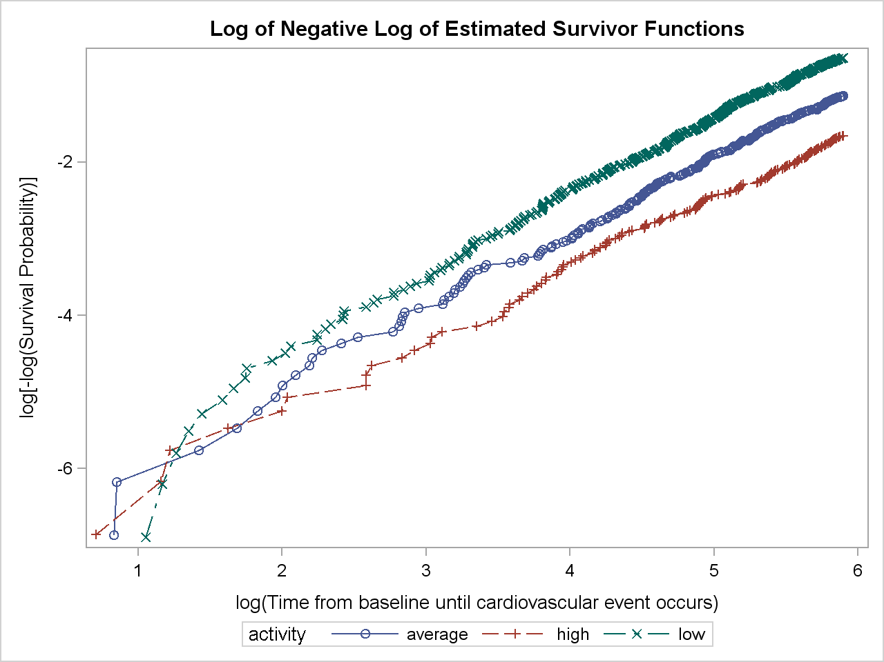

One method to assess the proportional hazards assumption is to plot thelog-negative-log of the Kaplan-Meier estimates of the survival function versusthe log of time. If the hazard ratios are constant, the plot has parallel lines.

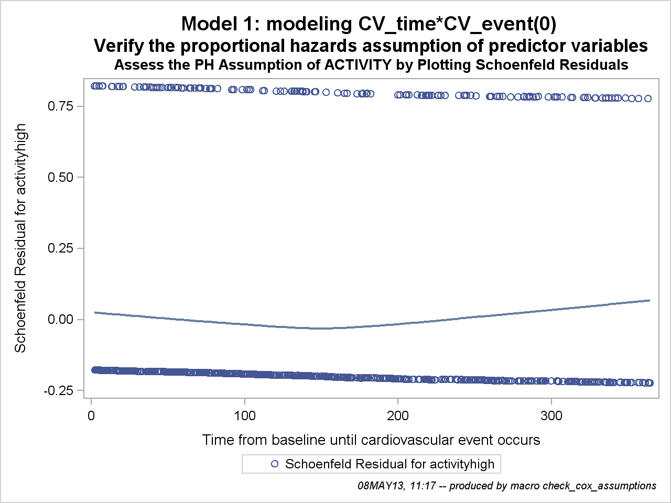

Because Schoenfeld residuals are based on the effects of the predictor variables that are assumed to be independent of time, a plot of the residuals by time could be used to visually assess whether the effect of the predictor variable changes over the period of follow-up. A smoothed line fit to the plot ofthe residuals should have an intercept and a slope of approximately 0 (Hosmer and Lemeshow 1999).

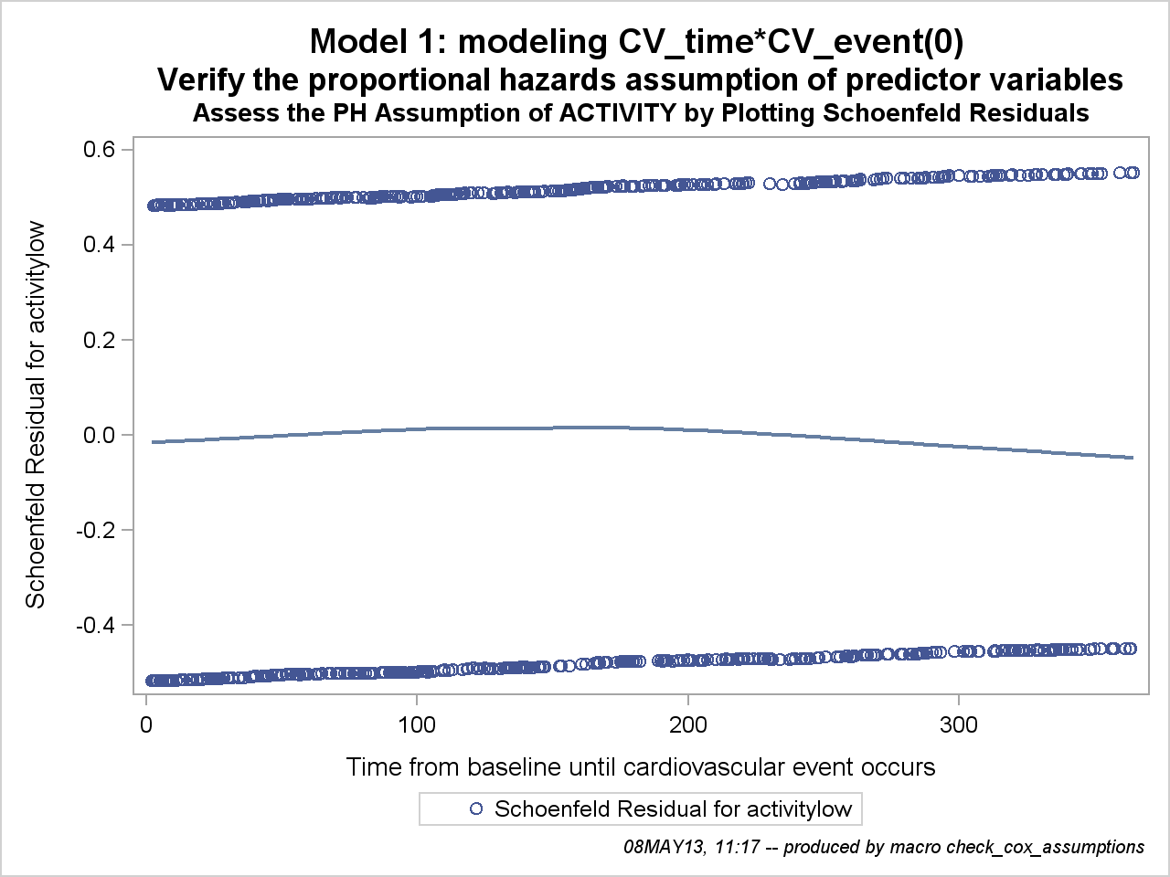

Because Schoenfeld residuals are based on the effects of the predictor variables that are assumed to be independent of time, a plot of the residuals by time could be used to visually assess whether the effect of the predictor variable changes over the period of follow-up. A smoothed line fit to the plot ofthe residuals should have an intercept and a slope of approximately 0 (Hosmer and Lemeshow 1999).

parameter | Label | Parameter Estimate | Standard Error | Chi-Square | Pr > ChiSq | flag
age*activity | Physical activity alevel high * Age in years | -0.00878 | 0.02058 | 0.1818 | 0.6698
age*activity | Physical activity alevel low * Age in years | 0.02092 | 0.01685 | 1.5399 | 0.2146
treatment*activity | Treatment 1 * Physical activity alevel high | -0.04757 | 0.21513 | 0.0489 | 0.8250
treatment*activity | Treatment 1 * Physical activity alevel low | -0.18319 | 0.16973 | 1.1650 | 0.2804

Results of a partial likelihood ratio test that compares the model with only the main effects to the model with the main effects and all two-way interactions. P-values less than 0.05 are marked

Parameter | Label | Crude Estimate (Error) | Crude Hazard Ratio (95% CI) | Adjusted Estimate (Error) | Adjusted Hazard Ratio (95% CI) | change | flag
age | Age in years | 0.04 ( 0.01) | 1.04 ( 1.03- 1.06) | 0.05 ( 0.01) | 1.05 ( 1.03- 1.06) | ( 6%)
treatment | Treatment 1 | 0.32 ( 0.07) | 1.37 ( 1.19- 1.59) | 0.35 ( 0.07) | 1.42 ( 1.23- 1.64) | ( 10%)

Estimating change between Parameter Estimates for Other variables varies significantly for model without (crude) or with (adjusted) variable of interest. Variables for which parameter estimates varies by more than 20 are flaged.Variables are flaged only if at least one of the estimates is larger then 0.01.

