The MEANS Procedure

Analysis Variable : age Age in years
Rank for Variable age | N Obs | Minimum | Maximum
0 | 593 | 31.63 | 45.63
1 | 594 | 45.64 | 48.66
2 | 593 | 48.67 | 51.22
3 | 594 | 51.22 | 54.27
4 | 593 | 54.28 | 70.18

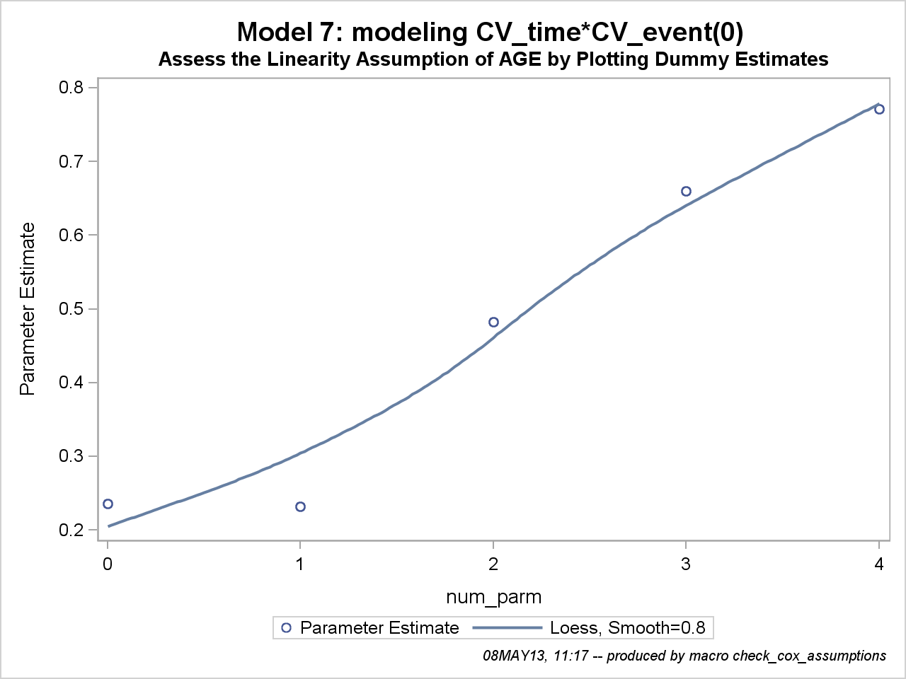

One method to check for linearity is to replace the predictor variable of interest with several dummy variables. Then fit the model with the new dummy variables and plot the parameter estimates of the dummy variables, with a point at zero representing the reference group. If the correct scale is linear in the log hazard, then a smoothed line is fairly linear. If the smoothed line departs substantially from a linear trend, then its form is used to decide how to model the predictor variable (Hosmer and Lemeshow 1999).

The LIFETEST Procedure

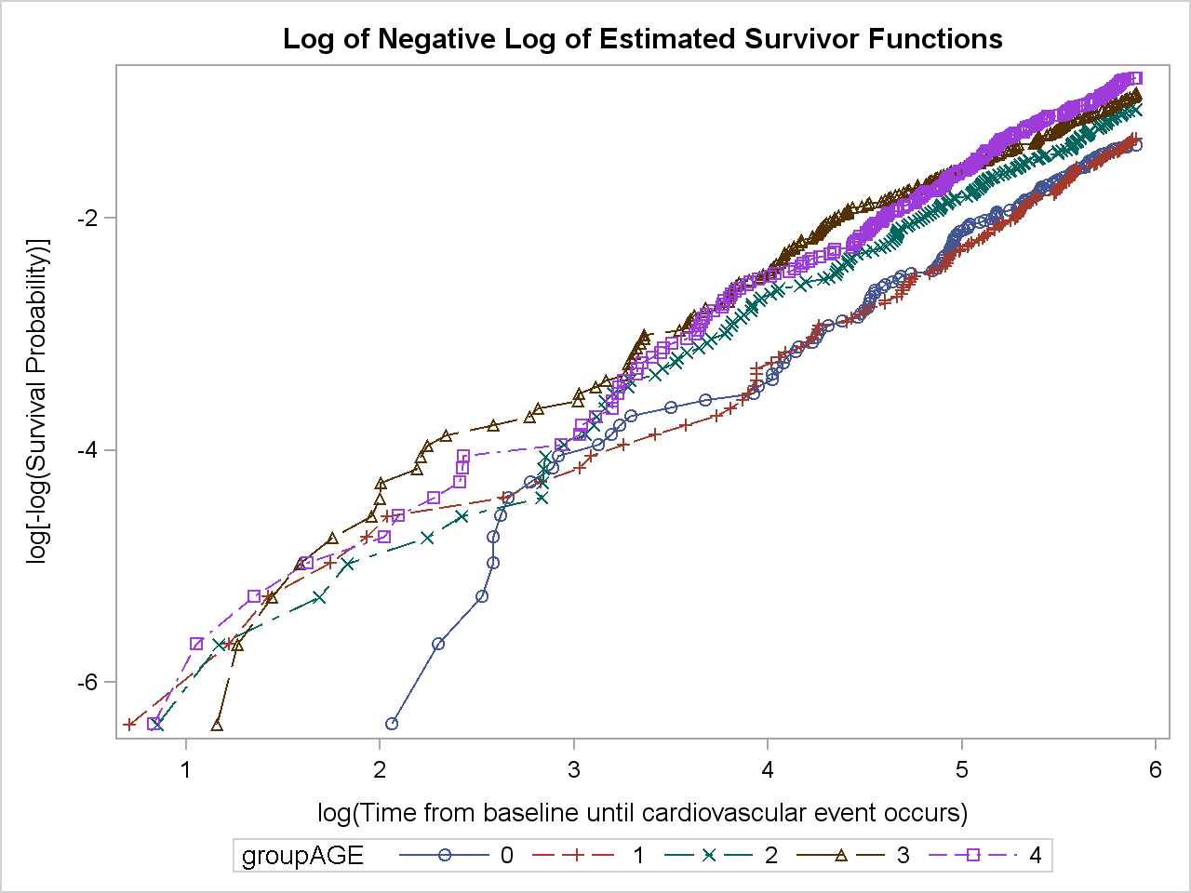

One method to assess the proportional hazards assumption is to plot thelog-negative-log of the Kaplan-Meier estimates of the survival function versus the log of time. If the hazard ratios are constant, the plot has parallel lines.

