The LIFETEST Procedure

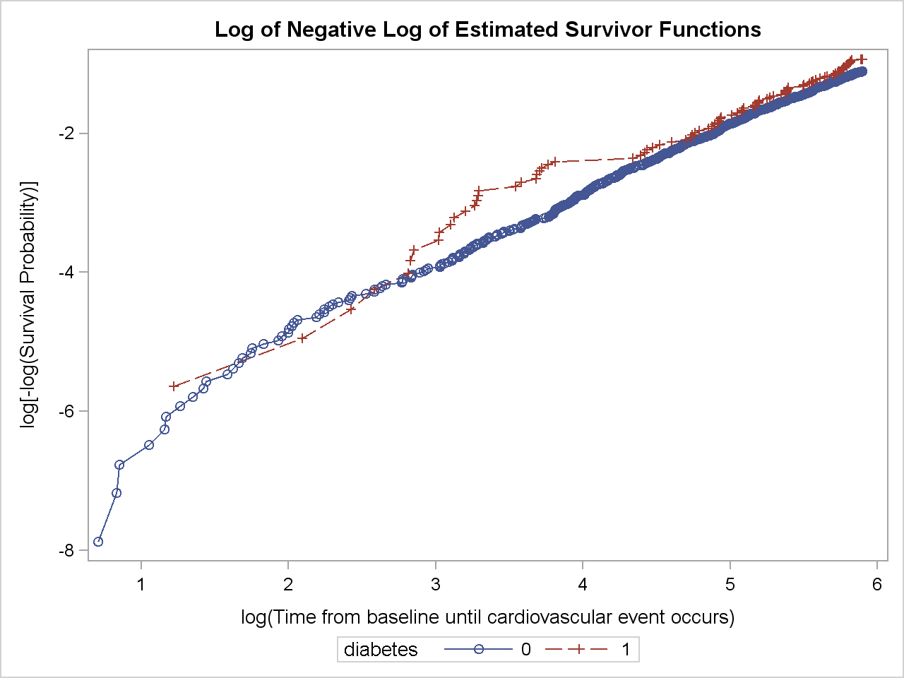

One method to assess the proportional hazards assumption is to plot thelog-negative-log of the Kaplan-Meier estimates of the survival function versusthe log of time. If the hazard ratios are constant, the plot has parallel lines.

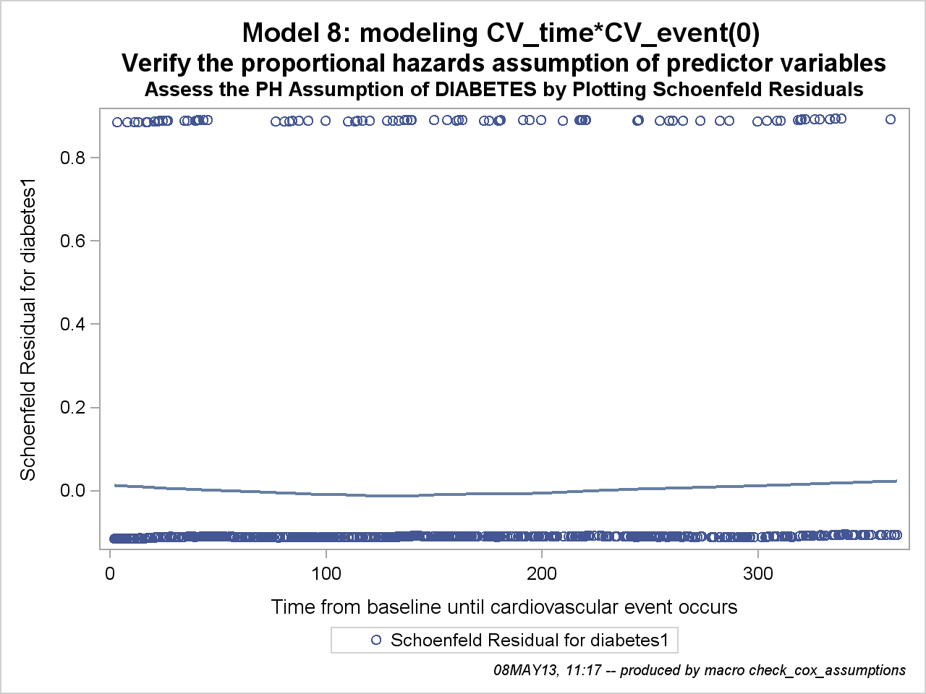

Because Schoenfeld residuals are based on the effects of the predictor variables that are assumed to be independent of time, a plot of the residuals by time could be used to visually assess whether the effect of the predictor variable changes over the period of follow-up. A smoothed line fit to the plot ofthe residuals should have an intercept and a slope of approximately 0 (Hosmer and Lemeshow 1999).

