NeuroConnect AI v2
Technical Report
Autism classification from whole-brain MRI using EfficientNetB3

This is a research prototype
It is not a clinically validated diagnostic system, it has not been approved by any regulatory body, and it must not be used to make medical decisions about any real person. Autism is diagnosed by clinicians through behavioural observation and developmental history. There is no brain scan that diagnoses autism, and this project does not claim otherwise.

Dataset: ABIDE-II · 306 subjects across 5 sites
Model: EfficientNetB3 (ImageNet pretrained)
Framework: TensorFlow 2.19 · Python 3.11

Contents
Contents 2
1. What this project is 3
2. The problem, and why it is hard 3
There is no visible marker 3
The dataset is small 3
The scanners differ 3
3. System overview 3
4. The raw material: what an MRI actually is 5
The five sites do not agree 5
5. Knowing who has autism 5
Two real problems solved here 6
6. Turning a 3D brain into pictures 7
Step 1 — Reorient to RAS 7
Step 2 — Normalise intensity 7
Step 3 — Build a tissue mask 8
Step 4 — Keep only brain-containing slices 8
Step 5 — Keep the central 80% 8
Step 6 — Sample 25 slices evenly 8
Step 7 — Crop to the brain and pad to square 8
Step 8 — Resize to 224 × 224 8
The result 8
7. Splitting patients, not pictures 10
Balancing across sites 10
Three groups, not two 11
8. The model 12
The idea in plain terms 12
Transfer learning: why we do not start from scratch 12
Architecture 12
9. How the model is trained 13
Two stages, deliberately 13
Data augmentation 13
Guardrails during training 14
10. From 25 scores to one answer 15
The decision threshold 15
11. Confidence 15
The High / Moderate / Low label 16
12. What happens when you click PREDICT 17
13. How the system is measured 17
Why AUC is reported alongside accuracy 18
Where results are written 18
14. Honest assessment 19
What this project does well 19
What it cannot do 19
Known limitations 19
What would actually improve it 19
15. Glossary 19

1. What this project is
NeuroConnect AI v2 takes one brain MRI scan file and returns one word — AUTISM or HEALTHY — together with a score indicating how strongly the model leans that way.
That is the entire user-facing behaviour. Everything else in this report describes what happens in between.
This report assumes no prior knowledge of machine learning or medical imaging. Technical terms are explained where they first appear, and a glossary is provided in section 15.
Framing the research question
This project does not attempt to diagnose autism. It asks a narrower question: does a neural network find any statistical signal in brain structure that correlates with an autism diagnosis? The honest answer, from this project and from the published literature, is: a weak one.

2. The problem, and why it is hard
Three properties of this problem shape every design decision that follows.

There is no visible marker
In a chest X-ray for pneumonia, a radiologist can point at the cloudy patch. In an autism MRI there is nothing to point at. Differences between groups are statistical tendencies spread across whole populations, not features visible in any one person's scan.

The dataset is small
This project has 306 patients. Modern image networks are normally trained on millions of images. With only 306 people, a large network can simply memorise them — learning "this particular brain is autistic" rather than anything generalisable. That failure is called overfitting, and much of the design exists to prevent it.

The scanners differ
The data comes from five research sites, each with its own MRI machine and settings. A network can easily learn to recognise the scanner rather than the brain. If one site happened to contain more autism cases, a model could score well by identifying that site, while being useless on any new scan. This is called confounding, and section 7 explains how it is controlled.

3. System overview
The project consists of four programs that run in sequence, plus shared supporting code.
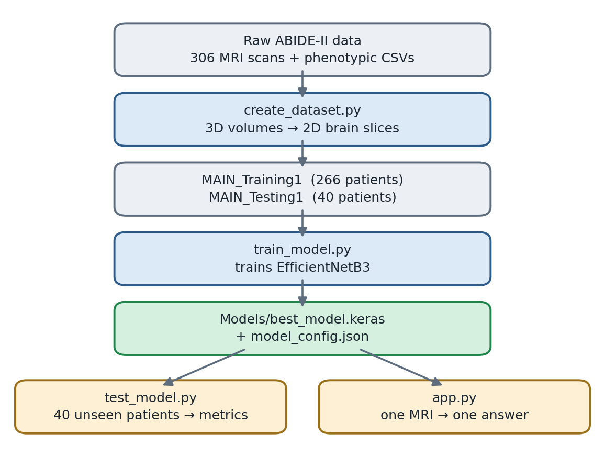
Figure 1 — How the four programs connect.
File | Role
neuro_utils.py | Reads MRI files, validates them, converts 3D volumes into slices
create_dataset.py | Builds the training and testing datasets
train_model.py | Trains the neural network
predictor.py | Loads the trained model and produces one patient answer
test_model.py | Measures accuracy on unseen patients
app.py | The graphical interface

Why the shared modules matter
neuro_utils.py and predictor.py are shared deliberately. The exact same code converts an MRI during training and during prediction. If those two paths ever differed, the model would be fed different-looking images than it learned from, and would silently degrade with no error message.

4. The raw material: what an MRI actually is
A brain MRI is not a photograph. It is a three-dimensional block of numbers.
Picture a loaf of bread, where the loaf is the head. An MRI machine measures tissue density at every point inside it, producing a 3D grid of values called voxels — three-dimensional pixels.
One scan in this project looks like this:
shape: (193, 256, 256) = 12,648,448 voxels
type: float32
size: ~8 MB compressed (.nii.gz)
Slicing that loaf produces flat images. There are three conventional directions:
- Axial — horizontal slices, as if viewed from the top down. This project uses these.
- Coronal — front-to-back slices.
- Sagittal — left-to-right slices.
The file format is NIfTI (.nii, or .nii.gz compressed), the standard for neuroimaging. Alongside the voxels it stores an affine matrix describing how the grid is oriented in real-world space. That matrix turns out to matter enormously.

The five sites do not agree
Site | Volume shape | Data type | Voxel size (mm)
ABIDEII-BNI_1 | (193, 256, 256) | float32 | 1.05
ABIDEII-GU_1 | (176, 256, 256) | float32 | 1.00
ABIDEII-SDSU_1 | (172, 256, 256) | float32 | 1.00
ABIDEII-STANFORD | (256, 256, 166) | int16 | 0.94
ABIDEII-TCD_1 | (256, 256, 180) | int16 | 0.90

Different grid sizes, different number formats, different physical resolutions — and critically, the axes are stored in different orders. For BNI the smallest dimension is first; for Stanford it is last. Slicing every file along "axis 2" would produce axial slices for some sites and sagittal slices for others: completely different pictures, fed to the model as though they were the same thing.
Resolving this is the first job of the pipeline.

5. Knowing who has autism
Each site ships a spreadsheet with one row per patient. Two columns matter:
Column | Meaning
SUB_ID | The patient's ID number, e.g. 29006
DX_GROUP | Diagnosis: 1 = Autism, 2 = Healthy

The code reads every CSV and builds a lookup table mapping patient ID to diagnosis. No patient ID is ever typed by hand.

Two real problems solved here
Not all files are UTF-8. ABIDEII-GU_1.csv is Latin-1 encoded, and reading it as UTF-8 crashes. The loader tries four encodings in order (utf-8-sig, utf-8, latin-1, cp1252) and uses the first that succeeds.
Folder names do not match file names. The MRI folder is called ABIDEII-STANFORD, but its spreadsheet is ABIDEII-SU_2.csv. Nothing links them by name.
The solution is to ignore names entirely and match on patient ID. All spreadsheets are read into one table, then every site folder is walked and each subject folder's number looked up. ABIDEII-STANFORD contains subjects 30168–30209, and those IDs appear in ABIDEII-SU_2.csv, so the association resolves automatically.
This is not merely a convenience. A hard-coded mapping table would break silently the moment someone downloaded a different subset of ABIDE-II. Matching on IDs works for any subset, on any machine.
Result: 306 patients with valid diagnoses — 155 Autism, 151 Healthy.

6. Turning a 3D brain into pictures
This is the heart of the input processing. A volume of twelve million voxels must become a handful of 224 × 224 images the network can read.
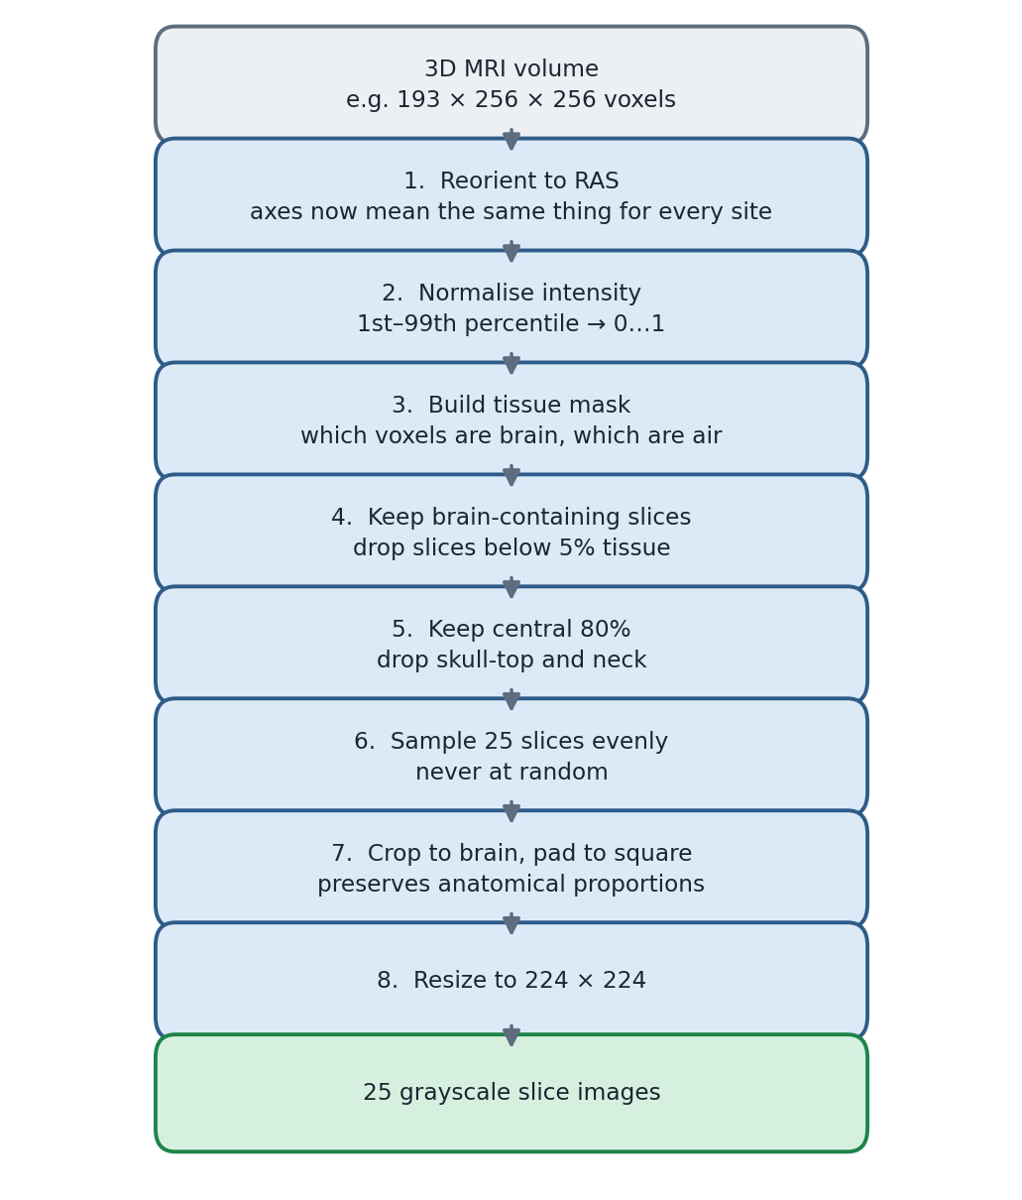
Figure 2 — The eight-step conversion applied to every scan.

Step 1 — Reorient to RAS
Using the NIfTI affine matrix, every volume is rotated into a standard orientation called RAS: axis 0 increases toward the Right, axis 1 toward the Anterior (front), axis 2 toward the Superior (top of head).
After this step, "slice along axis 2" means axial slice for every file from every site — and for any file a user later loads into the application. This single step erases the axis-order problem from section 4.

Step 2 — Normalise intensity
MRI values are not calibrated. Unlike a thermometer, a value of 800 has no fixed meaning; it depends on the machine and its settings. One scanner's bright white matter might read 400, another's 1200.
For each scan the 1st and 99th percentile of non-background voxels are found, and that range is rescaled to 0–1. Percentiles are used rather than minimum and maximum because a single hot voxel from scanner noise would otherwise squash the entire image into darkness.

Step 3 — Build a tissue mask
Everything brighter than 0.12 on the new scale is marked as tissue; everything below is air or background. This produces a 3D true/false map of where the head is.

Step 4 — Keep only brain-containing slices
Most slices at the top and bottom of a scan are pure black air. For each axial slice the code computes what fraction of its pixels are tissue, and discards any slice below 5%.

Step 5 — Keep the central 80%
Of the surviving slices, the outermost 10% at each end are dropped. The very top of the skull and the bottom of the cerebellum and neck contain little useful brain tissue and mostly show bone.

Step 6 — Sample 25 slices evenly
From the remaining range, 25 slices are taken at even intervals from bottom to top. Two decisions are deliberate here.
Why evenly spaced rather than random? Random selection would make the dataset irreproducible, and could miss entire brain regions for some patients. Even spacing guarantees consistent anatomical coverage for everyone.
Why 25? A trade-off. More slices means more data and better coverage, but training time scales directly with slice count. On a CPU-only machine, 25 slices per patient yields 6,650 training images and roughly three hours of training; 50 would double that. The value is a single constant (SLICES_PER_PATIENT in neuro_utils.py) and is easy to change.

Step 7 — Crop to the brain and pad to square
Each slice is cropped to the brain's bounding box, removing black margins that differ by site, then padded to a square with black.
Why pad instead of resizing directly? A 176 × 256 slice squashed straight into 224 × 224 would compress the brain horizontally, distorting anatomy by a different amount at each site. Padding first preserves true proportions.

Step 8 — Resize to 224 × 224
224 × 224 is the input size EfficientNetB3 expects. The result is saved as a JPG.

The result
Every patient, from every site, becomes 25 clean, comparable, 224 × 224 grayscale brain images.
Training images : 6,650 (266 patients × 25)
Testing images : 1,000 (40 patients × 25)
Patients skipped: 0 (all 306 scans were valid)

7. Splitting patients, not pictures
The single most important correctness decision in the project
To know whether a model has genuinely learned, it must be tested on data it has never seen. The obvious approach — shuffle all 7,650 images and hold back 20% — is catastrophically wrong here.
Slices 1 and 2 from patient 29006 are nearly identical pictures of the same brain. If slice 1 goes to training and slice 2 to testing, the model has effectively already seen the test image. It can memorise patient 29006, score brilliantly, and be useless on a genuinely new person.
This is called data leakage, and it is the most common way medical AI results become inflated.
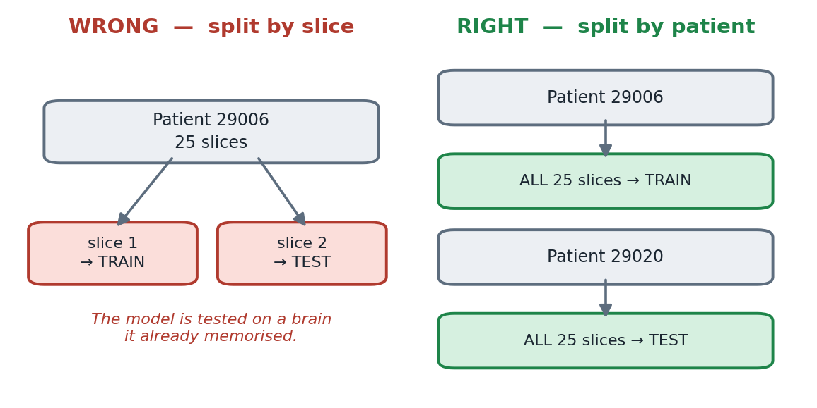
Figure 3 — Slice-level splitting leaks; patient-level splitting does not.
The split therefore happens by patient: all 25 of a patient's slices go to exactly one side. This is enforced rather than merely intended. After writing the files, create_dataset.py re-reads the folders and fails if any patient ID appears on both sides, and test_model.py independently re-checks before scoring.

Balancing across sites
The 40 held-out patients are chosen round-robin across the five sites:
Site | Autism | Healthy
ABIDEII-BNI_1 | 4 | 4
ABIDEII-GU_1 | 4 | 4
ABIDEII-SDSU_1 | 4 | 4
ABIDEII-STANFORD | 4 | 4
ABIDEII-TCD_1 | 4 | 4

This directly addresses the confounding problem from section 2. Because every site contributes equally and is internally balanced, a model that only recognised the scanner would score exactly 50% — chance. Any accuracy above chance must come from something else.

Three groups, not two
306 patients
├── 40 held-out TEST — untouched until the very end
└── 266 training pool
├── 213 TRAIN — the model learns from these
└── 53 VALIDATION — used to tune settings
The validation set exists because tuning decisions — which aggregation rule, which decision threshold, when to stop training — must be made on data the model did not train on. But if those choices were made using the test set, the test set would no longer be unseen and its accuracy would be optimistic. The validation patients absorb all tuning, and the 40 test patients are opened exactly once, at the end.

8. The model

The idea in plain terms
A convolutional neural network (CNN) learns to recognise images in layers. Early layers detect simple things — edges, corners, textures. Middle layers combine those into shapes and patterns. Deep layers combine those into complex concepts. Nobody programs these features; the network discovers them by being shown examples and corrected when wrong.

Transfer learning: why we do not start from scratch
Training a CNN from zero needs millions of images. We have 6,650.
The solution is transfer learning. We begin with EfficientNetB3, a network already trained on ImageNet — 1.2 million everyday photographs across 1,000 categories. In learning to tell cats from cars it developed a rich, general-purpose ability to detect edges, textures, curves and shapes.
Those low-level abilities transfer. A network that can perceive texture and structure in photographs can perceive texture and structure in brain tissue. We keep that visual machinery and retrain only the part that makes the final decision.

Architecture
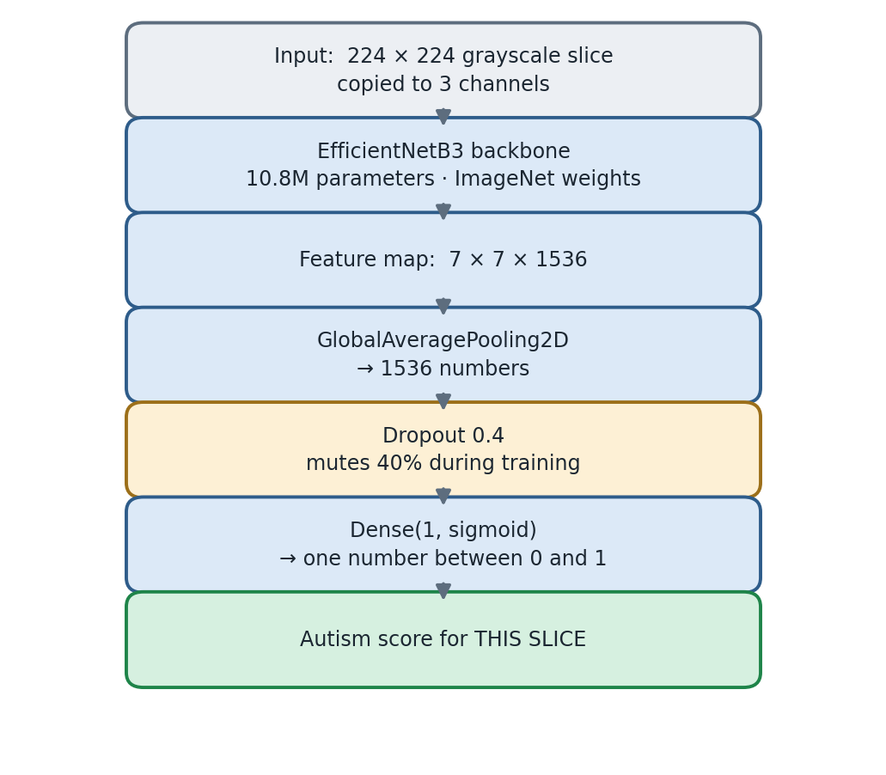
Figure 4 — The network, from input slice to slice score.
Grayscale to 3 channels. EfficientNetB3 expects colour images. Our slices are grayscale, so the single channel is copied three times. This is intentional: it lets the ImageNet weights be used unchanged rather than discarding the first layer.
Global average pooling collapses the 7 × 7 × 1536 feature map into 1536 numbers by averaging each feature across the image, summarising what was found rather than where.
Dropout 0.4 randomly silences 40% of those numbers at each training step. This sounds destructive, but it prevents the network relying too heavily on any single feature — an anti-overfitting measure that matters greatly with only 266 patients.
Dense(1, sigmoid) is the decision layer: one number between 0 and 1, where 0 means confidently Healthy and 1 means confidently Autism.

9. How the model is trained

Two stages, deliberately
 | Stage 1 | Stage 2
What learns | Only the final decision layer | Upper backbone blocks as well
Backbone | Frozen | block6a upward unfrozen
Learning rate | 1e-3 (fast) | 1e-5 (100× slower)
Purpose | Learn to use existing features | Gently adapt features to brain tissue

Why not train everything at once? The final layer starts with random weights, producing large, meaningless error signals. If the backbone were unfrozen, those wild corrections would flow backwards and destroy the carefully learned ImageNet features before they could be useful — like rebuilding a house's foundation while still choosing the paint colour.
Stage 1 lets the decision layer settle using good, frozen features. Only then, in stage 2, are the upper layers nudged — at a learning rate 100 times smaller, so adjustments are gentle.
Why only the upper blocks? Two reasons. Early CNN layers detect universal features that need no adaptation; only deep layers encode task-specific concepts. And practically: unfreezing everything is roughly 11 times slower per step on CPU (measured at 3.7 versus 41.5 images per second) and overfits badly at this dataset size.
BatchNorm layers stay frozen throughout stage 2. These layers hold running statistics learned from 1.2 million ImageNet images; re-estimating them from a few hundred brains is a well-known cause of fine-tuning collapse.

Data augmentation
Each training image is randomly altered slightly every time it is shown, so the model effectively never sees the identical image twice.
Transformation | Amount | Why it is safe
Horizontal flip | 50% chance | The brain is roughly symmetric about the midline
Rotation | ±4% | Head tilt varies between scans anyway
Zoom | ±8% | Head size and scanner distance vary
Translation | ±5% | Head position in the scanner varies
Contrast jitter | ±15% | Scanner contrast varies

The amounts are deliberately mild. Aggressive rotation would create anatomically impossible brains and teach the model nonsense.

Guardrails during training
- ModelCheckpoint — saves a copy whenever validation AUC improves, so the best version is kept even if later epochs get worse
- EarlyStopping — halts training if validation stops improving for six epochs
- ReduceLROnPlateau — halves the learning rate when progress stalls
- Class weights — slightly upweight the rarer class so the model cannot win by always guessing the majority
Decoded images are cached in RAM (about 270 MB) after the first epoch, so the 6,650 JPGs are read and decoded once per run rather than once per epoch.

10. From 25 scores to one answer
The network scores slices, but a user needs one answer per person. A patient produces 25 numbers such as:
0.61, 0.48, 0.72, 0.55, 0.43, 0.68, 0.51, ...
These must become one. That combining step is called aggregation, and five rules were implemented and compared:
Rule | How it works
Mean | Plain average of all 25 scores
Median | The middle value when sorted
Trimmed mean | Drop the extreme 20% at each end, average the rest
Top-third mean | Average only the 8 most autism-like slices
Mean of logits | Average in log-odds space, then convert back

Each has a rationale. The mean uses all evidence but is dragged by outliers. The median ignores extremes entirely. The top-third mean assumes any signal might be focal — present in some brain regions but not all.
The winner is chosen by measurement, not opinion
All five rules are evaluated on the validation patients, and the one with the best patient-level AUC wins. The choice is written to Models/model_config.json and reused identically by the command line and the GUI, so the two can never disagree.

The decision threshold
An aggregated score of, say, 0.58 must become a word. The obvious cut is 0.5, but that is rarely optimal.
The threshold is chosen on the validation patients by maximising Youden's J (sensitivity + specificity − 1) — the point that best balances catching true autism cases against raising false alarms. It typically lands slightly away from 0.5.
This has a visible consequence. If the threshold is 0.529 and a patient scores 0.443 autism, the verdict is HEALTHY with a Healthy score of 55.7%. If they score 0.513 the verdict is still HEALTHY, but the Healthy score reads 48.7% — below half. That looks odd, but it is the model's genuine number, displayed unaltered rather than rescaled to look tidier. Such cases are always flagged Low confidence.
Kept away from the test set
Both the aggregation rule and the decision threshold are chosen on validation patients — never on the 40 test patients. Tuning either against the test set would make the final accuracy figure meaningless.

11. Confidence
The displayed confidence percentage is slice agreement: the share of the patient's 25 slices whose individual scores fell on the same side of the threshold as the final verdict. 21 of 25 agreeing gives 84%.
This is deliberately not a restatement of the probability. It answers a different question: how consistent was the evidence?
Consider two patients who both score 60% autism:
- Patient A: every slice scored about 0.60 → 96% agreement, a steady result.
- Patient B: half the slices scored 0.95 and half scored 0.25 → 50% agreement. The model is deeply conflicted, and the average merely hides it.
Identical probabilities, completely different reliability. Only the agreement figure reveals it.

The High / Moderate / Low label
The label takes the weaker of two signals:
Signal | Question it asks | High | Moderate
Slice agreement | Were the slices consistent? | ≥ 85% | ≥ 70%
Margin from threshold | Did the score clear the line decisively? | ≥ 0.25 | ≥ 0.10

So "Confidence: 92.0% (Low)" is legitimate and informative: the slices agreed strongly, but the aggregate score only barely crossed the decision line. Strong consensus on a near-coin-flip verdict is still a near-coin-flip verdict.
Confidence is not certainty
Confidence measures the model's internal agreement, not medical certainty. 90% confidence does not mean the answer is 90% likely to be correct — a model can be confidently wrong. The question "how often is it right?" is answered only by the held-out test accuracy.

12. What happens when you click PREDICT
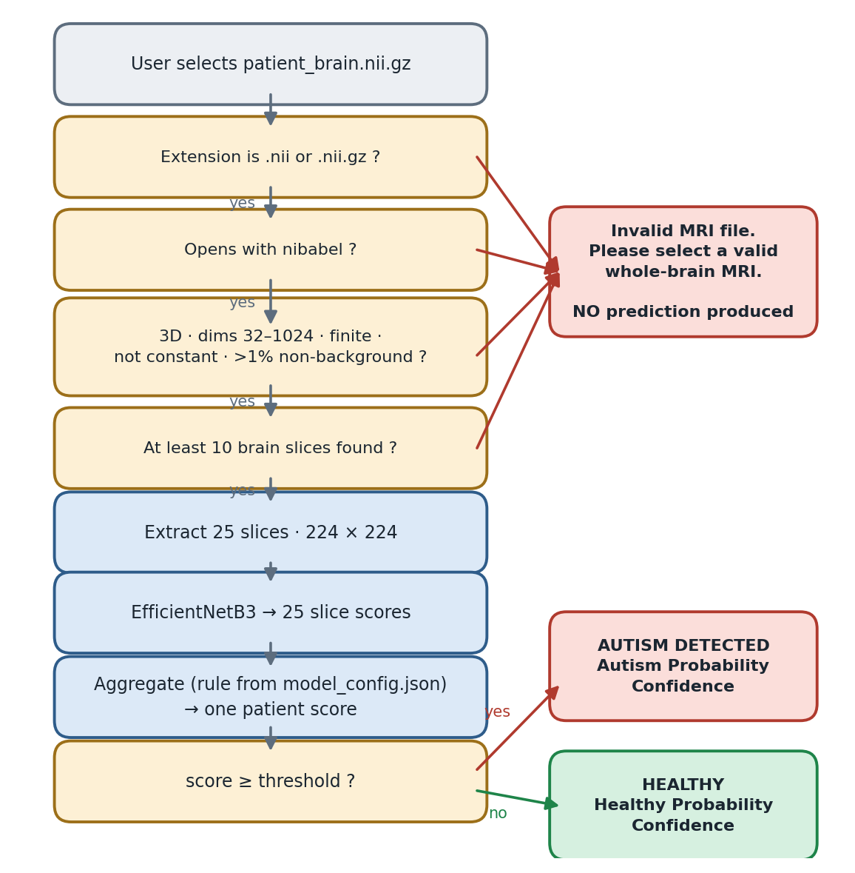
Figure 5 — The runtime path, including every rejection route.
It fails closed. Every validation failure leads to the same place: a refusal with no prediction. The system never guesses on input it does not understand. Feeding it a spreadsheet, a photograph or a corrupted file produces "Invalid MRI file", not a diagnosis.
Slice results are never shown. The 25 individual scores exist internally and are used to compute confidence, but the interface shows only the final patient-level result. Displaying 25 contradictory per-slice verdicts would invite misreading them as 25 independent opinions.
The GUI runs prediction on a background thread, so the window stays responsive while the model works.

13. How the system is measured
test_model.py opens the 40 held-out patients and reports:
Metric | Question it answers
Accuracy | Of all 40 patients, what fraction were labelled correctly?
Precision | When it says AUTISM, how often is that right?
Recall (sensitivity) | Of patients who truly have autism, how many were caught?
F1 | The balance between precision and recall
AUC | How well scores rank autism patients above healthy ones, independent of any threshold
Confusion matrix | The full breakdown of correct and incorrect calls per class

Why AUC is reported alongside accuracy
Accuracy depends on the chosen threshold; AUC does not. AUC asks: if you drew one autistic and one healthy patient at random, how often would the model give the autistic one a higher score? 0.5 is pure chance and 1.0 is perfect. It is the better measure of whether the model has learned anything at all.

Where results are written
Reports/classification_report.txt full metrics + per-patient scores
Reports/confusion_matrix.png
Reports/roc_curve.png
Reports/test_results.json machine-readable
Reports/accuracy.png, loss.png training curves

14. Honest assessment

What this project does well
The methodology is sound. Patient-level splitting is enforced by code rather than convention. The test set is site-balanced so scanner recognition cannot inflate the score. Tuning decisions are made on validation patients, leaving the test set genuinely unseen. The same preprocessing code runs at training and prediction time. All 306 scans processed without a single failure.

What it cannot do
It cannot diagnose autism — not because of an implementation shortcoming, but because the signal largely is not there. Autism is a behavioural and developmental condition. Structural brain differences between autistic and non-autistic people exist at the population level, but they are small, inconsistent, and heavily overlapping between individuals.
Setting expectations honestly
Published patient-level results on ABIDE using structural MRI generally land in the 60–75% range. A result far above that should raise suspicion of data leakage before it prompts celebration.

Known limitations
- 306 patients is very small for a 10.8-million-parameter network.
- The model sees 2D slices independently; 3D structure is not modelled.
- Site variability remains in the training data even though the test set is balanced.
- Each site contributes only 8 held-out patients, so per-site figures carry very wide error bars.
- A single train/test split is used, with no cross-validation, so the reported figure has meaningful variance.
- With 40 test patients, one patient is worth 2.5 percentage points of accuracy.

What would actually improve it
- More data — ABIDE-I adds roughly 1,100 further subjects.
- 3D CNNs or multi-view models that see the whole volume at once.
- Skull stripping and spatial registration to a standard brain template, removing anatomy irrelevant to the question.
- Functional MRI — connectivity between brain regions carries more autism signal than structure does, and resting-state scans are already present in ABIDE.
- Cross-validation for a more stable estimate.
- Explicit site harmonisation (for example ComBat) to remove scanner effects.

15. Glossary
Term | Meaning
Aggregation | Combining many slice scores into one patient score
AUC | Probability the model ranks a random autistic patient above a random healthy one. 0.5 = chance
Augmentation | Randomly altering training images so the model cannot memorise them
BatchNorm | A layer that normalises values flowing through the network
CNN | Convolutional Neural Network — a network designed for images
Confounding | When the model learns a correlated irrelevance (e.g. the scanner) instead of the real signal
Data leakage | Test information reaching the model during training, inflating results
Epoch | One complete pass over the training data
Fine-tuning | Adjusting a pretrained network's own layers, slowly
ImageNet | 1.2 million labelled photographs used to pretrain vision networks
Learning rate | How large a correction the model makes at each step
NIfTI | The .nii / .nii.gz neuroimaging file format
Overfitting | Memorising training data instead of learning generalisable patterns
RAS | Right-Anterior-Superior — a standard anatomical orientation
Sigmoid | A function squashing any number into the range 0 to 1
Threshold | The score above which the verdict becomes AUTISM
Transfer learning | Reusing a network trained on one task as the starting point for another
Voxel | A three-dimensional pixel — one measurement point in the volume

This document describes the system as implemented. For setup and usage instructions see README.md. For measured results see the Reports folder.

