Patryk Kulik (0989317) INF1B

Summative Assignment PLS

Analysis OP3

Table of contents

Requirements Specification 2

Use Case Diagram 3

UML Class Diagram 0

User Manual 0

Create Backup 0

Restore Backup 0

Adding a book item 1

Adding a customer 1

Showing all current book loans 2

Search through Book Catalog 2

Loan a Book copy 3

# Requirements Specification

The System:

* The system must contain a backend and frontend part. The frontend part may be made as a console based (textual) interface.
* The system is able to make a backup of the following data: Books and Book items, Loan administration and Customers
* The System is able to restore the backup of the data.

The Librarian:

* Can add a new customer to the administration.
* Can add new book items to the catalog.
* Can see the loan administration.
* Can search through the catalog of books.

The Customer:

* Can search through the catalog of books.
* Can loan a book from the library.

Constrains:

* The system must use only the standard Python library modules. Any exceptions must be mentioned in Readme.txt file.
* The delivery of the system must not include any bulky files.

# Use Case Diagram

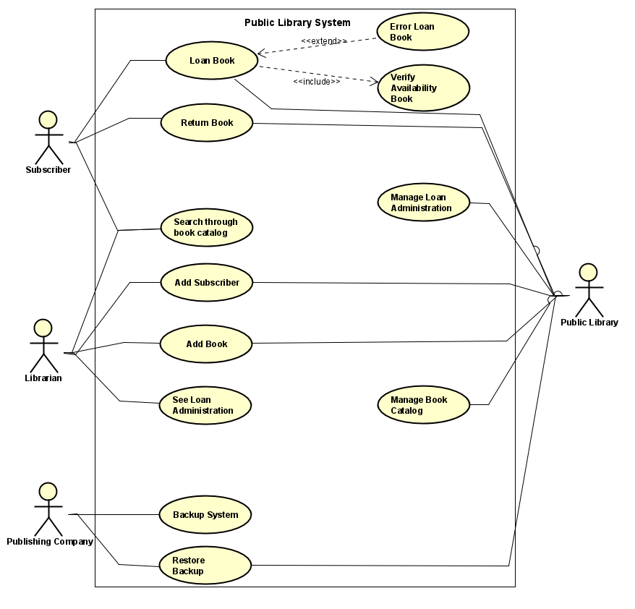

# UML Class Diagram

# User Manual

## Create Backup

The system will create a backup of the current status of your public library system. If you want to use it, simply write the digit ‘’1’’ in the input field. After execution, you will be able to find the backups of your system in ../backup/.. .

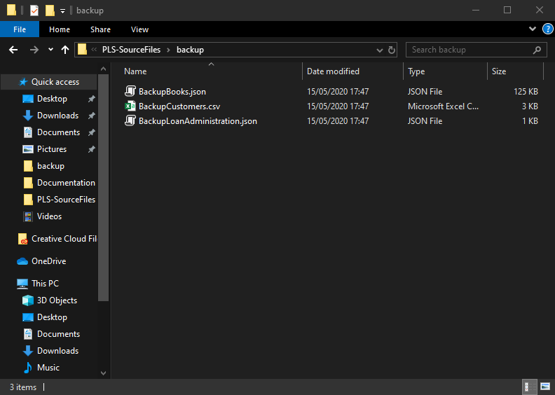Example:

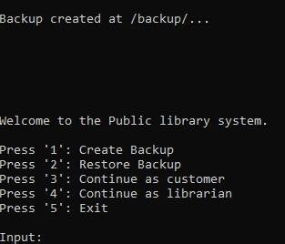

## Restore Backup

They system will restore the last saved backup of your PLS. if you want to use it, simply write the digit ‘’2’’ in the input field. After execution, you will get a message and all the backup-ed data will replace the current data.

Example:

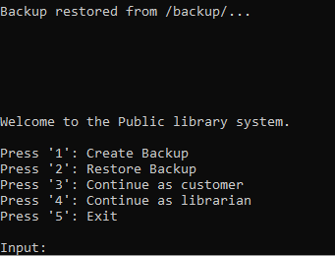

## Adding a book item

As a librarian, you will be able to add a book item. First you will have to enter ‘’4’’ to enter the librarian menu. Upon entering that, you will see the option ‘’Add Book’’. The system will let you see all the available books. You will be able to choose a book and the system will automatically add a new copy (book item) of the selected book. After execution, you will return to the librarian menu.

Example:

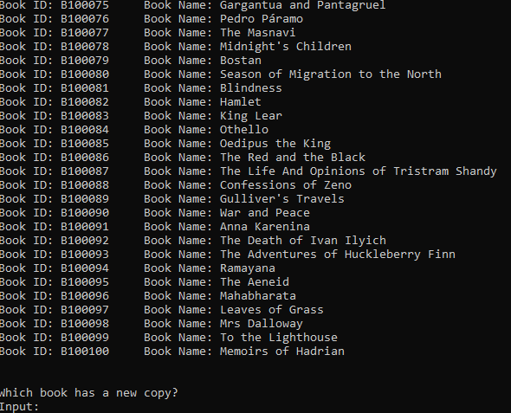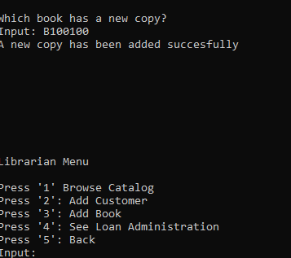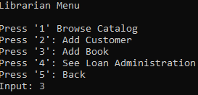

## Adding a customer

The system is able to add new customer. While being in the librarian menu, please choose that option. After entering the option, you will have to enter the information of the customer. The system will then automatically create a new customer for you.

Example:

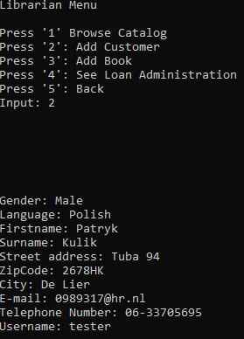

## Showing all current book loans

The system is able to show all current system loans. To access that option, you will have to be a librarian. Simply entering the digit ‘’4’’ will let you see the Loan Administration

Example:

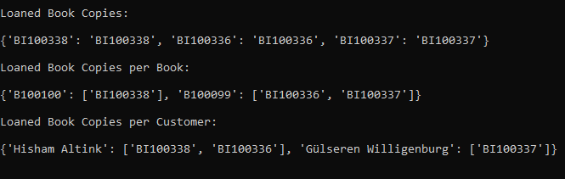

## Search through Book Catalog

As a customer and librarian, you will be able to search through the book catalog. After choosing the option. The system will ask you with what criteria you want to search. If you don’t want to search with a specific criteria, you can simply press ‘’Enter’’. After filling in the criteria, the system will find you all the books that met the criteria. You can then select a book that you are interested in and the system will let you see if there are any available copies of that book.

Example:

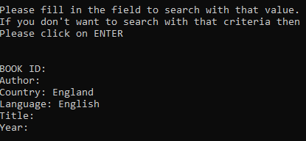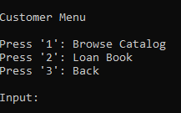

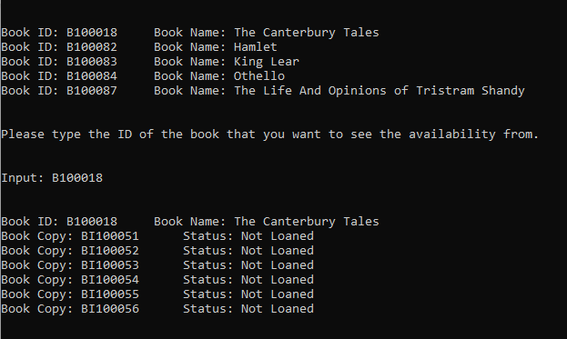

## Loan a Book copy

As a customer, you are able to loan book copies. If you want to do that, simply choose that option in the customer menu. You will the have to choose a book that you are interested in. After that you will have to choose a book copy that is not loaned(if you choose a loaned book copy, the system will force you to choose a different copy). After that you will have to give your username. The system will do the rest for you.

Example:

