Research pcb-design

**ESP32 Technical Reference Manual:**

<https://www.espressif.com/sites/default/files/documentation/esp32_technical_reference_manual_en.pdf>

**ESP32 Series Datasheet:**

<https://www.espressif.com/sites/default/files/documentation/esp32_datasheet_en.pdf>

**specifieke esp-datasheets:**

<https://www.espressif.com/en/products/modules/esp32>

**embedded flash memory:**

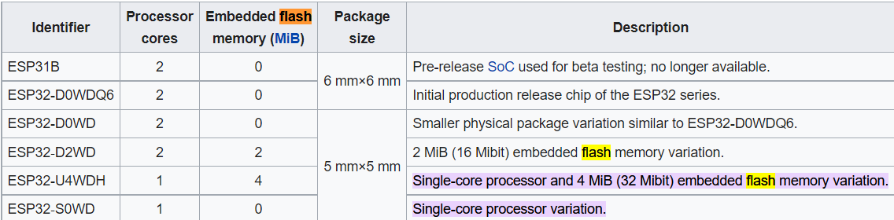

* Meestal extern flashgeheugen vereist.

**ESP32 Hardware Design Guidelines:**

<https://www.espressif.com/sites/default/files/documentation/esp32_hardware_design_guidelines_en.pdf>