**Commentary 1**

**Title of the article:** *Academics demand higher tobacco tax*

**Source of the article:** Taipei Times

<https://www.taipeitimes.com/News/taiwan/archives/2023/08/06/2003804322>

**Date the article was published:** 2023/8/6

**Date the commentary was written:** 2024/2/18

**Word count of the commentary:** 800

**Unit of the syllabus to which the article relates:** Microeconomics

**Key concept being used:** Efficiency

**Article**

**Academics demand higher tobacco tax**

Aug 06, 2023

By Chiu Chi-jou / Staff reporter

SURCHARGE GOAL: Last year the tax rate on a pack of cigarettes was 53 percent in Taiwan, which is lower than WHO recommendation of 75 percent, an expert said.

Local academics and civic health groups have urged the government to follow the WHO guidelines and set a clear goal for increasing the tobacco health and welfare surcharge to effectively reduce tobacco use in Taiwan.

Based on the Tobacco Hazards Prevention Act, the government needs to re-evaluate surcharge adjustments every two years with specialists in the fields of finance, economics and public health.

The surcharge has not been adjusted in the past few years, although an evaluation meeting was held in November last year.

Lee Yue-chune, a professor of public health at National Yang Ming Chiao Tung University, yesterday said the tobacco surcharge adjustments in 2009 and 2017 led to a significant decrease in smoking, but it has not been increased since then.

The average price of a pack of cigarettes last year was NT$116 (US$3.66), with a tax rate of 53 percent, which is lower than the minimum tax rate of 75 percent recommended by the WHO, she said, adding that the decrease in tobacco use in Taiwan has slowed down.

Taiwan each year spends up to nearly NT$80 billion on healthcare resources to treat smoking-related illnesses, and smoking costs the economy more than NT$200 billion, Lee said.

The government needs to set clear goals for the tobacco health and welfare surcharge tax rate and increase it regularly to reduce Taiwan’s smoking population and save medical resources.

**Taiwan has been slow**

John Tung Foundation tobacco division director Lin Ching-li said most countries did not adjust their tobacco surcharge rates during the COVID-19 pandemic, but in the post-COVID-19 era, Hong Kong took the lead by raising the price of mainstream cigarette brands to about NT$304 per pack, with a tax rate of 62 percent.

The government has been acting too slowly to increase the surcharge, as the tax rate continues to remain at about 50 percent in Taiwan, she said.

Chung-Hua Institution for Economic Research deputy director Huang Shih-chang said raising the tobacco surcharge might trigger a backlash and encourage cigarette smuggling.

Therefore, the government needs to set up an automatic tobacco surcharge adjustment mechanism similar to the one in France, and gradually raise the tax rate based on national income, the inflation rate and price changes, he said.

In other developments, the Health and Promotion Administration (HPA) said that eight companies had applied to manufacture of import heated tobacco products (HTPs), as of Friday last week, but only one company submitted the complete documents required for review.

Based on amendments to the Tobacco Hazards Prevention Act, which were enacted on March 22, HTPs must pass a health risk assessment to be permitted for manufacturing, import, sales and use.

The companies need to apply for manufacturing or import approval in advance, and submit 13 documents required to conduct a health risk assessment.

As students might easily become HTP consumers, if the products are allowed to be legally sold in Taiwan, the government should strictly prohibit tobacco companies from misleading the public to believe that HTPs cause less health problems, Lin said.

**Commentary**

The article is about the tobacco taxation policy in Taiwan, with an average price of NT$116 for a pack of cigarettes last year with a tax rate of 53%, lower than the 75% recommended by WHO. Tobacco consumption has negative impacts on both consumers and society, and thus taxation is beneficial for reducing negative externalities of consumption. Specialists plan to increase the tax rate gradually to better achieve allocative **efficiency**.

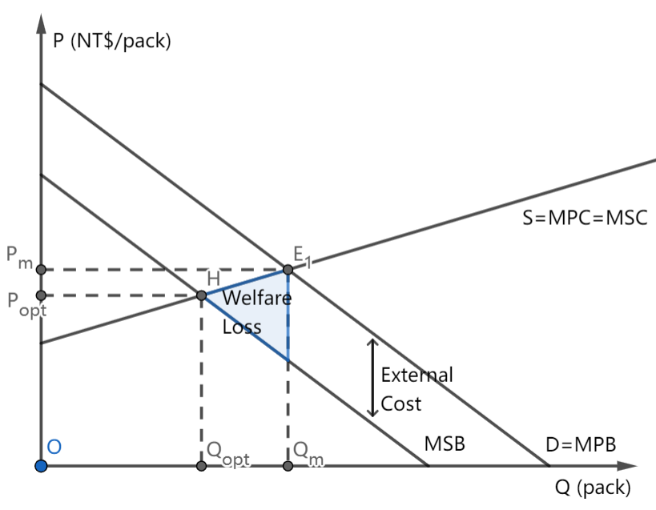

Figure 1. Negative Externality of Tobacco Consumption

Ideally, if the consumers smoke Qopt tobacco with producers manufacture Popt amount, the marginal social cost (MSC) equals the marginal social benefit (MSB), the social surplus could be maximized and the allocative **efficiency** could be achieved. However, since people only take their own benefits into consideration, they overconsume Qm amount of tobacco at price Pm, and the equilibrium, indeed, lies on E1, where MPC equals the marginal private benefit (MPB). Smoking-related diseases result in higher healthcare cost that is an extra burden to society, creating external costs, thus MSB is lower than MSC. The real consumption Qm is larger than Qopt, resulting in an overallocation of resources.

As the market does not meet allocative **efficiency**, the government eliminates the welfare loss, by imposing an indirect tax on the tobacco market.

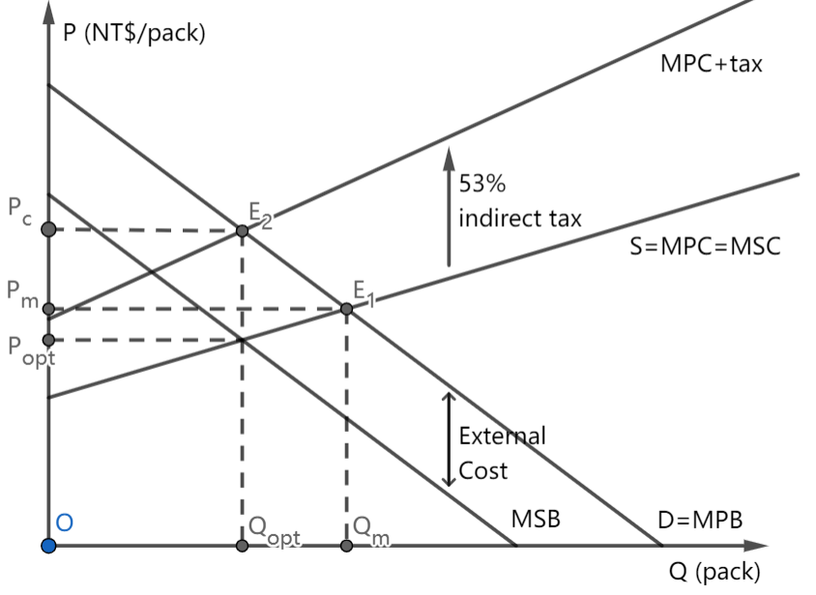

Figure 2. Effect of Indirect Tax Imposition on Taiwan Tobacco Essence

The government increases the cost of production for firms by charging 53% ad valorem tax. Raising the unit price to NT$116 (US$3.66) results in an upward shift of marginal cost (MPC to MPC+tax). The proper charge for indirect tax should meet the requirement that MPC+tax and MPB intersect at E2, such that the quantity consumed is reduced to Qopt. By imposing taxation, the Taiwanese government can reduce welfare loss and achieve allocative **efficiency** by imposing a 53% tax per pack of cigarettes.

To evaluate, the policy can bring some benefits. Firstly, the policy internalizes the externality and creates incentives for consumers to change their consumption patterns and reach allocative **efficiency**, as the tobacco surcharge adjustments in 2009 and 2017 correspond with a significant decrease in tobacco demand. Consumers now are required to pay for the external cost and have incentives to change their consumption pattern, i.e. stop smoking.

The tax imposition can reduce Taiwan’s smoking population and thus save medical resources. Smoking has negative effects on physical health, and consumption of tobacco may unnecessarily crowd out medical resources. Each year, Taiwan spends up to nearly NT$80 billion on healthcare resources to treat smoking-related illnesses, and smoking costs the economy more than NT$200 billion in total. The reduction in the smoking population in Taiwan can save medical resources. The reduction in the smoking population can help optimize the use of medical resources.

The government can gain more revenue through tobacco taxation. This revenue can serve as a vital source of revenue for public services. For example, the government can, instead, use this revenue to finance educational programs to discourage consumption of tobacco. If the consumers realize the consumption of tobacco should be avoided and stop smoking, the negative externality can be really reduced instead of simply being internalized, and therefore result in a better allocative **efficiency**.

However, existing potential disadvantages should be taken into consideration. The tax-determining step is difficult. There exist difficulties in measuring how much tax should be imposed as Taiwan does not have an automatic mechanism so that the tax rate can be raised gradually “based on national income, the inflation rate and price changes”. Difficulties in measuring the value of external costs and how much tax to impose result in a re-evaluating surcharge adjustment every two years with specialists in finance, economics, and public health. The challenge of accurately assessing external costs may impede the **efficiency** of the taxation system, necessitating periodic evaluations to ensure effective and efficient taxation.

At the same time, tobacco has an inelastic demand; Since the quantity demanded has a relatively smaller proportional decrease compared to the proportional increase of price to decrease tobacco consumption, the tax should be charged at a high price. A sudden increase in the tax rate may create sudden shocks to the market, “encourage cigarette smuggling”, “trigger a backlash”, and fail to reach allocative efficiency. Therefore, to balance economic and political concerns, a gradual increase is taken with a current tax rate of 53 percent instead of the minimum tax rate of 75 percent recommended by WHO.

High tobacco surcharge may also lead to growth in the underground market. This potential growth in the underground market represents an **efficiency** challenge, as it may undermine the intended goals of the surcharge and lead to less effective regulation of tobacco consumption.

In conclusion, tobacco consumption creates a negative externality, failing to reach allocative **efficiency**. And the imposition of a 53% ad valorem tax tries to reduce this negative effect. Government plans to increase the tax rate gradually to avoid the possible disadvantages and, at the same time, reach allocative **efficiency**.

**Commentary 2**

**Title of the article:** *Turkish central bank hikes key interest rate by another 500 bps*

**Source of the article:** Daily Sabah

<https://www.dailysabah.com/business/economy/turkish-central-bank-hikes-key-interest-rate-by-another-500-bps>

**Date the article was published:** 2023/11/23

**Date the commentary was written:** 2024/5/31

**Word count of the commentary:** 800

**Unit of the syllabus to which the article relates:** Macroeconomics

**Key concept being used:** Intervention

**Article**

**Turkish central bank hikes key interest rate by another 500 bps**

BY DAILY SABAH WITH AGENCIES | ISTANBUL | NOV 23, 2023 - 1:41 PM GMT+3

Türkiye's central bank on Thursday surprised the market with a larger-than-expected interest hike as it lifted its benchmark one-week repo rate by another 500 basis points to 40% in the sixth straight rise under a new governor and the shift in policymaking.

The bank, however, signaled that the pace of monetary tightening will slow down with the tightening cycle to be completed in a short period.

"The current level of monetary tightness is significantly close to the level required to establish the disinflation course," the Central Bank of the Republic of Türkiye (CBRT) said in a statement.

"Accordingly, the pace of monetary tightening will slow down and the tightening cycle will be completed in a short period."

Economists polled by an Anadolu Agency (AA) survey last week expected the bank would deliver a 250 basis points rate hike.

A Reuters poll similarly on Monday showed that the bank is expected to raise its policy rate by 250 basis points to 37.5% this week – according to 21 institutions in the poll. One predicted 300 basis points and another predicted 350.

According to the latest data from the Turkish Statistical Institute (TurkStat), Türkiye's annual inflation eased to 61.36% in October from a nine-month high of 61.53% in September.

"Headline inflation edged down in October and remains in line with the outlook presented in the most recent Inflation Report. The existing level of domestic demand, the stickiness in services inflation and geopolitical risks keep inflation pressures alive. On the other hand, recent indicators suggest that domestic demand has started to moderate as the monetary tightening is reflected in financial conditions," the central bank further said.

The bank, in its last quarterly inflation report of the year earlier this month, revised its year-end inflation forecasts upward for this year and the next.

It expects inflation to rise from around 61.4% last month to peak at 70%-75% in May before dipping to about 36% by the end of next year.

"Getting high and volatile inflation under control will be a long and difficult process. We will continue to use all tools available in a determined way to ensure disinflation," CBRT Governor Hafize Gaye Erkan said at the time.

"Really impressive move by the (central bank) ... getting well ahead of expectations," emerging markets economist Timothy Ash remarked in an emailed note.

The bank's previous policy of cutting interest rates amid high inflation was accompanied by a steep decline in lira in 2021, after which the government introduced a scheme that protects lira deposits from foreign exchange depreciation. The central bank meanwhile initiated a gradual exit from the scheme, also known as KKM, while the shares of Turkish lira deposits began to rise.

Excluding the KKM scheme, the share of lira deposits in the banking system has risen 7 percentage points in the last three months to above 38% amid government efforts to reduce dollarization.

President Recep Tayyip Erdoğan chose former Wall Street banker Erkan as central bank chief after his May reelection.

"To increase the functionality of market mechanisms and strengthen macro-financial stability, the committee continues to simplify and improve the existing micro- and macroprudential framework," the bank said.

"While lending rates are assessed to be in line with the targeted level of financial tightness, the committee evaluates that the regulations to increase the share of Turkish lira deposits and monetary tightening will continue to strengthen the transmission mechanism and to improve the funding composition of the banking system."

The bank has raised its one-week repo rate by 3,150 basis points since June, with 500-point hikes in the previous two months.

**Commentary**

The article concerns Turkey's demand-pull inflation of 61.36% annually due to its previous low interest rate. The government took **intervention** by increasing its interest rate to 40%, trying to lower the pace of inflation.

|  |
| --- |
|  |
| Figure 1: Inflation gap in Turkey |

Normally when the economy is overheating, adjusting interest rates is always an effective **intervention.** However, Turkey’s President, Recep Tayyip Erdogan, decided to instead, flood the economy with cheap money for his presidential election popularity. Due to the low interest rate, households consume rather than save, and firms are more willing to borrow money to invest. Also, to reduce dollarization, they increased the Lira deposit in banks, increasing the money supply. As consumption and investment, which are determinants of aggregate demand (AD), increase, AD shifts to the right, intersecting the SRAS at real output Yinfl higher than Yp, forming an overheating demand-pull inflation.

Unlike in most other countries, Turkey’s central bank is not independent of the government, meaning it is difficult for them to address the problem by adjusting the interest rate. As a result, the economy gradually shifted to an uncontrollable situation – in September 2023, the annual inflation rate reached its nine-month high of 61.53%. To change this severe situation, former Wall Street banker Erkan is chosen by Erdogan after his May reelection as central bank chief.

By November 2023, Turkiye’s central bank had raised the interest rate 6 times to 40% to **intervene** in the overheating inflation.

|  |
| --- |
|  |
| Figure 2: After the imposition of the contractionary monetary policy. |

Since the interest rate is higher, households and firms are likely to be discouraged from borrowing money. At the same time, households may choose to deposit their money into the bank rather than spending considering the high return for saving. The reduction in consumption and investment shifts AD to the left from AD1 to AD2 ideally at its potential output Yp. The inflation in Turkey is expected to decrease to about 36% by the end of 2024.

To evaluate, the monetary policy taken is a flexible **intervention** tool and can be changed often according to its needs. The central bank controlled the current level of monetary tightness very close to the level required to establish the disinflation course. The interest rate can be changed frequently and multiple times. The closest **intervention** taken is the 6th straight rise of 5% in interest rate under the new governor’s management.

Due to inflation, people in Turkey struggle to pay for their fundamental living costs. A successful government intervention may solve the inflation problem and return the price level to its original ideal value. Then people can return to better living conditions. At the same time, the **intervention** reveals that the Turkish government is actively trying to solve the inflation problem instead of overlooking it. Economist Timothy Ash addressed his delight “Really impressive move by the (central bank)… getting well ahead of expectations”. Households' and investors’ confidence can be restored, and they will be more inclined to engage in healthy economic activities, thereby improving the market function ability.

However, the **intervention** to raise interest rates increases the cost of borrowing for individuals and businesses, including those with already existing debts. The debtors may struggle to meet their debt obligations, leading to financial distress and poverty.

Also, as firms face higher borrowing costs, they may scale back production and investment, leading to layoffs and higher unemployment rates. The reduced consumer spending can further contribute to lower revenue and more job losses. This results in a worse living condition, and thus the **intervention**, on the other hand, can lead to widespread poverty and social unrest.

The increase in interest rate may increase income inequality – while wealthy individuals save money in banks and receive higher interest, the poor borrow money from banks and face higher debts, falling into severe poverty. Particularly in Turkey, its central bank is not independent of the government, so people may be unsatisfied with the **intervention** made by the government. The arising public dissatisfaction with the intervention may potentially lead to political pressure onto Turkish government.

Additionally, a 61.36% inflation rate may be too high for the monetary policy to work effectively. Instead of saving in the bank, people may prefer dollar to avoid the extreme inflation. The use of contractionary monetary policy alone to address the problem of an overheated economy may take too long and may need to be complemented by other government **interventions**. For example, fiscal policies such as increases in progressive income tax and business tax can be taken to reduce inequality and the possibility of social unrest.

In conclusion, the former incorrect interest rate set by the Turkish government and its central bank led to severe demand-pull inflation. Their determination to solve the problem is shown by their **intervention** of adding the interest rate to 40% in November 2023. The **intervention** started working gradually and other **interventions** may be taken to accompany it, such as increasing the tax.

**Commentary 3**

**Title of the article:** *China’s Cheap Steel Hurts Latin America’s Industry*

**Source of the article:** Dialogo Americas

<https://dialogo-americas.com/articles/chinas-cheap-steel-hurts-latin-americas-industry/>

**Date the article was published:** 2024/07/01

**Date the commentary was written:** 2024/11/13

**Word count of the commentary:** 797

**Unit of the syllabus to which the article relates:** Global Economy

**Key concept being used:** Change

**Article**

***China’s Cheap Steel Hurts Latin America’s Industry***

*BY Diálogo*

***July 01, 2024***

The Latin American steel industry is facing a crisis due to China’s unfair trade practices, which flooded the market with cheap steel, threatening regional producers’ jobs and livelihood, *Radio France International* reported.

“China’s production affects Latin American economies, putting at risk 1.4 million jobs in the steel sector; forcing the suspension of operations of several companies and massive layoffs,” Gabriela Fajardo Mejía, an expert in international relations and doctoral candidate in Global Society Law at the University of Navarra in Spain, told *Diálogo*on May 28. “[Production] is not subjected to environmental and quality standards. Chinese companies do not comply with rules of transparency and regulations.”

China’s strategy of selling its product below market prices has triggered a dumping situation that severely affects Latin America. According to data from the World Steel Association, China’s share of global crude steel production reaches 54 percent. Between January and April 2024 alone, China produced 343.7 metric tons of steel.

“The slowdown in China’s real estate and construction business caused domestic demand for steel to decline, leaving producers dependent on other countries to make up the shortfall,” Henry Ziemer, research associate with the Americas Program at the Center for Strategic and International Studies, told*Diálogo*. “As the U.S. market looks increasingly unfavorable for Chinese steel producers, they are now looking to Latin American countries with fewer trade barriers to get rid of excess capacity.”

In addition, the Chinese government subsidized steel production and exports during the pandemic. This caused a wave of cheap Chinese steel to spread around the world, Colombian newspaper *El Tiempo* reported.

Mexico, Chile, and Brazil have significantly increased tariffs on steel imports from China to protect domestic companies, with other countries in the region likely to follow suit.

Cheap Chinese steel is sinking the Latin American steel industry, causing several of the region’s large companies to freeze or shut down operations, the Latin American Steel Association (Alacero) said in a statement. For Alejandro Wagner, Alacero executive director from June 1, 2021 to June 1, 2024, the situation is creating a “process of deindustrialization in the region,” he told *BBC*.

In March, Chile’s Compañía de Aceros del Pacífico (CAP) suspended operations at its emblematic Huachipato industrial plant, citing its inability to compete with Chinese prices, and stressing that China’s dumping has affected the economic and social development of the region.  The company resumed activities after the government imposed a temporary tariff on Chinese steel imports. The Huachipato’s board of directors expressed hope that the measure would become definitive.

Similarly in Colombia, the steel industry is asking for fair competition, as they experience the devasting rippling economic effects. “We have been enduring unfair competition for two years through massive imports from China and Russia at predatory prices, even 40 percent below international and market prices,” Fabio Galán, president of Acerías Pazdelrío, told daily *El Colombiano*.

“In the past there have been reports that iron ore mines in Mexico, raided by organized crime cartels, played an important role in shipping looted iron ore to China, which was then converted into steel,” Ziemer said. “These reports provide additional evidence that China’s unfair and opaque trade practices create perverse incentives within the hemisphere, which can encourage criminal organizations and undermine the quality of governance.”

Brazilian steel producer Gerdau announced in March that it would temporarily lay off workers at its São José dos Campos plant, in São Paulo, blaming it on China’s unfair competition. Gustavo Werneck, president of the company, told the Brazilian media *InfoMoney* that these measures are only the first step to contain the Chinese surge.

“In addition, China subsidizes its companies in the sector, which allows lowering their costs. It is mainly worrying that quality and environmental standards for this production are not a factor taken into account by the Chinese government, but it is even more worrying that they are not a factor to be considered by steel buyers in Latin American countries, who to the detriment of their own local industry are mainly influenced by the low price,” Fajardo Mejía said. “While Latin American steel mills emit 1.55 tons of carbon dioxide (CO2) per ton of steel produced, China emits 2.24 tons of CO2, which represents 45 percent more pollution.”

The imposition of tariffs on China’s steel as a response to its unfair practices also underscore the potential for trade tensions between the Latin American countries and China, with a potential for retaliation from the Asian country, known for its coercive diplomacy.

For instance, China banned soy-based products from Argentina in 2016 in response to far-reaching anti-dumping measures, Argentine daily *La Nación* reported. In 2019, following the arrest of a Huawei executive in Vancouver, China suspended all purchases of Canadian canola seed, *AP* reported.

“China produces more steel than the next nine steel-producing countries combined, giving it a powerful tool to influence prices and disrupt local economies,” Ziemer said. “However, the fact that this latest round has targeted countries like Chile and Mexico may present an opportunity for the United States to coordinate with Latin American countries on ways to mitigate China’s unfair trade practices and protect their domestic industries.”

**Commentary**

The article addresses concerns about the tariff impositions on China’s cheap steel by many Latin American countries to protect local steel industry. Due to the slowdown of China’s real estate and construction business, the excess of steel leaves Chinese steel producers dependent on other countries to make up the shortfall. The exportation subsidy imposed by Chinese government during the pandemic further increased the wave of cheap Chinese steel to spread around the world. Latin American countries therefore impose trade protection to prevent deindustrialization as a result of the **change** insteel industry.

China and Russia have unfair competition with other countries at predatory prices, which are 40% below the original international and Latin American domestic market price. The world price is lowered to Pw<Pd, so only a quantity of Q1 is supplied by domestic steel producers, while the excess quantity Q2-Q1 is provided by export—mostly by China, which took up 54% of global crude steel production.

|  |
| --- |
|  |
| Figure 1: Under free trade, the steel price is Pw and domestic supply is Q1. |

To **change** the dumping situation, many Latin countries have imposed, or are currently considering imposing tariffs on China’s cheap steel, shifting the price of steel upwards to (Pw+tariff), to protect local industry.

|  |
| --- |
|  |
| Figure 2: After imposing policy, the new quantity supplied by domestic firms is Q3. |

At the **changed** world price (Pw+tariff), the domestic quantity of steel supplied increased from Q1 to Q3, the quantity of steel demanded fell from Q2 to Q4, the total quantity imported fell to Q4-Q3 while the quantity of steel supplied by domestic producers increased from Q1 to Q3. A misallocation of resources is caused by increasing production by inefficient producers and decreased consumption of consumers.

Tariff can help shield local producers from the influx of cheap steel that has been driving them out of business. After the imposition of tariff, consumers are required to buy imported steel products at (Pw+tariff), so fewer will prefer imported goods, as Chile’s Compañía de Aceros del Pacífico (CAP) “resumed activities.” The original lower steel price provided by China has created a derived demand for labor in China rather than their own, causing a **change** in job positions, creating job loss and negative impacts on standards of living of household in an economy, putting “1.4 million jobs in steel sector” at risk. By imposing tariffs, the increased demand for domestic steel will further excite domestic production, more labor forces are required, so employment increases, thus **changing** the current employment issue.

Instead, the production of steel in China also creates a higher carbon emission, resulting in a negative **change** inthe environment. Compared to Latin American steel mills which “emit 1.55 tons of carbon dioxide (CO2) per ton of steel produced,” China emits 45% more pollution. By imposing the tariff and reducing the steel imported from China, the demand for China steel will decrease, followed by a decrease in steel production, less carbon emission, and a better-protected environment.

Enduring “unfair competition” for two years at prices 40% below international and market prices from China and Russia, the tariff imposition can **change** the level of the playing field and reduce the impact of price competition. Therefore, the tariff can allow more local industries to compete more fairly against subsidized foreign products and change the current unfair dumping market.

However, the **change** of policybylocal governments may also lead to negative **changes** in international relationships.

As Latin American countries implement tariffs to address the issue of dumping, China could respond by introducing its own trade measures, such as imposing tariffs or restricting imports, as observed in previous disputes where China limited imports of soy-based products from Argentina and suspended purchases of Canadian canola seed. These actions could affect the trade dynamics between China and Latin American countries, potentially leading to increased trade tensions and impacting other sectors of the economy that depend on trade with China. A reduction in exports could potentially lower the real GDP of Latin American countries.

While tariffs may protect domestic industries, they can also lead to 40% higher steel prices for consumers and other industries reliant on steel. This **change** in steel import affects steel prices could ultimately increase the price of goods using steel as raw materials, hurt the economy, and lead to inflationary pressures.

Additionally, in trade protection, while trying to protect the domestic product by **changing** the tariff, the allocation of resources **changes** to a misallocated situation on a global scale, as the production moves away from the lowest cost producers in other countries to higher cost domestic producers, worsening the global resource allocation.

In conclusion, China’s low-cost steel exports have adversely affected the Latin American local steel industry, prompting the imposition of tariffs to address the challenges. While trade protection provides critical support for local industries and **changes** the situation, it brings both positive and negative ramifications. Careful policy consideration is essential to balance the benefits of domestic protection with the broader implications of trade protectionism.