**Commentary 1**

**Title of the article:** *Academics demand higher tobacco tax*

**Source of the article:** Taipei Times

<https://www.taipeitimes.com/News/taiwan/archives/2023/08/06/2003804322>

**Date the article was published:** 2023/8/6

**Date the commentary was written:** 2024/2/18

**Word count of the commentary:** 800

**Unit of the syllabus to which the article relates:** Microeconomics

**Key concept being used:** Efficiency

**Article**

**Academics demand higher tobacco tax**

Aug 06, 2023

By Chiu Chi-jou / Staff reporter

SURCHARGE GOAL: Last year the tax rate on a pack of cigarettes was 53 percent in Taiwan, which is lower than WHO recommendation of 75 percent, an expert said.

Local academics and civic health groups have urged the government to follow the WHO guidelines and set a clear goal for increasing the tobacco health and welfare surcharge to effectively reduce tobacco use in Taiwan.

Based on the Tobacco Hazards Prevention Act, the government needs to re-evaluate surcharge adjustments every two years with specialists in the fields of finance, economics and public health.

The surcharge has not been adjusted in the past few years, although an evaluation meeting was held in November last year.

Lee Yue-chune, a professor of public health at National Yang Ming Chiao Tung University, yesterday said the tobacco surcharge adjustments in 2009 and 2017 led to a significant decrease in smoking, but it has not been increased since then.

The average price of a pack of cigarettes last year was NT$116 (US$3.66), with a tax rate of 53 percent, which is lower than the minimum tax rate of 75 percent recommended by the WHO, she said, adding that the decrease in tobacco use in Taiwan has slowed down.

Taiwan each year spends up to nearly NT$80 billion on healthcare resources to treat smoking-related illnesses, and smoking costs the economy more than NT$200 billion, Lee said.

The government needs to set clear goals for the tobacco health and welfare surcharge tax rate and increase it regularly to reduce Taiwan’s smoking population and save medical resources.

**Taiwan has been slow**

John Tung Foundation tobacco division director Lin Ching-li said most countries did not adjust their tobacco surcharge rates during the COVID-19 pandemic, but in the post-COVID-19 era, Hong Kong took the lead by raising the price of mainstream cigarette brands to about NT$304 per pack, with a tax rate of 62 percent.

The government has been acting too slowly to increase the surcharge, as the tax rate continues to remain at about 50 percent in Taiwan, she said.

Chung-Hua Institution for Economic Research deputy director Huang Shih-chang said raising the tobacco surcharge might trigger a backlash and encourage cigarette smuggling.

Therefore, the government needs to set up an automatic tobacco surcharge adjustment mechanism similar to the one in France, and gradually raise the tax rate based on national income, the inflation rate and price changes, he said.

In other developments, the Health and Promotion Administration (HPA) said that eight companies had applied to manufacture of import heated tobacco products (HTPs), as of Friday last week, but only one company submitted the complete documents required for review.

Based on amendments to the Tobacco Hazards Prevention Act, which were enacted on March 22, HTPs must pass a health risk assessment to be permitted for manufacturing, import, sales and use.

The companies need to apply for manufacturing or import approval in advance, and submit 13 documents required to conduct a health risk assessment.

As students might easily become HTP consumers, if the products are allowed to be legally sold in Taiwan, the government should strictly prohibit tobacco companies from misleading the public to believe that HTPs cause less health problems, Lin said.

**Commentary**

The article is about the tobacco taxation policy in Taiwan, with an average price of NT$116 for a pack of cigarettes last year with a tax rate of 53%, lower than the 75% recommended by WHO. Tobacco consumption has negative impacts on both consumers and society, and thus taxation is beneficial for reducing negative externalities of consumption. Specialists plan to increase the tax rate gradually to better achieve allocative **efficiency**.

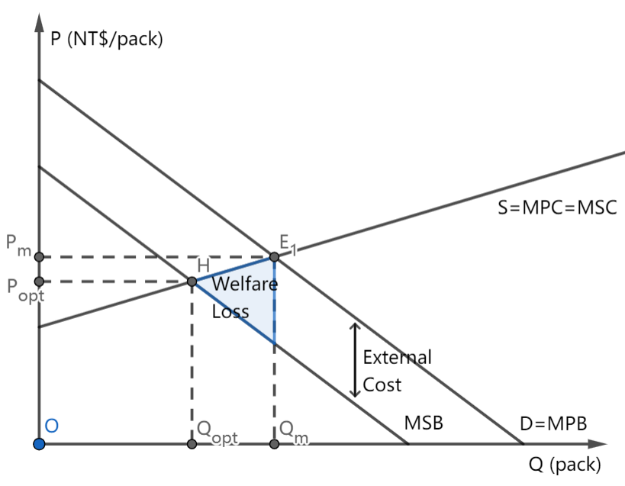

Figure 1. Negative Externality of Tobacco Consumption

Ideally, if the consumers smoke Qopt tobacco with producers manufacture Popt amount, the marginal social cost (MSC) equals the marginal social benefit (MSB), the social surplus could be maximized and the allocative **efficiency** could be achieved. However, since people only take their own benefits into consideration, they overconsume Qm amount of tobacco at price Pm, and the equilibrium, indeed, lies on E1, where MPC equals the marginal private benefit (MPB). Smoking-related diseases result in higher healthcare cost that is an extra burden to society, creating external costs, thus MSB is lower than MSC. The real consumption Qm is larger than Qopt, resulting in an overallocation of resources.

As the market does not meet allocative **efficiency**, the government eliminates the welfare loss, by imposing an indirect tax on the tobacco market.

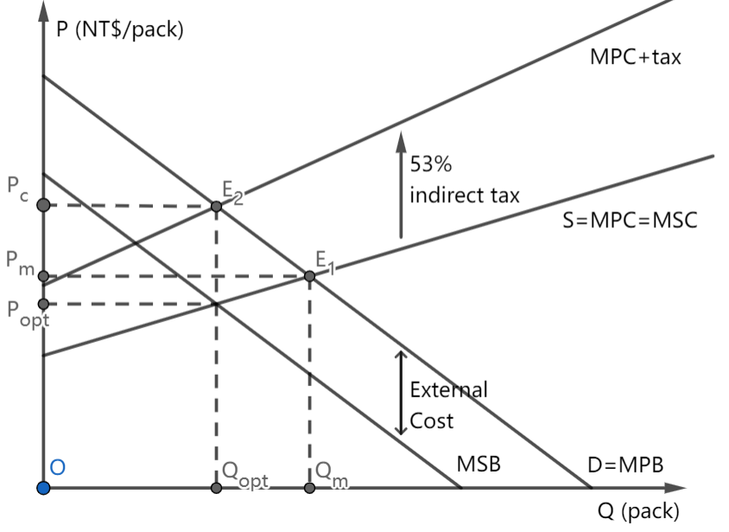

Figure 2. Effect of Indirect Tax Imposition on Taiwan Tobacco Essence

The government increases the cost of production for firms by charging 53% ad valorem tax. Raising the unit price to NT$116 (US$3.66) results in an upward shift of marginal cost (MPC to MPC+tax). The proper charge for indirect tax should meet the requirement that MPC+tax and MPB intersect at E2, such that the quantity consumed is reduced to Qopt. By imposing taxation, the Taiwanese government can reduce welfare loss and achieve allocative **efficiency** by imposing a 53% tax per pack of cigarettes.

To evaluate, the policy can bring some benefits. Firstly, the policy internalizes the externality and creates incentives for consumers to change their consumption patterns and reach allocative **efficiency**, as the tobacco surcharge adjustments in 2009 and 2017 correspond with a significant decrease in tobacco demand. Consumers now are required to pay for the external cost and have incentives to change their consumption pattern, i.e. stop smoking.

The tax imposition can reduce Taiwan’s smoking population and thus save medical resources. Smoking has negative effects on physical health, and consumption of tobacco may unnecessarily crowd out medical resources. Each year, Taiwan spends up to nearly NT$80 billion on healthcare resources to treat smoking-related illnesses, and smoking costs the economy more than NT$200 billion in total. The reduction in the smoking population in Taiwan can save medical resources. The reduction in the smoking population can help optimize the use of medical resources.

The government can gain more revenue through tobacco taxation. This revenue can serve as a vital source of revenue for public services. For example, the government can, instead, use this revenue to finance educational programs to discourage consumption of tobacco. If the consumers realize the consumption of tobacco should be avoided and stop smoking, the negative externality can be really reduced instead of simply being internalized, and therefore result in a better allocative **efficiency**.

However, existing potential disadvantages should be taken into consideration. The tax-determining step is difficult. There exist difficulties in measuring how much tax should be imposed as Taiwan does not have an automatic mechanism so that the tax rate can be raised gradually “based on national income, the inflation rate and price changes”. Difficulties in measuring the value of external costs and how much tax to impose result in a re-evaluating surcharge adjustment every two years with specialists in finance, economics, and public health. The challenge of accurately assessing external costs may impede the **efficiency** of the taxation system, necessitating periodic evaluations to ensure effective and efficient taxation.

At the same time, tobacco has an inelastic demand; Since the quantity demanded has a relatively smaller proportional decrease compared to the proportional increase of price to decrease tobacco consumption, the tax should be charged at a high price. A sudden increase in the tax rate may create sudden shocks to the market, “encourage cigarette smuggling”, “trigger a backlash”, and fail to reach allocative efficiency. Therefore, to balance economic and political concerns, a gradual increase is taken with a current tax rate of 53 percent instead of the minimum tax rate of 75 percent recommended by WHO.

High tobacco surcharge may also lead to growth in the underground market. This potential growth in the underground market represents an **efficiency** challenge, as it may undermine the intended goals of the surcharge and lead to less effective regulation of tobacco consumption.

In conclusion, tobacco consumption creates a negative externality, failing to reach allocative **efficiency**. And the imposition of a 53% ad valorem tax tries to reduce this negative effect. Government plans to increase the tax rate gradually to avoid the possible disadvantages and, at the same time, reach allocative **efficiency**.