logo

**Data Collection Worksheets**

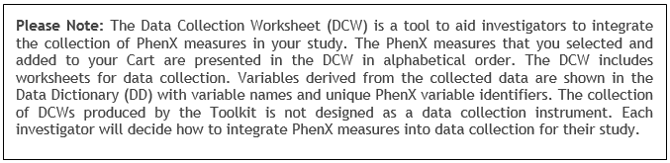

**PhenX Measure: Age of Initiation of First Cigarette Use (#030700)**

**PhenX Protocol: Age of Initiation of First Cigarette Use - Adult (#030703)**

Date of Interview/Examination/Bioassay (MM/DD/YYYY): _____________________

*The Working Group acknowledges that the following questions may gather sensitive information relating to the use of substances and/or illegal conduct. If the information is released it might be damaging to an individual’s employability, lead to social stigmatization, or other consequences.*

*For information on obtaining a Certificate of Confidentiality, which helps researchers protect the privacy of human research participants, please go to the National Human Genome Research Institute’s Institutional Review Board website.*

1. Have you smoked at least 100 cigarettes if your entire life?

1. Yes

2. No (Go to 2a)

2. How old were you when you first started smoking cigarettes FAIRLY REGULARLY?

Enter (0) if never smoked regularly (Go to 3)

Enter Age (01-99): ____

Don’t Know/Refused

3. You said that you never smoked regularly. How old were you the first time you smoked part or all of a cigarette?

Enter Age (01-99): ______

*Note to interviewer: ENTER (X) IF NEVER SMOKED REGULARLY.*

**PhenX Measure: Cigarette Smoking Status (#030600)**

**PhenX Protocol: Cigarette Smoking Status - Adult (#030604)**

Date of Interview/Examination/Bioassay (MM/DD/YYYY): _____________________

*The Working Group acknowledges that the following questions may gather sensitive information relating to the use of substances and/or illegal conduct. If the information is released it might be damagng to an individual’s employability, lead to social stigmatization, or other consequences.*

*For information on obtaining a Certificate of Confidentiality, which helps researchers protect the privacy of human research participants, please go to the National Human Genome Research Institute’s Institutional Review Board website.*

*Note to interviewer: Based on responses provided to earlier questions, the respondent may also be asked Questions 2, 3, and 4 (see interviewer notes before these questions).*

1. Have you ever smoked a cigarette, even one or two puffs?

**1** [ ] Yes

**2** [ ] No

**-8** [ ] DON’T KNOW

**-7** [ ] REFUSED

*If Question 1 is "Yes," then respondent is asked:*

2. Do you now smoke cigarettes…

**1** [ ] Every day

**2** [ ] Some days

**3** [ ] Not at all

**-8** [ ] DON’T KNOW

**-7** [ ] REFUSED

3. How many cigarettes have you smoked in your entire life? A pack usually has 20 cigarettes in it.

**1** [ ] 1 or more puffs but never a whole cigarette

**2** [ ] 1 to 10 cigarettes (about ½ pack total)

**3** [ ] 11 to 20 cigarettes (about ½ pack to 1 pack)

**4** [ ] 21 to 50 cigarettes (more than 1 pack but less than 3 packs)

**5** [ ] 51 to 99 cigarettes (more than 2 ½ packs but less than 5 packs)

**6** [ ] 100 or more cigarettes (5 packs or more)

**-8** [ ] DON’T KNOW

**-7** [ ] REFUSED

*If Question 1 is "Yes" and Question 2 is "Some days" (Current Some-Day Smoker) or if Question 1 is "Yes" and Question 2 is "Not at all" (Former Smoker), then respondent is asked:*

4. Around this time 12 months ago, were you smoking cigarettes every day, some days, or not at all?

**1** [ ] Every day

**2** [ ] Some days

**3** [ ] Not at all

**-8** [ ] DON’T KNOW

**-7** [ ] REFUSED

*Interpreting responses to assess smoking status of adults:*

* If answer to Question 1 is "*No,*" then respondent is a "Never Smoker."
* If answer to Question 1 is "*Yes*" and answer to Question 2 is "*Every day,*" then respondent is a "Current Every-Day Smoker."
* If answer to Question 1 is "*Yes*" and answer to Question 2 is "*Some days,*" then respondent is a "Current Some-Day Smoker."
* If answer to Question 1 is "*Yes*" and answer to Question 2 is "*Not at all,*" then respondent is a "Former Smoker."

Question 4 allows further classification of Current Some-Day and Former Smokers into those who smoked every day in the past from those who have not done so. The former would be indicating heavier past exposure.

**PhenX Measure: Alcohol - Age of First Use (#030200)**

**PhenX Protocol: Alcohol - Age of First Use (#030202)**

Date of Interview/Examination/Bioassay (MM/DD/YYYY): _____________________

The next question is about drinks of alcoholic beverages. By a "drink," we mean a can or bottle of beer, a glass of wine or a wine cooler, a shot of liquor, or a mixed drink with liquor in it. We are not asking about times when you only had a sip or two from a drink.

1. Think about the **first time**you had a drink of an alcoholic beverage. How old were you the **first time**you had a drink of an alcoholic beverage? Please do not include any time when you only had a sip or two from a drink.

AGE: ________

**PhenX Measure: Alcohol - 30-Day Quantity and Frequency (#030300)**

**PhenX Protocol: Alcohol - 30-Day Quantity and Frequency (#030301)**

Date of Interview/Examination/Bioassay (MM/DD/YYYY): _____________________

1. Think specifically about the past 30 days, from [DATEFILL*], up to and including today. During the past 30 days, on how many days did you drink one or more drinks of an alcoholic beverage?

# OF DAYS: ____ [RANGE: 0 - 30]  
[ ] Don’t Know / Refused

1. On the days that you drank during the past 30 days, how many **drinks** did you **usually** have each day? Count as a drink a can or bottle of beer; a wine cooler or a glass of wine, champagne, or sherry; a shot of liquor or a mixed drink or cocktail.

# OF DRINKS: ____ [RANGE: 1 - 90]  
[ ] Don’t Know / Refused

* DATEFILL is the date 30 days prior to the date of the interview.  
  
*Notes to interviewer:*

* *Definition of a standard drink: 1 12oz bottle of beer, 1 glass 4oz non-fortified wine, 1 mixed drink with 1oz liquor.*
* *If respondent needs a visual reference for the size of a drink, the flashcards from the Wave 1 National Epidemiologic Survey on Alcohol and Related Conditions (NESARC) study are provided below:*

[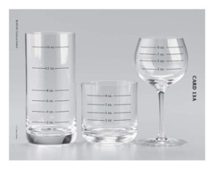](javascript:openImageWindow('toolkit_content/web/atos/Flashcard_1A.jpg','Card%201A.%20Cooler%20ounce%20size');)

Card 1A. Cooler ounce size

[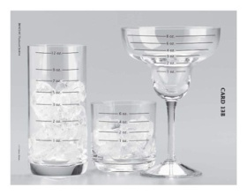](javascript:openImageWindow('toolkit_content/web/atos/Flashcard_1B.jpg','Card%201B.%20Cooler%20ounce%20size');)

Card 1B. Cooler ounce size

[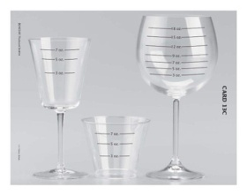](javascript:openImageWindow('toolkit_content/web/atos/Flashcard_1C.jpg','Card%201C.%20Cooler%20ounce%20size');)

Card 1C. Cooler ounce size

[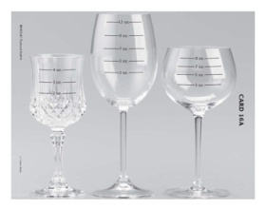](javascript:openImageWindow('toolkit_content/web/atos/Flashcard_2A.jpg','Card%202A.%20Wine%20ounce%20size');)

Card 2A. Wine ounce size

[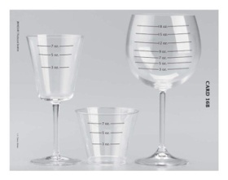](javascript:openImageWindow('toolkit_content/web/atos/Flashcard_2B.jpg','Card%202B.%20Wine%20ounce%20size');)

Card 2B. Wine ounce size

[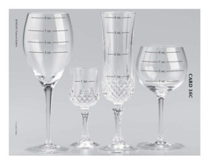](javascript:openImageWindow('toolkit_content/web/atos/Flashcard_2C.jpg','Card%202C.%20Wine%20ounce%20size');)

Card 2C. Wine ounce size

[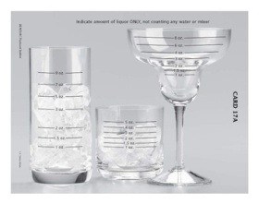](javascript:openImageWindow('toolkit_content/web/atos/Flashcard_3A.jpg','Card%203A.%20Liquor%20ounce%20size');)

Card 3A. Liquor ounce size

[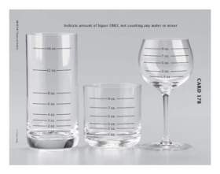](javascript:openImageWindow('toolkit_content/web/atos/Flashcard_3B.jpg','Card%203B.%20Liquor%20ounce%20size');)

Card 3B. Liquor ounce size

[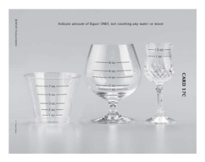](javascript:openImageWindow('toolkit_content/web/atos/Flashcard_3C.jpg','Card%203C.%20Liquor%20ounce%20size');)

Card 3C. Liquor ounce size

Protocol Source: <https://www.phenxtoolkit.org/index.php?pageLink=browse.protocoldetails&id=30301>

**PhenX Measure: Alcohol - Lifetime Use (#030100)**

**PhenX Protocol: Alcohol - Lifetime Use (#030101)**

Date of Interview/Examination/Bioassay (MM/DD/YYYY): _____________________

1. In your entire life, have you had at least 1 drink of any kind of alcohol, not counting small tastes or sips?

[ ] Yes

[ ] No

*Notes to interviewer:*

* *Definition of a standard drink: 1 12oz bottle of beer, 1 glass 4oz non-fortified wine, 1 mixed drink with 1oz liquor.*
* *If respondent needs a visual reference for the size of a drink, the flashcards from the Wave 1 National Epidemiologic Survey on Alcohol and Related Conditions (NESARC) study are provided below:*

[](javascript:openImageWindow('toolkit_content/web/atos/Flashcard_1A.jpg','Card%201A.%20Cooler%20ounce%20size');)

Card 1A. Cooler ounce size

[](javascript:openImageWindow('toolkit_content/web/atos/Flashcard_1B.jpg','Card%201B.%20Cooler%20ounce%20size');)

Card 1B. Cooler ounce size

[](javascript:openImageWindow('toolkit_content/web/atos/Flashcard_1C.jpg','Card%201C.%20Cooler%20ounce%20size');)

Card 1C. Cooler ounce size

[](javascript:openImageWindow('toolkit_content/web/atos/Flashcard_2A.jpg','Card%202A.%20Wine%20ounce%20size');)

Card 2A. Wine ounce size

[](javascript:openImageWindow('toolkit_content/web/atos/Flashcard_2B.jpg','Card%202B.%20Wine%20ounce%20size');)

Card 2B. Wine ounce size

[](javascript:openImageWindow('toolkit_content/web/atos/Flashcard_2C.jpg','Card%202C.%20Wine%20ounce%20size');)

Card 2C. Wine ounce size

[](javascript:openImageWindow('toolkit_content/web/atos/Flashcard_3A.jpg','Card%203A.%20Liquor%20ounce%20size');)

Card 3A. Liquor ounce size

[](javascript:openImageWindow('toolkit_content/web/atos/Flashcard_3B.jpg','Card%203B.%20Liquor%20ounce%20size');)

Card 3B. Liquor ounce size

[](javascript:openImageWindow('toolkit_content/web/atos/Flashcard_3C.jpg','Card%203C.%20Liquor%20ounce%20size');)

Card 3C. Liquor ounce size

Protocol Source: <https://www.phenxtoolkit.org/index.php?pageLink=browse.protocoldetails&id=30101>

**PhenX Measure: Substances - Age of First Use (#031200)**

**PhenX Protocol: Substances - Age of First Use (#031202)**

Date of Interview/Examination/Bioassay (MM/DD/YYYY): _____________________

1. How old were you the **first time** you used…?

AGE: ________ [RANGE: 1-110]

         [ ] DK/REF

**PhenX Measure: Substances - 30-Day Frequency (#031300)**

**PhenX Protocol: Substances - 30-Day Frequency (#031302)**

Date of Interview/Examination/Bioassay (MM/DD/YYYY): _____________________

1. Think specifically about the past 30 days, from [DATEFILL**] up to and including today. During the past 30 days, on how many days did you use…?

# OF DAYS: _________ [RANGE: 0-30]

         [ ] DK/REF

SHOW 30 DAY CALENDAR

**PhenX Measure: Substances - Lifetime Use (#031100)**

**PhenX Protocol: Substances - Lifetime Use (#031102)**

Date of Interview/Examination/Bioassay (MM/DD/YYYY): _____________________

**Now I’d like to ask you about your experiences with medicines and other kinds of drugs that you may have used ON YOUR OWN-that is, either WITHOUT a doctor’s prescription *(PAUSE)*; in GREATER amounts, MORE OFTEN, or LONGER than prescribed *(PAUSE)*; or for a reason other than a doctor said you should use them. People use these medicines and drugs ON THEIR OWN to feel more alert, to relax or quiet their nerves, to feel better, to enjoy themselves, to get high or just to see how they work.**

*(SHOW FLASHCARD 40)*

1a. Have you EVER used any of these medicines or drugs? *Read list. (If "YES" to any drug category, ask:***Which ones?**) *Record specific drug(s) used.*

**1** [ ]Sedatives or tranquilizers, for example…barbs, downers, Am’-bee-en, Lunesta, phenobarbital, pentobarbital, Hal’-see-on, Tuinal, Nembutal, Seconal, Librium, Valium, Xanax, benzodiayz’-a-peens, tranks, Ativan.

**2** [ ]Painkillers, for example…methadone, codeine, Demerol, Vy’-ko-din, Oxi-kon’-tin, opium, oxy, Per’-ko-set, Dill-odd’-id, Per’-ko-dan, morphine.

**3** [ ]Mariwa’-na, including THC, for example…weed, pot, dope, hashish, Mary Jane, joint, blunt.

**4** [ ]Cocaine or crack, for example…blow, rock, snow.

**5** [ ]Stimulants, for example…Add’-erall, Concerta, Sy’-lert, Pro-vig’-il, Ritalin or Dexedrine, speed, amphetamine, methamphetamine, uppers, bennies, pep pills, crystal, crank.

**6** [ ]Club drugs, for example…MDMA, ecstasy, GHB, Ro-hip’-nol, kett’-amine, Special K, XTC, roofies.

**7** [ ]Hallucinogens, for example…LSD, acid, PCP, mescaline, pay-o’-tee, sillosy’-bin, mushrooms, angel dust, cactus.

**8** [ ]Inhalants or solvents, for example…nitrous oxide, lighter fluid, gasoline, cleaning fluid, glue, poppers, whippets.

**9** [ ]Heroin, for example…smack, black tar, poppy.

**10** [ ]Any OTHER medicines or drugs, for example…steroids, Elavil, Thoarazine, or Haldol.

*(SELECT MOST FREQUENT USED OTHER DRUG) - Specify*

**CHECK ITEM 3.10**

Is at least one category marked in 1a?

**1** [ ]Yes - *Classify as ever (drug) use*

**2** [ ]No - *Classify as non (drug) user*

**FLASHCARD 40**

**TYPES OF MEDICINES/DRUGS**

1 **Sedatives or tranquilizers**, for example…barbs, downers, Ambien, Lunesta, phenobarbital, pentobarbital, Halcion, Tuinal, Nembutal, Seconal, Librium, Valium, Xanax, benzodiazepines, tranks, Ativan.

2 **Painkillers**, for example…methadone, codeine, Demerol, Vicodin, OxyContin, opium, oxy, Percocet, Dilaudid, Percodan, morphine.

3 **Marijuana, including THC**, for example…weed, pot, dope, hashish, Mary Jane, joint, blunt.

4 **Cocaine or crack**, for example…blow, rock, snow.

5 **Stimulants**, for example…Adderall, Concerta, Cylert, Provigil, Ritalin or Dexedrine, speed, amphetamine, methamphetamine, uppers, bennies, pep pills, crystal, crank.

6 **Club drugs**, for example…MDMA, ecstasy, GHB, Rohypnol, ketamine, Special K, XTC, roofies.

7 **Hallucinogens**, for example…LSD, acid, PCP, mescaline, peyote, psilocybin, mushrooms, angel dust, cactus.

8 **Inhalants or solvents**, for example…nitrous oxide, lighter fluid, gasoline, cleaning fluid, glue, poppers, whippets.

9 **Heroin**, for example…smack, black tar, poppy.

10 **Any OTHER medicines.**

Protocol Source: <https://www.phenxtoolkit.org/index.php?pageLink=browse.protocoldetails&id=31102>

**PhenX Measure: Tobacco - 30-Day Quantity and Frequency (#030800)**

**PhenX Protocol: Tobacco - 30-Day Quantity and Frequency - Adult (#030804)**

Date of Interview/Examination/Bioassay (MM/DD/YYYY): _____________________

***Every-Day Smokers***

1. **On the average, about how many cigarettes do you now smoke each day?**

(ONE PACK USUALLY EQUALS 20 CIGARETTES. IF CONVERTING PACKS TO CIGARETTES, ALWAYS VERIFY CALCULATION WITH RESPONDENT.)

ENTER NUMBER OF CIGARETTES PER DAY

(1-99)

|___| |___|

***Some-Day Smokers***

1. **On how many of the past 30 days did you smoke cigarettes?**

ENTER (0) FOR NONE

|___| |___| (0-30)

1. **Would you say you smoked on AT LEAST 12 DAYS in the past 30 days?**

1. Yes

2. No

|___|

1. **On the average, on those [C1 days IF entry for C1 NE D/R. OR "AT LEAST 12 days" IF C1i=1 YES] days, how many cigarettes did you usually smoke each day?**

|___| |___|

***FORMER SMOKERS***

1. **About how long has it been since you COMPLETELY quit smoking cigarettes?**

ENTER NUMBER

(1-99)

|___| |___|

ENTER UNIT REPORTED

(1) Days

(2) Weeks

(3) Months

(4) Years

|___|

1. **Have you EVER smoked cigarettes EVERY DAY for at least 6 months?**

(1) Yes

(2) No

|___|

1. **When you last smoked every day, on average how many cigarettes did you smoke each day?**

ENTER NUMBER OF CIGARETTES EACH DAY

(1-99)

|___| |___|