General Statistics

1. I chose Arabidopsis thalina and Arabidopsis lyrata.
2. I chose them because I know they are somewhat related A. lyrata is a tetraploid though, I initially tried Boechera stricta and A. thaliana but the stricta assembly was messy, so I switched B. stricta to A. lyrate.
3. Both A. thaliana and A. lyrata have pretty good assemblies and are annotated pretty well. A. lyrata is definitely the weaker of the two which makes sense.
4. A. lyrata has contigs but where is said that, it did not specify how many contigs, it also did not indicate that A. thaliana had contigs.
5. One species is a diploid, A. thaliana and the other is a tetraploid A. lyrata.
6. The source for both is Ensembl Plants, they did not specify a method.

Macrosynteny

1. They actually have fairly good synteny, meaning there are some good linear correlations between chromosomes. There is evidence of polyploidy because there are more chromosomes for A. lyrata and you can see quite a few linear groups, the 1st chromosome is almost perfectly matched and then as the Chr. Number for A. lyrata increases it does loose some synteny.
2. It does meet my expectations because I did expect quite a bit of correlation, I might even say how related they are exceeded my expectations because of the different ploidy levels.
3. It looks like there is one major inversion between Chr. 4 for A. thaliana and Chr. 7 for A. lyrata. Also a maybe minor rearrangement in the sense that A. lyrata’s Chr. 6 fits linearly with A. thaliana’s Chr. 5.
4. I think they are both assembled pretty well. If there is some week assembly it is for the Chr. Greater than 8, where all the scaffolds are smushed together. So I do think that A. thaliana has a better assembly than A. lyrata. But considering they match pretty well being different ploidys I think it is overall good.

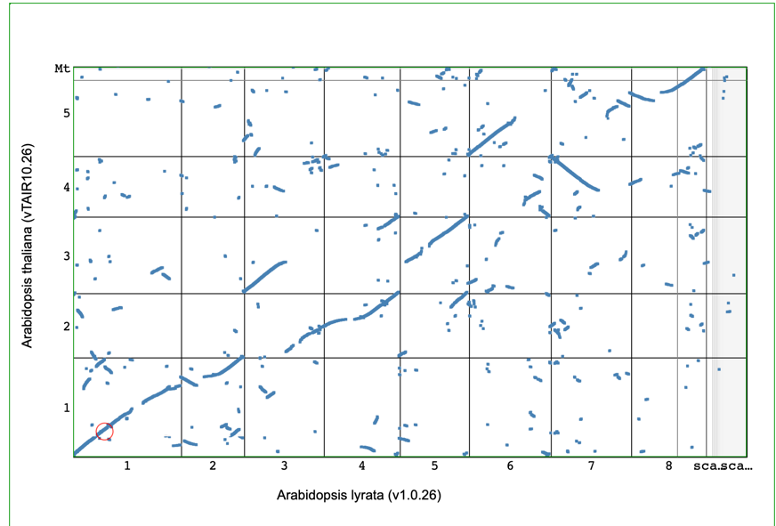

Microsynteny

1. I choose a region in chromosome one because of how well it matched up. There is a slight break in the linearity so I selected before the break.
2. There is some strong microsyntney, almost all the genes match up.
3. There are some expansions in A. lyrata compared to A. thaliana, as well as some conserved regions that are not in A. thaliana. It looks like there might be a few rearrangements, about 5.
4. Most of the gene connections are homologous with identity %s ranging from ~70%-~95%.

