|  |
| --- |
| NGwKs |
| LOST |
| **The Adventure Game** |
| Version #2.2  All work Copyright © 2012 by NGwKs Games.  All rights reserved. |
| **Paige Harvey** |
|  |



|  |
| --- |
| May 23rd 2013 |

**Table of Contents**

*Version History* 3

*Game Overview* 4

*Game-play Mechanics* 4

*Interface Sketch* 4

*Game World* 4

*Story Index* 5

**Version History**

Version 0.1 – *skeleton.py*  
 Very basic setup; building basic structure (manipulation of template code)  
 Story line under construction  
 using python 3.3

Version 0.2 – *skeleton 1.py*  
 using python 2.7  
 Structure is still fluid with no definitive structure  
 Storyline is planned out and half written

Version 0.3 – *LOST1.3.py*  
 Structure is made with if/elif/else lists

Version 2.0 – *LOST2_0.py*  
 Removed the need for if/elif/else lists.  
 Completely restructured game to call specific functions.  
 Tested all outcomes and loops.

Version 2.1 – *LOST2_1.py*  
 Added the story content and dramatic pauses.

Version 2.2 – *LOST2_2.py*  
 Minor edits to the story line; grammar, spelling  
 Added internal comments

1. **Game Overview**

The adventure story is told in second person. The character is lost, wandering a remote trail at dusk in late November. Through a series of decisions made by the User the character attempts to find their way to civilization again. The road is treacherous and long.

1. **Game Play Mechanics**

LOST is text-based and will ask the User to make decisions based off the current in-game situation. Each decision will be validated and passed into an if/else clause which will call the correct corresponding function to advance the plot. Each node function will request User input and call the next function.

At the last node tier all functions call Outcomes(), which uses if/elif/else clause to output the final text block of that storyline. Afterwards the game lands back in the while loop of the main(). The game will loop so long as the User types ‘yes’ or ‘y’ when asked if they want to play again.

1. **Interface Sketch**

Screen shot showing the game in progress.

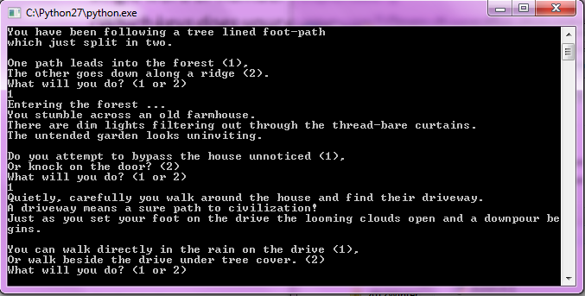

1. **Game World**

The world in-game is the same as Earth (technology, society, etc.) The exact date is unknown, but the month is late November and as such is quite cold. As the game starts the sun is going down, and clouds are gathering to rain.

1. **Story Index**