SourceLine
Crossplatform VCS Client

Version 0.3

June 10, 2014

Revision History

Version | Date | Author | Description
0.1 | 04/06/14 | Alex Chmykhalo | Created initial document.
0.2 | 05/06/14 | Vova Kochyn | Updated
0.3 | 05/10/14 | Alex Chmykhalo | Added main window mock and description

Contents
Introduction 4
Requirements 4
Supported Platforms 4
VCS Support 4
Description of functionality and user interface 4
Main Client Window 4
Settings 4

Introduction

The aim of the project is to create cross-platform client for popular version control systems (VCS), such as Subversion, Git, Mercurial.

Requirements

Supported Platforms
- Microsoft Windows (7/8)
- Linux (Arch, Fedora, Ubuntu)
- Mac OS X (10.8)

VCS Support
Client should support at least:
- Subversion
- Git

Description of functionality and user interface

Main Client Window

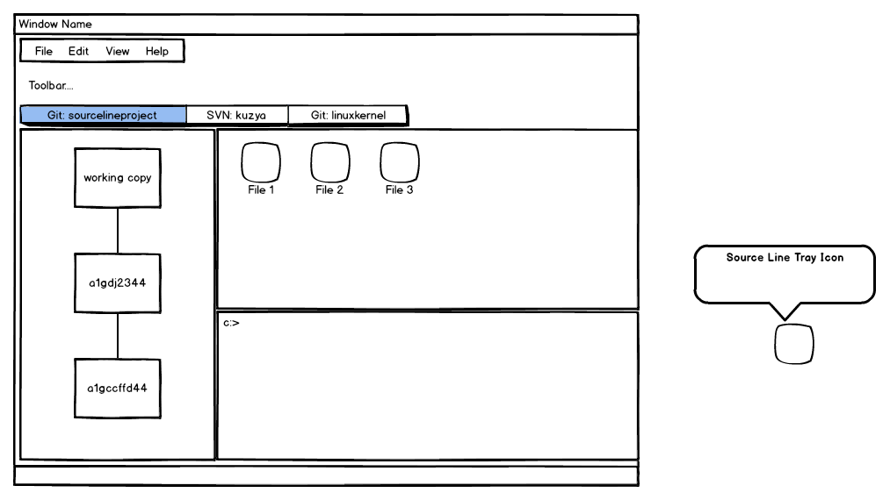

Main window operates with any number of working copies which stores in another tab widget. It can be Git or SVN repository. Tool bar will be updated to current VCS.

Main view for opened working copy consist of 3 parts:
- Revision Tree ( using model/view framework need to add a model for each VCS and create a universal view for image revision tree )
- File View ( review each changes in revision tree or current changes )
- Console

Each part should be as dock window and allow user to place it wherever he want.

There are also menu bar with main menu, status bar and tool bar (should be customizable).

Menu Bar
Menu bar mast contains next actions:
- add ( or create ) repository
- settings
- help

Settings

Following settings should be stored:
- Opened tabs
- Position of dock windows
- users login and password

