SourceLine
Crossplatform VCS Client

Version 0.5

July 08, 2014

Revision History

Version | Date | Author | Description
0.1 | 04/06/14 | Alex Chmykhalo | Created initial document.
0.2 | 05/06/14 | Vova Kochyn | Updated
0.3 | 10/06/14 | Alex Chmykhalo | Added main window mock and description
0.4 | 25/06/14 | Vova Kochyn | Added Plugins and system tray description
0.5 | 08/07.2014 | Alex Chmykhalo | Added generic VCS concept vocabulary, settings sbsystem chapter

Contents
Introduction 4
Requirements 4
Supported Platforms 4
VCS Support 4
Description of functionality and user interface 4
Main Client Window 4
Menu Bar 5
System tray 6
Settings 6
Plugins 6
Generic VCS Support Concepts 6
Vocabulary 6
Labels 6
Datamodel 6
Additional 6
Actions 7
Data Model 7

Introduction

The aim of the project is to create cross-platform client for popular version control systems (VCS), such as Subversion, Git, Mercurial.

Requirements

Supported Platforms
- Microsoft Windows (7/8)
- Linux (Arch, Fedora, Ubuntu)
- Mac OS X (10.8)

VCS Support
Client should support at least:
- Subversion
- Git

Description of functionality and user interface

Main Client Window

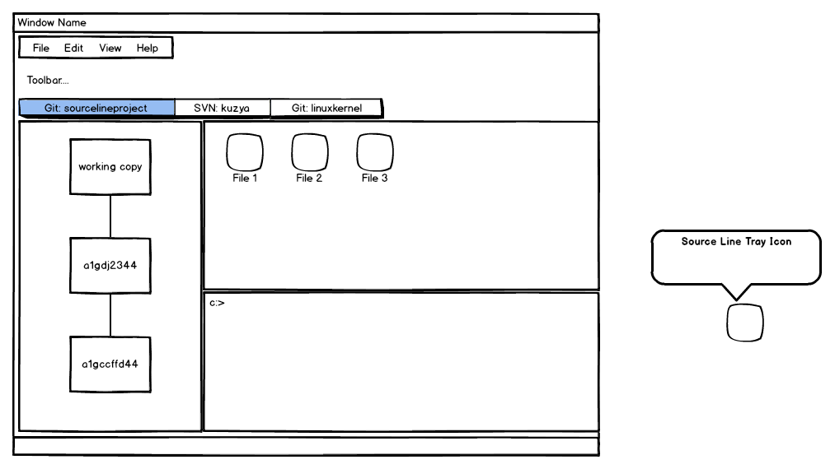

Main window operates with any number of working copies which stores in another tab widget. It can be Git or SVN repository. Tool bar will be updated to current VCS.

Main view for opened working copy consist of 3 parts:
- Revision Tree ( using model/view framework need to add a model for each VCS and create a universal view for image revision tree )
- File View ( review each changes in revision tree or current changes )
- Console

Each part should be as dock window and allow user to place it wherever he want.

There are also menu bar with main menu, status bar and tool bar (should be customizable).

Menu Bar
Menu bar mast contains next actions:
- add ( or create ) repository
- settings
- help

System tray
Need to add icon to system tray and in the next version of SourceLine need to show messages when new commit is coming.

Settings

Following settings should be stored:
- Opened tabs
- Position of dock windows
- users login and password

Plugins
Need to predict adding plugins for features like adding command to context menu of operation system or showing messages when new commit coming etc.

Generic VCS Support Concepts

Vocabulary

Labels
Baseline
Conflict
Head

Datamodel
Branch
Mainline
Repository
Stream
Working Copy

Additional
Delta
Change Set

Actions
Chekout
Export
Commit
Import
Merge
Resolve
Integrate
Promote
Share
Update

Data Model
Data model description will be here.

Implementation Details

Settings Subsystem

PluginSettings class
Plugin settings class implements all necessary functionality for handling settings for plugin. It contatins mathod that allows:
- Map some settings to certain widget state. This allows to implement controls that will represent settings state on settings dialog (settings controls),
- Commit\revert settings. This allows to commit all changes of setting controls, e.g. write state of control to setting. Also revert method is present, that will reject all changes and revert controls state if necessary.
- Allows to subscribe for certain settings changes. For example, plugin developer could create custon slot, and subscribe slot to changes of certain setting.

