TP05

Java Loops

# Remark

1. Loop while

Syntax:

while(Boolean_expression) {

// Statements

}

While Loop Activity Diagram

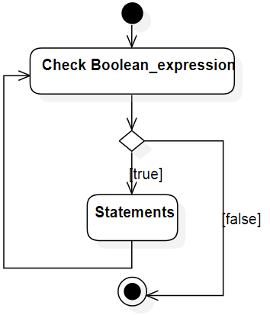

Example:

**public** **class** TestWhile {

**public** **static** **void** main(String[] args) {

**int** x = 10;

**while** (x < 20) {

System.***out***.print("value of x : " + x);

x++;

System.***out***.print("\n");

}

}

}

Output:

value of x : 10

value of x : 11

value of x : 12

value of x : 13

value of x : 14

value of x : 15

value of x : 16

value of x : 17

value of x : 18

value of x : 19

1. Loop: do … while

Syntax:

do {  
 // Statements  
}while(Boolean_expression);

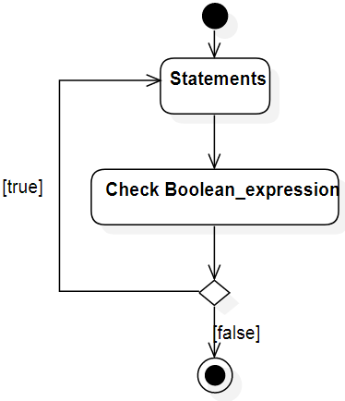Do…While Activity Diagram

Example:

**public** **class** TestDoWhile {

**public** **static** **void** main(String[] args) {

**int** x = 10;

**do** {

System.***out***.print("value of x : " + x);

x++;

System.***out***.print("\n");

} **while** (x < 20)

}

}

1. Loop for

Syntax:

for(create_and_init_control_var; expression; change_of_control_var) action;

Or

for(create_and_init_control_var; expression; change_of_control_var){  
 actions;  
}

Activity Diagram of Loop for:

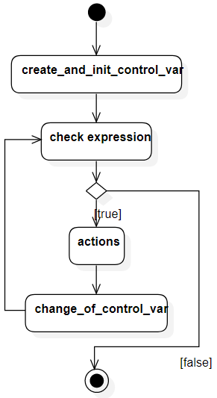

Example:

**public** **class** ForTest {

**public** **static** **void** main(String[] args) {

**for** (**int** x = 10; x < 20; x = x + 1) {

System.***out***.print("value of x : " + x);

System.***out***.print("\n");

}

}

}

Output:

value of x : 10  
value of x : 11  
value of x : 12  
value of x : 13  
value of x : 14  
value of x : 15  
value of x : 16  
value of x : 17  
value of x : 18  
value of x : 19

# TP05.1. Prime Number (review from TP04.1)

Write an application Java that let user input a number then list prime numbers from 2 to inputted number. Prime number is positive number greater than 2 and divisible only to its own and 1. Implements using while loop. Example:

Input number to list prime numbers from 2 to it: 29  
2 3 5 7 11 13 17 19 23 29 is prime number.

# TP05.2. Odd Numbers

Write a program in Java to display odd numbers (ex: 1, 3, 5, 7, etc.) located between 0 and 500.

# TP05.3. Even Numbers

Write a program in Java to display even numbers (ex: 2, 4, 6, 8, etc.) located between A and 500. Where A is given by user (0<A<500).

# TP05.4. Company Profits

Write a program in Java to calculate company profits for 12 months. Example:

Profit for month 1 : 25  
Profit for month 2 : 2.5  
Profit for month 3 : -63  
Profit for month 4 : 0  
Profit for month 5 : 10  
Profit for month 6 : 32  
Profit for month 7 : 26.5  
Profit for month 8 : 28.2  
Profit for month 9 : 29  
Profit for month 10 : 31.7  
Profit for month 11 : 29.5  
Profit for month 12 : 26  
  
Total profits for 12 months : 177.40

# TP05.5. Palindrome

Write a program in Java to check whether a given string is a palindrome. Palindrome are words or phrases that the same when reading from left to right or from right to left. The check method is chosen by user. Example:

Please gives a word to check: NOON  
Choose method (REV, LOOP): REV  
NOON is a Palindrome

Example 2:

Please gives a word to check: SOKKANG  
Choose method (REV, LOOP): LOOP  
SOKKANG is not a Palindrome

# TP05.6. String Mirroring

Write a method makePalindrome() that creates a reverse copy of given String, and then join them to make a Palindrome.

Then, write a program in Java to create a reverse copy of given String. Example:

Please enter a word: DICE  
DICEECID

# TP05.7. Escape Characters Replacement

Write a program in Java to read a sentence from keyboard. Then replaces all escape characters follow below table:

|  |  |
| --- | --- |
| Escape Character | Replacement |
| \n | (new_line) |
| \t | (tab) |
| \\ | (slash) |
| // | (comment_line) |
| :) | (smile) |

For Example:

Please enter a sentence: \n \t is used to represent new line \n\\ it is a // line comment :)  
  
(new_line) (tab) is used to represent new line (new_line)(slash) it is a (comment_line) line comment (smile)