**2.2.2 #26 Steps To Get Pop-outs Working Properly**

1. Find the following lines, where the data is being pulled from the database:

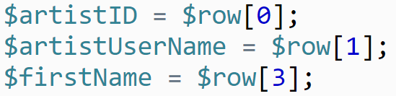

Add a line to create a new variable for the person’s **last name**, and pull that from row 4

of the table.

2. Look for the line where you are calling the **display_table()** function (around Line 65), and

add a fifth argument, which will be the last name from the variable that was just created.

3. The same argument needs to be added to where the **display_table()** function is created

(around Line 86).

4. Javascript will be generating the pop-outs, so you need to find where the Javascript

function **showDetailedView()**:



and pass through the same variable that was being used for last name.

5. Go to the file titled ‘popouts222.js.’ This is where the **showDetailedView()** function is

created in the Javascript. This will need to be modified in a few ways. First, add the last

name variable into the arguments on the following line:



This will enable you to use it within the function.

6. This function is printing out HTML to be used to create the pop-outs on the screen. In the

**popframe.innerHTML** variable, you will need to add the last name variable to the string

(look for where the firstname variable is being used, and add it there).

7. At this point, check the site in a separate browser, or incognito window, to see if the pop-outs are working properly (her last name should be added to each window). IF it works...please pat yourself on the back.

------------------------------------------------------------------------------------------------------------------------------

8. In the next phase, you need to get the picture to change for each popout. You will change

the HTML in the popouts222.js to add a dynamic file name:

1. Modify the following code in Line 22 to add the **idname** of the picture:



b. Modify the following code in Line 17 to add the **idname** as a function argument:



c. Modify the following code in the original *222indexB.php* file to pass the **idname** into the

function:

