**‘Python GUI’ Assignment**

**Goal/Objective:** Create an interactive Python GUI, where users can manipulate portions of the window to perform various tasks.

**Design Process Steps**

1. Define Problem
2. Generate Concepts
3. Develop a Solution
4. Construct and Test Prototypes
5. Evaluate the Solution

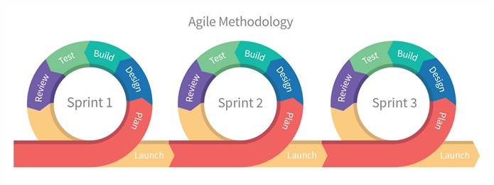

**Define Problem**

What is the purpose of your program?

**Generate Concepts**

Give some possible design layouts for your concept (include screenshots or hand-drawn elements):

**Develop a Solution**

Include a screenshot of your Trello board with Backlog and Sprint 1/2/3:

**Construct and Test Prototypes**

Include a screenshot of your finished GUI:

**Evaluate the Solution**

What is working properly, what is not, and what improvements can be made (if more time was given)?

