Installation Checklist for EMS/DC

The checklist serves to facilitate the verification of all required activities within the installation of EMS and RTU switchboards, thereby supporting the acceleration of subsequent configuration tasks.

Contact details for sending the checklist: projekty@energostation.com
If you have any questions, contact: Ing. Barbora Říčková
Phone.: +420 776 343 150
barbora.rickova@energostation.com

Name of the project: ……………………………………………………………………………………………………………
Address of the installation: ………………………………………………………………………………………………………….
Concact person: ……………………………………………………………………………………………………………
E-mail and phone.: ……………………………………………………………………………………………………………

Content
Installation Work Checklist 2
1. Electrical Work 2
2. Electricity Meters 2
3. Parametrization and Communication 4
4. Technology 4
5. System Settings 8
6. Delivered Documents Together with a Checklist (EMS/DC) 10
7. Notes 12
8. Legend to Individual Checklist Items 13
8.1. Electrical Work 13
8.2. Electricity Meters 13
8.3. Parametrization and Communication 15
8.4. System Settings 18
8.5. Delivered Documents Together with a Checklist (EMS/DC) 21

Installation Work Checklist
The individual items on the Checklist are explained in the Legend section.
In order to verify the completion of individual tasks, we request that you attach photographic documentation or technical documentation.

Electrical Work
- Installation and power connection of the EMS/DC switchboard YES NO
- Installation and power connection of the subsidiary MaC switchboard YES NO
- Number of actually installed MaC switchboards …………
- Installation and power connection of the remote measurement switchboard
YES NO
- Designation of switchboards according to SLD
Cabinet name | Designation of the switchboard according to SLD
Switchboard EMS/DC
MaC1
MaC2
Remote measurement

Electricity Meters
- Electricity meter in EMS/DC switchboard (SML133) for measurement at the delivery point
  - Installation and connection of MCT to EMS/DC switchboard YES NO
  - Installation and connection of MVT to EMS/DC switchboard YES NO
  - Checking the correctness of the current flow direction on the MCT (Measuring Current Transformer): YES NO
  - Phase sequence check YES NO
  - Checking the affiliation of voltage vs. current
(I₁→U₁; I₂→U₂; I₃→U₃) YES NO
  - Setting the electricity meter in the EMS/DC switchboard (for measuring the transfer point)
    - MCT gear ratio set YES NO
    - value (A) MCT …………
    - measured voltage level set YES NO
    - voltage level value …………
    - Measuring Voltage Transformer (MVT) gear ratio set ³ YES NO
    - Measuring Voltage Transformer (MVT) value …………
Number of other installed elektricity meters, e.g., for PV measurement, secondary electricity meters ………..
- Information about other installed electricity meters
Label of the electricity meter according to SLD | Type of elektricity meter | Communication method (Modbus RTU/TCP) | IP address + Modbus ID or Modbus ID only (RTU) | Connected to the switchboard

Notes on elektricity meters:

Parametrization and Communication
- Connecting the ETH cable (data network) to the EMS/DC switchboard YES NO
- Connecting the ETH cable (data network) to all MaC switchboards YES NO
- A data network is set up for the communication of control units YES NO
- IP addresses and IC numbers of control units
IC number of EMS/RTU control unit (PLC unit) | DHCP assigned IP address | Fixed IP address required

- Local network parameters where is the technology connected:
  - IP address range: ………………………………………
  - Mask: ………………………………………
  - Gateway: ………………………………………
  - DNS: ………………………………………
- Connection method for the installation site or EMS/RTU unit
  - Connection to the local data network YES NO
  - Connection through a mobile operator YES NO
- The start of configuration is conditional on functional data connectivity: attach a photo of the PLC display showing confirmation of correct PLC communication to the cloud; PLC registration status [100] is required – 8.3.g)

Technology
- All photovoltaic inverters are connected to control units YES NO
- In the case of connection via Modbus RTU (RS-485), terminating resistors (120 Ω) are installed at the ends of each communication branch YES NO
- In the case of Modbus RTU, the polarity of the RS-485 line (A, B, GND) is verified. YES NO
- All inverters are connected to the data logger YES NO
- Data logger is connected to a data network with visibility to the control unit YES NO
- Modbus communication is enabled on all connected devices YES NO
Data logger type | Total power [kW] of inverters behind the logger | Installed PV capacity behind the logger [kWp] | Modbus RTU address / IP TCP address + port | Modbus ID | FW version

- Information about inverters and their addressing (fill in if DataLogger is not installed)
 |  | In case of direct communication with inverters
Inverter designation according to SLD | Type of inverters |  | Inverter power [kW] | Installed PV capacity behind the inverter [kWp] | Modbus RTU address / IP TCP address + port | Modbus ID | Master (M) / Slave (S) / 0

- All battery storage components (inverters, BMS, etc.) are connected to the control units YES NO
- Information about battery storage and component addressing ce
  - Type of battery storage …………………………
  - Maximum SOC for charging ……………… %
  - Minimum SOC pro charging ……………… %
  - Additional information about battery storage
BU component (INV, BMS, MBMS) | BU capacity [kWh] | Max. invertor capacity [kW] | Modbus RTU address / IP TCP address + Modbus ID | Storage order in case of MBMS used

Notes on BU:

- Weather station is installed YES NO
- The weather station has an IP address set in the same network as the DC YES NO
- IP address of the weather station ………………………………………
- Compensation
  - compensation is installed YES NO
  - control will be influenced by PV and commands from the DC YES NO
  - it can be blocked by a blocking contact YES NO

System Settings
In order to set up the EMS, it is necessary to fill in several basic parameters of the "energy management" service itself, the operated "equipment" (inverter, battery storage) and the controlled "appliances" (proportionally controlled spiral of the storage tank, electromobility). Based on the given values, the EMS control system will be set and transferred.
Some values are also needed for Dispatch Control. Where EMS/DC is indicated, fill in even if you have only ordered dispatch control.
- OM (EMS/DC) parameters:
  - rated current of the main circuit breaker I_{N} = …….....… A
    - in the case of HV, convert to equivalent I_{N-VN} = ……….. A
  - value of reserved power according to Connection Agreement (CA) .……………… kW
  - value of the reserved power of the production plant according to CA ……………… kW
  - total installed power according to CA: ……………… kWp
  - reserved capacity (¼ hour maximum) ……………… kW
  - permission for overflows into the network during trial operation YES NO
    - permitted overflow value ……………… kW
  - Electricity supply contract - purchase is (EMS) SPOT FIX
  - Electricity supply contract - sale is (EMS) SPOT FIX
  - in the case of a purchase on SPOTu – instructions Chyba! Nenalezen zdroj odkazů..a)
    - costs on HT ………………. EUR/MWh
    - costs on LT ………………. EUR/MWh
    - daily costs (budgeted recurring payments) ………………. EUR/MWh
    - VAT ………………. %
  - in the case of a sell on SPOTu
    - price for the transmission system ………………. EUR/MWh
    - VAT ………………. %
    - Minimum profit ………………. %
  - prohibition of delivery to the network at negative SPOT prices (EMS) YES NO
- PV, Battery storage and other sources (EMS)
  - enable SPOT control YES NO
  - enable battery discharge into the mains (SPOT) YES NO
  - battery depreciation (SPOT) ……………… EUR/MWh
  - battery storage losses ……………… %
  - additional sources are installed (EMS/DC) YES NO
IMPORTANT: If the battery is charged from SPOT and POD (Point of Delivery) is billed according to ¼ hour reserved capacity (RC), it is necessary to monitor and control ¼ hour power directly from the billing electricity meter. If ¼ hour reserved capacity control from the billing meter is not used, it is possible that the RC limit will be exceeded and POD may be billed for exceeding the RC limits.

- ¼ hour maximum (fill in if it is part of the project)
  - A galvanic optocoupler is installed and connected for pulse collection to the billing electricity meter YES NO
  - galvanic optocoupler connected to switchboard ¼ h maximum YES NO
  - switchboard connected ¼ hour maximum to EMS/DC switchboard YES NO
    - CIB address of element AK.PULS (C-AM-0006I) ……………………………
  - description of pulses
    - imp1 (AK.PULS/AI1) ……………………………
    - imp2 (AK.PULS/AI2) ……………………………
    - imp3 (AK.PULS/AI3) ……………………………
  - regulation stages
    - Stage 1 – battery compensation YES NO
    - Level 2 – switching off the device 1 max. input …………… kW
    - Level 3 – turning off device 2 max. input …………… kW
    - Level 4 – turning off device 2 max. input …………… kW
    - Level 5 – turning off device 2 max. input …………… kW
    - further stages must be delat with individually

Delivered Documents Together with a Checklist (EMS/DC)
- Photo documentation of control unit displays (IC numbers) YES NO
- Photo documentation of labels controlled by technology according to the above YES NO
- Technical data sheets for the technologies used, specifying the specific type installed
YES NO
- Table of Modbus registers according to currently installed fw and interface type (TCP/RTU)
YES NO
- Documentation for switchboards with marked implemented signals and commands, or recorded changes YES NO
- Implementation project documentation
  - single-pole diagram with complete affected technology and affected switchboards (incl. elements according to the telemetry table) YES NO
  - situation diagram of the objects with the location of the affected technologies and switchboards drawn YES NO
- The connection agreement in the current version incl. annexes and additions YES NO
- Screen from distributor portal with contracted values of reserved power input, output, and capacity
With my signature, I confirm the correctness of the given data and the verifications carried out. I understand that if a discrepancy is found during the configuration and functional test, the resolution of this discrepancy will be resolved by EnergoStation s.r.o. as chargeable additional work according to the hourly rate from the current price list.

The checklist was completed: ………………………………………………. (readeble)

From the company name: ………………………………………………

On the date: ……………………………………………….

Signature: ……………………………………………….

Notes

Legend to Individual Checklist Items
The general recommendation for individual items is that it is good to support the checklist with photo documentation of key information, such as photos of transformers, SETUP technology screens, or photos of communication terminals, PLC unit displays, etc.
Suggestion: In general, we recommend supporting the checklist with photo documentation of key information or screenshots. Such as: photos of transformers, SETUP technology screens, photos of communication terminals, or a picture of the PLC unit display.

Electrical Work
- Installation and power connection of the EMS/DC switchboard – this is the structural assembly of the switchboard at the specified location defined by the project documentation. Next, connect the power and signal wires to the terminals according to the documentation.
- Installation and power connection of the MaC switchboards – this is the structural assembly of the switchboard at the specified location defined by the project documentation. Next, connect the power and signal wires to the terminals according to the documentation ( it is solved only if it is included in the project documentation). The switchboards provide communication, possibly measurement of the production modules and have the character of a secondary switchboard.
- Number of actually installed MaC switchboards - enter the number of actually installed switchboards.
- Installation and power connection of the ELMĚR switchboard – this is the structural assembly of the switchboard at the designated location defined by the project documentation. Next, connect the power and signal wires to the terminals according to the documentation (it is solved only if it is included in the project documentation). This is a secondary switchboard for those cases where the MCT/MVT are more than 20 m away from the EMS/DC switchboard in cable length.
- Labeling of switchboards according to SLD - enter the names of the installed switchboards as they are marked at the installation site. This name will then be used during configuration.

Electricity Meters
- Electricity meter in EMS/DC switchboard (SML133)
  - Installation and connection of MCT - this is the installation of measuring current transformers (MCT). The transformer is mounted in the places according to the documentation on the relevant gear ratio. During assembly, it is necessary to check the correct gear ratio or the accuracy class.
  - Installation and connection of MVT - this is the installation of measuring voltage transformers (MVT). The transformer is mounted in the places according to the documentation of the appropriate size. During assembly, it is necessary to check the correct gear ratio or the accuracy class.
  - Checking the correctness of the direction of current flow - the transformer needs to be mounted in the appropriate direction of current flow, when the correct direction is from the distribution network to the point of consumption, or to the production plant.
  - Phase sequence check – the correct phase sequence L ₁ -L ₂ -L ₃ must be observed
  - Checking the affiliation of voltage vs. current - it is necessary to observe the connection between the current and voltage inputs, so that the measured current from the phase, for example L1, corresponds to the L1 phase on the voltage terminals of the electricity meter - see the diagram (the SML133 electricity meter is shown as an example)
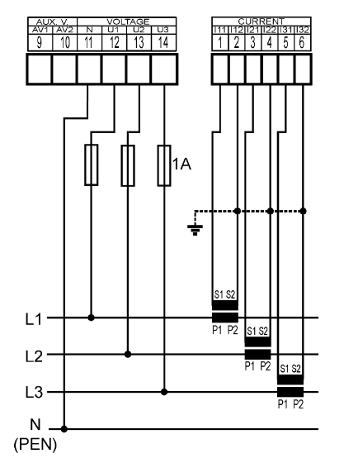  Figure 1- connection of semi-direct measurement ( using MCT) | 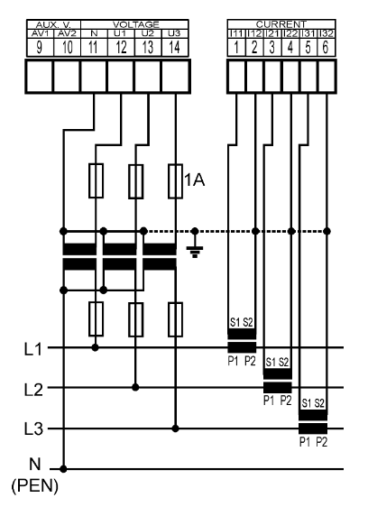  Figure 2- connection of indirect measurement (using MCT and MVT)
  - Setting the electricity meter in the EMS/DC switchboard – the electricity meter needs to be set according to local parameters and the connected MCT/MVT:
    - Example of MCT settings:
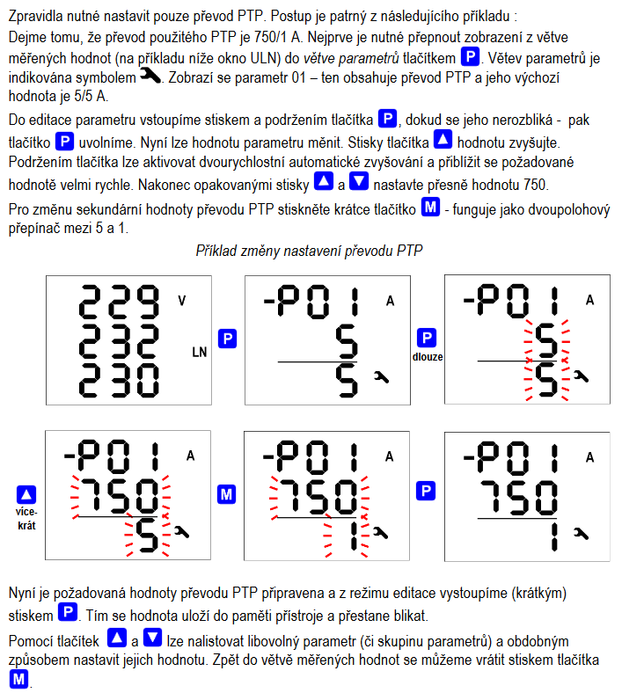

    - Overview of parameters to set:
01-05 is represented by P01-P05 on the display
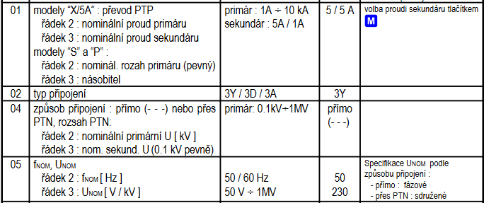

- Number of additional electricity meters installed, e.g. for PV measurement - state the number of additional electricity meters installed, e.g. partial measurement of individual production modules.
- Information on other installed electricity meters
  - Marking of the electricity meter according to SLD - enter the marking as stated in SLD
  - Type of electricity meter - enter the exact type of electricity meter (full name)
  - Communication method ( Modbus RTU/TCP) – Modbus RTU uses RS-485, Modbus TCP uses data networks and the meter must have an assigned IP address
  - Connected to switchboard - in the case of Modbus RTU, indicate which switchboard the meter is connected to
- Setting other installed electricity meters
  - Marking of the electricity meter according to SLD - enter the Marking as stated in SLD
  - MCT gear ratio (value, is set in the electricity meter) - enter the MCT value and confirm the value setting in the electricity meter
  - RTU address / IP TCP address – specify the appropriate set address, either ID address (RTU) or IP address (TCP)
  - The correctness of the connection is verified - here you confirm the correct connection of the MCT (see SML133 electricity meter)

Parametrization and Communication
- Connecting the Eth cable (data network) to the EMS/DC switchboard - physical connection of the data network to the switchboard according to the relevant documentation
- Connecting the Eth cable (data network) to all MaC switchboards - physical connection of the data network to the switchboard according to the relevant documentation
- A data network is set up for the communication of the control units – for the needs of the communication of the control units with the superior system, it is necessary to set the appropriate parameters within the data network. The data network with Internet access is connected to the ETH 2 port of the control unit (or to the RJ45/DIN keystone ). The ETH 2 port of the controller is reserved for external communication, for connecting to the user application using VPN, for accessing external data sources (time synchronization, solar prediction, weather, daily market prices, etc.). Our recommendation is to connect the control units to a dedicated part of the network with the possibility of communicating with the Internet. If a firewall is used, we request that communication be made available to the following addresses:
  - vpn.icool .cloud tcp /1194
  - cz.pool.ntp.org
  - 8.8.8.8 (DNS)
  - www.pvforecast.cz
  - www.ote-cr.cz
  - The control unit has a DHCP server enabled on the ETH 2 port to assign an IP address from a superior server. After connecting the unit, the ETH 2 item can be scrolled on the display and the assigned IP address can be read. We recommend dividing the given IP range into a part that dynamically assigns IP addresses from the DHCP server and a part where the defined range is fixed. After connecting the control unit to the EnergoStation back -end , we can turn off DHCP on the unit and set it to a fixed IP address according to local IT requirements. We recommend doing this for other technology with which the control unit communicates.
- IP addresses and IC numbers of control units – IC number is the registration number of the control unit in the superior system. It is necessary to write it down in the table and attach a photo of the display when sending the checklist. The IC number can be accessed by pressing the "Mode" Button, "RUN" will appear on the display. Then use the down arrow (placed below the display) to scroll through the display, see fig.
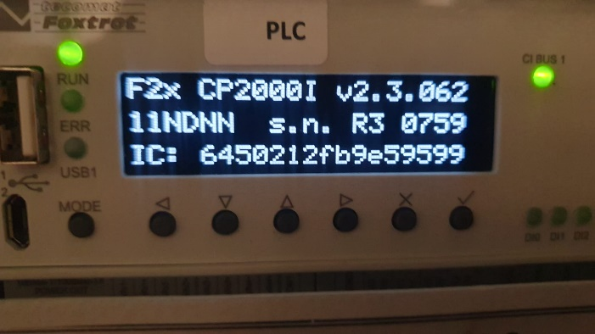
  - Designation of the switchboard according to SLD - designation of the switchboard where the unit is located
  - IC number of the control unit – IC number of the unit described from the display
  - DHCP assigned IP address – the IP address that the control unit received from the DHCP server
  - Requested fixed IP address – IP address to be set as fixed in the control unit -> request from local IT
- Local network parameters - used to check the settings of the control units
- Internet connection method – used to provide information about the connection method for possible diagnostics with data connectivity
- Connection status – the display shows the connection status.
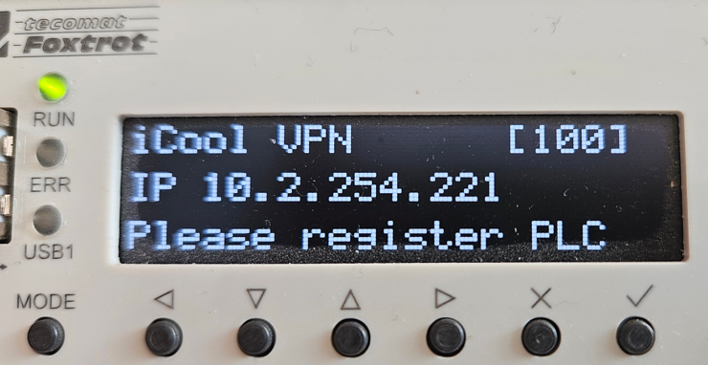
- Are all the photovoltaic inverters connected to the control units - if it is a connection using Modbus TCP, it is necessary to have the appropriate network parameters set on the inverters and to verify, for example, the visibility to the control unit using the "ping" command. If Modbus RTU is used, verify that all inverters are connected to the appropriate RS-485 bus.
- In case of connection using Modbus RTU (RS-485), terminating resistors (120 Ω) are installed at the ends of each communication branch - on the RS-485 ESSs, the last device at the end of the branch must have a terminating resistor of size 120 on the RS-485 terminals Ω. On some devices, the so-called internal termination can be turned on, which ensures this function. Information on whether the device installed by you is capable of internal termination must be found in the manufacturer's documentation. If the device does not have internal termination, it is necessary to install a terminating resistor on the RS-485 A/B terminals.
- In the case of Modbus RTU, the polarity of the RS-485 line (A, B, GND) is verified - as part of the installation, it is necessary to check the correctness of the polarity of the RS-485 line. It depends on the manufacturer how the RS-485 terminals are ordered, not always the order is A, B, GND. If the polarity is not observed, communication will not work.
- Are all the inverters connected to the Data logger - checking whether, in the case of using a smart logger or a Data Hub, all the inverters are connected to it and communicating with it.
- Is the Data logger connected to a data network with visibility to the control unit - these types of devices communicate using Modbus TCP and it is necessary to set the correct network parameters and verify their visibility in the network.
- Information about inverters and their addresses - fill in the technical and data parameters of individual inverters and loggers here
  - Designation according to SLD - name affiliation according to SLD
  - Type of Data logger - enter the type designation of the Data logger as precisely as possible + attach a photo of the label
  - The sum of the power of the inverters behind the logger – this is the sum of the power of all the inverters connected to the Data logger
  - Installed PV power behind the logger – this is the total power of the installed panels below the logger
  - Type of inverter - state the type designation of the inverter as accurately as possible + attach a photo of the label
  - Inverter power - enter the maximum power of the inverter
  - Installed PV power behind the inverter – this is the total power of the installed panels behind the inverter
  - Modbus RTU address / IP TCP address - if the inverter is connected to Modbus RTU, enter the ID address. If on Modbus TCP, enter the IP address
  - Master (M) / Slave (S) – if the inverters are connected to RS-485 and are in Master/Slave mode, fill in M or S. If communicating to each inverter separately, enter 0
- Are all elements of the battery storage (inverters, BMS, etc.) connected to the control units - this is a check whether all battery technologies are connected to the same data network as the control units and their visibility is verified, e.g. using a ping command to the IP address of the main control unit unit from the connection point of the battery component.
- Battery storage information and component addressing
  - Type of battery storage - state the type of battery storage as accurately as possible + complete with a photo of the label. If the ESS is composed of several components, list them in the table below and take a photo of each component
  - Storage capacity – this is the total storage capacity specified by the manufacturer
  - Max. storage capacity – this is the operating maximum capacity, which usually corresponds to 90-95% of the total capacity. The battery must not be charged above this limit.
  - Min. storage capacity – this is the operating minimum capacity, which usually corresponds to 5-12% of the total capacity. The battery must not be discharged below this limit.
  - Additional information on battery storage
    - ESS component – this is an inverter, BMS, or another part of the ESS
    - Component type – exact type designation of the ESS component + supplemented with a photo of the production label
    - Max. inverter power - this is a battery inverter and state its maximum power.
    - Min. inverter power - this is a battery inverter and state its minimum power.
    - Modbus RTU address / IP TCP address - if the inverter or other ESS component is connected to Modbus RTU, enter the ID address. If on Modbus TCP, enter the IP address.
- The METEO station is installed - confirmation that the METEO station has been installed and connected to the data network. This is the installation of the METEO station, which is installed on an elevated place (e.g. roof). The METEO station must be connected to a data network, while the data cable must have power, the so-called PoE.
- METEO has an IP address set in the same network as the control units station – for the station, it is necessary to set the IP address according to the parameters of the LAN network in which the other elements are located (RTU, inverters, etc.). Instructions for setting the IP address can https://support.icool4.cz/a/solutions/articles/47001256155
- IP address of the METEO station – enter the IP address that was set to the METEO station

System Settings
- OM (EMS/DC) parameters:
  - rated current of the main breaker - enter the value of the main breaker at the transfer point between the demand point and the distribution system
  - value of reserved power according to CA – enter the value of reserved power from the current CA
  - the value of the reserved power of the production plant according to the CA - enter the value of the reserved power from the current CA, this is the permitted overflow into the distribution network
  - total installed power according to the CA – enter the value of the total installed power from the current CA
  - allow overflows into the network during the test operation - if a source has already been installed at the point of consumption, it is possible that overflows are allowed according to the original CA .
    - value of the permitted flow - enter the value of the permitted flow
  - electricity supply contract - purchase is - what business relationship is contracted at the point of consumption. The point of consumption is controlled by SPOT , or has a fixed electricity price.
  - electricity supply contract - sale is - what business relationship is contracted at the point of consumption. The point of consumption is controlled by SPOT , or has a fixed electricity price.
  - SPOT purchase – calculation instructions are here: https://support.energostation.com/a/solutions/articles/47001247456?lang=cs&portalId=47000082337
  - SPOT sales – see previous point for instructions
  - prohibit delivery to the network at negative SPOT prices – in the case of a SPOT contractual relationship, should the EMS system block delivery to the distribution network at negative SPOT prices?
  - reserved capacity (¼ hour maximum) – if the take-off point has an agreed ¼ hour maximum, state the contracted value.

- PV, Battery storage and other sources
  - enable SPOT control - define whether the technology should be controlled by SPOT
  - enable battery discharge into the network (SPOT) – define whether the ESS should be charged and discharged according to SPOT from/to the network
  - battery storage losses – manufacturer-defined percentage own loss of the ESS
  - other resources are installed (EMS/DC) – list other devices that were not mentioned in the checklist in the above points
- ¼ hour maximum
  - installed and connected a galvanic optocoupler for collecting pulses from the billing electricity meter to the billing electricity meter - this is a device that is installed as close as possible to the billing electricity meter. Its connection to the billing electricity meter is provided by PDS. The installation of the optocoupler is governed by the local PDS connection conditions.
  - connected galvanic optocoupler to the switchboard 1/4h maximum - for proper functionality, it is necessary to ensure the connection between the optocoupler and the switchboard ¼ hour maximum. The pulses are connected to the inputs of the element C-AM-0006I.
  - switchboard connected ¼ hour maximum to the EMS/DC switchboard – this is a communication connection to the EMS/DC switchboard using the CIB ESSs, possibly using a data network.
    - CIB address of the AK.PULS element (C-AM-0006I) – if it is a variant with CIB connection, it is necessary to indicate the CIB address of the element, which can be found on the element itself.
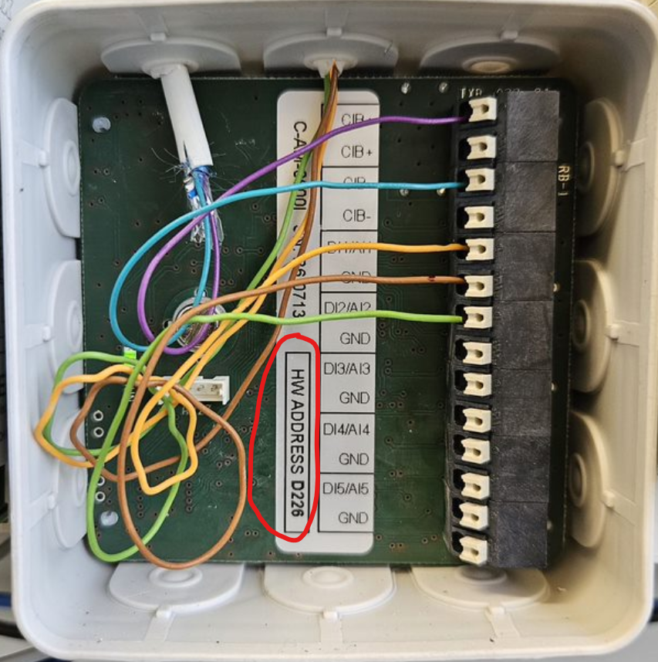
  - description of the pulses – indicate which type of pulse was connected where. It must correspond to the output from the FA electricity meter via the input to the opto-separator and then its output. A synchronizing pulse, A+, A-, or reactive power is usually connected
  - regulatory stages – this is about defining technologies and the order in which they should be disconnected or connected. Technology control may cause additional HW and wiring requirements.

Delivered Documents Together with a Checklist (EMS/DC)
- Photo documentation of the displays of the control units (IC numbers) - make sure that you have taken photos of the displays of all the control units and they are attached to this checklist
- Photo documentation of the technology controlled labels as mentioned above - check that you have taken photos of the production labels of all the technologies concerned and they are attached to this checklist
- Technical sheets for the technologies used, from which the specific installed type will be known - attach the Datasheets of the technologies in question to the checklist
- Table of Modbus registers according to the currently installed fw and interface type (TCP/RTU) - in the case when a new driver is being solved , it is necessary to supply the table of Modbus registers incl. parameters for communication settings
- Documentation for switchboards with marked implemented signals and commands, or recorded changes - if you do not implement all commands or signals, or if you make any changes in the types of connected interfaces, or if you add something or connect to a reserve interface, always record it in the documentation and send it together with a checklist – see example:
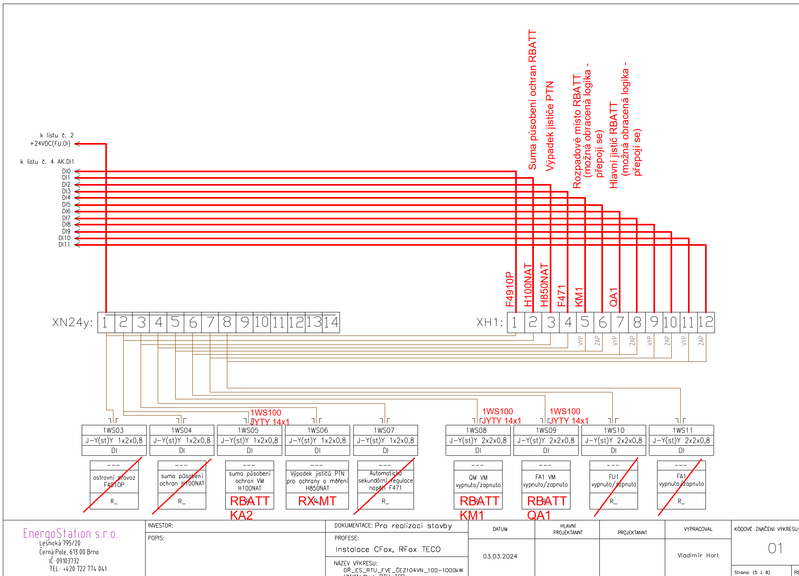

- Implementation project documentation – along with the checklist, it is necessary to supply current implementation documentation that exactly corresponds to the situation on site. The system cannot be configured without this documentation.
  - single-pole diagram with the complete affected technology and affected switchboards (including elements according to the telemetry table) - a single-pole diagram including the actual situation on site with the affected technologies marked and, in the case of DC, with all commands and signals drawn. In addition, the SLD must contain the names of all affected elements and technologies, including the listed basic technical parameters such as current values, etc.
  - situation diagram of objects with the location of the affected technologies and switchboards drawn – diagram with the spatial situation with the location of the technologies and switchboards drawn
- The connection agreement in the current one will be changed incl. appendices and additions - current CA.

If multiple cabinets are installed, use the notes field
If multiple electricity meters are installed, use the comments field
³ To be filled in only if the electricity meter will measure at the HV level If multiple electricity meters are installed, use the comments field
To be filled in only if the electricity meter will measure at the HV level
Fill in only if the inverters are connected to a Smart Logger, Data Hub, or similar device
If multiple inverters are installed, use the comments field
Fill in only if communication with the inverters is via RS-485 and the inverters are in Master/Slave mode; if communication is direct, enter 0
If additional sources such as cogeneration units are installed, list them and provide the information specified in point "3.m" in the Notes
Only if, within the installed technologies, there will be a device that is not supported by the EMS/DC system and a new driver will be needed for it
If you have ordered the development of a driver for an unsupported electricity meter, please include the communication speed and parity in the notes.

