NIFTY 50 STRATEGY RESEARCH AND BACKTESTING PLATFORM
Five-Phase Implementation Roadmap
Code Delivery, Integration Contracts, Test Gates and Multi-Agent Execution Plan
Purpose
Convert the existing PostgreSQL, historical data and accumulated backtesting code into five sequential, independently testable implementation packages. Each package includes production-oriented reference code, migrations, phase tests, a detailed Codex integration prompt and a concise low-context-agent runner.
Project | NIFTY 50 intraday, swing and buying-only option research platform
Prepared for | Internal quantitative engineering, financial research and application teams
Document reference | NIFTY-ROADMAP-001
Version | 1.0
Issue date | 2 August 2026
Classification | Confidential — Internal Engineering and Trading Research
Important implementation status
The reference implementation and sequential-overlay packaging have been verified offline. Integration with the actual target repository, live PostgreSQL instance and full historical data estate remains a controlled implementation activity under the phase release gates.
Document Control
Table 1: Document control
Field | Value
Document title | NIFTY Strategy Research and Backtesting Platform — Five-Phase Implementation Roadmap
Reference | NIFTY-ROADMAP-001
Version | 1.0
Status | Reference implementation complete; target integration pending
Owner | Platform architecture and quantitative engineering
Primary audience | Product owner, quant researchers, data engineers, backtest engineers, ML/statistics engineers, derivatives specialists, API/UI developers and coding agents
Intended use | Phase allocation, code integration, technical implementation, acceptance review, test evidence and programme handover
Table 2: Revision history
Version | Date | Description | Status
0.1 | 2 August 2026 | Architecture-to-roadmap decomposition and source mapping | Superseded
0.5 | 2 August 2026 | Five sequential overlays, phase prompts and automated tests | Superseded
1.0 | 2 August 2026 | Reviewed roadmap, packaged code bundles and delivery verification | Current
Executive Summary
Programme decision
Implement the platform in five sequential phases: trusted data/time; exact economics and simulation; resumable replay; reverse discovery and calibrated probability; then buying-only options, historical/online parity and research packs. Later paper, shadow and constrained-live work must consume the same contracts rather than create another engine.
The starting objective is broader than a single strategy script. The system must repeatedly accept buy/sell rules, replay them through historical daily and minute data as though the market were unfolding in real time, calculate actual net outcomes, restart safely after interruption, compare performance by regime/stock/sector/time, discover candidate precursors to historical opportunities, and later apply parity-certified logic to current SmartAPI data. The existing code and PostgreSQL estate therefore become inputs to a controlled consolidation rather than material to discard.
Five phases are used because later analytical sophistication is worthless if source timestamps, constituents, charges, fill semantics or run state are wrong. Every phase is a sequential overlay into a bounded package under the target repository; every package carries its own acceptance criteria, integration map, detailed Codex prompt, low-context-agent task, overlay installer and verifier.
Table 3: Executive phase decisions
Phase | Outcome | Release gate | Bundle
1 | Trusted data/time/contracts and historical qualification | No unqualified source enters research | Data Foundation
2 | Exact net economics, strategy SDK and event simulator | Temporal and financial golden tests pass | Economics & Simulator
3 | Deterministic, resumable ten-year replay and validated results | Kill/restart and publication controls pass | Resumable Replay
4 | Leakage-controlled discovery and calibrated probability | Strict out-of-fold evidence exists | Discovery & Calibration
5 | Buying-only options, parity and analyst research packs | Premium, freshness, parity and ZIP gates pass | Options/Parity/Packs
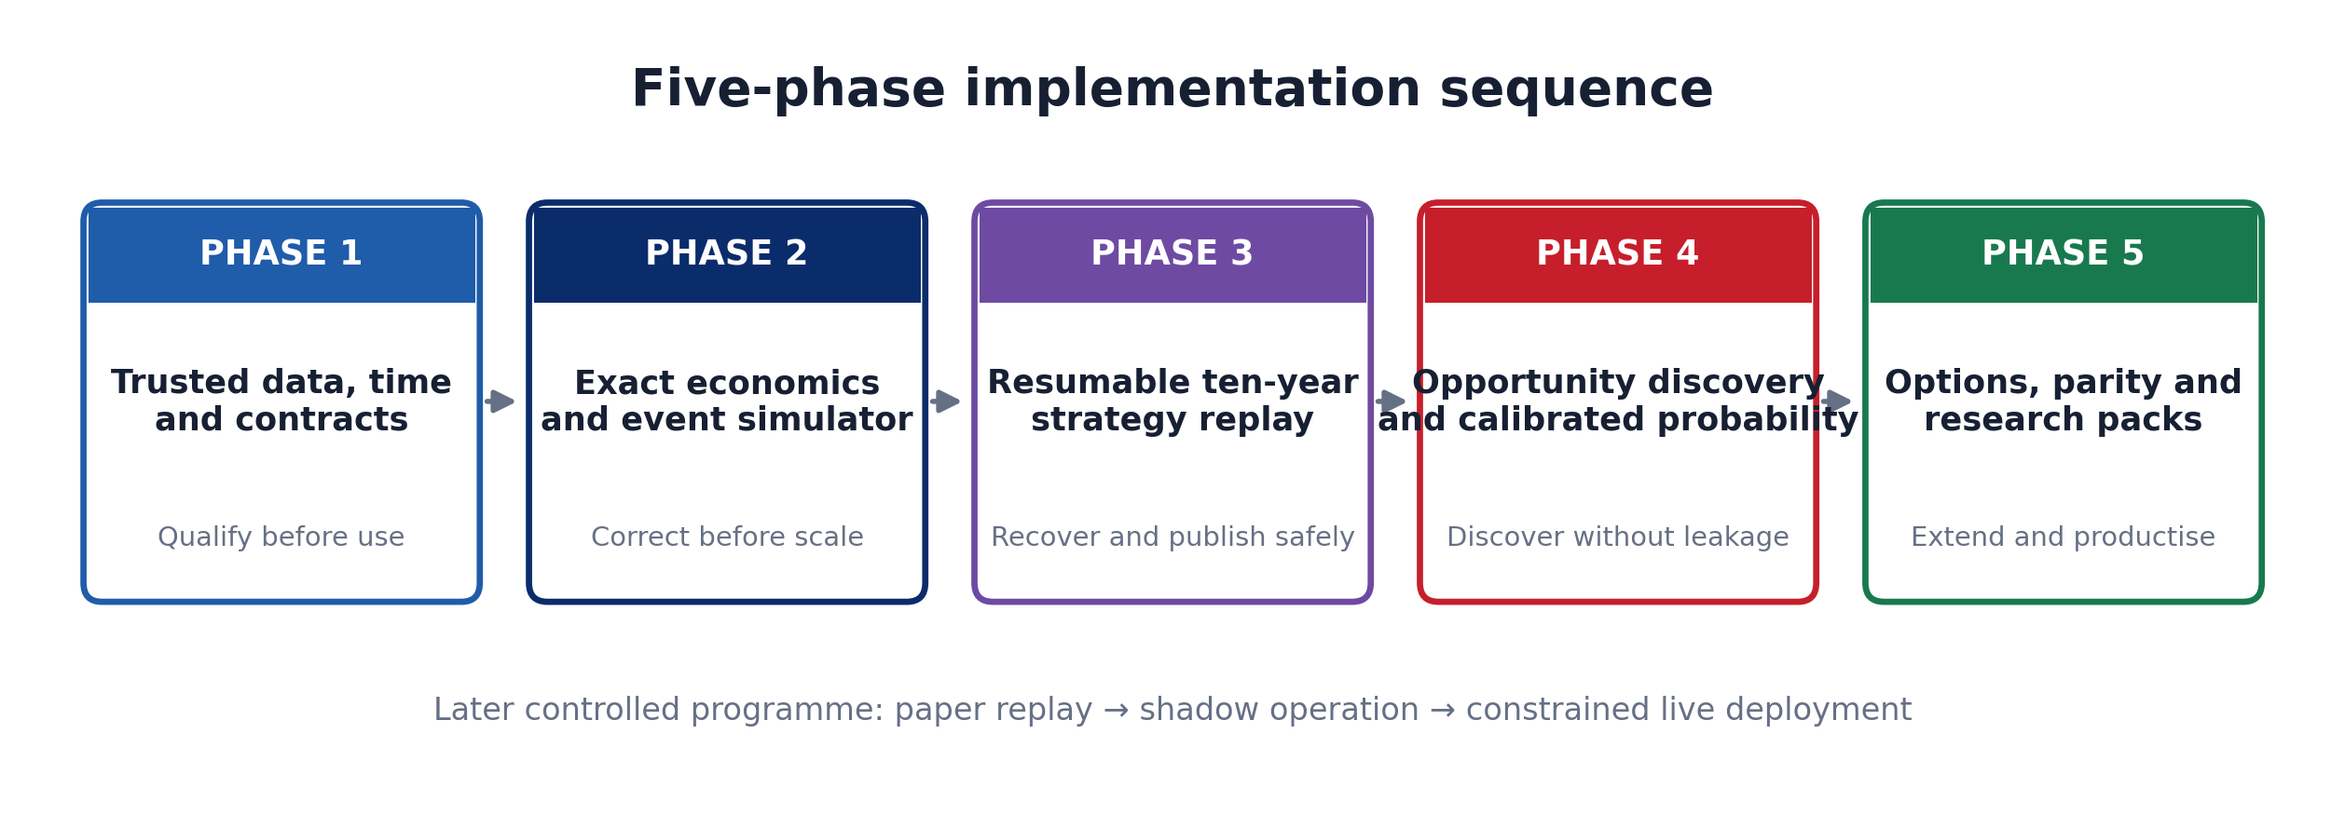
Figure 1: Five-phase implementation sequence
Table of Contents
1 Project Context and Starting Objective 4
1.1 Operating Scenarios 4
1.2 Programme Boundaries 4
2 Evidence Basis and Current Estate 4
2.1 Architecture Decision 5
3 Five-Phase Programme Structure 6
3.1 Standard Phase Release Model 6
4 Phase 1: Data Foundation, Point-in-Time Contracts and Qualification 8
4.1 Features and Work Packages 8
4.2 Existing-Code Integration 8
4.3 Test and Release Gate 8
4.4 Agent Execution 8
5 Phase 2: Exact Economics, Feature Registry, Strategy SDK and Event Simulator 9
5.1 Features and Work Packages 9
5.2 Existing-Code Integration 9
5.3 Test and Release Gate 9
5.4 Agent Execution 9
6 Phase 3: Resumable Historical Backtesting, Experiment Ledger and Results 10
6.1 Features and Work Packages 10
6.2 Existing-Code Integration 10
6.3 Test and Release Gate 10
6.4 Agent Execution 10
7 Phase 4: Reverse Opportunity Discovery, Walk-Forward Validation and Calibrated Probability 11
7.1 Features and Work Packages 11
7.2 Existing-Code Integration 11
7.3 Test and Release Gate 11
7.4 Agent Execution 11
8 Phase 5: Buying-Only Options Research, Historical/Online Parity and Analyst Research Packs 12
8.1 Features and Work Packages 12
8.2 Existing-Code Integration 12
8.3 Test and Release Gate 12
8.4 Agent Execution 13
9 Parallel Developer and Coding-Agent Operating Model 13
9.1 Repository and Contract Governance 14
10 Integration with the Existing Application 14
10.1 Sequential Overlay Method 14
11 Testing, Validation and Acceptance Strategy 15
11.1 Mandatory Invariants 16
12 Stepwise Implementation Roadmap 16
12.1 Programme Success Criteria 16
13 Code Delivery and Package Guide 17
13.1 Contents of Every Phase ZIP 17
13.2 Reference Implementation Verification 17
14 Risks, Assumptions and Open Decisions 18
14.1 Decisions Requiring Target-Environment Confirmation 18
15 Conclusion and Immediate Next Action 18
16 Appendix: Complete Phase Acceptance Register 18
17 Appendix: Target-Environment Validation Checklist 21
18 Appendix: Source Register 21
List of Figures
Figure 1: Five-phase implementation sequence 2
Figure 2: Incremental architecture and governed boundaries 6
Figure 3: Relative implementation effort by phase 7
Figure 4: Standard release gate applied to each phase 8
Figure 5: Parallel work packages inside sequential phase gates 14
Figure 6: Verification stack and deployment-confidence boundary 16
List of Tables
Table 1: Document control 1
Table 2: Revision history 1
Table 3: Executive phase decisions 1
Table 4: Operating scenarios preserved across the five phases 5
Table 5: Current estate used by the implementation plan 5
Table 6: Non-negotiable shared services 6
Table 7: Phase scope, dependency and relative effort 7
Table 8: Phase 1 deliverables 9
Table 9: Phase 2 deliverables 10
Table 10: Phase 3 deliverables 11
Table 11: Phase 4 deliverables 12
Table 12: Phase 5 deliverables 13
Table 13: Parallel work-package ownership 14
Table 14: Existing-code disposition map 15
Table 15: Automated test layers and required evidence 16
Table 16: Implementation sequence and exit evidence 17
Table 17: Programme-level success measures 17
Table 18: Delivery package catalogue 18
Table 19: Principal implementation risks and controls 19
Table 20: Complete acceptance register 19
Table 21: Source register used for the roadmap 22

Project Context and Starting Objective
This roadmap starts from the full programme objective rather than from the latest code change. Over several years, different Python, Go, SQL and TypeScript implementations were created for NIFTY indicators, backtesting, historical ingestion and live analytics. Development restarted several times, creating useful but overlapping logic. The current SmartAPI collector now supplies real-time stock, index, future and option information to PostgreSQL, while separate CSV estates provide longer historical stock, index, sector and VIX coverage.
The target is a reusable research platform in which a new strategy author supplies a versioned strategy manifest, parameters and tests. The platform supplies data qualification, effective-dated market rules, feature computation, charges, target solving, execution simulation, capital accounting, checkpoints, metrics, probability calibration, comparison, reporting and later historical/live parity.

Operating Scenarios
Table 4: Operating scenarios preserved across the five phases
Scenario | System input | Required output
Declared-strategy replay | Strategy, parameters, dates, universe, capital and execution assumptions | Point-in-time signals, simulated fills, net P&L, equity, metrics and auditable evidence
Reverse opportunity discovery | Net target/stop/horizon and qualified history | Executable historical opportunities, only pre-entry conditions, stable candidates and untouched validation
Buying-only option replay | Underlying context, active contracts and actual premium bars | Contract selection, lot sizing, premium target/stop, costs, Greeks diagnostics and expiry handling
Later live parity | Incremental SmartAPI/PostgreSQL events | Same features and signal intents as historical replay, subject to freshness/risk gates
Research pack exchange | Candidate stock/date plus stored evidence | Checksummed ZIP, Markdown summary, selected data and structured analyst response

Programme Boundaries
- In scope: historical cash-equity replay, intraday-to-swing evaluation, reverse discovery, long-option research, parity evidence, research packs, PostgreSQL run/result schemas and developer integration tooling.
- Preserved boundary: the SmartAPI collector remains the live-ingestion owner and is not replaced by these packages.
- Deferred: broker order placement, automatic live authority and canary deployment. These require a later paper/shadow/live programme and independent risk approval.
- Data limitation: the supplied inventories prove paths, file names, sizes and checksums, but not the quality of every historical timestamp or corporate-action adjustment.
- Options limitation: audited options history is materially shorter than the equity file estate; Phase 5 fails closed until actual contract and premium history passes qualification.

Evidence Basis and Current Estate
Basis: Supplied architecture report V1.0, technical audit, PostgreSQL data audit, column dictionary, historical minute-file inventory, FII/DII download record, market-event research and historical code archive.
Table 5: Current estate used by the implementation plan
Estate | Confirmed basis | Roadmap treatment
PostgreSQL `tradingdb` | 208 tables/partitions across 11 schemas; approximately 26.37 GiB in the supplied audit | Reuse facts and operational controls; add bounded catalog/research/simulation entities rather than another disconnected database
Minute bars | `public.bars_1m` contained approximately 23.66 million rows at audit time | Use partition-aware point-in-time adapters and prevent research scans from degrading collector writes
Daily facts | EOD coverage from 8 March 2021 and bhavcopy from 1 January 2024 in audited tables | Backfill earlier periods from qualified historical files or another verified source
Historical stock CSV | 100 files, approximately 4.30 GiB | Phase 1 qualification and checksum registration before admission
Index/sector/VIX CSV | 680 files, approximately 3.90 GiB | Qualify and align with stock bars and market calendar
Options and derivatives | Contract/instrument, chain, OI and PCR data present; Greeks were stale relative to other feeds at audit time | Freshness gate and actual-premium history qualification in Phase 5
Legacy code | Go runners, Python worker, SQL marts, strategy registry and TypeScript routes | Wrap/reconcile progressively; quarantine known look-ahead and inconsistent charge logic

Architecture Decision
The implementation is an additive bounded package, recommended at `platform/nifty_stratlab`, installed as five sequential overlays. It is not a replacement repository. Existing services consume canonical contracts through narrow adapters; legacy result tables remain readable until row-level reconciliation is complete.
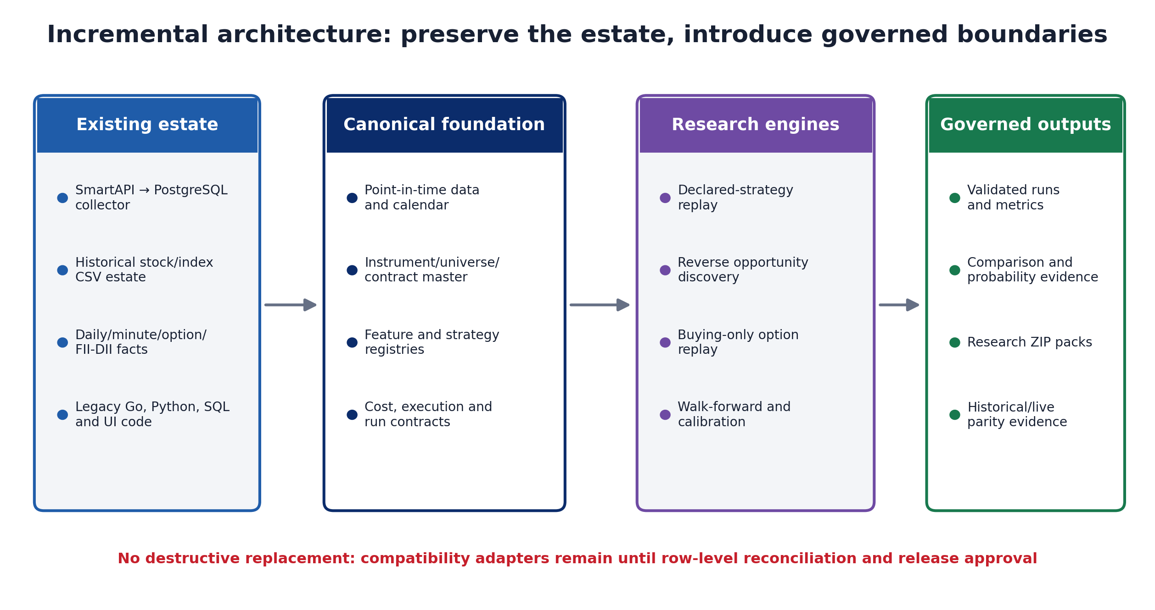
Figure 2: Incremental architecture and governed boundaries
Table 6: Non-negotiable shared services
Shared service | Reason it is centralised | Forbidden duplication
Market calendar and expiry | Historical rules vary by effective date and holidays | Hard-coded weekday/session logic inside a strategy
Instrument and universe identity | Prevents survivorship and inactive-contract selection | Current constituents applied backwards
Feature registry | Supports batch/incremental parity and versioning | Separate historical and live RSI/VWAP logic
Cost and target engine | Determines whether ₹500/₹1,000 net objectives are actually reached | Brokerage-only or environment-dependent formula
Execution simulator | Defines next-bar entry, fill/path rules and capital state | A different fill assumption in each strategy
Experiment ledger | Makes runs deterministic, resumable and comparable | Unlogged ad-hoc scripts and overwritten results

Five-Phase Programme Structure
Table 7: Phase scope, dependency and relative effort
Phase | Primary outcome | Dependency | Relative effort
1 | Trusted data/time/contracts and qualification | None | 20%
2 | Exact economics, strategy SDK and event simulator | Phase 1 gate | 25%
3 | Resumable replay, run ledger and governed results | Phases 1–2 | 20%
4 | Reverse discovery, walk-forward and calibrated probability | Phases 1–3 + qualified data | 20%
5 | Buying-only options, parity and research packs | Phases 1–4 + qualified premium history | 15%
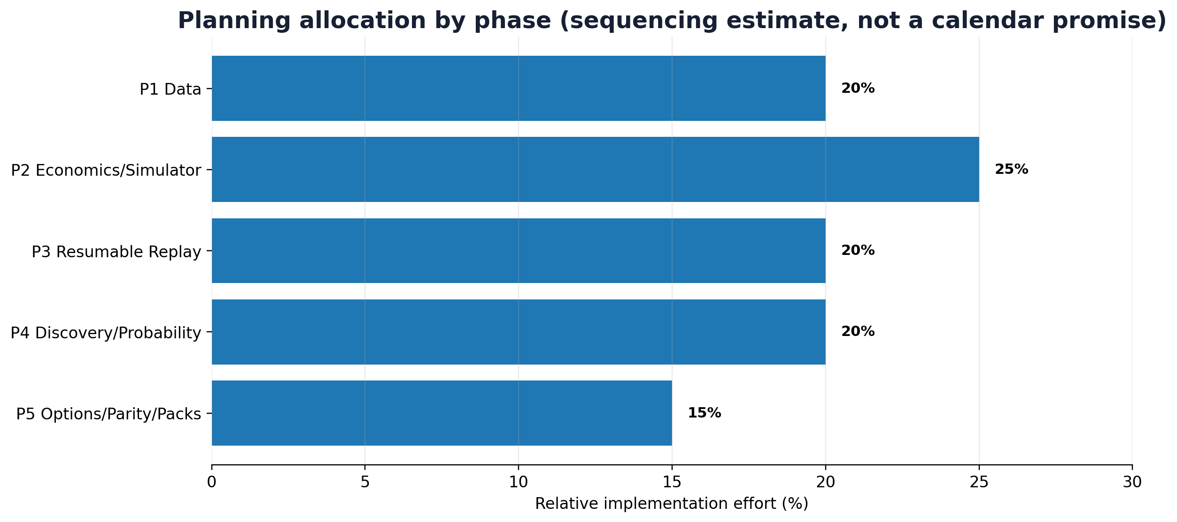
Figure 3: Relative implementation effort by phase

Standard Phase Release Model
Every phase follows the same controlled flow. A package can be applied in dry-run mode; its Codex prompt requires repository inspection before modification; migrations are tested against a disposable database; affected legacy tests are rerun; and the phase owner records evidence and rollback before merge.
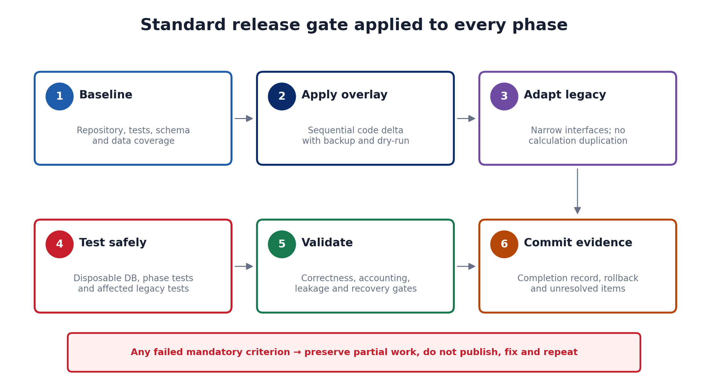
Figure 4: Standard release gate applied to each phase

Phase 1: Data Foundation, Point-in-Time Contracts and Qualification
Phase objective
Create the trusted point-in-time data and market-rule boundary required before any strategy result can be believed.
Dependency: None. This is the mandatory first phase.

Features and Work Packages
- Contracts and calendar service
- Historical CSV qualification and immutable manifests
- Read-only PostgreSQL coverage and effective-dated universe adapter
- Additive catalog migration and language-neutral schemas
Table 8: Phase 1 deliverables
Deliverable | Implementation result
P1-D1 | Timezone-aware MarketBar/SignalIntent contracts
P1-D2 | Effective-dated CM/F&O sessions and expiry resolution
P1-D3 | PASS/WARN/FAIL source qualification with SHA-256
P1-D4 | Point-in-time NIFTY membership queries
P1-D5 | Session/expiry golden vectors

Existing-Code Integration
Existing component | Required treatment
archive_runner.go | Retain discovery/parser ideas; enforce qualification before persistence
history.go | Replace weekday assumptions with calendar service
nse_intraday.universe_membership | Use effective_from/effective_to
nifty_bhavcopy_ingest.py | Quarantine cross-symbol RSI/Williams calculation

Test and Release Gate
- Contract validation
- Session and holiday-adjusted expiry vectors
- OHLC/duplicate/order/session/missing-minute qualification
- Read-only PostgreSQL adapter tests
- Phase 1 smoke test
Mandatory phase gate
A phase may merge only when every acceptance criterion in the package has saved evidence. Synthetic tests prove the reference implementation; they do not replace real-repository, disposable-database and qualified-data validation.

Agent Execution
The package includes both a full-context Codex integration contract and a short task for low-context agents. Both operate against the target repository and prohibit destructive production migrations or broker orders.

Phase 2: Exact Economics, Feature Registry, Strategy SDK and Event Simulator
Phase objective
Create one financially exact and temporally correct engine that every cash-equity strategy must reuse.
Dependency: Phase 1 must be merged and its release gate must pass.

Features and Work Packages
- Effective-dated Decimal fee engine and component rounding
- Minimum valid-tick solver for configured net P&L
- Chronological feature registry and prefix-parity tests
- Strategy manifest/plug-in SDK
- Finite-cash next-bar event simulator and path policies
Table 9: Phase 2 deliverables
Deliverable | Implementation result
P2-D1 | Brokerage/STT/exchange/SEBI/IPFT/stamp/GST/DP breakdown
P2-D2 | ₹500/₹1,000 target solver
P2-D3 | RSI, Williams %R, SMA, MACD and VWAP features
P2-D4 | SignalIntent-only strategy boundary
P2-D5 | Gross and net-liquidation equity, skipped signals and open positions

Existing-Code Integration
Existing component | Required treatment
backtest_transaction_charges.go | Replace calculation with canonical golden-vector-compatible wrapper
nifty_backtesting_worker.py | Remove dynamic fee fallback and use shared engine
runner.go target calculation | Replace brokerage-only approximation
strategy_backtest.go | Reconcile next-bar and stop-first semantics
a02.go | Quarantine same-day look-ahead path

Test and Release Gate
- Cross-language fee vectors
- Prior tick fails / returned tick passes target
- No same-bar entry
- Stop/target ambiguity policy
- Cash/accounting invariants
- Deterministic reference-strategy replay
Mandatory phase gate
A phase may merge only when every acceptance criterion in the package has saved evidence. Synthetic tests prove the reference implementation; they do not replace real-repository, disposable-database and qualified-data validation.

Agent Execution
The package includes both a full-context Codex integration contract and a short task for low-context agents. Both operate against the target repository and prohibit destructive production migrations or broker orders.

Phase 3: Resumable Historical Backtesting, Experiment Ledger and Results
Phase objective
Scale the correct simulator into a deterministic, resumable historical service with governed publication.
Dependency: Phases 1 and 2 must be merged and stable.

Features and Work Packages
- Immutable run identity and deterministic shard planning
- Leases, heartbeats, attempts, cursors and checksums
- Local recovery ledger and PostgreSQL SKIP LOCKED ledger
- Idempotent trade/equity/result persistence
- Validation-gated atomic publication and metrics
Table 10: Phase 3 deliverables
Deliverable | Implementation result
P3-D1 | Date-block × symbol-bucket shards
P3-D2 | Restart from durable checkpoint
P3-D3 | Net P&L, profit factor, drawdown, Sharpe and ambiguity metrics
P3-D4 | Failed-run publication guard
P3-D5 | Compatibility period for legacy result readers

Existing-Code Integration
Existing component | Required treatment
history.go | Route date-range work through canonical RunSpec/shards
nifty_backtesting_worker.py | Split monolith into orchestration/adapters
nse_app.backtest_* | Keep read-only compatibility until reconciliation
batch_run_audit | Map to validation/publish lifecycle and forbid failed publication

Test and Release Gate
- Deterministic run/shard identifiers
- Worker kill and resume
- Lease expiry/reclaim
- Idempotent writes and output checksum
- Accounting reconciliation
- Incomplete/failed run cannot publish
Mandatory phase gate
A phase may merge only when every acceptance criterion in the package has saved evidence. Synthetic tests prove the reference implementation; they do not replace real-repository, disposable-database and qualified-data validation.

Agent Execution
The package includes both a full-context Codex integration contract and a short task for low-context agents. Both operate against the target repository and prohibit destructive production migrations or broker orders.

Phase 4: Reverse Opportunity Discovery, Walk-Forward Validation and Calibrated Probability
Phase objective
Find stable pre-entry conditions around executable historical opportunities without leaking outcomes into features.
Dependency: Phases 1–3 and a qualified historical dataset snapshot.

Features and Work Packages
- Net-target opportunity labels using Phase 2 execution semantics
- MFE/MAE/time-to-exit and ambiguity evidence
- Pre-entry feature association ranking
- Chronological expanding walk-forward with purge/embargo
- Out-of-fold calibration and reliability evidence
Table 11: Phase 4 deliverables
Deliverable | Implementation result
P4-D1 | Checksummed opportunity dataset
P4-D2 | Candidate feature associations clearly labelled non-causal
P4-D3 | Brier/log-loss/ROC AUC and probability bins
P4-D4 | Immutable model artifact and feature list
P4-D5 | Untouched-holdout workflow

Existing-Code Integration
Existing component | Required treatment
security_daily_features.fwd_return_* | Use as labels only, never features
security_minute_feature | Reuse after availability and parity checks
heuristic confidence scores | Retain as ranking only until calibrated
event/FII-DII tables | Join by actual availability, commonly next-session context

Test and Release Gate
- Decision < entry ≤ exit
- No future/outcome columns in feature matrix
- Chronological splits with purge/embargo
- Strict out-of-fold calibration
- Model/feature/data hashes
- Frozen candidate replay under Phase 3 before promotion
Mandatory phase gate
A phase may merge only when every acceptance criterion in the package has saved evidence. Synthetic tests prove the reference implementation; they do not replace real-repository, disposable-database and qualified-data validation.

Agent Execution
The package includes both a full-context Codex integration contract and a short task for low-context agents. Both operate against the target repository and prohibit destructive production migrations or broker orders.

Phase 5: Buying-Only Options Research, Historical/Online Parity and Analyst Research Packs
Phase objective
Extend the governed platform to buying-only option premiums and produce parity-certified, portable analyst evidence.
Dependency: Phases 1–4; actual historical option contract and premium data must pass qualification.

Features and Work Packages
- Point-in-time active CE/PE contract selection
- Observed premium-bar simulator and lot sizing
- Premium target/stop/expiry/time exits and charges
- Black–Scholes Greeks and IV diagnostics
- Incremental replay parity oracle
- Checksummed research packs and analyst-response contract
Table 12: Phase 5 deliverables
Deliverable | Implementation result
P5-D1 | Contract-aware option trades using actual premiums
P5-D2 | Greeks/IV diagnostic vectors
P5-D3 | Freshness and quality gates
P5-D4 | Batch/incremental feature parity evidence
P5-D5 | ZIP packs with manifest, summary, source data and response schema

Existing-Code Integration
Existing component | Required treatment
options_backtest.go | Retain useful contract/bar selection; replace synthetic pricing
public instruments/universe/option tables | Create point-in-time adapters and freshness gates
public.option_greeks | Treat stale data as a hard gate
SmartAPI collector | Remain ingestion owner; parity service only consumes events
API/UI routes | Add canonical result/pack endpoints after contracts freeze

Test and Release Gate
- Active/known contract at decision time
- Integer lot quantity fits cash including charges
- Actual premium bars, not theoretical prices
- Greeks/IV golden vectors
- Stale data fails closed
- ZIP checksum and safe-path validation
- Batch/online parity tolerance
Mandatory phase gate
A phase may merge only when every acceptance criterion in the package has saved evidence. Synthetic tests prove the reference implementation; they do not replace real-repository, disposable-database and qualified-data validation.

Agent Execution
The package includes both a full-context Codex integration contract and a short task for low-context agents. Both operate against the target repository and prohibit destructive production migrations or broker orders.

Parallel Developer and Coding-Agent Operating Model
The five phase gates are sequential, but bounded work packages within a phase can run concurrently after shared interfaces freeze. Ownership is enforceable through file/schema boundaries, CODEOWNERS, golden vectors and consumer tests rather than through informal coordination alone.
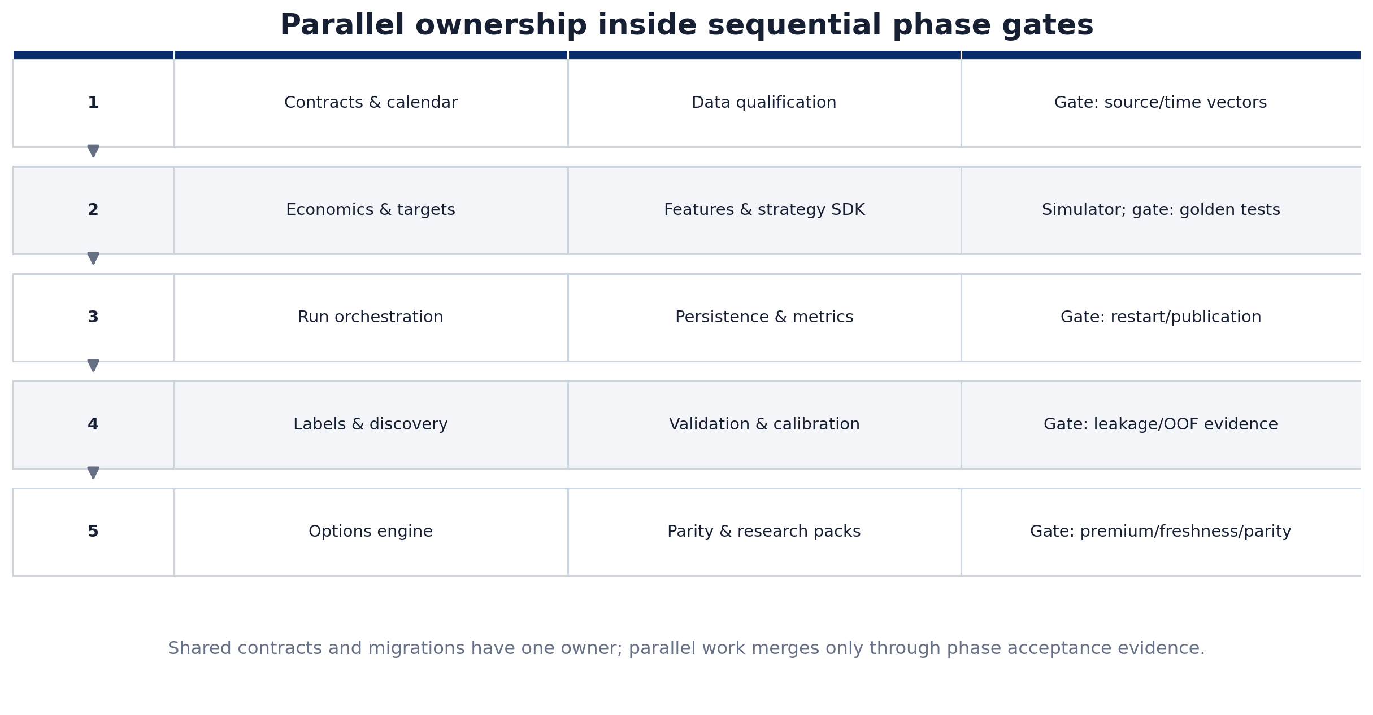
Figure 5: Parallel work packages inside sequential phase gates
Table 13: Parallel work-package ownership
WP | Owner | Owns | Parallel with | Merge gate
P1-WP1 | Platform architect | Contracts, calendar, schemas and vectors | P1-WP2 | Session/expiry vectors
P1-WP2 | Data engineer | Manifests, CSV qualification and PostgreSQL adapters | P1-WP1 | Qualification report
P2-WP1 | Quant/platform | Economics, target solver and fee vectors | P2-WP2 | Contract-note/golden parity
P2-WP2 | Quant engineer | Feature registry, SDK and reference strategy | P2-WP1 | Prefix parity and manifests
P2-WP3 | Backtest engineer | Event simulator and portfolio state | After P2-WP1 interface | Event/accounting tests
P3-WP1 | Platform engineer | Run orchestration, shards and recovery | P3-WP2 | Restart/idempotency
P3-WP2 | DB/analytics | Persistence, metrics and publication | P3-WP1 | Reconciliation/publication guard
P4-WP1 | Quant research | Labels and pattern discovery | P4-WP2 | Leakage audit
P4-WP2 | ML/statistics | Walk-forward and calibration | P4-WP1 | Out-of-fold evidence
P5-WP1 | Derivatives quant | Contracts, premiums, Greeks, simulator | P5-WP2 | Premium/freshness tests
P5-WP2 | Integration/reporting | Parity, research packs and response contracts | P5-WP1 | Parity/archive verification

Repository and Contract Governance
- Integration branch: use `DEV_PM_CODE`; use short-lived feature branches or worktrees for individual work packages and review before merge.
- Single ownership: one named owner controls each shared contract, golden vector and migration file.
- Contract changes: regenerate schemas/vectors and run consumer tests before merge.
- Calculation authority: no agent independently edits equivalent fee, calendar, feature or fill logic in Python, Go and TypeScript. Canonical code plus golden vectors governs retained ports.
- Schema boundaries: services write only their owned schemas; cross-context reads use approved views or APIs.
- Handover: every phase writes `PHASE_X_COMPLETION.md` with baseline, changed files, commands, results, rollback and unresolved items.

Integration with the Existing Application
Table 14: Existing-code disposition map
Existing path/component | Disposition | Target use
backtesting/internal/backtest/history.go | Reuse and refactor | Date-range orchestration; route through run/shard contracts
archive_runner.go | Reuse and harden | File discovery behind qualification and manifests
strategy_backtest.go | Reuse pattern | Next-bar execution and explicit stop-first semantics
a02.go::evaluateExit | Quarantine | Known same-day look-ahead semantics must not migrate
options_backtest.go | Substantial refactor | Actual contracts/premium bars, complete economics and freshness
nifty_backtesting_worker.py | Split and adapt | Retain candidate/template/finite-capital layering; remove monolithic orchestration
_delivery_charge_breakdown | Replace | One effective-dated cost engine; no silent fallback
_publish_batch | Fix immediately | Failed validation cannot publish
indicator_strategy_registry.yml | Promote | Immutable strategy manifests and changelog
nse_app.backtest_* | Compatibility period | Read-only comparison until canonical reconciliation
TypeScript backtesting routes | Consume only | Canonical results and packs; no business-calculation duplication

Sequential Overlay Method
1. Inspect the actual repository, branch, manifests, service topology, current migrations and baseline tests.
2. Dry-run the package overlay and review every file that would be added or overwritten.
3. Apply the phase overlay into `platform/nifty_stratlab`; backups are created for overwritten files.
4. Implement only the documented legacy adapters and preserve compatibility until reconciliation passes.
5. Test additive migrations against `TRADING_TEST_DATABASE_URL`; do not apply production migrations automatically.
6. Run phase tests, smoke test, affected legacy tests and cross-language vectors where applicable.
7. Save evidence, complete the phase report, commit and merge only after release approval.
# inspect only
bash APPLY_OVERLAY.sh /path/to/repo --dry-run
# full Codex integration
bash RUN_CODEX.sh /path/to/repo
# concise low-context task
bash RUN_LOW_CONTEXT_AGENT.sh /path/to/repo
# verification after integration
bash VERIFY_PHASE.sh /path/to/repo

Testing, Validation and Acceptance Strategy
Testing is layered so developers receive fast calculation feedback while release confidence grows through database, historical, recovery and later paper/shadow evidence. No single synthetic test is treated as deployment proof.
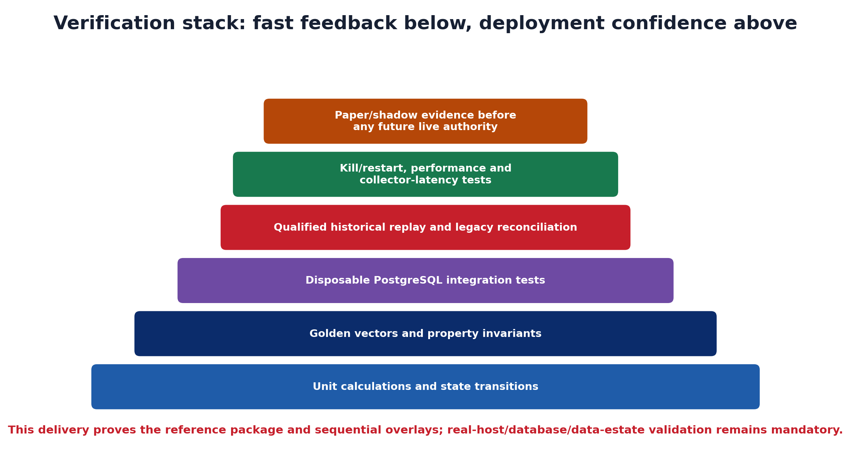
Figure 6: Verification stack and deployment-confidence boundary
Table 15: Automated test layers and required evidence
Layer | Purpose | Examples | Release evidence
Unit | Calculation and state-transition correctness | Fee rounding, indicators, Greeks, state machines | Deterministic pass/fail and edge cases
Golden/property | Cross-language and invariant parity | Session/expiry, fees, Greeks, target tick, OHLC/accounting | Pinned vectors and checksums
PostgreSQL integration | Migration, SQL and locking behaviour | Idempotent migration, SKIP LOCKED, publish guard | Disposable DB log and rollback
Qualified replay | Real historical semantics and compatibility | Pinned sessions, legacy trade/result comparison | Data snapshot hash and reconciliation
Failure/recovery | Operational restart and fail closed | Kill worker, expire lease, stale source, failed validation | Recovery and no-publication evidence
Performance | Full-host feasibility and collector isolation | Ten-year benchmark, memory, DB load, collector latency | Measured baseline and thresholds
Later paper/shadow | Historical/live execution fidelity | Actual fills, slippage, parity and drift | Separate deployment approval

Mandatory Invariants
- `available_at` never precedes the source event and a strategy never observes a feature before availability.
- A completed-bar signal cannot fill before the next executable event.
- `net_pnl = gross_pnl − total_cost` and gross equity equals cash plus market value.
- Net liquidation value includes estimated exit costs and does not exceed gross equity under non-negative costs.
- Historical universe and option-contract membership are effective-dated.
- A run cannot publish unless every expected shard is complete and every mandatory validation passes.
- Model calibration uses strictly chronological out-of-fold predictions and an untouched final holdout is frozen before selection.

Stepwise Implementation Roadmap
Table 16: Implementation sequence and exit evidence
Step | Action | Owner | Exit evidence
1 | Assign Phase 1 owners; run historical file and PostgreSQL preflight | Platform + data | Qualification report and source manifest
2 | Freeze session/expiry/data contracts | Platform architect | Golden vectors and approved contract version
3 | Integrate Phase 2 costs/features/SDK/simulator | Quant + backtest | Contract-note reconciliation and event tests
4 | Run a narrow qualified historical vertical slice | Backtest + QA | Trades, equity, metrics and reproducible checksum
5 | Integrate Phase 3 sharding/restart/publication | Platform + DB | Kill/restart and failed-publish evidence
6 | Expand to full qualified equity scope and benchmark host | Data + platform | Performance and collector-latency report
7 | Freeze an untouched holdout; begin Phase 4 discovery | Quant + ML | Split registry and leakage audit
8 | Replay frozen candidates through Phase 3 | Quant + QA | Out-of-sample metrics and calibration evidence
9 | Qualify actual option contracts/premium history | Derivatives + data | Coverage/freshness report
10 | Integrate Phase 5 option/parity/pack services | Derivatives + reporting | Actual-premium, parity and archive tests
11 | Open separate paper/shadow programme | Risk + live integration | Independent approval; outside this delivery

Programme Success Criteria
Table 17: Programme-level success measures
Quality attribute | Success measure
Correctness | No known look-ahead, survivorship, cross-symbol indicator or fee inconsistency
Reproducibility | Same run identity and pinned inputs produce identical output checksums
Recovery | Interrupted work resumes from the last durable shard/checkpoint
Financial fidelity | Charges reconcile to approved broker vectors and targets use exchange-valid ticks
Research validity | Walk-forward, holdout, calibration and complete trial history are retained
Operational safety | Failed quality, freshness or validation gates fail closed and cannot publish
Extensibility | A new strategy requires a manifest, plug-in and tests rather than an engine rewrite
Parity | Historical and incremental replay match for certified features and signals

Code Delivery and Package Guide
The code is delivered both as five sequential phase ZIPs and as one cumulative reference implementation. Each phase ZIP contains only that phase delta and is applied after its predecessor. It also contains a complete integration contract for a high-context Codex session and a short task that a low-context coding agent can execute directly.
Table 18: Delivery package catalogue
File | Purpose | Order
NIFTY_BACKTEST_PHASE_01_DATA_FOUNDATION_V1.0.zip | Phase 1 overlay, migration 001, qualification tests, prompts and runners | First
NIFTY_BACKTEST_PHASE_02_ECONOMICS_SIMULATOR_V1.0.zip | Phase 2 overlay, migration 002, fee/feature/simulator tests | After Phase 1
NIFTY_BACKTEST_PHASE_03_RESUMABLE_REPLAY_V1.0.zip | Phase 3 overlay, migration 003, run/restart/result tests | After Phase 2
NIFTY_BACKTEST_PHASE_04_DISCOVERY_CALIBRATION_V1.0.zip | Phase 4 overlay, migration 004, discovery/calibration tests | After Phase 3
NIFTY_BACKTEST_PHASE_05_OPTIONS_PARITY_PACKS_V1.0.zip | Phase 5 overlay, migration 005, options/parity/pack tests | After Phase 4
NIFTY_BACKTEST_INTEGRATED_REFERENCE_V1.0.zip | Cumulative package with all source, migrations, schemas, vectors and tests | Reference/review
NIFTY_BACKTESTING_FIVE_PHASE_COMPLETE_DELIVERY_V1.0.zip | Roadmap, all phase ZIPs, cumulative ZIP and checksum manifest | Archive/handover

Contents of Every Phase ZIP
- `overlay/platform/nifty_stratlab/`: phase-specific source, migration, schemas/vectors and tests.
- `CODEX_PROMPT.md`: full repository-inspection, integration, migration, test, review and handover contract.
- `LOW_CONTEXT_TASK.md`: concise bounded task for a low-context agent.
- `RUN_CODEX.sh/.ps1` and `RUN_LOW_CONTEXT_AGENT.sh/.ps1`: direct non-interactive execution wrappers.
- `APPLY_OVERLAY.py/.sh/.ps1`: dry-run-capable copier with timestamped backup of overwritten files.
- `VERIFY_PHASE.sh/.ps1`: compile, phase tests and smoke test.
- `PHASE_PLAN.md`, `INTEGRATION_MAP.md`, `ACCEPTANCE_CRITERIA.md`, `SOURCE_BASIS.md` and `MANIFEST.json`.

Reference Implementation Verification
Verified in this delivery
Python source compiled successfully; 22 automated tests passed; all five phase smoke tests passed; the five overlays were applied sequentially to a clean mock Git repository; every cumulative phase verifier passed; and CLI demonstrations completed for equity replay, deterministic run planning, reverse discovery/calibration, option simulation, parity, research packs and the net-target solver.
This evidence validates the reference code and packaging only. It does not prove deployment into the actual repository, operation against the real PostgreSQL server, qualification of the complete eight-plus-gigabyte historical estate, or production readiness of fee schedules and option history.

Risks, Assumptions and Open Decisions
Table 19: Principal implementation risks and controls
Risk | Impact | Control / decision
Historical file quality unknown | False signals, missing sessions or corporate-action discontinuities | Mandatory qualification, quarantine and overlapping-source reconciliation
Options history too short | Overconfident expiry/Greek conclusions | Qualify actual contracts/premiums; restrict evidence window until backfill exists
Market-rule changes | Wrong session or expiry in historical replay | Effective-dated calendar/expiry master and golden vectors
Execution edge smaller than friction | ₹500 target consumed by charges/slippage | Complete costs, tick solver and execution sensitivity
Automatic carry adverse selection | Losing intraday positions become overnight risk | Separate conditional carry policy in later strategy work; compare force-close versus carry
Overfitting across many ideas | Best historical result may be luck | Complete trial ledger, walk-forward, untouched holdout and later multiple-testing controls
Concurrent developer divergence | Duplicate calculations and incompatible schemas | Bounded ownership, ADRs, contracts, vectors and consumer tests
Operational DB overload | Research affects live collector writes | Partition pruning, query budgets, benchmark, optional analytical cache/replica
Broker/API mismatch in later programme | Duplicate or unmanaged positions | Outside this delivery: reconciliation, idempotency, fail closed and kill switch

Decisions Requiring Target-Environment Confirmation
- Actual target repository path, service topology and dependency-management convention.
- Reference compute host and measured full-scope runtime/memory/database-load target.
- Historical source precedence when community CSV and exchange/verified data disagree.
- Production-approved fee schedules and effective dates reconciled against contract notes.
- Initial point-in-time universe, liquidity and eligibility filters.
- Swing stop/horizon policy and intraday-to-swing carry criteria for each strategy version.
- Authoritative/licensed source for historical option contracts and premium bars.
- Separate approval path for paper, shadow and any later constrained-live authority.

Conclusion and Immediate Next Action
The correct next action is not to add another isolated indicator or strategy script. It is to integrate Phase 1 into the actual repository, run its source and database qualification against the real paths, and freeze the calendar/data contracts. Phase 2 then creates the economic and execution truth on which all later strategies depend. Only after resumable Phase 3 replay is stable should reverse discovery begin, and only after actual option premium history passes qualification should Phase 5 option claims be considered.
Recommended programme start
Assign one Phase 1 owner, one data-qualification workstream and one contract/calendar workstream. Run the Phase 1 Codex integration script against the target repository, review its dry-run and qualification evidence, and do not open Phase 2 for merge until the Phase 1 acceptance register is complete.

Appendix: Complete Phase Acceptance Register
Table 20: Complete acceptance register
ID | Phase | Mandatory criterion | Initial status
AC-01-01 | Phase 1 | All Phase 1 tests and smoke test pass from a clean virtual environment. | Pending target evidence
AC-01-02 | Phase 1 | Every admitted source file has SHA-256, schema profile, timestamp range and explicit PASS/WARN/FAIL status. | Pending target evidence
AC-01-03 | Phase 1 | Conflicting duplicate bars and invalid OHLC rows force quarantine. | Pending target evidence
AC-01-04 | Phase 1 | A historical query can resolve the universe as of a supplied date rather than current constituents. | Pending target evidence
AC-01-05 | Phase 1 | NSE CM resolves 375 one-minute bars for 09:15–15:30; configured F&O session changes resolve by effective date. | Pending target evidence
AC-01-06 | Phase 1 | No production database write occurs during qualification; migration execution is separately authorised. | Pending target evidence
AC-02-01 | Phase 2 | Every golden fee vector matches in Python and any retained Go/TypeScript implementation. | Pending target evidence
AC-02-02 | Phase 2 | The returned target is the first exchange-valid tick meeting the configured net P&L; the prior tick fails. | Pending target evidence
AC-02-03 | Phase 2 | A signal generated at a completed bar cannot enter on that same bar. | Pending target evidence
AC-02-04 | Phase 2 | Same-bar stop/target conflicts are counted and follow the declared path policy. | Pending target evidence
AC-02-05 | Phase 2 | Cash never becomes negative and ticket size includes entry charges. | Pending target evidence
AC-02-06 | Phase 2 | Open-position reporting includes estimated exit costs in net liquidation value. | Pending target evidence
AC-02-07 | Phase 2 | The reference strategy runs end to end on deterministic synthetic bars and produces reproducible checksums. | Pending target evidence
AC-03-01 | Phase 3 | Killing a worker after a durable checkpoint reruns only the uncompleted shard. | Pending target evidence
AC-03-02 | Phase 3 | Expired leases can be reclaimed; completed shards are never silently recomputed. | Pending target evidence
AC-03-03 | Phase 3 | The same run specification produces the same run/shard IDs and checksummed outputs. | Pending target evidence
AC-03-04 | Phase 3 | All accounting identities reconcile: net P&L = gross P&L − total cost; gross equity = cash + market value. | Pending target evidence
AC-03-05 | Phase 3 | A run with any incomplete shard or failed mandatory validation cannot publish. | Pending target evidence
AC-03-06 | Phase 3 | Full-scope performance is benchmarked on the actual host without affecting collector/live-write latency. | Pending target evidence
AC-04-01 | Phase 4 | Every label has decision_ts < entry_ts ≤ exit_ts and uses observed future bars only for the label. | Pending target evidence
AC-04-02 | Phase 4 | No forward-return, future high/low, final-day or outcome column enters the model feature matrix. | Pending target evidence
AC-04-03 | Phase 4 | Walk-forward splits are chronological and respect declared label horizon through purge/embargo. | Pending target evidence
AC-04-04 | Phase 4 | Displayed probabilities are derived from strictly out-of-fold predictions and include sample counts/reliability bins. | Pending target evidence
AC-04-05 | Phase 4 | An untouched final holdout is reserved before strategy selection in the production workflow. | Pending target evidence
AC-04-06 | Phase 4 | Candidate rules remain research artefacts until replayed as frozen strategy versions under Phase 3. | Pending target evidence
AC-05-01 | Phase 5 | Option backtests use actual option premium bars and a contract that was active/known at decision time. | Pending target evidence
AC-05-02 | Phase 5 | Order quantity is an integer multiple of the effective lot size and fits the cash ticket including charges. | Pending target evidence
AC-05-03 | Phase 5 | Greeks/IV calculations pass golden vectors and are clearly diagnostic rather than substitutes for market premiums. | Pending target evidence
AC-05-04 | Phase 5 | Stale or absent option chain/Greeks/contract data fails closed and is visible in result quality. | Pending target evidence
AC-05-05 | Phase 5 | Batch and incremental replay features match within declared tolerance for all parity-certified features. | Pending target evidence
AC-05-06 | Phase 5 | Every research ZIP verifies its own file checksums and contains no unsafe archive paths. | Pending target evidence
AC-05-07 | Phase 5 | No broker order placement is added; the output is ready for later paper/shadow integration only. | Pending target evidence

Appendix: Target-Environment Validation Checklist
1. Confirm actual target repository paths and dependency topology; record any divergence from the supplied archive.
2. Run Phase 1 against `/home/novius2/data/nifty-50-minute-data/aaditya555` and `/home/novius2/data/nifty-50-minute-data/debashis74017` and review every FAIL/WARN.
3. Profile the FII/DII workbook sheets, columns, date coverage and publication timing before feature use.
4. Run all five migrations against a disposable clone of `tradingdb`; prove idempotency or migration-framework equivalence.
5. Reconcile equity and option fee vectors against actual contract notes and approved effective dates.
6. Reconcile canonical outputs against legacy backtests for checksum-pinned samples; explain differences rather than forcing equality.
7. Benchmark full qualified history, memory, PostgreSQL load and impact on collector/live-write latency.
8. Qualify actual option contracts/premium coverage and Greeks freshness; do not infer ten-year coverage from current snapshots.
9. Keep broker order placement disabled until a separate paper/shadow/live programme is approved.

Appendix: Source Register
Table 21: Source register used for the roadmap
Source | Use in this roadmap
NIFTY Strategy Research, Backtesting and Live Decision Intelligence Platform — Architecture V1.0 | Target architecture, modules, contracts, work ownership, roadmap and acceptance basis
NIFTY 50 Intraday and Swing Strategy Platform — Technical Review | Existing-code defects, economic model, consolidation and implementation priorities
Novius2 Trading Stack PostgreSQL Data Audit | Current schemas, row counts, temporal coverage, options freshness and database footprint
Novius2 Trading Stack PostgreSQL Column Dictionary | Existing feature, universe, backtest, options and operational column contracts
NIFTY-50 Minute-Data File Inventory | Historical stock/index/sector/VIX paths, file counts, sizes and checksums
FII, DII and Nifty Historical Study — Download Record | Workbook location and integrity evidence; internal profiling remains required
Major Events That Moved India’s Nifty 50, 2016–2026 | Event/regime stress periods suitable for later validation slices
Universal Browser Chat Execution and Microsoft Word Report Contract | Report structure, evidence, assumption and Word-quality requirements

