NOVIUS2 TRADING STACK

NIFTY Strategy Research, Backtesting and Live Decision Intelligence Platform
Target Architecture, Modular Design and Implementation Blueprint

Purpose of this document
Define an implementation-ready architecture for a robust, reusable platform that can test new equity and option-buying strategies over historical data, discover candidate strategies from past opportunities, and apply the same governed logic to live market data without repeatedly rebuilding the surrounding infrastructure.

Project | NIFTY 50 Intraday, Swing and Option-Buying Research Platform
Prepared for | Internal engineering, quantitative research and financial analysis teams
Document reference | NIFTY-ARCH-001
Version | 1.0
Issue date | 2 August 2026
Classification | Confidential — Internal Engineering and Trading Research
Important notice
This document defines research and engineering controls. It is not investment advice and does not represent a guarantee of profit. Any transition to order placement requires separate authorisation, broker reconciliation, risk limits and controlled deployment evidence.

Document Control
Table 1: Document control
Field | Value
Document title | NIFTY Strategy Research, Backtesting and Live Decision Intelligence Platform
Document reference | NIFTY-ARCH-001
Version | 1.0
Date | 2 August 2026
Status | Final architecture issue — complete with stated assumptions
Owner | Platform architecture and quantitative engineering
Primary audience | Product owner, quantitative researchers, software developers, coding agents, data engineers, trading-risk reviewers and financial analysts
Intended use | Architecture baseline, parallel work-package allocation, implementation governance, technical review and acceptance planning

Table 2: Revision history
Version | Date | Description | Status
0.1 | 2 August 2026 | Source review and current-state findings | Superseded
0.5 | 2 August 2026 | Target architecture and module definition | Superseded
1.0 | 2 August 2026 | Reviewed implementation blueprint | Current

Basis of assessment
The architecture starts from the original business objective: establish a reusable research and implementation platform for NIFTY 50 stocks and buying-only option strategies. It uses the existing SmartAPI-to-PostgreSQL collector as the live-data boundary, the supplied ten-year file estate as a historical source, and the supplied Go, Python, SQL and TypeScript code as reusable evidence rather than assuming a greenfield build.

Table of Contents
Document Control 2
Table of Contents 3
List of Figures 7
List of Tables 8
1 Executive Summary 9
2 Project Context, Objective and Operating Scenario 11
2.1 Starting objective 11
2.2 Operating scenarios 11
2.3 Scope 12
2.4 Material assumptions 12
3 Evidence Reviewed and Current-State Assessment 13
3.1 Information reviewed 13
3.2 Existing data estate 13
3.3 High-value existing features 14
3.4 Existing code assessment 15
4 Architecture Decisions 16
5 Overall Target Architecture 17
5.1 System boundaries 17
5.2 Primary data flow 18
6 Shared Platform Foundation 19
6.1 Canonical Data and Time Service 19
6.2 Instrument, universe and contract master 19
6.3 Feature and indicator registry 20
6.4 Cost, execution and risk libraries 20
6.5 Experiment and artifact ledger 20
7 Module A — Historical Research and Backtesting 22
7.1 Purpose and submodules 22
7.2 Declared-strategy replay pipeline 22
7.2.1 Run request 23
7.3 Resumability and concurrency 23
7.4 Path and fill semantics 24
7.5 Reverse Opportunity Discovery 24
7.5.1 Executable opportunity labels 25
7.5.2 Discovery controls 25
7.5.3 Candidate discovery methods 26
8 Module B — Live Market Intelligence 27
8.1 Live operating model 27
8.2 Effective-dated session profiles 27
8.3 Live services 28
8.4 Intraday-to-swing carry decision 28
9 DFSS P-Diagram and Trade-Suitability Decision 30
9.1 Decision taxonomy 30
9.2 Market and symbol factor catalogue 31
9.3 Abnormal participation and operator-like movement 32
10 Research Reporting and Analyst Exchange 33
10.1 Morning and on-demand research packager 33
10.2 Analyst response contract 34
10.3 External advice and research intelligence 34
11 Data and PostgreSQL Architecture 35
11.1 Use of the existing PostgreSQL estate 35
11.2 Core new entities 36
11.3 Retention and backup 36
12 Feature, Indicator and Strategy Plug-in Architecture 37
12.1 Strategy contract 37
12.2 Strategy manifest 37
12.3 Shared contracts and contract tests 38
13 Equity Execution, Net Targets and Carry Economics 39
13.1 Target-price solver 39
13.2 Execution model hierarchy 39
13.3 Portfolio accounting 39
14 Buying-Only Options Research and Live Intelligence 40
14.1 Scope and terminology 40
14.2 Greek and volatility features 40
14.3 Options strategy families 41
14.4 Historical options limitation and backfill 42
15 Probability, Evaluation and Strategy Governance 43
15.1 Probability definitions 43
15.2 Calibration and evidence 43
15.3 Validation design 43
15.4 Metric catalogue 44
16 Application Programming Interfaces and User Interface 45
16.1 API design 45
16.2 Dashboard information architecture 45
17 Multi-Developer and Coding-Agent Engineering Model 47
17.1 Recommended repository structure 47
17.2 Work ownership 48
17.3 Engineering governance 48
18 Non-Functional Requirements, Security and Operations 49
18.1 Failure and degraded-operation policy 49
19 Testing, Validation and Acceptance 51
19.1 Test layers 51
19.2 Release gates 51
20 Stepwise Implementation Roadmap 53
20.1 Implementation waves 53
20.2 First vertical slice 53
20.3 Dependencies and sequencing 54
21 Risks, Constraints and Open Decisions 55
21.1 Decisions requiring confirmation during implementation 55
22 Conclusion and Recommended Next Action 57
23 Appendices 58
23.1 Existing Code Reuse and Disposition Map 58
23.2 Historical Data Qualification Checklist 59
23.3 Detailed Success Criteria 59
23.4 Definition of Done for Each Module 60
23.5 Research Pack Example Manifest 61
23.6 Reference Sources 61

List of Figures
Figure 1: Two-module target architecture with shared platform services 17
Figure 2: Data, research and decision layers 18
Figure 3: Point-in-time historical strategy replay 22
Figure 4: Resumable and deterministic backtest orchestration 23
Figure 5: Leakage-controlled reverse opportunity discovery 25
Figure 6: Trading-day operating flow with effective-dated sessions 27
Figure 7: DFSS P-diagram for the trade-eligibility function 30
Figure 8: Evidence stack required before a trade is eligible 31
Figure 9: Decision-gate flow for NO TRADE, WATCH and ELIGIBLE outcomes 31
Figure 10: Research ZIP pack and analyst-response workflow 33
Figure 11: Buying-only options research architecture 40
Figure 12: Strategy promotion, suspension and rework lifecycle 44
Figure 13: Parallel team boundaries and shared-contract dependency 47

List of Tables
Table 1: Document control 2
Table 2: Revision history 2
Table 3: Executive architecture decisions 10
Table 4: Core operating scenarios 12
Table 5: Scope boundaries 13
Table 6: Assumptions and limitations 13
Table 7: Evidence register 14
Table 8: Current data baseline 14
Table 9: Existing feature assets 15
Table 10: Existing code reuse and remediation summary 16
Table 11: Architecture decision register 17
Table 12: System boundaries 18
Table 13: Canonical time and data requirements 20
Table 14: Feature registry contract 21
Table 15: Experiment-ledger evidence 21
Table 16: Historical module decomposition 23
Table 17: Backtest run request 24
Table 18: Backtest run-state model 24
Table 19: Simulation path policies 25
Table 20: Opportunity outcome labels 26
Table 21: Reverse-discovery methods 27
Table 22: Market-session and expiry treatment 28
Table 23: Live service decomposition 29
Table 24: Conditional carry gates 29
Table 25: Trade-decision taxonomy 31
Table 26: P-diagram factor catalogue 32
Table 27: Abnormal-participation evidence 33
Table 28: Research ZIP package contents 34
Table 29: Analyst response schema 35
Table 30: Advice-intelligence components 35
Table 31: Proposed PostgreSQL bounded schemas 36
Table 32: Core entity catalogue 37
Table 33: Retention and recovery policy 37
Table 34: SignalIntent contract 38
Table 35: Shared contract-test matrix 39
Table 36: Execution model hierarchy 40
Table 37: Options feature groups 42
Table 38: Buying-only option strategy families 42
Table 39: Probability-calibration evidence 44
Table 40: Mandatory metric groups 45
Table 41: API bounded contexts 46
Table 42: Dashboard page catalogue 46
Table 43: Parallel workstream ownership 49
Table 44: Non-functional requirements 50
Table 45: Failure and degraded-operation behaviour 50
Table 46: Test architecture 52
Table 47: Release promotion gates 52
Table 48: Implementation roadmap 54
Table 49: Principal implementation dependencies 55
Table 50: Principal risk register 56
Table 51: Open implementation decisions 56
Table 52: Detailed existing-code disposition 59
Table 53: Ten-year historical data qualification protocol 60
Table 54: Detailed platform success criteria 60
Table 55: Module Definition of Done 61
Table 56: Supplied source references 62
Table 57: External authoritative references 63

Executive Summary
This project is not a request for another isolated backtest script. It is the consolidation of several years of repeated strategy experiments into a governed platform in which data qualification, indicators, transaction costs, execution, risk, restartability, experiment logging, comparison, reporting and live application are established once and reused for every new strategy.
The recommended target consists of two separately deployable modules connected by one shared foundation:
- Module A — Historical Research and Backtesting: replays declared strategies through ten years of daily and intraday data as if each decision were made at that historical instant, and separately performs reverse opportunity discovery to identify candidate pre-move conditions without using future data in the final confirmation.
- Module B — Live Market Intelligence: consumes the existing SmartAPI data already written to PostgreSQL, computes the same features online, evaluates market and stock suitability, produces NO TRADE / WATCH / ELIGIBLE decisions, supports paper and shadow operation, and records every decision and outcome.
- Supporting live services — Research Packager, Analyst Response Ingestion and Advice Intelligence: create reproducible per-symbol ZIP evidence packs, ingest analyst conclusions, collect external opinions with provenance, and score their later usefulness without allowing unverified advice to directly trigger a trade.
The highest-priority architectural rule is parity: one strategy definition, feature implementation, cost model and decision state machine must be used in historical replay, paper mode, shadow mode and live mode. A separate “historical” implementation and “live” implementation will eventually disagree and cannot be trusted.
Table 3: Executive architecture decisions
Priority decision | Required treatment | Reason
Preserve the existing collector | Treat SmartAPI collection and current PostgreSQL writes as an upstream source contract; do not rebuild them inside the strategy platform. | Reduces operational risk and allows the new modules to be developed independently.
Separate replay from discovery | Declared-strategy replay and reverse opportunity discovery use different workflows, run identities and evidence gates. | Discovery on the same data used for final reporting creates overfitting and false confidence.
Make NO TRADE first-class | A valid output is no order when data, liquidity, regime, event, economics or risk gates fail. | The desired ₹500/₹1,000 net targets are small enough that poor execution or one uncontrolled shock can consume the edge.
Use effective-dated calendars | Session, expiry, lot, tick, corporate-action and broker-cut-off rules are data, not constants in code. | Tuesday expiry is not valid for the full ten-year history, and market closing modalities change over time.
Use calibrated probabilities | A score may rank setups, but only out-of-sample calibration may be displayed as a probability. | A displayed 70% must correspond to approximately 70% realised success in comparable unseen cases.
Retain every experiment | Failed, unprofitable and rejected runs remain immutable. | Multiple-strategy testing is otherwise subject to hidden data snooping and survivorship of only successful ideas.

Immediate operational change — effective 3 August 2026
NSE circulars confirm revised trading modalities associated with the Closing Auction Session. Equity-derivatives trading is scheduled to close at 15:40 IST from 3 August 2026, not 15:30. The collector, market-session service, live cut-offs and backtest session profiles must therefore be effective-dated. The 1 August 2026 Saturday data in PostgreSQL must be identified as mock-session data and excluded from normal strategy evidence by default. [E3]

The supplied estate provides a substantial base rather than a blank project: a 26.37 GiB PostgreSQL database with 208 tables/partitions, 23.66 million minute bars, daily features, intraday relative-strength and participation features, option-chain/OI/PCR data, strategy and backtest tables, operational jobs and quality checks; approximately 8.20 GiB of historical stock/index files; and a code catalogue containing 29 Go, 13 Python, 32 TypeScript and 9 SQL files. [S2][S3][S4][S6]
The architecture reuses the strongest parts of that estate—historical range orchestration, archive CSV ingestion, strategy registries, next-bar simulation patterns, theoretical trade templates, finite-capital replay, paper-order evidence, analytics routes and PostgreSQL operational controls—while replacing or quarantining known defects such as look-ahead entry pricing, survivorship bias, incomplete charges, environment-dependent fee calculations, synthetic option pricing, failed-run publication and destructive overwriting of results.

Project Context, Objective and Operating Scenario

Starting objective
The platform is being built to support repeated evaluation and controlled implementation of buy/sell ideas for NIFTY 50 stocks, principally for intraday and swing trading, and buying-only option strategies linked to NIFTY 50 and eligible stocks. The intended economic scenario is approximately ₹2,00,000 allocated per stock, with an intraday target of ₹500 net after transaction charges and an intended swing target of ₹1,000 net after transaction charges when an intraday position is conditionally carried. These are configurable strategy objectives, not guaranteed outcomes.
The platform must make it inexpensive to add a new indicator, strategy, execution assumption or evaluation metric. Developers should provide a versioned plug-in and tests; they should not reimplement market calendars, brokerage, taxes, portfolio accounting, logs, resumption, charts or database persistence.

Operating scenarios
Table 4: Core operating scenarios
Scenario | What the system receives | What the system must do
Historical strategy replay | A declared strategy, parameters, dates, universe, capital, product and execution assumptions. | Advance through daily/minute history in event time, form only as-of features, simulate decisions and orders, calculate net P&L, and publish validated evidence.
Historical opportunity discovery | A target definition such as ₹500 net intraday or ₹1,000 net within a swing horizon, plus stop/liquidity constraints. | Find executable historical opportunities, capture pre-entry conditions, discover stable candidates, freeze them, and test them on untouched periods.
Pre-market intelligence | Prior-day close, current instrument master, events, research/advice, institutional flows and overnight context. | Validate inputs, rank candidates, prepare market/stock suitability evidence and generate analyst research packs.
Live session intelligence | SmartAPI bars, quotes, depth where available, option chains, OI, PCR, index/sector context and operational health. | Update online features, run decision gates, issue signal intents and monitor positions without recomputing the entire history each minute.
Intraday carry review | An open equity position near the broker cut-off with realised path, current liquidation value, risk and overnight context. | Compare closing now with conditional overnight expected value; carry only when funded, eligible and risk-approved.
Post-market learning | Broker fills/contract-note charges, final prices, open positions and outcomes. | Reconcile predicted versus actual execution, close labels, update calibration monitoring, and retain an auditable record.

Scope
Table 5: Scope boundaries
In scope | Out of scope for the first controlled release
NIFTY 50 stocks, NIFTY 50 index context, sector/index/VIX context, long equity entries, intraday-to-swing state, buying-only index/stock options, paper/shadow operation, analyst evidence packs, advice/source scoring. | Naked option selling, high-frequency market making, fully autonomous live deployment without approval, unsupported broker APIs, tax-return preparation, guaranteed profit, and unlicensed republication of third-party content.
Daily, one-minute and derived 5/15/30/60-minute analysis; point-in-time universes; effective-dated market rules; finite-capital portfolio replay. | Assuming all ten years of option-chain history already exist; the supplied audit supports only recent options history until a separate backfill is completed.

Material assumptions
Table 6: Assumptions and limitations
Type | Assumption or interpretation | How it is used | Verification
Confirmed | The current SmartAPI collector writes live market, options and related data to the existing PostgreSQL estate. | The new platform begins at the database/source-contract boundary. | Confirm collector schemas and service-level objectives during implementation.
Professional assumption | The initial production strategy family is long-only cash equity and buying-only options. | Order contracts, risk and user-interface workflows exclude short option liabilities. | Extend only through a governed architecture decision.
Recommended requirement | PostgreSQL remains the authoritative control and audit store; large immutable history and feature matrices may use a versioned Parquet cache behind the same data adapter. | Protects the operational database from repeated multi-gigabyte scans while preserving PostgreSQL-based orchestration. | Benchmark before enabling the cache.
Limitation | The file inventory proves file presence and checksums but not timestamp quality, corporate-action treatment or complete ten-year coverage for every symbol. | Historical data is quarantined until qualification passes. | Run the Appendix data qualification protocol.
Limitation | The supplied FII/DII workbook attachment is a download record; its workbook contents were not attached locally. | Use validated PostgreSQL institutional-flow tables and re-profile the workbook on the source host. | Produce a column/coverage report.

Evidence Reviewed and Current-State Assessment

Information reviewed
Table 7: Evidence register
Reference | Material | Use in this architecture
S1 | Universal Browser Chat Execution and Microsoft Word Report Contract. | Document quality, completeness, assumption and review requirements.
S2 | Novius2 Trading Stack PostgreSQL Data Audit, captured 1 August 2026. | Database inventory, temporal coverage, data freshness and operational gaps.
S3 | Novius2 Trading Stack PostgreSQL Column Dictionary, 2,965 columns across 208 tables/partitions. | Existing feature, backtest, operational and market-data structures.
S4 | NIFTY-50 minute-data file inventory. | Historical file volumes, symbols, intervals, indices, sectors and checksums.
S5 | FII, DII and Nifty historical study download record. | Provenance and limitation of the workbook attachment.
S6 | Historical_Back-test code catalogue and source files. | Reusable code paths, defects and target refactoring.
S7 | Major Events That Moved India’s Nifty 50, 2016–2026. | Stress-event and regime-test library.
E1–E3 | Current NSE contract, market-timing and CAS circulars. | Effective-dated expiry and session rules.
B1–B2 | Current Zerodha support/charges sources. | Broker cut-off and cost-model configuration examples.

Existing data estate
Table 8: Current data baseline
Area | Confirmed position at audit | Architectural implication
Database footprint | 208 tables/partitions in 11 schemas; 26.37 GiB total. | Add bounded schemas and views; do not create another disconnected database.
Minute bars | public.bars_1m contained approximately 23.66 million rows. | Historical scans require partition pruning, indexed point-in-time adapters and optional columnar acceleration.
Daily equity facts | EOD coverage from 8 March 2021; bhavcopy from 1 January 2024 in the audited tables. | Earlier history must come from qualified file backfill or another verified source.
Dedicated intraday features | 148,127 July 2026 rows for raw security minutes and minute features, ending 15:30 IST on 31 July. | The existing feature layer is a strong starting point, but must support the 15:40 derivatives close effective 3 August 2026.
Options data | Option chains, OI, PCR and instrument tables are present; derived Greeks ended 28 July while other feeds continued. | Greeks freshness becomes a hard gate; long-horizon options research requires historical backfill.
Existing backtest results | Strategy versions, candidates, templates, trades, equity, stock/regime summaries and validations already exist. | Consolidate rather than discard; migrate to immutable run identities and a common simulator.
Historical files | 100 stock files (4.30 GiB) and 680 multi-interval index/sector files (3.90 GiB). | Qualify, normalise and register by checksum before use.

High-value existing features
The current column dictionary shows that the platform already computes materially useful context rather than only simple OHLC indicators. [S3]
Table 9: Existing feature assets
Feature family | Existing examples | Use in the target platform
Stock relative behaviour | beta_20d, beta_60d, index returns, residual returns over 5/15/30/60 minutes. | Separate stock-specific movement from broad index movement and evaluate strategy dependency on beta/correlation.
VWAP and path quality | VWAP deviation, time above VWAP, crossing count, hold quality, range efficiency and close location. | Evaluate whether a move is persistent, efficient or noisy.
Participation and volume | minute-volume ratio, cumulative volume versus profile, volume-curve surprise. | Detect emerging abnormal participation and estimate execution risk.
Market breadth | breadth up, above VWAP, dispersion, sign agreement, weighted participation and top-ten concentration. | Decide whether the NIFTY move is broad, narrow or internally conflicting.
Daily context | 52-week distance, volatility, delivery, bulk/block, short sale, margin, surveillance, events and corporate actions. | Pre-market/swing filters and event-risk gates.
Current regime outputs | market session summary, participation labels, primary/secondary states and confidence score. | Reuse inputs and narratives, but calibrate any displayed probability separately.

Existing code assessment
Table 10: Existing code reuse and remediation summary
Component | Useful foundation | Required correction
Go Runner and historical range | Concurrent daily/live/archive loops, calendar-aware date iteration and historical summary. | Replace whole-day restart with sharded checkpoints; do not couple live recalculation to full A02 replay.
Archive CSV runner | Discovers and loads minute CSVs and can persist to PostgreSQL. | Add schema profiling, time-zone validation, duplicate/missing-minute checks and immutable source manifests.
A02 backtest | Worker pool, RSI/Williams/VWAP/Bollinger features and signal evidence. | Quarantine evaluateExit: entry uses (day open + day close)/2 and same-bar highs, creating look-ahead.
Generic strategy backtest | EMA pullback, opening-range breakout, Supertrend and Bollinger examples; next-bar-open entry and stop-first order. | Move strategies behind plug-in contracts; add complete costs, fill, liquidity and portfolio accounting.
Option backtest | Uses actual CE/PE contracts and bars, expiry selection, lot sizes and trigger evidence. | Add bid/ask, costs, next-bar/latency, IV/Greeks, stop/time risk, historical contract truth and immutable results.
Python daily worker | Strong separation of features, candidates, theoretical templates and finite-capital replay. | Correct current-member survivorship bias, environment-dependent fee fallback, net liquidation, validation publication and coarse restartability.
Indicator registry YAML | Versioned scenarios, documentation and assumptions. | Promote to a formal manifest schema and remove duplicate indicator implementations.
Paper trade code | Deterministic IDs, slippage application and persistence. | Unify with the same order/fill state machine and broker reconciliation used by live operation.
TypeScript analytics routes | Existing market state, FII, leadership, events, options and quality endpoints. | Retain as API/UI foundation; consume new versioned result contracts rather than bespoke table joins.

Critical conclusion
The current bottleneck is not a lack of indicators. It is the absence of one point-in-time, effective-dated, net-of-cost, restartable and parity-tested research-to-live engine. Building more independent strategy scripts before fixing that foundation will reproduce the same repeat work.

Architecture Decisions
Table 11: Architecture decision register
ID | Decision | Rationale and consequence
AD-01 | Two primary modules, one shared foundation. | Historical research can scale independently from live services, while contracts, features, costs and strategy definitions remain common.
AD-02 | Declared replay and reverse discovery are separate workflows. | Discovery data cannot be used as the final proof of the discovered strategy.
AD-03 | Python is the canonical research/strategy runtime; Go is the resilient collector/execution runtime; TypeScript is the API/UI runtime. | Uses the supplied code strengths and avoids rewriting every indicator in several languages. Shared contracts and golden vectors enforce parity.
AD-04 | Market sessions and expiries are effective-dated reference data. | Historical rules, current Tuesday expiries, holidays, mock sessions and the August 2026 CAS change are represented correctly.
AD-05 | PostgreSQL is the authoritative system of record; an optional versioned Parquet cache accelerates large immutable scans. | Preserves the existing estate and auditability without forcing repeated ten-year scans through operational tables.
AD-06 | Final backtests are event-driven; vectorised processing is used only for feature generation and broad screening. | Orders, fills, path ambiguity, cash and carry require stateful simulation.
AD-07 | Outcome labels and forward returns are physically/logically separated from live feature views. | Prevents accidental leakage from the existing daily table that contains forward-return columns.
AD-08 | NO TRADE is a successful controlled output. | The platform optimises risk-adjusted net outcomes, not the number of alerts.
AD-09 | Probability means calibrated out-of-sample frequency, not a heuristic confidence score. | Reliability curves, Brier score, sample size and confidence intervals accompany probabilities.
AD-10 | All runs are immutable and content-addressed. | Code, data, configuration, cost and execution versions can be reproduced and compared.
AD-11 | Options research uses actual option contracts and premiums. | Synthetic ATR premiums or treating a put as a short underlying are retained only as educational prototypes, not production evidence.
AD-12 | External advice and analyst reports are evidence inputs, not order authority. | Source provenance, horizon and historical usefulness are evaluated before the information influences a gate.

Overall Target Architecture
The target platform shown in Figure 1 separates historical and live workloads while keeping the underlying decision semantics common.
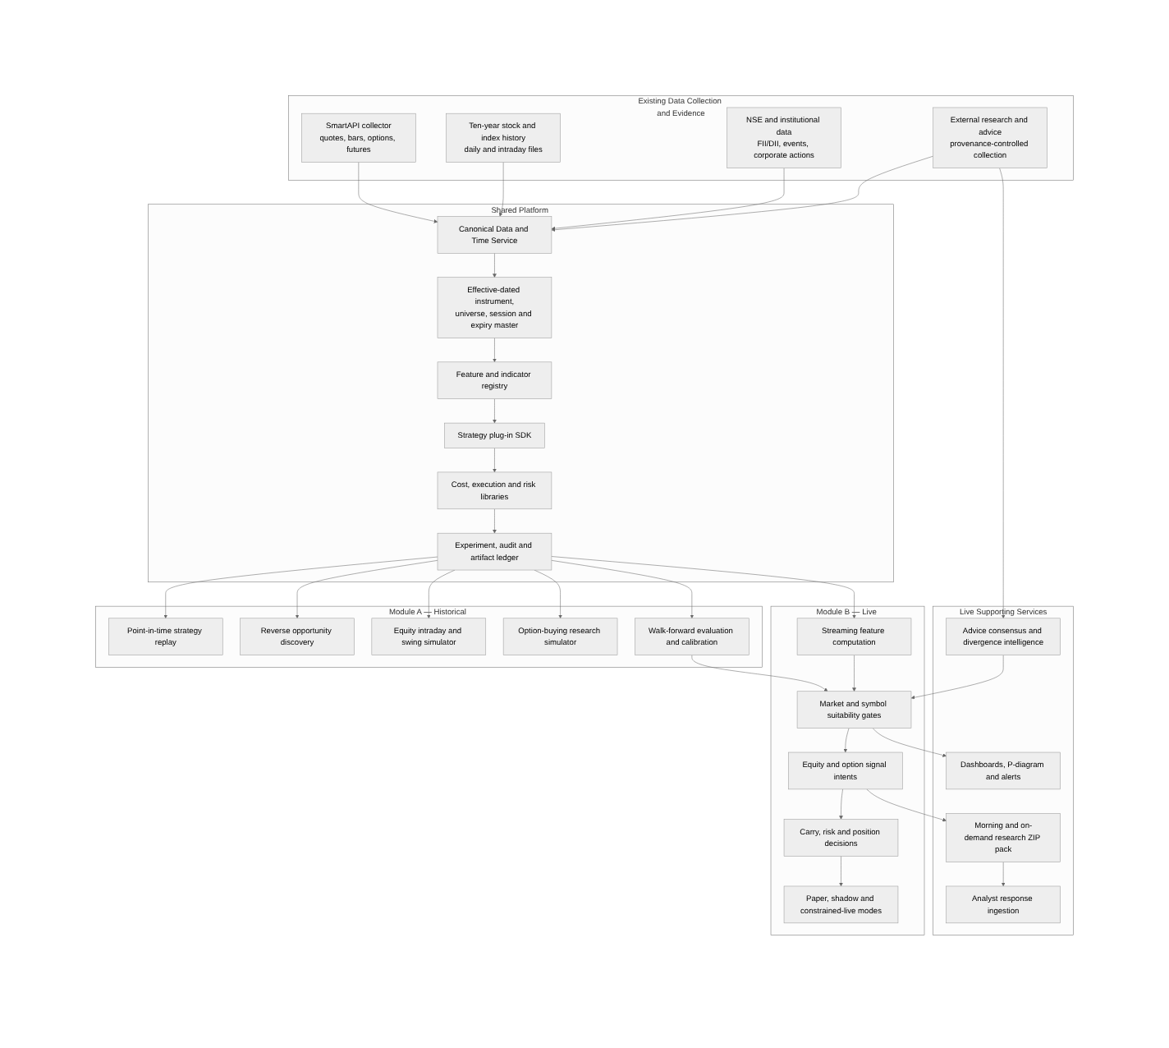
Figure 1: Two-module target architecture with shared platform services

System boundaries
Table 12: System boundaries
Boundary | Owns | Does not own
Existing collector boundary | SmartAPI/API connectivity, subscription management, raw quote/bar/chain capture and current PostgreSQL ingestion. | Strategy interpretation, trade probability, experiment comparison or research-pack generation.
Shared foundation | Canonical time/instrument/data contracts, feature registry, strategy SDK, charges, execution/risk primitives and experiment lineage. | A specific trading thesis.
Historical module | Replay, discovery, optimisation controls, walk-forward evaluation, calibration and research evidence. | Broker order placement.
Live module | Online features, decision gates, signal intents, carry decisions, paper/shadow state and monitoring. | Unapproved autonomous order authority.
Reporting/advice services | Reproducible evidence packaging, analyst response ingestion, source provenance and consensus/divergence. | Overriding hard data/risk gates.

Primary data flow
All sources enter through immutable evidence and are normalised into canonical facts. A feature is computed against an explicit availability timestamp. Strategies consume feature snapshots and emit SignalIntent objects. The execution and risk layers decide whether an intent becomes an OrderIntent, a paper record, a watch state or a rejection. Orders, fills, positions, decisions and outcomes are written as events rather than overwritten states.
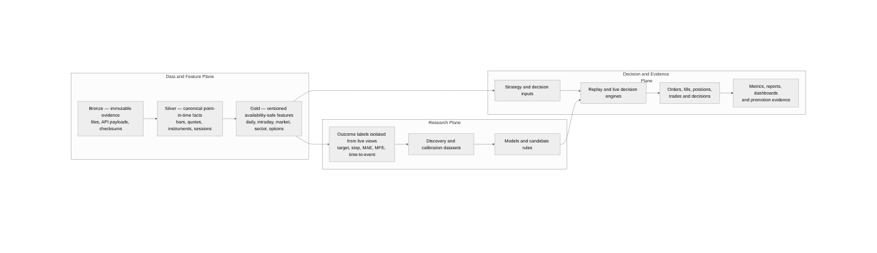
Figure 2: Data, research and decision layers

Shared Platform Foundation

Canonical Data and Time Service
This service is the most important dependency. It makes “what was knowable at time t?” explicit and supplies identical views to historical and live consumers.
Table 13: Canonical time and data requirements
Capability | Required behaviour
Event time and availability time | Store market/event timestamp separately from ingestion and first-available timestamp; strategies query by available_at.
Session phase | Represent PRE_OPEN, CONTINUOUS, CLOSING_AUCTION, EXTENDED_DERIVATIVES, POST_CLOSE, SPECIAL, MOCK and CLOSED.
Trading calendar | Use NSE holidays, special sessions and exchange circular effective dates; never use a generic business-day calendar.
Bar finalisation | Declare whether timestamp is bar start or bar end; do not evaluate a one-minute close before the minute is complete.
Source precedence | Define authoritative source order and reconciliation tolerances when CSV, SmartAPI and NSE facts overlap.
Quality flags | Missing, duplicate, conflicting, out-of-session, stale, corporate-action discontinuity and source-revision flags travel with the data.

Instrument, universe and contract master
A stable internal instrument_id must survive symbol changes, constituent changes, splits and contract expiries. Every strategy run resolves its universe and contracts as of the decision timestamp.
- Equities: instrument_id, symbol/series history, ISIN, listing/removal, sector/industry, NIFTY membership, tick size, price band, CAS eligibility and broker/product eligibility.
- Options/futures: underlying instrument_id, exchange token, contract symbol, instrument type, actual expiry date, strike, right, lot size, tick, quantity freeze, settlement type and active interval.
- Session/expiry rules: retained as reference history; actual contract-master expiry is authoritative over a weekday formula.
- Corporate actions: ex-date, ratio/cash amount, adjustment policy and whether price/quantity/strike/lot histories are raw or adjusted.

Feature and indicator registry
Table 14: Feature registry contract
Registry field | Purpose
feature_id and semantic version | Stable identity; a formula change creates a new version.
input contracts | Required canonical fields, source quality and time resolution.
lookback and warm-up | Minimum observations before the feature is valid.
availability policy | Exact time at which the value can be consumed.
batch implementation and online state | One definition with parity tests, not separately invented calculations.
null/quality behaviour | Whether missing input blocks a trade, uses a fallback or yields an explicit unknown.
code hash and dependency lock | Reproducibility of every run.
golden vectors | Known input/output cases shared across Python, Go and TypeScript consumers.

Cost, execution and risk libraries
The same effective-dated library must price intraday equity, delivery equity, option entry/exit, expiry/exercise and broker-specific operational charges. The target solver finds the minimum valid tick that produces the requested net P&L after charges, slippage and impact; it must not approximate the target using brokerage alone.
- Charge schedule versioned by effective date, exchange, segment, product, side, order count and stock/contract category.
- Statutory rounding rules tested against calculator and actual contract-note examples.
- Execution models from statutory-only through fixed slippage, spread/participation impact and empirical paper/live fills.
- Risk primitives for max loss, exposure, sector concentration, correlated positions, daily loss, capital reserve and carry eligibility.

Experiment and artifact ledger
A run identity is a hash over strategy code/configuration, data snapshot, universe, feature versions, cost profile, execution model, calendar, random seed and scope. Repeating the same identity must either return the existing validated result or reproduce it exactly.
Table 15: Experiment-ledger evidence
Evidence | Examples
Identity | experiment_id, run_id, parent_run_id, strategy_version_id, run_hash.
Software | Git commit, source archive checksum, dependency lock, image digest.
Data | source checksums, canonical snapshot hash, universe hash, calendar/contract version.
Economics | charge schedule, slippage/impact model, capital and risk policy.
Execution | shards, attempts, checkpoints, worker versions, errors and timings.
Outputs | predictions, trades, fills, positions, equity, metrics, charts, reports and comparison artifacts.
Governance | validation status, reviewer, promotion decision, supersession and rollback reason.

Module A — Historical Research and Backtesting

Purpose and submodules
Table 16: Historical module decomposition
Submodule | Responsibility | Primary output
A1 Data qualification and snapshot builder | Profile/import ten-year CSVs and construct immutable point-in-time snapshots. | Qualified data snapshot and exception report.
A2 Declared-strategy replay | Replay a supplied strategy scenario bar by bar. | Validated trades, decisions, equity and metric slices.
A3 Reverse opportunity discovery | Find target opportunities and identify stable pre-entry patterns. | Candidate hypotheses/models, never direct production strategies.
A4 Equity intraday/swing simulator | Model cash, order fills, intraday exits and conditional carry. | Net P&L and capital-occupancy evidence.
A5 Buying-only options simulator | Use actual contract/option bars, expiry, Greeks and premium risk. | Net option results and Greek attribution.
A6 Evaluation and calibration | Walk-forward, regime stress, probability calibration and multiple-testing controls. | Promotion-ready evidence pack.

Declared-strategy replay pipeline
Figure 3 shows the final event-driven path. Vectorised calculations may generate features and candidates, but accepted results come from the event simulator.
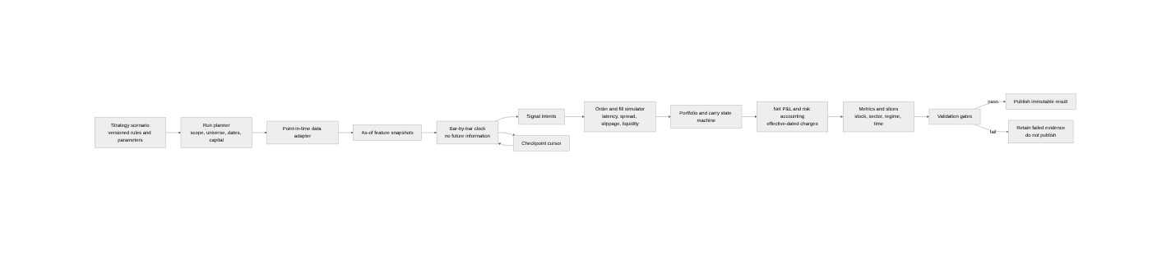
Figure 3: Point-in-time historical strategy replay
The simulator advances a deterministic market clock. At each event it exposes only data with available_at less than or equal to the clock. A signal formed from a completed 10:15 bar can submit no earlier than the configured decision/latency time; it cannot enter at that bar’s favourable low or use that day’s close.

Run request
Table 17: Backtest run request
Request element | Examples
Strategy | strategy_version_id, direction, feature dependencies and parameter set.
Scope | date range, point-in-time NIFTY universe, selected symbols or sector.
Resolution | daily, one minute, derived 5/15/30/60 minutes; explicitly defined bar timestamps.
Capital | starting cash, ₹2 lakh ticket rule, maximum positions and reserve.
Economics | intraday/delivery/options product, charge profile and execution model.
Exit/carry | net target, stop, time barrier, carry review and maximum swing horizon.
Evidence | required metric slices, charts and validation gates.

Resumability and concurrency
A ten-year run is partitioned by strategy version × scenario × date block × symbol bucket. Workers claim shards atomically with PostgreSQL FOR UPDATE SKIP LOCKED, maintain a lease/heartbeat, stage checksummed output and record a cursor. A failed worker requeues only its expired shard.
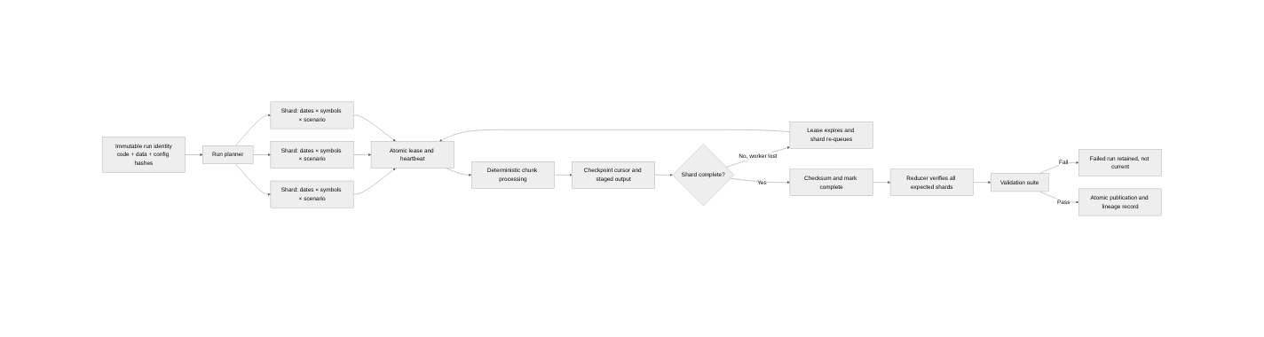
Figure 4: Resumable and deterministic backtest orchestration
Table 18: Backtest run-state model
State | Meaning | Allowed transition
PLANNED | Run identity and expected shards exist. | RUNNING or CANCELLED.
RUNNING | At least one shard is leased. | CHECKPOINTED, FAILED or REDUCING.
CHECKPOINTED | Partial deterministic output is durable. | RUNNING.
REDUCING | All shards complete and aggregate metrics are building. | VALIDATING or FAILED.
VALIDATING | Data, accounting, temporal and statistical checks execute. | VALIDATED or FAILED.
VALIDATED | All mandatory gates pass. | PUBLISHED.
PUBLISHED | Current immutable result is available to readers. | SUPERSEDED, never overwritten.
FAILED | Evidence retained with exact error and completed shards. | RETRY creates a new attempt under the same run identity.

Path and fill semantics
Table 19: Simulation path policies
Issue | Required policy
Target and stop in the same OHLC bar | Use tick/order-book data when available; otherwise publish conservative stop-first and count the ambiguous cases.
Same-bar entry | Disallowed unless a lower-frequency signal is explicitly mapped to a later executable event.
Limit fill | Require price touch plus a stated queue/participation model; do not assume every touched limit fills.
Market fill | Use bid/ask or modelled spread, latency and volume impact; close price alone is not executable evidence.
Missing minute | Block or apply an explicitly versioned policy; never silently forward-fill tradable OHLC.
Corporate action | Apply the registered adjustment and position event before comparing targets/stops.
Open end-of-run position | Retain open with gross and net-liquidation value; do not force a convenient close without a declared rule.

Reverse Opportunity Discovery
Reverse discovery addresses the second backtesting objective: search historical data for movements that could have produced the desired result, then determine which information was observable before those movements. It is a hypothesis-generation system, not proof that the discovered indicators caused the move.
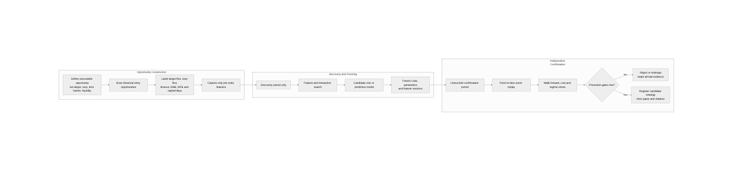
Figure 5: Leakage-controlled reverse opportunity discovery

Executable opportunity labels
Table 20: Opportunity outcome labels
Label | Definition
INTRADAY_TARGET_FIRST | After an executable entry, the path reaches at least ₹500 net before stop and carry cut-off.
INTRADAY_STOP_FIRST | The declared net/risk stop is reached before the intraday target.
INTRADAY_TIMEOUT | Neither target nor stop occurs before cut-off; record net liquidation value.
SWING_TARGET_FIRST | A conditionally carried position reaches at least ₹1,000 net before stop and vertical horizon.
SWING_STOP_FIRST | Carry stop is reached before target.
SWING_TIMEOUT | Position reaches horizon without target or stop; record exit and capital-days.
UNEXECUTABLE | Spread, liquidity, price band, missing data or order model makes the apparent move unavailable.

Each opportunity also stores maximum favourable excursion (MFE), maximum adverse excursion (MAE), time to target, path ambiguity, spread/liquidity state and capital-days. Labels are net of the selected cost and execution profile.

Discovery controls
- Separate chronological discovery, tuning and untouched confirmation periods.
- Create features only from timestamps before entry and purge overlapping labels from validation folds.
- Search for broad stable feature regions and interactions, not one exact threshold that wins in-sample.
- Require a minimum independent sample per stock, regime, time bucket and probability band.
- Record every attempted feature set and parameter configuration so data-snooping risk is measurable.
- Freeze code, parameters and feature versions before confirmation replay.
- Describe outputs as predictive associations or hypotheses unless a separate causal design supports stronger language.

Candidate discovery methods
Table 21: Reverse-discovery methods
Method | Use | Control
Univariate event study | Compare pre-entry distributions for wins, losses and timeouts. | False-discovery correction and effect-size reporting.
Rule search / decision trees | Generate explainable conjunctions such as breadth + residual strength + volume surprise. | Depth/complexity limit and independent confirmation.
Regularised logistic model | Baseline probability of target-first. | Chronological folds, calibration and coefficient stability.
Gradient-boosted trees | Capture nonlinear interactions. | Nested walk-forward, SHAP stability and strict holdout.
Survival / competing-risk model | Estimate time to target versus stop. | Censoring policy and horizon-specific calibration.
Clustering / regime discovery | Identify market states before applying strategy-specific models. | No use of future outcomes in live regime assignment.

Module B — Live Market Intelligence

Live operating model
The live module does not query and recompute ten years of history every minute. It loads a validated prior state, consumes new finalized market events, incrementally updates online features and evaluates only affected candidates. Full historical recomputation remains an offline recovery/verification operation.
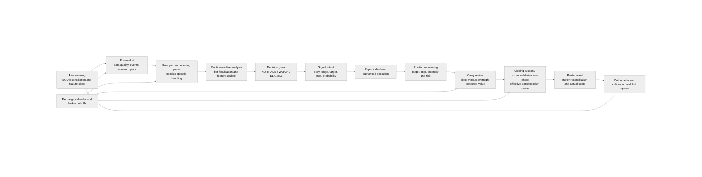
Figure 6: Trading-day operating flow with effective-dated sessions

Effective-dated session profiles
Table 22: Market-session and expiry treatment
Period / product | Required treatment
Historical ten-year replay | Resolve actual session and expiry from the date-specific exchange/contract master. Do not apply current Tuesday expiry backwards.
NIFTY weekly/monthly and stock monthly contracts from the revised regime | Current NSE specifications place NIFTY weekly expiries on Tuesday and stock monthly expiries on the last Tuesday, with previous trading day when Tuesday is a holiday. [E1]
Equity derivatives through 31 July 2026 | Normal close at 15:30 unless a special-session record says otherwise.
Equity derivatives from 3 August 2026 | Normal close scheduled at 15:40 in connection with CAS. [E3]
Cash stocks eligible for CAS | Represent continuous and auction phases separately; do not treat auction indicative prices as ordinary continuous trades.
1 August 2026 | Flag as NSE mock-session evidence, not a normal Saturday trading session.

Immediate collector requirement
Before the next normal session, verify that SmartAPI subscriptions, bar builders, jobs, alerts and database partitions continue through 15:40 for equity derivatives and correctly tag the closing-auction-related period. Any component still assuming 15:30 must fail a pre-market readiness check rather than silently truncate the session.

Live services
Table 23: Live service decomposition
Service | Responsibility | Suggested runtime
live-session-controller | Loads exchange/broker session profile, starts phases, detects special/mock days and publishes clock events. | Go or Python service with PostgreSQL reference tables.
online-feature-service | Maintains rolling windows and emits FeatureSnapshot at minute/bar finalisation. | Python stateful worker; optional Redis only if justified.
market-state-service | Computes NIFTY/sector breadth, VIX, participation, dispersion, concentration and event state. | Python, reusing nse_intraday feature definitions.
symbol-suitability-service | Runs stock/option gates and produces evidence objects. | Python strategy SDK.
decision-policy-service | Combines hard gates, calibrated probability, EV, downside and portfolio policy. | Python; stateless over versioned evidence.
paper-shadow-service | Records would-have-submitted orders, fills, positions and outcomes. | Go execution state machine plus PostgreSQL.
broker-reconciliation-service | Compares requested, accepted, filled, rejected and broker-held states. | Go; required before any constrained live release.
live-monitoring-service | Data lag, drift, stale feature, risk and kill-switch alerts. | Go/Python metrics with API/UI exposure.

Intraday-to-swing carry decision
An intraday trade that has not reached target must not be carried automatically. Failed intraday positions can be adversely selected. At the carry review time, the platform compares the net liquidation value now with the conditional expected value and tail risk of holding overnight.
Table 24: Conditional carry gates
Carry gate | Required evidence
Funding and broker eligibility | Sufficient cash/margin for conversion; product and instrument permitted; broker cut-off not passed.
Position condition | Current net P&L, MAE/MFE, trend integrity, VWAP/market structure and residual strength.
Overnight context | Events, results/corporate action, index/sector regime, global/volatility context and gap-risk model.
Expected value | P(target) × expected win − P(loss) × expected loss − incremental charges − capital-occupancy penalty.
Portfolio risk | Sector/correlation concentration, daily loss, total overnight exposure and available capital.
Decision | CLOSE_NOW, CARRY_APPROVED, CARRY_REJECTED_RISK or MANUAL_REVIEW; every reason logged.

DFSS P-Diagram and Trade-Suitability Decision
The requested qualitative page is implemented as a Design for Six Sigma parameter diagram: the trade-decision function converts a defined input request into a controlled output while control factors are intentionally set and noise factors increase the probability of error states.
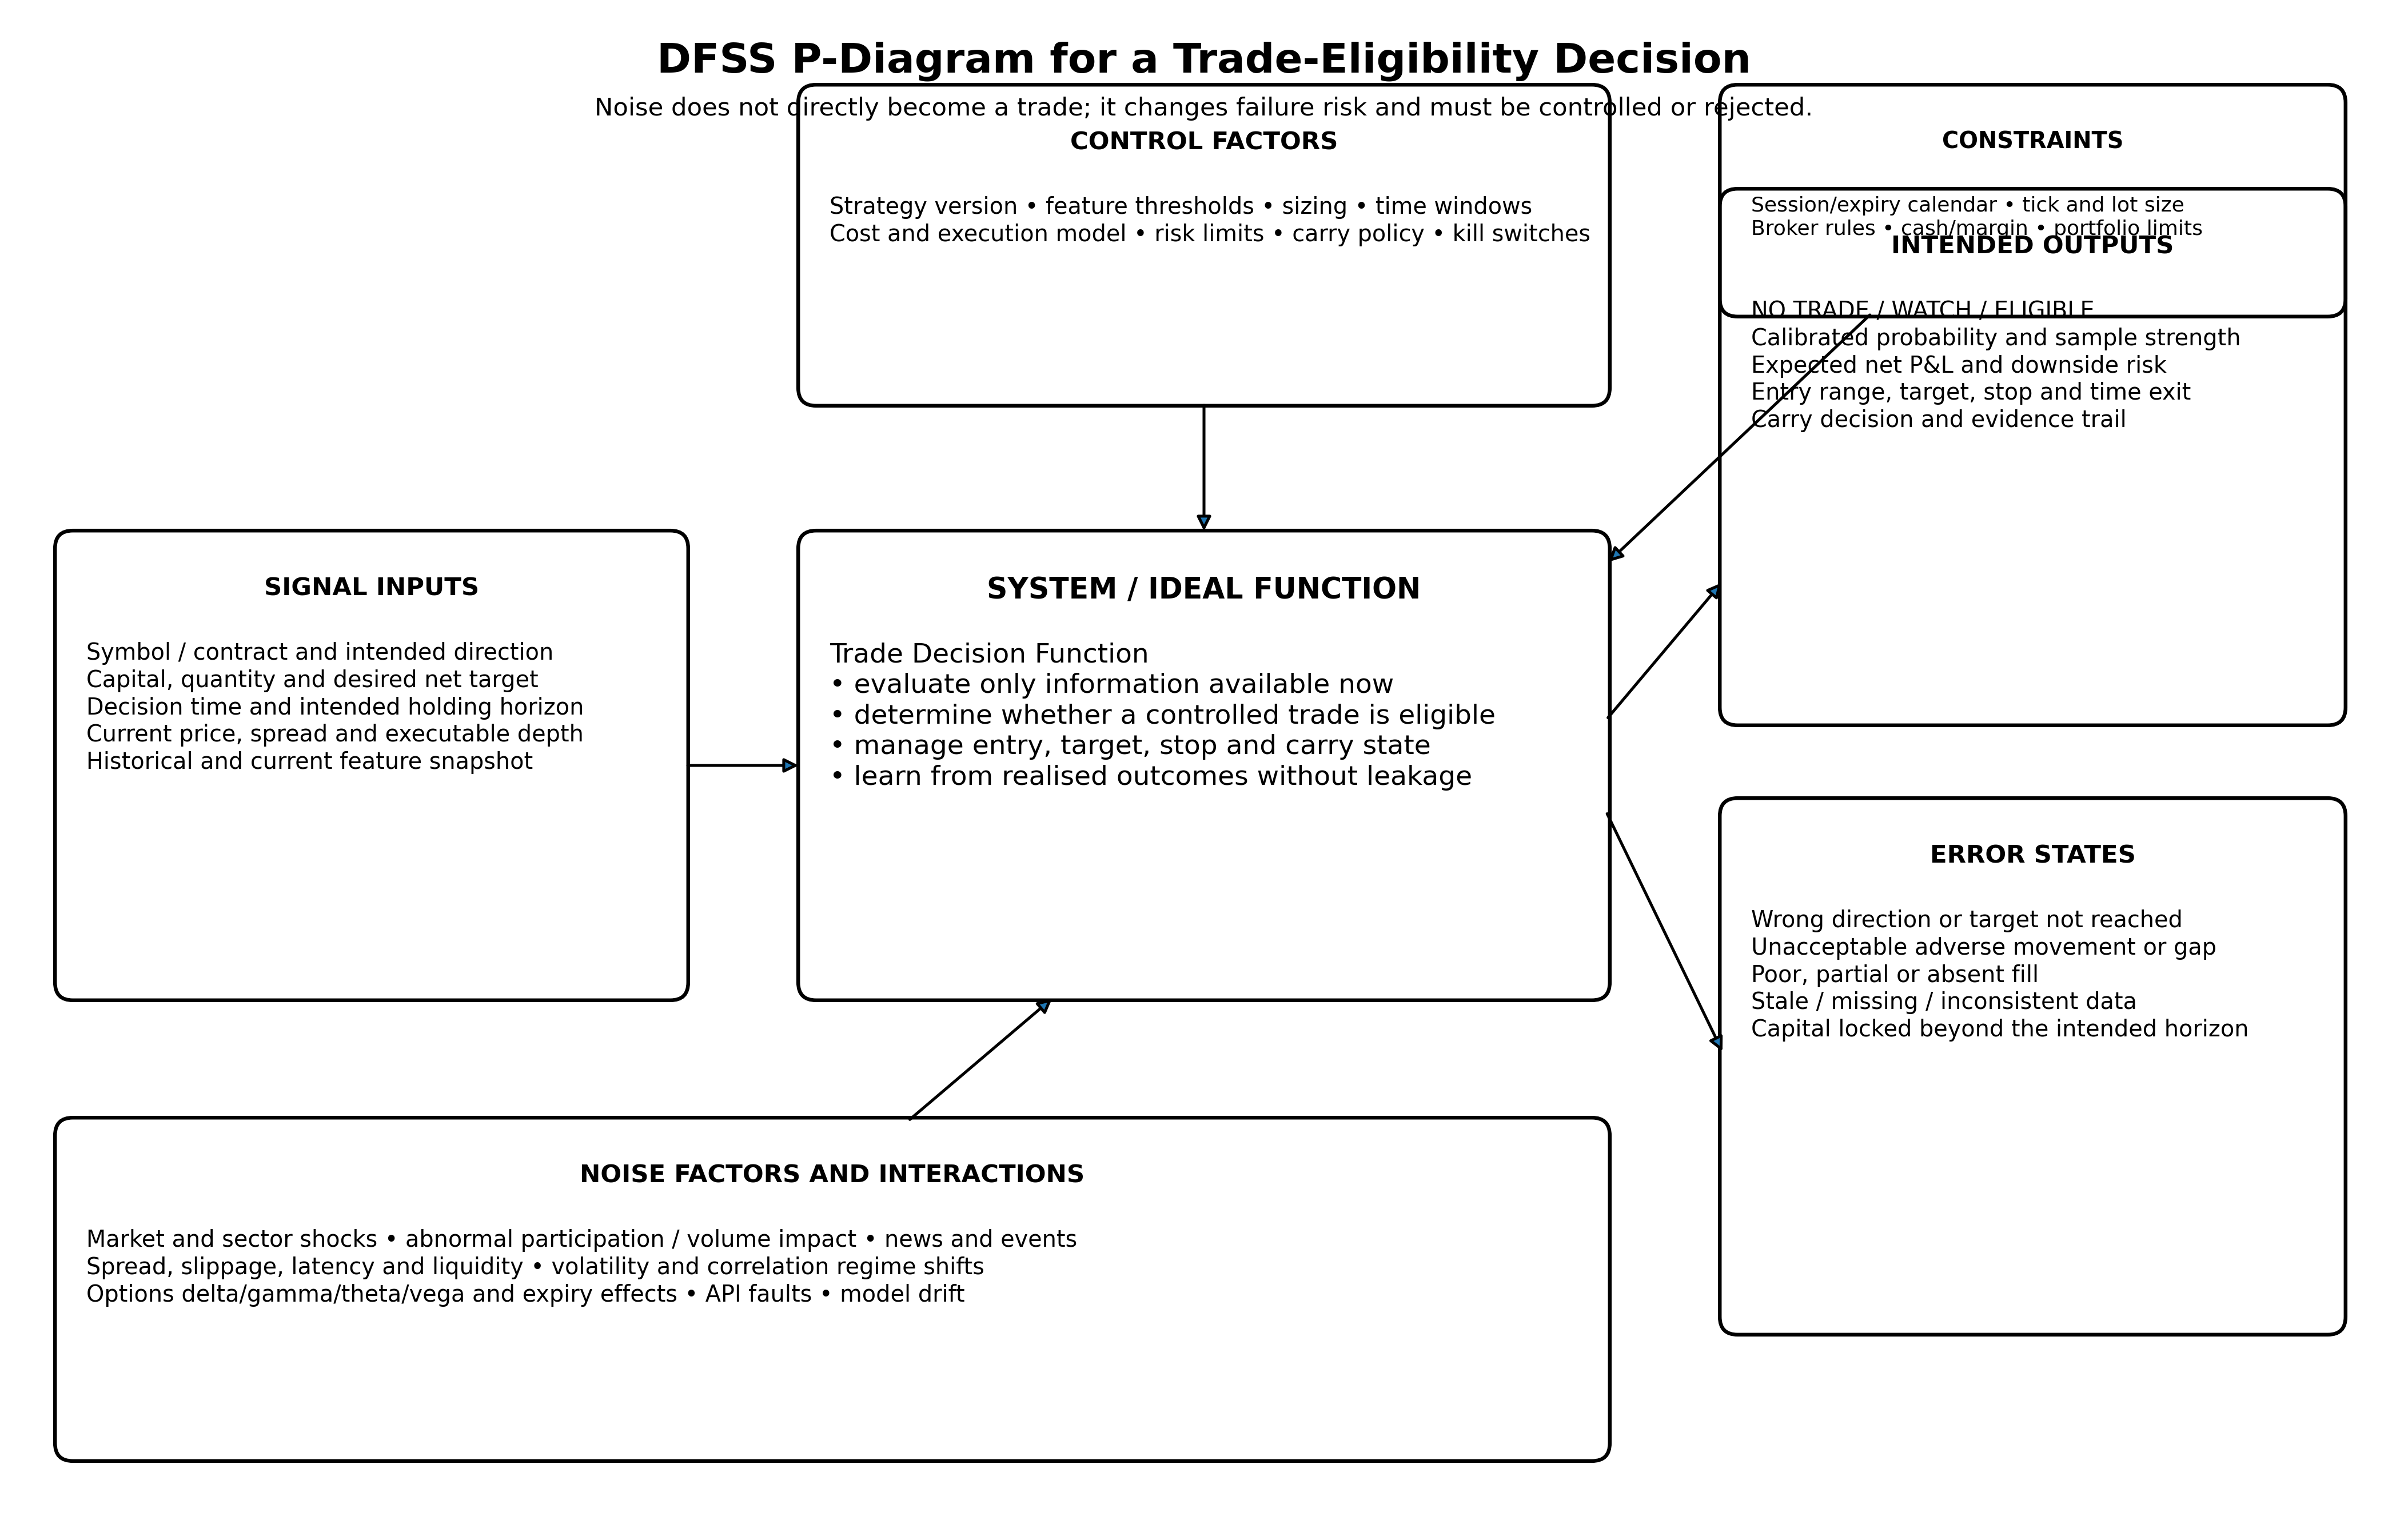
Figure 7: DFSS P-diagram for the trade-eligibility function
The P-diagram is not a decorative dashboard. Each item is a versioned evidence field. The page must show which factors passed, failed, are unknown or are stale; a single composite colour without traceable evidence is insufficient.

Decision taxonomy
Table 25: Trade-decision taxonomy
Decision | Meaning | Permitted action
NO TRADE | One or more hard gates fail or expected value is non-positive. | No order; retain reason and next re-evaluation trigger.
WATCH / MAYBE | No hard failure, but confirmation or sample strength is insufficient. | Monitor; no order until the explicit missing condition changes.
ELIGIBLE / YES | All hard gates pass and strategy-specific probability, EV, downside and portfolio gates pass. | Produce a controlled trade plan; order placement still depends on deployment mode and authorisation.

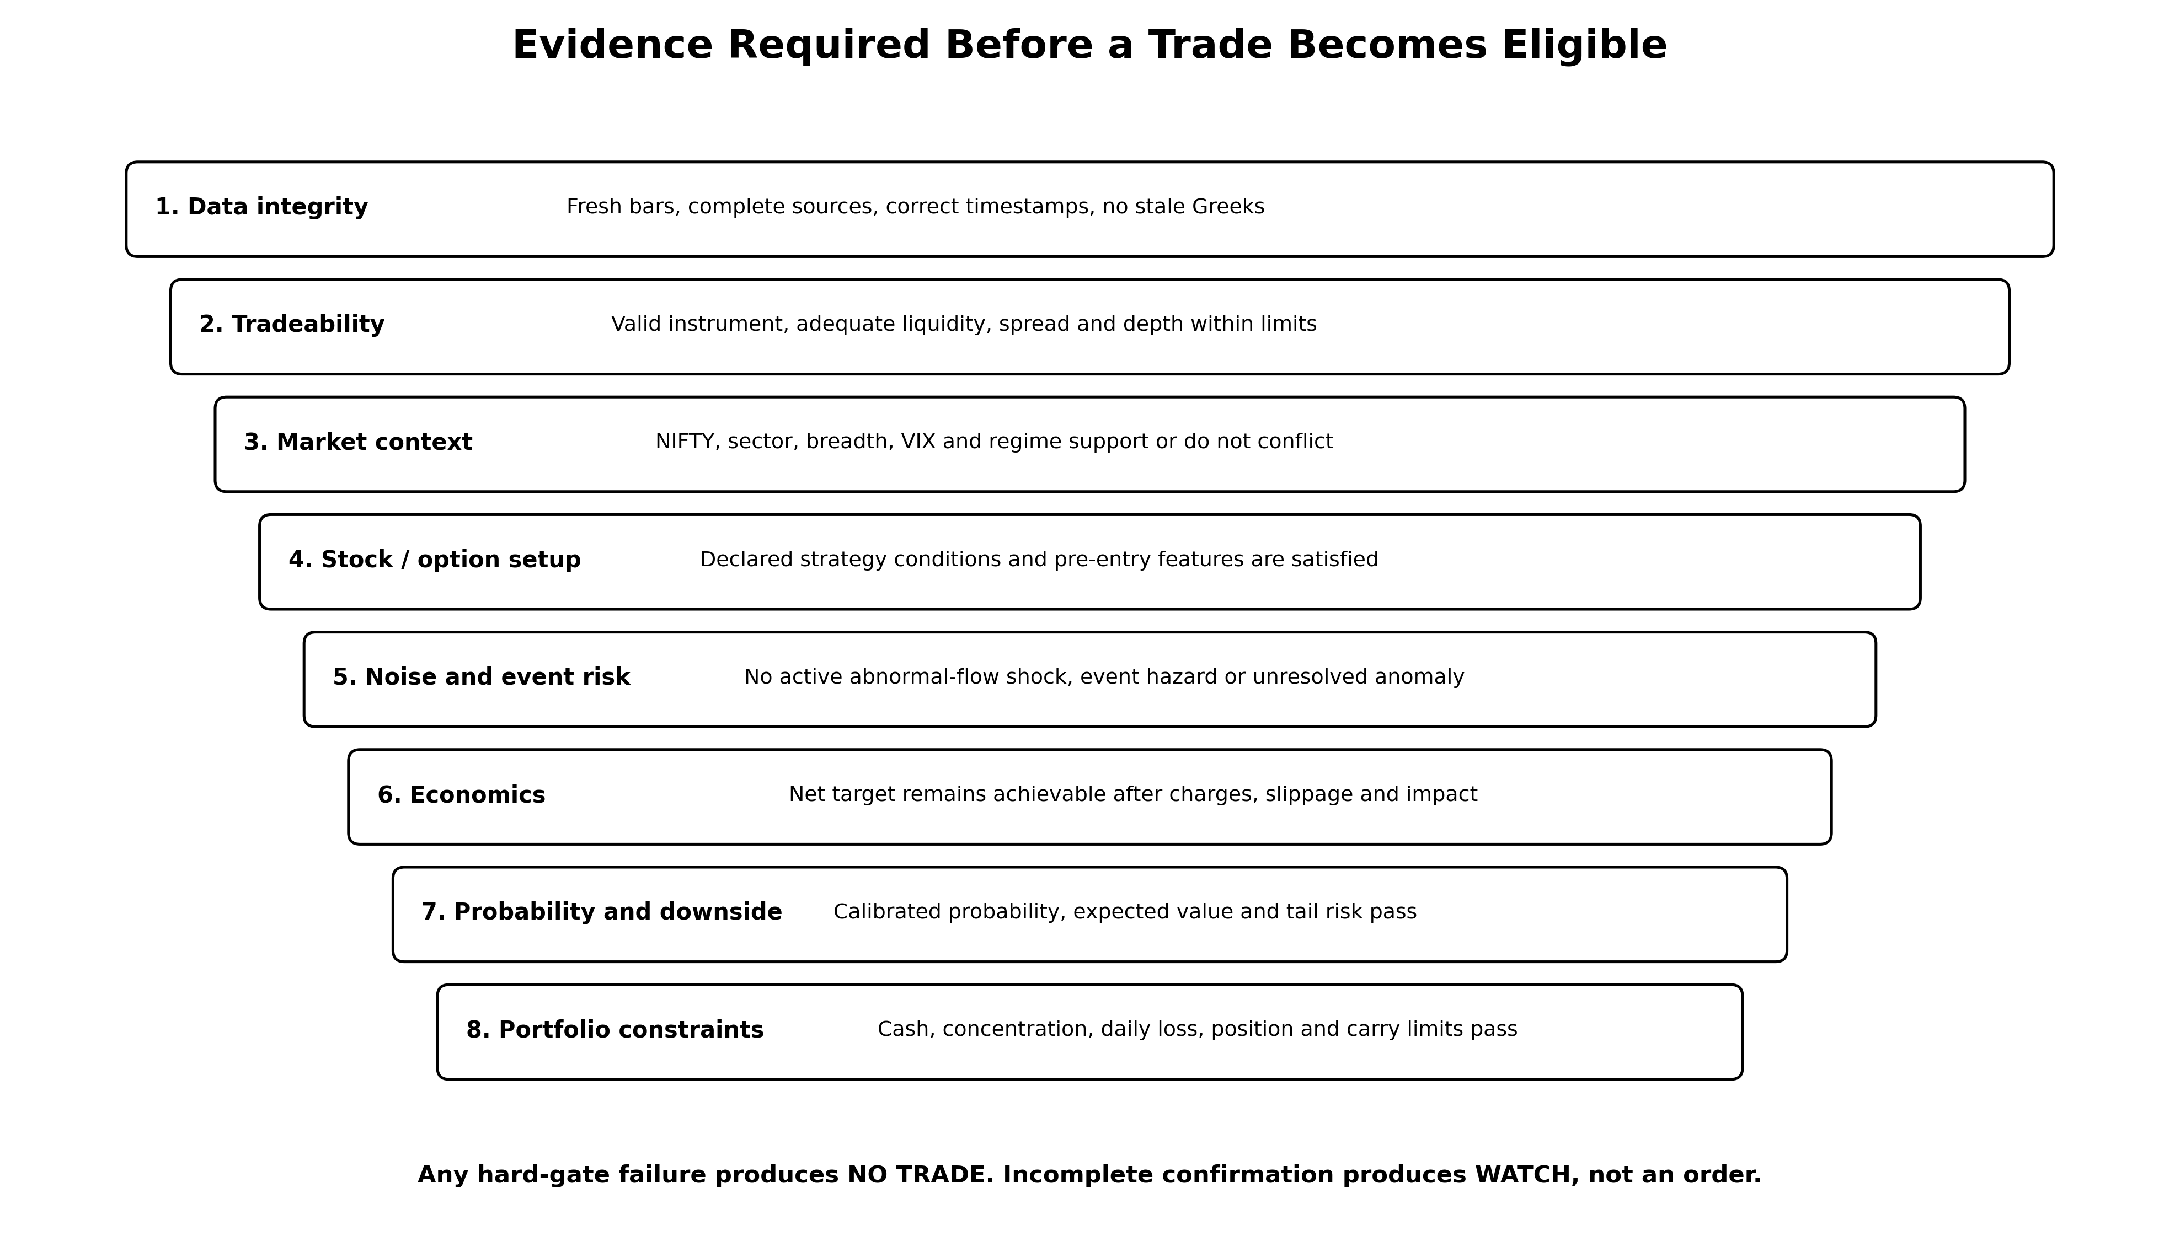
Figure 8: Evidence stack required before a trade is eligible
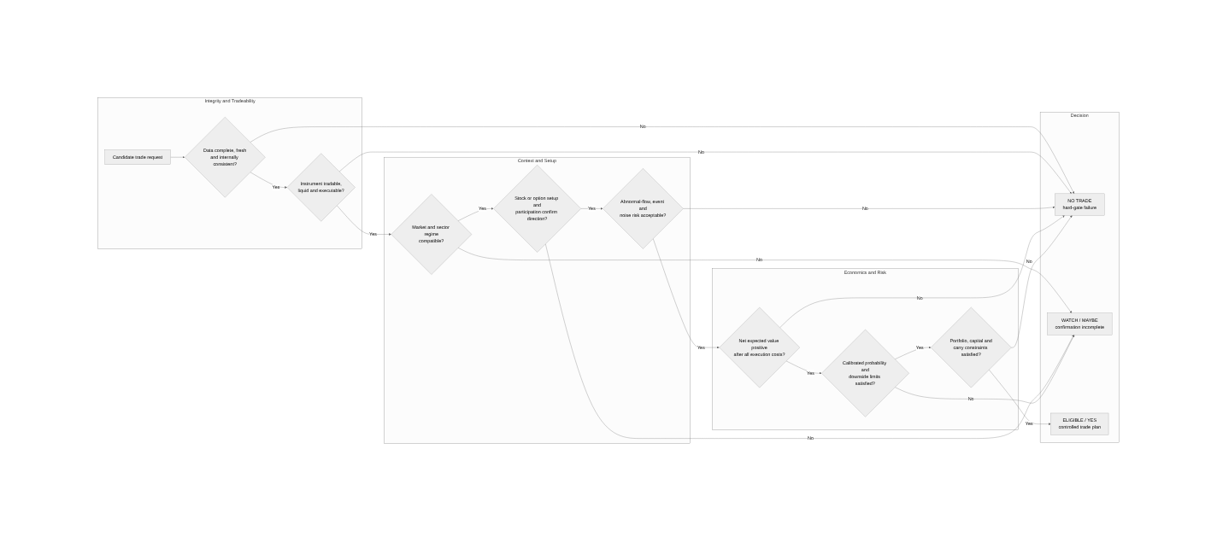
Figure 9: Decision-gate flow for NO TRADE, WATCH and ELIGIBLE outcomes

Market and symbol factor catalogue
Table 26: P-diagram factor catalogue
P-diagram group | Representative factors
Inputs | Symbol/contract, direction, intended capital/quantity, desired net target, horizon, decision timestamp, entry order style.
Control factors | Strategy version, thresholds, time window, sizing, target/stop, carry policy, execution model, cost profile, risk limits and kill switches.
Market noise | NIFTY gap/path, breadth, dispersion, VIX level/change, sector divergence, event shock, foreign flows and index concentration.
Symbol noise | Residual return, beta/correlation, volume surprise, price impact, spread/depth, price-band proximity, news/result/corporate action and surveillance.
Option noise | DTE, delta/gamma/theta/vega, IV rank/skew, OI change, PCR, premium spread, expiry/exercise risk and IV crush.
System noise | Source lag, missing bars, stale Greeks, token changes, network/API errors, clock drift, duplicate events and model drift.
Error states | Wrong direction, target miss, stop/gap loss, poor/no fill, stale-data decision, capital lock, unauthorised carry and unreconciled position.
Outputs | Decision class, p(target), expected net P&L, downside/tail estimate, entry range, target, stop, time exit, carry plan and evidence IDs.

Abnormal participation and operator-like movement
The system should not claim to identify a specific “operator” from market data. It can detect abnormal participation, price impact and liquidity shocks that are consistent with concentrated or informed flow. The state model should be EMERGING, ACTIVE_SHOCK, POST_SHOCK_UNSTABLE, STABILISING or NORMAL.
Table 27: Abnormal-participation evidence
Signal | Examples | Decision use
Volume anomaly | Minute volume z-score, cumulative volume versus expected profile, turnover burst. | Raise shock probability and execution impact estimate.
Price impact | Residual return per unit volume, range expansion, gap through liquidity, close-location quality. | Distinguish ordinary volume from directional impact.
Order-book/liquidity | Spread widening, depth depletion, imbalance and repeated sweeps where depth is available. | Block or reduce size when fill risk is unacceptable.
Cross-sectional concentration | NIFTY top-ten concentration, sector breadth collapse, one-stock residual shock. | Identify narrow leadership or index distortion.
Derivative confirmation | Futures basis/OI change, option OI migration, skew/PCR and IV jump. | Assess whether cash move is confirmed, hedged or contradicted.
Aftershock behaviour | Reversal, repeated burst, failed breakout and volatility decay after the first shock. | Do not assume “the shock has happened, therefore it is safe”; require a stabilisation gate.

Research Reporting and Analyst Exchange

Morning and on-demand research packager
The reporting module creates an immutable, point-in-time evidence package for a selected stock or option candidate. It must be reproducible from a pack_id and must not expose database credentials or uncontrolled dumps.
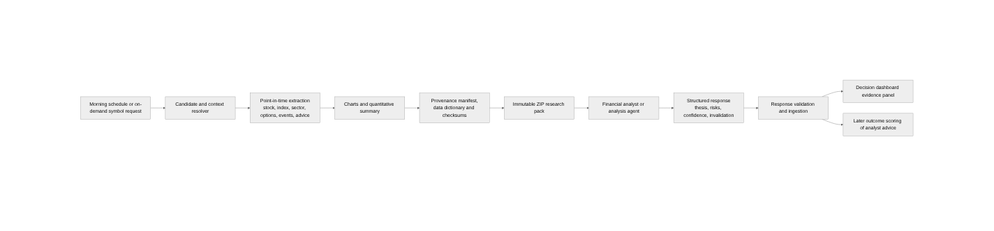
Figure 10: Research ZIP pack and analyst-response workflow
Table 28: Research ZIP package contents
Path in ZIP | Contents
manifest.json | pack_id, as_of timestamp, symbol/contract IDs, data/run versions, file hashes and quality status.
summary.md | Plain-language candidate summary, market suitability, hypotheses, risks and unresolved questions.
data_dictionary.md | Field definitions, units, timestamps, availability and quality flags.
data/prices_daily.csv | Qualified daily OHLCV, delivery, corporate-action and 52-week context.
data/prices_intraday.csv | Recent minute bars and derived intervals, explicitly timestamped.
data/features.csv | Daily/intraday feature snapshot and historical percentiles.
data/market_sector.csv | NIFTY, sector, breadth, VIX, beta/correlation and relative-return context.
data/options.csv | Selected contracts, chain, OI/PCR, IV/Greeks, spread and DTE where valid.
data/events_and_advice.jsonl | Time-stamped events, announcements and external claims with source provenance.
charts/ | Price/volume, relative strength, event window, option surface and P-diagram evidence.
provenance/source_manifest.csv | Source URI/name, checksum, first-available timestamp, parser and query identity.
checksums.sha256 | Integrity of every packaged file.
analyst_brief.md | Requested questions and response schema.

Analyst response contract
Table 29: Analyst response schema
Field | Required content
response_id / pack_id | Trace the response to the exact evidence pack.
thesis | BULLISH, BEARISH, NEUTRAL or INSUFFICIENT_EVIDENCE with horizon.
entry conditions | Conditions, not a hindsight price.
target / stop / invalidation | Gross and net basis plus time horizon.
key supporting evidence | Feature and source IDs used.
risks and contrary evidence | Mandatory; absence is a validation warning.
confidence | Analyst-stated score kept separate from platform-calibrated probability.
signature and timestamp | Human/agent identity, model/version where applicable, and completion time.

External advice and research intelligence
External recommendations, articles and financial advice can provide event context and consensus, but they are noisy, duplicated and horizon-dependent. The collection module therefore stores the original document and extraction provenance before creating claims.
Table 30: Advice-intelligence components
Component | Responsibility
Source registry | Publisher, URL pattern, licence/terms status, collection method, rate limit and trust notes.
Document store | Raw page/document hash, publication time, collection time and parser version.
Claim extractor | Entity, stance, target/horizon, rationale, cited event and quoted/derived status.
Deduplicator | Group syndicated or copied claims to avoid false consensus.
Source scorecard | Historical directional accuracy, calibration, timeliness, revision behaviour and sample size.
Consensus engine | Agreement, disagreement, surprise and change in stance by stock/horizon.
Decision adapter | Provides evidence and uncertainty to the suitability gates; never bypasses hard quality/risk gates.

Data and PostgreSQL Architecture

Use of the existing PostgreSQL estate
The existing tradingdb remains the authoritative operational and audit database. New schemas should be introduced in the same estate, with explicit ownership and read-only adapters over existing facts. Large historical matrices may be materialised in partitioned PostgreSQL tables initially and optionally cached as Parquet after benchmark evidence; the application contract remains unchanged.
Table 31: Proposed PostgreSQL bounded schemas
Schema / bounded context | Principal tables or responsibilities | Writer
catalog | instrument_history, universe_membership, market_session, contract_history, data_snapshot, feature_definition, strategy, strategy_version, cost_profile, execution_model. | Data Foundation / Governance.
research | experiment, run, run_shard, opportunity_label, prediction, metric, metric_slice, artifact, promotion_decision. | Historical and Discovery services.
simulation | order_event, fill, position_event, trade, equity_point, skipped_intent, carry_decision. | Event simulator.
live_intel | decision_snapshot, market_gate_result, symbol_gate_result, signal_intent, risk_state, model_monitor, kill_switch_event. | Live intelligence services.
reporting | research_pack, pack_file, analyst_response, response_evaluation. | Reporting service.
advice | source, document, claim, claim_entity, consensus_snapshot, source_score. | Advice ingestion service.
ops | job/run/step, quality results, watermarks, alerts, service health, retention actions. | Platform operations.
existing nse / nse_app / nse_intraday / public | Retained as source/legacy result schemas through governed views while migration occurs. | Existing collectors/workers.

Core new entities
Table 32: Core entity catalogue
Entity | Minimum key fields | Purpose
catalog.market_session | exchange, segment, trade_date, phase, start_ts, end_ts, session_kind, effective_source. | Correct historical/live clocks and mock/special exclusion.
catalog.data_snapshot | snapshot_id, source manifests, checksum, as_of, quality_status. | Immutable input identity.
research.run | run_id/hash, experiment, strategy version, data snapshot, config, status, validation. | Reproducible experiment identity.
research.run_shard | run_id, strategy/scenario, date block, symbol bucket, lease, cursor, checksum. | Restart and concurrency.
research.opportunity_label | instrument, entry_ts, horizon, barrier outcomes, MAE/MFE, execution profile. | Reverse discovery without mixing labels into live features.
live_intel.decision_snapshot | decision_id, as_of, target request, gate results, p/EV/risk, decision and reasons. | Every live NO/MAYBE/YES decision.
simulation.order_event | order_intent_id, event sequence, price/qty, state, broker/paper IDs. | Event-sourced order lifecycle.
reporting.research_pack | pack_id, as_of, subject, manifest hash, status, path. | Reproducible analyst exchange.

Retention and backup
Table 33: Retention and recovery policy
Class | Policy
Raw source evidence | Immutable; retain checksum/version. Storage tiering is allowed, deletion requires an approved retention decision.
Canonical market facts | Retain for research horizon; corrections create source versions rather than silent replacement.
Feature matrices | Retain definitions indefinitely; materialisations may be rebuilt and can use tiered retention if source/version remains reproducible.
Runs and decisions | Retain all validated, failed, rejected and live decisions indefinitely for governance and multiple-testing evidence.
Operational debug logs | Time-limited, e.g. 90–180 days, while error summaries and audit events remain.
Backup | PostgreSQL point-in-time recovery, daily backup, encrypted local secondary copy of critical artifacts, and quarterly restore tests.

Feature, Indicator and Strategy Plug-in Architecture

Strategy contract
A strategy produces intents; it does not directly mutate cash, insert arbitrary database rows or place broker orders. This keeps research logic independent from execution and allows the same plug-in to run in historical and live contexts.
class Strategy(Protocol):
manifest: StrategyManifest
def required_features(self) -> set[FeatureRef]: ...
def on_bar(
self,
context: StrategyContext,
features: FeatureSnapshot,
) -> Sequence[SignalIntent]: ...
def on_timer(
self,
context: StrategyContext,
event: TimerEvent,
) -> Sequence[SignalIntent]: ...
Table 34: SignalIntent contract
SignalIntent field | Meaning
strategy_version_id | Immutable source of the decision.
as_of / decision_ts | Time the strategy formed the intent.
instrument / direction | Stable instrument identity and BUY_CALL / BUY_PUT / BUY_EQUITY intent.
entry policy | Market/limit/stop intent, valid time and acceptable range.
target objective | Net target profile and solver version.
risk policy | Stop, time barrier, max adverse risk and carry policy.
evidence | Feature snapshot IDs, rules satisfied and model prediction ID.
idempotency key | Prevents duplicate processing.

Strategy manifest
strategy_id: equity_residual_breakout
version: 1.0.0
instrument_scope: [NIFTY50_EQUITY]
bar_intervals: [1m, 1d]
required_features:
- residual_return_15m@2
- cum_volume_vs_profile@1
- breadth_above_vwap_pct@1
- daily_rsi_14@3
entry_windows:
- start: "09:35"
end: "14:45"
position_policy: long_equity_intraday_with_conditional_carry
risk_policy_id: eq_2l_v1
cost_profile_id: zerodha_equity_effective
execution_model_id: empirical_liquidity_v1
minimum_warmup: 60d
owner: team-backtest
status: draft
The manifest is validated before registration. Any change to rule semantics, required features, cost/execution assumptions or risk treatment creates a new strategy version; dashboard labels must never collapse materially different versions into one result.

Shared contracts and contract tests
Table 35: Shared contract-test matrix
Contract | Consumers | Required tests
Bar / Quote / Depth | Collector, feature, backtest and live services. | Timestamp, timezone, OHLC validity, sequence/idempotency and sample serialisation.
FeatureSnapshot | Feature, strategy, reporting and UI. | Version, availability, null/quality and batch-online parity.
SignalIntent / OrderIntent | Strategy, policy, paper and Go execution gateway. | Schema compatibility, deterministic idempotency and rejection reasons.
CostBreakdown | Backtest, live, reporting and reconciliation. | Golden contract-note and target-solver vectors.
DecisionSnapshot | Live policy, UI, reporting and audit. | Every gate present; reason codes and evidence IDs resolvable.
RunManifest | Orchestrator, workers, reducer and API. | Hash stability, resumability and read compatibility.

Equity Execution, Net Targets and Carry Economics

Target-price solver
For an actual filled quantity Q and average entry price Pₑ, the exit target is the smallest valid exchange tick Pₓ such that net profit is at least the configured target after buy costs, sell costs, slippage and impact. The solver is numerical because several charges depend on exit turnover and rounding.
NetPnL(Px) = Q × (Px − Pe)
− BuyCharges(Pe, Q, product, date)
− SellCharges(Px, Q, product, date)
− SlippageAndImpact(entry, exit)
TargetPrice = first_valid_tick(Px) where NetPnL(Px) >= target_rupees
The existing buildEquityScenarioMeta approximation and duplicated Go/Python fee functions are replaced by this one effective-dated engine. Annual income tax remains a separate portfolio/year estimate and is not silently mixed into a live transaction target.

Execution model hierarchy
Table 36: Execution model hierarchy
Model | Use
E0 Statutory-only | Sanity check; no claim of live realism.
E1 Fixed slippage | Initial sensitivity bands such as 1, 2.5 and 5 basis points per side.
E2 Spread-aware | Uses bid/ask or a spread model by symbol/time/volatility.
E3 Liquidity/participation | Adds volume participation, depth and price-impact constraints.
E4 Empirical | Estimated from paper/live decision-to-fill evidence.
E5 Stress | Shock spread, latency, partial fill and reduced liquidity.

Portfolio accounting
- Reserve full cash for every position eligible to carry; a leverage-only test may not assume free conversion to delivery.
- Track available and committed cash, market value, gross unrealised P&L and net-liquidation P&L separately.
- Enforce position-count, sector/correlation, daily-loss and overnight-risk limits.
- Log every skipped intent with a reason code, including insufficient cash, duplicate position, stale data, risk limit or broker restriction.
- Compare carry policies on identical entries; report incremental net P&L and capital-days.

Buying-Only Options Research and Live Intelligence

Scope and terminology
The first options scope permits premium-paid positions only: long call, long put, long straddle and long strangle, plus rule variants that only buy legs. Strategies containing a short option leg require a separate risk architecture and are excluded from the first release.
For an option, delta—not beta—is the primary first-order sensitivity to its underlying. Gamma is the curvature of that sensitivity. The platform may also use the underlying stock’s beta to NIFTY as context, but it must not substitute beta for option delta.
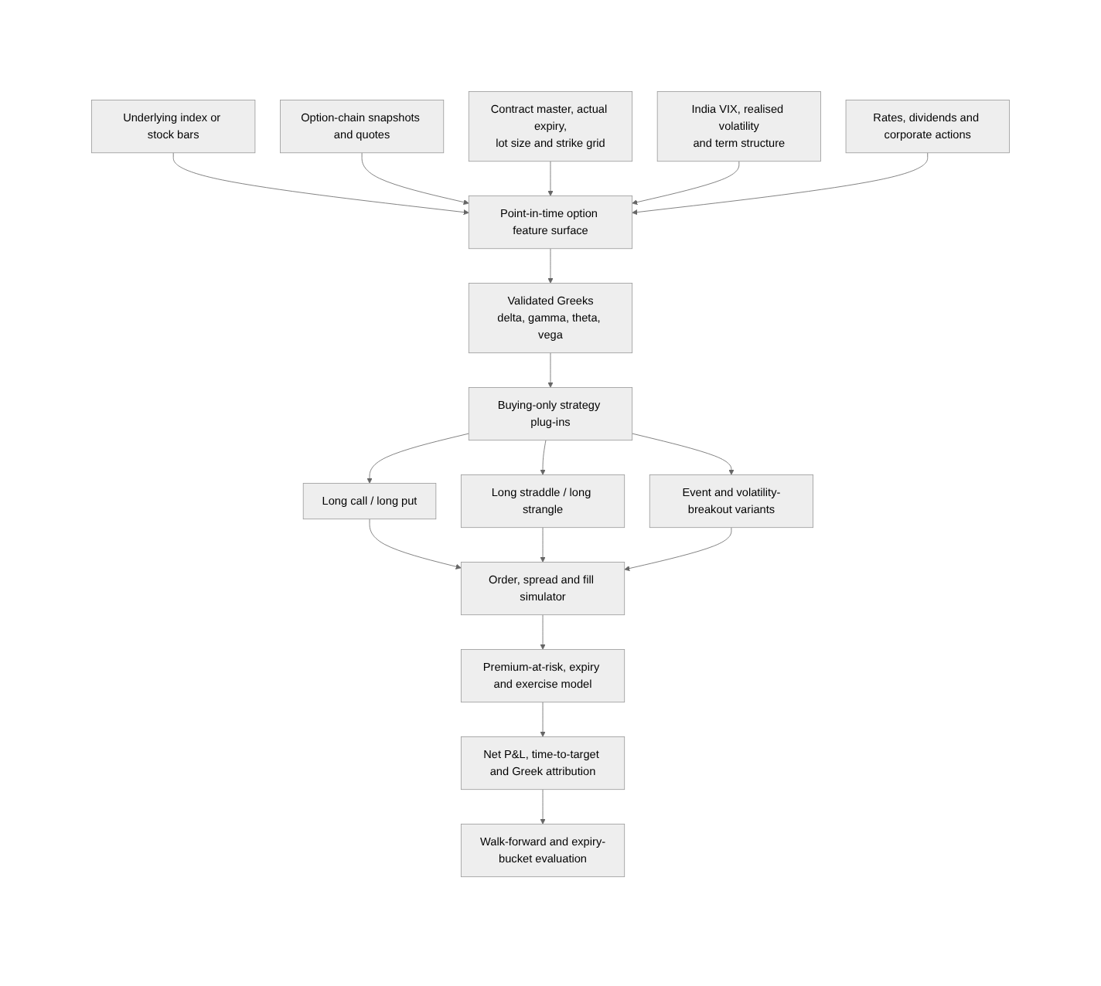
Figure 11: Buying-only options research architecture

Greek and volatility features
Approximate option P&L attribution:
ΔV ≈ Delta × ΔS + 0.5 × Gamma × (ΔS)^2
+ Vega × ΔIV + Theta × Δt
Effective directional notional ≈ Delta × UnderlyingPrice × Quantity
Table 37: Options feature groups
Feature family | Required fields and use
Contract and expiry | Actual expiry, DTE in trading/calendar time, strike distance, lot/tick and settlement/exercise treatment.
Underlying | Spot/future path, beta/correlation, realised volatility, trend, breadth and event context.
Premium microstructure | Bid, ask, spread, depth, volume, OI, quote age and execution capacity.
Volatility | IV, IV rank/percentile, skew, term structure, VIX and realised-implied spread.
Greeks | Delta, gamma, theta, vega and quality/freshness; recompute or block when stale.
Positioning | OI change by strike, PCR, max-pain distance and futures basis—used as context, not deterministic truth.

Options strategy families
Table 38: Buying-only option strategy families
Strategy | Entry hypothesis | Principal failure mode
Directional long call | Bullish underlying setup with sufficient delta and expected movement exceeding premium decay/cost. | Wrong direction, IV crush or theta.
Directional long put | Bearish underlying setup with sufficient delta and expected movement exceeding premium decay/cost. | Reversal, IV crush or theta.
Long straddle | Expected realised move exceeds combined premium and costs; direction unknown. | Move too small or IV collapses.
Long strangle | Cheaper convex exposure to a larger move. | Both options decay with no sufficiently large move.
Event/expiry gamma variant | Short DTE only when event/flow evidence supports a move large enough to compensate extreme theta and spread. | Rapid premium loss, exercise/settlement and illiquidity.

Historical options limitation and backfill
Confirmed limitation
The supplied PostgreSQL audit supports recent option-chain, OI, PCR and Greeks data, not a complete ten-year option surface. Equity/index research can use the ten-year files after qualification; ten-year options conclusions require a separate contract-wise historical backfill with actual contracts, premiums, volumes and expiries. Until then, options models must state the shorter evidence window and wider uncertainty.

- Backfill contract masters and contract-wise price/volume for every date, preserving actual expiry rules and lot changes.
- Validate underlying-option timestamp alignment and stale/no-trade bars.
- Recompute Greeks from point-in-time spot/future, rates, dividends and IV only when inputs are valid; store model/version and residual error.
- Model expiry exercise/settlement and current transaction treatment separately from ordinary sell exits.
- Evaluate by DTE/expiry bucket, strike distance, IV regime, time of day and liquidity—not only aggregate win rate.

Probability, Evaluation and Strategy Governance

Probability definitions
P_intraday = P(net P&L >= ₹500 before carry cut-off | information available at t)
P_swing = P(net P&L >= ₹1,000 before swing horizon
| information available at carry review and position not closed intraday)
The live decision should also expose expected net P&L, probability of stop, expected shortfall, expected time to target, timeout probability and capital-days. Probability alone does not describe payoff asymmetry.

Calibration and evidence
Table 39: Probability-calibration evidence
Measure | Interpretation
Reliability curve | Observed target rate in each forecast band.
Brier score | Mean squared probability error; lower is better.
Log loss | Penalises confident wrong forecasts.
Calibration intercept/slope | Detects systematic over/under-confidence.
Expected calibration error | Weighted difference between predicted and observed bands.
Sample size and interval | Prevents a small 70% bucket from appearing equivalent to a large one.
Economic calibration | Observed average net P&L and downside within probability bands.

Validation design
- Expanding and rolling chronological walk-forward evaluation.
- Purging and embargo where target/holding windows overlap.
- An untouched final out-of-time holdout that is not repeatedly inspected during development.
- Regime stress periods from the supplied 2016–2026 event study, including policy, credit, pandemic, election, war, tariff and oil shocks. [S7]
- Leave-one-stock, leave-one-sector and leave-one-period sensitivity.
- Cost, spread, latency and liquidity stress.
- Parameter-neighbourhood stability rather than selection of one isolated optimum.
- Multiple-testing evidence, including the number of trials and appropriate backtest-overfitting/deflated-performance methods.

Metric catalogue
Table 40: Mandatory metric groups
Category | Required metrics
Economics | Gross/net P&L, charges, slippage, expectancy, median, payoff ratio, profit factor and net rupees per capital-day.
Risk | MAE, maximum drawdown, drawdown duration, expected shortfall, gap loss, daily loss and concentration.
Target-specific | ₹500 intraday hit rate/time, carry rate, ₹1,000 swing hit rate/time, incremental carry value and capital lock.
Execution | Fill rate, partial fill, decision-to-fill latency, spread, impact, rejection and capacity curve.
Probability | Brier/log loss, calibration, confidence intervals and sample by bucket.
Stability | Rolling expectancy, period/stock/sector contribution, parameter surface and out-of-sample degradation.
Operations | Data lag/completeness, run time, restart count, parity failures, reconciliation breaks and alert latency.

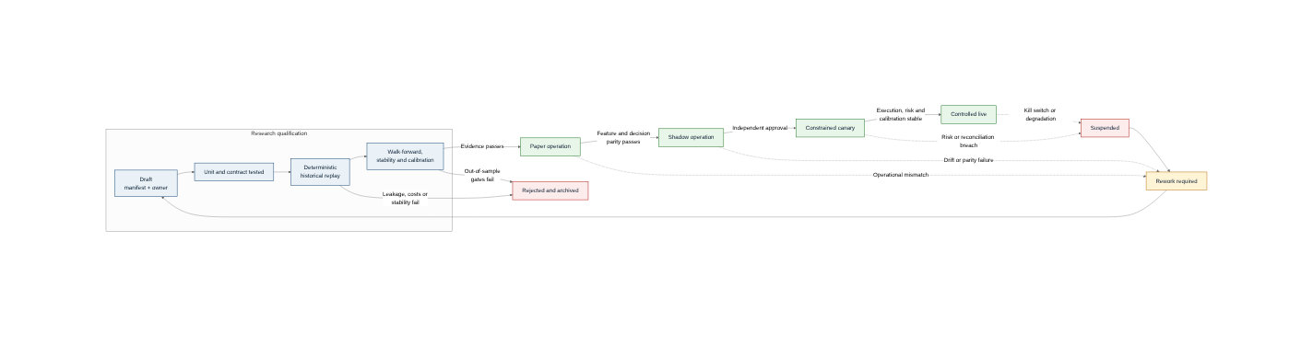
Figure 12: Strategy promotion, suspension and rework lifecycle

Application Programming Interfaces and User Interface

API design
Table 41: API bounded contexts
API group | Representative endpoints
Catalog | GET /instruments/{id}/history, /sessions/{date}, /features, /strategies/{version}.
Research | POST /experiments, POST /runs, GET /runs/{id}, /metrics, /artifacts, /compare.
Discovery | POST /opportunity-scans, GET /candidates/{id}, POST /candidates/{id}/freeze.
Live | GET /market/state, /symbols/{id}/suitability, /decisions/{id}, /positions, /risk.
Options | GET /options/surface, /contracts, /greeks, /strategies/results.
Reporting | POST /research-packs, GET /research-packs/{id}, POST /analyst-responses.
Advice | GET /claims, /consensus, /sources/{id}/scorecard.
Operations | GET /health, /quality, /watermarks, /jobs and POST /kill-switch subject to role.

Dashboard information architecture
Table 42: Dashboard page catalogue
Page | Purpose | Must show
Market Readiness | Is the session safe and data ready? | Session phase, collector/feature lag, missing sources, mock/special status, VIX/breadth/regime and hard blocks.
P-Diagram Decision | Should this specific trade be considered? | Inputs, controls, noise, constraints, error risk, all gates, NO/WATCH/ELIGIBLE, p/EV/downside and reasons.
Candidate Explorer | Compare stocks/options and supporting evidence. | Rank, regime, setup, anomaly, liquidity, advice consensus and historical comparable cases.
Strategy Lab | Create and run new strategy versions. | Manifest, parameters, data scope, run progress/checkpoints, validation and comparison.
Opportunity Discovery | Review mined patterns without confusing them with confirmed strategies. | Discovery/confirmation split, feature effects, stability and candidate status.
Backtest Results | Definitive economic and statistical evidence. | Net equity/drawdown, trades, costs, slices, calibration, ambiguity and run lineage.
Options Intelligence | Contract and premium context. | Expiry/DTE, IV/Greeks, chain/OI/PCR, spread, strategy payoff and freshness.
Positions and Carry | Monitor open positions and decisions. | Net-liquidation P&L, target/stop, carry EV, capital, cut-off and reconciliation.
Research Packs and Advice | Manage external analysis evidence. | Pack status/hash, analyst response, claims, consensus, source score and later outcome.
Operations | Maintain service reliability. | Jobs, QC, source watermarks, alerts, schema/data versions, backups and kill switches.

Multi-Developer and Coding-Agent Engineering Model
The platform is expected to be developed by several people and coding agents concurrently. Separation therefore needs to be enforceable through repositories, schemas, contracts and tests—not only through a diagram.
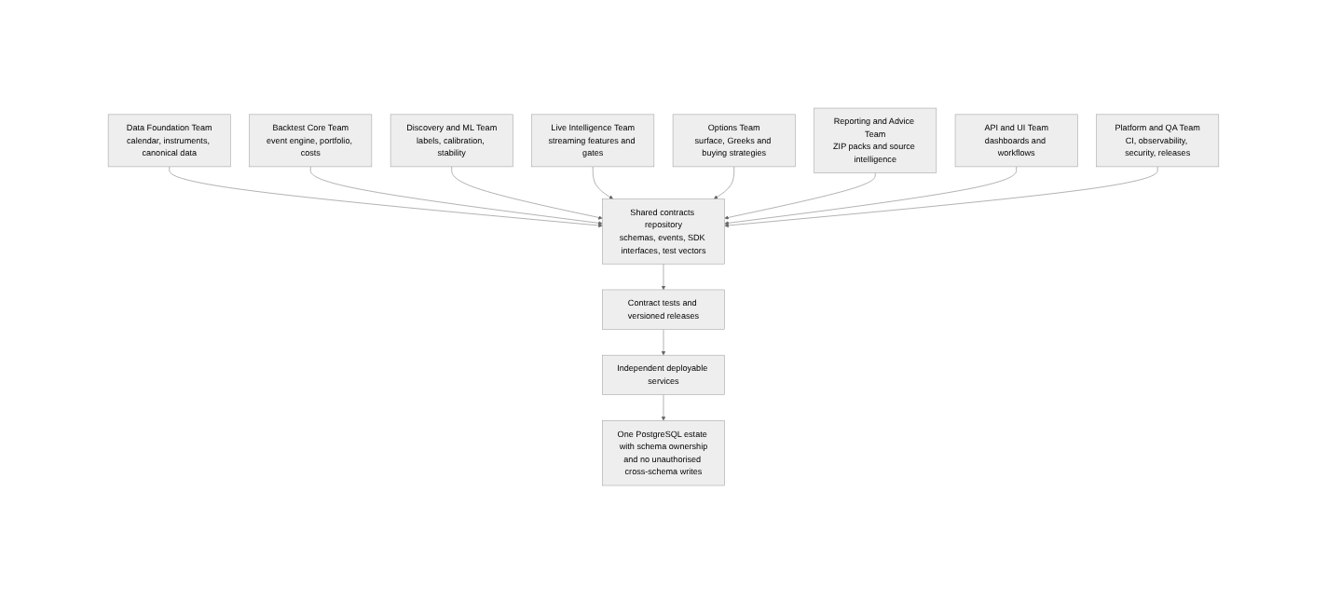
Figure 13: Parallel team boundaries and shared-contract dependency

Recommended repository structure
trading-platform/
contracts/ # JSON Schema / Protobuf / OpenAPI and golden vectors
libs/
market-calendar/
instrument-master/
cost-engine/
feature-sdk/
strategy-sdk/
execution-simulator/
risk-policy/
services/
data-qualification/
backtest-orchestrator/
backtest-worker/
opportunity-discovery/
online-feature-service/
live-decision-service/
options-intelligence/
research-packager/
advice-ingestor/
results-api/
apps/web/
db/migrations/ # schema-owned migrations only
docs/
adr/ data-contracts/ strategies/ runbooks/ test-evidence/
tests/
unit/ property/ golden/ integration/ parity/ failure/

Work ownership
Table 43: Parallel workstream ownership
Team / workstream | Owns | Key dependency
Data Foundation | Qualification, canonical adapters, calendars, instruments, sessions and source manifests. | Existing collector/database and exchange reference data.
Backtest Core | Event clock, order/fill simulation, portfolio, costs, shards and reducer. | Contracts and canonical data.
Discovery and ML | Opportunity labels, feature research, walk-forward, calibration and model registry. | Backtest Core and feature registry.
Live Intelligence | Online features, market/symbol gates, decision policy, carry and monitoring. | Parity-certified features and registered strategies.
Options | Contract history, surface/Greeks, option simulators and buying-only strategies. | Instrument master and recent/historical options data.
Reporting and Advice | ZIP packs, analyst response, source registry, claims and scorecards. | Canonical data, decisions and storage.
API and UI | OpenAPI implementation, dashboards, access control and user workflows. | Versioned contracts only.
Platform and QA | CI/CD, environments, observability, security, backup, load/failure testing and release gates. | All workstreams.

Engineering governance
- One main branch with short-lived feature branches, mandatory code review and CODEOWNERS by bounded context.
- Architecture Decision Records for changes to contracts, strategy semantics, costs, market calendar, risk or storage.
- Schema migration ownership: a service may write only its schema; cross-context reads use approved views/APIs.
- Consumer-driven contract tests run before merging producer changes.
- Every strategy and feature has an owner, version, changelog, tests, assumptions and retirement status.
- No coding agent may modify another module’s contract without an explicit change proposal and compatibility tests.
- Generated reports, test evidence and migration plans are committed or attached to the relevant release artifact.

Non-Functional Requirements, Security and Operations
Table 44: Non-functional requirements
Quality attribute | Recommended requirement / acceptance basis
Correctness | No future data access; point-in-time universe/contract/session; exact accounting identity; failed validation cannot publish.
Determinism | Same run identity and deterministic seed produce the same checksummed outputs.
Restartability | A killed worker resumes from the last durable shard checkpoint without recomputing completed shards.
Performance | Establish a benchmark suite; provisional target is a ten-year NIFTY 50 one-minute single-strategy run within 30 minutes on the agreed reference host after caching, without sacrificing event semantics.
Live latency | Provisional targets: finalised one-minute bar visible within 5 seconds, feature/decision within 15 seconds, with explicit stale thresholds.
Availability | Live decision support degrades to NO TRADE on missing critical data; it does not use stale values silently.
Scalability | Independent worker pools for strategies/scenarios and independent live services; no unbounded full-table polling.
Observability | Structured logs, metrics, traces, run/job IDs, data watermarks, lag, quality and reason-coded alerts.
Security | Service accounts with least privilege, secrets outside code/ZIPs, TLS, RBAC, audit events and controlled export.
Recovery | PITR, daily backup, encrypted secondary artifact copy and quarterly restore evidence.
Maintainability | Versioned contracts, plug-in SDKs, ADRs, runbooks, code owners and automated documentation.

Failure and degraded-operation policy
Table 45: Failure and degraded-operation behaviour
Failure | System behaviour
SmartAPI lag or disconnect | Mark affected sources stale; block dependent strategies; collector retries independently.
Missing index/sector context | Block strategies declaring it mandatory; other strategies receive explicit unknown.
Stale option Greeks | Recompute from valid inputs or block option eligibility; never carry forward silently.
PostgreSQL read pressure | Use replicas/caches where approved; queue research runs rather than degrade live writes.
Worker crash | Lease expiry, checkpoint recovery and idempotent output.
Broker mismatch | Freeze new live intents, alert and reconcile; paper/research may continue.
Model drift/calibration failure | Demote to WATCH/paper, suspend promotion and retain evidence.
Market shock / circuit / price band | Activate risk state, cancel or block according to policy, and log manual intervention.
Unknown session rule | Fail closed and require session-master update.

Testing, Validation and Acceptance

Test layers
Table 46: Test architecture
Layer | Examples
Unit | Indicators, rolling state, Greeks, target solver, charges, rounding and risk rules.
Property | OHLC invariants, accounting conservation, no negative quantity/cash, monotonic target solver and idempotency.
Golden | Known strategy decisions and trade results on fixed miniature market sequences.
Temporal/leakage | Feature available_at, next-bar execution, no same-bar future high/low and isolated forward labels.
Data quality | Duplicate/missing minutes, out-of-session/mock data, time zones, symbol changes and corporate actions.
Integration | PostgreSQL migrations, run/shard state, API contracts, pack generation and analyst-response ingestion.
Batch-online parity | Historical and online feature values for the same event stream match within declared tolerance.
Failure/restart | Kill workers/services at each state; verify checkpoint, lease, idempotency and no partial publication.
Statistical | Walk-forward, calibration, multiple testing, regime stress and sample adequacy.
Paper/live reconciliation | Decision, submitted order, broker acknowledgement, fill, position and contract-note charges reconcile.
Security/operations | RBAC, secret leakage, export safety, backup/restore, load and alert drills.

Release gates
Table 47: Release promotion gates
Gate | Evidence required
Historical engine ready | Golden trades pass; no-look-ahead suite passes; fees reconcile; deterministic rerun and restart proven.
Discovery ready | Labels net of costs; discovery/confirmation separation; trial ledger complete; stability report generated.
Live shadow ready | Online feature parity, session service, data freshness gates, decision logs and broker-free shadow operation pass.
Paper ready | Order/fill state, capital/carry, reconciliation and actual slippage capture pass.
Canary live ready | Independent risk approval, kill switch, constrained capital/universe, monitoring and rollback runbook.
General live ready | Sustained execution/calibration/reconciliation evidence and change-control approval.

Stepwise Implementation Roadmap

Implementation waves
Table 48: Implementation roadmap
Wave | Work packages | Parallelism and exit condition
Wave 0 — Freeze and qualify | WP0 source/code freeze; WP1 live session/CAS/expiry correction; WP2 data profiling; WP3 cost and target solver. | Data/source manifests, immediate 15:40 readiness, known defects quarantined, cost golden tests pass.
Wave 1 — Shared foundation | WP4 canonical contracts/time/instruments; WP5 feature registry/parity; WP6 strategy SDK; WP7 experiment/run/shard ledger. | One reference strategy can run deterministically over a qualified small period.
Wave 2 — Historical replay | WP8 event simulator; WP9 portfolio/carry; WP10 metrics/reporting; WP11 ten-year import/acceleration. | Reference equity strategy completes ten-year replay, restarts and publishes only after validation.
Wave 3 — Reverse discovery and options | WP12 opportunity labels/discovery; WP13 calibration; WP14 option contract history/Greeks; WP15 buying-only option simulator. | One discovered candidate passes untouched confirmation; options evidence states valid coverage.
Wave 4 — Live intelligence | WP16 online features; WP17 P-diagram/gates; WP18 paper/shadow; WP19 broker reconciliation and risk. | Historical/live parity and a complete paper session pass.
Wave 5 — Reporting and productisation | WP20 ZIP pack; WP21 analyst response; WP22 advice intelligence; WP23 API/UI; WP24 operations/security. | End-to-end candidate-to-pack-to-response-to-decision workflow and operational acceptance.
Wave 6 — Controlled deployment | WP25 canary strategy, calibration/drift monitoring and champion/challenger governance. | Independent approval and sustained constrained-live evidence.

First vertical slice
The first implementation should prove the architecture rather than maximise strategy complexity:
- Qualify a small but representative equity/index dataset covering normal, volatile and event sessions.
- Implement the effective-dated session/expiry service, complete fee engine and ₹500/₹1,000 target solver.
- Port one simple reference equity strategy to the plug-in SDK, preserving next-bar execution and explicit target/stop/time/carry rules.
- Run it through the event simulator with finite ₹2 lakh tickets, hard data/risk gates and resumable shards.
- Generate trades, net equity, metric slices, P-diagram evidence and an immutable research pack.
- Replay the same market stream through the online feature/decision service and prove parity.
- Run paper/shadow for a defined period before introducing additional strategies.

Dependencies and sequencing
Table 49: Principal implementation dependencies
Work package | Cannot complete before | May proceed in parallel with
Backtest event simulator | Canonical event/time contracts and cost engine. | Data qualification and UI wireframes.
Reverse discovery | Qualified data, labels and replay semantics. | Live service scaffolding after contracts freeze.
Options simulator | Historical contract master, premium bars and option charge/exercise model. | Equity simulator and reporting.
Live decision policy | Online feature parity and registered strategy contract. | Reporting/advice services.
Canary live | Paper/shadow, broker reconciliation, risk approval and kill-switch drills. | Additional research strategies remain in lower stages.

Risks, Constraints and Open Decisions
Table 50: Principal risk register
Risk | Impact | Mitigation / decision
Historical file quality unknown | False signals, missing sessions or corporate-action discontinuities. | Mandatory qualification/quarantine and overlapping-source reconciliation.
Options history too short | Overconfident expiry/Greek conclusions. | Backfill actual contracts or explicitly restrict evidence window and deployment.
Market-structure change | Truncated sessions and wrong exits, especially from 3 August 2026. | Effective-dated session master and pre-market source verification.
Overfitting from many strategies | Best historical result may be luck. | Complete trial ledger, untouched holdout, stability and multiple-testing controls.
Execution edge smaller than friction | ₹500 target consumed by spread/slippage. | Empirical execution models, capacity gates and net-target solver.
Automatic carry adverse selection | Losing intraday positions become overnight risk. | Compare force-close versus conditional carry and enforce EV/risk gates.
External advice quality/licensing | Misleading consensus or compliance exposure. | Provenance, deduplication, terms review and no direct trade authority.
Concurrent developers diverge | Duplicate indicator/cost logic and incompatible schemas. | Shared contracts, ownership, ADRs, contract tests and schema boundaries.
Operational DB overload | Research scans affect collector/live writes. | Query budgets, partitioning, replicas and optional immutable columnar cache.
Broker/API outage or mismatch | Unmanaged or duplicate positions. | Idempotency, reconciliation, fail-closed policy and kill switch.

Decisions requiring confirmation during implementation
Table 51: Open implementation decisions
Decision | Recommended default | Confirmation owner
Reference compute host and performance target | Benchmark on the actual PostgreSQL/server hardware; retain the provisional 30-minute ten-year target until measured. | Platform owner.
Historical source precedence | NSE/verified source over community CSV where conflicts exist; retain both versions. | Data owner.
Initial equity universe | Point-in-time NIFTY 50 plus explicit liquidity/eligibility filters. | Product and risk owner.
Swing maximum horizon and stop | Test 1/3/5/10 sessions with explicit risk; do not assume one value. | Quant/risk owner.
Broker cut-offs after CAS go-live | Load from broker configuration and verify daily; never rely on a static document. | Execution owner.
Options backfill source/licence | Use authoritative contract-wise data with reproducible files and permitted use. | Data/compliance owner.
Live order authority | Default paper/shadow; constrained live only under separate approval. | Business/risk owner.

Conclusion and Recommended Next Action
The correct next step is not another strategy-specific script. It is a reference implementation of the shared foundation and one end-to-end vertical slice. Once that slice proves point-in-time correctness, exact economics, restartability, historical/live parity and auditability, every additional strategy becomes a small controlled plug-in rather than a new project.
The two primary modules must remain separately scalable: historical replay/discovery can consume large compute and run for hours, while the live module must remain lightweight, fail closed and operate from current state. Their outputs remain comparable because both use the same contracts, features, costs, strategy versions, execution semantics and metrics.
Recommended programme decision
Approve the architecture as the target baseline; immediately implement the effective-dated session/expiry correction and data qualification; then build the shared cost/time/feature/strategy contracts before assigning parallel teams to replay, discovery, options, live intelligence, reporting and UI work.

Appendices

Existing Code Reuse and Disposition Map
Table 52: Detailed existing-code disposition
Existing path / component | Disposition | Target use
backtesting/internal/backtest/history.go | Reuse and refactor. | Date-range orchestration and calendar query pattern; replace all-or-nothing day loop with run shards.
backtesting/internal/backtest/archive_runner.go | Reuse and harden. | CSV discovery/parser foundation behind qualification and source manifests.
backtesting/internal/backtest/strategy_backtest.go::simulateStrategyTrades | Reuse pattern. | Next-bar-open decision semantics and explicit stop-first ordering; move into canonical simulator.
backtesting/internal/backtest/a02.go::evaluateExit | Quarantine. | Uses day close in entry price and same-bar path, causing look-ahead.
backtesting/internal/backtest/options_backtest.go | Refactor substantially. | Actual contract/bar selection retained; add point-in-time contracts, costs, fills, Greeks and immutable versions.
returns_performance/.../backtest_transaction_charges.go | Replace with canonical package. | Current sell-side STT/intraday-like function is incomplete for delivery/options/effective dates.
nifty_backtesting_worker.py feature/candidate/template/replay layers | Reuse architecture. | Best existing separation between signals, theoretical paths and finite-capital replay.
nifty_backtesting_worker.py current-member query | Replace. | Use effective-dated universe to remove survivorship bias.
nifty_backtesting_worker.py _delivery_charge_breakdown | Replace. | Remove dynamic import and silent hard-coded fallback.
nifty_backtesting_worker.py _publish_batch | Fix immediately. | Failed validation must not publish or supersede last-good data.
indicator_strategy_registry.yml | Promote to formal manifest. | Versioned strategy/indicator documentation and configuration.
paper.go | Reuse evidence/idempotency concepts. | Integrate with common order/fill/position event state machine.
analytics TypeScript routes | Reuse and adapt. | Foundation for market, FII, events, leadership, options and quality APIs.
nse_app / nse_intraday / nse_ops tables | Retain and migrate through views. | Source features, results and operations during transition.

Historical Data Qualification Checklist
Table 53: Ten-year historical data qualification protocol
Check | Acceptance
File identity | Path, source, SHA-256, size, parser version and source licence/use note recorded.
Schema | Columns/types/header/decimal/time format detected and mapped; unknown variants quarantined.
Coverage | Minimum/maximum timestamp and rows per session/symbol reported.
Timezone and bar convention | IST/UTC and bar-start/bar-end verified by overlapping source comparisons.
Session validity | No unlabelled weekend, holiday, mock, Muhurat or out-of-session bars.
Duplicates/conflicts | Exact duplicates deduplicated by policy; conflicting OHLC rows retained as exceptions.
Missing minutes | Expected versus observed grid; missing runs and market-wide versus symbol-specific gaps.
OHLC/volume validity | Low ≤ open/close ≤ high; non-negative prices/volume; volume semantics known.
Corporate actions | Splits/bonuses/dividends/symbol changes identified; raw and adjusted policies documented.
Universe history | Membership resolved as of each date; removed constituents remain available.
Overlap reconciliation | CSV versus SmartAPI/PostgreSQL/NSE differences quantified.
Quality decision | QUALIFIED, QUALIFIED_WITH_FLAGS or QUARANTINED with reason and reviewer.

Detailed Success Criteria
Table 54: Detailed platform success criteria
Area | Success criterion
Architecture | Historical and live modules deploy independently and communicate only through versioned contracts.
Data | Every trade decision resolves to source snapshot, quality result, session phase and instrument/universe version.
Temporal correctness | Automated tests prove no feature/order uses information after decision time.
Market rules | Historical expiries/session profiles reproduce actual date-specific rules; 1 August mock and 3 August 2026 changes are correctly represented.
Costs | Golden equity/delivery/options examples and actual contract notes reconcile to the agreed rounding tolerance.
Target solver | Minimum valid tick always meets or exceeds configured net target under the chosen execution profile.
Determinism | Repeated run with identical hash produces identical trade/metric/artifact checksums.
Restart | Forced worker termination resumes the shard without duplicate trades or loss of completed output.
Publication | A failed mandatory validation cannot become current; last-good result remains available.
Parity | Batch and online feature/decision outputs match within declared numerical tolerance on replayed events.
Probability | All displayed probabilities have out-of-sample reliability, sample size and calibration evidence.
Equity policy | Force-close, always-carry and conditional-carry results are separately measurable; carry requires funding and risk approval.
Options | Every result uses actual contract, expiry, lot, premium and stated fill/cost model; stale Greeks block eligibility.
P-diagram | Every NO/WATCH/ELIGIBLE state exposes gate values, unknowns, stale inputs and reason codes.
Reporting | A research ZIP is reproducible by pack_id, contains checksums/data dictionary/provenance and no secrets.
Advice | Every claim has source, publication/collection time, horizon, dedupe group and later score; no claim directly places an order.
Operations | Data lag, job/run health, quality, risk and broker reconciliation are observable and alertable.
Recovery | Quarterly restore test proves PostgreSQL and critical artifacts can be recovered.
Engineering | Module ownership, ADRs, contract tests, migration policy, runbooks and Definition of Done are in the repository.

Definition of Done for Each Module
Table 55: Module Definition of Done
Module | Definition of Done
Shared foundation | Versioned contracts, migrations, documentation, unit/golden tests, compatibility tests, observability, runbook and owner.
Backtest replay | Point-in-time semantics, event simulator, costs, portfolio, shards, metrics, validation, deterministic benchmark and failure tests.
Reverse discovery | Net labels, split policy, trial ledger, candidate freeze, confirmation replay, stability/calibration report and no automatic promotion.
Live intelligence | Session-aware online features, gates, NO/WATCH/YES, paper/shadow, complete decisions, lag/drift monitoring and fail-closed tests.
Options | Contract history, actual premiums, DTE/Greeks, buying-only strategies, costs/exercise, liquidity gates and expiry-bucket validation.
Reporting/advice | Pack/response/claim schemas, provenance, checksums, RBAC, safe export, source scorecards and reproducibility tests.
API/UI | OpenAPI, accessible/readable pages, evidence drill-down, role controls, error states, contract tests and visual acceptance.

Research Pack Example Manifest
{
"pack_id": "rp_20260803_RELIANCE_081500_v1",
"as_of": "2026-08-03T08:15:00+05:30",
"subject": {"instrument_id": "...", "symbol": "RELIANCE"},
"candidate_strategy_versions": ["..."],
"data_snapshot_id": "...",
"session_profile_id": "NSE_CM_CAS_2026_08_03",
"quality_status": "PASS",
"files": [
{"path": "summary.md", "sha256": "..."},
{"path": "data/features.csv", "sha256": "..."}
],
"generated_by": {"service": "research-packager", "version": "1.0.0"}
}

Reference Sources
Table 56: Supplied source references
ID | Source
S1 | Universal Browser Chat Execution and Microsoft Word Report Contract — user-supplied document.
S2 | Novius2 Trading Stack PostgreSQL Data Audit — captured 1 August 2026 — user-supplied file.
S3 | Novius2 Trading Stack PostgreSQL Column Dictionary — captured 1 August 2026 — user-supplied file.
S4 | NIFTY-50 minute-data file inventory — generated 1 August 2026 — user-supplied file.
S5 | FII, DII, and Nifty Historical Study — July 2023 download record — user-supplied file.
S6 | Historical_Back-test source catalogue — user-supplied ZIP archive.
S7 | Major Events That Moved India’s Nifty 50, 2016–2026 — user-supplied research report.

Table 57: External authoritative references
ID | Reference | Relevance
E1 | NSE Circular NSE/FAOP/68747 — Revision in Expiry Day of Index and Stock Derivatives Contracts | Current Tuesday expiry regime and effective-date treatment.
E2 | NSE Market Timings | Exchange session reference.
E3 | NSE Circular NSE/FAOP/75472 — CAS-related trading modalities live from 3 August 2026 | 15:40 equity-derivatives close and August 1 mock-session evidence.
B1 | Zerodha — Intraday auto square-off timings | Broker cut-off is configurable and subject to broker change.
B2 | Zerodha Charges | Reference for effective-dated cost test vectors.
Confidential — Internal Engineering and Trading Research

