Municipal Licensing & Property Platform
UI/UX Specification, Prompt Guide, Dummy Data Design, and Application Overview
Prepared against the current implementation repository and the implementation brief.
Generated: 17 Apr 2026 UTC

Purpose. This document defines how the current codebase should evolve from a secure CRUD shell into a usable municipal operations interface for property register and licensing workflows, while staying compatible with the repository generated from the implementation brief.

Key deliverables covered in this document
Application | UI/UX | Data & Prompting
What the platform is, what it does, where it fits beside ERP/GIS/C-DAC systems | Screen-by-screen rules, navigation, design system, states, forms, tables, workflow visibility | Prompting strategy, realistic seed data package, import approach, v2 data model

1. Executive summary
The application is a municipal workflow core. It manages property records, license applications, supporting documents, workflow transitions, audit trail, and operator diagnostics in a fully self-hosted deployment. It is best positioned as a brownfield-compatible platform that can coexist with ERP, GIS, works-management, identity, and digital-signature systems rather than replace them.
The current repository is technically strong but product-light. The backend, auth, ops, and deployment foundations are already serious. The frontend, however, is still closer to a generic CRUD starter. The main work now is productization: role-based dashboards, filtered inboxes, detail pages, document/evidence UX, workflow ergonomics, and realistic municipal data.
This document therefore does four things: it explains the application, defines the target UI/UX, evaluates how prompts should be written for future coding-agent work, and packages a realistic synthetic data strategy that matches both the current schema and a recommended v2 model.

2. Current repository review
The current repository already contains the right technical modules. What it lacks is a municipal-grade user experience. The review below summarizes the current state and the required next step.
Area | Current state | Strength | Gap to close
Backend APIs | Property, license, workflow, document, health, admin routes exist | Strong functional spine | Needs aggregation endpoints later, but base is sound
Authentication | Keycloak/OIDC pattern already present | Enterprise-ready starting point | Login/user-context UX needs polish
Security & Ops | Backups, validation, readiness/liveness, scripts, docs exist | Above-average implementation foundation | Operational UI is still skeletal
Frontend shell | Sidebar, page structure, API clients, pages present | Good scaffolding | Still generic and sparse
Property UI | Create + list exists | MVP coverage | Needs filters, details, linked licenses, documents, map, audit
License UI | Create + list exists | MVP coverage | Needs real inbox, detail page, status actions, SLA visibility, evidence view
Data realism | No packaged seed story in repo | None yet in repo | Needs synthetic but realistic ward/property/license dataset

3. What the application is and what it does
The platform should be described to stakeholders as a secure on-premises municipal licensing and property workflow platform. It is neither a generic content system nor a full municipal ERP.

3.1 Core business capabilities
- Maintain a ward-linked property register with address, classification, owner/contact, geo reference, assessment zone, and remarks.
- Create and route municipal license applications linked to property records.
- Store and retrieve supporting documents against license or property records.
- Preserve a searchable workflow and audit trail for every material action.
- Expose administrative maintenance, health, backup, and validation surfaces for operators.

3.2 What it is not
- Not a full payroll / finance / procurement / treasury ERP.
- Not a full enterprise GIS, though it should coexist with GIS and use ward-aware spatial context.
- Not a full asset-maintenance suite with work orders, condition assessments, inventory, and lifecycle planning.

3.3 How it fits beside C-DAC and other municipal systems
C-DAC’s current product pages show that NextGen ERP is positioned for broader enterprise/government administrative and finance functions, while WAMIS is positioned around works/infrastructure and project-financial management. e-Pramaan provides strong authentication/SSO patterns and e-Hastakshar provides legally acceptable online signing. That makes the most defensible architecture pattern a federated one: this platform as workflow core, ERP for enterprise back-office, works stack for project management, GIS for spatial truth, and e-sign/identity as integration points where required.
Practical positioning statement. Use this application to manage municipal property-linked casework and license processing. Use ERP/works/GIS systems for their native domains. Integrate instead of pretending one system should do everything.

4. Primary users and UX implications
Role | Primary goal | What must be visible first | What the UI must optimize for
Municipal Admin | Cross-ward supervision | Platform status, totals, audit, ops | Control and confidence
Licensing Officer | Work applications quickly | Inbox, status, assignee, next action | Throughput and low-friction decisions
Property Officer | Find and verify properties | Property identity, ward, ownership, linked licenses | Search and contextual detail
Auditor | Inspect what happened | Timeline, actor, timestamp, action, evidence | Traceability and seriousness
Viewer / Facilitation | Answer status questions safely | Lookup and read-only record summary | Speed with minimal accidental action risk

5. Information architecture
The application should use a stable left-navigation model, with page header actions and role context visible in the top header.
Module | Why it exists | Notes
Dashboard | Operational summary and queues | Role-aware; not just technical health
Property Register | Canonical property lookup and management | Search, filters, detail, linked licenses
Licensing Inbox | Primary officer work queue | Tabs/segments by status and assignee
Documents | Evidence retrieval and upload view | Aggregate-aware, grouped by record
Audit & Workflow | Cross-record event review | For auditors, supervisors, operators
Health & Ops | Diagnostics, capacity, maintenance, backup | Operator-first
Administration | Safe admin and configuration surface | No secret leakage

6. Design system and interaction rules

6.1 Visual character
- High-trust municipal workbench, not consumer app.
- Desk-operator first: stable surfaces, tables, filters, chips, timelines.
- Restrained blue/navy system with limited accent colors for status.
- Enough density for real work, but with generous spacing around decision-critical elements.

6.2 Core interaction rules
- List-first workflow: most municipal work starts in an inbox or register.
- Every detail page must answer: what record is this, what is its state, which ward does it belong to, who owns it now, what happens next.
- Workflow actions must always be visible and role-aware.
- Loading, empty, and error states are mandatory; plain blank panels are not acceptable.
- Color cannot be the only status signal; use labels/chips and state text.

6.3 Required reusable components
AppShell, SidebarNav, TopHeader, PageHeader, KPI card, Queue card, FilterBar, SearchInput, DataTable, StatusChip, AssigneeChip, Timeline, DocumentList, AuditTable, RightActionPanel, EmptyState, and Skeleton loaders.

7. Wireframe target states
These reference wireframes show the visual direction the code should follow. They are not final pixel-perfect designs, but they define layout intent, density, and information hierarchy.
Dashboard target state
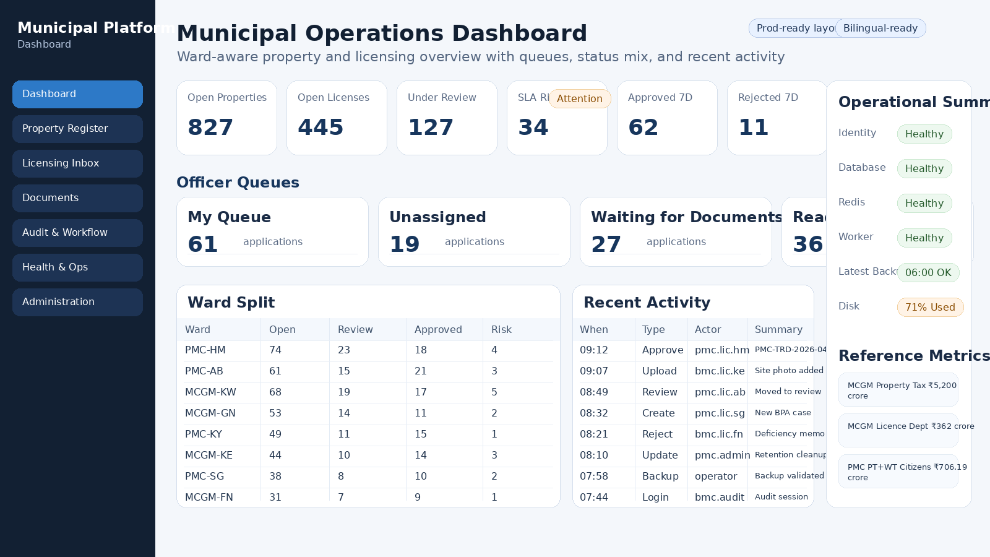
Dashboard target state
Property detail target state
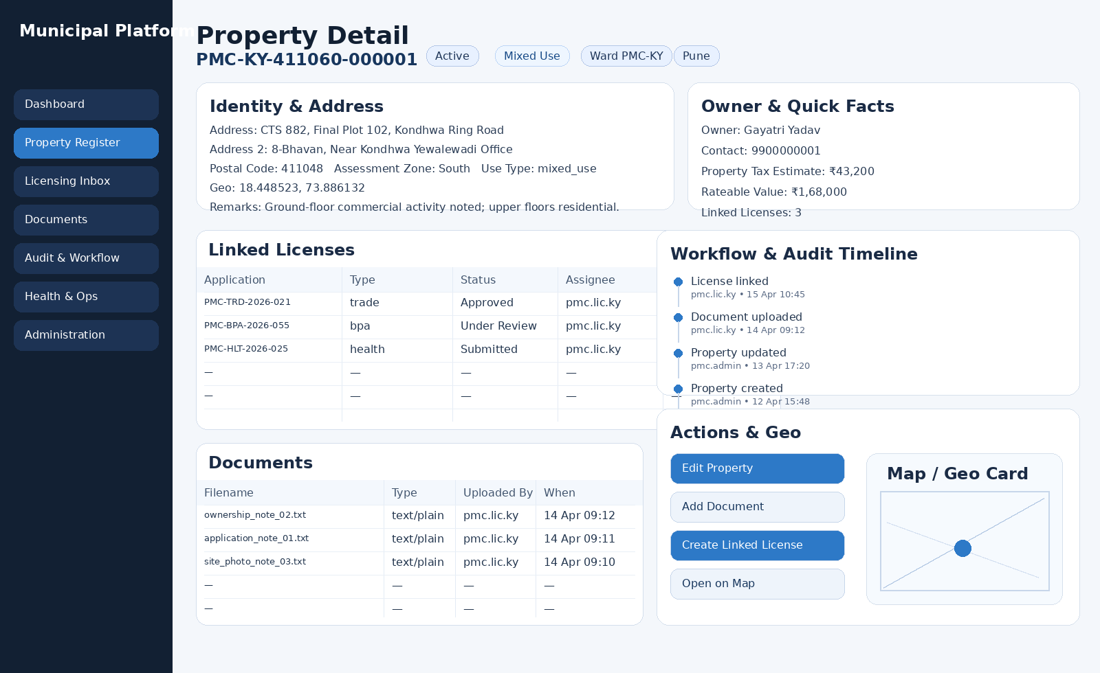
Property detail target state
Licensing inbox target state
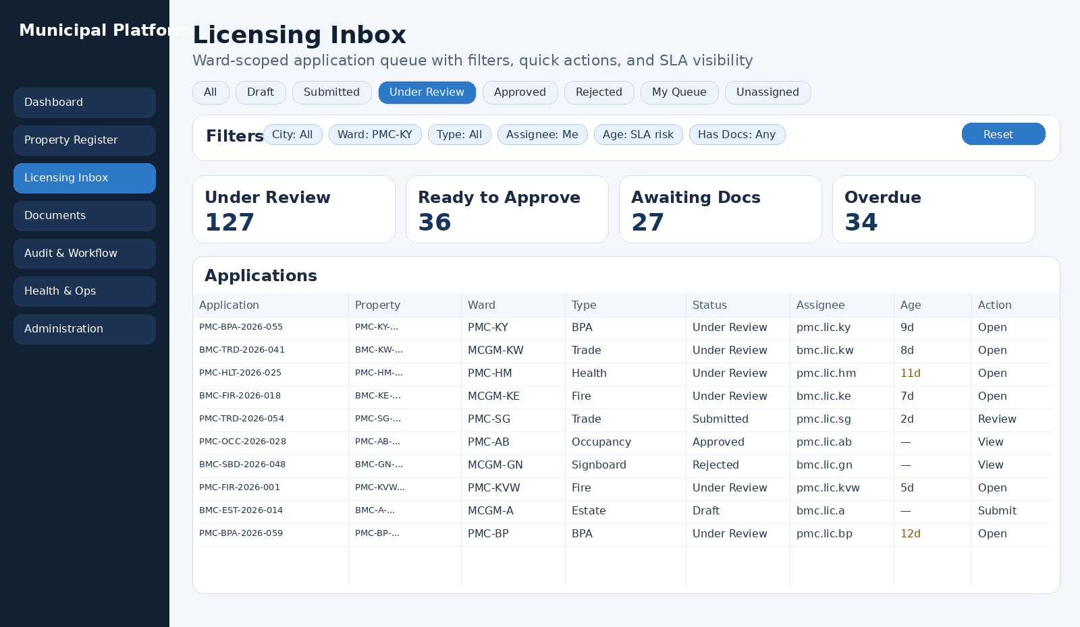
Licensing inbox target state

8. Screen-by-screen specification
Screen | Required behavior
Dashboard | Show ward-aware KPIs, officer queues, status mix, recent activity, and clearly labeled reference metrics. The first row should never be just deployment facts. Keep 4–6 KPI cards, queue cards, ward split, recent activity, and an ops summary panel.
Property Register list | Support full-text search, ward/status/use-type filters, sortable columns, visible total count, row click to open detail, and strong business identifiers as the first columns.
Property create/edit | Use explicit sectioned forms: identity, address, classification, ownership. Replace raw key-value form generation with purpose-built fields.
Property detail | Present property summary, ward, address, classification, ownership, linked licenses, document list, workflow/audit timeline, and geolocation card in a two-column desktop layout.
Licensing Inbox | Primary officer work screen. Use segmented views by status, ward/type/assignee filters, age/SLA visibility, quick actions, and state-aware row styling.
License create | Use searchable property lookup, explicit license-type select, applicant block, and notes/help text. Avoid raw property UUID entry in the final UI.
License detail | Show status, assignee, ward, linked property, applicant, workflow action panel, SLA/age summary, document evidence, notes, and timeline.
Documents | Enable grouped retrieval by property or license, with file type, uploader, upload time, and aggregate linkage visible.
Audit & Workflow | Provide a cross-record event table with actor, timestamp, action, aggregate, result, and drill-in links.
Health & Ops | Operator-facing health cards, dependency status, disk/log/backup context, and safe actions such as backup and validation.
Administration | Show user/role context, safe config summaries, RBAC reference, audit links, and runbook shortcuts without disclosing sensitive settings.

8.1 Table and filter standards
- Sticky or strongly separated table header.
- Search + visible filters + sort are baseline, not advanced features.
- First columns should be stable business identifiers: Property No., Application No., Ward.
- Assignee and status must remain visible without opening the record.
- Back-navigation should preserve filters where practical.

8.2 Form standards
- Use sectioned forms rather than flat generated grids.
- Controlled selects for enum-like fields such as ward, status, use type, and license type.
- Inline validation near fields plus a top summary for multi-error submits.
- Unsaved-change warning on navigation away from modified forms.
- Destructive or workflow-advancing actions must require deliberate confirmation where appropriate.

8.3 Accessibility and bilingual readiness
- Preserve visible focus states and keyboard reachability.
- Do not rely on color only for workflow state.
- Allow room for Marathi labels and longer text without layout breakage.
- Support a Devanagari-compatible font pairing in the frontend token system.

9. Data model guidance for UI work
The UI must follow the current codebase today, but it should leave room for a richer municipal v2 model.

9.1 Current fields that the UI must fully support now
Property schema | License schema
property_number, ward_code, address_line_1, address_line_2, city, district, state, postal_code | application_number, property_id, license_type, status, applicant_name, applicant_contact
geo_lat, geo_lng, status, use_type, owner_name, owner_contact | current_assignee, submitted_at, decided_at, notes
assessment_zone, remarks | workflow transition endpoints already present in current API

9.2 Recommended v2 fields to plan for
Property v2 | License v2 | Operational extensions
survey_no, hissa_no, cts_no / cs_no, plot_no, final_plot_no | filing_channel, target_sla_days, deficiency_count | inspection records and outcomes
locality / peth, land_area_sq_m, built_up_area_sq_m | fee_amount, payment_status, payment reference | document category taxonomy
rateable_value, estimated_annual_property_tax, ownership_type | architect, developer, structural engineer, site engineer | signed-order / e-sign evidence

10. Prompt guide evaluation
The implementation brief is unusually strong for security, resilience, documentation, and Windows/Docker deployment. It is not, by itself, enough to yield a high-quality municipal product interface. The missing layer is explicit product prompting.
Area | Original brief strength | Additional prompt needed
Infrastructure & security | Excellent | Minimal additional prompting
Deployment & runbooks | Excellent | Minimal additional prompting
Domain UX | Partial | Need explicit screen, role, and workflow prompts
Data realism | Low | Need dedicated seed-data prompt
Acceptance criteria for frontend | Partial | Need explicit UX acceptance checklist

10.1 Recommended prompting sequence
- Product / UX prompt first: define screens, roles, and behavior.
- Frontend implementation prompt second: translate approved UX into code.
- Dummy-data prompt third: generate realistic synthetic data and import helpers.
- QA/review prompt last: validate against both the implementation brief and the UX/data specification.

10.2 Prompt rules that matter most
- Always tell the agent that this is a municipal workflow platform, not a CRM.
- Always say what must remain unchanged: stack, API compatibility, deployment model, self-hosting.
- Always define the role and the decision each screen must support.
- Always include acceptance criteria and explicit anti-patterns.

11. Dummy data package design
A realistic municipal application needs a realistic but safe seed-data strategy. The attached data pack provides both current-schema payloads and a future-state v2 extension model.
Profile | Purpose | Main contents
developer_seed | Quick local development and smoke tests | Compact property/license dataset, documents, users, metrics
hybrid_demo | Demo/UAT and richer UX validation | Broader ward spread, more status variety, more documents and workflow history
recommended_extension_model | Future schema and richer UX planning | v2 CSVs for properties, licenses, inspections, payments, documents

11.1 What is real and what is synthetic
Real / public anchors | Synthetic records
Ward names, many ward addresses, public budget/tax reference metrics, and public field patterns from PMC/MCGM/C-DAC sources | Properties, applicants, owners, workflow events, audit events, users, and sample documents

11.2 Import flow for the current repository
- Import properties from JSONL using POST /api/v1/properties.
- Resolve created property IDs by property number.
- Create license applications from JSONL using POST /api/v1/licenses.
- Replay transition paths such as submit, review, approve, and reject.
- Upload matching text documents to created license records.

11.3 Why the metrics are separated
The data pack deliberately separates official public reference metrics from synthetic operational metrics. That allows dashboard demos to feel realistic without incorrectly presenting generated transactional counts as real municipal throughput.

12. Implementation priorities
Priority | Work items | Why now
Phase 1 | Dashboard redesign; property list; licensing inbox; property detail; license detail; states/chips/filter bar | These convert the app from generic CRUD to usable municipal operations UI
Phase 2 | Documents workspace; cross-record audit screen; richer ops/admin views; saved filters; SLA cues | These improve operational maturity and review confidence
Phase 3 | Schema v2 extensions: planning identifiers, participants, inspections, payments, deficiency tracking, e-sign metadata | These move the app closer to realistic municipal lifecycle coverage

13. Final recommendations
- Keep the current backend and operations foundation; it is already the strongest part of the repository.
- Treat the next iteration as a product/UX implementation project, not another infrastructure rewrite.
- Preserve current schema compatibility while introducing a clearly documented v2 model in parallel.
- Use the dummy data pack in every frontend sprint so UX decisions are made against realistic records rather than toy rows.

Appendix A. Artifact set produced
- Main document: this DOCX specification.
- Standalone UI/UX spec in Markdown.
- Standalone prompt guide in Markdown.
- Standalone application overview in Markdown.
- ZIP dummy-data package with generator, import helper, current-schema exports, and v2 CSV model.

Appendix B. Source anchors used for realism and positioning
- C-DAC NextGen ERP — https://www.cdac.in/index.aspx?id=service_details&serviceId=CDACNextGenERP
- C-DAC WAMIS — https://cdac.in/index.aspx?id=ev_corp_wamis
- e-Pramaan — https://cdac.in/index.aspx?id=st_egov_e-Pramaan_Info_120220
- e-Hastakshar — https://www.cdac.in/index.aspx?id=service_details&serviceId=e-Hastakshar%3AC-DAC%27sOn-lineDigitalSigningService
- MCGM ward office address PDF — https://portal.mcgm.gov.in/irj/go/km/docs/documents/HomePage%20Data/CFC/Address%20and%20E-mail%20ID%27s%20of%20Ward%20Assistant%20Commissioner%20%26%20CFC%28Modified%20File%29.pdf
- MCGM budget speech 2025-26 — https://www.mcgm.gov.in/irj/go/km/docs/documents/MCGM%20Department%20List/Chief%20Accountant%20%28Finance%29/Budget/Budget%20Estimate%202025-2026/1-%20MC%27s%20Speech/BUDGET%20A%2CB%2CG/ENGLISH%20SPEECH.pdf
- PMC open-data accounts / schedules — https://opendata.pmc.gov.in/opendata/6f5d15dd-7fd3-4b53-8a01-f85a00848952.pdf
- PMC AutoDCR public portal — https://autodcr.pmc.gov.in/

