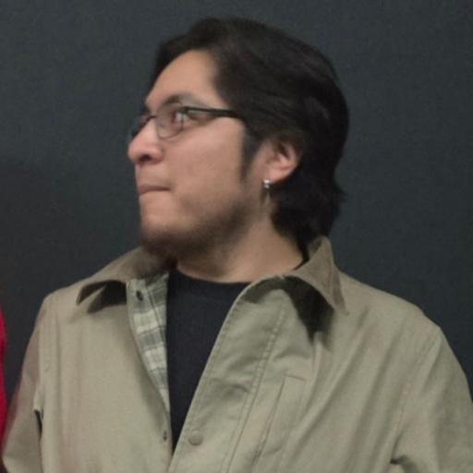Gary Gonzalez
- I am currently learning more frontend via UX/UI.
- Professional interests are Arts and Humanities, Science and Tech, Business and Administration, Healthcare, Skilled Trades
- Going for a Design degree and becoming a product designer and working on building tools that resolve real world issues via UX/UI skills acquired.
- Photography, Reading, Outdoor Actives (Jogging with my dog, any sports, naps in Central Park), building side projects
- In L1, I built a PC Builder and I have been proud of that build ever since.

Ibrahima
- I don't know the skills I have not gonna lie
- A big interests of mine is actually trying to get money in order to train to become a wrestler and another is maybe getting into a production for like film or shows just because I've done video editing n seen that world it just looks cool even if I'm not editing but if I can just be around there and have some type of opportunity
- I don't know my career path I am still trying to find it as of this moment
- Hobbies are playing basketball used to play football but stopped, playing video games and going to the gym, as well as trying to learn how to get better at cooking
- One project I actually liked even tho I don't really save them like a mad man was the language learning tool app I had created to combat Duolingo n other apps where it was just based off of you learning other languages where it would be strictly just voice to voice. You would get graded off confidence, how well you said it, and if the tone is the right tone with a score and a history panel where you could constantly go back to whatever you are learning till u feel like you have mastered it fully
BONUS - I've met two wrestlers that I actually seen on tv about two times but it never crossed my mind to ask about some advice on how I can get into the business or Even ask if the professional company they work at ARE HIRING

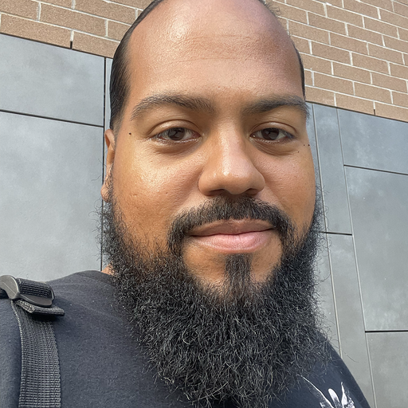Manny (Manuel
• What are your skills? Project management
• What are your professional interests? Building accessible tech solutions for underserved communities
• What is your career path? Currently seeking roles in AI product development and full-stack engineering
• What are your hobbies? Music, movies, and AI experimentation
• What project are you most proud of from your journey so far in the class?
The project I am most proud of is Calldone, which earned me entry into Level 2 at Pursuit. It was originally designed as a model for corporations, but I reimagined it for consumers to help them regain control of their time and decision-making.

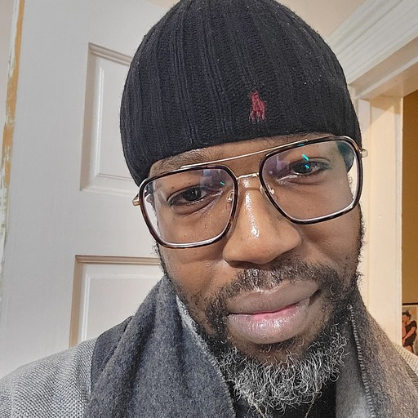Joel P.
1. What are your skills? Ui/UX design, project management, psychology & mental health advocate
2. What are your professional interests? Psychology, tech research, art and creative building, voice over work, writing
3. What is your career path? Pivoting from government infrastructure to ethical technology usage and advanced technology-basedcreativity
4. What are your hobbies? Music, writing, poetry, philosophy and gaming
5. What project are you most proud of from your journey so far in the class? I'm most proud of my mental health app, Deep Hug. Creating a companion app for anxiety helped me understand how many different ways I can apply my skill set to helping others.

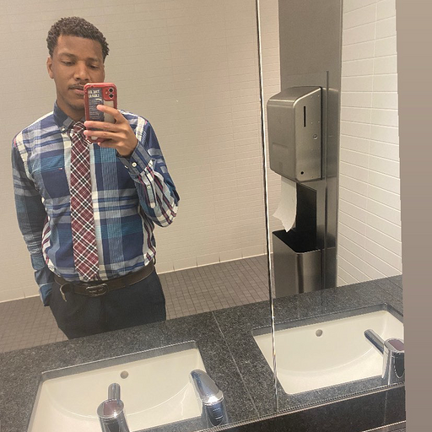Duvall Morgan
. What are your skills?
My core stack is built on the Technical Trinity: Python, Machine Learning, and Data Engineering—all architected within the Google Cloud (GCP) ecosystem. I specialize in turning complex datasets into actionable logic.
2. What are your professional interests?
I’m focused on the intersection of AI Engineering and Data Architecture. My goal is to design "Agentic" systems—AI that doesn't just process information but acts as an intelligent sentinel to solve legacy infrastructure pain.
3. What is your career path?
I don’t set traditional "goals" anymore; I find they create ceilings. Instead, I attack the mission. My path is defined by constant forward momentum, high-velocity learning, and building systems that outlast the hype. I don't look back.
4. What are your hobbies?
I’m a high-signal learner. My "downtime" is spent deep-reading AI research and studying the latest breakthroughs from the MIT, Stanford, and Harvard Innovation Labs. I’m obsessed with how top-tier institutions architect the future.
5. What project are you most proud of from your journey so far?
I’m most proud of the project I’m cooking up right now (MotionFrame/Sentinel). After a period of recalibration, I’ve hit a 650% spike in momentum. This project proves I’m back at full speed, and I have no plans of slowing down from here on out.
 BONUS: Little-known fact?
Beyond the code, I’m a Google Higher Ed Leader. I operate with a "Humble Giant" mindset—I’m deeply ambitious about my own vision, but I’m a true team player who finds genuine fuel in seeing others win.

Michael Chabler
What are your skills?

IT Support, writing, fine art, some acting

2. What are your professional interests?
AI software development, writing, acting

3. What is your career path?
I have been a support tech for over 15 years, with some acting in theater and movies.

4. What are your hobbies?
Writing, Reading, Swimming, running (weather permitting), hiking (including up and down mountains in the Catskills when I can)

5. What project are you most proud of from your journey so far in the class?
I like the way our Spotify improvement app is looking.
 BONUS: Add one little-known fact about yourself.
Released an album of original children's music with the band I helped form (Treehouse 10) in 2009 which included singers from the smash group The Hillside Singers.

Album: Bug in a Puddle
Gamaliel

- Python, web development, Backend development
- Software dev and engineering
- I’m a former healthcare operations professional transitioning into Software Engineering, currently specializing in Python and AI to build tools that simplify complex user experiences.
- Anime, boxing, reading, philanthropy, computers and I love views
- Meeting such an amazing group of people since various cohorts have confirmed nobody doing it like us.
FF: If I cross my legs while I am talking to you I am locked in meaning you got my full and undivided attention

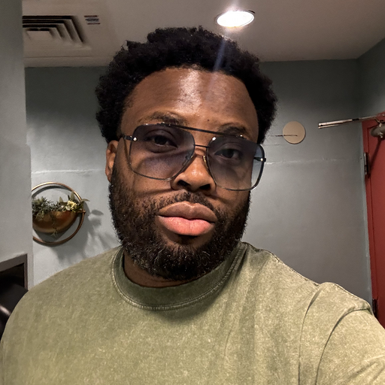David Omokagbor
Hello Paula Apologies for late responds.

Skills Full-stack development (Python, JavaScript), AI/ML fundamentals, recommender systems, backend API design, database modeling (MongoDB), and product-focused problem decomposition.

2. Professional interests
Applied AI, full-stack development, and building scalable, intelligent products that combine ML with strong backend systems.

3. Career path
Working toward becoming a full-stack AI engineer, with long-term goals of building impactful AI-driven products and leading technical projects.

4. Hobbies
Music is my main creative outlet. I’m a music producer and audio engineer, and I spend my downtime producing, mixing, and experimenting with sound.

5. Most project proud of from my journey so far in the class
My recommendation system work and my Smart Unit Converter project, where I focused on clean data modeling, edge cases, and building user-friendly experiences.

BONUS – One little-known fact about me
I learn extremely fast and stay deeply curious. I tend to dive deep into new systems until I really understand how they work.

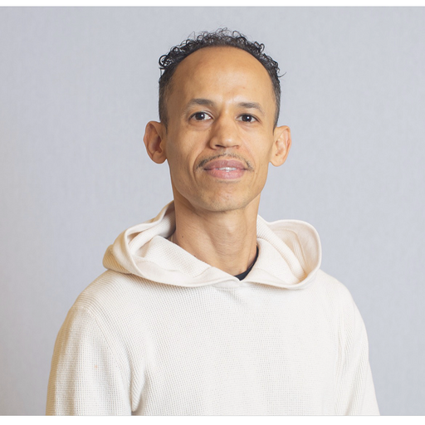Juan Franco
AI-Native Software Engineer | Full-Stack Developer | 15+ Yrs Audio Engineering & Studio Operations
2. Ai native full stack developer, recording studio / video production
3. Full stack developer
4. Sports , music , ai
5. Wingmate ( airport app)
I enjoy the warm weather Caribbean Florida style and ideally get hired as remote job.
I enjoy crypto and financial world as well as politics

Kevin Natera
. What are your skills?

React, Redux, Ruby on Rails, Node.js, Python, Swift, HTML, CSS, Javascript

2. What are your professional interests?

I am professionally interested in a software development role of any kind

3. What is your career path?

My career path is non-existent at the moment, but I am hoping to evolve it into a tech one.

4. What are your hobbies?

I am into gaming, anime, card magic and parkour

5. What project are you most proud of from your journey so far in the class?

I am the most proud of my project called “Your Sol”, an app designed to store user interests in the form of a solar system they generate one star at a time.

Ismael Carabollo
Your Interview Questions
When we connect on Slack, we'll ask you the following:
1. What are your skills?
2. What are your professional interests?
3. What is your career path?
4. What are your hobbies?
5. What project are you most proud of from your journey so far in the class?
 BONUS: Add one little-known fact about yourself.

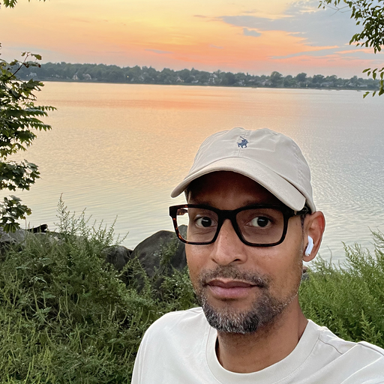Victor
1. I was a cable and satellite technician for 15 years, I worked with DirecTV and Spectrum
2. My goal is to become fully AI native developer specializing in UI/UX
3. I'm a movie buff who also enjoys running and the great outdoors.
4. The project I’m most proud of is “CommonGround”. It’s an app that connects people who are going through any one of life’s big transitions like becoming a new parent, doing a career change or even parents who just became empty nesters. The app set ups local meet-ups like at a coffee shop, morning runs or even a walk in park. While there, they can share their experiences and support one another through solidarity. Like our talk the other day, I truly believe in building apps that can possibly make the world a better place.

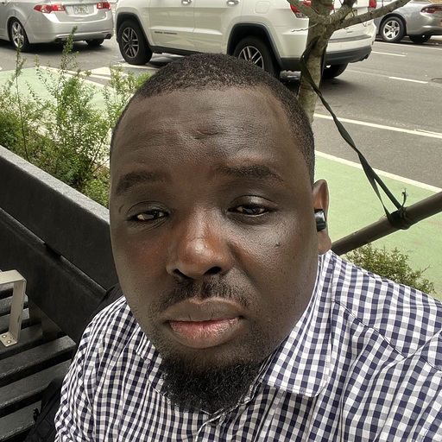Pape Sy

1. What are your skills?
2. What are your professional interests?
3. What is your career path?
4. What are your hobbies?
5. What project are you most proud of from your journey so far in the class?
 BONUS: Add one little-known fact about yourself.

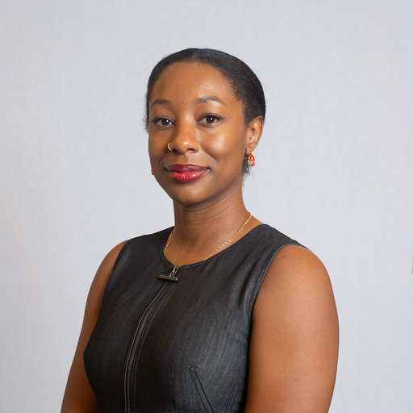Jonel Richardson
- UX/UI design with accessibility focus, Problem scoping and MVP development, Git/GitHub workflows for collaborative development
- Accessibility tools that serve diverse population
- becoming AI native, fitness, cookingexplainThis:
- an app translating technical jargon into plain language
- Bonus: fun fact: I lived in Japan for 8 years teaching preschool

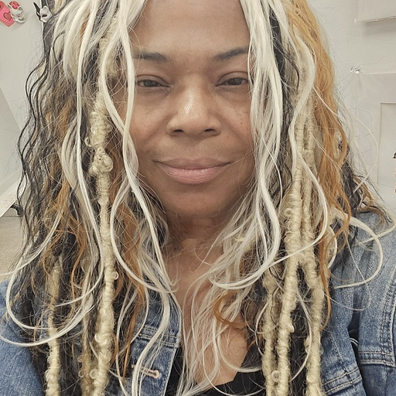Jagger Sonia Toure
1. What are your skills?
2. What are your professional interests?
3. What is your career path?
4. What are your hobbies?
5. What project are you most proud of from your journey so far in the class?
 BONUS: Add one little-known fact about yourself.

Luba Kaper
1. What are your skills?
iOS development (Swift, SwiftUI, Xcode), front-end development (React, TypeScript, Tailwind), backend fundamentals (Node.js, APIs), and AI/LLM integration. Strong in product thinking, debugging, UX-driven development, and turning messy ideas into working MVPs.

2. What are your professional interests?
Building AI-native products, human-centered UX, and tools that actually solve real problems. I’m especially interested in how LLMs can support learning, decision-making, and everyday workflows — not just flashy demos.

3. What is your career path?
I started in iOS engineering and product-adjacent roles, and I’m now intentionally moving deeper into AI-native development and applied AI product work. My goal is to work on small, fast teams where I can build, iterate, and ship meaningful features end-to-end.

4. What are your hobbies?
Music, cooking, traveling and long walks . I also genuinely enjoy learning new tools and experimenting with side projects.

5. What project are you most proud of from your journey so far in the class?
Sveti, an AI tutor project I’m building around real learning needs. It pushed me to think beyond “just code” — into UX, guardrails, learning styles, and how AI should actually support humans instead of overwhelming them.

BONUS: One little-known fact about yourself
I graduated from music school — major in cello, minor in piano

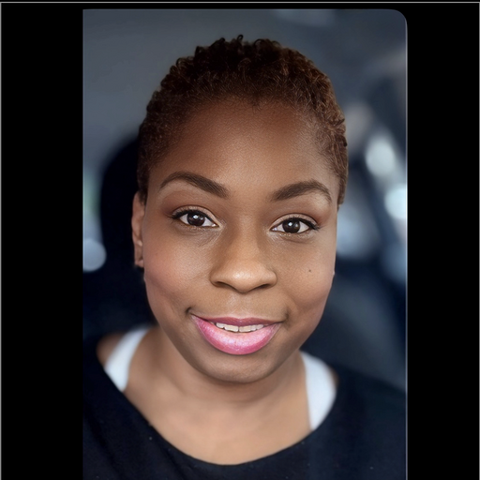Paula Lawton”s RecRoom Profile

1. What are your skills?
Full-stack development (React, Node.js, Express, Vite), AI/LLM prompt engineering and integration, project management, program administration, grant management (multimillion-dollar federal programs), workforce development, Mental Health First Aid instruction (certified instructor), SHRM-CP HR certification (in progress via Temple University), digital literacy instruction, workshop facilitation, financial literacy education, community organizing, and business development.

2. What are your professional interests?
AI training and development, AI compliance and governance, workforce development with AI integration, mental health support in professional settings, financial technology education, HR systems optimization, transformational workshop design, and building AI-powered solutions that bridge gaps in financial literacy, workforce readiness, and social services delivery.

3. What is your career path?
Transitioning from 12+ years in nonprofit leadership and higher education administration into AI-focused roles in training, development, compliance, and workforce solutions. Currently leveraging AI prompt engineering and full-stack collaboration skills from the Pursuit AI Fellowship to architect solutions (like AI Money Mentor for financial education and DHS intake tracking systems) while launching ZenPawZ LLC. Seeking positions that combine AI innovation with workforce development, mental health awareness, HR optimization, and social impact.

4. What are your hobbies?
SGI Buddhism practice, memoir writing (currently working on My Life as a Social Experiment), financial literacy advocacy, community organizing, cultural entrepreneurship (former Festival Director for African Restaurant Week), and pet wellness (building ZenPawZ brand).

5. What project are you most proud of from your journey so far in the class?
The AI Money Mentor — a financial education platform that makes complex financial concepts accessible through AI-powered conversational learning. It represents the intersection of my passion for financial literacy, my growth in AI prompt engineering and solution architecture, and my commitment to creating tools that empower underserved communities to build generational wealth.

BONUS: One little-known fact about yourself
I performed stand-up comedy for 2½ years, hitting stages at legendary venues like The Laugh Factory, The Comedy Cellar, and Carolines on Broadway, coached by the incredible Linda Smith.

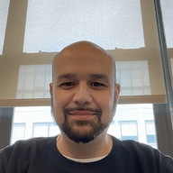Erick Perez
- My skills include systems administration, networking, mobile device management and cyber security with a focus on incidence response
- My target career path is to be a consultant's consultant
- I am most proud of https://listingtruthfinder.com/ a site designed to verify a Zillow listing's picture with a Google Street View.
- Ask me about legal subjects
- I am actively trying to learn about AI
- My hobbies outside of tech include mechanical engineering
Bonus: A little known fact about me is that I am from on of the smallest counties in New York State, the County of Kings

Two resources I find valuable are:
https://news.ycombinator.com/ <-Forum with news links usually focused on tech
https://krebsonsecurity.com/ <-A Blog that covers some of the larger breachs and scams

