Mongo DB queries.

1. To retrieve info on databases.

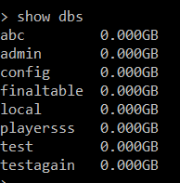

1. Retrieve documents that are inserted into Mongo DB through the python code.

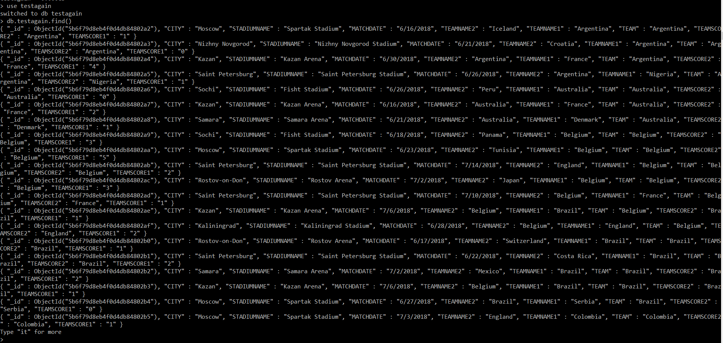

1. Deleting Databases.

