**TEMPERATURE MONITORING AND FIRE CONTROL SYSTEM**

## A PROJECT REPORT

***Submitted by***

**PRATEEM GIRI (UE215070)**

***in partial fulfillment for the award of the degree of***

**BACHELOR OF ENGINEERING**

***in***

## ELECTRONICS AND COMMUNICATION ENGINEERING



**UNIVERSITY INSTITUTE OF ENGINEERING AND TECHNOLOGY SECTOR 25, CHANDIGARH**

**PANJAB UNIVERSITY: CHANDIGARH 160014**

## JULY 2022

**ABSTRACT**

The idea of the project is to create a temperature monitoring system which would display the temperature readings of the surrounding environment on an LCD (LIQUID CRYSTAL DISPLAY). Green and red LEDs (Light emitting diodes) will be used to showcase safe and unsafe temperature readings for the working of a specific appliance. A flame sensor will be used to show the presence of fire. In case the appliance catches fire, the flame sensor circuit will beep showcasing a warning. The maximum safe working temperature limit is different for different appliances and as such can be programmed to different values via a microcontroller (in this case an ARDUINO UNO R3 microcontroller board). The Arduino board is the key unit of the project and will control all the aspects of functioning of the circuit. The temperature detection system will be a circuit consisting of a 100K ohm thermistor and a 100K ohm resistor. The alarm system will consist of one red and one green led, Arduino fire sensor module and a buzzer. The Arduino UNO R3 microcontroller will take the inputs from the detection system as well as the alarm system and display the temperature readings on the LCD and showcase the warnings as per the defined maximum safe working temperature and the presence of fire.

**TABLE OF CONTENTS**

**CHAPTER NO. TITLE PAGE NO.**

**ABSTRACT 2**

**ACKNOWLEDGEMENT 4**

**1) INTRODUCTION 6**

|  |  |  |  |
| --- | --- | --- | --- |
| 1.1) | Temperature detection system | * + 1. Thermistor     2. Resistor     3. Liquid crystal display | 5  6  6 |
| 1.2) | Alarm system | 1.2.1) Buzzer  1.2.2) Arduino flame sensor module | 8  8 |
| 1.3) | Arduino UNO |  | 9 |

**2) WORKING**

|  |  |  |
| --- | --- | --- |
| 2.1) | Temperature detecting unit | 10 |
| 2.2) | Fire sensing unit | 12 |
| 2.3) | LCD display | 14 |

**3) CONCLUSION**

|  |  |  |
| --- | --- | --- |
| 3.1) | Applications | 16 |
| 3.2) | Future Scope | 17 |

**REFERENCES 18**

**ACKNOWLEGNEMENT**

I would like to express special thanks of gratitude to my teacher Dr. Garima Joshi, Assistant Prof (ECE) who gave me the wonderful opportunity to do this Wonderful Project of Temperature monitoring & Fire control unit , who also helped me in completing my project. I came to know about so many things I am really thankful to her. Secondly I would also like to thank Prof. J. K Goswamy, Director, UIET who have also given us an opportunity to test our knowledge.

Prateem Giri-UE215070

ECE 1ST Year

1. **INTRODUCTION**

**1.1) TEMPERATURE DETECTION SYSTEM :**

**1.1.1) THERMISTOR :**

A thermistor is a resistance thermometer, or a resistor whose resistance is dependent on temperature. The term is a combination of “thermal” and “resistor”. It is made of metallic oxides, pressed into a bead, disk, or cylindrical shape and then encapsulated with an impermeable material such as epoxy or glass.

There are two types of thermistors: Negative Temperature Coefficient (NTC) and Positive Temperature Coefficient (PTC). With an NTC thermistor, when the temperature increases, resistance decreases. Conversely, when temperature decreases, resistance increases. This type of thermistor is used the most**.**

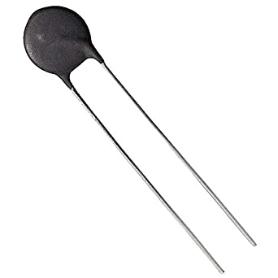

Fig 1 Thermistor

Type : negative temperature coefficient

Range: -50OC to 260O C

Resistance : 100K ohms

**1.1.2) RESISTOR :**

A resistor is an electrical component that limits or regulates the flow of electrical [current](https://www.techtarget.com/whatis/definition/current) in an electronic circuit. Resistors can also be used to provide a specific voltage for an active device such as a [transistor](https://www.techtarget.com/whatis/definition/transistor). We can easily determine the value of resistance by the help of color code :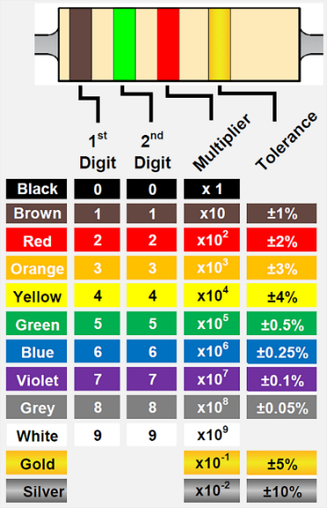

Fig 2 Resistor colour code

**1.1.3) 16 x 2 LIQUID CRYSTAL DISPLAY :**

A liquid crystal display is a flat panel display which uses the optical properties of liquid crystals to display alphabets, numbers or special characters as per the condition on the display panel. A 16 x 2 LCD display as the name suggests has 16 columns and 2 rows while the other dimensions LCDs available are 8 x 1, 8 x 2, 10 x 2, 16 x 1, etc. The most commonly used LCD however is 16 x 2. It has a total of 32 (16 x 2) characters and each character is made of 5 x 8 pixel dots. The pin layout and configuration of a 16 x 2 LCD is shown below :

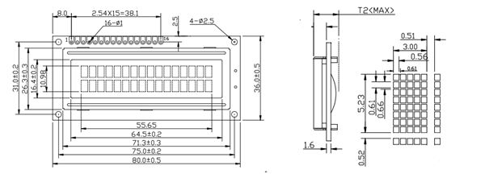

Fig 3 LCD pin layout and configuration

|  |  |  |
| --- | --- | --- |
| Pin no. | Pin name | Description |
| 1 | VSS (Ground) | Ground pin |
| 2 | VDD (+5V Volt) | Provides 5V voltage supply |
| 3 | VE (Contrast V) | Decides the contrast level of the display |
| 4 | Register select | Connected to Arduino to shift between command/data register |
| 5 | Read/Write | Read or write data |
| 6 | Enable | Connected to Arduino and toggled between 0 and 1 |
| 7 | Data Pin 0 | Connected to microcontroller to send data |
| 8 | Data Pin 1 |  |
| 9 | Data Pin 2 |  |
| 10 | Data Pin 3 |  |
| 11 | Data Pin 4 |  |
| 12 | Data Pin 5 |  |
| 13 | Data Pin 6 |  |
| 14 | Data Pin 7 |  |
| 15 | LED positive | Backlight LED pin positive terminal |
| 16 | LED negative | Backlight LED pin negative terminal |

Table 1

**1.2) ALARM SYSTEM :**

**1.2.1) BUZZER :**

Buzzers are devices which are used to generate sounds by converting various forms of energy to sound energy. The buzzer used in the project is an electromagnetic buzzer.

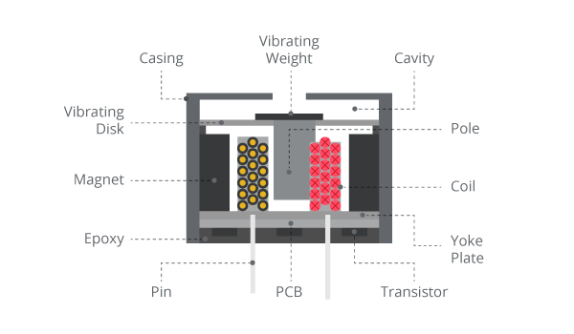

Fig 4 Construction of electromagnetic buzzer

An electromagnetic buzzer consists of an oscillator, solenoid coil, magnet, vibration diaphragm etc. The current in the solenoid coil will in the presence of a magnet will generate a force on the vibrating disk and cause it to move towards the coil and return to it’s original state on the removal of the current. This movement of the disk produces the sound.

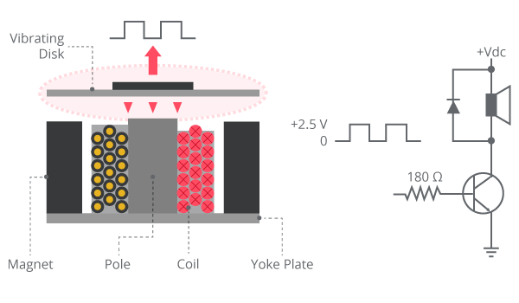

Fig 5 Working of electromagnetic buzzer

**1.2.2) ARDUINO FLAME SENSOR MODULE :**

The Arduino flame sensor module is an infrared flame sensor module which is used to detect fire as the name suggests. This module can detect a flame source having wavelength in the range 760 nm – 1100 nm. The detection angle is 60o and the minimum test distance of the flame is 80 cm. Bigger sized flames can be tested with larger distances. The schematic diagram of the flame sensor is given below :

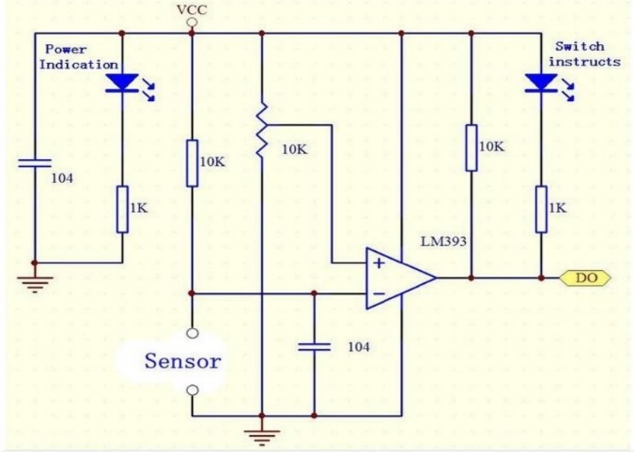

Fig 6 Schematic diagram of Arduino flame sensor module

**1.3) ARDUINO UNO R3 (MICROCONTROLLER) :**

The Arduino Uno R3 is a microcontroller board based on a removable, dual-inline-package (DIP) ATmega328 AVR microcontroller. It has 20 digital input/output pins (of which 6 can be used as PWM outputs and 6 can be used as analog inputs). Programs can be loaded on to it from the easy-to-use Arduino computer program. The Arduino has an extensive support community, which makes it a very easy way to get started working with embedded electronics. The R3 is the third, and latest, revision of the Arduino Uno.

It has 20 digital input/output pins (of which 6 can be used as PWM outputs and 6 can be used as analog inputs), a 16 MHz resonator, a USB connection, a power jack, an in-circuit system programming (ICSP) header, and a reset button. It contains everything needed to support the microcontroller; simply connect it to a computer with a USB cable or power it with a [AC-to-DC adapter](https://www.pololu.com/product/1463) or battery to get started.

The Uno differs from all preceding boards in that it does not use the FTDI USB-to-serial driver chip. Instead, it features an ATmega16U2 programmed as a USB-to-serial converter. This auxiliary microcontroller has its own USB bootloader, which allows advanced users to reprogram it.

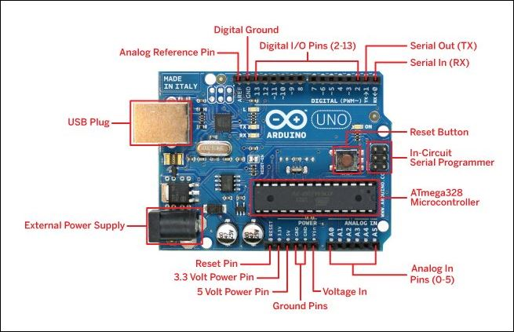

Fig 7 Arduino UNO R3

**WORKING :**

The whole circuit consists of three different parts :

1. **Temperature detection unit** :

It consists of a 100 kilo ohm thermistor and 100 kilo ohm resistor. The resistance of thermistor changes with change in temperature. In this case, NTC ( negative temperature coefficient) thermistor is used. Therefore, the value of resistance decreases with increase in temperature and the change is conveyed to the microcontroller via the analog pin.

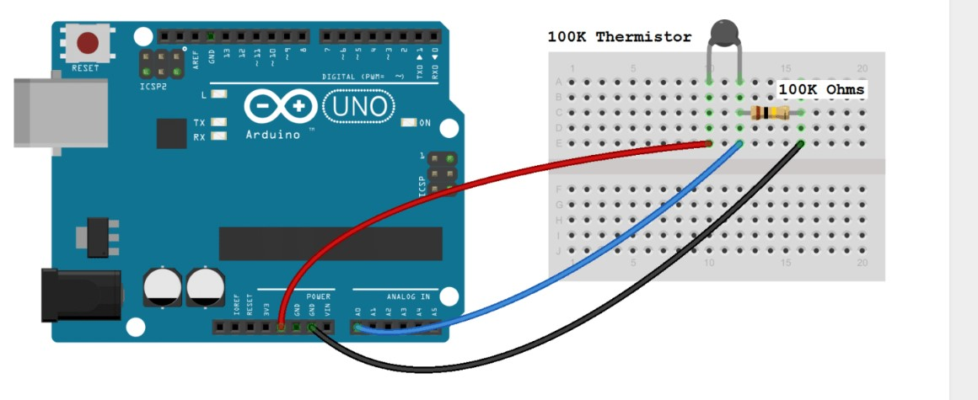

Fig 8 Temperature detection unit

The code for the given unit is :

int ThermistorPin = 0;

int Vo;

float R1 = 10000;

float logR2, R2, T, Tc, Tf;

float c1 = 1.009249522e-03, c2 = 2.378405444e-04, c3 = 2.019202697e-07;

void setup() {

Serial.begin(9600);

}

void loop() {

Vo = analogRead(ThermistorPin);

R2 = R1 * (1023.0 / (float)Vo - 1.0);

logR2 = log(R2);

T = (1.0 / (c1 + c2*logR2 + c3*logR2*logR2*logR2));

Tc = T - 273.15;

Tf = (Tc * 9.0)/ 5.0 + 32.0;

Serial.print("Temperature: ");

Serial.print(Tf);

Serial.print(" F; ");

Serial.print(Tc);

Serial.println(" C");

delay(500);

}

1. **Flame sensor or Alarm unit :**

It consists of the Arduino flame sensor module and a buzzer. The Arduino flame sensor consists of three or four pins of which three are of interest – Vcc (5V supply) , GND (ground) , DO (digital output) . The arduino flame sensor detects the presence of a flame having wavelength in the range 800 – 1100 nm which is the infrared spectrum. The Vcc and GND pins are for providing voltage supply to and grounding the flame sensor module respectively. The digital output pin conveys the signal of the presence of a flame to the microcontroller. The microcontroller then sends a digital output to the buzzer depending on the conveyed signal – LOW if the flame is absent and HIGH if the flame is present.

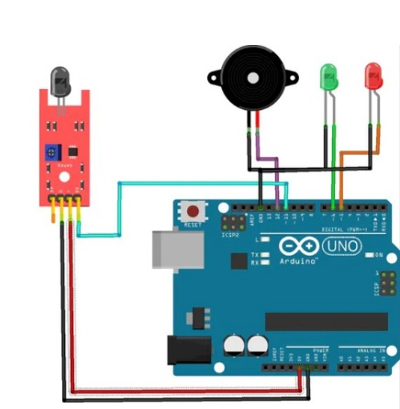

Fig 9 Arduino flame sensor unit

The code for the given unit is :

const int buzzpin = 9;

const int flamepin = 8;

int Flame = HIGH;

void setup() {

// put your setup code here, to run once:

pinMode(buzzpin,OUTPUT);

pinMode(flamepin,INPUT);

Serial.begin(9600);

}

void loop() {

Flame = digitalRead(flamepin);

if(Flame == LOW){

digitalWrite(buzzpin,HIGH);

} else {

digitalWrite(buzzpin,LOW); }}

1. **LCD DISPLAY :**

This unit just consists of an LCD display connected to the Arduino board according to it’s pin configuration. Pin 1 and Pin 2 are for providing voltage supply (+5V) to and grounding the LCD display respectively. Pin 3 is connected to the middle pin of a 10K potentiometer which adjusts the contrast between the LCD display and the screen by changing the variable resistance of the potentiometer by controlling the leg of the potentiometer. Pin 15 & 16 are the positive and negative terminals for the backlight of the LCD. The middle pins are the digital pins which transfers data bit by bit to the microcontroller. The resistor controls the brightness of the LCD. Larger the value of resistance, less brighter the LCD display.

A typical value of resistance is 220 ohm which is used in this case.

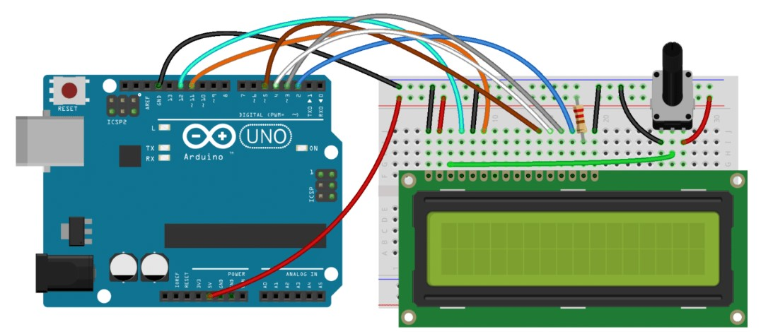

Fig 10

The code for the given unit is :

#include <LiquidCrystal.h>

int ThermistorPin = 0;

int Vo;

float R1 = 10000;

float logR2, R2, T;

float c1 = 1.009249522e-03, c2 = 2.378405444e-04, c3 = 2.019202697e-07;

LiquidCrystal lcd(12, 11, 5, 4, 3, 2);

void setup() {

Serial.begin(9600);

}

void loop() {

Vo = analogRead(ThermistorPin);

R2 = R1 * (1023.0 / (float)Vo - 1.0);

logR2 = log(R2);

T = (1.0 / (c1 + c2*logR2 + c3*logR2*logR2*logR2));

T = T - 273.15;

T = (T * 9.0)/ 5.0 + 32.0;

lcd.print("Temp = ");

lcd.print(T);

lcd.print(" F");

delay(500);

lcd.clear();

}

**CONCLUSION**

1. **APPLICATIONS:**

**A ) TEMPERATURE SENSOR :**

Temperature sensors are all around us, monitoring temperature is a vital process in many fields and needs to be measured in a highly accurate and efficient way.

Some temperature sensor applications are;

**Motorsport and other vehicles** – within motorsports there are many temperature sensor applications. These include; ensuring motors do not overheat, surface plate temperature, exhaust gas temperature, oil temperature etc

**Industrial equipment**– most machinery used within industrial equipment and manufacturing will contain a temperature sensor for safety reasons. Temperature sensors used within this environment are required to be highly robust and resistant to dirt and moisture.

**Medical Applications** – Temperature sensors are used for patient monitoring as well as within machines and devices for a range of medical procedures. To be used in this industry temperature sensors will require various safety standards and approvals.

**Food and Beverage Industry** – temperature sensors are used within this environment as part of food safety standards, ensuring food is kept at the correct temperature. They are also used on various manufacturing equipment used within this sector.

**Home appliances and white goods**– many appliances within the home will contain a temperature sensor; oven, toaster, kettles, washing machines, coffee machines, dishwashers, electric radiators, boilers etc.

**Computers and devices**– temperature sensors are used within computers and other devices to ensure they do not overheat and become dangerous.

**B) FLAME SENSOR :**

These sensors are used in several dangerous situations which include the following.

* Hydrogen stations
* Industrial heating
* Fire detection
* Fire Alarm.
* Fire Fighting Robot.
* Drying systems
* Industrial gas turbines
* Domestic heating systems
* Gas-powered cooking devices

Thus, this is all about a flame sensor. From the above information finally, we can conclude that the main purpose of this sensor is to reduce the risks which are associated with the ignition.

1. **FUTURE SCOPE :**

The temperature monitoring system can further be extended to general purpose temperature regulating system by implementing a temperature control unit which can be flexible and compatible with the change in programming of the microcontroller. Most systems in which temperature control is involved for e.g Air conditioners, Refrigerators etc are constrained to a specific use due to the bulkiness and rigidity of the temperature control unit. They also have different operating temperatures as well which causes the specificity. This project is only a small part of a much bigger project which will be a endeavour at a general purpose temperature monitoring and control unit programmed in such a manner that the user interface is easy to operate and can be set to a certain demand i.e one UI (user interface) and multiple applications (AC, microwave, refrigeration etc.)

**REFERENCES:**

1. [www.arduino.cc](http://www.arduino.cc)
2. [www.fierceelectronics.com](http://www.fierceelectronics.com)
3. [www.circuitdigest.com](http://www.circuitdigest.com)
4. [www.lastminuteengineers.com](http://www.lastminuteengineers.com)