# **Build and Execution Instructions**

**Resources Required:-**

* Internet Connection
* Python 3 (Refer- https://www.python.org/downloads/release/python-363/)
* pip package (refer-https://pip.pypa.io/en/stable/installing/) and path should be declared for pip
* requests module ,to install it execute the command in terminal

**$** **pip install requests**

**Execution Steps:**

1. The input should be in the form of CSV file.

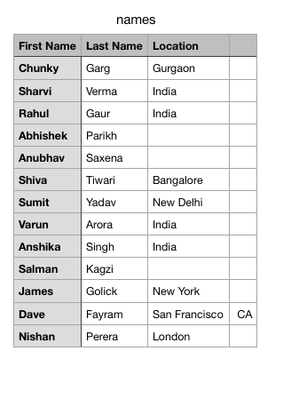

1. The rateLimiter.py and the input file should be within the same directory.
2. Open the terminal and navigate to the directory which contains rateLimiter.py file.
3. Enter the command in the terminal:
4. **$** **pip install requests**
5. When all the dependencies are installed, enter the command for execution of the program **rateLimiter.py** in the terminal.
6. **$ python rateLimiter.py**
7. Enter the input filename.

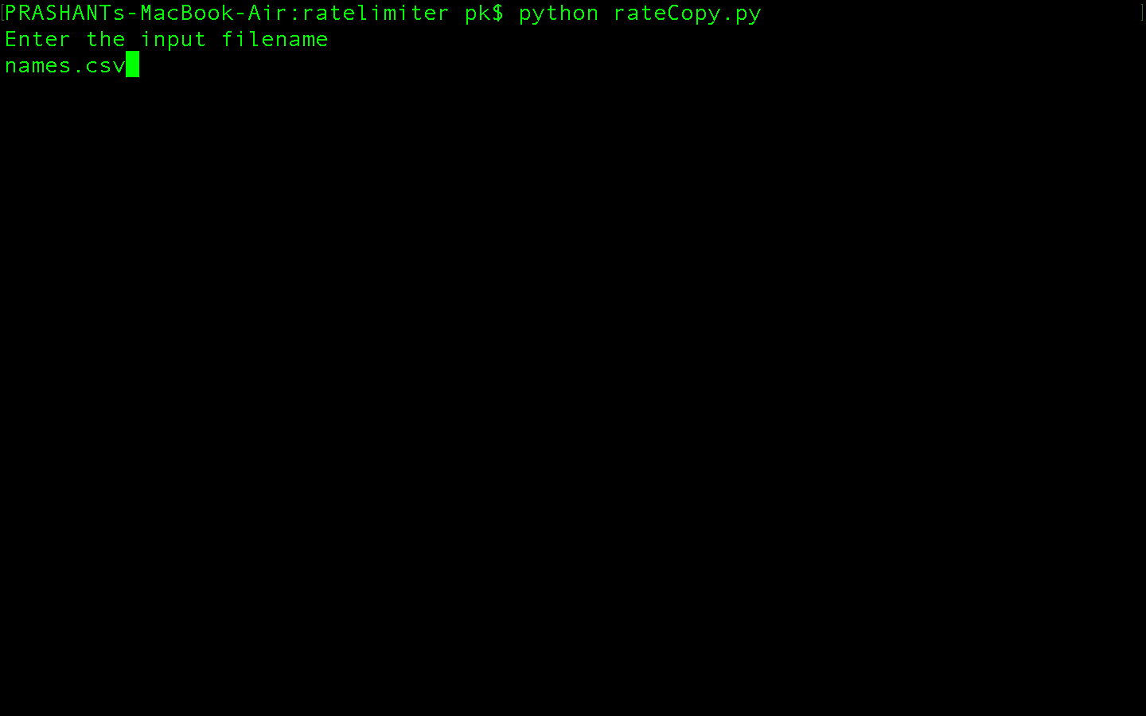

1. If the input file with the specified filename does not exist, the program terminates with the following output.

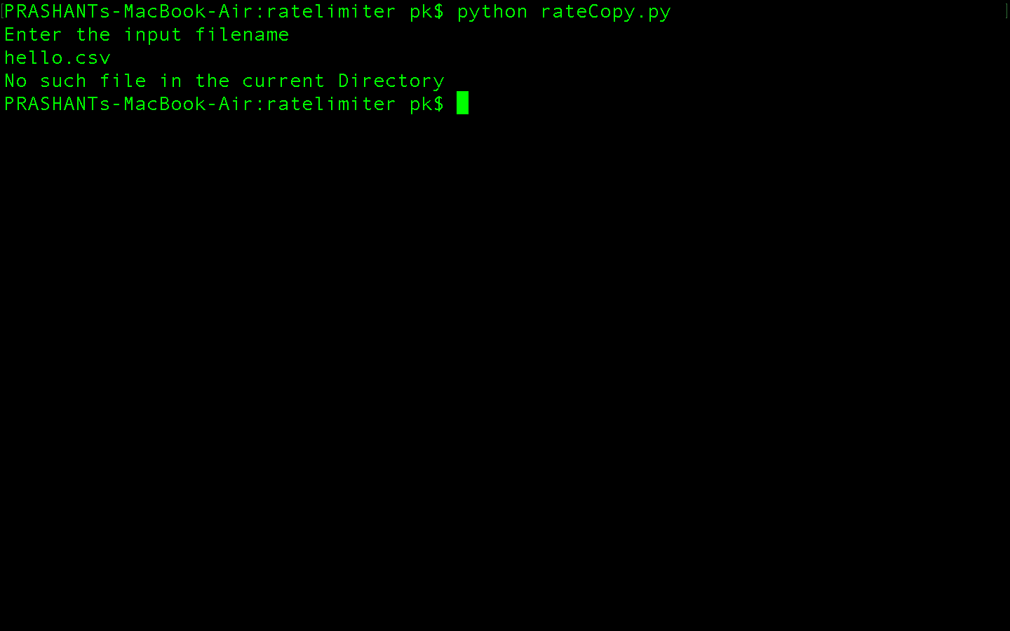

1. If the file exists in the same directory, the output will be shown.

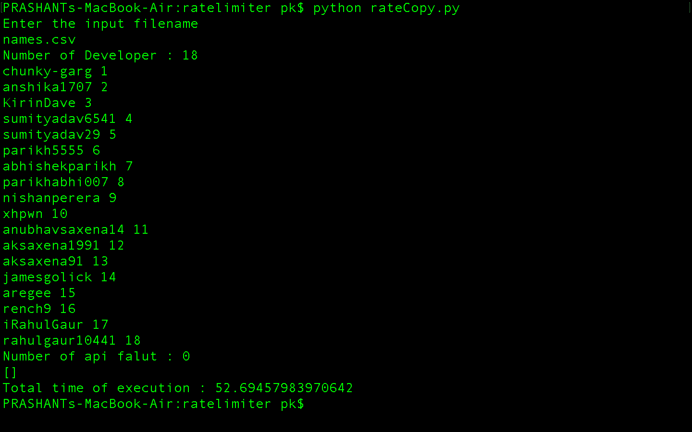

1. After execution of the program, the output file will be present in the same directory with the name **output.csv.**

