**Research Project (IT4010) – Proposal Presentation Justification Sheet**

Name of the Student: Denuwan P.M.K

IT Number: IT22229434

Project ID: 25-26J-396

Title of the Project: Al-Driven Vehicle Health and Service

Intelligence Platform

Individual Component in Brief : Best Garage Recommendation and Repair Time Estimation with Chatbot in Sri Lanka

**1.Knowledge gap (Problem) with novel and creative solution:**In Sri Lanka, vehicle breakdowns and repairs create major inconvenience for drivers due to the lack of transparent, intelligent support systems. One of the most critical challenges is that when a fault occurs—such as engine overheating, drivers must rely on word of mouth, trial and error, or calling multiple garages individually to find available help. This wastes valuable time, creates uncertainty about repair duration, and leaves vehicle owners vulnerable to delays and poor service. Unlike developed countries where predictive maintenance and smart workshop management solutions are emerging, Sri Lanka has no system that intelligently connects drivers, garages, and mechanics in real time.

First, existing garage directories or web-based platforms in Sri Lanka only provide static listings of nearby workshops. They do not predict repair times, estimate waiting delays, or recommend the most suitable garage based on data-driven insights. To address this, my system introduces an AI-powered repair ETA prediction model, which uses car model, fault type, and historical repair data to forecast repair duration—giving users realistic expectations before making a decision.

Second, while some systems (e.g., MyMech) offer mechanic dispatch, they stop at providing on-demand help and lack decision support on whether a vehicle needs a mechanic, a garage, or even towing. My solution integrates a conversational chatbot interface that uses NLP to interpret the driver’s fault description (e.g., “My engine is overheating”) and determine whether the car is drivable, requires a mechanic, or needs a tow. This adds intelligence beyond static options, guiding drivers like a virtual assistant.

Third, no system in Sri Lanka currently ranks garages dynamically. Drivers often choose based only on distance, but this ignores critical factors like job queues, available employees, and user ratings. My solution introduces a multi-criteria garage ranking model that integrates Google Maps (distance/ETA), workforce data, ongoing job queues, repair ETA, and customer reviews to generate a ranked list of the best garages—helping drivers make informed choices.

Finally, most existing solutions do not provide transparency during the repair process. Once a car is dropped at a garage, users have little visibility into progress. My solution bridges this gap with a garage portal where workshops update job progress (In Progress → Completed), and users can track status in real time, similar to food delivery apps.

Therefore, my research contributes by developing Sri Lanka’s first AI-based Garage Recommendation and Repair Time Estimation System with an Intelligent Chatbot Interface. This novel solution combines NLP, machine learning, and location-based services to address repair uncertainty, reduce waiting times, and build trust among vehicle owners, mechanics, and garages.

**2.Compare existing systems and related work:**

Current systems in Sri Lanka and globally offer partial solutions but fail to provide a comprehensive, intelligent platform.

* In Sri Lanka, platforms like *MyMech* only connect users to mechanics with manual descriptions and no predictive features. Similarly, *AA Ceylon Breakdown Service* relies on phone-based reporting with no digital intelligence or real-time transparency.
* Globally, OEM fleet systems (e.g., Mercedes, BMW) offer repair predictions but only within authorized dealer networks, leaving ordinary drivers without access. Uber-style apps like *FixMyCar* or *YourMechanic* provide convenience but lack predictive ETA or intelligent drivability checks. Insurance roadside apps only support emergency dispatch with minimal intelligence.
* None of these systems combine fault interpretation (NLP), predictive repair ETA (ML), multi-criteria garage ranking, and real-time progress tracking in one unified solution.

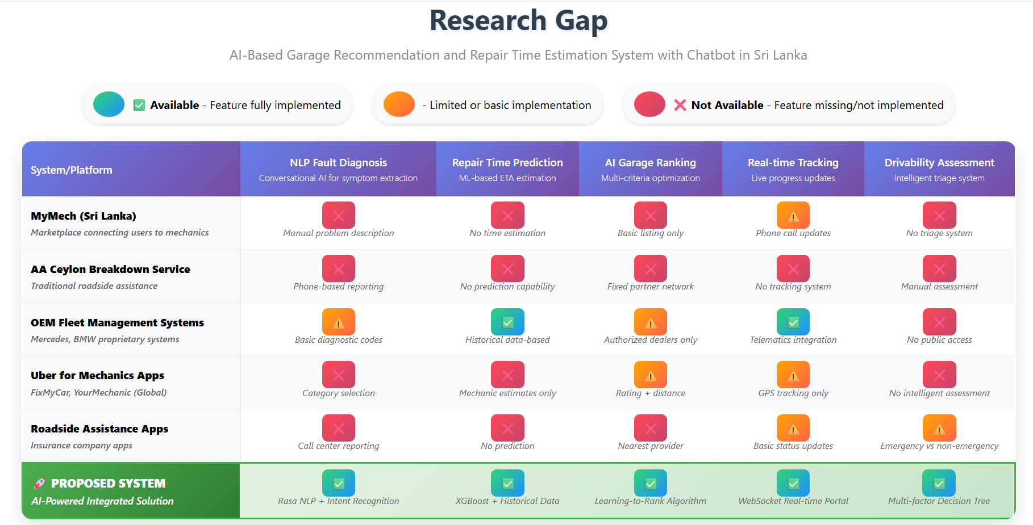

*Diagram 1*

Against this backdrop, our AI-Based Garage Recommendation and Repair Time Estimation System with Chatbot Interface is novel:

* It leverages NLP (Rasa) to extract faults and assess drivability.
* It introduces Sri Lanka’s first ML-powered repair ETA prediction model.
* It ranks garages dynamically using multi-criteria optimization (distance, jobs, employees, ratings, ETA).
* It provides real-time tracking and feedback through a garage portal.
* It bridges the gap by offering both drivable guidance (garage) and non-drivable support (mechanic/tow) in one system.

**3.** **Application of key pillars in the specialized area of knowledge**Our project integrates Machine Learning (ML), Natural Language Processing (NLP), Data Science, and Human-Computer Interaction (HCI).

* ML & Data Science → Used for repair time (ETA) prediction and dynamic garage ranking.
* NLP → Chatbot (Rasa) interprets user fault descriptions (“My engine is overheating”), checks drivability, and routes to garage or mechanic.
* HCI → Ensures a simple, intuitive mobile app and garage portal for easy adoption.
* Location-Based Services → Google Maps API finds nearby garages, routes, and travel ETA.

This combination enables a novel, intelligent platform that goes beyond static garage directories by offering real-time, predictive, and user-friendly assistance.

**4.** **Application of technologies in the relevant key pillar/area**  NLP (Rasa) → Intent recognition & entity extraction for faults, drivability conversations.

* ML – ETA Prediction (Scikit-learn Regression) → Predicts repair time using features: Car model, year, fault category/type, parts, workforce.
* ML – Garage Ranking (Scikit-learn + Weighted Scoring) → Ranks garages on distance, waiting time, available employees, ratings, and ETA.
* Database (MySQL) → Stores car/job/repair history, ratings, and garage details.
* Google Maps API → Retrieves nearest garages, routes, travel ETA.
* React Native → Cross-platform mobile app (drivers).
* Web Portal (Node.js + React) → Garage portal for job updates.

**5.** **High-level System Architecture and identification of self evaluation plan/criteria**

**Modules:**

1. **Chatbot (NLP)** – Captures fault, checks drivability.
2. **ETA Prediction Model** – Predicts repair hours.
3. **Garage Ranking Model** – Scores and ranks garages.
4. **Google Maps API** – Finds distance, travel ETA, routes.
5. **Garage Portal** – Job progress updates.
6. **Database** – Stores job data, ratings, repair times.
7. **Feedback System** – Collects ratings, retrains ML models.

**Self-Evaluation Criteria:**

* **Prediction Accuracy:** Compare predicted ETA vs. actual repair times.
* **Ranking Effectiveness:** % of users choosing top 2 ranked garages.
* **Usability:** User satisfaction surveys.
* **System Latency:** Response time for chatbot + recommendations.  
    
  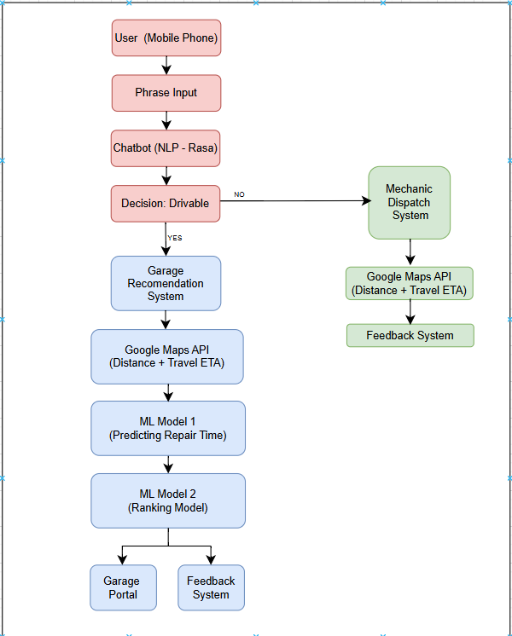

Diagram 2 : System Architecture

**6.** **User Requirements / Functional Requirements**

User (Vehicle Owner):

* Report faults easily (text/voice).
* Receive best garage suggestions with predicted repair time.
* Track repair progress and provide feedback.
* Dispatch mechanic/tow if not drivable.

Garage:

* Simple portal to update job queues & progress.
* Receive more jobs via system recommendations.
* Manage both walk-in and booked customers.

Functional Requirements:

* NLP chatbot for natural conversation.
* ETA prediction model.
* Garage ranking model.
* Integration with Google Maps API.
* Booking, progress tracking, and feedback

**7.** **Work Breakdown Structure (WBS)** 1.Project Management   
 1.1 Requirements   
 1.2 Planning  
 1.3 Risk management.

2.Dataset Development

2.1Collect repair times

2.2 car-fault mappings.

3.ML Development

3.1ETA prediction

3.2 ranking models.

4.Chatbot Development

4.1NLP training with Rasa.

5.Backend Development

5.1 Database

5.2 APIs

5.3 Authentication.

6.Frontend Development

6.1Mobile app (drivers)

6.2Web portal (garages).

7.System Integration

7.1ML

7.2chatbot

7.3Google Maps.

8.Testing & Validation

8.1Accuracy

8.2usability

8.3 latency testing.

9.Deployment

9.1Pilot in Matara Colombo area.

10.Maintenance

10.1Feedback loop

10.2Retraining.