**International Debt Analysis**

A. KPI’s

**1. Number of Distinct Countries:**

SELECT

COUNT(DISTINCT country_name) AS Total_Countries

FROM

ids;

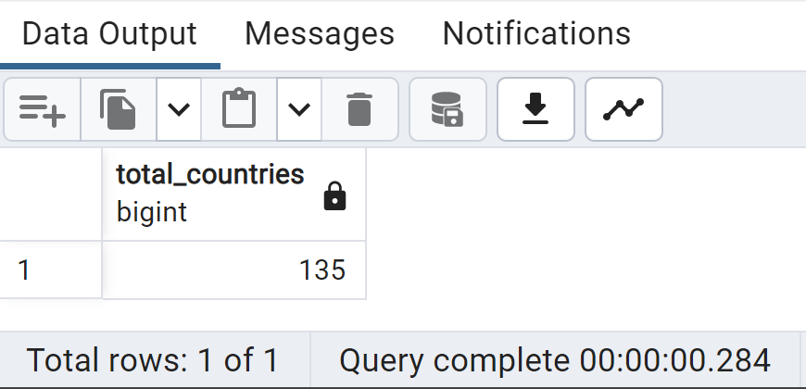

**2. Number of Distinct Debt indicators:**

SELECT

COUNT(DISTINCT series_name) AS total_indicators

FROM

Ids;

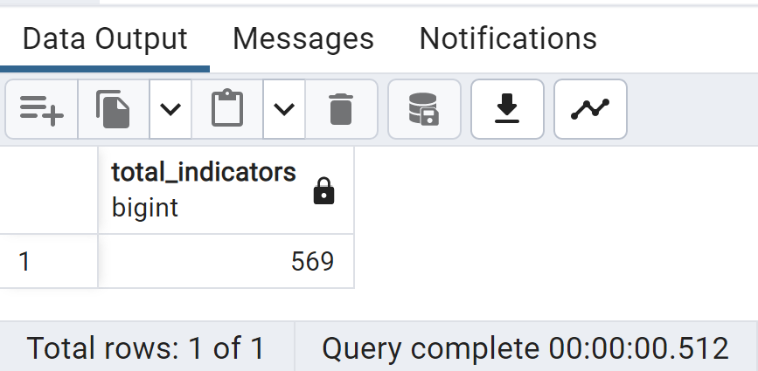

**3.** **Total amount of Debt owed by countries for 2022**

SELECT

country_name, SUM(_2022) AS Total_Debt_2022

FROM

ids

GROUP BY 1

ORDER BY 1;

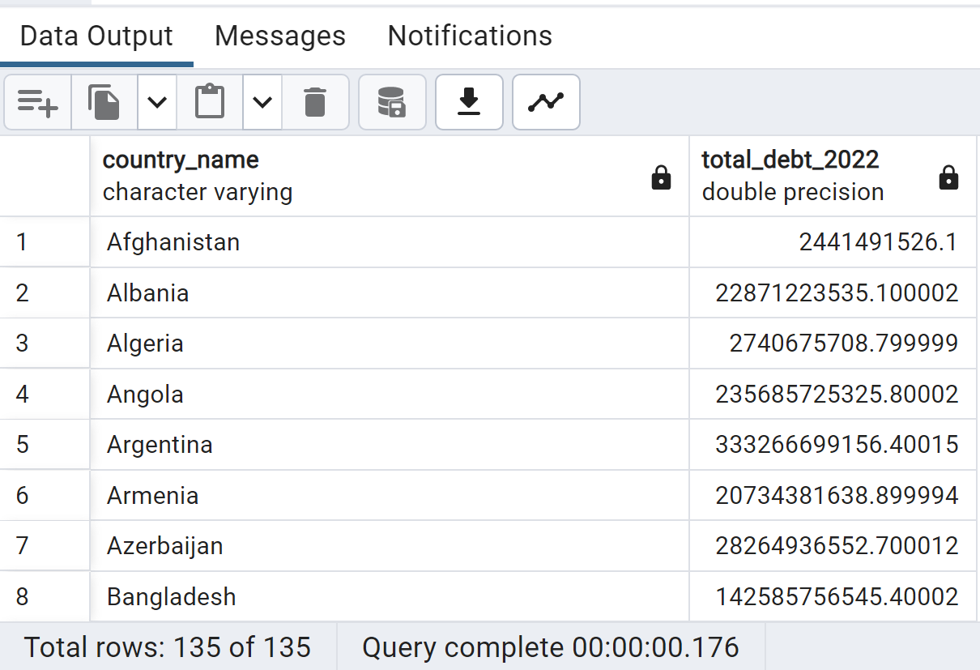

**4.** **Country with highest Total Debt in 2022**

SELECT

country_name, SUM(_2022) AS Total_Debt_2022

FROM

ids

GROUP BY 1

ORDER BY 2 DESC

LIMIT 8;

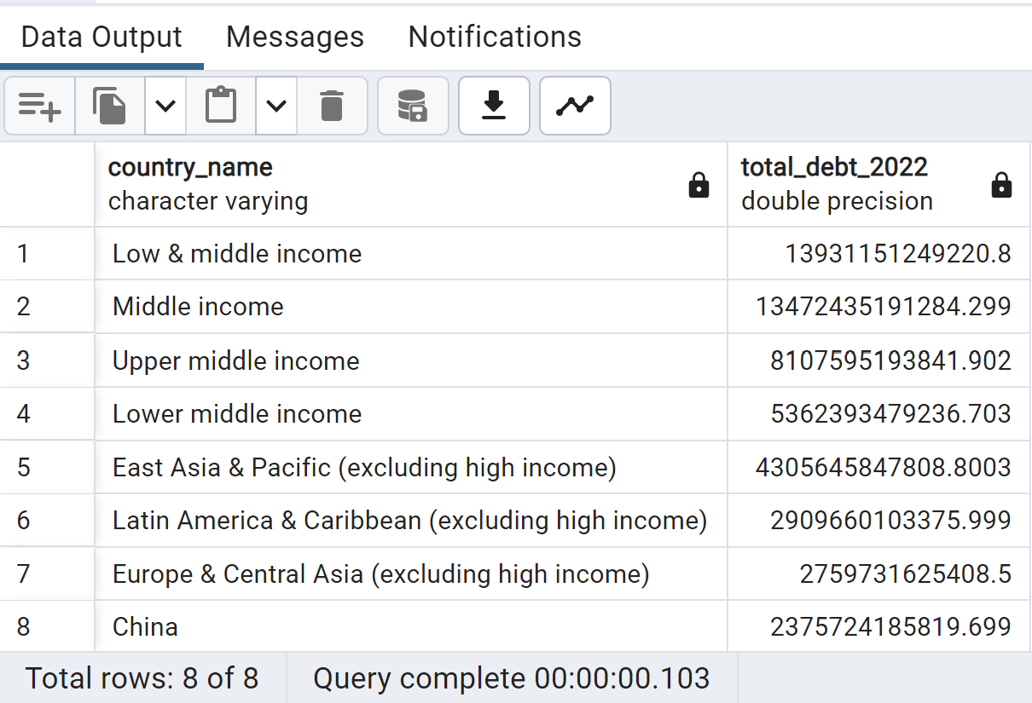

**5.** **Average debt across all indicators for 2022**

SELECT

series_code, ROUND((AVG(_2022))::numeric, 2) AS Average_Debt

FROM

ids

GROUP BY 1

ORDER BY 2 DESC

;

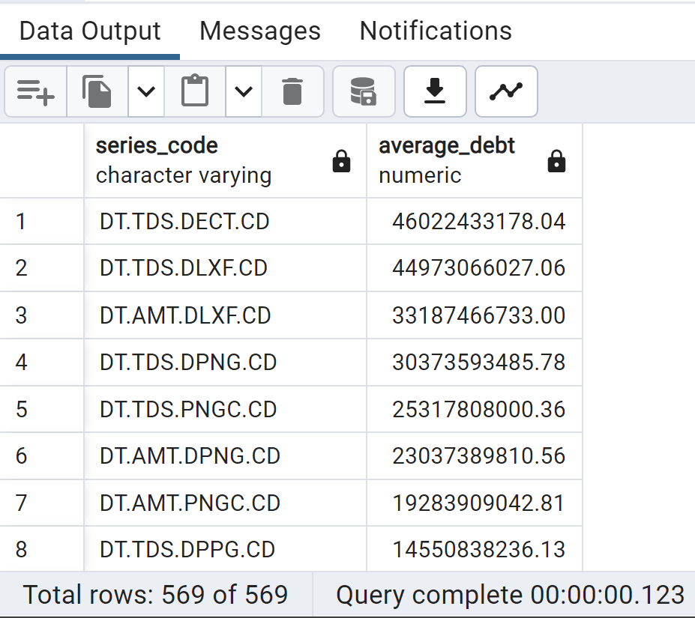

B. Country with the Highest Debt Increase from 2021 to 2022

SELECT

Country_Name, (_2022 - _2021) AS debt_increase

FROM

ids

ORDER BY

debt_increase DESC

LIMIT 25;

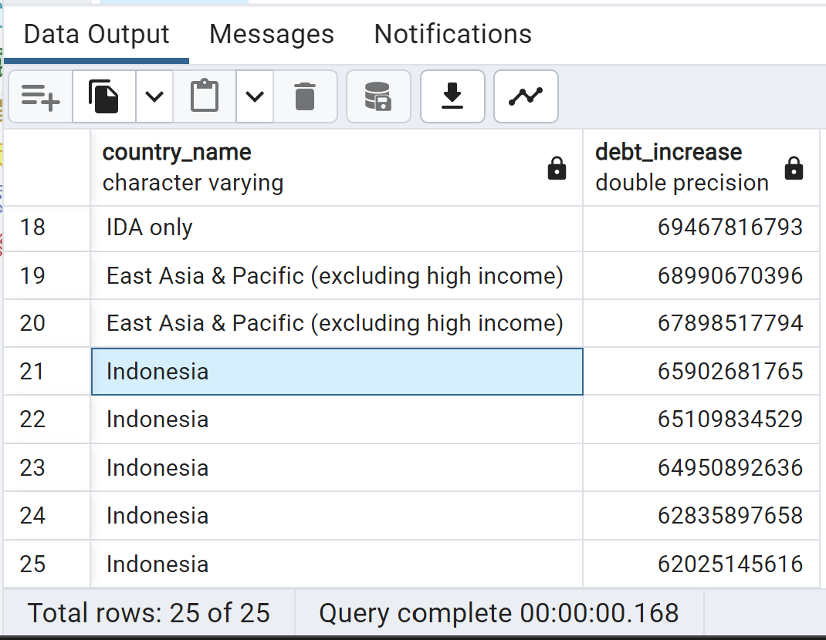

C. Country with the Highest Accumulated Debt Over All Years(2006-2022)

SELECT Country_Name,

(_2006 + _2007 + _2008 + _2009 + _2010 + _2011 + _2012 +

_2013 + _2014 + _2015 + _2016 + _2017 + _2018 + _2019 +

_2020 + _2021 + _2022 ) AS total_accumulated_debt

FROM ids

ORDER BY total_accumulated_debt DESC

LIMIT 25;

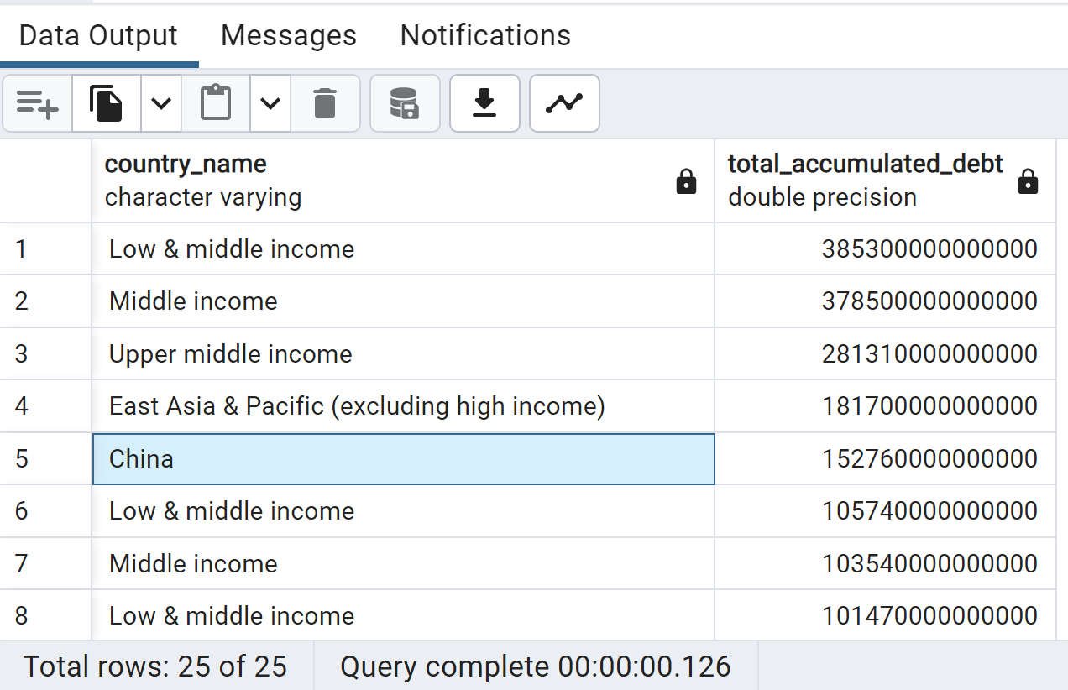

D. Debt Change Percentage between 2021 and 2022 for Each Country

SELECT

Country_Name,

ROUND(((_2022 - _2021) / _2021 * 100)::numeric, 2) AS debt_change_percentage

FROM

ids

WHERE

_2021 != 0

ORDER BY

debt_change_percentage DESC;

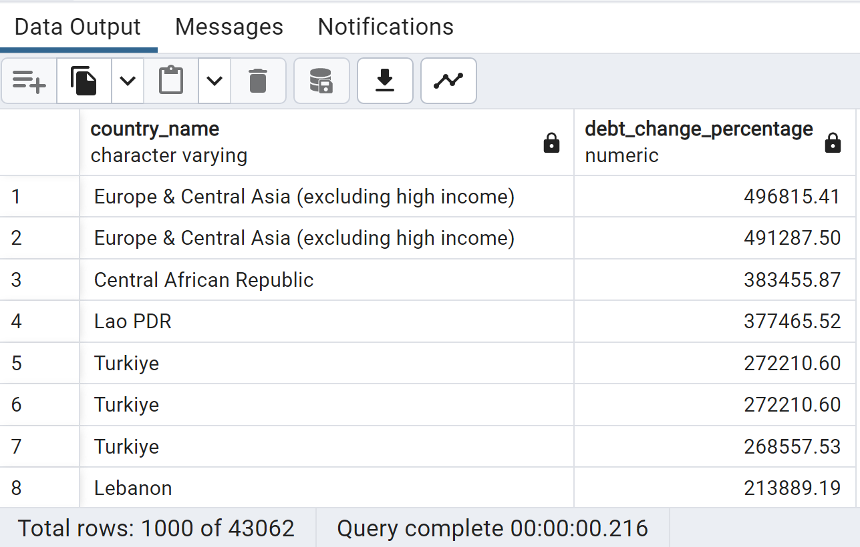

E.