Software Requirements Specification (SRS)

Project: Project Management System (PMS)
Version: 1.0
Authors:
Date: 07-09-2026
Status: Model Answer / Approved

Revision history
Version | Date | Author | Change summary | Approval
1.0 | 07-09-2026 |  | Initial SRS for Project Management System

Approvals
Role | Name | Signature / Email | Date
Course Coordinator

Table of Contents
1. Introduction
2. Overall description
3. External interface requirements
4. System features (detailed)
5. Non-functional requirements (detailed)
6. Quality attributes & Acceptance tests
7. System models and diagrams
8. Requirements Traceability Matrix (RTM)

1. Introduction

1.1 Purpose
The purpose of the Project Management System (PMS) is to provide a simple web-based application for organizing projects, users, tasks, milestones, progress, comments, and basic project reports.

1.2 Scope
The PMS covers user authentication, role-based access, user management, project creation and editing, project member management, task creation and assignment, task priorities and deadlines, task status tracking, milestone management, dashboards, comments, basic reports, and audit logging.

1.3 Audience
Developers, QA Engineers, System Administrators, Project Managers, Team Members, and Assessment Evaluators.

1.4 Definitions
List of acronyms: PMS, RBAC, UI, API, DB, FR, NFR.

2. Overall description

2.1 Product perspective
The PMS is a standalone web-based project management application using a frontend, backend, and database. It provides a central place for users to manage projects, project members, tasks, milestones, progress, comments, and basic reports.

2.2 Major product functions (detailed)
- User and authentication management
- Project management
- Project member management
- Task management
- Task assignment, priority, and deadline management
- Task status tracking and comments
- Milestone management
- Project progress dashboard
- Basic project reporting
- Audit logging

2.3 User roles and characteristics (expanded)
- Admin: manages system users and has administrative access.
- Project Manager: creates and manages projects, members, tasks, milestones, and project progress.
- Team Member: views assigned work, updates task status, and adds task comments.
Users are expected to have basic web application knowledge.

2.4 Operating environment
The PMS is a web-based application accessed through a modern web browser on a standard desktop or laptop. database is used for persistent data storage. No specialized hardware is required.

2.5 Constraints
The system is planned for completion within approximately three weeks. Development will focus on the core requirements in this document. Complex external integrations, advanced analytics, file management, and other enterprise-level features are excluded.

3. External interface requirements

3.1 User interfaces
The application shall provide a login page, dashboard, project pages, task list or board, milestone section, task comment area, notification area, user management page for Admins, and a basic reports view.

3.2 Hardware interfaces
The system does not require specialized hardware. It can be accessed using a standard desktop or laptop computer with a keyboard, pointing device, display, and normal network connectivity.

3.3 Software interfaces
The application shall use a modern web browser for the user interface, an application backend for business logic, and database for persistent data storage.

3.4 Communications
The system shall use normal web application communication between the user interface and backend and shall maintain authenticated user sessions.

4. System features
The following functional requirements are grouped into five core modules. The system contains 17 functional requirements in total.

4.1 User & Authentication Module
This module handles user login, logout, role-based permissions, and administration of user accounts.
Req ID | Requirement | Type | Priority | Source/Stakeholder | Acceptance criteria / Test case ref | Comments / Dependencies
PMS-FR-01 | User Login | Functional | High | Users | Valid credentials allow access | TC-Auth-01
PMS-FR-02 | User Logout | Functional | High | Users | Logout ends the authenticated session | TC-Auth-02
PMS-FR-03 | Role-Based Access Control | Functional | High | Security / Users | Each role can perform only permitted actions | TC-Auth-03
PMS-FR-04 | User Management | Functional | High | Admin | Admin can add, edit, and remove users | TC-User-01

4.2 Project Management Module
This module allows Project Managers to create and edit projects and manage the members assigned to each project.
PMS-FR-05 | Create Project | Functional | High | Project Manager | A project is created with valid basic details | TC-Proj-01
PMS-FR-06 | Edit Project | Functional | High | Project Manager | Project details can be updated | TC-Proj-02
PMS-FR-07 | Manage Project Members | Functional | High | Project Manager | Members can be added or removed | TC-Proj-03

4.3 Task Management Module
This module supports task creation, assignment, priority, deadlines, status updates, and comments.
PMS-FR-08 | Create Task | Functional | High | Project Manager | A task can be created inside a project | TC-Task-01
PMS-FR-09 | Assign Task | Functional | High | Project Manager | A task can be assigned to a project member | TC-Task-02
PMS-FR-10 | Manage Task Priority | Functional | Medium | Project Manager | Task priority can be set or changed | TC-Task-03
PMS-FR-11 | Manage Task Deadline | Functional | Medium | Project Manager | Task deadline can be set or changed | TC-Task-04
PMS-FR-12 | Update Task Status | Functional | High | Project Members | Task status can be To Do, In Progress, or Completed | TC-Task-05
PMS-FR-13 | Add Task Comments | Functional | Medium | Project Members | Members can add and view task comments | TC-Task-06

4.4 Milestone Management Module
This module allows Project Managers to create, update, and track project milestones.
PMS-FR-14 | Create and Edit Milestones | Functional | Medium | Project Manager | Milestones can be created and updated | TC-Mile-01
PMS-FR-15 | Track Milestones | Functional | Medium | Project Manager | Milestone status and progress can be viewed | TC-Mile-02

4.5 Dashboard & Reporting Module
This module displays project progress and provides a basic summary of project and task status.

PMS-FR-16 | View Project Dashboard | Functional | High | All Users | Dashboard shows project progress and task information | TC-Dash-01
PMS-FR-17 | View Basic Project Report | Functional | Medium | Project Manager | Basic project and task status summary is displayed | TC-Report-01

5. Non-functional requirements (detailed)
The following non-functional requirements define quality expectations for the PMS. IDs follow PMS-NFR-###.

Req ID | Requirement | Category | Priority | Acceptance criteria / Measurement
PMS-NFR-001 | Security | Security | High | Authentication and role-based access protect restricted features; TC-Sec-01
PMS-NFR-002 | Availability | Reliability | Medium | System is available for normal project-management use except planned maintenance; TC-Rel-01
PMS-NFR-003 | Usability | Usability | Medium | Users can navigate core workflows with clear and consistent screens; TC-UX-01
PMS-NFR-004 | Maintainability | Maintainability | Medium | Application components are modular and basic documentation is maintained; TC-Maint-01
PMS-NFR-005 | Reliability | Reliability | High | Saved project and task data is retained correctly and common errors do not discard saved data; TC-Rel-02

5.1 Security

5.1.1 Security Objectives
SO-01 Protect Data: Protect user and project information from unauthorized access or modification.
SO-02 Authorized Actions and Accountability: Ensure users can perform only actions permitted by their assigned role and maintain logs of important system activities.

5.1.2 Security Requirements
Req ID | Requirement (shall...) | Type | Priority | Acceptance criteria / Test case ref
PMS-SR-001 | Authentication | Security | High | Protected features require authenticated users; TC-Sec-01
PMS-SR-002 | Password Storage | Security | High | Passwords are stored only in hashed form; TC-Sec-02
PMS-SR-003 | Role-Based Access | Security | High | Admin, Project Manager, and Team Member permissions are enforced; TC-Sec-03
PMS-SR-004 | Logout | Security | Medium | Logout invalidates the user's authenticated session; TC-Sec-04
PMS-SR-005 | Audit Logs | Security | High | Important user, project, and task actions are recorded in audit logs; TC-Sec-05

6. Quality attributes & Acceptance tests
Exit criteria for acceptance: all high-priority functional requirements are implemented and verified; all non-functional requirements are reviewed; the security objectives and security requirements are verified; and no critical defects remain in the core workflows.
Acceptance test suites: Authentication and RBAC, User Management, Project Management, Task Management, Milestones and Dashboard, Comments and Notifications, Reporting, Security, Reliability, and Usability.

7. System models and diagrams

7.1 UML Use-Case diagram
At least 2 UML use-case diagrams shall be included: (1) Authentication, User Management, and Project Management;
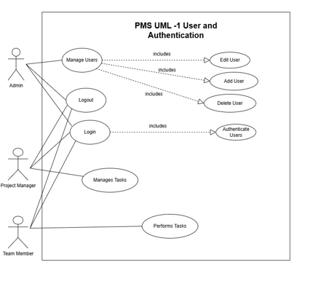
(2) Project and Task Management.
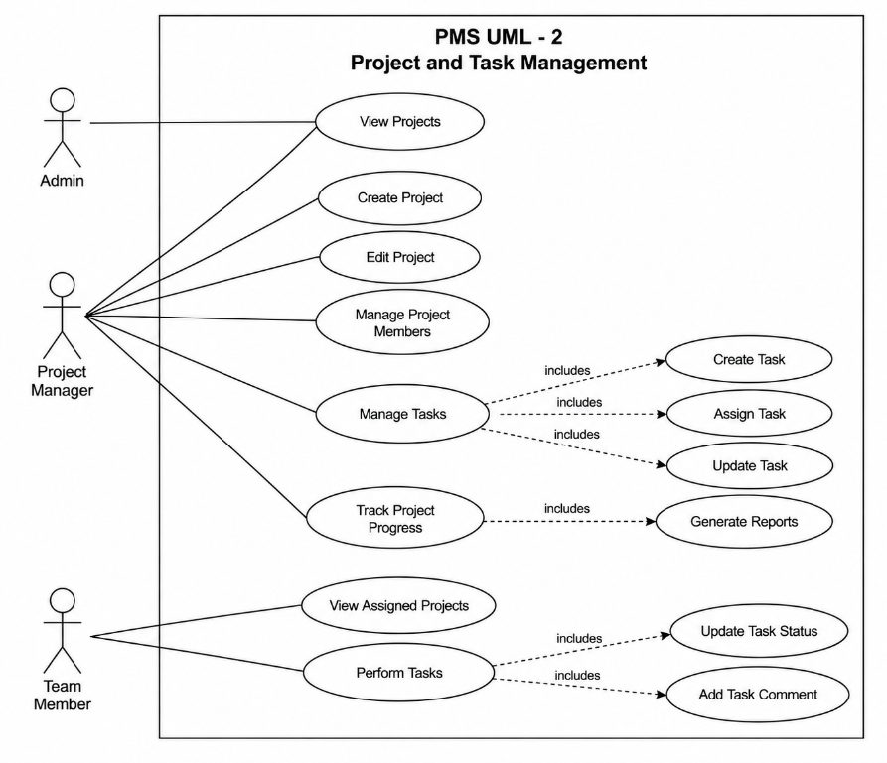

8. Requirements Traceability Matrix (RTM)

Req ID | Requirement short | Section ref / Design Spec | Module | Test case(s) | Status (N/P/A) | Comments
PMS-FR-01 | User Login | 4 / Design | PMS Module | TC-Auth-01 | N
PMS-FR-02 | User Logout | 4 / Design | PMS Module | TC-Auth-02 | N
PMS-FR-03 | Role-Based Access Control | 4 / Design | PMS Module | TC-Auth-03 | N
PMS-FR-04 | User Management | 4 / Design | PMS Module | TC-User-01 | N
PMS-FR-05 | Create Project | 4 / Design | PMS Module | TC-Proj-01 | N
PMS-FR-06 | Edit Project | 4 / Design | PMS Module | TC-Proj-02 | N
PMS-FR-07 | Manage Project Members | 4 / Design | PMS Module | TC-Proj-03 | N
PMS-FR-08 | Create Task | 4 / Design | PMS Module | TC-Task-01 | N
PMS-FR-09 | Assign Task | 4 / Design | PMS Module | TC-Task-02 | N
PMS-FR-10 | Manage Task Priority | 4 / Design | PMS Module | TC-Task-03 | N
PMS-FR-11 | Manage Task Deadline | 4 / Design | PMS Module | TC-Task-04 | N
PMS-FR-12 | Update Task Status | 4 / Design | PMS Module | TC-Task-05 | N
PMS-FR-13 | Add Task Comments | 4 / Design | PMS Module | TC-Task-06 | N
PMS-FR-14 | Create and Edit Milestones | 4 / Design | PMS Module | TC-Mile-01 | N
PMS-FR-15 | Track Milestones | 4 / Design | PMS Module | TC-Mile-02 | N
PMS-FR-16 | View Project Dashboard | 4 / Design | PMS Module | TC-Dash-01 | N
PMS-FR-17 | View Basic Project Report | 4 / Design | PMS Module | TC-Report-01 | N
PMS-NFR-001 | Security | 5 / Quality | Security Module | TC-Sec-01 | N
PMS-NFR-002 | Availability | 5 / Quality | System | TC-Rel-01 | N
PMS-NFR-003 | Usability | 5 / Quality | UI Module | TC-UX-01 | N
PMS-NFR-004 | Maintainability | 5 / Quality | Application | TC-Maint-01 | N
PMS-NFR-005 | Reliability | 5 / Quality | System | TC-Rel-02 | N
PMS-SR-001 | Authentication | 5.1.2 / Security | Security Module | TC-Sec-01 | N
PMS-SR-002 | Password Storage | 5.1.2 / Security | Security Module | TC-Sec-02 | N
PMS-SR-003 | Role-Based Access | 5.1.2 / Security | Security Module | TC-Sec-03 | N
PMS-SR-004 | Logout | 5.1.2 / Security | Security Module | TC-Sec-04 | N
PMS-SR-005 | Audit Logs | 5.1.2 / Security | Audit Module | TC-Sec-05 | N

