SMART INDIA HACKATHON 2026 · SIH26171
PRESENTER'S HANDBOOK
CORDON — on-device visual perception for light-weight browser agents
Slide-by-slide notes · competitor comparison · question bank
READ THIS FIRST
This handbook maps one-to-one onto the six-slide deck. Section 2 is what to SAY for each slide, with timings. Section 3 is every number you may quote and where it comes from — do not quote a figure that is not in that table. Sections 5 and 6 are the question bank: user-facing questions and technical ones. Section 7 lists what we have NOT built, and you must be willing to say it out loud.

The pitch, in one breath
An AI agent has to see your screen to help you — and today that means uploading it. Cordon reads your screen on your own device, replaces every personal value with a typed reference like EMAIL_1, and lets the server plan the work without ever receiving a single value.
The three sentences to memorise
- 1. A 1.2 MB vision model reads the page inside the browser.
- 2. Personal values are swapped for opaque typed handles before anything is sent.
- 3. An independent verifier re-reads the outgoing bytes and can refuse to transmit.

1 · Before you walk in
──────────────────────────────────────────────────────────────────
Who says what
Role | Owns | Must be able to answer
Presenter | Slides 1, 2 and 5 — the story and the impact | Why this matters; who it helps; why it is not an existing product
Technical lead | Slides 3 and 4 — architecture and feasibility | How the model runs in a browser; what the verifier does; the risks
Demo operator | The laptop | Runs the live demo; opens the privacy receipt
Everyone | The numbers in Section 3 | Every figure on every slide

The one-minute setup, before anyone is watching
Three terminals, one browser. Do this while the previous team presents:
- Terminal 1 — npm run build, then reload the extension and check the build stamp matches.
- Terminal 2 — npm run server, left visible. The judge will watch this.
- Terminal 3 — npm run demo.
- Chrome — open http://127.0.0.1:8788/application.html and pin the Cordon icon.
- Side panel — unlock My data. A locked vault means the fill demo does nothing.
THE ONE THING THAT BREAKS DEMOS
If the build stamp in the side panel header does not match what npm run build printed, the extension was not reloaded and you are demoing stale code. Check it every single time.

2 · The nine-minute pitch
──────────────────────────────────────────────────────────────────
HOW THIS SECTION WORKS
Every slide has a wall-clock window, a time budget, and one sentence in a green box that MUST come out of your mouth. If you are running late, cut the detail and say the green box. If you say nothing else on a slide, say that.

Plan A — with the live demo (recommended)
Use this one. A working prototype is our single biggest advantage over other teams at the idea stage, and ninety seconds of it beats three minutes of description.
Clock | Slide | Budget | The job of this segment
0:00 – 0:20 | 1 · Title | 20 sec | State the problem statement. Nothing more.
0:20 – 2:30 | 2 · Idea title | 2 min 10 | The problem, then the whole mechanism in four panels.
2:30 – 4:20 | 3 · Technical approach | 1 min 50 | How it actually runs. Point at the tech, dwell on the diagram.
4:20 – 6:00 | LIVE DEMO | 1 min 40 | Three tasks. Show the receipt. Show the masked face.
6:00 – 7:15 | 4 · Feasibility | 1 min 15 | It already runs — and here is what is not finished.
7:15 – 8:30 | 5 · Impact | 1 min 15 | One real person. Then national alignment.
8:30 – 8:50 | 6 · References | 20 sec | Prior art, and the gap we filled.
8:50 – 9:00 | Close | 10 sec | The three-sentence ending.

Plan B — slides only
Use this if you are told slides only, or the laptop dies. Same nine minutes, redistributed.
Clock | Slide | Budget
0:00 – 0:25 | 1 · Title | 25 sec
0:25 – 3:20 | 2 · Idea title | 2 min 55
3:20 – 5:40 | 3 · Technical approach | 2 min 20
5:40 – 7:15 | 4 · Feasibility | 1 min 35
7:15 – 8:35 | 5 · Impact | 1 min 20
8:35 – 9:00 | 6 · References + close | 25 sec

PACE CHECK — GLANCE AT THE CLOCK AT THESE THREE MOMENTS
At 2:30 you should be leaving slide 2. At 6:00 you should be leaving the demo. At 8:30 you should be on the last slide. If you are more than twenty seconds behind at any of those, drop to the green boxes and keep moving — running over is worse than saying less.

Slide 1 — Title page 0:00 – 0:20 (20 seconds)
MUST BE SAID: “Problem statement SIH26171 — on-device visual perception for browser agents. Our solution is Cordon.”

Read the ID and the title. Do not editorialise, do not preview the solution. The panel is still settling; give them a clean twenty seconds to find your slide.
Slide 2 — Idea title 0:20 – 2:30 (2 min 10 — the most important slide)
MUST BE SAID: “The server plans the work. It never receives a single value.”

0:20 – 0:45 · Open with the problem, not the product
“An AI agent has to see your screen to help you. Every browser agent today solves that by uploading the screen — your passwords, your face, everything. That single fact is the ceiling on what anyone will let an agent do.”
0:45 – 1:40 · Walk the four panels, left to right, pointing at each
- What you see: “This is what you see. Your email, your password, your photo.”
- What we send: “This is everything we send. The email became EMAIL_1. The password was removed — not masked, never read. The face was blacked out in the pixels.”
- Server replies: “The server plans the step using EMAIL_1. It never learns the address.”
- Your browser: “And your browser swaps the handle back and types the real value.”
1:40 – 1:50 · Pause, then land the line under the diagram
“The server plans the work. It never receives a single value.”
Actually pause before this sentence. It is the thesis of the entire project and it needs a beat of silence in front of it.
1:50 – 2:15 · The two columns — one line each, do not read them all
“That addresses the problem statement directly: the screen is read on the device, only structure leaves, and a verifier can refuse to send. What is new is the handle itself — because it is stable, the server can tell two fields hold the SAME email without ever learning it.”
2:15 – 2:30 · Close on the green box
“And this is not a concept. It runs today. A 1.2 megabyte model, 92 percent of every screen never analysed, perfect precision and recall on our PII test set, and most steps send zero bytes.”
Slide 3 — Technical approach 2:30 – 4:20 (1 min 50)
MUST BE SAID: “The model runs inside the browser, and only structure and placeholders ever cross the line.”

2:30 – 3:00 · The stack — point, do not read
“A TypeScript extension. ONNX Runtime Web on WebGPU with a CPU fallback. A 1.2 megabyte face detector running inside the browser. And on the server, an open-weights model — Llama or Qwen through vLLM — so it is offline deployable, as the problem statement requires.”
3:00 – 3:50 · The architecture diagram — this is where the time goes
- “Content script reads the page. Service worker holds the vault — the web page has no route to it at all. And the model lives in an offscreen document, because WebGPU is not available to service workers.”
- “Everything below this red line is about ten kilobytes of structure and handles. No values. Ever.”
3:50 – 4:10 · The efficiency argument — judges score this at 20 percent
“We do not run the model on every frame. We work out which pixels the page structure already explains, and look only at what is left — images, canvases, anything the DOM cannot describe. That is how 92 percent of a screen is never analysed at all.”
4:10 – 4:20 · The proof box, bottom right
“Every claim on this slide is reproducible. One command prints our precision and recall; another verifies the model loads and its outputs match our code.”
LIVE DEMO 4:20 – 6:00 (1 min 40 — rehearse this until it is muscle memory)
MUST BE SAID: “Watch the server terminal. Nothing left the machine.”

Three tasks only. Do not improvise, do not browse, do not explain the UI. Have the page and the panel already open before you start talking.
Clock | Do this | Say this
4:20 | Task: save draft | “Watch the server terminal. Nothing. That step never left the machine.”
4:45 | Task: what sensitive data is on this page? | “Every personal value on the page is now a placeholder.”
5:10 | Expand ‘What was sent’ | “This is the literal text we transmitted. Read it — the email and the password are not in there.”
5:35 | Point at the masked face on the page | “And the model found that face in the pixels. The page only says it is an image.”

IF THE DEMO FAILS — DECIDE IN FIVE SECONDS, DO NOT FIGHT IT
Say: “Let me show you the same thing without the browser,” switch to the terminal and run npm run eval. It prints precision, recall, the checksum arbitration and the verifier results in about two seconds. You lose twenty seconds and no credibility. Wrestling a laptop for a minute loses both.

Slide 4 — Feasibility and viability 6:00 – 7:15 (1 min 15)
MUST BE SAID: “It already runs — and here is the one thing we have not finished.”

6:00 – 6:30 · Feasibility is easy for us, so say why
“Feasibility is straightforward here because it is already built. The model is smaller than most web fonts. It needs no new hardware. And there is no third-party code inside the privacy boundary at all.”
6:30 – 6:50 · Sustainability — a scored criterion most teams skip
“It is built entirely on open standards, the server model is open-weights so there is no vendor lock-in, and perception costs us no GPU because it runs on the client.”
6:50 – 7:15 · The risks column — do NOT skip this
“We have named seven risks and what we do about each. And the last one is honest: our Firefox build compiles from the same codebase, but we have not loaded it yet.”
WHY YOU VOLUNTEER THE GAP
Judges are testing whether you know your own weaknesses. A team that names a gap before being asked is believed on everything else. A team caught hiding one is believed on nothing. This costs you eight seconds and buys the whole panel.

Slide 5 — Impact and benefits 7:15 – 8:30 (1 min 15)
MUST BE SAID: “Data minimisation is not our policy — it is our transport format.”

7:15 – 7:50 · One real person, not four categories
“Take someone applying for a scholarship on a government portal. Today, letting an agent fill that form means uploading their Aadhaar. With Cordon the number never leaves the phone. The server is told only that an Aadhaar-shaped value exists, and which box it belongs in.”
7:50 – 8:10 · Then widen — quickly
“The same holds for banking forms, for hospitals and legal offices, and for blind users who need an agent to read the page for them without surrendering the screen.”
8:10 – 8:30 · National alignment — land this one properly
“Under the DPDP Act, data minimisation is usually a policy promise. Here it is the transport format — the server is structurally incapable of receiving the data. And because the model is open-weights and self-hosted, there is no foreign API anywhere in the loop.”
Slide 6 — Research and references 8:30 – 8:50 (20 seconds)
MUST BE SAID: “Nobody else puts a verifier in front of the network call. That gap is what we built.”

Do not read the list. It exists to prove you did the reading. Use the twenty seconds for one point only:
“We surveyed the prior art. Computer-use agents upload the screen. Redaction tools work server-side, after the data has already left. Password managers fill locally but cannot reason. Nobody puts a verifier in front of the network call — and that gap is what we built.”
Close 8:50 – 9:00 (10 seconds)
MUST BE SAID: “The server does its job on a page it has genuinely never seen.”

“Every browser agent today asks you to upload your screen. We built the one that does not have to — so the server does its job on a page it has genuinely never seen. Thank you.”

3 · Every number you may quote
──────────────────────────────────────────────────────────────────
RULE
If a figure is not in this table, do not say it. Every row below is either measured by a command anyone can run, or a property of a file in the repository. Inventing a number is the fastest way to lose a panel's trust.

Measured — reproducible on the spot
Figure | What it means | How to prove it
1.21 MB | Size of the on-device vision model | ls the file: ultraface-320.onnx
92.0% | Share of a screen the model never analyses | npm run eval
1.000 / 1.000 | PII precision and recall on our test set | npm run eval
5 of 9 | Benchmark tasks resolved with zero network calls | npm run eval
84.8 ms | Model inference, CPU single-thread (faster on WebGPU) | npm run model-check
4,420 → ≤24 | Candidate boxes reduced by NMS | npm run model-check
310,000 | PBKDF2 iterations protecting the local vault | crypto.ts
~10 KB | Typical sanitized payload per step | Side panel, bytes sent
0 bytes | Sent when a step resolves on the device | Side panel + server log

Architectural — true by construction, not benchmarked
Claim | Why it is true
Passwords are never read into the payload | The redactor emits sensitive:true and never touches the value. Not masking — absence.
Masks are irreversible | Black is composited INTO the bitmap and re-encoded. Original pixels stop existing.
The page cannot reach the vault | Zero storage references in content scripts; the vault lives in the service worker.
Exactly one network call exists | One fetch in the extension, and the verifier stands in front of it.
No third-party runtime code in the boundary | ONNX Runtime Web is the only dependency, and it sits in the offscreen document.

4 · How Cordon compares to what exists
──────────────────────────────────────────────────────────────────
HOW TO USE THIS SECTION
Each comparison is a chart followed by a plain-language explainer. Learn the EXPLAINERS, not the charts — if you understand why each row is true, you can answer a question that is worded differently. Reciting a table cannot survive a follow-up question.

AND BE HONEST ABOUT WHAT THIS IS
These are ARCHITECTURAL comparisons: what each design can and cannot do, taken from public documentation. We have NOT run anybody else's product and we have not benchmarked anyone. If a judge presses, say exactly that: “This compares what each approach is capable of by construction, not lab results.” Never invent a competitor's number.

Who we are comparing against
The four approaches | What it is | Real examples
CORDON — ours | Reads the screen on your device, sends only structure | This project
Computer-use agents | Take a screenshot, send it to a model, act on the reply | Browser-automation agents, RPA tools
Server PII tools | Detect and mask personal data — on a server | Presidio-class redaction services
Password managers | Store credentials locally and autofill them | Browser and third-party password tools

A · How much of you leaves the machine
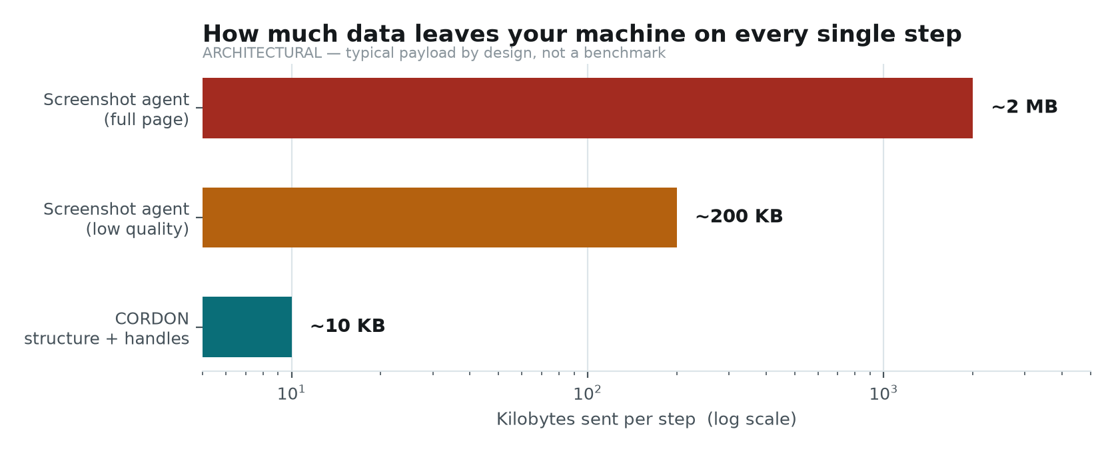
Typical payload per step. Log scale — each gridline is ten times the previous one.
▸ We send about 10 KB. A screenshot agent sends 200 KB to 2 MB.
In plain words: We send a list of what is on screen — roles, labels, positions — plus placeholders. They send the actual picture of your screen.
Why it matters: It is not just bandwidth. A screenshot contains everything visible: your name, the email in your inbox behind the form, the document open in the next tab. Our list contains none of it because it was never a picture in the first place.
If they push back: “Couldn't they just compress the screenshot?” — Compression changes the size, not what is in it. A 50 KB screenshot still shows your face.
B · What actually crosses the boundary
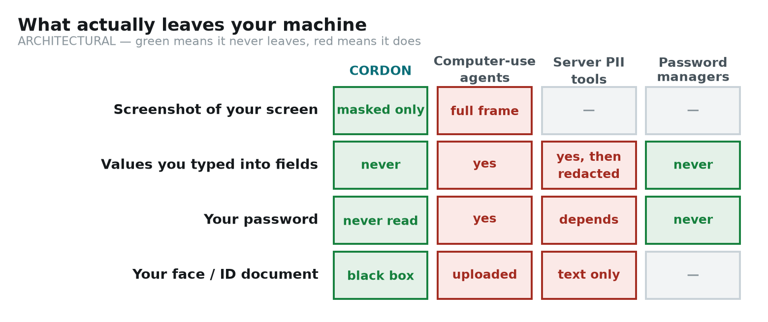
Green means it never leaves your machine. Red means it does.
▸ Your typed values never leave. Theirs do.
In plain words: When you type your email into a form, we replace it with the label EMAIL_1 before anything is sent. A screenshot agent sends the pixels showing your email.
Why it matters: This is the whole idea in one row. The server can still plan — it knows there is an email field and which one — but it cannot read, store, leak or be subpoenaed for a value it never received.
If they push back: “So the server is working blind?” — Not blind, anonymous. It sees the shape of the page perfectly. It just cannot see the contents of the boxes.
▸ Your password is never even read.
In plain words: Most systems mask a password — they read it, then hide it. We never read it. The payload says the field is sensitive and stops there.
Why it matters: You cannot leak what you never held. There is no masked copy sitting in memory, no debug log with it in, no bug that could accidentally include it.
If they push back: “How does it log me in then?” — It does not. Password autofill is off by default; you type it, or your password manager does. The agent handles everything around it.
▸ Faces and ID documents are blacked out in the pixels themselves.
In plain words: The model finds the face on your machine and paints solid black over that rectangle, into the image, before the image is re-encoded.
Why it matters: The original pixels stop existing in the file we send. This is different from drawing a box on top, or blurring — both of those can be undone.
If they push back: “Why not blur, like the problem statement suggests?” — Blur and pixelation can often be partially reversed with image processing. Solid black destroys the information. It is a deliberate upgrade on the example, not a shortcut.
C · WHEN the data gets cleaned — the part people miss
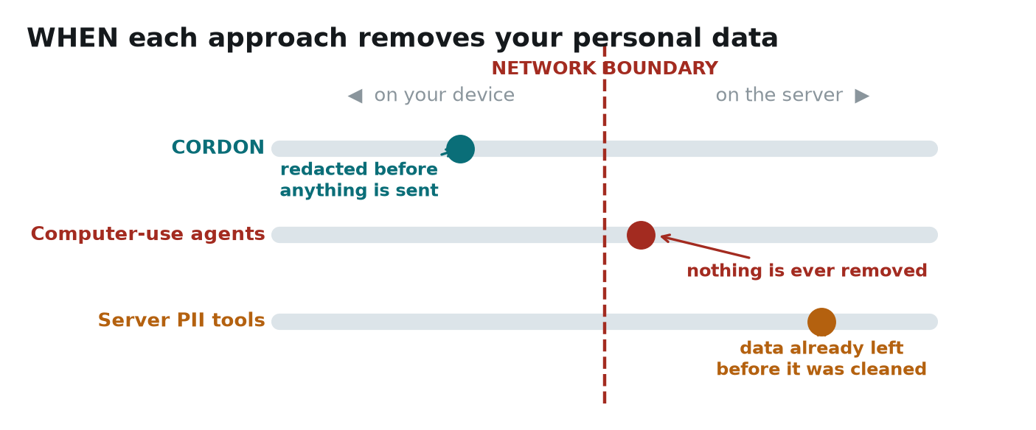
The dashed line is the moment data leaves your computer. Position on the line is what matters.
▸ We redact BEFORE the network call. Server tools redact after.
In plain words: A server-side redaction tool has to receive your data in order to clean it. By the time it acts, the data has already crossed the internet and landed on someone else's machine.
Why it matters: Their protection is about what gets STORED. Ours is about what gets SENT. If the connection is intercepted, or that server is breached, or the operator is compelled to hand over logs, server-side redaction protects nothing.
If they push back: “Surely the connection is encrypted anyway?” — TLS protects it in transit. It does not protect it once it arrives, and it does nothing about who runs the server.
D · Which part of the job runs where
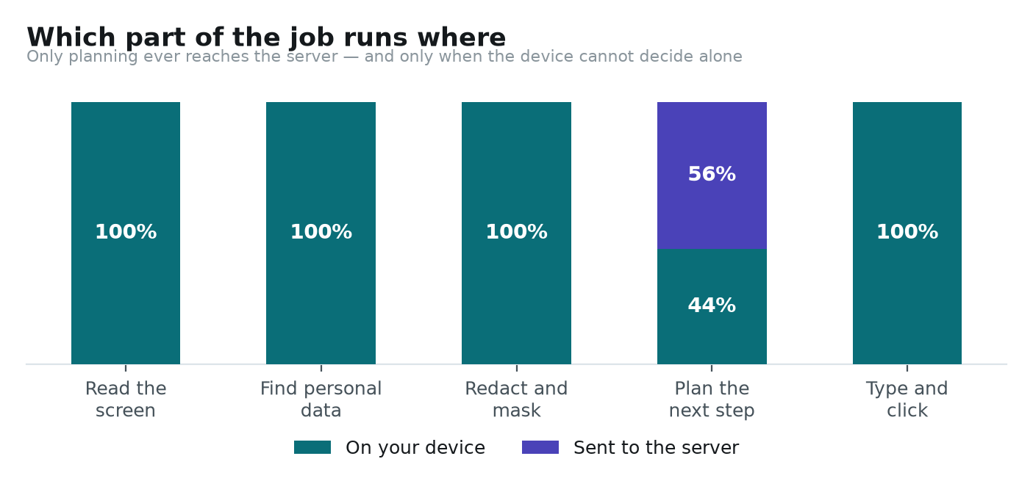
Only planning ever reaches the server — and only when the device cannot decide alone.
▸ Reading, detecting and redacting are 100% on your device.
In plain words: The screen is read locally. Personal data is found locally. Redaction happens locally. Only the decision about what to do next may go out.
Why it matters: This is what the problem statement asks for in so many words: the local model reads the screen and takes the decision, and sends to the server only if it must.
If they push back: “Why send anything at all?” — Because the statement itself says a laptop cannot host a full reasoning pipeline. We put exactly the part that needs weight on the server, and nothing else.
▸ In our benchmark, 5 of 9 tasks needed no server at all.
In plain words: “Click Submit” is unambiguous. The device just does it — no network, no redaction work, about fifteen milliseconds.
Why it matters: It is a privacy win and a speed win at once. The steps that never leave cannot leak, and they cost no round trip.
If they push back: “Is 5 of 9 representative?” — It is our benchmark set of nine tasks, and we say so. The proportion moves with the task; the mechanism does not.
E · Safety features, present or absent
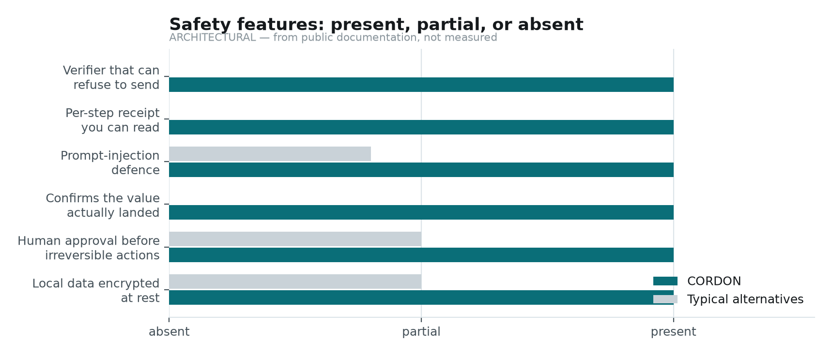
Six safety behaviours. Most alternatives have none of them.
▸ A verifier that can refuse to send.
In plain words: A separate piece of code, sharing nothing with the redactor, re-reads the exact bytes about to go out and can stop the send.
Why it matters: Redaction is code and code has bugs. Everyone else logs what they redacted. We check it afterwards, independently, and abort if it is wrong.
If they push back: “What if the verifier has a bug too?” — Then it fails closed: on any failure it re-redacts harder, re-checks twice, and if still unsure refuses to transmit at all.
▸ A receipt for every step, showing the exact bytes.
In plain words: Open the side panel and read the literal JSON we sent. Not a summary — the actual text.
Why it matters: It converts a privacy claim into something checkable. A judge does not have to believe us; they can read it.
If they push back: “Couldn't you show a fake receipt?” — The same payload goes to the server, and the server terminal logs its size and content class. Compare the two on screen.
▸ Prompt-injection defence that does not rely on the model behaving.
In plain words: A hostile page can hide text telling the AI to leak your email. Our defence is that each value type is bound to the kinds of field it may enter — an email cannot go into a comment box.
Why it matters: Everyone else defends by wording the prompt more firmly. That is asking the model not to be fooled. Ours works even when it is fooled, because the client refuses.
If they push back: “What if the page mislabels a comment box as an email field?” — A large free-text area is disqualified as a PII sink regardless of its label.
▸ It confirms the value actually landed.
In plain words: After typing, we read the field back and compare. Websites revert values, truncate them, or reformat them silently.
Why it matters: An agent that assumes success fills half a form wrongly and submits it. Ours reports the step as failed instead.
If they push back: “Does that mean you keep a copy of the value?” — Only the verdict travels: verified yes or no, a reason, and a character count. That is why the panel shows 9/13 chars rather than the text.
F · Our own measured numbers
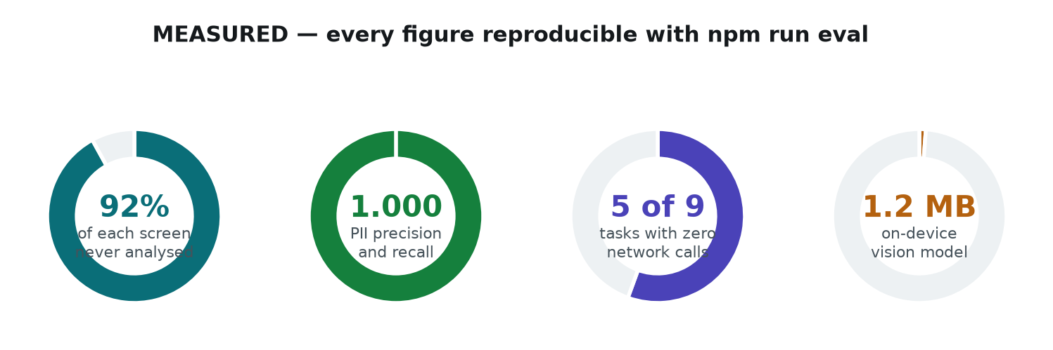
MEASURED — reproducible in about two seconds with npm run eval.
These four are ours and ours alone — no competitor is implied. They are also the only figures on the deck that came from running something rather than reading documentation. If a judge asks you to prove one, run the command.
The one-sentence version of this whole section
SAY THIS IF YOU ONLY GET ONE SENTENCE
Everyone else either uploads your screen and hopes the server behaves, or cleans the data after it has already arrived. We clean it before it leaves, and we check our own work before we send — so the server does its job on a page it has genuinely never seen.

5 · Question bank — user-oriented
──────────────────────────────────────────────────────────────────
Non-technical questions, from judges, users, or anyone at the stall. Answer in plain language. Never say “it's encrypted” and stop there — say what that protects against.
Q. Is my data actually safe if I type it into a browser extension? [trust]
Yes, and here is precisely why. Your details are encrypted on your own machine with AES-256, under a key made from a passphrase only you know. The web page you are visiting cannot reach it — that is enforced by the browser, not by us being careful. And it is never included in anything sent to our server. You can open the panel and read the exact bytes we transmit.
Q. Where exactly is my data stored? [storage]
In the extension's own encrypted storage on your device. Not in a cloud account, not on our server, not in a file any website can open. The encryption key lives only in memory and disappears when you close Chrome, so even the encrypted copy cannot be read until you unlock it again.
Q. What happens if I forget my passphrase? [storage]
The data is gone. There is no recovery and no back door — if we could recover it, so could someone else. The interface warns you about this before you commit to a passphrase.
Q. Can I see what the agent typed into the form? [transparency]
Yes. The side panel has a section called “What the agent entered” listing every field it filled. Values are hidden by default, because a side panel is often on screen while other people are around, and you press Show to reveal one.
Q. How do I know it really removed my password before sending? [trust]
Open the privacy receipt for that step and expand “What was sent”. It shows the literal text that crossed the boundary. Read it — your password is not in there. It is not hidden or starred out; the field simply says sensitive: true, because the value was never read.
Q. What if it fills in the wrong thing, or fills the wrong box? [safety]
Two protections. Before typing, the agent checks that the field is the right kind for that value — an email can only go into something that is actually an email field. After typing, it reads the field back and compares. If the value did not land correctly the step is marked failed, not quietly assumed to have worked.
Q. Will it submit something without asking me? [safety]
No. Anything irreversible — submit, pay, delete, confirm — always stops and asks for your explicit approval, however confident the model is.
Q. Does it work on any website, or only your demo pages? [scope]
Any website. The extension runs on all URLs. Our demo pages exist so we can show specific situations on cue — an ID photo, a blank form — not because it needs them.
Q. Do I need internet for this to work? [offline]
For part of it, no. Reading the screen, finding personal data and redacting it all happen on your machine. In our benchmark five of nine tasks finish without any network call at all. Complex planning does need the server.
Q. Is this slower than a normal AI agent? [performance]
For simple actions it is much faster, because there is no round trip at all — a click resolves in about fifteen milliseconds. For complex steps it is comparable, because we send about ten kilobytes of structure instead of a full screenshot.
Q. Who can see my face if I upload a photo? [vision]
Nobody outside your device. The model finds the face on your machine and paints solid black over it, into the actual image, before anything is sent. We do not blur — blur can often be undone.
Q. What does your company get out of my data? [trust]
Nothing, because we never receive it. There is no per-user data stored on the server at all. That is not a policy we are promising to follow — the system is built so the server cannot receive it in the first place.
Q. Why should I trust you more than a big company's assistant? [trust]
Do not trust us — check. Every step produces a receipt with the exact bytes we sent. You can read it yourself. That is a different kind of assurance from a privacy policy you have to take on faith.

6 · Question bank — technical
──────────────────────────────────────────────────────────────────
Expect these from the technical judge. Where a number is involved, quote from Section 3 only. Where we have not built something, say so.
Q. Why not run the LLM locally as well? Then nothing leaves at all. [architecture]
Because the problem statement says the local system cannot host a full pipeline — that is the premise we are given. Practically, a three-billion-parameter model is roughly two gigabytes of weights in a browser tab, which would destroy the client-resource metric. So the split is deliberate: vision on the client, reasoning on the server.
Q. Is it really a Vision Transformer? [model]
No, and we are careful to say so. UltraFace is a convolutional network. The problem statement asks for a Vision Transformer OR an equivalent computer vision model, and a CNN qualifies. We chose it because it is 1.2 megabytes rather than a hundred, and metric four grades client resource use. A ViT-Tiny crop classifier is planned work, not a claim.
Q. If you already have a vision model, why do you need the DOM at all? [architecture]
They answer different questions at wildly different costs. An input of type password is certain and free to identify; recognising a password field from pixels is neither. The DOM handles what it can explain, and vision runs only on what it cannot — images, canvases, custom widgets. That is how 92% of a screen goes unanalysed.
Q. How does the server plan anything if it cannot see values? [protocol]
It sees structure and types. It knows element el_7 is a textbox labelled Email that holds EMAIL_1, and that el_9 is a password field whose value was removed. Planning “fill the email box” needs the type, not the value. Because handles are stable, it can also tell that two fields hold the same email — a relationship it does need.
Q. What stops the model from just asking for the raw email? [security]
It has no channel to. The response schema only accepts a handle or a string the server itself composed, and the server screens its own output for anything that pattern-matches as real PII. Even if it asked, the client would have nothing to give — the server never received it.
Q. How do you defend against prompt injection from a hostile page? [security]
Structurally, not by persuasion. Each handle carries an allowedSinks rule binding its class to the kinds of field it may be written into. An email handle cannot be typed into a comment box, and a large free-text area never qualifies as a PII sink. Even a completely fooled model cannot cause exfiltration, because the client refuses to resolve the handle there.
Q. How is redaction precision measured, and why does it matter? [metrics]
Metric three grades precision of redaction, so blanking a paragraph to hide one email costs marks. We use Range.getClientRects to mask exactly the matched characters, and the detector's own box plus a four-pixel margin for regions. Our harness reports mask IoU, over-redaction rate and leak rate.
Q. How do you keep PII precision at 1.000 without hurting recall? [detection]
Checksums, mostly. Order number 1234567890 and Phone 9876543210 are identical to a regex. But a twelve-digit number failing Verhoeff is not an Aadhaar, and a sixteen-digit number failing Luhn is not a card. That is hard negative evidence at almost no cost, so we can search aggressively and still prove when we are wrong.
Q. What is your fusion rule when detectors disagree? [detection]
Noisy-OR over calibrated probabilities, with two thresholds. Above 0.80 we redact; below 0.35 we keep; between them a context tie-break decides using label proximity, checksum outcome, container role, repetition and task relevance.
Q. Why is the model in an offscreen document rather than the service worker? [architecture]
Because MV3 service workers do not expose WebGPU, or a DOM, or canvas. The offscreen document is the only extension context that has them. It receives frames and returns coordinates — it has no access to the vault and no network access.
Q. What happens when WebGPU is unavailable? [runtime]
ONNX Runtime Web falls back to WASM with SIMD, and we request the providers in that order. The fallback is tested, not aspirational. Fast mode completes a task with no vision at all.
Q. How does the agent avoid clicking the wrong element after a re-render? [execution]
Grounding. Before every action we re-derive a stability signature from the element's role, accessible name and rounded geometry, and compare it to what the plan was made against. On a mismatch the action is discarded and the page re-read, rather than clicking whatever now occupies that position.
Q. How do you know a value actually entered the field? [execution]
We read it back and compare. Six failure modes are covered and tested: exact match, reformatting by an input mask, reversion by a framework, truncation by maxlength, a different value entirely, and a dashed card mask. A fill that did not stick is reported as failed. Only the verdict travels — never the value.
Q. Walk me through the verifier. [security]
Six checks, sharing no code with the redactor. V1 re-scans the serialised bytes with the full pattern battery. V2 asserts no vault plaintext appears anywhere, including URLs and alt text. V3 re-samples the masked bitmap to confirm every mask actually painted. V4 sweeps for high-entropy strings that are not known handles. V5 is a deny-by-default key whitelist. V6 escalates: re-redact harder, re-verify twice, then abort rather than send.
Q. What crypto, and what are its limits? [security]
AES-256-GCM under a PBKDF2-SHA256 key at 310,000 iterations. GCM authenticates, so a wrong passphrase fails cleanly rather than returning plausible garbage. The key sits in session storage — memory-backed, wiped when the browser closes. The honest limit: an attacker with code execution inside the extension while it is unlocked could read the key. Against the page, the network and disk theft, it holds.
Q. Which server model, and is it really offline deployable? [server]
We speak the OpenAI-compatible chat API, which vLLM, Ollama and llama.cpp all expose. So the same code runs against Qwen2.5-VL or Llama-3.2-Vision self-hosted, with no vendor SDK. If the model is unreachable or replies badly, it falls back to a rule-based planner rather than stalling the agent.
Q. What is your end-to-end latency? [performance]
It depends on the route, and that is the point. A locally resolved step is about fifteen milliseconds with no network at all. A server step is dominated by the round trip, because we send roughly ten kilobytes rather than a screenshot. The panel shows per-stage timings live.
Q. How would this scale to a million users? [scale]
Perception, detection and redaction all run on the client, so the fleet only ever sees the escalated fraction, at about ten kilobytes per step. There is no per-user data stored server-side — which is also why there is nothing to breach.

7 · What we have NOT built
──────────────────────────────────────────────────────────────────
SAY THESE BEFORE YOU ARE ASKED
Volunteering a gap costs you nothing and buys credibility for everything else. Being caught hiding one costs you the panel.

Not built | Status | How to say it
Local NER model | Phase 3 | “Two of our four detectors are live. Names in free prose need NER — that is next.”
OCR on image text | Phase 3 | “We detect that a document is present; reading text out of it is the next detector.”
ViT-Tiny crop classifier | Phase 3 | “We run a CNN detector today. A ViT classifier on crops is planned.”
Firefox build tested | Untested | “It compiles from the same codebase with its own manifest. We have not loaded it yet.”
Labelled set for metric 1 | Open | “Our PII numbers are measured. Screen-understanding accuracy needs a labelled corpus — that is our largest remaining gap.”
Full form automation | Partial | “Standard fields fill reliably. Unusual labels with no autocomplete attribute still miss, and we are extending the classifier.”

How to answer “so it does not really work yet?”
“It works end to end today — you can watch it read a page, find personal data, mask a face, send a censored map, and act on the reply. What is unfinished is breadth: more detectors, more browsers, a larger test corpus. We chose to build one complete path rather than four partial ones, because a working loop can be extended and a scaffold cannot.”

8 · The live demo
──────────────────────────────────────────────────────────────────
# | Do | Say | Proves
1 | Open application.html, click Cordon | “It is reading the page now.” | On-device perception
2 | Task: save draft | “Watch the server terminal. Nothing. That step never left the machine.” | Local-first routing
3 | Task: what sensitive data is on this page? | “Every personal value is now a handle.” | Detection and redaction
4 | Expand “What was sent” | “Read it. The email and password are not there.” | The privacy claim, checkable
5 | Replace the photo with a real one | “The DOM only knows there is an image. The model finds the face.” | The vision model
6 | Unlock My data, open job-form.html | “Dashed boxes mean my device has a value ready.” | Local profile vault
7 | Task: fill this form from my profile | “The server decided which slot goes where without seeing any of them.” | Handles end to end
8 | Open “What the agent entered” | “And I can audit exactly what it typed.” | User transparency
9 | Task: submit application | “Irreversible actions always stop for a human.” | Safety policy

IF THE DEMO BREAKS
Do not fight it. Say: “Let me show you the same thing without a browser” and run npm run eval. It prints the precision and recall, the checksum arbitration, the coverage map result and the verifier checks in about two seconds. A team with a fallback looks prepared; a team wrestling a laptop does not.

9 · One-page cheat sheet
──────────────────────────────────────────────────────────────────
If you remember nothing else
- The line: The server plans the work. It never receives a single value.
- The numbers: 1.2 MB model · 92% of screen skipped · 1.000 precision and recall · 0 bytes most steps
- The three firsts: Handles keep meaning · vision only where the page is opaque · a verifier that can refuse
- The gaps: Local NER, OCR, Firefox testing, and a labelled screen corpus.
Words to use, and words to avoid
Say this | Not this | Why
equivalent CV model | Vision Transformer | UltraFace is a CNN. The PS allows equivalents; claiming a ViT invites a question you lose.
solid masking | blurring | Blur is partially reversible. We deliberately do better than the PS example.
the value was removed | the password is masked | It was never read into the payload at all. Absence, not concealment.
unidentifiable | invisible | The server does learn that a field exists. The PS's own word is unidentifiable.
architectural comparison | benchmark | We have not run competitors' code. Say what the comparison actually is.

Three sentences to close on
“Every browser agent today asks you to upload your screen. We built the one that does not have to. The model reads your page on your own machine, your data is replaced with references before anything is sent, and a verifier checks the bytes and can refuse — so the server plans your work without ever receiving a single value of yours.”

