Here is a detailed outline of **Patient Demographic Reports** typically generated within a Patient Management System to provide comprehensive insights for clinical, administrative, and strategic decision-making:

**Detailed Patient Demographic Reports**

**1. Patient Population Overview Report**

* **Purpose:** Summarizes overall patient demographics to understand the population served.
* **Key Data Fields:**
  + Total number of active patients
  + Breakdown by age groups (e.g., 0-18, 19-35, 36-60, 60+)
  + Gender distribution (Male, Female, Other)
  + Ethnicity or race (if collected)
  + Blood group distribution
  + Geographic distribution (city, state, country)
  + Patient types (inpatient, outpatient, emergency)
* **Typical Filters:** Date of registration range, geographic area, patient type
* **Use:** Hospital planning, resource allocation, public health reporting

**2. New Patient Registration Report**

* **Purpose:** Tracks newly registered patients over a selected time period.
* **Key Data Fields:**
  + Number of new registrations daily/weekly/monthly
  + Demographic breakdowns of new patients (age, gender, location)
  + Source of registration (walk-in, online portal, referral)
  + Insurance coverage status (insured vs uninsured)
* **Use:** Trends analysis in patient inflow, marketing effectiveness, operational readiness

**3. Age and Gender Distribution Report**

* **Purpose:** Shows the distribution of patients by age and gender groups, critical for clinical service tailoring.
* **Key Data Fields:**
  + Detailed age brackets with patient counts
  + Gender ratios per age bracket
  + Median and average age statistics
* **Visuals:** Bar charts, population pyramids
* **Use:** Epidemiological insights, staffing, and specialty service planning

**4. Geographic Distribution Report**

* **Purpose:** Visualizes patient origins for regional service delivery evaluation.
* **Key Data Fields:**
  + Patient counts by city, ZIP/postal code, or region
  + Heatmaps indicating patient density areas
  + Demographics breakdown by region
* **Use:** Outreach program planning, location-based service optimization

**5. Patient Status and Type Report**

* **Purpose:** Categorizes patients based on their current status and care type.
* **Key Data Fields:**
  + Number of active vs inactive or archived profiles
  + Patient classification: inpatient, outpatient, emergency, referral, follow-up
  + Trends in status changes (e.g., number admitted/discharged in a period)
* **Use:** Hospital occupancy and operational reporting

**6. Blood Group and Allergy Summary Report**

* **Purpose:** Summarizes patient blood group distribution and allergy status.
* **Key Data Fields:**
  + Blood group counts and percentages
  + Patients flagged with critical allergies (type and frequency)
* **Use:** Blood bank planning, emergency preparedness

**7. Insurance Coverage and Demographics Report**

* **Purpose:** Details insurance types and coverage across patient demographics.
* **Key Data Fields:**
  + Percentage of insured vs uninsured patients
  + Insurance provider breakdown
  + Coverage types mapped to demographic groups
* **Use:** Financial planning, eligibility verification process optimization

**8. Special Population Reports**

* **Purpose:** Identify demographic subsets requiring specialized care.
* **Examples:**
  + Pediatric patient demographics
  + Geriatric patient groups
  + Patients with chronic diseases or specific conditions by demographics
* **Use:** Tailored healthcare programs and resource allocation

**9. Patient Demographic Trends and Changes Report**

* **Purpose:** Analyzes how patient demographics evolve over time.
* **Key Data Fields:**
  + Month-over-month or year-over-year changes in patient counts by demographic slices
  + Patient turnover rates (new vs exited patients)
* **Use:** Strategic planning, forecasting patient needs

**Additional Considerations for Patient Demographic Reports**

* **Data Privacy:** Ensure compliance with healthcare data protection laws (HIPAA, GDPR).
* **Visualization:** Use charts, heat maps, and tables for clear communication of demographic trends.
* **Export Options:** Enable report exports in PDF, Excel, or dashboard formats for sharing with management.
* **Filtering & Segmentation:** Allow dynamic filtering by dates, regions, patient types, and other criteria.
* **Automation:** Schedule automated generation for routine monitoring.

design specific templates and dashboard mockups

design specific templates and dashboard mockups

Here is a detailed design outline for specific templates and a dashboard mockup tailored for Patient Demographic Reports in a Patient Management System. This design supports clear visualization and analysis of patient population data for clinical, administrative, and strategic use.

**Patient Demographic Reports Dashboard Template**

**Layout Overview**

* **Top Filter Panel:**
  + Date Range Selector
  + Patient Type Dropdown (Inpatient, Outpatient, Emergency)
  + Region/City Selector
  + Search Box (for quick filtering)
* **Summary Metric Cards:**
  + Total Active Patients
  + New Registrations This Month
  + Percentage Insured vs. Uninsured
  + Average Patient Age
* **Visual Charts Section:**
  + **Age and Gender Distribution Bar Chart**
    - Displays number of patients by age groups (0-18, 19-35, 36-60, 60+) split by Male, Female, Other.
  + **Geographic Distribution Heatmap or Choropleth Map**
    - Highlights patient density across cities or regions.
  + **New Patient Registrations Over Time Line Chart**
    - Monthly new registrations trend across the past 12 months.
  + **Insurance Coverage Pie or Donut Chart**
    - Shows insured vs uninsured proportions.
  + **Blood Group Distribution Bar Chart**
    - Patient counts by each blood group (A+, A-, B+, etc.).
* **Detailed Data Table:**
  + Displays key demographic fields for each patient or aggregate by demographic group.
  + Columns such as Age Group, Gender, City, Insurance Status, Blood Group, Registration Date.

**Example Visual for Age and Gender Distribution**

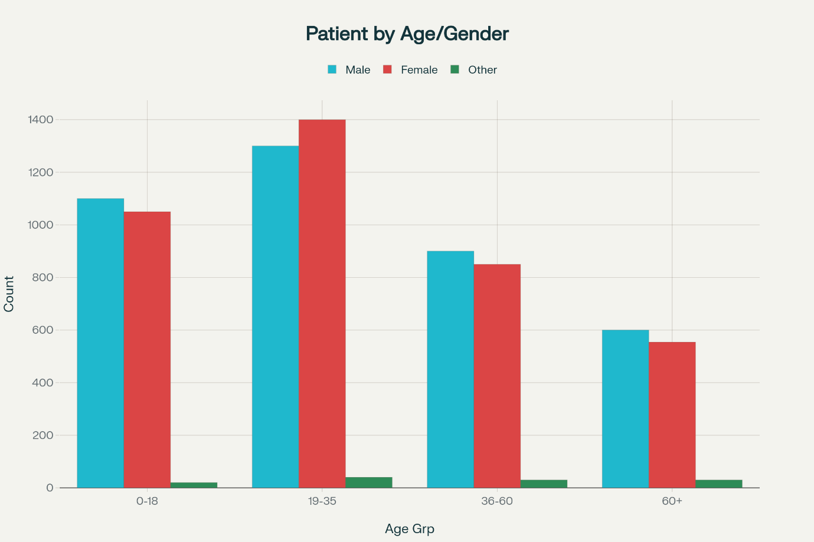

Dashboard mockup template for Patient Demographics Reports with visual charts and tables

This chart clearly differentiates patient counts by gender and age brackets, making it easier to identify demographic trends and focus areas.

**Dashboard Features and Usability**

* User-friendly interface with clear navigation and tooltips for each chart.
* Interactive filtering dynamically updates all visualizations and tables.
* Export options for PDF or Excel reports.
* Responsive design for desktop and tablet access.

This template design ensures that healthcare administrators and clinicians can quickly grasp comprehensive demographic insights to guide resource allocation, patient care strategies, and outreach programs. If you want, I can proceed to create additional specific report templates or detailed UI mockups for other report types like Medical History or Billing.