**MIDDLE EAST TECHNICAL UNIVERSITY**

**ELECTRICAL AND ELECTRONICS ENGINEERING DEPARTMENT**



**EE462 UTILIZATION OF ELECTRICAL ENERGY**

**EE464 STATIC POWER CONVERSION – II**

**SOFTWARE PROJECT**

**REPORT**

**Design of a SM-PMSM Variable Frequency Drive with Matlab/Simulink**

**Due Date: 02.06.2019**

**Team Members:**

**İven GÜZEL 2030831**

**Huzeyfe HİNTOĞLU 2093920**

Table of Contents

1. INTRODUCTION 3

2. PART A: Pre-design Stage 3

3. PART B: Sinusoidal PWM 5

4. PART C: Space Vector PWM (SVPWM) 6

5. PART D: Component selection and verification 6

6. CONCLUSION 6

References 6

# INTRODUCTION

In this project, we are asked to design a SM-PMSM Variable Frequency Drive using Matlab/Simulink. The available supply is a three-phase AC source (50 Hz, 400Vl-l) and the PM is a surface-mount motor.

The motor ratings of the surface mount PM synchronous machine (SM-PMSM);

* 𝑃𝑛𝑜𝑚𝑖𝑛𝑎𝑙=80 𝑘𝑊
* 𝑇𝑛𝑜𝑚𝑖𝑛𝑎𝑙=300 𝑁𝑚
* 𝑛𝑚𝑎𝑥 =7000 𝑟𝑝𝑚
* Pole number: p=8
* 𝐹𝑙𝑢𝑥 𝑙𝑖𝑛𝑘𝑎𝑔𝑒: 𝜆𝑃𝑀= 0.2 Vs (Wb-t)
* 𝐿𝑑=𝐿𝑞= 500 µH
* 𝐼𝑛𝑜𝑚𝑖𝑛𝑎𝑙= 250 𝐴 (peak)
* Phase resistance: 𝑅𝑠=50 mOhm
* Equivalent inertia of the system: 𝐽𝑒𝑞= 10 kg m2

3-phase full-bridge diode rectifier is connected to the grid. The 3-phase motor drive inverter is

connected to the diode rectifier as shown in Figure 1.

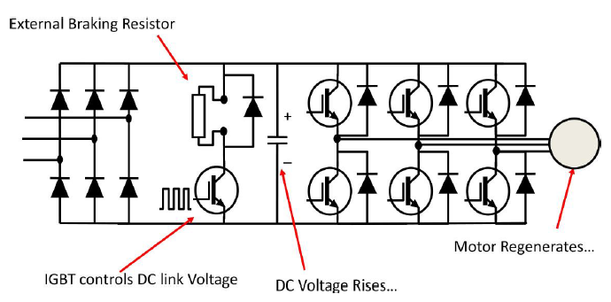

Figure 1: The model used in overall schematic of the Motor Drive in Open-Loop configuration

Starting with pre-design, rated values are to be calculated. Then, a suitable DC-Link capacitor is chosen according to created Simulink model illustrated in Figure 3.

Later on, Sinusoidal PWM method with current and speed controller using id-iq parameters are implemented with our own designed Clarke-Park transformation subcircuits. Then, some analysis using the data obtained from Voltage, Current, Speed etc. are performed. In these analysis, different load-characteristics and speed requirements are implemented.

After finishing the Sinusoidal PWM analysis, Space Vector PWM method is applied with readily available blocks. Then, 2 methods are compared and differences are discussed.

Finally, component selection and verification part is finished. Designed system is realized using the commercially available components. While choosing the components, application notes are used heavily. The characteristics for each component are analyzed and components are chosen accordingly. Efficiency is calculated and the drive is completed.

# PART A: Pre-design Stage

1. Rated torque of the motor is Tnominal, 300Nm. Rated speed of the motor is found by (1) and (2).
$$P_{nominal}=T_{nominal}* ω_{m } \left(1\right)$$

$$ω_{m}=\frac{P_{nominal}}{T_{nominal}}=\frac{80000}{300}=266.67 \frac{rad}{s} \left(2\right)$$

2. The maximum applied electrical frequency is found by (3).

$$f_{e}=\frac{n_{max}}{60}*pp=\frac{7000}{60}*4=466.67 Hz (3)$$

In LV applications where the inverter output is in between 380-460Vrms, IGBT voltage class in low-level inverter topology is 1200V. In Figure A.1, total semiconductor losses as a function of carrier frequency can be seen. [1]. Choosing FF200R12KS4 as our IGBT and 2000W as a reasonable loss we decided to use 5000Hz. In this case mf is given by (4). Since we are operating below mf =21, mf should be an odd integer. To have mf approximately equal to 11, we chose fs as **5130Hz.**

$$m_{f}=\frac{5000}{466.67}=10.71 (4)$$

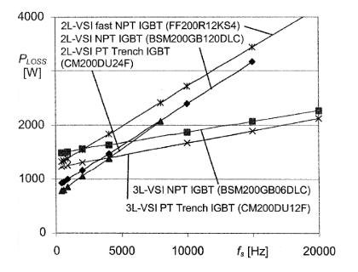

Figure 2: Total semiconductor loss as a function of carrier frequency

1. In this part we are required to find the suitable DC link capacitor for the rectifier output so that the DC input of the inverter will be 540V. Equivalent resistance at the rated current is 2.16Ω. The rectifying circuit and voltage output waveform can be seen in Figure A.2 and 3, respectively. DC link capacitor is 1mF as it can be seen output voltage is oscillating around 540V. However, 1mF is already is a big value.

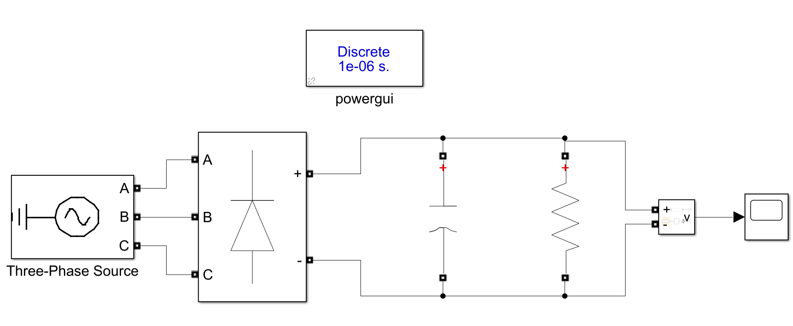

Figure 3: Simulink circuit of the rectifier

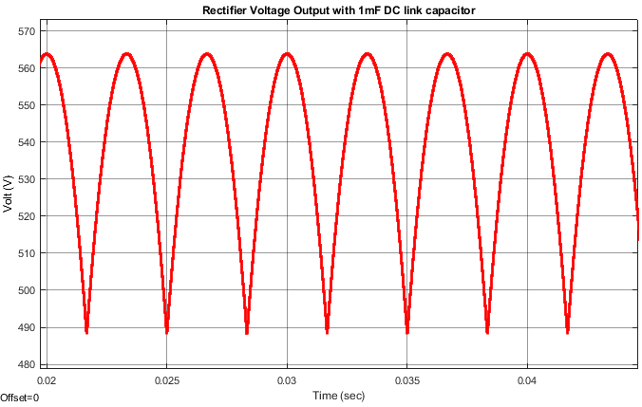

Figure 4: Output voltage of the rectifying unit

# PART B: Sinusoidal PWM

In this part, we are asked to implement a SMPMSM motor drive using sinusoidal PWM scheme. The controller must adjust the rotor speed according to the reference value and set a current limit to the nominal value using id, iq parameters. This motor drive can be seen in Figure B.1. Subsystem details in the given Simulink model can be observed in the slx. files uploaded to ODTUClass.

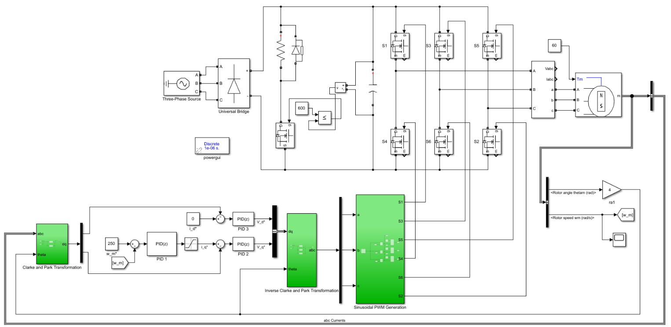

Figure 5: Detailed Simulink model of the SPWM motor drive

1. %90 of the rated speed is found using the equation (5).

Now, apply the %90 rated speed to rated speed at rated current while driving a constant torque load of 60Nm.

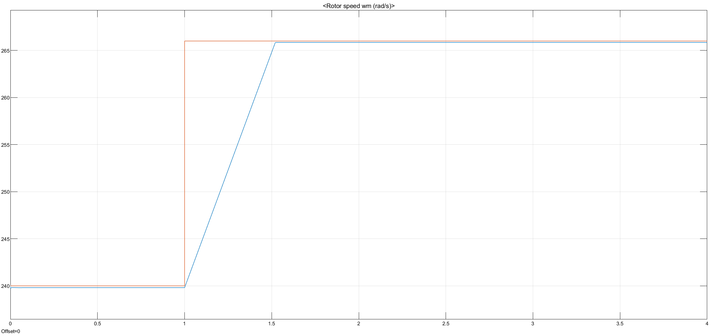

Figure 6: Applied input and Speed vs Time plot

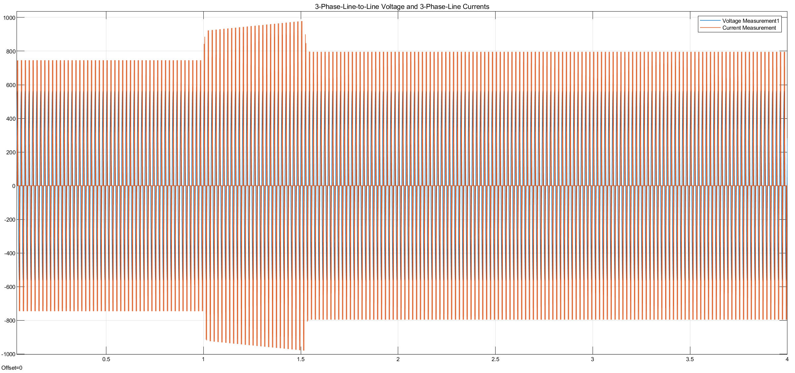

Figure 7: 3-phase line-to-line voltages and currents vs time plot

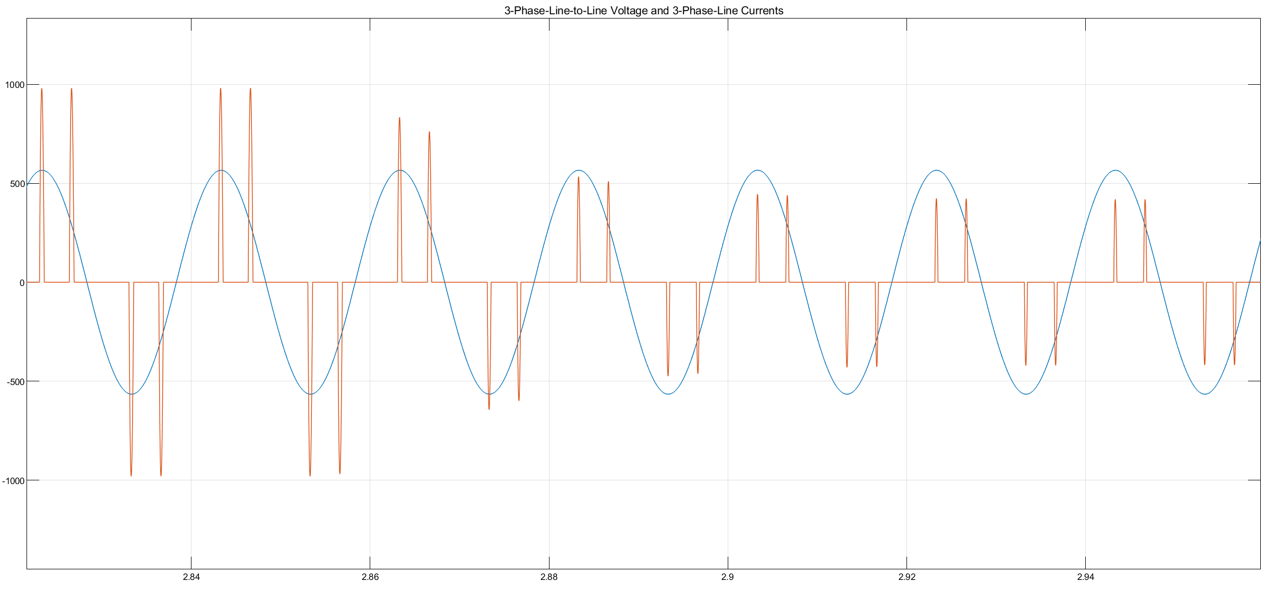

Figure 8: 3-phase line-to-line voltages and currents vs time plot zoomed in

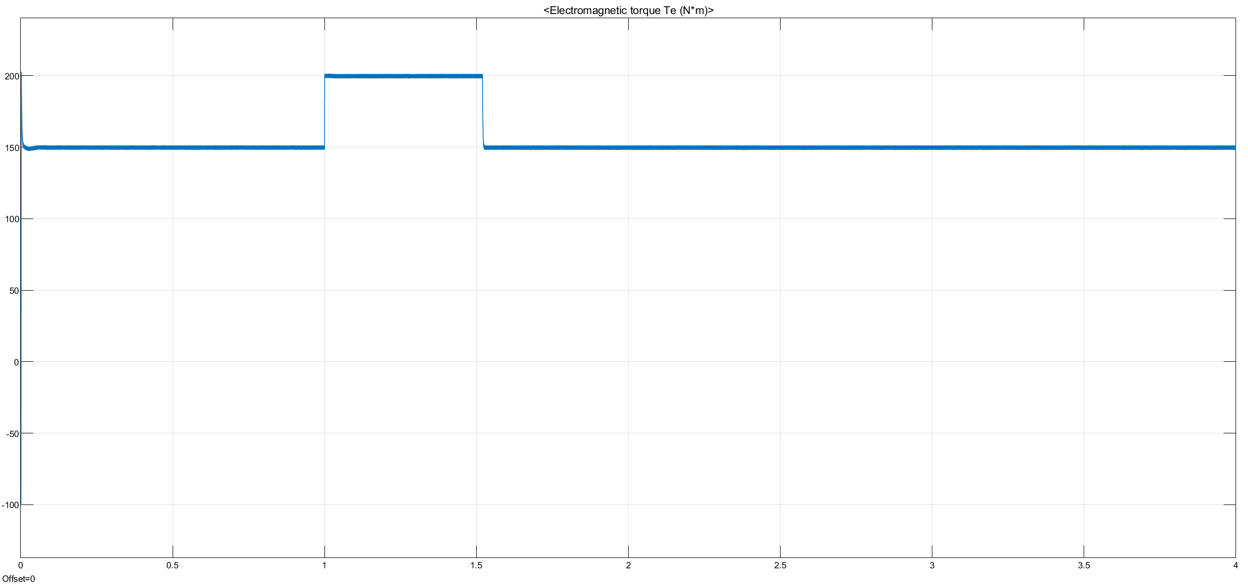

Figure 9: Torque vs time plot

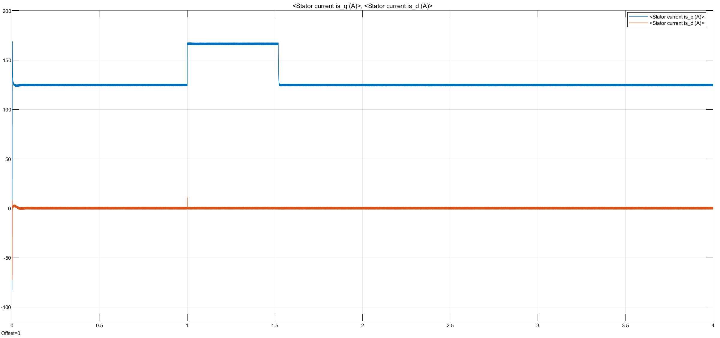

Figure 10: d and q currents of the motor

**Comments:**

1. Speed reference is set to 266 rad/sec.

First, the load torque is reduced from 150Nm to 0Nm at time = 1sec. Then, the load torque is kept constant at 0Nm.

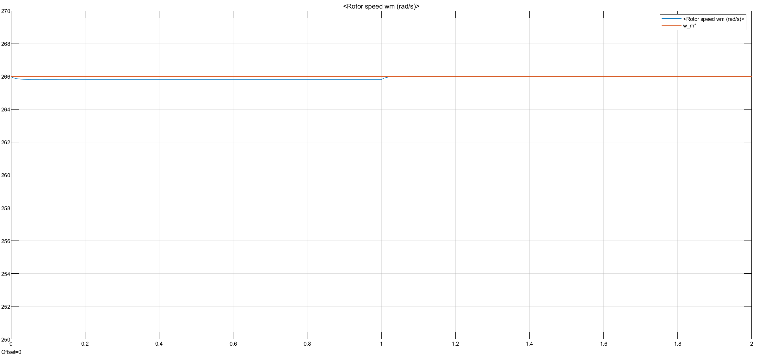

Figure 11: Speed vs time plot with torque load 150Nm to 0Nm

Then, the load torque is reduced from 250Nm to 0Nm at time = 1sec. Then, the load torque is kept constant again at 0Nm.

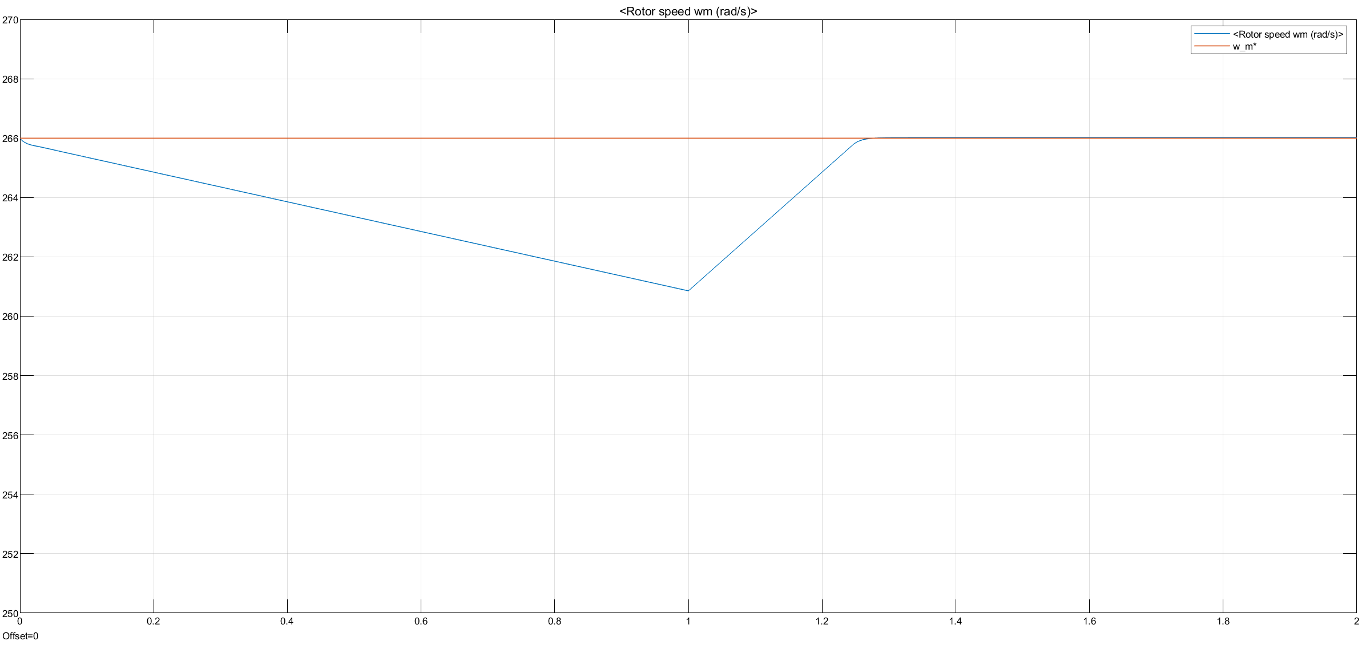

Figure 12: Speed vs time plot with torque load 250Nm to 0Nm

Later on, the load torque is reduced from 300Nm to 0Nm at time = 1sec. Then, the load torque is kept constant again at 0Nm.

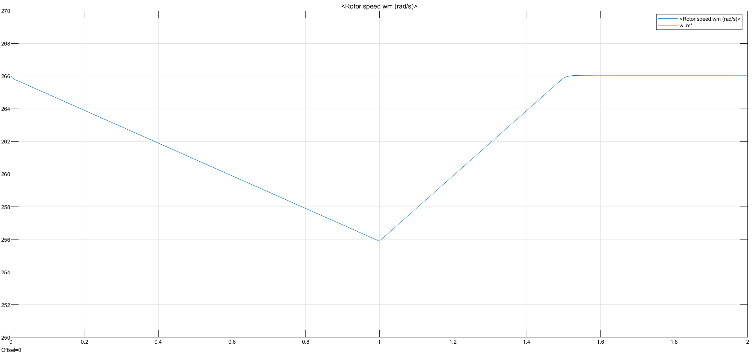

Figure 13: Speed vs time plot with torque load 300Nm to 0Nm

Finally, the load torque is reduced from 75Nm to 0Nm at time = 1sec. Then, the load torque is kept constant again at 0Nm.

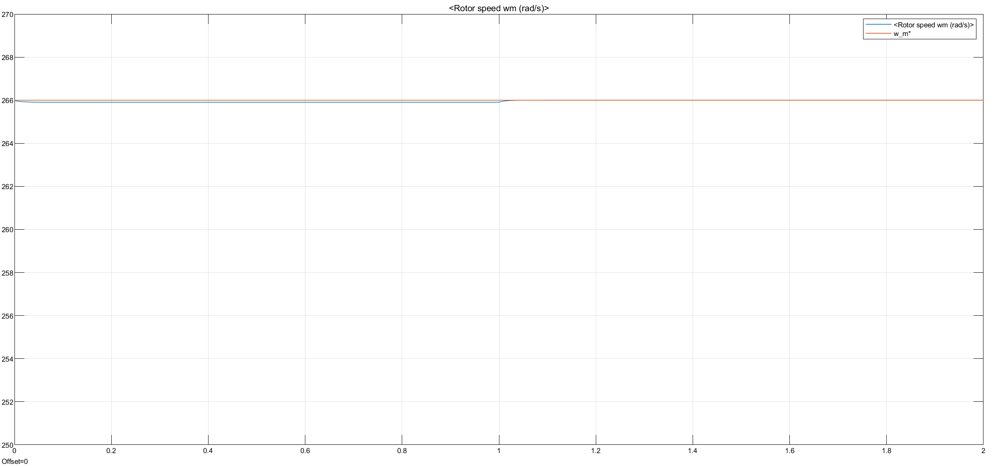

Figure 14: Speed vs time plot with torque load 75Nm to 0Nm

**Comments:**

Considering Figures 11 to 14, when the load torque gets bigger initially, the response to change to no load becomes slower. This is because the machine tries to handle higher load torques. When the load torque is higher, the current and applied torque to the output from inverter becomes much higher. Hence, the response becomes slower as the control system is giving commands to reduce more currents and torque values. Also, considering mechanical situation, it is hard to stabilize the system with higher load torques compared with light loads due to high inertia of the machine. As a result, the drive performance is better with light loads, but it is still working with nominal torque values with a slower response to changes.

1. Firstly, braking resistor is not implemented to the system.

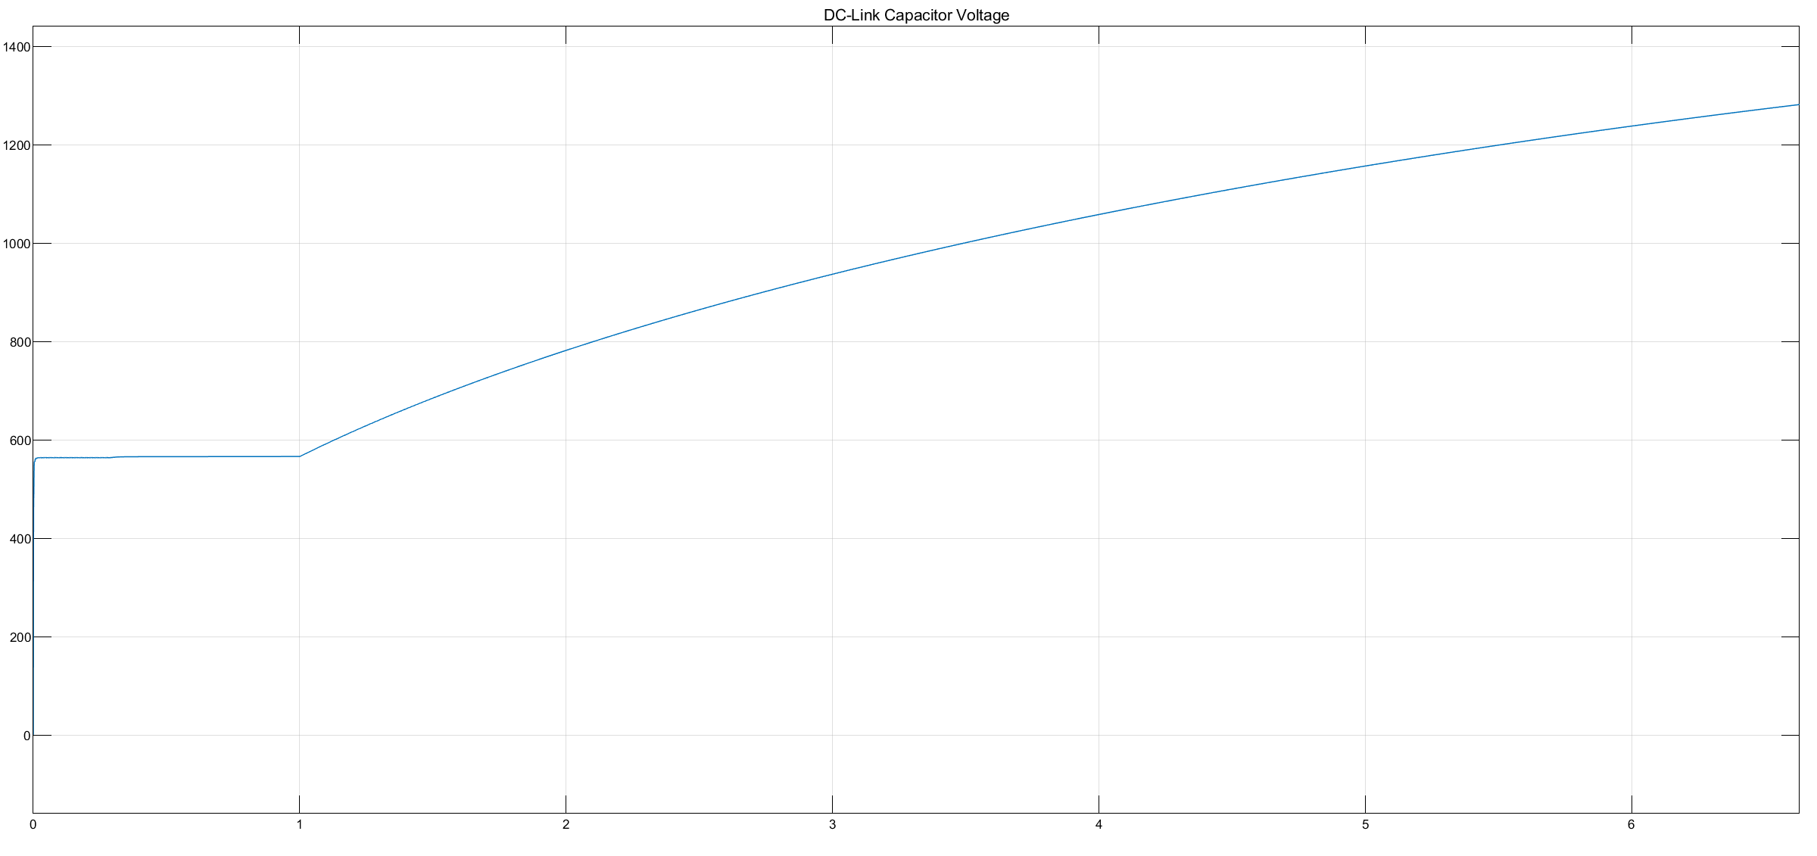

Figure 15: DC-Link Capacitor Voltage waveform

As seen in Figure 15, DC-Link capacitor voltage exceeds 600V while trying to reverse the speed. It is because system tends to operate in generating mode. However, 3-Phase rectifier blocks current to flow through source. Hence, capacitor voltage increases incredibly. Therefore, a braking resistor is implemented. Operation is not feasible.

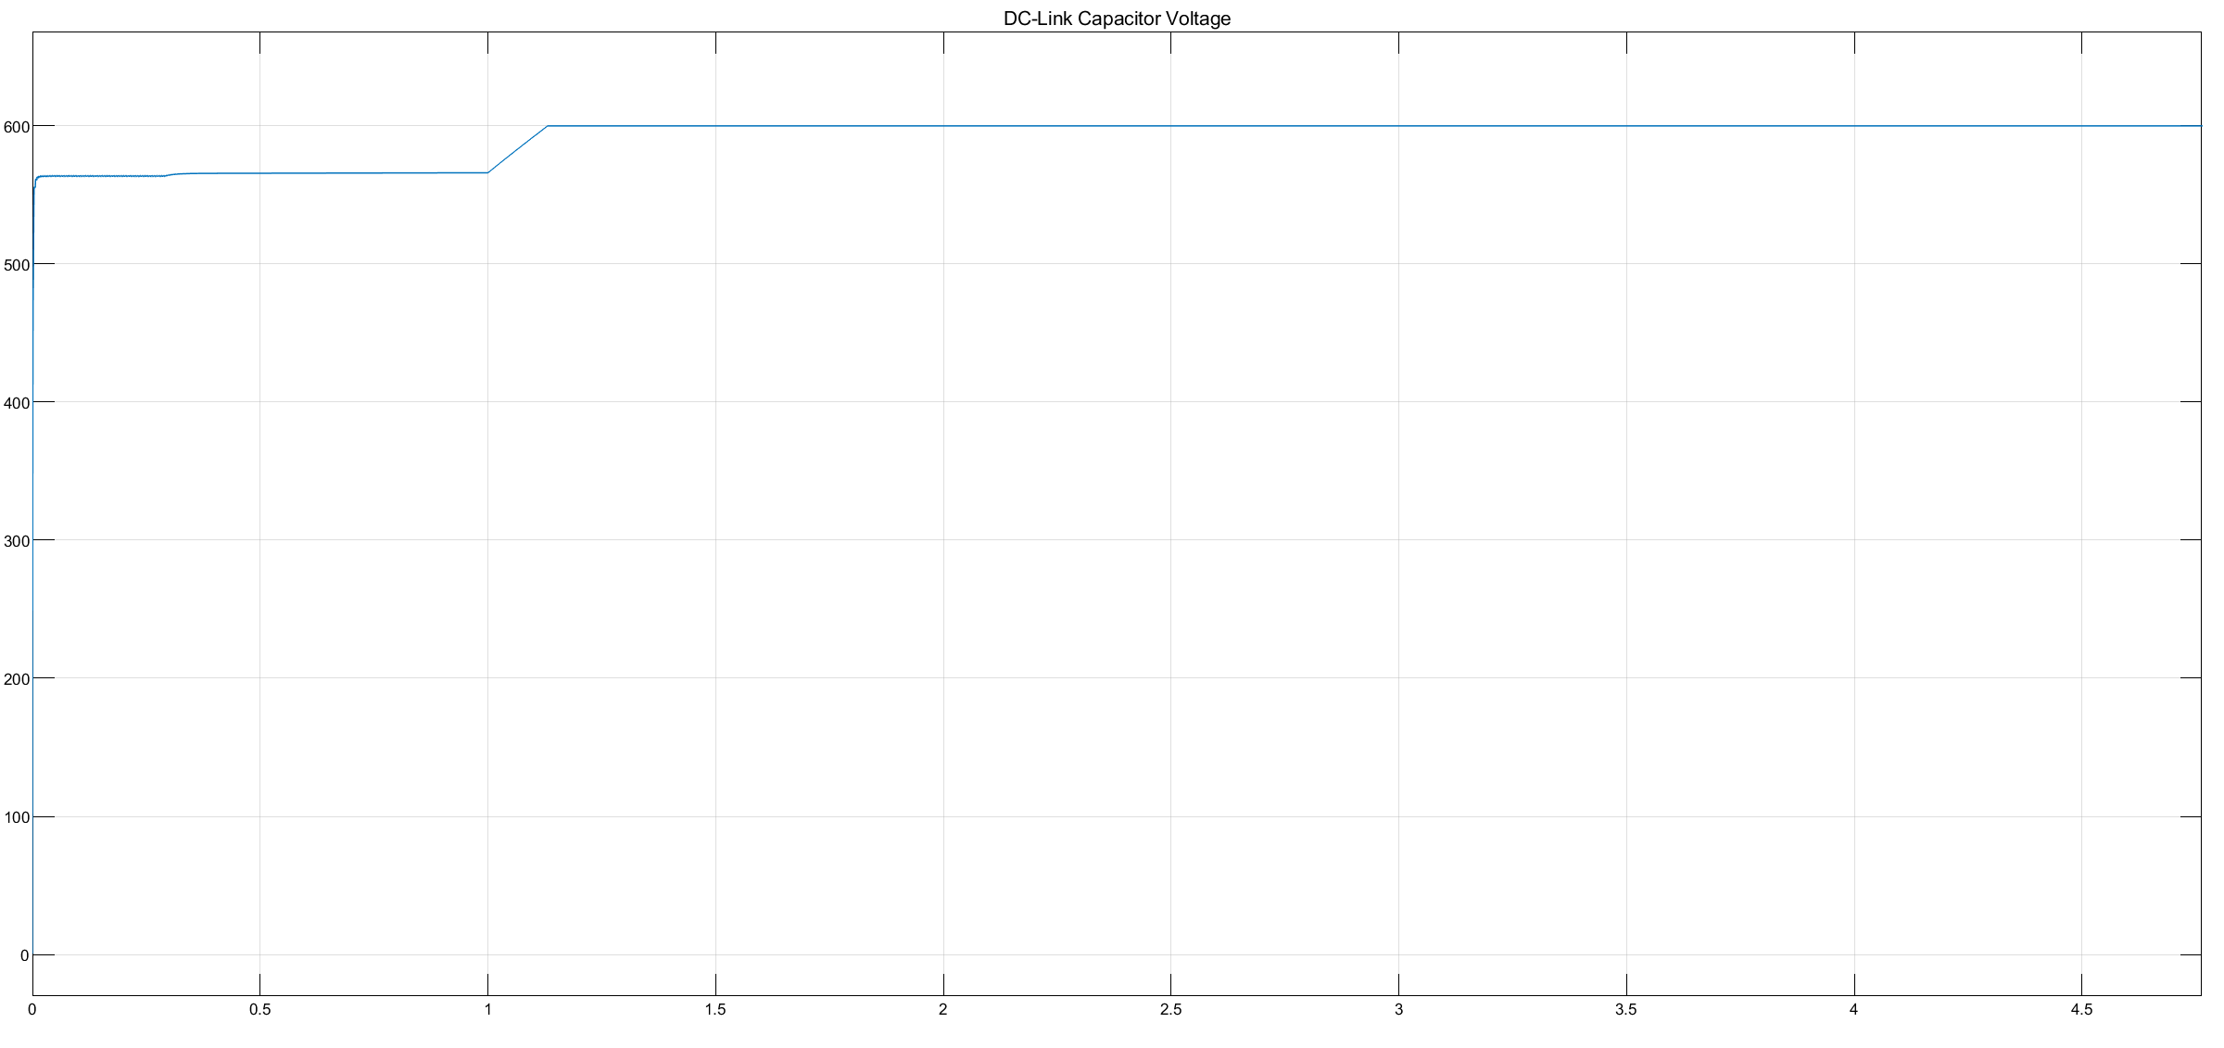

Figure 16: DC-Link Capacitor Voltage waveform with braking resistor implemented

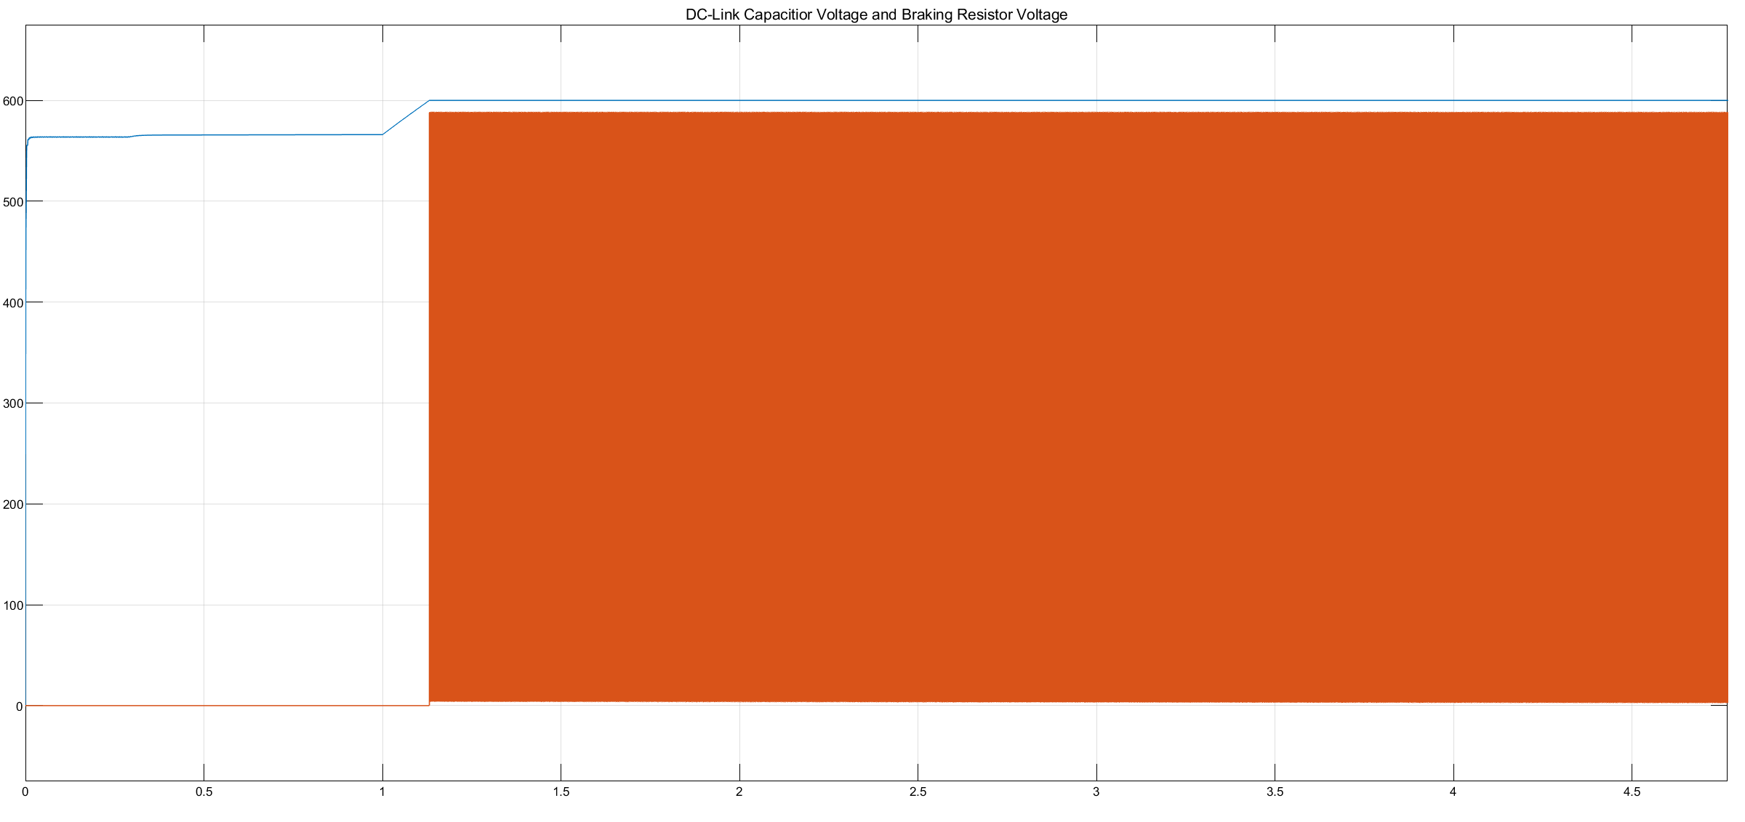

Figure 17: Voltages on DC-Link Capacitor and braking resistor

As seen in Figure 17, when the voltage tries to exceed 600V, braking resistor system is activated and the voltage is dissipated on it.

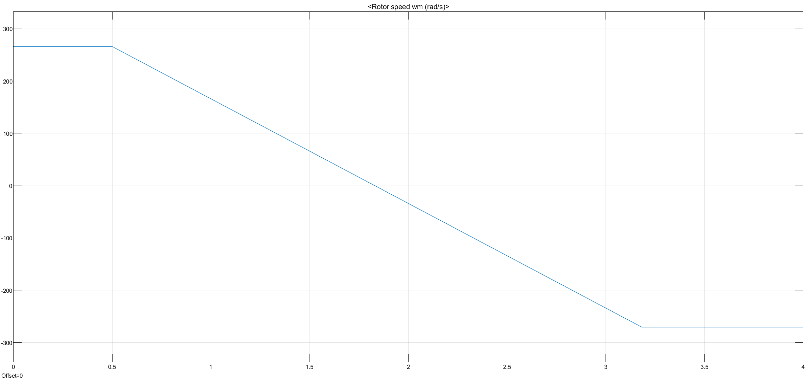

Figure 18: Speed vs time plot

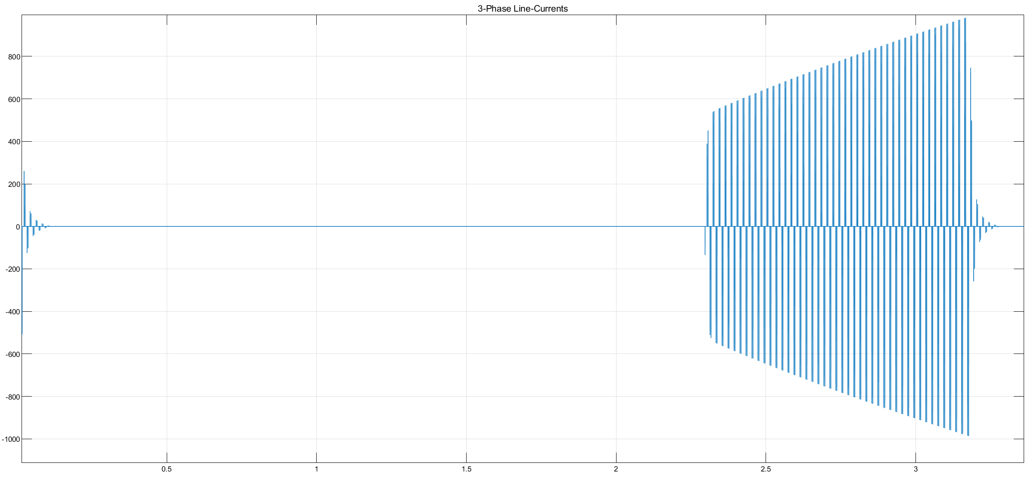

Figure 19: 3-Phase Line currents during speed reversal

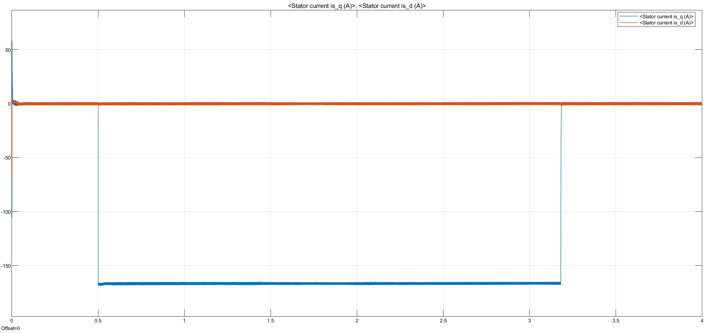

Figure 20: d and q currents

**Comments:**

1. Having half of the rated torque at rated speed, in order to increase speed to %150 of the rated speed, field weakening should be applied. Otherwise, the current drawn by the motor exceeds the rated current as power should be conserved. In base speed range, Id=0 and Iq>0. In field weakening region, Id<0 and Iq>0. Therefore, a negative d current should be applied to the system.

For SM-PMSM, torque is found using the equation (6). Inserting values, T=150Nm and motor parameters given;

Now, id can be found using the equation (8) where imax is equal to 250A.

# PART C: Space Vector PWM (SVPWM)

Since in this part we are allowed to use readily available Simulink blocks implementing SVPWM is quite easy. Without changing control loops, SVPWM Generator (2-level) block, which can be seen in Figure 21, is added which uses inverse Clarke’s transformation instead of Sinusoidal PWM Generator.

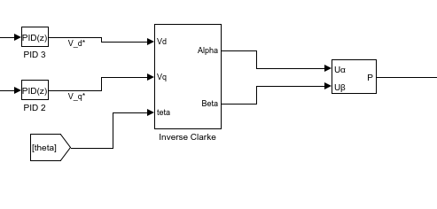

Figure 21: SVPWM Simulink model

In this part, we are asked to repeat part B using a Space Vector PWM algorithm.

Speed versus time plot of SVPWM scheme from %90 of the rated speed to rated speed can be seen in Figure ??. Also, motor 3-phase line-to-line voltages and 3-phase line currents vs. time plots are in Figure ??. Plots of d and q currents are in Figure ??. Finally, since in this part we are driving constant torque, its plot is not added.

# PART D: Component selection and verification

**Power Semiconductor Selection:**

According to [1] when the inverter output is in between 380-460Vrms, IGBT voltage class in low-level inverter topology should be 1200V. The current passing through one of the switches, S1, can be seen in Figure ??. Then, the switches and diodes should at least be capable of carrying 50A.

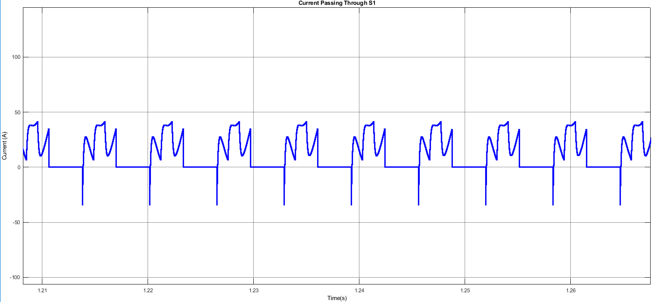

Figure 22: Current on S1

We chose FF200R12KS4 which is a fast switching IGBT, whose datasheet is given by [2]. Its maximum rated values can be seen in Figure ??.

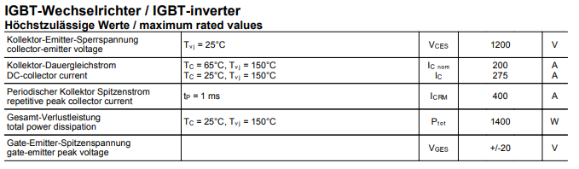

Figure 23:Maximum rated values of IGBT

Diodes in the three-phase inverter should have the same ratings as well. We chose QR_1230R30 which is a fast switching diode, whose datasheet is given by [3]. Its maximum rated values can be seen in Figure ??.

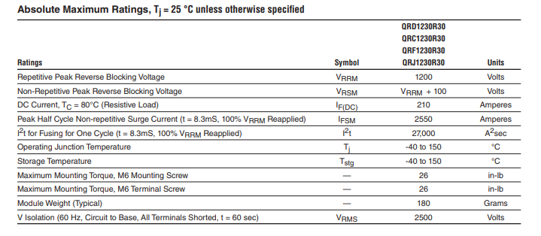

Figure 24:Diode characteristics

**Semiconductor device power losses:**

To find the semiconductor losses in Watts at rated operation, we can use Volt-Ampere Method. Adding one Watt-meter at the input and one at the output line to line terminals of the three-phase inverter, by the conservation of complex power we can find approximate total switching loss. Using the datasheets, we added switch and diode parameters to the models. Power dissipation on the three phase inverter can be seen in Figure ??. As it can be seen that it fluctuates between positive and negative values. Since the motor is basically an RL load there will be phase shift between voltage and current waveforms as can be seen in Figure ??. Therefore; instantaneous power on the inverter shifts from 25000W to -20000W, which is consistent with the prediction we have made in part A. When we take the magnitude of this plot and find the mean, it is found as 21000 Watts. High values such as these were expected since Inominal =250A

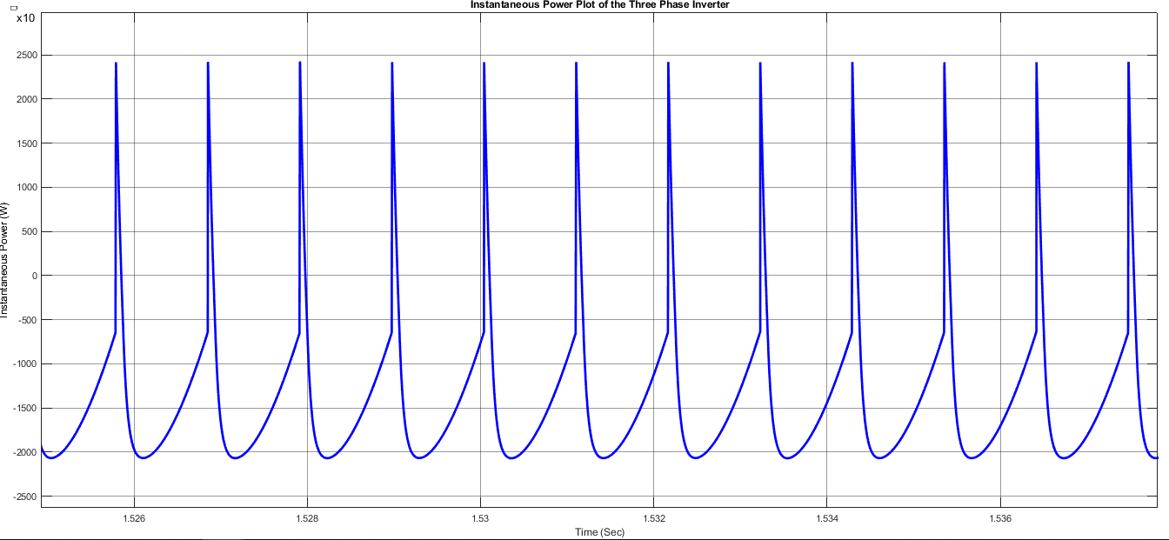

Figure 25: Instantaneous Power On the Switches

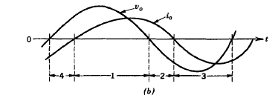

Figure 26: Phase shift between voltage and current waveforms

**Efficiency:**

# CONCLUSION

# References

[1] R. Teichmann and S. Bernet, “A comparison of three-level converters versus two-level converters for low-voltage drives, traction, and utility applications,” Industry Applications, IEEE Transactions on, vol. 41, no. 3, pp. 855 – 865, 2005.

[2] <http://www.igbt.ru/pdf/FF200R12KS4.pdf>

[3] <http://www.pwrx.com/pwrx/docs/QR_1230R30.pdf>