Yellow Sky

(Game Logo here)

**Game Design Document**

João Oliveira, Luís Chaves, Martim Fernandes, Pedro Valério

Master in Digital Game Development

2D Game Project/Game Design and Development

2022/2023

**Game created by:**

Tissue Box Games

(Studio Logo here)

# Introduction

Yellow Sky is a resource management game set in a post-apocalyptic future. After humanity has been mostly wiped out due to their own mistakes, you find yourself forced to face an inhospitable world, or what’s left of it, in an attempt to survive, and possibly restore balance for future generation’s sake.

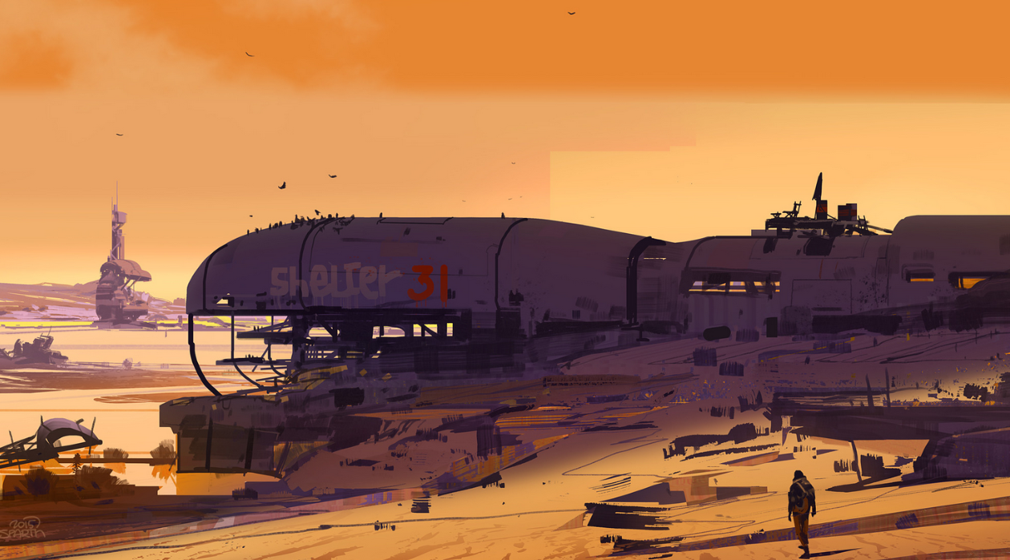The player will need to explore a desolate world in order to survive, either by recovering and managing old facilities, or by interacting and trading with the small local communities that are left. **Index**

Introduction 3

Game Overview 6

Elevator Pitch 7

Genre 7

Theme/Context 7

Unique Selling Points 7

Target Platform 7

Target Audience 7

Rating 7

Narrative 6

Intro 7

Gameplay 6

Overall 7

Mechanics Listing 7

Visual Identity 6

Look 7

List 7

Game Design 6

Intro 7

Sound 6

Intro 7

List 7

Interface 6

HUD 7

Menus 7

Font 7

Target Audience 6

Intro 7

Market 6

Competition 7

Influences 7

Distribution 7

Business Model 7

Marketing Strategy(?) 7

Vertical Slice 6

CDJ Stuff 6

Conclusion 6

# Game Overview

## Elevator Pitch

A strategy adventure game set in a post-apocalyptic setting.

## Genre

Yellow Sky is a strategy game focused on resource-management and survival, played through the lens of a more traditionally inclined RPG/Adventure game

## Theme/Context

The game is set in a post-apocalyptic future, after humanity committed sever mistakes that led to the decay of the natural ecosystem. The player plays the role of a lonely character who has to find foot in the inhospitable world, all while trying to survive and if possible, help the planet regenerate.

## Unique Selling Points

* Unique mix of game genres.
* Easy to learn, hard to master strategy game.
* Science focused post-apocalyptic wasteland to explore.
* Gameplay affected by realistic whether simulations.
* Ambient narrative imbued into strategy gameplay.

## Target Platform

Yellow Sky is being developed for PC.

## Target Audience

Our potential target audience are people in their 15 to 24 years of age, which means high school/college students as well as recently graduated young adults. Even though not all people belonging to the aforementioned age-gap have a stable disposable income, the younger audience has more time to play/share the game, which is why it is also important to cater to them.

## Rating

Yellow Sky falls into the PEGI 16 rating category.

“This rating is applied once the depiction of violence (or sexual activity) reaches a stage that looks the same as would be expected in real life. The use of bad language in games with a PEGI 16 rating can be more extreme, while the use of tobacco, alcohol or illegal drugs can also be present.”[1]

# Narrative

## Intro

Description of our approach to narrative, as well as describing its background. Not only should this topic touch on what the narrative is and our approach to it, but should also describe the world and setting the world takes place in, both in terms of look and feel as well as its backstory, if relevant. List of characters and their description (visual description if needed, personality, back story if needed, how do they affect the story/other characters if relevant). What is the back story, what is the “current story” and how it progresses, and how do we approach it (if it is through cutscenes these should be described, if it is through flavor text, the approach to the same should also be explicit).

# Gameplay

## Overall

(-Gameplay overall progression and structure,

including loops (core loop, gameplay loop and retention loop. They should have a visual graph accompanying them. Gameplay progression can also have an explanatory flowchart).

Does the game provide a save system?

Describe progression between multiple play sessions in case the game supports several play sessions.

General approach to gameplay and what do we want to achieve in the player with it.

Is the game single-player or multiplayer (of what type).

Estimated game length. How big is the game and how much there is to do both at a single point in time and overall.

-Discrete description of game objective(s).

-Discrete list of game states; win state, lose state, intermediary states?

-How the player interacts with the game, both from a control scheme point of view (control list section) but also through a list of verbs (basic actions that the player can take in game aka move, buy, build, etc…) Should also touch on interaction with HUD and menus.)

Gameplay in Yellow Sky revolves around the player having to manage a set number of resources available to it across the game world, and doing it in a way that allows for extended play, which is to say, the main objective of the game is to survive for as long as it is possible. In that sense, the game communicates how well the player did through its end screen, which ties into the narrative approach and rewards a player that managed to survive for long, while incentivizing a player that died in the first minutes of gameplay to try harder next time.

While the goal of the game is to survive for as long as one can manage, the player soon finds out that the only way to do this is through a playstyle that takes into account the “well-being” of the planet. In practice, this means that if a player prioritizes more immediate solutions, such as generating energy through the use of fossil fuels, there is only so much one can do until the environment catches up to you, which in turn makes that the player who plans out long-term solutions, which are often the more environmentally friendly ones, naturally ends up surviving the longest. That said, it is impossible for the planet to get fixed overnight, so even if a player adopts an optimal playstyle, they will end up succumbing to nature’s relentless force.

Despite the apparent dark outset the game presents, there are quite a few mechanics the player has access to in order to keep pushing forward. In addition to being able to freely roam the world, they player will find small communities of people gathered around in settlements, as well as abandoned facilities which will be the main method the player has access to when it comes to generating resources and surviving. With that said, a standard run of the game might go something like this:

The player starts on an abandoned settlement, which is implied to be destroyed by a recent natural disaster. While scavenging the destroyed settlement, the player finds some crafting materials as well as some food. Heading out, the player starts exploring and soon finds another settlement, but this time, this one is still lucky to be intact and has some people the player can interact with. While interacting with this new settlement, the player finds out that there is and abandoned power plant nearby, and that the inhabitants are trying to rebuild it, but to no avail. Leaving the settlement and heading to the power plant, the player restores the latter with the previously acquired crafting materials and is now able to produce energy.

After being introduced to the core mechanics of the game, the day begins to come to an end, as well as the player’s stamina. The player rests at the settlement but consumes the food items previously acquired to regain stamina, so the next day the priority is getting some more food. With some energy available, the player restores and gets a water extraction facility up and running in order to provide water to the nearest settlement in order to keep it running, since there are talks of an upcoming disaster.

The player keeps exploring the surrounding world, finding/producing new materials, and keeping the settlements that it finds along the way running, as well as fortifying them, until the day of the foretold upcoming disaster comes, and the player needs to take refuge in a settlement. This disaster damages all existing facilities and settlements, so the player needs to have a hefty amount of provisions already put into place to respond to the damage done by the disaster. Upon mending the damage, the cycle repeats and the player needs to organize itself in order to be able to manage the next disaster.

These disasters get progressively worse, so it is only a matter of time until the player fails to keep updating all settlements and ends up having no protection when a disaster comes around, ending the game.

To better exemplify our gameplay, the same can be explained using the recurring method of gameplay loops. These can be divided into *Gameplay Loop,* *Core Loop*, and *Retention Loop,* in increasing order of abstraction. This means that the *Gameplay Loop* describes the game using only the basic verbs available to the player, the *Core Loop* describes the game through its mechanics, and the *Retention Loop* approaches the game from a more high-level abstraction layer, taking into account several play sessions of the game.

First, the *Gameplay Loop* sees the player explore its surroundings, exploit whatever it can from settlements or currently producing facilities, and then proceed to use the fruits from that exploitation in order to expand the number of resources it can produce, be it quantity or quality.

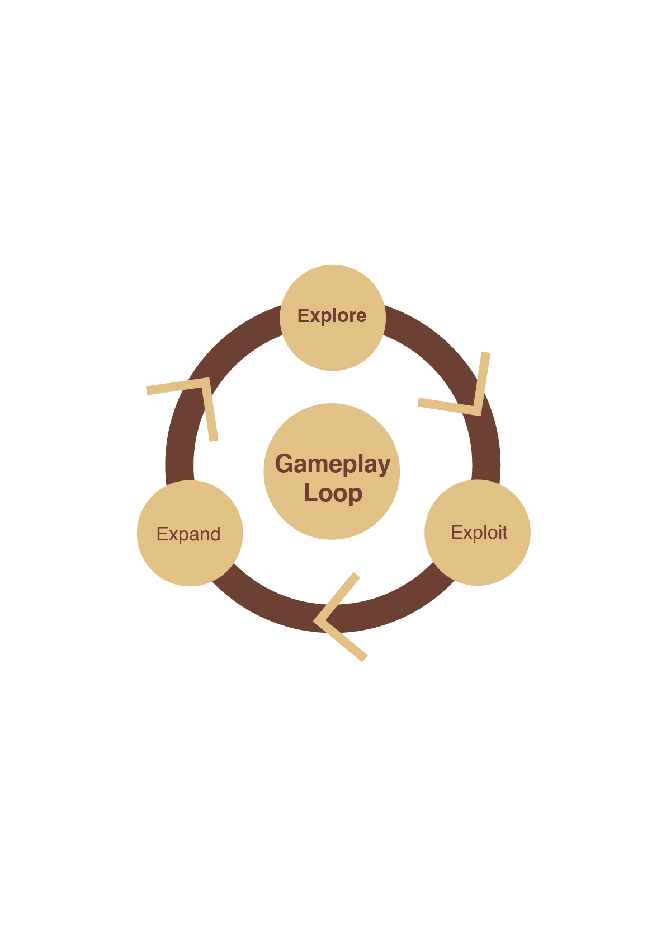

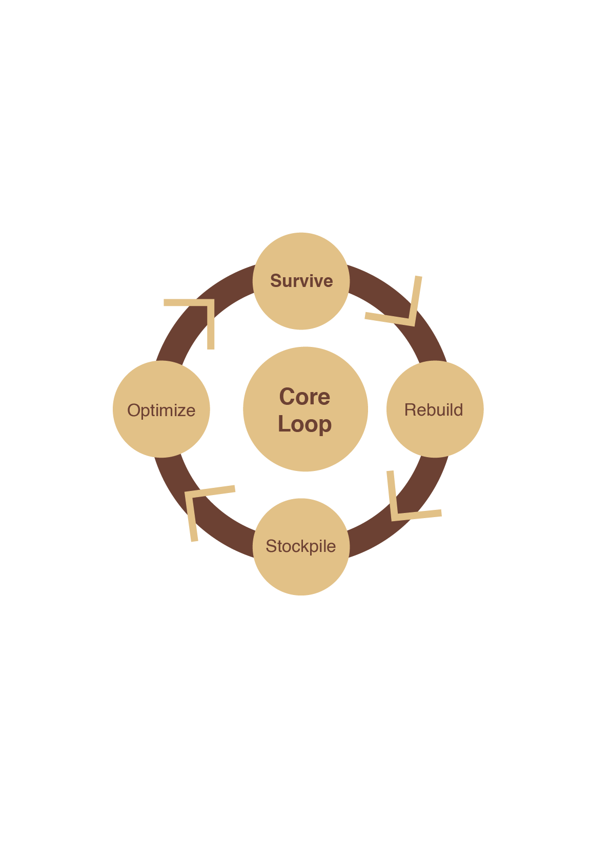Then, the *Core Loop* synthesizes the overall game progression, where the player character wakes up after a disaster has occurred, tries to get itself together, and then, to the best of its abilities, prepares itself for the next upcoming disaster, with the intent of surviving it as well, while also taking action as to make the next cycle more doable (*Optimize*).

Finally, the *Retention Loop* takes into account several runs of the game, in which the player tries to survive for as long as it can despite losing eventually, but by learning something from that loss, the next run will be improved.

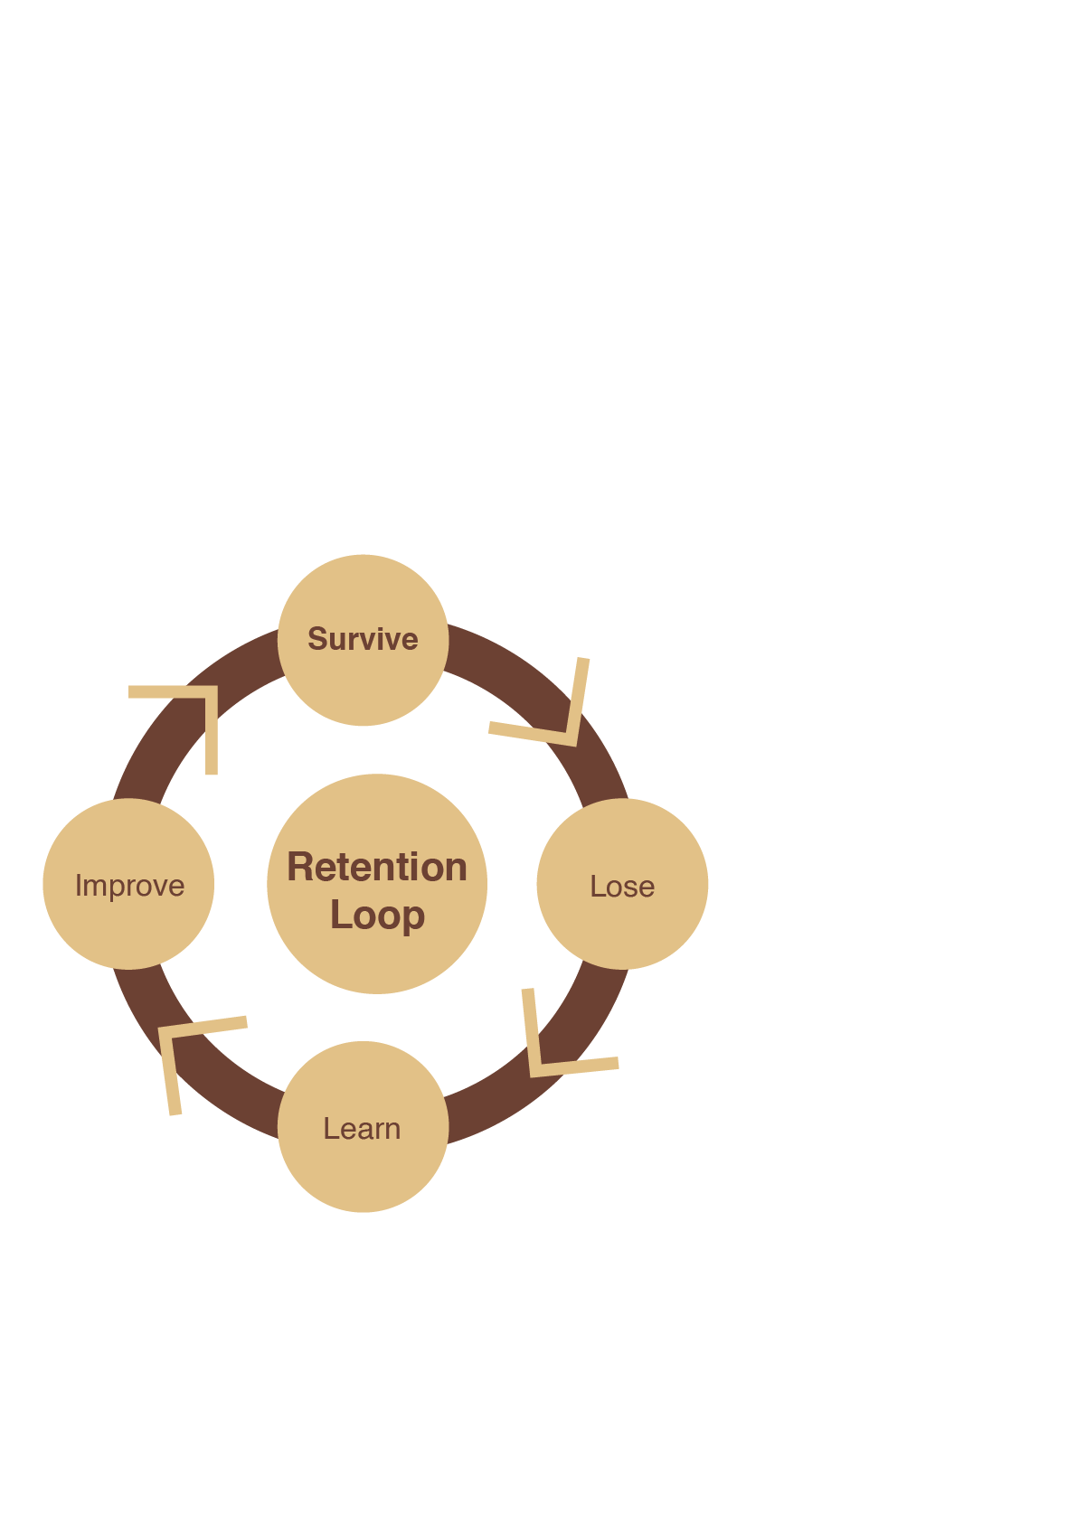

Finally, the *Retention Loop* takes into account several runs of the game, in which the player tries to survive for as long as it can despite losing eventually, but by learning something

## Mechanics Listing

Description of all game mechanics. What rules govern them and how they interact. From how the player can move around the world, to how the facility upgrade system works. Talk about character movement, how facilities work, how settlements work, how disasters work and what do they affect, how missions work, how different types of objects work, how the inventory system works, how the trade system works, how the camera is placed and how it is controlled…

-types of missions. List and description.

-list of objects. What is the purpose of each one.

- list of disasters

-list of types of tiles

-list of facilities

# Visual Identity

## Look

What is the look of the game. Description of the visual identity. Can also touch upon the approach taken regarding the game’s animation’s feel.

## List

General list of visual assets/gfx needed for the game. Not only includes static sprites, but also animation spreadsheets and vfx be it through particle effects or any other kind.

# Game Design

## Intro

Thought process behind the decisions taken regarding the game’s design. How do certain elements are supposed to affect the player, both in a pragmatic “regarding gameplay” kind of way, but also psychologically.

# Sound

## Intro

Description of general soundscape as well as the approach to composition/picking pre-made songs.

## List

Listing/description of every sfx as well as musical pieces. What do they communicate and where are they used in-game. What is their purpose? Are they used to communicate anything? If so, what do they communicate?

# Interface

## HUD

Description of the HUD. What elements does it have and how it interferes with the gameplay. Thoughts behind design process.

## Menus

Menu flow description, accompanied by a flowchart. In case of settings menu, describe what each setting does.

## Font

Talk about font use. Why we chose the fonts we chose and the logic behind its usage in game.

# Target Audience

## Intro

In depth discussion of target audience, including personas, and how the game targets them.

# Market

## Competition

How the game fits in the market, through comparing with other games (how the game relates to its competition

## Influences

How other games influenced yellow sky.

## Distribution

Touch upon how the game is expected to be distributed (in what platforms, and in what way)

## Business Model

Talk about the business model of the game (includes prices, potential discounts, how the game is expected to make money overall, etc.…)

## Marketing Strategy(?)

We can even talk about how we plan to market the game if relevant.(?)

# Vertical Slice

Explain what we set to accomplish with the deliverable project, and how that might differ from the game that could be made if given enough time and resources. Talk about features that were not implemented in this vertical slice or that could be considered extras.

# CDJ Stuff

Justify game engine choice, comparing with other possible choices. Overall production planning structure with reasons justifying it. Justify use of hardware/platform/controls.

# Conclusion

Reflect upon the game and its development. What went right and what could have been better.

1. “What do the labels mean?”, PEGI, *PEGI, 2017,* <https://pegi.info/what-do-the-labels-mean>