Promax Care Mobile App
Testing Report — Staff Shift Issues
Report Date: 03 October 2026 | App Version: 1.1.0 | Status: Open | Format: Microsoft Word (.docx)

1. Summary
This short testing report documents four defects observed during staff shift operations on the Promax Care mobile application. Issues were reproduced against a live shift for staff Serah Adeniyi and client Ajeh Wumi Tao (3 October 2026, 4:15 PM – 5:18 PM Australian time). Evidence is attached as embedded screenshots (Figures 1–6) captured from the staff mobile app and the admin Schedule Board.
ID | Issue | Severity | Status | Screenshot refs
BUG-01 | Trip can start before/after shift window | High | Open | Figures 1, 6
BUG-02 | Shift date/time shown on wrong day; clock-in blocked | Critical | Open | Figures 1, 2, 3
BUG-03 | Document upload rejects images | High | Open | Figure 4
BUG-04 | No client selection for multi-client report/trip | High | Open | Figures 5, 6

2. Test Environment
Item | Detail
Application | Promax Care Mobile (Staff)
Admin Reference | ProMax Care web Schedule Board (app.promaxcare.com.au)
Business Timezone | Australia/Sydney
Test Staff | Serah Adeniyi
Test Client | Ajeh Wumi Tao
Test Shift | Sat 3 Oct 2026, 4:15 PM – 5:18 PM (Australian time)
Activities | Transport, Install phone, Personal Support
Admin Board Status (at ~4:17 PM Sydney) | In Progress — see Figure 2
Staff Detail Status (device ~7:20) | Not Started — see Figure 1
Staff Roster Display | Sunday 4 Oct, 1:15 AM – 3:18 AM, ACTIVE — see Figure 3

2.1 Screenshot Catalogue
Ref | Source | What it shows
Figure 1 | Staff mobile — shift detail | Date 3 Oct; times 4:15–5:18 PM; Not Started; transport button visible; no clock-in
Figure 2 | Admin web — Schedule Board | Same shift Sat 3 Oct 4:15–5:18 PM Sydney shown In Progress
Figure 3 | Staff mobile — Shift Roster | Same shift listed on Sunday 4 Oct at 1:15–3:18 AM, ACTIVE
Figure 4 | Staff mobile — Add a document | Upload File accepts only .pdf, .doc, .docx — no images
Figure 5 | Staff mobile — Edit Shift Report | Client’s Name: Ajeh Wumi Tao, Olatunji John — one report, no picker
Figure 6 | Staff mobile — shift detail (completed) | Two clients combined; Shift Completed; transport button still shown

Screenshots are embedded in the relevant defect sections below and repeated in Appendix A.

3. BUG-01 — Travel Trip Available Outside Shift Window
Severity: High
Screenshot reference: Figure 1 (before start); Figure 6 (after shift completed)

3.1 Description
Staff can start or process a travelling trip before the shift has begun and after the shift has ended. Trip/travel actions should only be available while the shift is active (clocked in / in progress).

3.2 Evidence
- Before start: Shift detail shows status “Not Started” and “Your shift hasn't started yet. You can request to cancel if needed.” The transport (steering wheel) control remains visible and usable (Figure 1).
- After end: A later completed shift for two clients still shows “Shift Completed” while the transport button remains on screen (Figure 6).
- Code note: Transport button is shown whenever the shift activities include “Transport”, with no check that the shift is in progress. Status-based guards are commented out in code (shift detail screen).
Figure 1 — Staff shift detail — Not Started, transport control visible
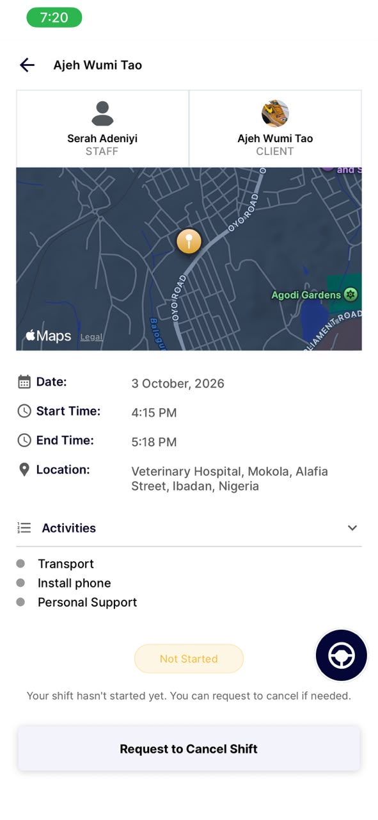
Staff mobile shift detail for client Ajeh Wumi Tao (staff Serah Adeniyi). Date shows 3 October 2026, start 4:15 PM / end 5:18 PM. Status is “Not Started” with message “Your shift hasn't started yet.” Transport (steering wheel) button is still visible. CTA is “Request to Cancel Shift”; clock-in is not offered.
Figure 6 — Completed multi-client shift — trip control still available
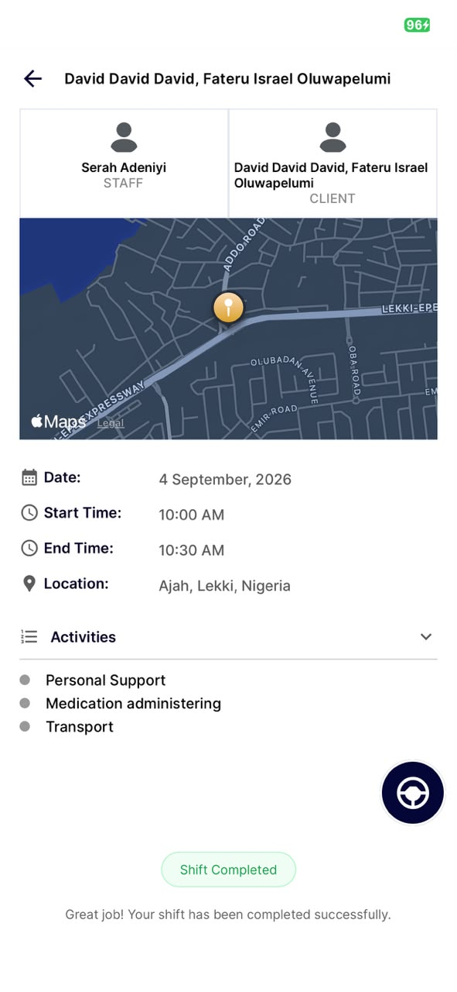
Shift detail for clients “David David David, Fateru Israel Oluwapelumi” (staff Serah Adeniyi). Status is “Shift Completed” with message “Great job! Your shift has been completed successfully.” Activities include Transport. The steering-wheel trip button remains visible. There is no client selector for which participant a trip would cover.

3.3 Steps to Reproduce
- Open a shift that includes the Transport activity (see Figure 1 before start, Figure 6 after complete).
- Confirm shift status is Not Started / Upcoming (before start), or Shift Completed / Absent / Present (after end).
- Tap the transport / trip control (steering-wheel button in Figures 1 and 6).
- Observe that trip tracking can still be started or processed.

3.4 Expected vs Actual
Expected | Actual
Trip start/process only when shift is In Progress (staff clocked in). | Trip control available before start (Figure 1) and after the shift is completed (Figure 6).

4. BUG-02 — Incorrect Shift Date/Time and Blocked Clock-In
Severity: Critical
Screenshot references: Figure 2 (admin), Figure 3 (staff roster), Figure 1 (staff detail)

4.1 Description
A shift created for 3 October 2026, 4:15 PM – 5:18 PM Australian time appears on the staff dashboard as 4 October with times 1:15 AM – 3:18 AM. Opening shift detail shows Date as 3 October, but status remains “Not Started” and clock-in is unavailable, even when the admin Schedule Board (Sydney time) shows the same shift as “In Progress”.
This indicates inconsistent timezone handling between roster day grouping, detail date display, clock-in window logic, and/or device local time versus Australia/Sydney.

4.2 Evidence
- Admin: Admin Schedule Board at 4:17:31 pm – Sydney, AU shows shift Sat Oct 3, 4:15 PM – 5:18 PM as “In Progress” (Figure 2).
- Staff roster: Staff Shift Roster selects Sunday Oct 4 and shows the same client/activities at 1:15 AM – 3:18 AM with status ACTIVE (Figure 3).
- Staff detail: Shift detail Date field is “3 October, 2026”; start/end 4:15 PM / 5:18 PM; status “Not Started”; CTA “Request to Cancel Shift” with no clock-in (Figure 1).
- Code note: Detail “Date” uses dateCreated (not dateFrom). Roster calendar day chips use device-local dates while shift grouping/times use Australia/Sydney helpers — mixed sources can place a shift on the wrong day and block clock-in.

4.2.1 Admin (expected source of truth)
Figure 2 — Admin Schedule Board — same shift In Progress (Sydney)
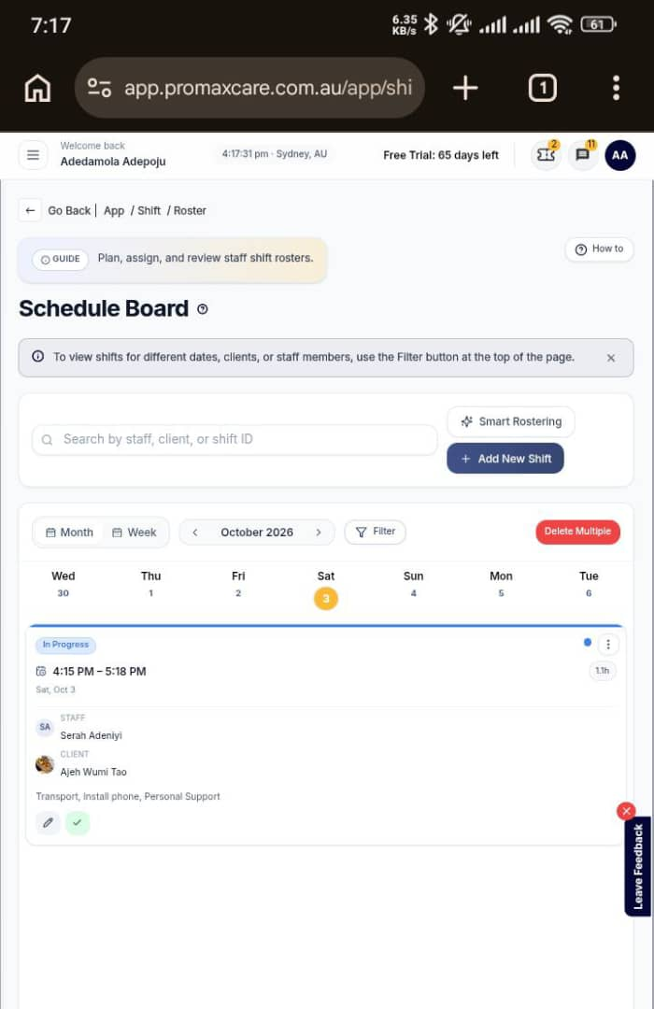
ProMax Care web Schedule Board at app.promaxcare.com.au (header 4:17:31 pm – Sydney, AU). Saturday 3 October 2026, 4:15 PM – 5:18 PM for staff Serah Adeniyi / client Ajeh Wumi Tao is shown as “In Progress” with activities Transport, Install phone, Personal Support.

4.2.2 Staff roster (wrong calendar day / converted times)
Figure 3 — Staff roster dashboard — shift listed on 4 October
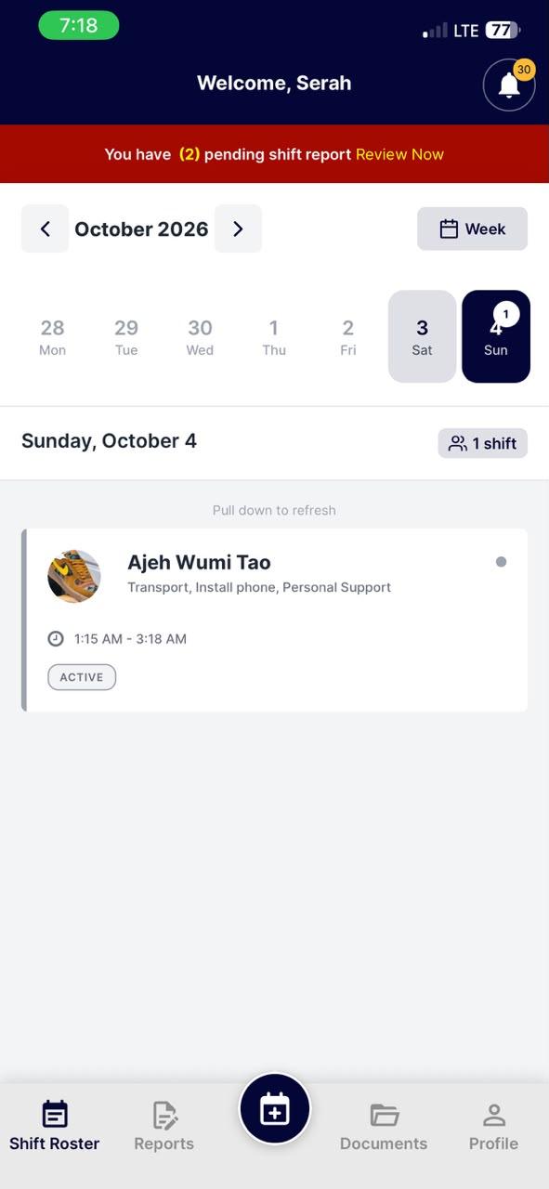
Staff mobile Shift Roster for Serah. Calendar selects Sunday 4 October 2026. The same client/activities card shows 1:15 AM – 3:18 AM with status ACTIVE, instead of Saturday 3 October 4:15 PM – 5:18 PM Australian time.

4.2.3 Staff detail (date 3 Oct, clock-in blocked)
Figure 1 — Staff shift detail — Not Started, transport control visible
Staff mobile shift detail for client Ajeh Wumi Tao (staff Serah Adeniyi). Date shows 3 October 2026, start 4:15 PM / end 5:18 PM. Status is “Not Started” with message “Your shift hasn't started yet.” Transport (steering wheel) button is still visible. CTA is “Request to Cancel Shift”; clock-in is not offered.

4.3 Steps to Reproduce
- In admin, create/confirm a shift for 3 Oct 2026, 4:15 PM – 5:18 PM Australian time (Figure 2).
- On staff mobile, open Shift Roster and locate the shift (Figure 3).
- Observe which calendar day and start/end times are shown.
- Open shift detail and compare Date, Start Time, End Time, and status (Figure 1).
- Attempt to clock in while admin board shows the shift In Progress in Sydney time.

4.4 Expected vs Actual
Expected | Actual | Evidence
Roster and detail show 3 Oct 2026, 4:15 PM – 5:18 PM (Sydney). | Roster shows 4 Oct, 1:15 AM – 3:18 AM; detail Date shows 3 Oct. | Figures 3 and 1 vs Figure 2
Staff can clock in once Sydney window is open / shift has started. | Status stays Not Started; clock-in unavailable; only cancel offered. | Figure 1
Staff status matches admin Schedule Board for the same shift. | Admin: In Progress; Staff detail: Not Started. | Figures 2 and 1

5. BUG-03 — Document Upload Does Not Accept Images
Severity: High
Screenshot reference: Figure 4

5.1 Description
Staff document upload should accept image files (e.g. photos of certificates and IDs). In practice, image selection/upload is not accepted as expected for compliance documents.

5.2 Evidence
- Observed: The “Add a document” screen labels Upload File as “Tap to select file (.pdf, .doc, .docx)”. No image types are listed (Figure 4).
- Code / UX note: Upload uses DocumentPicker with a limited MIME list: image/jpeg, application/pdf, and Word types only. The on-screen hint omits images entirely. image/png and camera/gallery paths are not offered (unlike profile photo).
Figure 4 — Add a document — file types limited to PDF and Word
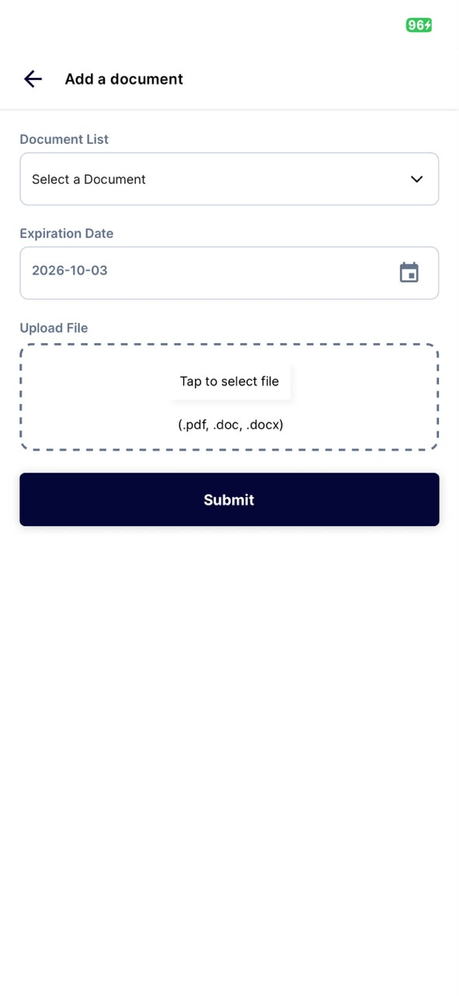
Staff “Add a document” screen. The Upload File control reads “Tap to select file (.pdf, .doc, .docx)”. Image formats (JPEG, PNG, HEIC) are not listed or offered.

5.3 Steps to Reproduce
- Open Documents tab → Add a document (Figure 4).
- Confirm the upload hint lists only .pdf, .doc, .docx.
- Tap “Tap to select file” and attempt to choose a JPEG, PNG, HEIC, or camera photo.
- Observe that images are not offered or cannot be submitted as a compliance document.

5.4 Expected vs Actual
Expected | Actual | Evidence
Staff can upload common image formats (JPEG, PNG; ideally HEIC via conversion) and PDF/Word for compliance documents. | Upload File hint allows only .pdf, .doc, .docx. Images are not accepted. | Figure 4

6. BUG-04 — No Client Selection for Multi-Client Report / Trip
Severity: High
Screenshot references: Figure 5 (report); Figure 6 (trip on completed multi-client shift)

6.1 Description
When multiple clients are assigned to a staff member on a shift, a single shift report and a single travelled trip are tied to both clients together. Staff cannot choose which client the report applies to, or which client a trip covers.

6.2 Evidence
- Report: Edit Shift Report shows Client’s Name as “Ajeh Wumi Tao, Olatunji John” with no dropdown or picker. One report form is shared by both clients (Figure 5).
- Trip: Shift detail header concatenates two clients (“David David David, Fateru Israel Oluwapelumi”). Transport remains a single shift-level button even after completion (Figure 6). There is no client selector for the trip.
- Data model: Shift model exposes a combined clients string and a single profile object; report submit payload sends shiftRosterId + form fields with no clientId selector.

6.2.1 One report tied to two clients
Figure 5 — Edit Shift Report — two clients on one report, no selector
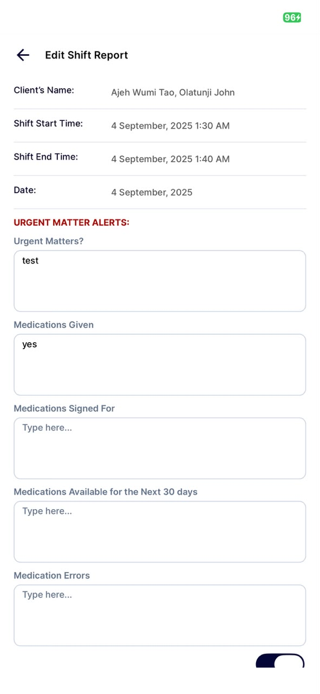
Edit Shift Report for staff Serah. Client’s Name is shown as a combined string “Ajeh Wumi Tao, Olatunji John”. There is no control to choose which client the report is for. One form (urgent matters, medications, etc.) applies to both clients.

6.2.2 One trip control for two clients (after shift completed)
Figure 6 — Completed multi-client shift — trip control still available
Shift detail for clients “David David David, Fateru Israel Oluwapelumi” (staff Serah Adeniyi). Status is “Shift Completed” with message “Great job! Your shift has been completed successfully.” Activities include Transport. The steering-wheel trip button remains visible. There is no client selector for which participant a trip would cover.

6.3 Steps to Reproduce
- Assign a shift with more than one client for the same staff member.
- Open Edit/Create Shift Report and confirm Client’s Name lists both clients with no selector (Figure 5).
- Submit or save the report and observe it is stored against the shift, not a chosen client.
- Open shift detail for a multi-client shift that includes Transport (Figure 6).
- Start/save a trip via the steering-wheel control. Observe the trip is not attributed to a specific client.

6.4 Expected vs Actual
Expected | Actual | Evidence
Staff selects which client a shift report is for when multiple clients apply. | One report is tied to all clients on the shift (combined name string). | Figure 5
Staff selects which client a travelled trip covers. | Trip is recorded against the shift only; transport button is shift-level. | Figure 6

7. Recommended Fixes (Testing Focus)
Bug | Recommended Fix Direction | Suggested Retest
BUG-01 | Gate TransportButton / trip start to Clock-In or Shift In Progress only; block after Present/Absent/Cancelled/Upcoming. | Before start, during active, after end — only mid-shift allows trip. Compare to Figure 1.
BUG-02 | Standardise all roster day keys, calendar selection, detail Date, and clock-in windows on Australia/Sydney; show dateFrom (not dateCreated) as shift date; align staff status with admin Sydney clock. | Create Sydney-afternoon shift; verify day, times, In Progress, and clock-in on a device set to a non-AU timezone. Compare Figures 1–3.
BUG-03 | Accept image/jpeg, image/png, and preferably ImagePicker/camera with conversion; keep PDF/Word support. | Upload JPEG, PNG, and camera photo for a required document type. Compare to Figure 4.
BUG-04 | Add mandatory client selector on report create and trip start when clients.length > 1; persist clientId on report and trip payloads. | Multi-client shift: submit two reports and two trips for different clients. Compare to Figures 5 and 6.

8. Appendix A — Embedded Screenshots
The following figures are the original test captures. They are also placed inline under BUG-01 through BUG-04.
Figure 1 — Staff shift detail — Not Started, transport control visible
Staff mobile shift detail for client Ajeh Wumi Tao (staff Serah Adeniyi). Date shows 3 October 2026, start 4:15 PM / end 5:18 PM. Status is “Not Started” with message “Your shift hasn't started yet.” Transport (steering wheel) button is still visible. CTA is “Request to Cancel Shift”; clock-in is not offered.
Figure 2 — Admin Schedule Board — same shift In Progress (Sydney)
ProMax Care web Schedule Board at app.promaxcare.com.au (header 4:17:31 pm – Sydney, AU). Saturday 3 October 2026, 4:15 PM – 5:18 PM for staff Serah Adeniyi / client Ajeh Wumi Tao is shown as “In Progress” with activities Transport, Install phone, Personal Support.
Figure 3 — Staff roster dashboard — shift listed on 4 October
Staff mobile Shift Roster for Serah. Calendar selects Sunday 4 October 2026. The same client/activities card shows 1:15 AM – 3:18 AM with status ACTIVE, instead of Saturday 3 October 4:15 PM – 5:18 PM Australian time.
Figure 4 — Add a document — file types limited to PDF and Word
Staff “Add a document” screen. The Upload File control reads “Tap to select file (.pdf, .doc, .docx)”. Image formats (JPEG, PNG, HEIC) are not listed or offered.
Figure 5 — Edit Shift Report — two clients on one report, no selector
Edit Shift Report for staff Serah. Client’s Name is shown as a combined string “Ajeh Wumi Tao, Olatunji John”. There is no control to choose which client the report is for. One form (urgent matters, medications, etc.) applies to both clients.
Figure 6 — Completed multi-client shift — trip control still available
Shift detail for clients “David David David, Fateru Israel Oluwapelumi” (staff Serah Adeniyi). Status is “Shift Completed” with message “Great job! Your shift has been completed successfully.” Activities include Transport. The steering-wheel trip button remains visible. There is no client selector for which participant a trip would cover.

9. Sign-Off
Role | Name | Date | Signature
Tester
Developer
Product / Ops

Document format: Microsoft Word (.docx). Embedded files: fig-01-shift-detail-not-started.jpg, fig-02-admin-schedule-board.jpg, fig-03-staff-roster-4-oct.jpg, fig-04-add-document-no-images.jpg, fig-05-edit-report-two-clients.jpg, fig-06-completed-shift-multi-client-trip.jpg (docs/screenshots/).

