Supplementary material.
Contrasting biogeochemical characteristics of the Oubangui River and tributaries(Congo River basin).
Steven Bouillon, Athanase Yambélé, David P. Gillikin, Cristian Teodoru, François Darchambeau, Thibault Lambert, and Alberto V. Borges.
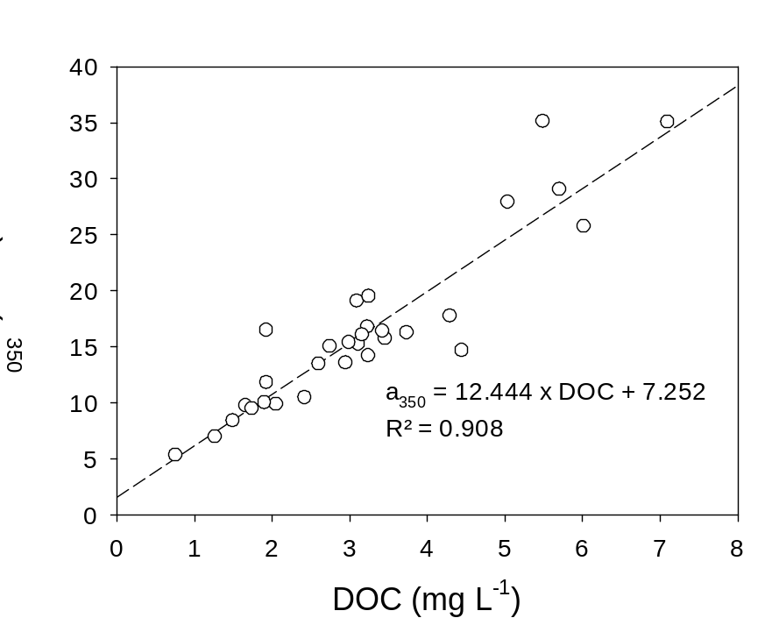
Figure S1: Relationship between DOC concentrations and a₃₅₀ for all sites in the Oubangui tributaries sampled in 2012 and 2013. This relationship was used to estimate DOC concentrations and the annual flux of DOC in the mainstam Oubangui for the 2nd year of monitoring, when no direct DOC measurements are available. The relationship shown here is consistent with other data collected throughout the Congo basin (own unpublished data).

Supplementary Table 1: Comparison of concentrations and δ¹³C signatures of dissolved organic carbon (DOC) on samples prepared by (i) immediately preserving samples filtered through 0.7 µm GF/F filters, and (ii) preservation after further filtration through 0.2 µm syringe filters. No significant differences were found for either DOC concentrations or δ¹³C_{DOC} (paired t-test).

Site (March 2011 samples) | [DOC], 0.2 µm | [DOC], 0.7 µm | δ¹³C_{DOC}, 0.2 µm | δ¹³C_{DOC}, 0.7 µm
Imbalataka (tributary of Mbaéré) | 1.27 | 1.40 | -29.9 | -30.0
Mbaéré | 1.50 | 1.54 | -29.7 | -29.0
Mbaéré | 1.66 | 1.74 | -29.9 | -29.6
Kélé (tributary of Mbaéré) | 4.45 | 4.41 | -30.2 | -30.3
Lubé (left bank tributary of Lobaye) | 5.50 | 5.46 | -27.1 | -26.4
Lobaye | 1.93 | 1.76 | -28.2 | -28.7
Mamboussou (right bank tributary of Lobaye) | 12.23 | 12.10 | -29.2 | -29.1
Lobaye | 2.06 | 1.98 | -28.6 | -28.6
Ibéléké (right bank tributary of Lobaye) | 3.24 | 3.29 | -29.7 | -29.8
Mbaéré, after confluence with Bodingué | 2.42 | 2.32 | -30.0 | -29.8
Lobaye, dowstream of confluence with Mbaéré | 1.90 | 1.89 | -29.0 | -29.0
Lobaye | 1.74 | 1.72 | -27.3 | -28.3
Lobaye | 1.93 | 2.00 | -28.7 | -28.4
Bodingué | 4.30 | 4.29 | -30.1 | -30.0
Mbaéré, after confluence with Bodingué | 3.46 | 3.50 | -29.9 | -29.9

Supplementary Table 2 : Full dataset on physico-chemical and biogeochemical data collected on the mainstem Oubangui River between April 2011 and March 2012.

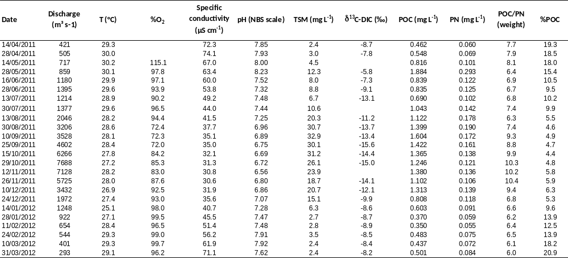

Supplementary Table 2 (continued)
Date | δ¹³C-POC (‰) | TA (mmol L⁻¹) | DIC (mmol L⁻¹) | pCO₂ (ppm) | N₂O (nmol L⁻¹) | CH₄ (nmol L⁻¹) | Ca (µM) | Mg (µM) | Si (µM)
14/04/2011 | -29.2 | 0.686 | 0.696 | 487 | 7.2 | 126.7 | 162.0 | 123.0 | 180.0
28/04/2011 | -28.8 | 0.699 | 0.699 | 289 | 8.5 | 138.5 | 170.7 | 124.3 | 175.4
14/05/2011 | -28.9 | 0.636 | 0.676 | 1373 | 6.4 | 341.3 | 148.5 | 111.5 | 154.7
28/05/2011 | -27.2 | 0.592 | 0.651 | 1990 | 7.3 | 450.6 | 135.9 | 105.4 | 35.1
16/06/2011 | -29.8 | 0.536 | 0.572 | 1226 | 6.6 | 324.5 | 132.2 | 100.1 | 148.3
28/06/2011 | -29.1 | 0.485 | 0.521 | 1239 | 6.4 | 261.8 | 111.7 | 89.4 | 171.5
13/07/2011 | -29.2 | 0.429 | 0.458 | 981 | 6.7 | 234.1 | 107.0 | 70.4 | 218.8
30/07/2011 | -28.5 | 0.366 | 0.393 | 935 | 6.2 | 230.4 | 97.4 | 61.1 | 202.1
13/08/2011 | -28.4 | 0.346 | 0.388 | 1356 | 8.4 | 187.5 | 89.9 | 55.4 | 177.4
30/08/2011 | -27.0 | 0.308 | 0.380 | 2341 | 11.7 | 147.0 | 85.3 | 48.1 | 219.6
10/09/2011 | -26.6 | 0.265 | 0.339 | 2379 | 9.3 | 122.4 | 82.9 | 42.3 | 224.3
25/09/2011 | -26.4 | 0.307 | 0.425 | 3810 | 8.2 | 127.7 | 75.6 | 44.9 | 223.7
15/10/2011 | -26.3 | 0.293 | 0.423 | 4114 | 8.8 | 101.6 | 63.9 | 45.7 | 237.6
29/10/2011 | -26.2 | 0.283 | 0.401 | 3679 | 8.1 | 105.2 | 67.4 | 44.3 | 239.3
12/11/2011 | -26.7 | 0.266 | 0.426 | 5123 | 7.8 | 80.5 | 65.7 | 45.8 | 238.5
26/11/2011 | -27.5 | 0.271 | 0.364 | 2958 | 7.6 | 91.9 | 63.0 | 43.9 | 242.0
10/12/2011 | -28.0 | 0.288 | 0.375 | 2704 | 7.5 | 96.0 | 66.6 | 44.9 | 245.9
24/12/2011 | -28.7 | 0.333 | 0.394 | 1934 | 6.7 | 94.3 | 75.4 | 52.9 | 233.1
14/01/2012 | -29.9 | 0.386 | 0.430 | 1327 | 7.3 | 88.8 | 87.9 | 63.2 | 225.0
28/01/2012 | -31.2 | 0.434 | 0.465 | 997 | 6.9 | 80.2 | 104.9 | 75.1 | 234.8
11/02/2012 | -30.6 | 0.478 | 0.511 | 1088 | 6.5 | 79.4 | 119.3 | 85.4 | 231.7
24/02/2012 | -29.5 | 0.523 | 0.533 | 451 | 6.6 | 128.2 | 135.1 | 92.7 | 218.5
10/03/2012 | -29.1 | 0.579 | 0.590 | 481 | 6.3 | 137.5 | 146.5 | 103.2 | 212.1
31/03/2012 | -29.5 | 0.663 | 0.695 | 1116 | 6.1 | 159.3 | 180.9 | 119.7 | 181.0

Supplementary Table 3 : Full dataset on physico-chemical and biogeochemical data collected in various tributaries of the Oubangui during 3 field campaings between 2010 and 2012.

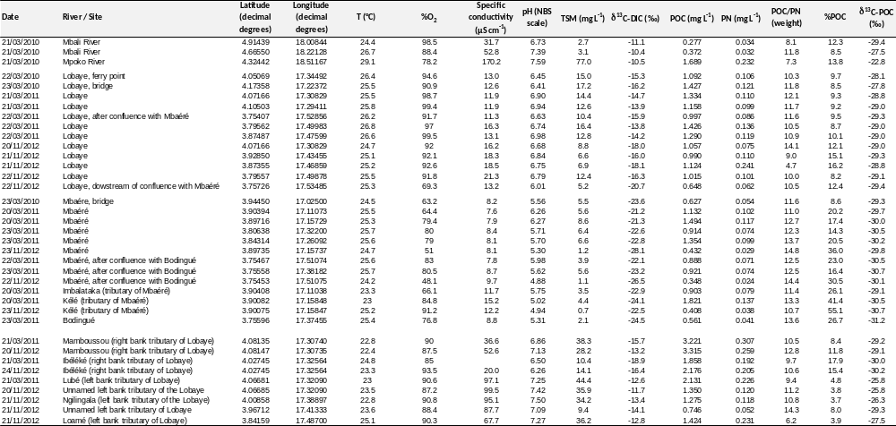

Supplementary Table 3 (continued)

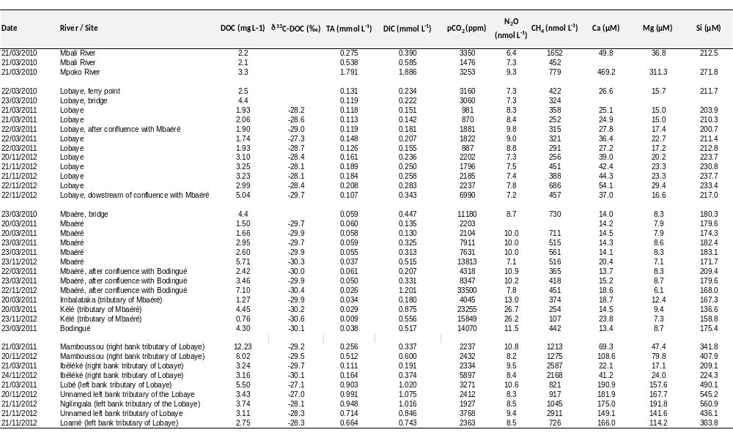
Supplementary Table 4: CDOM parameters of various tributaries of the Oubangui River during 2 field compaings in 2011 and 2012.
Date | River/Site | DOC | a₃₅₀(m⁻¹) | a₂₅₀:a₃₆₅ | S₂₇₅₋₂₉₅ (nm⁻¹) | S₃₅₀₋₄₀₀ (nm⁻¹) | S_{R}
21/03/2011 | Lobaye | 1.93 | 8.8 | 4.1 | 0.0126 | 0.0156 | 0.8072
21/03/2011 | Lobaye | 2.06 | 9.8 | 3.9 | 0.0125 | 0.0151 | 0.8302
22/03/2011 | Lobaye. after confl with Mbaéré | 1.90 | 10.0 | 3.9 | 0.0122 | 0.0150 | 0.8131
22/03/2011 | Lobaye | 1.74 | 9.5 | 3.9 | 0.0119 | 0.0148 | 0.8063
22/03/2011 | Lobaye | 1.93 | 11.8 | 3.7 | 0.0118 | 0.0145 | 0.8171
20/11/2012 | Lobaye | 3.10 | 19.1 | 3.7 | 0.0114 | 0.0148 | 0.7675
21/11/2012 | Lobaye | 3.25 | 19.5 | 3.7 | 0.0111 | 0.0147 | 0.7551
21/11/2012 | Lobaye | 3.23 | 16.8 | 3.8 | 0.0119 | 0.0151 | 0.7857
22/11/2012 | Lobaye | 2.99 | 15.4 | 3.9 | 0.0121 | 0.0152 | 0.7934
22/11/2012 | Lobaye. dowstream of confluence with Mbaéré | 5.04 | 27.9 | 3.6 | 0.0114 | 0.0145 | 0.7807
20/03/2011 | Mbaéré | 1.50 | 8.4 | 4.1 | 0.0124 | 0.0144 | 0.8630
20/03/2011 | Mbaéré | 1.66 | 9.7 | 4.0 | 0.0123 | 0.0134 | 0.9167
23/03/2011 | Mbaéré | 2.95 | 13.5 | 4.1 | 0.0125 | 0.0146 | 0.8563
23/03/2011 | Mbaéré | 2.60 | 13.4 | 3.9 | 0.0120 | 0.0144 | 0.8370
23/11/2012 | Mbaéré | 5.71 | 29.0 | 3.8 | 0.0114 | 0.0147 | 0.7808
22/03/2011 | Mbaéré. after confl with Bodingué | 2.42 | 10.5 | 4.3 | 0.0131 | 0.0152 | 0.8605
23/03/2011 | Mbaéré. after confl with Bodingué | 3.46 | 15.7 | 4.0 | 0.0126 | 0.0144 | 0.8732
22/11/2012 | Mbaéré. after confl with Bodingué | 7.10 | 35.0 | 3.7 | 0.0117 | 0.0146 | 0.7987
20/03/2011 | Imbalataka (tributary) of Mbaéré | 1.27 | 6.9 | 3.7 | 0.0117 | 0.0125 | 0.9343
20/03/2011 | Kélé (tributary of Mbaéré) | 4.45 | 14.7 | 4.3 | 0.0129 | 0.0143 | 0.8967
23/11/2012 | Kélé (tributary of Mbaéré) | 0.76 | 5.3 | 3.7 | 0.0115 | 0.0127 | 0.9016
23/03/2011 | Bodingué | 4.30 | 17.7 | 4.1 | 0.0125 | 0.0147 | 0.8564
20/11/2012 | Mamboussou (right bank tributary of Lobaye) | 6.02 | 25.7 | 4.0 | 0.0119 | 0.0154 | 0.7742
21/03/2011 | Ibéléké (right bank tributary of Lobaye) | 3.24 | 14.2 | 4.0 | 0.0123 | 0.0154 | 0.7973
24/11/2012 | Ibéléké (right bank tributary of Lobaye) | 3.16 | 16.0 | 4.0 | 0.0118 | 0.0154 | 0.7644
21/03/2011 | Lubé (left bank tributary of Lobaye) | 5.50 | 17.4 | 4.2 | 0.0124 | 0.0163 | 0.7576
20/11/2012 | Unnamed left bank tributary of Lobaye | 3.43 | 16.4 | 4.0 | 0.0118 | 0.0163 | 0.7235
21/11/2012 | Ngilingala (left bank tributary of Lobaye) | 3.74 | 16.2 | 4.1 | 0.0120 | 0.0164 | 0.7356
21/11/2012 | Unnamed left bank tributary of Lobaye | 3.11 | 15.2 | 4.0 | 0.0117 | 0.0170 | 0.6868
21/11/2012 | Loamé (left bank tributary of Lobaye) | 2.75 | 15.0 | 3.7 | 0.0115 | 0.0158 | 0.7285

Supplementary Table 5: Temporal variations of CDOM parameters in the Oubangui mainstream.
Date | a₃₅₀ (m⁻¹) | a₂₅₀:a₃₆₅ | S₂₇₅₋₂₉₅ (nm⁻¹) | S₃₅₀₋₄₀₀ (nm⁻¹) | S_{R}
17/03/2011 | 5.6 | 5.0 | 0.0161 | 0.0137 | 1.1745
14/04/2011 | 5.2 | 5.0 | 0.0164 | 0.0128 | 1.2741
28/04/2011 | 5.3 | 5.2 | 0.0170 | 0.0130 | 1.2990
14/05/2011 | 4.8 | 5.4 | 0.0168 | 0.0127 | 1.3234
28/05/2011 | 5.9 | 5.5 | 0.0171 | 0.0136 | 1.2549
16/06/2011 | 10.0 | 5.1 | 0.0159 | 0.0145 | 1.0984
28/06/2011 | 12.9 | 4.7 | 0.0151 | 0.0155 | 0.9742
13/07/2011 | 16.9 | 4.4 | 0.0141 | 0.0154 | 0.9101
30/07/2011 | 18.0 | 4.2 | 0.0137 | 0.0150 | 0.9108
13/08/2011 | 20.1 | 4.1 | 0.0130 | 0.0149 | 0.8691
30/08/2011 | 23.6 | 4.3 | 0.0130 | 0.0159 | 0.8137
10/09/2011 | 24.0 | 4.3 | 0.0131 | 0.0159 | 0.8195
25/09/2011 | 22.4 | 4.2 | 0.0129 | 0.0158 | 0.8206
15/10/2011 | 22.5 | 4.3 | 0.0131 | 0.0160 | 0.8169
29/10/2011 | 23.2 | 4.2 | 0.0128 | 0.0159 | 0.8035
12/11/2011 | 25.1 | 4.2 | 0.0127 | 0.0157 | 0.8132
26/11/2011 | 22.8 | 4.2 | 0.0126 | 0.0157 | 0.7979
10/12/2011 | 22.0 | 4.1 | 0.0125 | 0.0156 | 0.7995
24/12/2011 | 19.2 | 3.7 | 0.0118 | 0.0147 | 0.8050
11/02/2012 | 3.8 | 4.6 | 0.0126 | 0.0122 | 1.0273
24/02/2012 | 6.9 | 4.7 | 0.0157 | 0.0144 | 1.0919
10/03/2012 | 7.3 | 4.6 | 0.0168 | 0.0135 | 1.2468
31/03/2012 | 5.1 | 5.2 | 0.0168 | 0.0139 | 1.2109

