Historic of sea ice concentration

Philippe Massicotte

10 May, 2017

This document presents an overview of the methodology used to extract the historic of sea ice concentration of the stations visited by the Amundsen in 2016 (project Green Edge).

## Data

Sea ice concentration has been extracted from AMSR2 radiometer on a 3.125 km grid. At each Amundsen station, the historic of sea ice concentration was extracted between 2016-03-01 and 2016-07-14. Sea ice concentration was extracted form the closest pixel using the Eucledian distance between ship position and the center of each pixel.

## Example

This is an example for station **G104**.

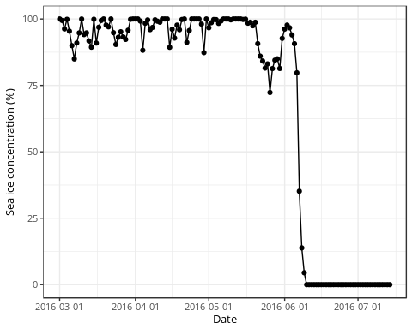

## Average sea ice concentration

This is the averaged ( $±$ S.D.) sea ice concentration between 2016-03-01 and 2016-07-14

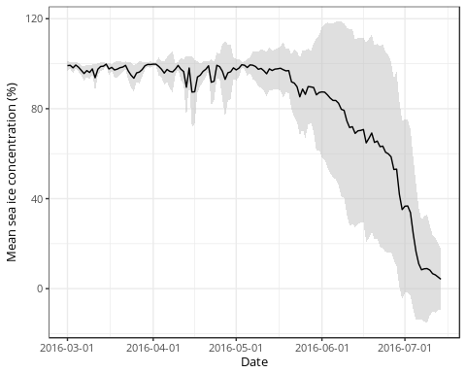

## How to cite the data

If you use this dataset please cite University of Hamburg and the following article:

Beitsch, A.; Kaleschke, L.; Kern, S. Investigating High-Resolution AMSR2 Sea Ice Concentrations during the February 2013 Fracture Event in the Beaufort Sea. Remote Sens. 2014, 6, 3841-3856, <doi:10.3390/rs6053841>

Paper Open Access available online: <http://www.mdpi.com/2072-4292/6/5/3841>

For citations of the data itself you may use:

Kaleschke, L. and X. Tian-Kunze (2016), "AMSR2 ASI 3.125 km Sea Ice Concentration Data, V0.1", Institute of Oceanography, University of Hamburg, Germany, digital media (ftp-projects.zmaw.de/seaice/), [BEGIN DAY/MONTH/YEAR - END DAY/MONTH/YEAR].

## Detailed information

Detailed information can be found in the following official README file: <ftp://ftp-projects.zmaw.de/seaice/AMSR2/README.txt>