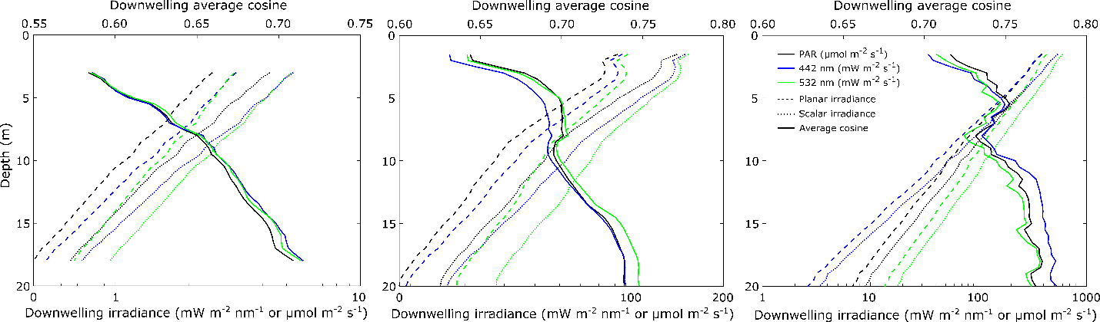

b)

c)

a)

Figure : Under-ice vertical profiles of downwelling planar (dashed line) and scalar (doted line) irradiance (442, 532 nm) and PAR, and calculated downwelling average cosines measured beneath snow-covered sea ice on a) 16 May 2016, white ice on b) 20 June 2016 and ponded ice on c) 30 June 2016. Please note the different units for the irradiance measurements.

**Matlab code for plots:**

Subplot a) 16 May 2015

figure1212 = figure;

axes1 = axes('Parent',figure1212,'Position',[0.12 0.12 0.75 0.7]);

hold(axes1,'on');

plot(Pep11605_umol,depth2015,'Parent',axes1,'Color',[0 0 0],'LineWidth',1,'LineStyle','--');

plot(Pes11605_umol,depth2015,'Parent',axes1,'Color',[0 0 0],'LineWidth',1,'LineStyle',':');

plot(ep11605_wrawi_442,depth2015,'Parent',axes1,'Color',[0 0 1],'LineWidth',1,'LineStyle','--');

plot(es11605_wrawi_442,depth2015,'Parent',axes1,'Color',[0 0 1],'LineWidth',1,'LineStyle',':');

plot(ep11605_wrawi_532,depth2015,'Parent',axes1,'Color',[0 1 0],'LineWidth',1,'LineStyle','--');

plot(es11605_wrawi_532,depth2015,'Parent',axes1,'Color',[0 1 0],'LineWidth',1,'LineStyle',':');

ylabel('Depth (m)');

xlabel('Downwelling irradiance (mW m^{-2} nm^{-1} or umol m^{-2} s^{-1})');

set(axes1,'XColor',[0 0 0],'YColor',[0 0 0],'XScale','log','xlim',[0 10],'ydir','rev','ylim',[0 20],'box','on');

legend(axes1,'Planar irradiance','Scalar irradiance','Average cosine','location','northwest','box','off');

axes2 = axes('Parent',figure1212,'Position',[0.12 0.12 0.75 0.7]);

hold(axes2,'on');

plot(pac_1605,depth2015,'Parent',axes2,'Color',[0 0 0],'LineWidth',1);

plot(ac_1605_442,depth2015,'Parent',axes2,'Color',[0 0 1],'LineWidth',1);

plot(ac_1605_532,depth2015,'Parent',axes2,'Color',[0 1 0],'LineWidth',1);

ylabel(' ');

xlabel('Downwelling average cosine');

set(axes2,'Color','none','XAxisLocation','top','XColor',[0 0 0],...

'YAxisLocation','right','YColor','none','xlim',[0.55 0.75],'ydir','rev','ylim',[0 20]);

legend(axes2,'PAR (umol m^{-2} s^{-1})','442 nm (mW m^{-2} nm^{-1})','532 nm (mW m^{-2} nm^{-1})','location','southeast','box','off');

Subplot b) 20 June 2016

% Create figure

figure1213 = figure;

axes1 = axes('Parent',figure1213,'Position',[0.12 0.12 0.75 0.7]);

hold(axes1,'on');

plot(Pep24a_umol,depth,'Parent',axes1,'Color',[0 0 0],'LineWidth',1,'LineStyle','--');

plot(Pes24a_umol,depth,'Parent',axes1,'Color',[0 0 0],'LineWidth',1,'LineStyle',':');

plot(ep24a_wrawi_442,depth,'Parent',axes1,'Color',[0 0 1],'LineWidth',1,'LineStyle','--');

plot(es24a_wrawi_442,depth,'Parent',axes1,'Color',[0 0 1],'LineWidth',1,'LineStyle',':');

plot(ep24a_wrawi_532,depth,'Parent',axes1,'Color',[0 1 0],'LineWidth',1,'LineStyle','--');

plot(es24a_wrawi_532,depth,'Parent',axes1,'Color',[0 1 0],'LineWidth',1,'LineStyle',':');

ylabel('Depth (m)');

xlabel('Downwelling irradiance (mW m^{-2} nm^{-1} or umol m^{-2} s^{-1})');

set(axes1,'XColor',[0 0 0],'YColor',[0 0 0],'XScale','log','ydir','rev','box','on');

legend(axes1,'Planar Irradiance','Scalar Irradiance','Average cosine','location','northwest','box','off');

axes2 = axes('Parent',figure1213,'Position',[0.12 0.12 0.75 0.7]);

hold(axes2,'on');

plot(pac_4a,depth,'Parent',axes2,'Color',[0 0 0],'LineWidth',1);

plot(ac_4a_442,depth,'Parent',axes2,'Color',[0 0 1],'LineWidth',1);

plot(ac_4a_532,depth,'Parent',axes2,'Color',[0 1 0],'LineWidth',1);

ylabel(' ');

xlabel('Downwelling average cosine');

set(axes2,'Color','none','XAxisLocation','top','XColor',[0 0 0],...

'YAxisLocation','right','YColor','none','xlim',[0.6 0.8],'ydir','rev');

legend(axes2,'PAR (umol m^{-2} s^{-1})','442 nm (mW m^{-2} nm^{-1})','532 nm (mW m^{-2} nm^{-1})','location','southeast','box','off');

Subplot c) 30 June 2016

% Create figure

figure1214 = figure;

axes1 = axes('Parent',figure1214,'Position',[0.12 0.12 0.75 0.7]);

hold(axes1,'on');

plot(Pep220a_umol,depth,'Parent',axes1,'Color',[0 0 0],'LineWidth',1,'LineStyle','--');

plot(Pes220a_umol,depth,'Parent',axes1,'Color',[0 0 0],'LineWidth',1,'LineStyle',':');

plot(ep220a_wrawi_442,depth,'Parent',axes1,'Color',[0 0 1],'LineWidth',1,'LineStyle','--');

plot(es220a_wrawi_442,depth,'Parent',axes1,'Color',[0 0 1],'LineWidth',1,'LineStyle',':');

plot(ep220a_wrawi_532,depth,'Parent',axes1,'Color',[0 1 0],'LineWidth',1,'LineStyle','--');

plot(es220a_wrawi_532,depth,'Parent',axes1,'Color',[0 1 0],'LineWidth',1,'LineStyle',':');

ylabel('Depth (m)');

xlabel('Downwelling irradiance (mW m^{-2} nm^{-1} or umol m^{-2} s^{-1})');

set(axes1,'XColor',[0 0 0],'YColor',[0 0 0],'XScale','log','ydir','rev','xlim',[0 200],'box','on');

legend(axes1,'Planar Irradiance','Scalar Irradiance','Average cosine','location','northwest','box','off');

axes2 = axes('Parent',figure1214,'Position',[0.12 0.12 0.75 0.7]);

hold(axes2,'on');

plot(pac_20a,depth,'Parent',axes2,'Color',[0 0 0],'LineWidth',1);

plot(ac_20a_442,depth,'Parent',axes2,'Color',[0 0 1],'LineWidth',1);

plot(ac_20a_532,depth,'Parent',axes2,'Color',[0 1 0],'LineWidth',1);

ylabel(' ');

xlabel('Downwelling average cosine');

set(axes2,'Color','none','XAxisLocation','top','XColor',[0 0 0],...

'YAxisLocation','right','YColor','none','xlim',[0.6 0.8],'ydir','rev');

legend(axes2,'PAR (umol m^{-2} s^{-1})','442 nm (mW m^{-2} nm^{-1})','532 nm (mW m^{-2} nm^{-1})','location','southeast','box','off');