Use first agent – modern

- Remove heritage button. Instead of heritage restoration, use renovation heading and link to separate page for restoration projects.
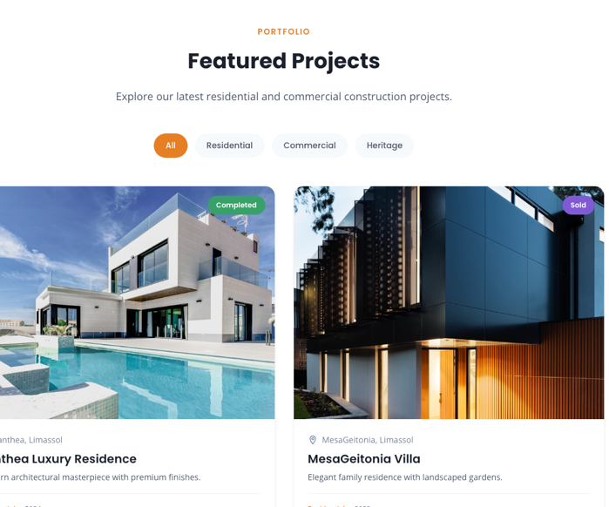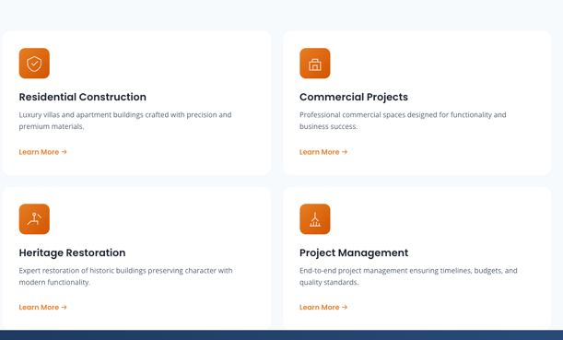

- Following narrations may be used if it is considered as an improvement
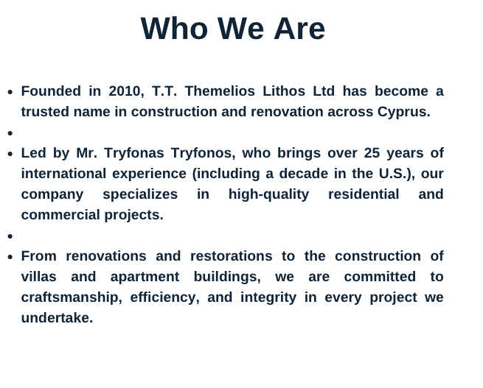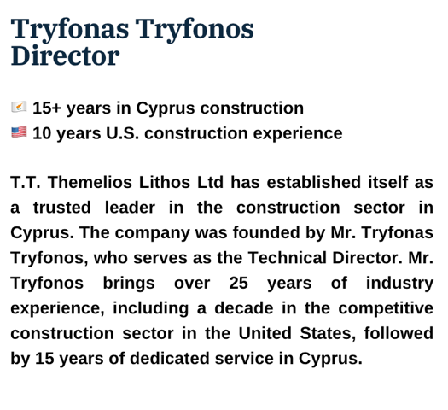

- Dynamic projects system: Separate page for each project detailing characteristics from architects’ plans, photos, brochure (see various projects folder). Each project to list the below fields, if they exist:
Image, Title, Location, Description, Bedrooms, Area, Floors, Features (grid), Gallery
Use this as a model: https://liferealty.cy/listing-2978/2-bedroom-apartment-agios-athanasios-limassol/?utm_medium=paid&utm_source=fb&utm_id=120248393060970151&utm_content=120248741290200151&utm_term=120248393060990151&utm_campaign=120248393060970151&fbclid=IwY2xjawQvjm1leHRuA2FlbQEwAGFkaWQBqzWYN2xeV2JyaWQRMWFVaDlJakNWNkxqNHVlTmZzcnRjBmFwcF9pZBAyMjIwMzkxNzg4MjAwODkyAAEetz_hSusdqedc1mdOzUdBOFBx-RVi2-lOTbemzwaVsUbwdpUgg3IV76r9w4A_aem_AitTE3W_jBXt88-BcLKL8A
For the below projects:
a. Panthea Residences. Residential. Under Construction. Location https://maps.app.goo.gl/My3kjvU14BoPerps9
Prices: first floor 400,000, second floor 430,000, third floor 450,000, for each apartment.
b. Agios Athanasios Residences. Residential. Under Construction. Location https://maps.app.goo.gl/V576GJ7FWSD4xAVL9
Prices: first floor 360,000, second floor sold, third floor 430,000, for each apartment.
c. Historical City Center, Business Centre. Under Study. Location https://maps.app.goo.gl/QZU1xuxjax1o9Y359
d. Yermasoyia, Business Centre. Under Study. Location https://maps.app.goo.gl/648W4qVKVcurVedf7
e. Columbia Residences. Under Study. Location https://maps.app.goo.gl/CVpCJ2v8BVuc65kU6
f. Makarios Avenue, Under Study. Location https://maps.app.goo.gl/LJwkLrqvpeXEbdQg7
g. Mesa Geitonia Residences. Residential. Completed. Sold. Location https://maps.app.goo.gl/bGHcEGHfGeGe8Ajb9
Use night photo as main photo.

