D1014636 潘子珉

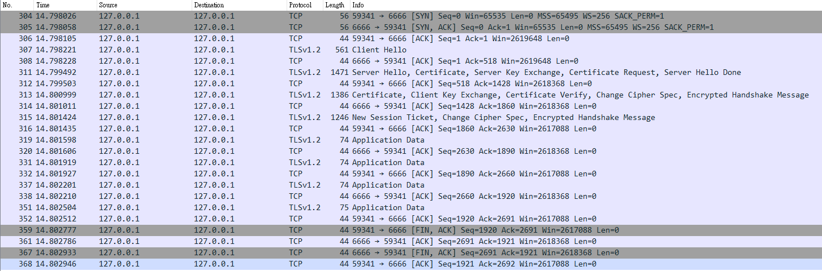

|  |  |
| --- | --- |
| 304, 305, 306 | 三方交握 |
| 307, 308 | client_hello |
| 311, 312 | server_hello, certificate, server_key_exchange |
| 313, 314 | certificate, client_key_exchange, certificate_verify, change_cipher_spec |
| 315, 316 | change_cipher_spec |
| 319 ~ 352 | send data |
| 359 ~ 368 | close |