­­<https://www.youtube.com/watch?v=SLB_c_ayRMo>

prerequisite:

create free tier account in AWS

Go to [www.terraform.io](http://www.terraform.io) === > Download === > Windows(32/64 bit) (Select OS as per your choice)

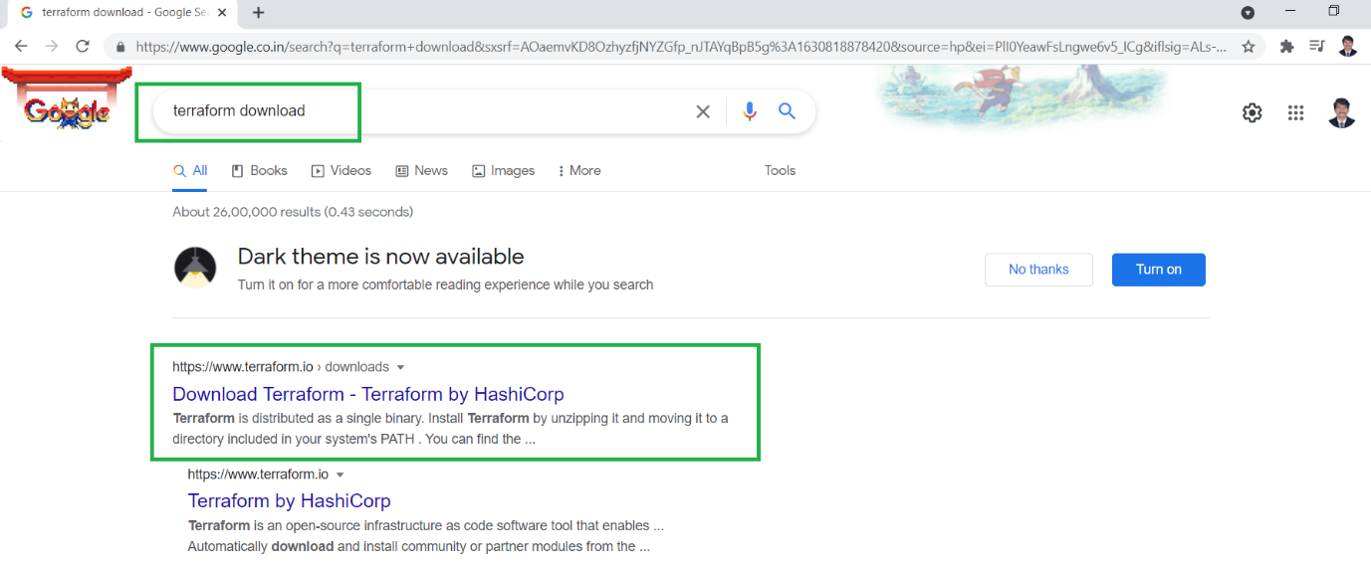

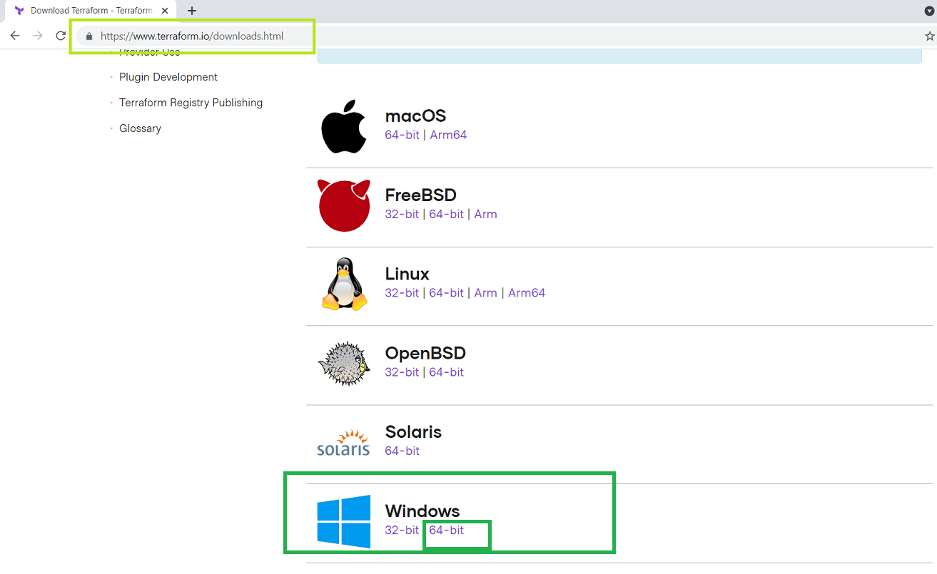

Unzip the below file.

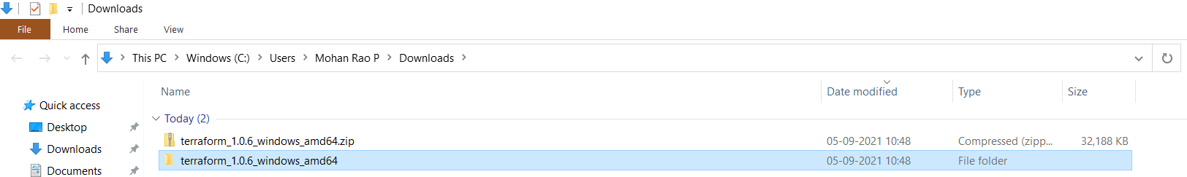

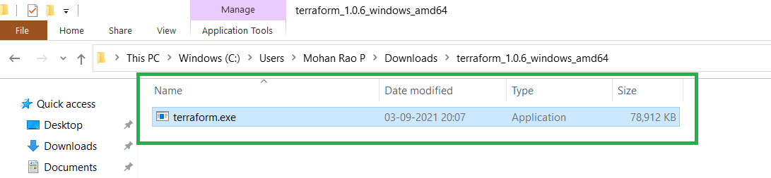

Copy terraform.exe file to any folder (Optional but you should remember it)

Example : D:\Terraform

Set this in environmental path variables

Type windows === > env === > Edit environment variables for your account.

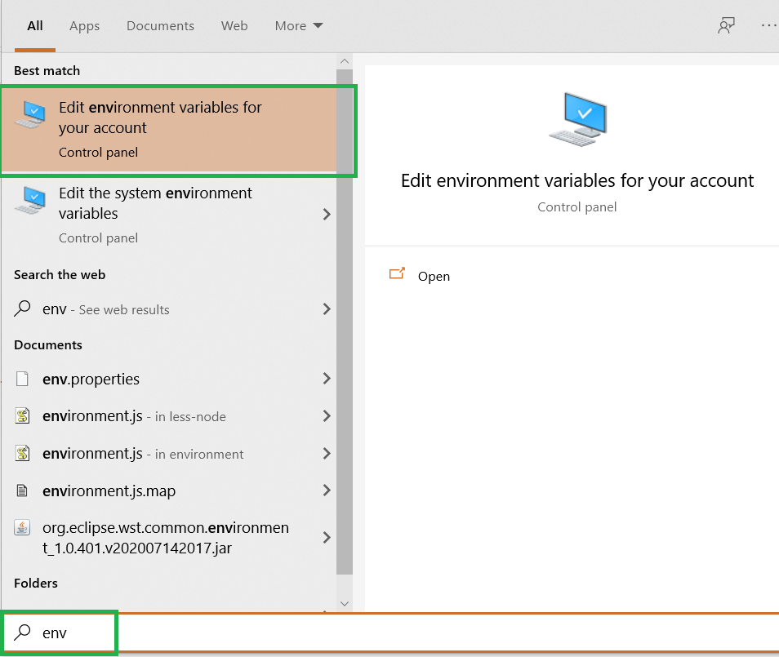

Terraform is distributed as a single binary. Install Terraform by unzipping it and moving it to a directory included in your system's [PATH](https://superuser.com/questions/284342/what-are-path-and-other-environment-variables-and-how-can-i-set-or-use-them).

Advanced === > Environment variables === > System variables === > select Path === > Edit === > New === > Paste as shown in below figure === > Ok === > Ok === > Ok

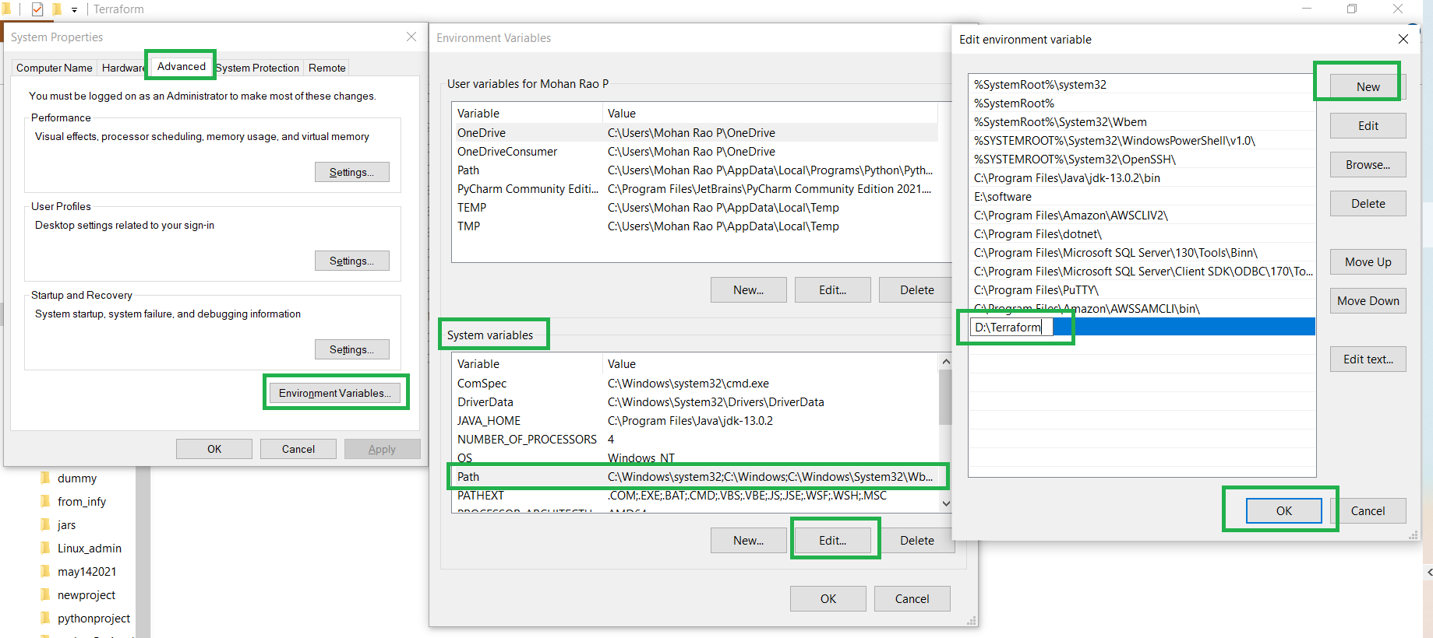

Go to windows === > type cmd === > terraform -v (to check the terraform version)

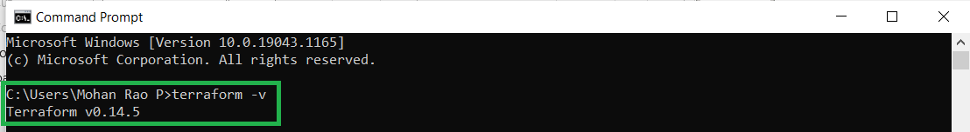

<https://code.visualstudio.com/>

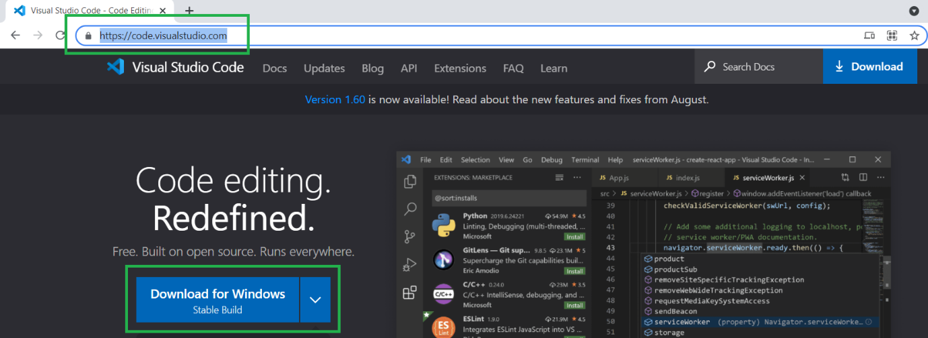

Down load and double click on it.



Accept the terms === > next === > Next === > Next === > Install === > finish

Install HashiCorp Terraform (preferably)

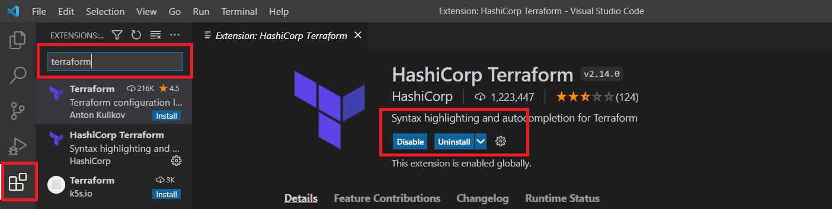

Create folder like below. D:\Terraform\terraformproject2021\project1

Go to visual studio === > File === > Open Folder === >

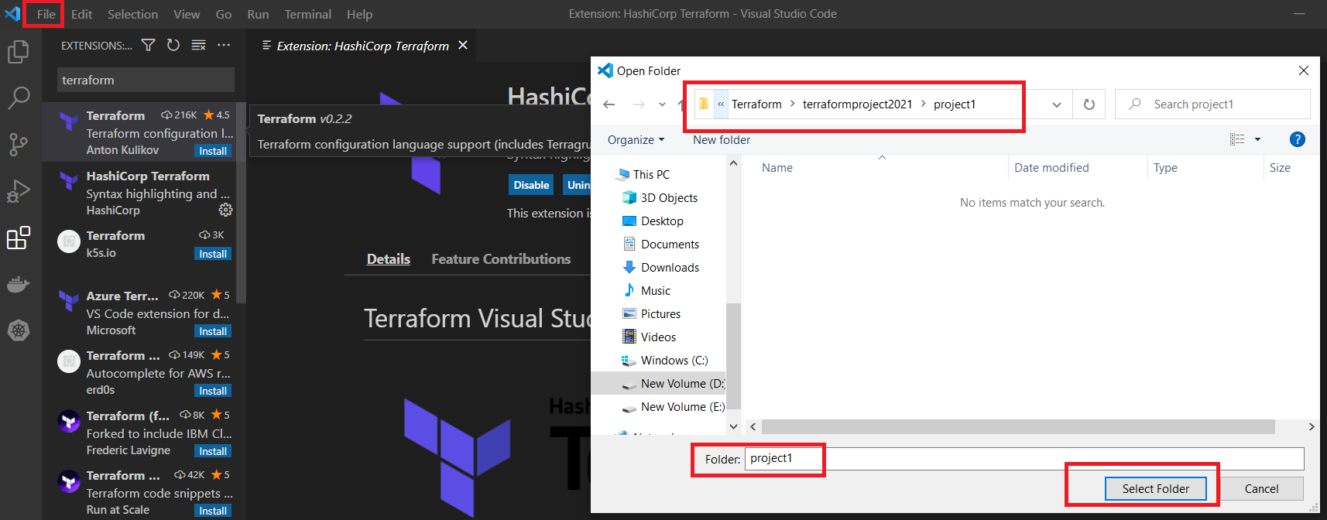

Create file with .tf extension

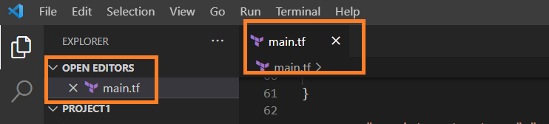

Go to below link to see providers.

<https://www.terraform.io/docs/language/providers/index.html>

setup providers:

<https://registry.terraform.io/providers/hashicorp/aws/latest/docs>

provider "aws" {

region = "us-east-1"

access_key = "my-access-key"

secret_key = "my-secret-key"

}

Go to new terminal using below steps.

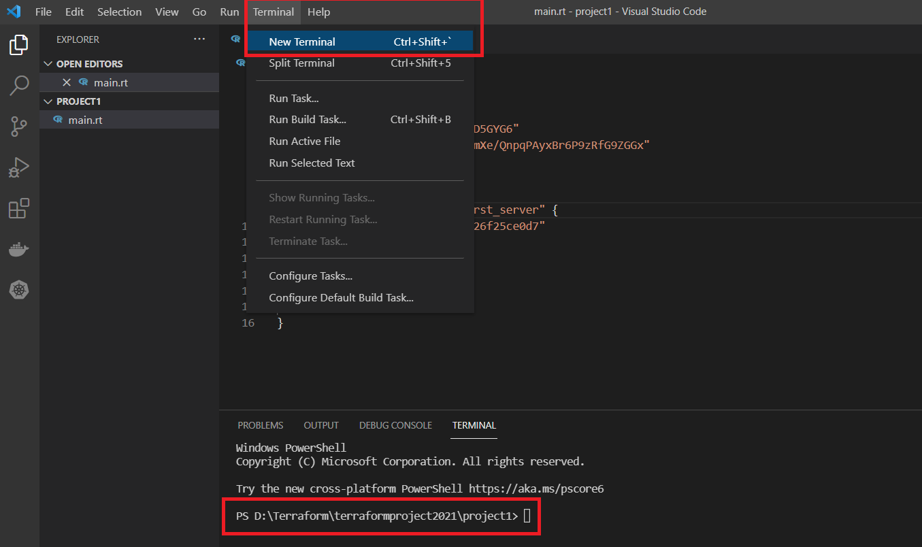

Execute : terraform init === > To initialize terraform.

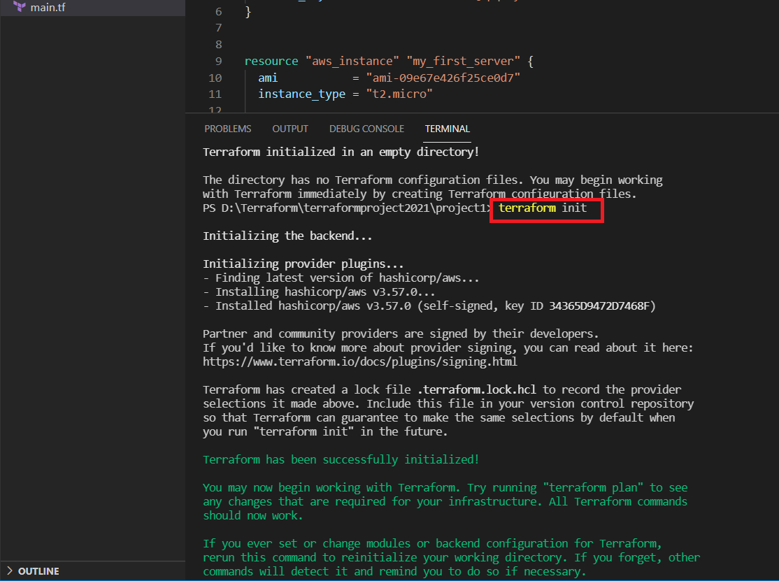

terraform apply === > to apply the changed

terraform plan === > to dry run the plan.