**C Sc 335 Analysis and Design Artifacts for Final Project**

**1. Team Name:**  Merge Conflict Anonymous

**2. Project:** Pokemon Safari Zone

**3. Team Members**: Paul Castleberry, Issac Kim,

Angel Burr, Sohyun Kim

**4. Candidate Objects or Class Hierarchies**

List the most important objects, or an inheritance hierarchy name, and the single responsibility of each.

|  |  |
| --- | --- |
| **Candidate Object** | **Single Responsibility in 1 or 2 sentences** |
| MapView | The view for the player while walking around and interacting with the open world. |
| Tile | A single cell on the map that contains a graphic, whether a Pokemon is hiding, and whether or not the player can walk on that cell. |
| Trainer | The players character in game, used to explore the map, and maintain current state of the players character. (Step count, inventory, Pokedex, etc) |
| Pokemon | The in game pocket monsters with a particular rarity, likely hood to flee, HP, max HP capable to be captured with, time until flight. |
| Inventory | Maintains the trainers current item count. |
| Game | The game object that serves as the brains between all player interactions with the interface to the game itself. |
| SafariZoneGUI | The user interface to the game. Controls what the player sees on screen depending on actions and current situation. |
| Pokedex<Pokemon> | The trainers current haul of Pokemon(list, array, or vector> |
| PokedexView | The view for the player when viewing their Pokedex, aka the Pokemon caught so far. |
| BattleView | The view for the player when they encounter and attempt to catch a Pokemon. |

**5. Sequence Diagram 1:** Your team UML Sequence Diagram should show the most important scenario you can think of. Your sequence diagram should show most of your objects from above and how they communicate with each other.

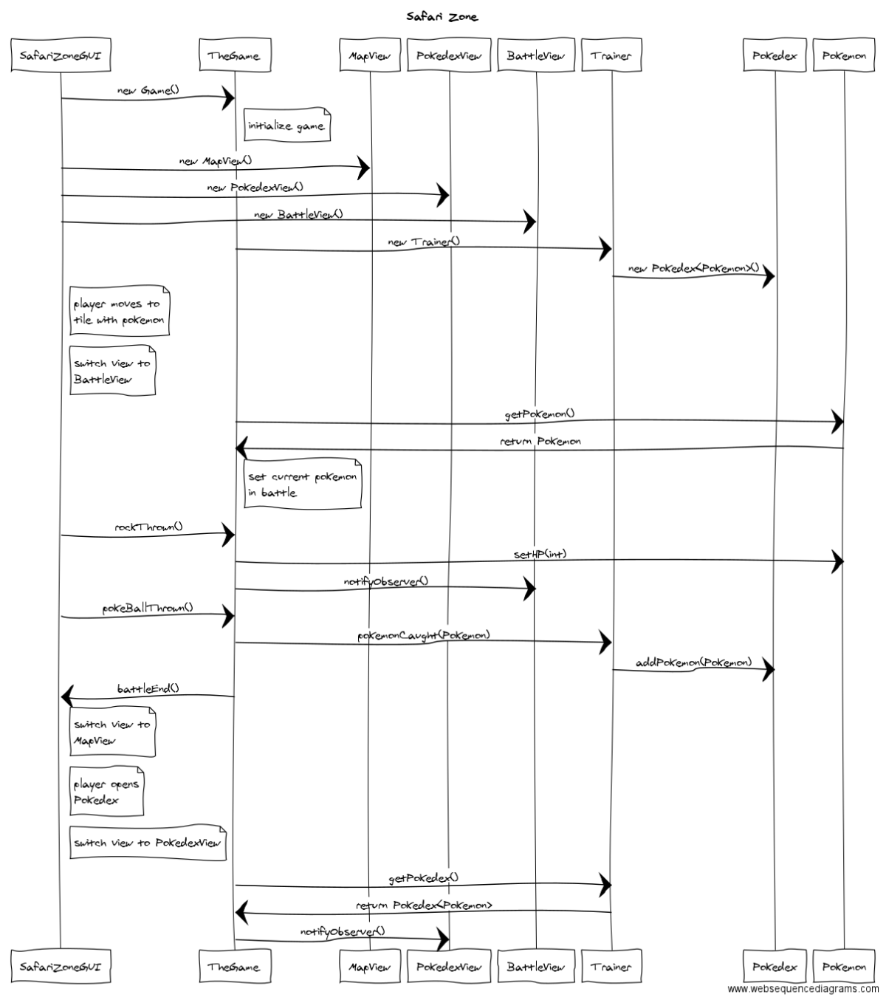

**6. Sequence Diagram 2:** Your team UML Sequence Diagram should show the second most important scenario you can think of. Your sequence diagram should show most of your objects from above and how they communicate with each other.

