# Bulk Load Prep Toolbox v1.0

The bulk load prep toolbox contains custom Python tools that are intended to increase the efficiency of data preparation prior to bulk loading into Biotics.

## EO/SF Separation Distance Analysis Tools

### PURPOSE OF TOOL

* Used to prepare feature classes and/or shapefiles for bulk load into Biotics by assigning an existing EOID/SFID or new EO/SF grouping string to observations based on separation distance.

### DATA NEEDED TO RUN EO/SF ASSIGN TOOL

* Spatial dataset (feature class or shapefile) of observations intended for bulk load. This dataset must include:
  + A field named ‘SNAME’ to include scientific name of species
* Table of separation distance values for species present in spatial dataset. This dataset must include:
  + A field named ‘SNAME’ with scientific name of species
  + A field named ‘sep_dist_km’ that includes the separation distance for the species in kilometers
* Geodatabase containing existing source features in three feature classes named:
  + eo_sourcept – for source points
  + eo_sourceln – for source lines
  + eo_sourcepy – for source polygons

### BEST PRACTICE METHODS FOR RUNNING EO/SF ASSIGN TOOL

1. Create new file geodatabase <name>.gdb
2. Import a copy of your dataset intended for bulk load and your separation distance table into newly created geodatabase, <name>.gdb.
3. If the bulk load dataset is in a geographic coordinate system, be sure to change it to a projected coordinate system to ensure accurate measurements. To do so, project the bulk load dataset using the Project tool.
4. Open the EO/SF Assign Script tool. Use the projected dataset created in step 3 as the input feature class or shapefile to be bulk loaded. Select the true OBJECTID field (this may be different depending on if the dataset was copied – see below for example). Use the separation distance table where indicated. Click OK.

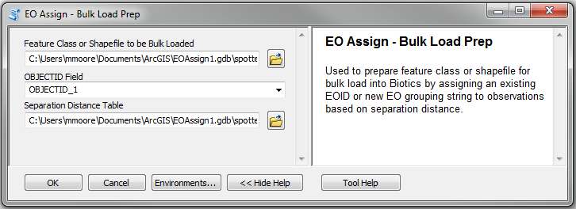

1. You can watch the progress box as your records are assigned to EO and SF groups.
2. If a record is within the separation distance of multiple existing EOs or SFs, it will list all existing EO IDs or SF IDs in the EO_ID or SF_ID fields, respectively. Therefore, once completed, a user must manually check to see which existing EO or SF the record should be assigned (this can be switched to automatically assign the closest or newest existing EO or SF, but a manual check approach allows the user to account for separation barriers, historic EOs, or EOs that should be considered for merging).