

**Tuition World - School Management**

**System Based on Web and Mobile Applications**

**ABSTRACT**

School Management System helps headmasters to get the most accurate information to make more effective decisions. Teachers and headmasters gain time-saving administrative tools, parents gain immediate access to their children’s grades and students can track their own progress. School Management System equipped features makes it possible to generate schedules and reports in minutes and to retrieve attendance records, grade checks, report cards, transcripts, and form letters in just a few clicks.

School Management Systems helps Teachers to complete grade book, track students attendance, input class notes, create lesson plans and detailed reports, and communicate with other staff members, students, and parents all via e-mail.

It also helps Students to access assignments and tests, and view attendance records, grades, report cards, and progress reports all online. They also can communicate through mail and forums with teachers and other students online.

Tuition World is a web and mobile applications developed in ReactJS and flutter and Android studio, powerful MYSQL database backend. To implement Tuition World application, schools do not need expensive hardware and software, they just need an internet connection and desktops. Our system works as a centralized database and application that schools can easily access the system from anywhere based on the login credentials. Tuition World is a platform-independent system that virtually any user can access from anywhere through a standard internet-accessible system. We can also customize Tuition World for individual school needs.

**Chapter 1**

**INTRODUCTION**

**Background**

* Nowadays education plays a great role in development of any country. Many of education organizations try to increase education quality. One of the aspects of this improvement is managing of school resources.
* Our system is a major tool through this managing process by making a continuous communication between headmaster, teacher, parents and student. So in order to achieve that goal, we need a Website that covers the needs of all users at the same time.
* For Students, they can view their subject's grades, contact with the headmaster and teachers for any complaint, recommendation or an absence permission, and they also up to date with all school's news or posts that publish by the other users.
* For Headmasters, they have a full control on the system, like they can add a new parents, teachers and students with their subjects.
* For Teachers, they can add student’s grades or edit it for their own subjects only, and they have a direct connection with students and their parents.
* For Parents, they have an access for their sons/daughters grades without any possibility to edit on it, and they can directly contact with teachers and headmasters.
* All the system users can publish whatever they need within the educational process on the last updates section, and these posts is visible for all the users.

**Problem Statement:**

The academic achievement for many students has decline, because of lake of care of them from their parents, and this refer to that their parents do not have a free time to come to school. Headmasters and Teachers are facing problems at the start of every new academic year, because of distribution process for courses and classes, in addition to this, through and at the end of every year another problem is facing them, which is the complexities of the grades entry process for their students. Lack of communication after a school day between Headmasters, Teachers, Parents and Students, which has a bad reflection on the educational process.

**Motivation:**

The importance of school education lies in the fact that the children of today will become adult citizens of tomorrow. The growth and future of our country highly depends upon the quality of the present school education system. And in a good school the chief objective is to stimulate interest and curiosity in the students and provide all possible facilities for headmasters, teachers and parents to achieve the desired goal which is a better and easier educational way for students. So, the motivation for our project came from that it has been made for that purpose, and for trying hardly to achieve all the previous goals

**Objectives:**

* To build a responsive website to manage the different school activities.
* To track student’s grades from their parents.
* To facilitate distribution process of courses and classes for teachers.
* To facilitate grades entry process for students by teachers.
* To make a virtual community between the members of educational process.

**Scope and Limitation of the Project**

Tuition World has been designed to provide an easy way for my Indian students- to get their grades, and for their parents to be familiar with that grades and the academic achievement for their kids. However, this project is facing some obstacles which is deny it from achievement it’s goals, like: lack of acceptance these idea from some teachers and headmasters, because of their poor knowledge about using that technology or they find that using computers in their works instead of the paper works so hard and difficult. And also, the same thing for some parents where they do not prefer that way for the same previous reasons.

**Chapter 2**

**LITERATURE REVIEW**

**Introduction**

This chapter identify the concepts of Tuition World for management, teacher, students and parents. Also review the related works with it.

**Tuition World, School Management System Strategy**

Tuition World is a complete school information management solution. Today's schools need to manage more information than ever before. Without a solid internal infrastructure for teachers, headmasters and departments to share data, critical school and student information can be lost, or worse leading to a host of problems that can effect of a school's image and endurance. To remain competitive, school needs a simple solution that can run individual function, connect their entire operation, use the web as a key communication tool and simplify day to day operational responsibilities, giving staff more time with students. Tuition World automates various scheduling activities of school and optimizes the use of premium resources. Concerned authorities can now easily and seamlessly use the system to create timetables, otherwise a time consuming and tedious task.

**Tuition World for Management**

* Single points school management software
* Manage multiple campuses.
* Enable internet front-end for the school.
* Connect with Parents and other stakeholders effectively
* Build and Manage community of parents, teachers and students
* Manages all administrative records with zero redundancy
* Achieve best possible resource optimization
* Automate all operational functions like fees, Attendance, Exam Management.
* Automatic generation and regeneration of timetable with dynamic substitute management.

**Tuition World for Teacher**

* Complete marks/grade management
* Publish articles for others.
* Interact with parents efficiently and effectively.
* View analytical reports
* Email and Internal messaging system.
* Participate in forum and share knowledge with others.
* View Timetable in advance.

**Tuition World for Student**

* Real time exposure for better learning.
* View online marks and timetable for exams.
* Interaction with other students, teachers and parents.
* View Timetable in advance.
* View current events and holidays at school.
* Get latest updates about school through image Gallery, News etc.
* Share knowledge and views with other parents and school through various features like article and forums.
* Get connected with schools effectively and easily
* Interact with teachers through internal messaging system.
* know status about her child through attendance, marks, fees etc. ...

**Technologies used in Tuition World**

**HTML:**

Is the standard markup language used to create web pages Web browsers can read HTML files and render them into visible or audible web pages? HTML elements form the building blocks of all websites. HTML allows images and objects to be embedded and can be used to create interactive forms. It provides a means to create structured documents by denoting structural semantics for text such as headings, paragraphs, lists, links, quotes and other items.

**CSS:**

Is a Web page derived from multiple sources with a defined order of precedence where the definitions of any style element conflict? The Cascading Style Sheet, level 1recommendation, from the World Wide Web Consortium (W3C), which is implemented in the latest versions of the Netscape and Microsoft Web browsers, specifies the possible style sheets or statements that may determine how a given element is presented in a Web page. And describes how HTML elements are to be displayed on screen, paper, or in other media (1).

**ReactJS**

React is **a declarative, efficient, and flexible JavaScript library for building user interfaces**. It lets you compose complex UIs from small and isolated pieces of code called “components”. React has a few different kinds of components, but we'll start with React. Component subclasses: class Shopping List extends React.

**MySQL Database:**

MySQL is the world's most popular open source database. With its proven performance, reliability and ease-of-use, MySQL has become the leading database choice for web-based applications, used by high profile web properties including Facebook, Twitter, YouTube, Yahoo! and many more

**Conclusion**

We have identified the concepts of our system and the technologies that have been used with Tuition World. Also, the related systems and their advantages and disadvantages, and a comparison between our system and the other systems.

**Chapter 3**

**METHODOLOGY**

**Introduction**

This chapter states the methodology used to reach the objectives of the project. The framework in which software is designed, developed, and maintained is known as the Software Development Life Cycle (SDLC). It shows the steps, phases, milestones, and evolution of the software development process. There are many types of models used in software design and development. Among them are the spiral models, rapid development model, Evolutionary model, waterfall model, prototyping model, etc.

**Methodology**

Prototyping Model has been used to develop this application. The Prototyping model is a technique for quickly building a function but incomplete model of the information system. There are several kinds of prototypes but they all intend to reduce risk by building a quick and dirty replica or mockup of the intended system. It can be used to demonstrate technical feasibility when the technical risk is high. It can also be used to better understand and elicit user requirements. In either case, the goal is to reduce risk and limit costs by increasing understanding of proposed solutions before committing more resources, as shown in figure 1.

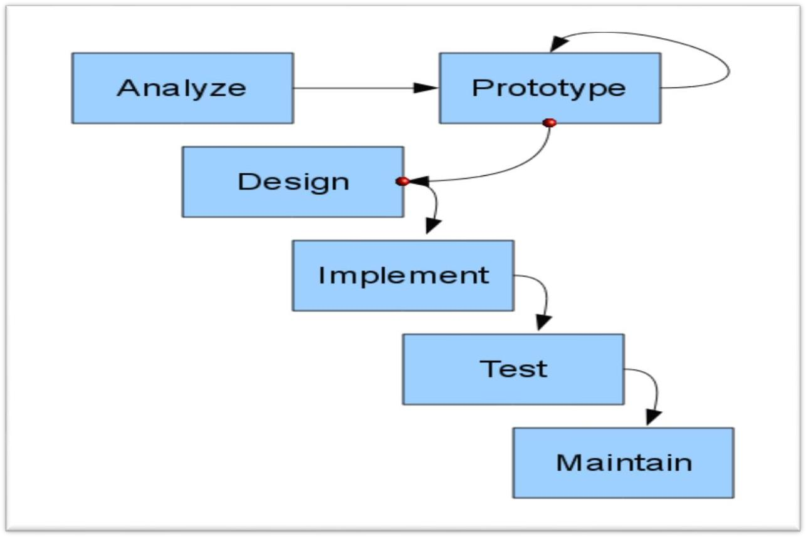

Figure 1 : Prototype Model Process**.**

**Prototype Model: -**

**Advantages of Prototyping**

* Reduces development time.
* Reduces development costs.
* Requires user involvement.
* Developers receive quantifiable user feedback.
* Facilitate system implementation since users know what to expect.
* Results in higher user satisfaction.
* Exposes developers to potential future system enhancements.

**The Process of Prototyping**

**- Identify basic requirement:** Determine basic requirements including the input and output information desired. Details, such us security, can typically be ignored.

**-Develop initial prototype:** The initial prototype is developed that includes only user interfaces.

**-Review:** The customers, end-users, examine the prototype and provide feedback on additions or changes.

**-Revise and enhancing the prototype:** Using the feedback, both the specifications and the prototype can be improved.

This method involves a series of iterations and refinement until the prototype product is a fully working system, and the user is satisfied.

**Reason of using Prototype Model**

* Users are actively involved in the development.
* Since in this methodology a working model of the system is provided, the users get a better understanding of the system being developed.
* Errors can be detected much earlier.
* Quicker user feedback is available leading to better solutions.
* Missing functionality can be identified easily.
* Confusing or difficult functions can be identified requirements validation, quick implementation of incomplete, but functional application.

**Phases in prototype Model**

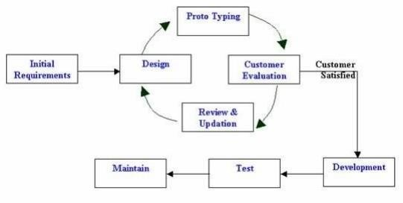

**Figure 2 : Prototype Model Phases.**

**Phase 1:**

**Identify some requirements to begin with:** Get lists of some major requirements which define the need for the new system including the main input output information.

**Phase 2:**

**Develop initial prototype:** Develop a basic initial prototype which only has UI screens.

**Phase 3:**

**Review the prototype:** End users and SME’s work and examine the prototype and provide feedback for improvements/enhancements.

**Phase 4:**

**Revise and enhance the prototype:** Scope is changed based on feedback from end users and the prototype is enhanced and refined to accommodate user feedback.

**Conclusion**

We used Prototyping Model as our methodology for developing this system, and we described the advantages of prototyping, it’s process, it’s phases and reasons of using its model.

**Chapter 4**

**Requirement and Analysis**

**Introduction**

This chapter will provide a full description of the system and its users. Then it depicts the functional and non-functional requirements that have been collected using several methods like brainstorming, interview and e-surveys. After determining the most important requirements, requirement analysis was adopted using several tools such as use-case diagram, sequence diagram and activity diagram.

**System description**

Tuition World is a web and mobile application system that serving Students, Teachers, Headmasters and Parents, the main idea of our system is to allow the students to be up to date with the school activities and with their grades, and the same thing for their parents in addition to be in touch permanently with the teachers and the headmaster for any complaint, recommendation or anything that related to their students. And for teachers it considered as an easy way to manage their job’s day, to be in touch with students and to enter their grades or anything they want to send it or view it to the students. And for the headmasters, they have a full control of the system, and like the teachers, it will be a great tool to manage their days and plans for the school, also they will be in a permanent connection with all the other users which will be a wonderful virtual educational social community that definitely will improve the student’s performance and education, and make the school for them really as they second’s home.

**User description**

There are four main users for the proposed system; these are Admin, student, teacher and the parent. Each user can perform several different functions during the use of the system. These functions were determined according to the design of the proposed system and a user-friendly function to make the system more effective and efficient. Figure 4 summarizes the functions performed by each user.

|  |  |
| --- | --- |
| **ACTORS** | **FUNCTIONS** |
| **ADMIN ( Headmaster )** | Log In/Out  Add New Subject  Add New Class  Add New Teacher  Edit Teacher  Add New Student  Edit Student  Add New Parent  -Edit Parent  Post tasks and any updates |
| **TEACHER** | Log In/Out  Enter students grades  Post tasks and any updates  -View complaints and recommendations |
| **STUDENT** | Log In/Out  View subject’s grades  Post complaint and recommendation |
| **PARENT** | Log In/Out  View their kids grades  Post complaint and recommendation |

**Figure 3 : User Descriptions**

**System Requirement**

Before creating any website or a mobile App, it is necessary to visualize the layout, design and all features intended to be incorporated. In addition, how users will interact with each page and icon and how the website/App should perform (behavior, load time etc.). Requirements are the necessary attributes in the system, a statement that identifies a capability, characteristic or quality factor of the system in order to have value and utility to the users. Once the requirements are set, developers can initiate the other technical work including system design, development, testing, implementation, and operation.

For any system, there are functional and non-functional requirements to be considered while determining the requirements of the system. The functional requirements are user “visible” features that are typically initiated by stakeholders of the system, such as generate report, login, and signup. On the other hand, nonfunctional requirements are requirements that describe how the system will do what it is supposed to do, for example, security, reliability and maintainability.

**Functional Requirement**

**Admin (Headmaster)**

* Create, edit and delete student account.
* Create, edit and delete teacher account.
* Create, edit and delete parent account.
* Post tasks or any updates for users (Teacher, Student, and Parent).
* Store, edit, delete, calculate and print student's grade.
* Add Classes and Subject and connect them with the subject’s teachers.
* Exam Portal
* Centralized Management System
* Global Competitive System
* Dynamic Report

**Teacher**

* Enter Student's grades per Subject.
* Contact with students and parents.
* Post tasks or any updates for users (Admin, Student, and Parent).
* Digital Content
* Syllabus Planning
* Time Table
* Attendance
* Exam Portal

**Student**

* View their grades.
* Contact with their teacher and headmaster.
* Attendance
* Fee Payment
* Time Table
* Exam Portal

**Parent**

* View the grades of their children.
* Contact with their children’s teachers and headmaster.
* Attendance
* Student information
* Global competitive Exam Portal
* Fee payments

**Non-Functional Requirement**

**Security**

Every user has his own account and only authorized users can access the system with username and password. The passwords are encrypted using a React function sha1 ().

**Performance**

Easy tracking of records and updating can be done.

**Availability**

The system is available to users anytime, anywhere, just need a PC and Internet Connection. Also, the system work in multiple web browsers like (Chrome, Mozilla, Opera, and Internet Explorer).

**User Friendly**

The system has a friendly user interface and the system very interactive

**System Analysis**

This part contains the analysis of the functional and non-functional requirements using use-case diagrams, and use-cases details. In addition, the interactive behavior of the activities is analyzed using sequence diagrams and activity diagrams.

**Use case Diagram**

This part contains the analysis of the functional and non-functional requirements using use-case diagrams, and use-cases details.

**Admin**

* The functions that Admin can do after login, as shown in figure 7:
* Add Teacher include (Modify/Delete).
* Add Student include (Modify/Delete).
* Add Parent include (Modify/Delete).
* Add Class include (Modify/Delete).
* Contact with teachers, students and parents.

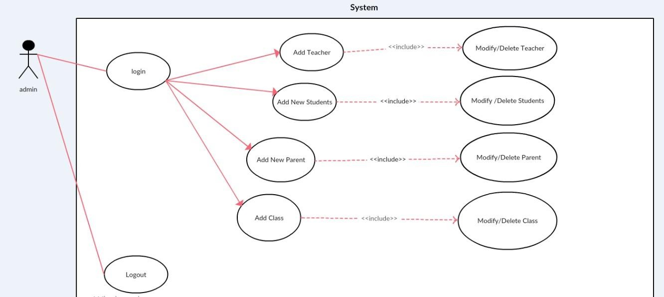

Figure 5: Admin use case Diagram

**Student**

* The functions that Student can do after login, function as shown in figure 8:
* View Personal Information.
* View Courses Marks.
* Exam Portal
* Contact with teachers and headmaster.
* Syllabus
* Time Table

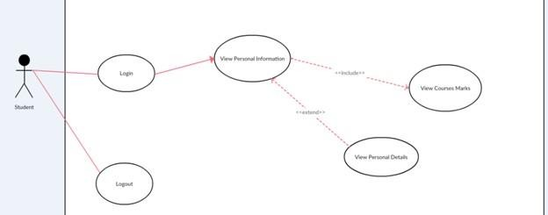

Figure 8: Student use case Diagram

**Teacher**

* The functions that Teacher can do after login, as shown in figure 9:
* Enter Student's grades.
* Modify or delete grades.
* Contact with students, parents and headmaster.
* Digital Content.

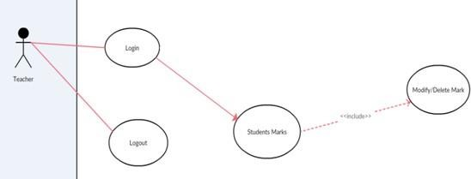

Figure 9 : Teacher use case Diagram

**Parent**

* The functions that Parent can do after login, as shown in figure 10:
* View their children’s grades.
* Contact with teachers and headmaster
* Fees Management
* Student attendance
* Exam portal
* 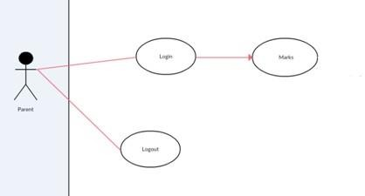Time table

Figure 10: Parent use case Diagram

**Sequence Diagram**

Describes an Interaction by focusing on the sequence of Messages that are exchanged, along with their corresponding Occurrence Specifications on the Lifelines

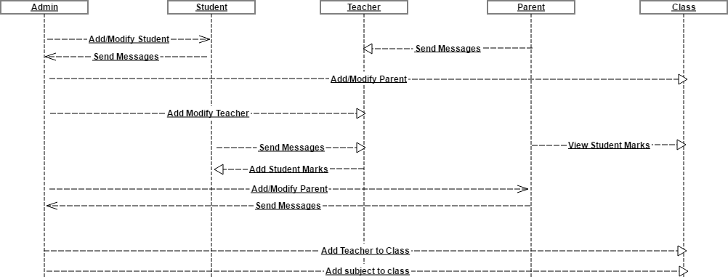

Figure 3: Sequence Diagram

**Activity Diagram**

Describe dynamic aspects of the system. It is basically a flow chart to represent the flow form one activity to another activity. The activity can be described as an operation of the system. So, the control flow is drawn from one operation to another.

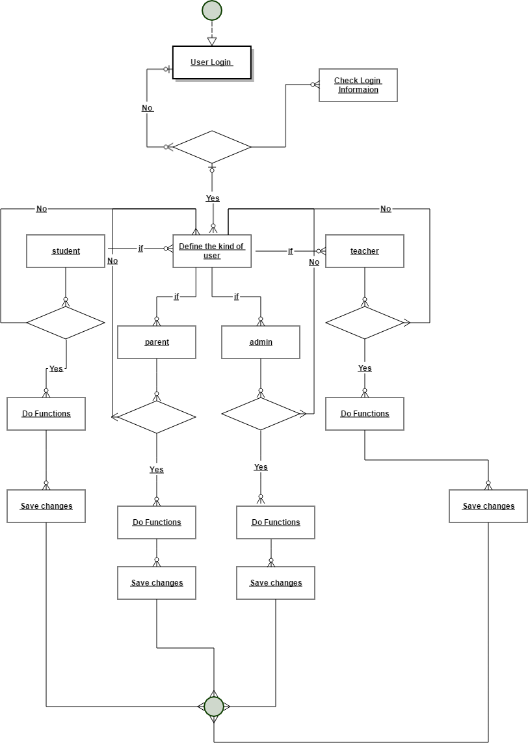

Figure 4: Activity Diagram

**Conclusion**

We had a description for the system and its users, and the functional and non- functional requirements, then we talked about several tools such as use- case diagram, sequence diagram and activity diagram that have been used to analyze the interactive behavior of the activities.

**Chapter 5**

**Design and Implementation**

**Introduction**

This chapter explains the design and implementation phases of the system. It depicts the class diagram, ER diagram and database schema the System. Moreover, the implementation phase combines the requirements, design phase outputs, and process them using the appropriate technologies.

**Analyze Phase**

During the analyze phase, we determine the requirement of the project and get in touch how we can improve the school's performance, also we determine how implement the school's needs to help them to get professional work.

**Build A Prototype.**

In this phase, the tools used in developing the prototype and the developed system are described:

**Programming Tool**

The system is developed using web development techniques (HTML5, CSS3, JavaScript, ReactJs) that let us design the system layout such as login form, tables, panels and colors, then implement UI/UX element's such as: Make the system ease to use.

* + - * Make the system ease to use.
      * Make the system ease to learn.
      * Choose the website color's carefully to enhance user interfaces

Then, make the system dynamic using programming tools (Reactjs and Nodejs, MYSQL DBMS) it’s let us store the user's information in database and view it through the Web Pages using Reactjs and Nodejs

**Design Phase**

During the design phase, the relationships between classes was designed and analyzed using the class diagram. After that, the database schema was developed to illustrate the mapping of the data. Finally, the

**Class Diagram**

To illustrate the relationships and source code dependencies among classes, class diagram was developed. In this context, the class defines the methods and variables in an object, which is a specific entity in a program or the unit of code representing that entity.

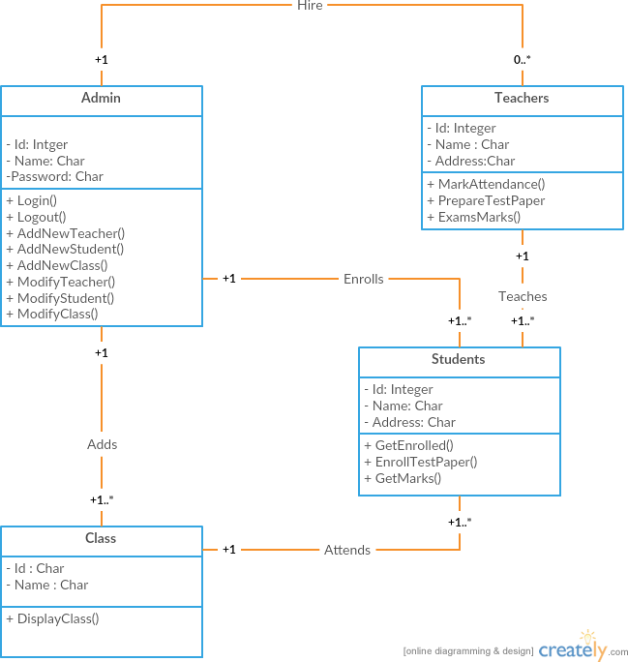

Figure 5 : class diagram

**Database Schema**

A database schema is the skeleton structure that represents the logical view of the entire database. It defines how the data is organized and how the relations among them are associated. It formulates all the constraints that are to be applied on the data.

The system has five database tables as shown in Figure 16. Each table contains an ID and several different attributes related to different functions in the system.

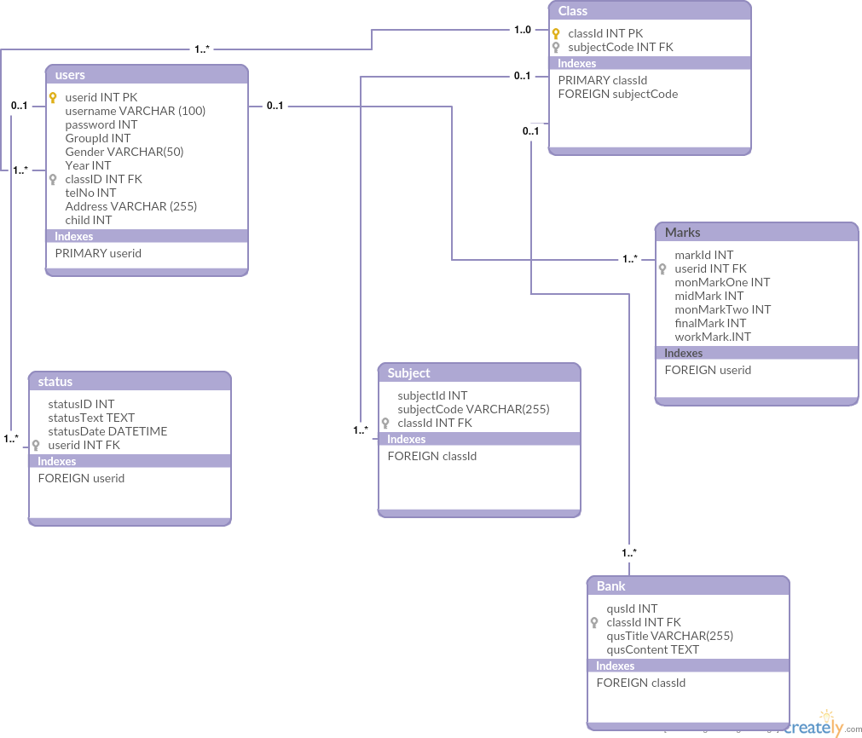

Figure 6 : Database Scheme

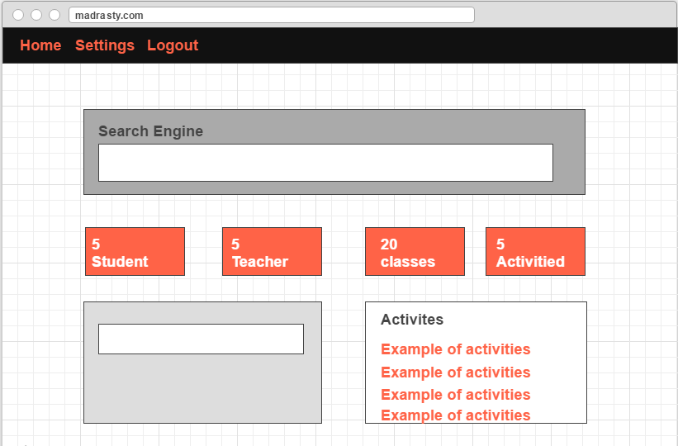

Figure 7 : Prototype Control Panel

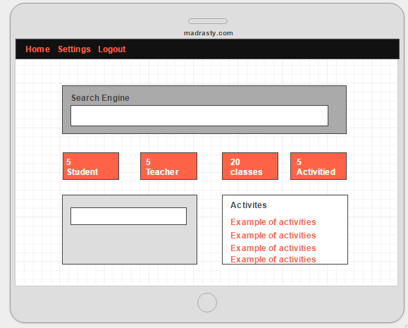

Figure 8 : Prototype Mobile Working

**Implementation Phase**

After developing the databases of the system, the implementation phase emerges and through this phase, several activities and techniques were used to develop the website and mobile App, as shown in blew. The development of the website starts with designing the website structure using HTML5, then the style of the website was designed using CSS3. After that, enhanced user interfaces and dynamic website were developed using JavaScript and reactjs. Later on, the website contents and databases were managed through the use of Reactjs and Nodejs7. Finally, the panorama was incorporated in the website.

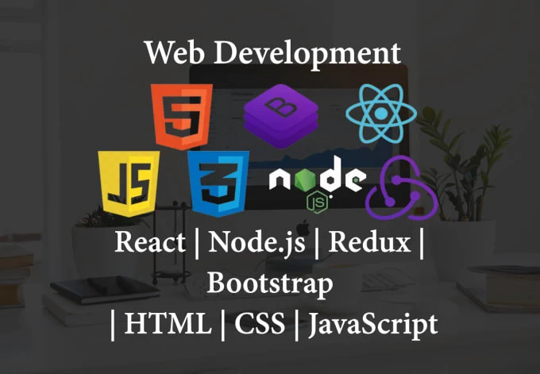

Figure : The Implementation Phase Activities.

**Conclusion**

We had an explain for the design and implementation phases of the system, which include the class diagram, ER diagram and database schema the System. Also, the admin and users’ interfaces.

**Chapter 6**

**Testing and Evaluation**

**Introduction**

This chapter illustrates the last two phase of the project the testing and evaluation phases. In the testing phase, the performance testing and functionality testing performed. In addition, the evaluation was performed through this steps School Manager, Teacher, Student, and Parent.

**Testing**

Two types of testing were performed to test the website and how it supports mobile working. These tests were mainly performance testing and functionality testing.

**Performance Testing**

The website was tested on Firefox browser using an online tool called **GT Metrix**, which analyzes web pages according to different rules by giving each rule a weigh, and then evaluate the score of each rule for the website. The rules tested by this tool is indicated in Table blew.

|  |  |
| --- | --- |
| **1.** Make fewer HTTP requests | **2.** Remove duplicate JavaScript and  CSS |
| **3.** Use a CDN | **4.** Configure ETags |
| **5.** Avoid empty src or href | **6.** Make AJAX cacheable |
| **7.** Add Expires headers | **8.** Use GET for AJAX requests |
| **9.** Compress components with  GZip | **10.**Reduce the number of DOM  elements |
| **11.**Put CSS at top | **12.**Avoid HTTP 404 (Not Found) error |
| **13.**Put JavaScript at bottom | **14.**Reduce cookie size |
| **15.**Avoid CSS expressions | **16.**Use cookie-free domains |
| **17.**Make JavaScript and CSS  external | **18.**Avoid AlphaImageLoader filter |
| **19.**Reduce DNS lookups | **20.**Do not scale images in HTML |
| **21.**Minify JavaScript and CSS | **22.**Make favicon small and cacheable |
| **23.**Avoid URL redirects |  |

Table 1: Rules used during the test of the website

The system’s website was tested using this tool, and the results showed that the system belongs to grade B, which is the first grade with an overall performance score of 87%, as shown in blew.

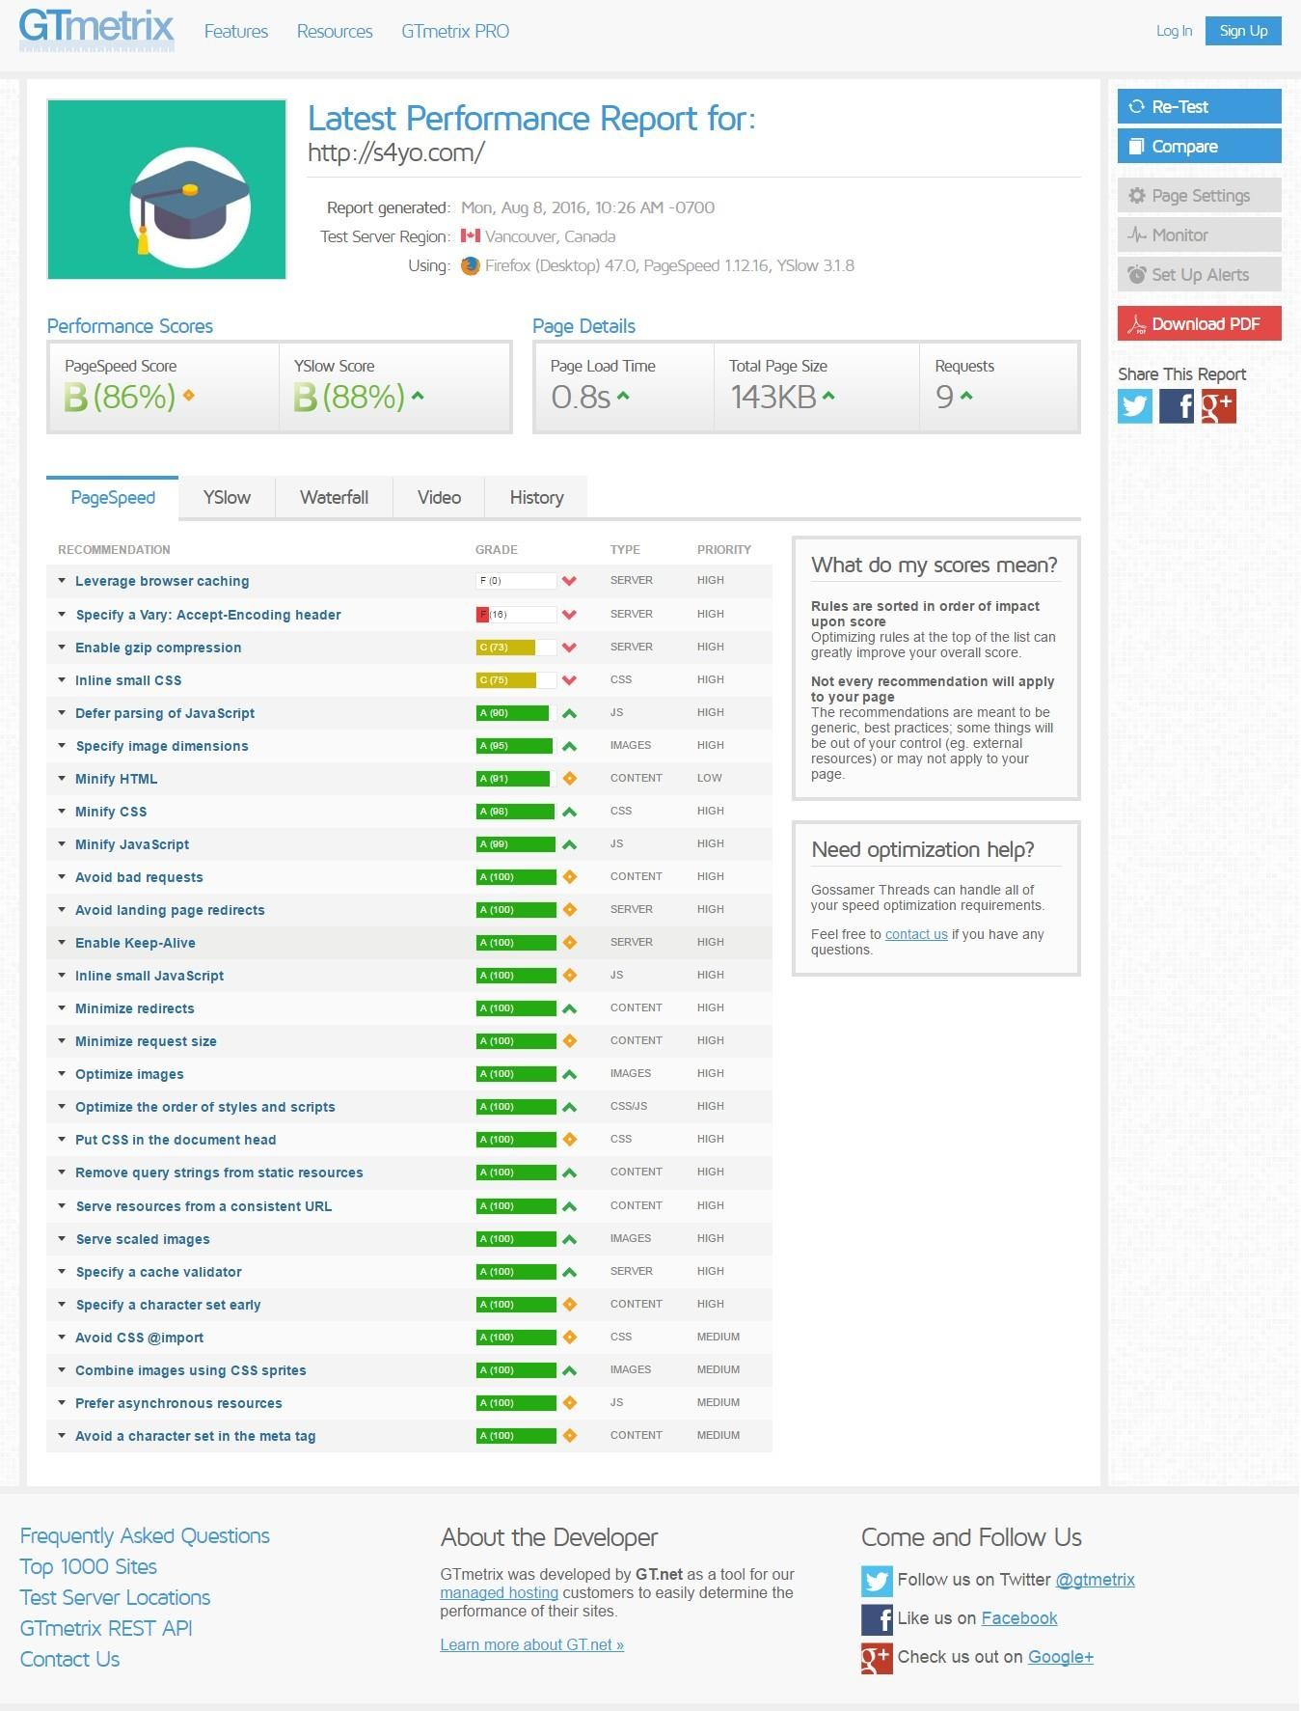

Figure 13: GTmetrix Online Performance Testing of the website.

**Functionality Testing**

All functions in the application, database connection, forms used to enter data for submission, editing, getting or deleting information from users were tested. Developers performed the test of the website. Some functionality requirements were tested during the test:

**Security Testing**

Security was tested by pasting internal URL directly into browser address bar without login. SQL injection SQL MAP tool was used to test all pages in website. Also, when the user (Admin, Teacher) need to edit marks or information to other user if he edits the id in URL the system will redirect to logout page or home page.Ex: (student.php?userid=120110220) if the user tries edit the id number to access to other user information or other hacking.

**Database Testing.**

Data consistency is very important. Data integrity and errors while editing, deleting, modifying the forms or do any DB related functionality were checked. Moreover, the entire database queries were checked to be executed correctly, data is retrieved correctly and even updated correctly.

**Evaluation**

Since the system has four users whose opinion about the system is very important, a sample of student, teacher, parent, and school manager were consulted to evaluate the website.

**Usability Evaluation**

To evaluate the system based on the users (student, teacher, parent, admin),

**End-Users' Evaluation**

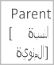

Teacher

Student

Figure 14: Distribution of the user’s kind



Female 43.33%

Male 56.67%

Male Female

Figure 15: Distribution of the users



Above 30

years 20.0%

15-18

years 10.0%

25-30

years 40.0%

19-24

years 30.0%

15-18 years 19-24 years

25-30 years Above 30 years

Figure 16: Distribution of the users age

**Users Evaluation**

In this evaluation process, we go to the school in Rafah and distribute thirty questionnaires and we get just 20 from it as shown blew (9 student, 6 teacher, 3 parents, 2 admin).

|  |  |  |  |  |  |
| --- | --- | --- | --- | --- | --- |
|  | **Strongly agree** | **agree** | **Neutral** | **Disagree** | **Strongly Disagree** |
| **Easy to use** | **5** | **2** | **5** | **3** | **5** |
| **Easy access to**  **the functions of the system** | **4** | **8** | **4** | **8** | **1** |
| **Age completion** | **8** | **2** | **5** | **1** | **4** |
| **Help me**  **tracking the student** | **2** | **2** | **8** | **5** | **1** |
| **Help us to concatenation**  **within the school** | **10** | **5** | **2** | **2** | **1** |

Figure 17: Distribution of the use’s evaluation

**Conclusion**

We have explained the testing and the evaluation phases for the project, also the functionality and the performance testing, and the evaluation that has performed through School manager, teacher, student and parent.

**Chapter 7**

**Conclusion and Future**

**Work**

**Conclusion**

In recent years, with the pace of technological development, people have become more and more demanding in terms of quality of life, and the school’s managers in recent years look to improve a performance in their schools to get the highest rate of knowledge and experience in their student.

**Future Work**

Some ideas and features can be considered as a future work for this project. These features can be summarized in the following points:

* Let the student perform exams Online.
* Bank of question per subject.
* Let teacher add questions to the bank of question.
* Let admin add new classes.
* Add a medical examination part to the system, with a medical supervisor as a new user.