

Toy management

* **Faculty: Ho Hoan Kiem**
* **Batch:**
* **Team Member:**
  + - * **Pham Duy Hai**
      * **Tran The Mi**
      * **Phung Ngoc Khuong Duy**

**Ho Chi Minh City, Sep 10 2012**

Table of Contents

1. Review 1

* **Problem Definition..…………………………………………………………………………………01**
* **Software****Requirement** **Specifications……………………………………………………………… 02**

1. Review 2

* ***Use Case Diagram* 04**
* ***Class Diagram* 15**
* ***Sequence Diagram* 16**
* ***ERD* 18**
* ***Entity Description* 19**
* ***Table Relationship Diagram* 26**

1. Review 3

* Interface Design………………………………………………………………………………..... 27
* Site Map……………………………………………………………………………………………… 51
* Report ………………………………………………………………………………………………..53
* Tasksheet……………………………………………………………………………………………. 56

REVIEW 1

Problem Definition

1. **The Object Of The Project**

This project will aim at creation of a toy management system. This will be accessible to who have a valid User Id and Password. This system provides the following facilities:

* Manage Customers
* Manage Employees
* Manage Products
* Manage Orders

Software Requirement   
 Specification

1. **Functional Requirements**

## UC001 – Login

## UC002 – Manage Products

## UC002.1 – View Product

## UC002.2 – Add Product

## UC002.3 – Delete Product

## UC002.4 – Update Product

## UC003 – Manage Employees

## UC003.1 – View Employee

## UC003.2 – Add Employee

## UC003.3 – Delete Employee

## UC003.4 – Update Employee

## UC004 – Manage Customers

## UC004.1 – View Customer

## UC004.2 – Add Customer

## UC004.3 – Delete Customer

## UC004.4 – Update Customer

## UC005 – Manage Orders

## UC005.1 – View Order

## UC005.2 – Add Order

## UC005.3 – Delete Order

## UC005.4 – Update Order

# Hardware/ Software Requirements

1. **System Requirement**

* **For Users**
  + **Hardware**
    - CPU: Pentium IV 2.0 GHz or higher
    - RAM: 512 MB or higher
  + **Software**
    - OS: Windows 7/XP Professional/Server 2003…
    - Browser: Internet Explorer 8.0 or higher
* **For Software Developers**
  + **Hardware**
    - CPU: Pentium IV 2.0 GHz or higher
    - RAM: 512 MB or higher
  + **Software**
    - OS: Windows XP Professional/Server 2003…
    - Environment: Microsoft .NET Framework 4.5
    - Database Management System: Microsoft SQL Server 2008
    - IDE: Microsoft Visual Studio 2017
    - Web Server: Internet Information Services (IIS) JSP / Servlets Dev. Kit

|  |  |  |
| --- | --- | --- |
| **Date: Sep 10, 2012** | **Prepared by Project Group 4**  **Team Leader:** | **Approved by**  **Mr Ho Hoan Kiem** |
| **Signature** |  |  |

REVIEW 2

**USE CASE DIAGRAM**

**Administrators :**

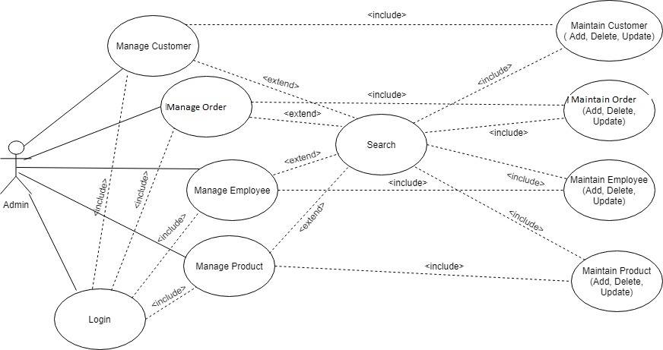

**USE CASE DESCRIPTION**

1. **Actor:**

* **Administrators :** The person(s) that manage and maintain this software.

1. **Usecase:**

|  |  |
| --- | --- |
| **Usecase** | Login |
| **Short Description** | Log in website to use any function of admin. |
| **Pre-Conditions** |  |
| **Post-Conditions** |  |
| **Main flow** | _Admin inputs the login information :   * Login ID. * Password.   _Admin clicks on the Login button.  _System check the Login ID and Password.  _If Login ID and Password are valid, system will move admin to Home. |
| **Alternative flow(s)** | _If guest clicks on “Reset” button, the Login ID field and Password field are blank.  _If Login ID field or Password field is invalid form or blank when guest clicks on the “Login” button, system will notify the error. |

|  |  |
| --- | --- |
| **Usecase** | Manage Customer |
| **Short Description** | Manage all information about customer. |
| **Pre-Conditions** |  |
| **Post-Conditions** |  |
| **Main flow** | _Manage all information of customer |
| **Alternative flow(s)** | _If server notifies any error when it’s processing, system must be write report into Log file. |

|  |  |
| --- | --- |
| **Usecase** | View Customer’s Information |
| **Short Description** | Administrator view customer’s information. |
| **Pre-Conditions** |  |
| **Post-Conditions** |  |
| **Main flow** | _Administrator choose the customer that administrator wants to see information.  _Administrator clicks on the “View Information” button.  _System shows the customer’s information to the administrator. |
| **Alternative flow(s)** | _If server notifies any error when it’s processing, system must be write report into Log file. |

|  |  |
| --- | --- |
| **Usecase** | Administrator Edit Account |
| **Short Description** | Edit member’s information. |
| **Pre-Conditions** |  |
| **Post-Conditions** |  |
| **Main flow** | _System check this information and save it on the server.  _System notify report to member. |
| **Alternative flow(s)** | _If any information edit are invalid, system’ll notify the error.  _If server notifies any error when it’s processing, system must be write report into Log file. |

|  |  |
| --- | --- |
| **Usecase** | Manage Transaction |
| **Short Description** | Manage all information about Transaction. |
| **Pre-Conditions** |  |
| **Post-Conditions** |  |
| **Main flow** | _Administrator can view detail transaction.  _Admin can view, insert, update, delete transaction.  _Transaction reporting in the days, months, years .  _System passes administrator to the page that administrator can interact with system. |
| **Alternative flow(s)** | _If server notifies any error when it’s processing, system must be write report into Log file. |

|  |  |
| --- | --- |
| **Usecase** | View Transaction Information |
| **Short Description** | View details information of Transaction. |
| **Pre-Conditions** |  |
| **Post-Conditions** |  |
| **Main flow** | _Administrator chooses the transaction that administrator wants to see information.  _System shows the details information of this transaction. |
| **Alternative flow(s)** | _If server notifies any error when it’s processing, system must be write report into Log file. |

|  |  |
| --- | --- |
| **Usecase** | Manage Employee |
| **Short Description** | Manage all information about Employee. |
| **Pre-Conditions** |  |
| **Post-Conditions** |  |
| **Main flow** | _ Manage all information of customer.  _Admin can view, insert, update, delete employee. |
| **Alternative flow(s)** | _ If server notifies any error when it’s processing, system must be write report into Log file. |

|  |  |
| --- | --- |
| **Usecase** | Manage Product |
| **Short Description** | Manage all information about Product. |
| **Pre-Conditions** |  |
| **Post-Conditions** |  |
| **Main flow** | _ Manage all information of Product.  _Admin can view, insert, update, delete products. |
| **Alternative flow(s)** | _ If server notifies any error when it’s processing, system must be write report into Log file. |

**CLASS DIAGRAM**

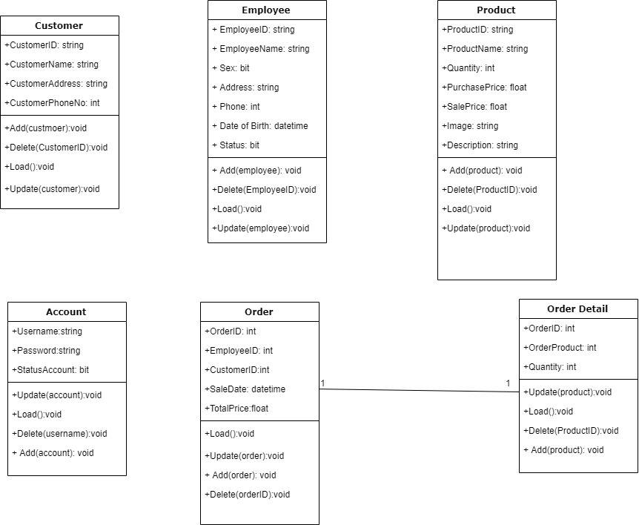

**ENTITY RELATIONSHIP DIAGRAM (ERD)**

Entity

Entity Relationship

One to many relationship

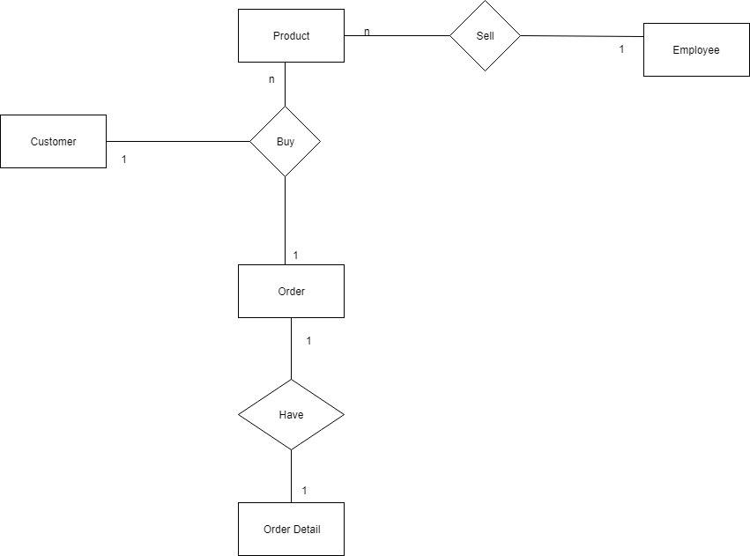

**ENTITY DESCRIPTION**

**1.Account Admin :**

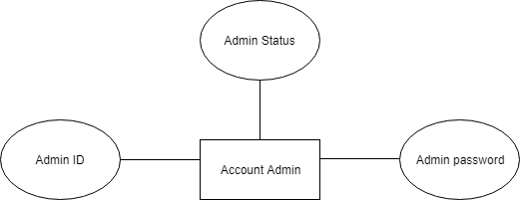

**2.Account Customer:**

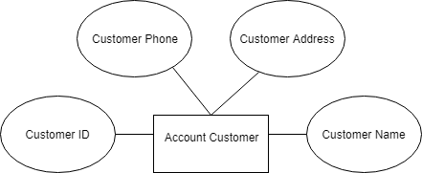

**3.Account Employee:**

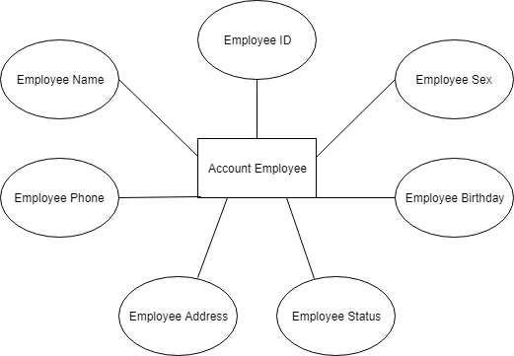

**4.Account Product:**

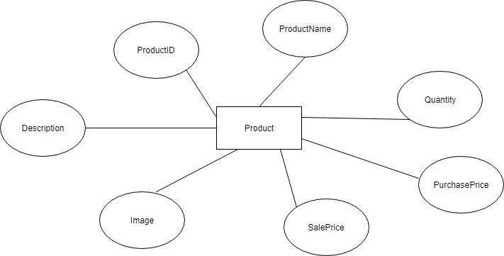

**5.Order:**

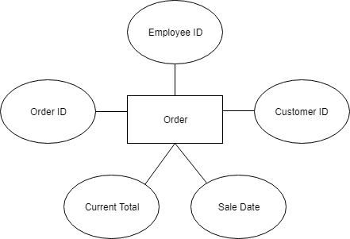

**5.Detail Order:**

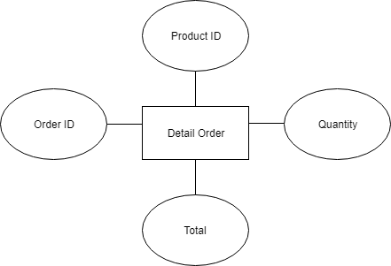

**TABLE DESIGN**

1. **Admin :**

|  |  |  |  |  |  |
| --- | --- | --- | --- | --- | --- |
| **No** | **Column Name** | **Data Type** | **Size** | **Check** | **Description** |
| 1 | **🗝**Username | Varchar | 15 | Not Null | Admin ID |
| 2 | Passwords | Varchar | 20 | Not Null | Admin password |
| 3 | Account Status | Bit |  | Not Null | Admin user name |

1. **Employee :**

|  |  |  |  |  |  |
| --- | --- | --- | --- | --- | --- |
| **No** | **Column Name** | **Data Type** | **Size** | **Check** | **Description** |
| 1 | **🗝**EmployeeID | Nvarchar | 50 | Not Null | Employee ID |
| 2 | EmployeeName | Nvarchar | 50 | Not Null | Employee Name |
| 3 | Sex | Nvarchar | 50 | Not Null | Employee Sex |
| 4 | Address | Nvarchar | 50 | Not Null | Employee Address |
| 5 | Phone | Nvarchar | 50 | Not Null | Employee Phone |
| 6 | Birthday | date |  | Not Null | Employee Birthdate |
| 7 | status | bit |  | Not Null | Employee active or non-active |

1. **Product :**

|  |  |  |  |  |  |
| --- | --- | --- | --- | --- | --- |
| **No** | **Column Name** | **Data Type** | **Size** | **Check** | **Description** |
| 1 | **🗝**ProductID | Nvarchar | 50 | Not Null | Product ID |
| 2 | ProductName | Nvarchar | 50 | Not Null | Product Name |
| 3 | Quantity | Int |  | Not Null | Product Quantity |
| 4 | PurchasePrice | Float |  | Not Null | Product Purchase Price |
| 5 | SalePrice | Float |  | Not Null | Product Sale Price |
| 6 | Image | Nvarchar | 50 | Not Null | Product Image |
| 7 | Describe | Nvarchar |  | Not Null | Product describe |

1. **Customer:**

|  |  |  |  |  |  |
| --- | --- | --- | --- | --- | --- |
| **No** | **Column Name** | **Data Type** | **Size** | **Check** | **Description** |
| 1 | **🗝**CustomerID | Nvarchar | 50 | Not Null | Customer ID |
| 2 | CustomerName | Nvarchar | 50 | Not Null | Customer Name |
| 3 | Address | Nvarchar | 50 | Not Null | Customer Address |
| 4 | Phone | Nvarchar | 50 | Not Null | Customer Phone |

1. **Order:**

|  |  |  |  |  |  |
| --- | --- | --- | --- | --- | --- |
| **No** | **Column Name** | **Data Type** | **Size** | **Check** | **Description** |
| 1 | **🗝**OrderID | Nvarchar | 50 | Not Null | Order ID |
| 2 | EmployeeID | Nvarchar | 50 | Not Null | Employee ID |
| 3 | CustomerID | Nvarchar | 50 | Not Null | Product Quantity |
| 4 | SaleDate | Date |  | Not Null | Date of create order |
| 5 | CurrentTotal | Float |  | Not Null | Total order |

1. **OrderDetails:**

|  |  |  |  |  |  |
| --- | --- | --- | --- | --- | --- |
| **No** | **Column Name** | **Data Type** | **Size** | **Check** | **Description** |
| 1 | **🗝**OrderID | Nvarchar | 50 | Not Null | Order ID |
| 2 | ProductID | Nvarchar | 50 | Not Null | Product ID |
| 3 | Quantity | Int |  | Not Null | Product Quantity |
| 4 | Total | Float |  | Not Null | Total product with quantity |

**Note**

**** Primary key

**TABLE RELATIONSHIP DIAGRAM**

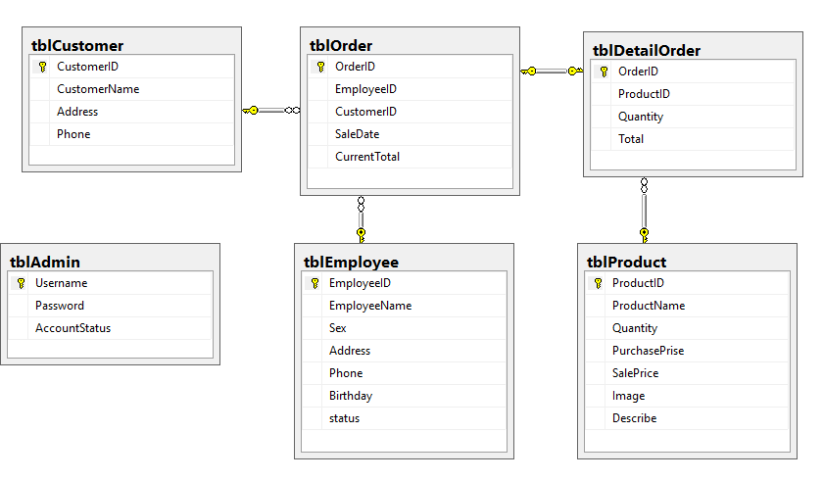

|  |  |  |
| --- | --- | --- |
| **Date: Sep 20, 2012** | **Prepared by Project Group 4**  **Team Leader:** | **Approved by**  **Mr. Ho Hoan Kiem** |
| **Signature** | 1. **Pham Duy Hai** 2. **Phung Ngoc Khuong Duy**   **Tran The Mi** |  |

REVIEW 3

**INTERFACE DESIGN**

1. **Home Page**

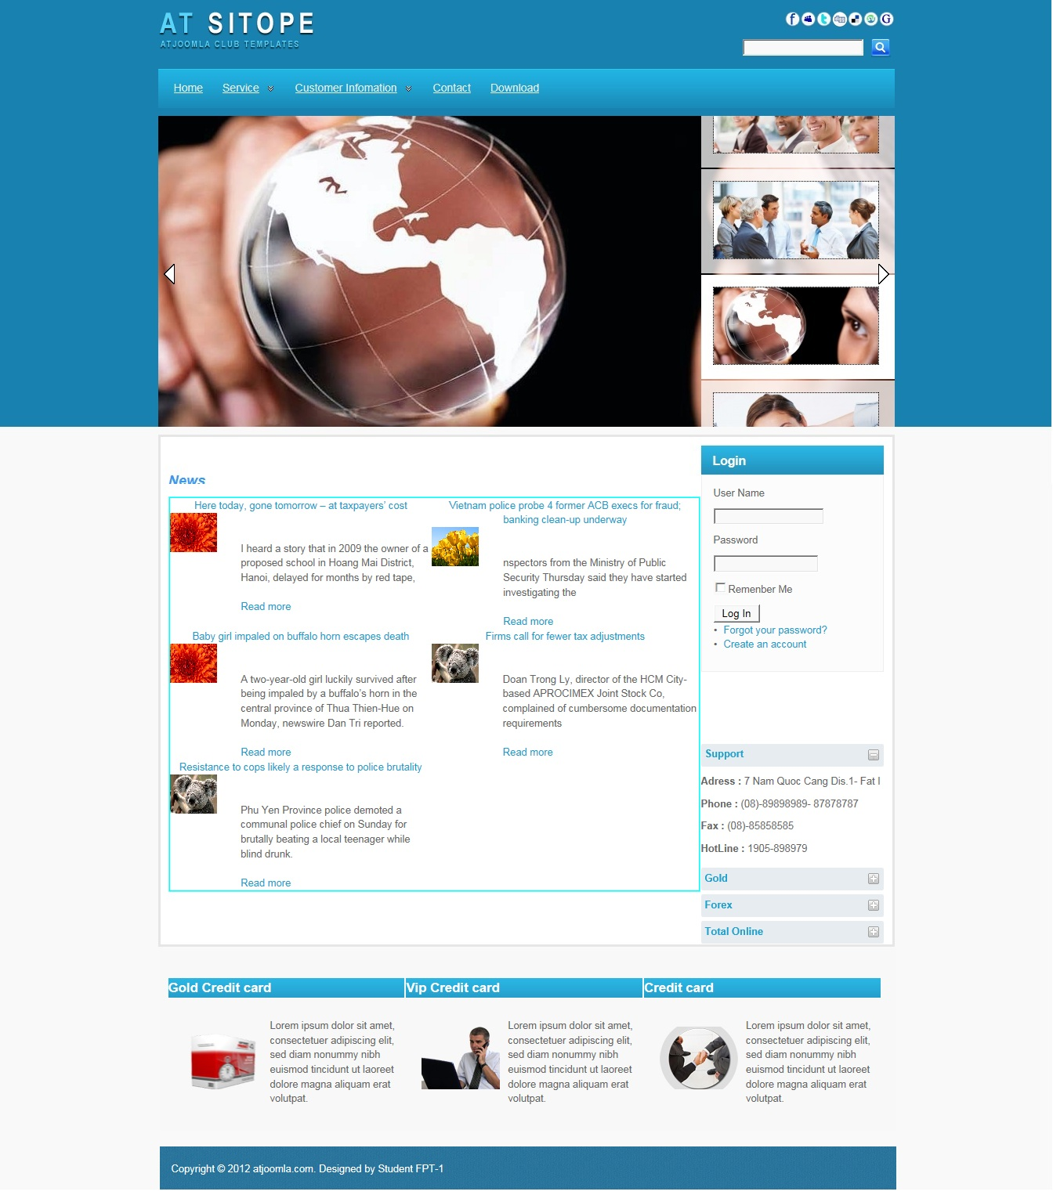

|  |  |  |  |  |  |
| --- | --- | --- | --- | --- | --- |
| **Name** | **Type** | **Event** | **Validation** | **Description** | **Status** |
| User Name | TextBox |  | String, not null | Input Customer’s user name |  |
| Password | TextBox |  | String, not null, | Input Customer’s password |  |
| Remember Me | Check Box |  | Stick | Remember Customer next time |  |
| Login | Button |  | Click | Choose Login |  |
| Forgot your Password | Hyperlink |  | Click | When Customer forgot password, they can help service supply again. |  |
| Create an Account | Hyperlink |  | Click | Create New Account when Customer like to create. |  |

1. **Login:**

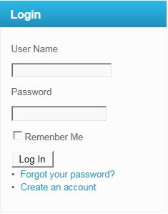

|  |  |  |  |  |  |
| --- | --- | --- | --- | --- | --- |
| **Name** | **Type** | **Event** | **Validation** | **Description** | **Status** |
| User Name | TextBox |  | String, not null | Input Customer’s user name |  |
| Password | TextBox |  | String, not null, | Input Customer’s password |  |
| Remember Me | Check Box |  | Stick | Remember Customer next time |  |
| Login | Button |  | Click | Login |  |

**3.Create Account Customer:**

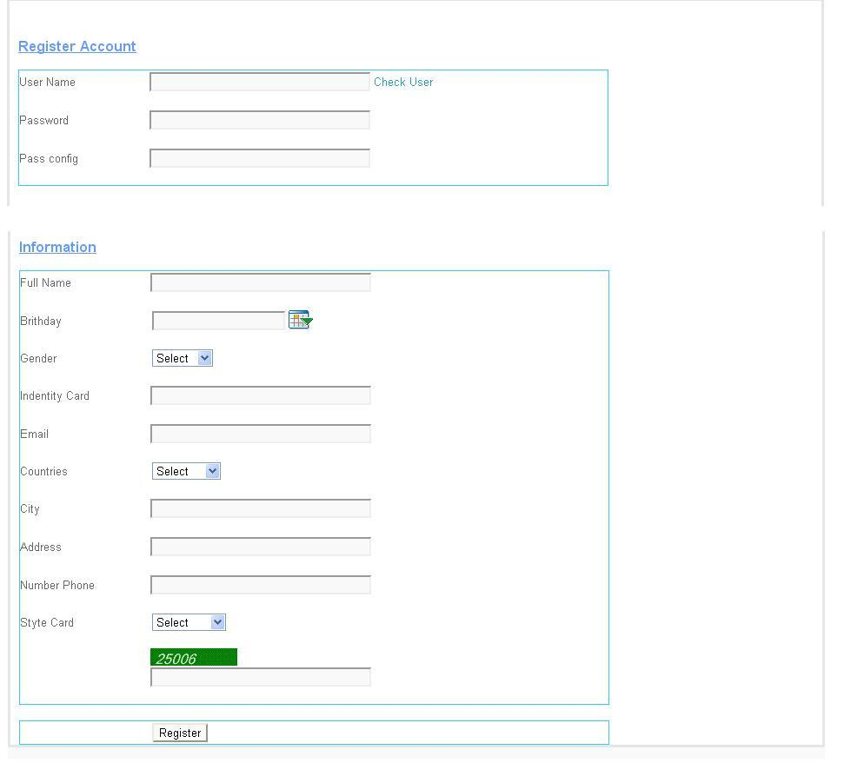

|  |  |  |  |  |  |
| --- | --- | --- | --- | --- | --- |
| **Name** | **Type** | **Event** | **Validation** | **Description** | **Status** |
| UserName | TextBox | Onchange | String, not null | Input UserName Customer |  |
| Password | TextBox |  | String, not null, | Input Customer’s New password |  |
| Config Password | TextBox |  | String,not null | Input Customer’s Config Password |  |
| Full Name | TextBox |  | String, not null | Input Full Name Customer |  |
| Birthday | BasicDate picker |  | Date,not null | Input BirthDay customer |  |
| Gender | DropdownList |  | Select Male,female | Input Male,Female |  |
| Identity Card | TextBox |  | Number, not null | Input Number Identity card |  |
| Email | TextBox |  | String ,not null, have Validation | Input Email Customer |  |
| Countries | Dropdownlist |  | Select | Input Countries Customer |  |
| City | TextBox |  | String, not null | Input City Customer |  |
| Address | TextBox |  | String, not null | Input Address Customer |  |
| Phone Number | TextBox |  | Number,not null | Input Phone Number Customer |  |
| Styte Card | DropDownList |  | Select | Input Styte Card Customer |  |
| CapChar | TextBox |  |  | Input number follow Image at above Text Box |  |
| Register | Button |  | Click | Register Customer |  |

**4.Forgot Password:**

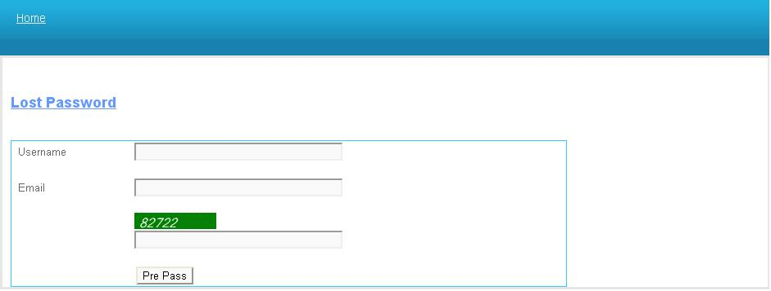

|  |  |  |  |  |  |
| --- | --- | --- | --- | --- | --- |
| **Name** | **Type** | **Event** | **Validation** | **Description** | **Status** |
| UserName | TextBox |  | String,not null | Input UserName Customer |  |
| Email | TextBox |  | String ,not null, have Validation | Input Email Customer |  |
| CapChar | TextBox |  |  | Input number follow Image at above Text Box |  |

**5.Change Password:**

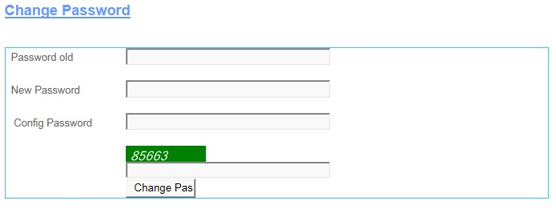

|  |  |  |  |  |  |
| --- | --- | --- | --- | --- | --- |
| **Name** | **Type** | **Event** | **Validation** | **Description** | **Status** |
| Password Old | TextBox |  | String, not null | Input Customer’s Password old |  |
| New Password | TextBox |  | String, not null, | Input Customer’s New password |  |
| Config Password | TextBox |  | String,not null | Input Customer’s Config Password |  |
| CapChar | TextBox |  |  | Input number follow Image at above Text Box |  |
| Change Password | Button |  | Click | Change Password |  |

**6.Change CodePin:**

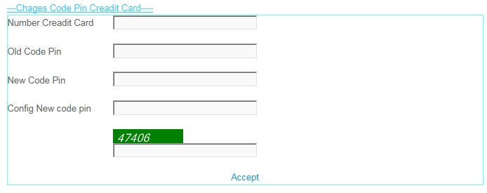

|  |  |  |  |  |  |
| --- | --- | --- | --- | --- | --- |
| **Name** | **Type** | **Event** | **Validation** | **Description** | **Status** |
| Number Credit Card | TextBox |  | int, not null | Input Customer’s Number Credit Card |  |
| Old Code Pin | TextBox |  | int, not null, | Input Customer’s Old Code Pin |  |
| New Code Pin | TextBox |  | int,not null | Input Customer’s New Code Pin |  |
| Config New Code Pin | TextBox |  | int, not null | Input Customer’s Config New Code Pin |  |
| CapChar | TextBox |  | int ,not null | Input number follow Image at above Text Box |  |
| Accept | LinkButton |  | Click | Accept Change code Pin . |  |

**7.Create Information:**

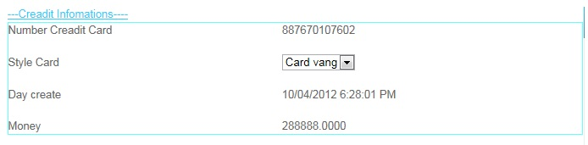

|  |  |  |  |  |  |
| --- | --- | --- | --- | --- | --- |
| **Name** | **Type** | **Event** | **Validation** | **Description** | **Status** |
| Number Credit Card | Label |  | Read Only | View Number Credit Card |  |
| Style Card | Drop Down List |  | Select | View and select Card |  |
| Day Create | Label |  | Read Only | View Day Create |  |
| Money | Label |  | Read Only | View Money |  |

**8.Edit Account User:**

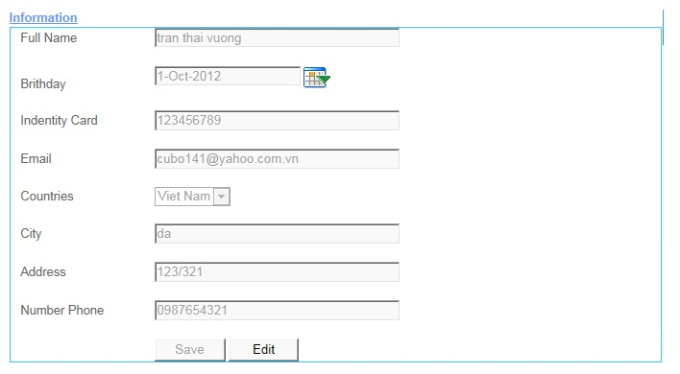

|  |  |  |  |  |  |
| --- | --- | --- | --- | --- | --- |
| **Name** | **Type** | **Event** | **Validation** | **Description** | **Status** |
| Full Name | TextBox |  | String, not null | Input Full Name |  |
| Birthday | TextBox |  | DatetTime | Input DateTime |  |
| Calendar Tool | Calendar |  | Select | Select Date on Calendar |  |
| Identity Card | TextBox |  | Int , not null | Input identity Card |  |
| Email | TextBox |  | String ,not null, have Validation | Input Customer’s Email |  |
| Country | DropDownList |  | Select | Select country |  |
| Address | TextBox |  | Int, not null | Input Customer’s Address |  |
| Number Phone | TextBox |  | Int, not null | Input Customer’s Number Phone |  |
| Save | Button |  | Click | click save edit enable |  |
| Edit | Button |  | Click | click edit Save unenable |  |

**9.Transaction:**

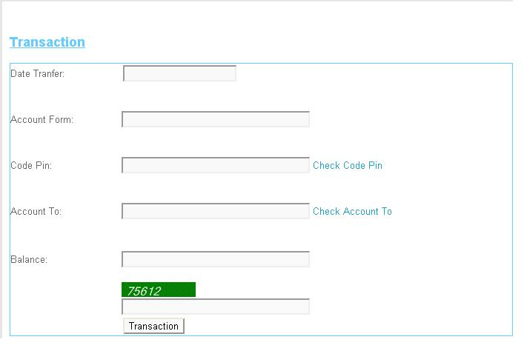

|  |  |  |  |  |  |
| --- | --- | --- | --- | --- | --- |
| **Name** | **Type** | **Event** | **Validation** | **Description** | **Status** |
| Date Tranfer | TextBox |  | DateTime, not null | Input Date Tranfer |  |
| Account From | TextBox |  | DatetTime | Input Account From |  |
| Code Pin | TextBox |  | Int, not null and Valiadaton | Input Code Pin |  |
| Account To | TextBox |  | DateTime, not null and Validation | Input Account To |  |
| Balance | TextBox |  | String ,not null, have Validation | Input Customer’s Balance |  |
| Transaction | Button |  | Click | Transaction |  |
| Check CodePin | LinkButton |  | Click | Check Codepin inval or not inval.. |  |
| Check Account To | LinkButton |  | Click | Check Account Inval or Not inval |  |
| CapChar | TextBox |  | int ,not null | Input number follow Image at above Text Box |  |

**10.Transaction Admin:**

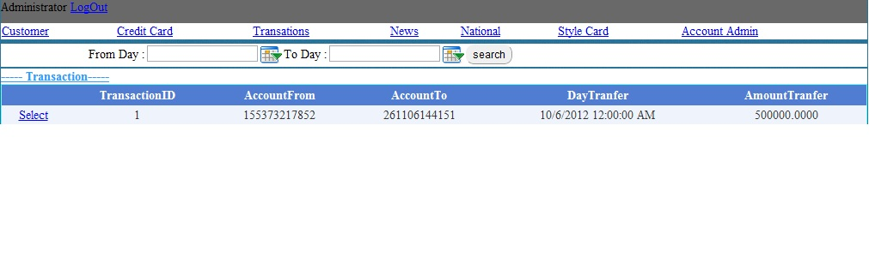

|  |  |  |  |  |  |
| --- | --- | --- | --- | --- | --- |
| **Name** | **Type** | **Event** | **Validation** | **Description** | **Status** |
| Log Out | LoginStatus |  | Click | Click Log Out |  |
| From Day | BasicdatePicker |  | Date time | Input From Date tranfer |  |
| To Day | BasicDatePicker |  | Date Time | Input To Date Tranfer |  |
| Transaction | Drop Down List |  | Select inform | Select Transaction |  |
| List Transaction | Grid view |  | Read Only | View inform Transaction |  |
| Select | LinkButton |  | Select | Select then view Detail |  |

**11.View Transaction:**

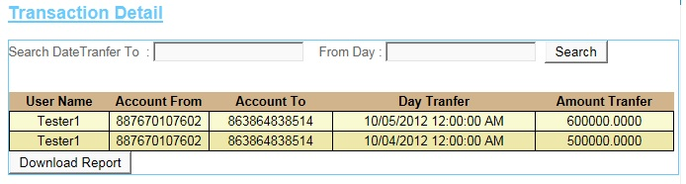

|  |  |  |  |  |  |
| --- | --- | --- | --- | --- | --- |
| **Name** | **Type** | **Event** | **Validation** | **Description** | **Status** |
| Search Date Transfer To | TextBox |  | DateTime , not null | Input DateTime |  |
| From Day | TextBox |  | DateTime , not null | Input DateTime |  |
| Search | Button |  | Click | Search |  |
| Transaction Detail | GridView |  | Read Only | View Inform of Detail’s Transaction |  |
| DownLoad Report | Button |  | Click | DownLoad Report |  |

**12.News:**

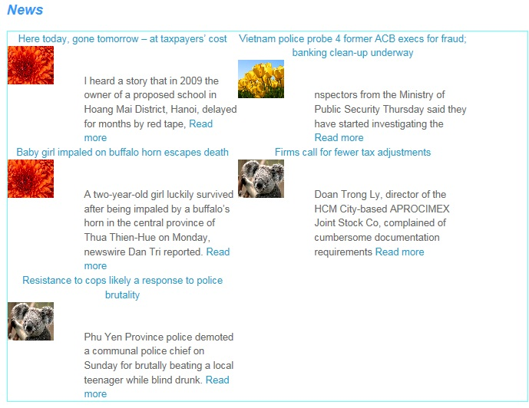

**13.AdminLogin:**

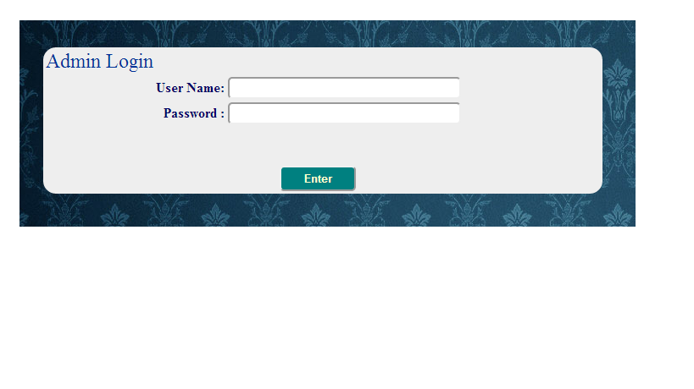

|  |  |  |  |  |  |
| --- | --- | --- | --- | --- | --- |
| **Name** | **Type** | **Event** | **Validation** | **Description** | **Status** |
| User Name | TextBox |  | String, not null | Input Admin’s user name |  |
| Password | TextBox |  | String, not null, | Input Admin’s password |  |
| Enter | Button |  | Click |  |  |

**14.AccountAdmin:**

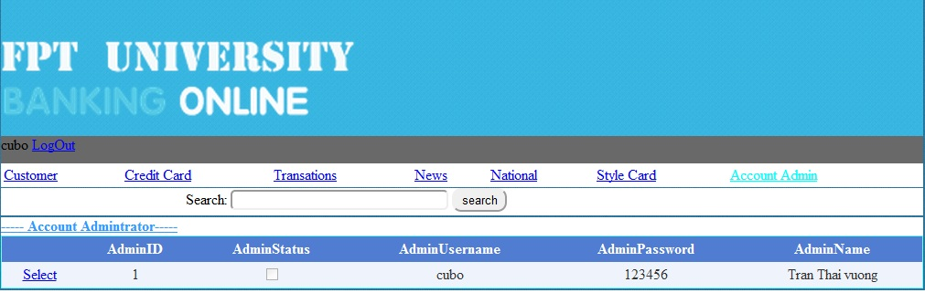

|  |  |  |  |  |  |
| --- | --- | --- | --- | --- | --- |
| **Name** | **Type** | **Event** | **Validation** | **Description** | **Status** |
| Search | TextBox | Onkeydown | String, | Search Admin’s Usernmae |  |
| Select Object | Hyperlink |  |  |  |  |
| DetailView1 | DetailsView |  |  | Select Account Admin |  |
| Select | Linbutton |  |  | Select Details Account Admin |  |

**15.AccountCustomer:**

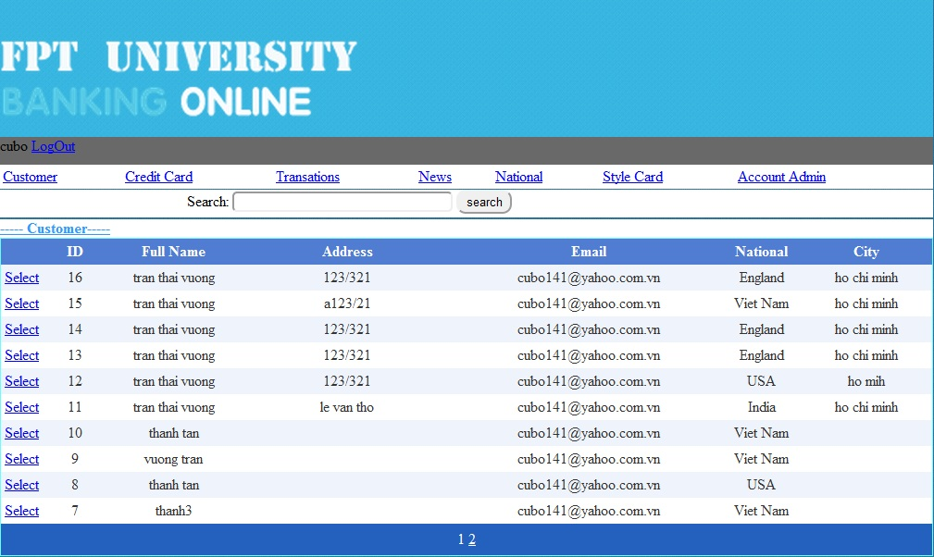

|  |  |  |  |  |  |
| --- | --- | --- | --- | --- | --- |
| **Name** | **Type** | **Event** | **Validation** | **Description** | **Status** |
| Search | TextBox |  | String | Search Customer’s Username |  |
| Select Object | Hyperlink |  |  |  |  |
| GridviewAccountCustomer | Gridview |  |  | Select Account Customer |  |
| Select | Linbutton |  |  | Select Details Account Customer |  |

**16.CreditCard:**

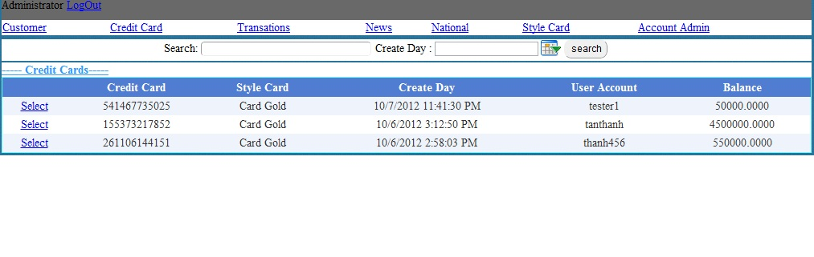

|  |  |  |  |  |  |
| --- | --- | --- | --- | --- | --- |
| **Name** | **Type** | **Event** | **Validation** | **Description** | **Status** |
| Search | TextBox | OnKeyDown | String | Search UserName |  |
| Select Object | Hyperlink |  |  |  |  |
| GvCreditCard | Gridview |  |  | Select ListCreditCard |  |
| Select | Linbutton |  |  | Select Details CreditCard |  |

**17.StyleCard:**

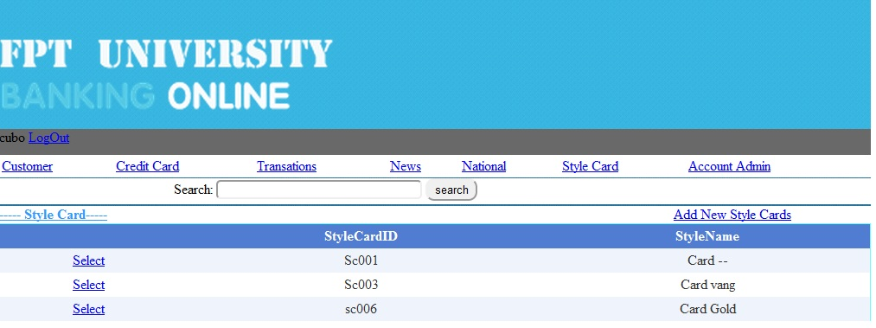

|  |  |  |  |  |  |
| --- | --- | --- | --- | --- | --- |
| **Name** | **Type** | **Event** | **Validation** | **Description** | **Status** |
| Search | TextBox | OnkeyDown | String | Search Style CardName |  |
| Select Object | Hyperlink |  |  |  |  |
| GvStyleCard | Gridview |  |  | Select Style Card |  |
| Select | Linbutton |  |  | Select Details Style Card |  |

**18.News:**

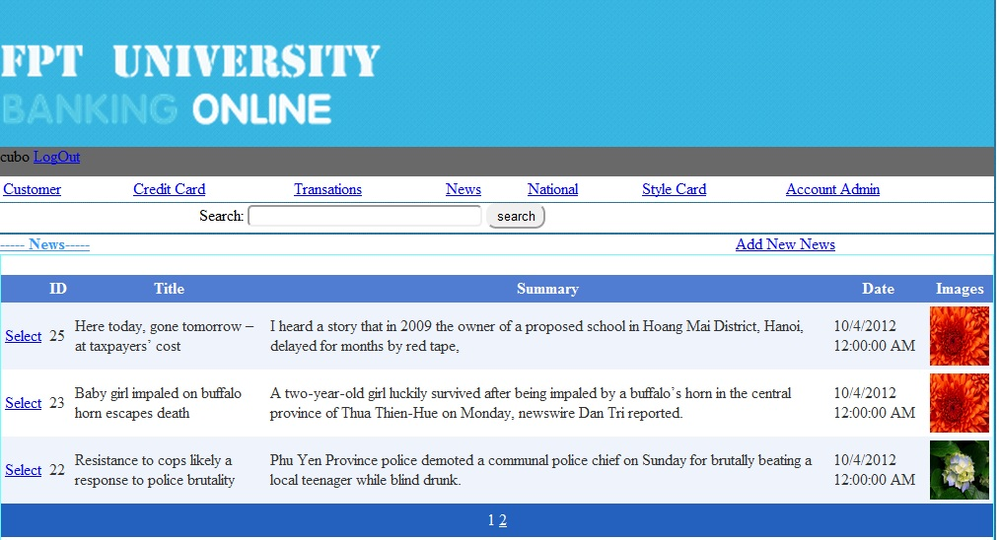

|  |  |  |  |  |  |
| --- | --- | --- | --- | --- | --- |
| **Name** | **Type** | **Event** | **Validation** | **Description** | **Status** |
| Search | TextBox | Onkeydown | String | Search Title News |  |
| Select Object | Hyperlink |  |  | Go Add new News |  |
| GvNews | Gridview |  |  | Select News |  |
| Select | Linbutton |  |  | Select Details News |  |

**19.National:**

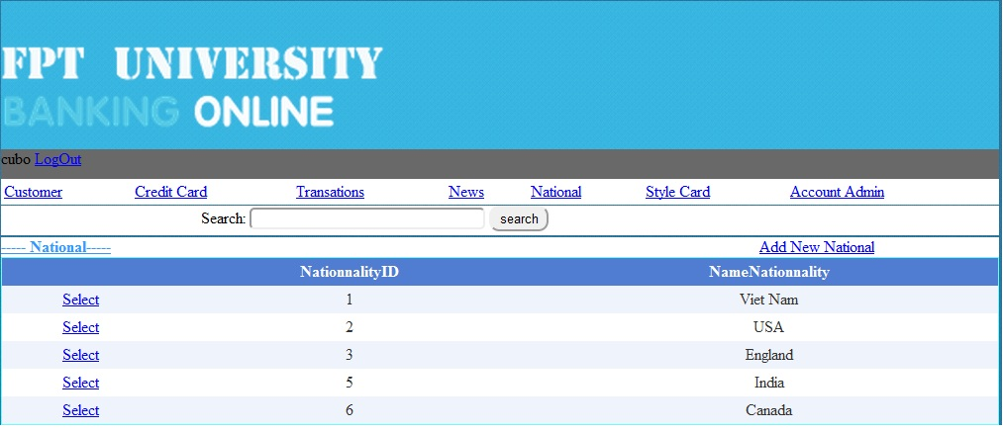

|  |  |  |  |  |  |
| --- | --- | --- | --- | --- | --- |
| **Name** | **Type** | **Event** | **Validation** | **Description** | **Status** |
| Search | TextBox | onKeydown | String | Search Name Nationality |  |
| Select Object | Hyperlink |  |  |  |  |
| Gv Nationality | Gridview |  |  | Select Nationality |  |
| Select | Linbutton |  |  | Select Details Nationality |  |

**20.Details Account Admin:**

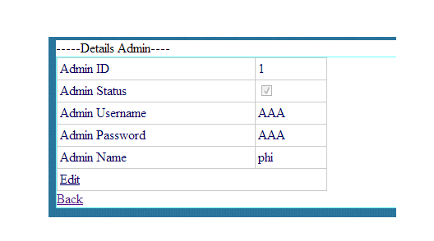

|  |  |  |  |  |  |
| --- | --- | --- | --- | --- | --- |
| **Name** | **Type** | **Event** | **Validation** | **Description** | **Status** |
| Edit | LinkButton |  |  | Edit Account Admin |  |
| Back | LinkButon |  |  | Back to MainAdmin.aspx |  |
| DetailsView1 | DetailsView |  |  | Select Details Admin |  |

**21.Details Account Customer:**

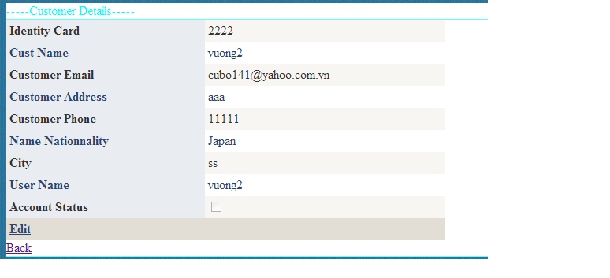

|  |  |  |  |  |  |
| --- | --- | --- | --- | --- | --- |
| **Name** | **Type** | **Event** | **Validation** | **Description** | **Status** |
| Edit | LinkButton |  |  | Edit Account Customer |  |
| Back | LinkButon |  |  | Back to MainAdmin.aspx |  |
| DetailsView1 | DetailsView |  |  | Select Customer Information |  |

**22.Details Credit Card:**

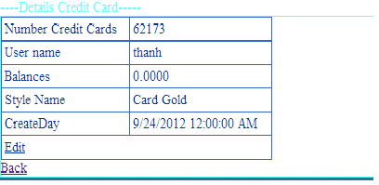

|  |  |  |  |  |  |
| --- | --- | --- | --- | --- | --- |
| **Name** | **Type** | **Event** | **Validation** | **Description** | **Status** |
| Edit | LinkButton |  |  | Edit Balance of Customer |  |
| Back | LinkButon |  |  | Back to MainAdmin.aspx |  |
| DetailsView1 | DetailsView |  |  | Select Details Credit Card of |  |

**23.Details Style Card:**

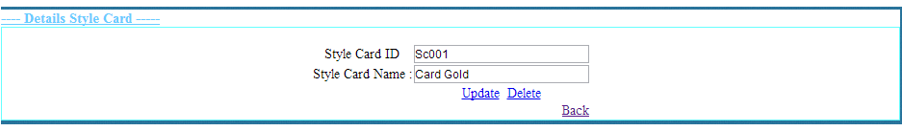

|  |  |  |  |  |  |
| --- | --- | --- | --- | --- | --- |
| **Name** | **Type** | **Event** | **Validation** | **Description** | **Status** |
| txtStyleCardID | TextBox |  | String,Not null | Input Style CardID |  |
| txtStyleCardName | TextBox |  | String,Not null | Input Style Card Name |  |
| Update | LinkButton |  |  | Update Style Card |  |
| Delete | LinkButton |  |  | Delete Style Card |  |
| Back | LinkButtom |  |  | Back to MainAdmin.aspx |  |

**24.News:**

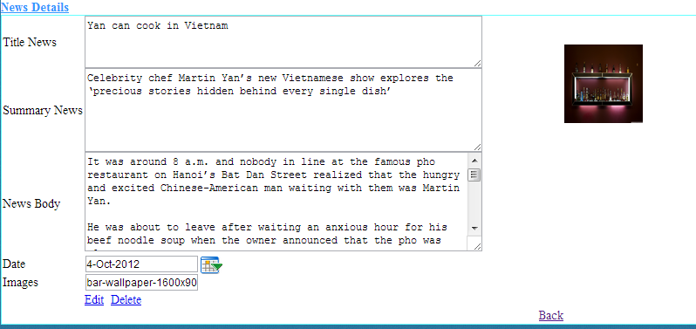

|  |  |  |  |  |  |
| --- | --- | --- | --- | --- | --- |
| **Name** | **Type** | **Event** | **Validation** | **Description** | **Status** |
| txtTitle News | TextBox |  | String,Not null | Input Title News |  |
| txtSummary News | TextBox |  | String,Not null | Input Summary News |  |
| txtNews Body | TextBox |  | String,Not null | Input News Body |  |
| txtDay | BasicDatePicker |  | Datetime,Not null | Input Datetime |  |
| txtImages | TextBox |  | String ,Not null | Input Images |  |
| Edit | LinkButton |  |  | Update Style Card |  |
| Delete | LinkButton |  |  | Delete Style Card |  |
| Back | LinkButtom |  |  | Back to MainAdmin.aspx |  |

**24.Details Nationality:**

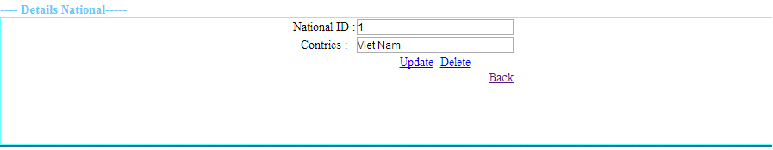

|  |  |  |  |  |  |
| --- | --- | --- | --- | --- | --- |
| **Name** | **Type** | **Event** | **Validation** | **Description** | **Status** |
| txtID | TextBox |  | String,Not null | Input CardID |  |
| txtNationalityName | TextBox |  | String,Not null | Input Nationality |  |
| Update | LinkButton |  |  | Update Nationality |  |
| Delete | LinkButton |  |  | Delete Nationality |  |
| Back | LinkButtom |  |  | Back to MainAdmin.aspx |  |

**Support:**

**+ Connected**

* **Gold :**

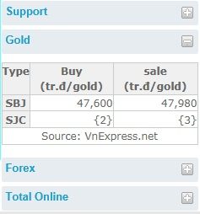

* **Forex :**

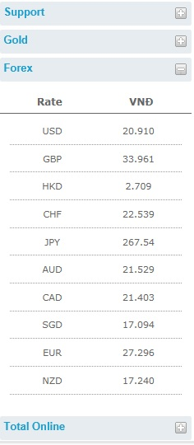

**+Disconnection**

* **Gold :**

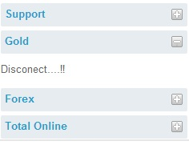

* **Forex :**

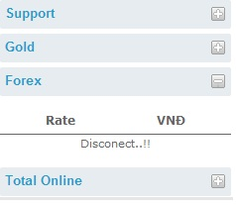

**+Total Online**

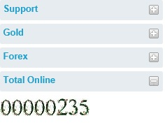

**TASK SHEET**

|  |  |  |  |  |  |  |
| --- | --- | --- | --- | --- | --- | --- |
| **Project Group FFG** | | **Project Title**  **Laptop Shop Online** | | **Date of Preparation** | | **Activity Plan Prepared by**  **Le Hoang Hai** |
| **No** | **Task Title** | | **Planned Start Date** | **Planned Completed Date** | **Team Mate Names** | **Status** |
| 1 | Login Customer | | Sep 10, 2012 | Oct 10, 2012 |  |  |
| 2 | Search admin evevnt onkeydown | |  |
| 3 | Change CodePin Credit Card | |  |
| 4 | Load News Masterpage Customer | |  |
| 5 | Design Masterpage Customer | |  |
| 6 | Register Customer | |  |  |
| 7 | Change Password | |  |
| 8 | Forget Password | |  |
| 9 | Credit card Infomation | |  |
| 10 | Your`s Profile | |  |
| 11 | Login Admin | |  |  |
| 12 | Edit Credit Card | |  |
| 13 | Edit Style Card | |  |
| 14 | Edit National | |  |
| 15 | Masterpage Admin | |  |
| 16 | Edit Status Customer | |  |  |
|  |
| 17 | Show Transaction | |  |
| 18 | Edit Balance | |  |
| 19 | Add, Edit, Delete news | |  |
| 20 | Customer Transaction | |  |  |
| 21 | Detail Transaction | |  |
| 22 | Download Report Transaction | |  |
| 23 | Create Report | |  |
| 25 | Contact | |  |
| 26 | Search Report | |  |
| 27 | Design Masterpage Customer | |  |

|  |  |  |
| --- | --- | --- |
| **Date: Oct 10, 2012** | **Prepared by Project Group 4**  **Team Leader:** | **Approved by**  **Mr. Ho Hoan Kiem** |
| **Signature** |  |  |