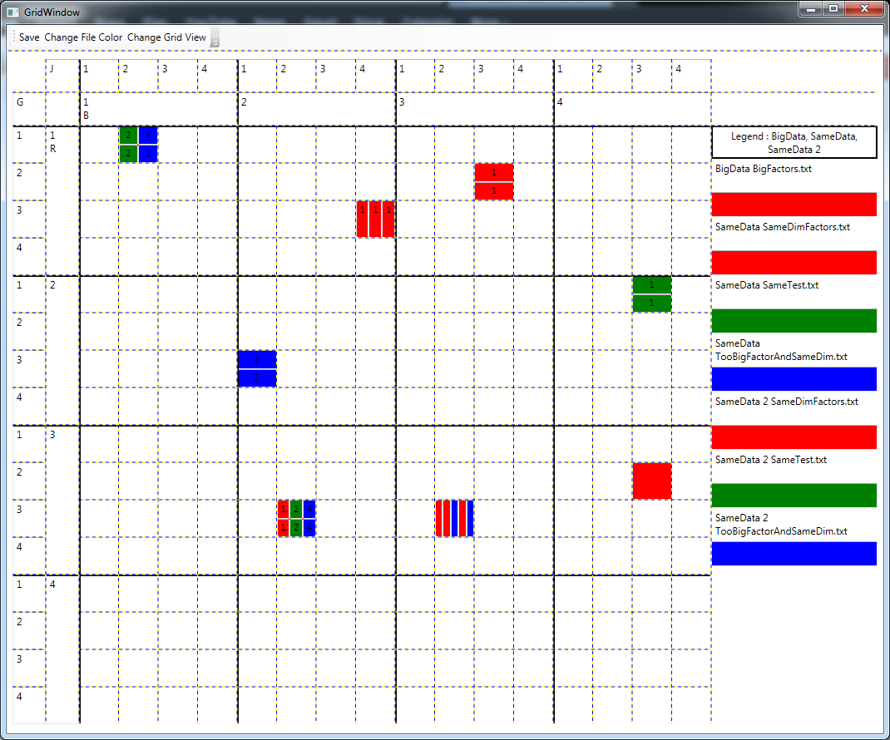
Using GlycoGrid 4D Application Tool to
Visualize data
Myanna Harris
PNNL

Abstract-
The GlycoGrid 4D is available to all those who download the application onto their computers. The application is meant for generic use as a one to four dimensional interactive-grid data visualizer. The Instruction PowerPoint manual (Instructions_GlycoGrid4D.ppt) has step-by-step instructions for the user.
Introduction-
The GlycoGrid 4D is an application that creates grids of data using generic coordinate input. It is a Windows Presentation Foundation (WPF) application written in C# and XAML using the Visual Studio Environment. The application was written from scratch with the goal of a 4D interactive grid.
The Biological Separations & Mass Spectrometry group originally desired this application to make processed mass spectrometry data easier to sift through and present to others. The specific research this was needed for was the glycan biomarker research which is applicable to detecting diseases such as cancer. The GlycoGrid 4D is part of PNNL Glycomicis and is the visualizer for the HPC GlyQ-IQ (Glycomics Quadravarient-Informed Quantification) data analysis software. It helps with data quality and rapid data quality control.
Methods-
The GlycoGrid 4D has many functions.
There is a UI (User Interface) that allows the user to create data folders in the correct format to be used by the application.
The last directory used is saved to be automatically used the next session.
Users can choose specific folders, files, and factors to grid leaving others out and focusing on certain ones. All the folders can be put on the same grid or each can be on its own grid.
One to four factors can be used to grid data. The order on the grid of the factors used can be changed.
The legend displays the main folder name at the top. The titles of each file contain first the name of the sub-folder in which they reside and then the file name to differ between similarly named files. Below each file title is the file’s color in the grid.
When hovering over a cell, the tooltip displays a list of the folders that collide in the cell and the coordinates in order.
The grid takes care of collisions. A collision is when a cell’s coordinates appear more than once in the data. The number of times a file has the same coordinate is counted and displayed in the cell. If multiple files collide, the cell will divide for each new file creating a mini grid of colors and their corresponding counts inside the cell.
During runtime, the grids can be altered. Users can switch colors of files using the “Change File Color” button. They can also change the view of the grid to having a specific file dominate collisions instead of having collisions show all the colors of different files that collided in that cell.
The grid and its legend can be saved as a JPEG in a smaller format that doesn’t show the divided cell’s counts or in a larger format that does show the count.
The application is functional and available to anyone who downloads its file. There is an included Application Note and an optional Instruction PowerPoint.

Results-
The swapping axis help show different relationships between the glycans by showing what sugars they have in common.

Acknowledgements-
Mentor: Scott Kronewitter
Project Funding: Dick Smith, Gordon Anderson, Tao Liu, Karin Rodland, and Josh Adkins
Fellow YWIS Intern: Christina Polyukh
YWIS Coordinators: Kathy Feaster and Laura Turo
All of my colleagues who have made this internship an amazing experience

