Eksigent Technologies

Instrument Software Control Specification,

Beta Release, revision 0.3 – Not for commercial release.

Intended for Eksigent Software version 2.06 and above

May 3, 2005

Scope
This document defines and describes the software components and automation interfaces of the Eksigent instrument.

These components and interfaces allow an external “Run Manager” to communicate with the instrument and provide operational information regarding the device status.

Software Components
There is a single primary software component (Instrument Controller) that must be supported for an external program to control an Eksigent instrument. An Optional Direct Control OCX and an Instrument Status OCX will be provided for convenience and may be utilized if desired. Although each one of these three components is covered in detail in later sections of this document, the following information provides a brief high-level description of each:

The Instrument Controller
This component is implemented as a local (EXE) OLE Automation object and can be created by external programs as an out-of-process server. It provides services to an external Run Manager during a sample run for method download, start/stop control, instrument status, and data collection. This object requires multiple external DLLs and configuration files provided in the installation package and should be located in its original installation directory.

The Instrument Status OCX
This component provides visual feedback to the user about the instrument status during a run.

The Direct Control OCX
This component is a limited user interface that directly controls the instrument. This component provides a limited means for directly controlling pump flow rates, mixture fraction, etc.

The Method Editor OCX
This component is the user interface for creating LC Methods for instruments.

The Instrument Configuration OCX
This component is the user interface for configuring the instrument system.

Instrument Controller Object
The Eksigent Instrument Controller (EXE) object is a custom interface derived from the IDispatch class. When an instance of this interface is created and initialized, the instance will provides all of the necessary functions required to communicate and control the Eksigent instrument.
To properly control an Eksigent instrument through the Instrument Controller COM object, the developer must adhere to the definition of this interface and the associated method description.

Automation Interface Definition
The definition of the Eksigent Interfaces and IIDs is information that must be shared between the Eksigent Instrument and any application that attempts to utilize these interfaces. As such, Eksigent provides two files, EksigentNanoLC.h and EksigentNanoLC_i.c, which contain this shared information for developers.

The file EksigentNanoLC_i.c provides the Eksigent NanoLC device interface IIDs (Software Developers need only include this file once in their project).

There are three Interface definitions, EksigentInterface, EksigentInterface2, and COM_Driver. EksigentInterface and COM_Driver were originally developed to support Thermo Finnigan’s Xcalibur Mass Spectrometer control software. EksigentInterface2 is a newer interface developed to support Scientific Software’s EZChrom control software. Between these three interfaces you should hopefully be able to find the API you need to connect you software/drivers/hardware to the Eksigent devices.

Note: Since these two files are shared between the Eksigent Instrument Controller Software and external Applications, if Eksigent alters these interfaces, then any changes will be reflected accordingly in this document….

Automation Method Description for EksigentInterface

Initialize( )

IMPORTANT: This command must be called after the component instance is created. This routine should be the first call to the new instance when using EksigentInterface. No other routines should be called in EksigentInterface until this routine has been called and returns successfully. Return values are TRUE or FALSE depending on successful initialization.

This routine causes the instrument to be initialized. Any power-up diagnostics are run and the instrument is set to a default condition. The routine will return immediately and initialization is done in the background. When initialization is complete, the instrument will be in one of the following states: PUMPRESET, INSTRUMENTBUSY, READYFORDOWNLOAD, NOTCONNECTED

GetNumChannels ( ) as Byte

Each pair of pumps in a Instrument is called a “channel” and they are numbered 1,2,3… Outside applications should start up by asking the Instrument how many channels exist. Care should be taken to not pass a channel number to routines if the channels do not exist.

GetVersion ( ) as String

Returns a string containing the version of the EXE (“1.96a”)

GetStatus( [in] ChannelNumber as Byte ) as Long

Returns the state of the pumps for the provided channel.

Caution:
The channels will change state in a logical manner to affect control of the Instrument. The instrument does not wait until queried to change state. If the methodology used to implement an external Run Manager requires forced state changes, it may be necessary to include this logic within a wrapper between the run manager and the Eksigent interface to prevent a run from stalling, or otherwise behaving incorrectly.

Each valid channel status is defined and described below:

EK_PUMPINITIALIZE = 0
The instrument is initializing. This could be when it first starts up or while the Initialize routine is being handled.

EK_WAITINGFORMETHOD = 1
The instrument is ready to download a method. The Run Manager can call the PrepareForRun routine. If a new method is not loaded, the previous method is used when the run begins.

EK_METHODLOADING = 2

The instrument is busy downloading the method. This state is rarely returned as the instrument loads the method immediately after requested

EK_PREFLUSH = 3
The instrument is preparing for a run. Examples include executing the pre-run flush requirements of the chromatography method. The instrument may also return this state if column temperature control is selected and still stabilizing. If these method attributes are not selected, this state will not occur. If these method attributes are selected, the preflush state will begin immediately after the new method is loaded. While in this state the instrument will accept a StartRun command, but the instrument will not start until the pre-run flush requirements have been met (i.e. pre-run attributes of the method may not be bypassed)

EK_READYTOSTART = 4
The instrument is ready for a run. The Run Manager can call the StartRun routine. This state occurs after 'Preflush' is complete.

EK_WAITINGFORTRIGGER = 5
The instrument is waiting for a contact closure to begin the run. This occurs when the Run Manager gives the StartRun command specifying that the instrument should wait for a contact closure. The Instrument Controller will move on to the 'Running' state as soon as possible after it receives the external trigger.

EK_RUNNING = 6
The instrument is running. The instrument will remain "Running" until it has completed its current method or is stopped by external intervention.

EK_POSTFLUSH = 7
The instrument is executing the post-run requirements of the method. The run can be considered finished as far as the Run Manager is concerned. External data collection can be closed at this point. This state informs the run manager that the instrument is still busy, and gives an informative (post run) state to the operator. The run manger should treat this as "not ready for the next run yet". Although not recommended, this state may be bypassed by loading the next method or by giving the StartRun command.

EK_ERRORCONDITION = 8
The instrument is in an error condition. It will not be able to do a run.

EK_INSTRUMENTBUSY = 9
The instrument is busy. For example: Another application (supplied with the instrument) is using private interfaces into this instrument, to perform tuning or calibration.

EK_NOTCONNECTED = 10
No Eksigent device was found connected to the computer. Possible reasons for setting this status are:

- The instrument wasn't powered up.

- The instrument wasn't connected to the proper COM port or was disconnected.

EK_STANDBY = 11

The instrument is in standby.

EK_INSTRUMENTOFF = 12

The instrument is off.

EK_INSTRUMENTPAUSED = 13

The instrument is paused.

EK_WAITINGFORLAMPSTABILIZE = 14

The lamp temperature is stabilizing.

EK_PUMPRESET = 15
Equivalent to “Pump Not Ready.” The Run Manager should assume that the device will become ready in time and should wait.

EK_MAJORFLUSH = 16
The device is under direct control from another application or is executing a required flush operation (i.e. as required to change mobile phase fluids)

EK_PEAKPARK = 17
The device is in peak-park mode and is operating at reduced flowrates.

EK_WAITINGFORCOLUMNSTABILIZE = 18
The column temperature is stabilizing.

EK_WAITINGFORFLOWSTABILIZE = 19
The device flow is stabilizing.

GetStatusInfo( [in] ChannelNumber as Byte,
[out]StateStr as String,
[out]MethodName as String,
[out]EstDuration as String)

This routine tries to provide a user-friendly status update for what the channel is doing. It will return the state of the channel as a string (i.e. “17-Peak Park”), the current method name, and the estimated remaining duration of the method (i.e. “hh:mm:ss”) , if a method is running. The duration is considered an estimate because peak-parking can occur.

Boolean ShutDown( )

Returns:
TRUE, if an instrument was shutdown,
FALSE, otherwise.

IMPORTANT: This command must be called if your are using EksigentInterface before the external run Manager exits. The successful shutdown of the instrument and storage of configuration files can be adversely affected if this procedure is ignored.

InstrumentLock( [in] ChannelNumber as Byte,
[in] ProcessName as String)
InstrumentUnlock(( [in] ChannelNumber as Byte,
[in] ProcessName as String )
InstrumentWhoHasLock(( [in] ChannelNumber as Byte ) as String

These routines are used to “lock” a channel during an acquisition. Lock returns TRUE if the lock was acquired and FALSE if the lock is held by another application. Unlock returns TRUE if the instrument is unlocked (you were the previous owner). An application should not call Unlock unless it successfully called lock.

The lock is on the honor system; i.e. it does not prevent the instrument from accepting other commands.

Currently not supported.

PrepareForRun( [in] ChannelNumber as Byte,
[in] MethodFileName as String,
[in] SequenceRow as Long,
[in] StartMode as Long,
[in] Vial as String,
[in] InjVolume as Double,
[in] RunFlags as Long
) As Boolean

Returns:
TRUE, if a channel has prepared for the run,
FALSE, otherwise.

The instrument prepares for the run by downloading its Method to the hardware. All filenames have full path information. If the RawFileName is a zero-length string, the instrument does a run using the given method, but does not save any data. If the MethodFileName is a zero-length string, the instrument does a run using the previous method.

While in the process of downloading, the instrument status will be METHODLOADING. Once the instrument is finished downloading, it will either change it status to PREFLUSH or READYTOSTART. In either of these two modes, the Run Manager can call StartRun().

The MethodFileName argument is the filename with full path that specifies which method file to use during the run.

The SequenceRow argument is currently unused.

The Vial argument species the vial position to be used with the Eksigent autosampler procedure. See above.

The StartMode argument determines what the instrument will do when the StartRun() command is received.
StartMode = 0 - Start the run immediately
StartMode = 1 - Wait for a contact closure before starting the run

The Vial argument specifies the vial position (i.e. “A1”, “H12”) to be used.

The InjVolume argument specifes the total volume of sample to inject in nL.

The RunFlags argument can have the following values:

RUN_FLAG_METHOD_UNCHANGED = 1 -
This value will cause the MethodFileName parameter to be ignored and the method that was previously used will be used again. Any other value for RunFlags will cause the parameter MethodFileName to be used.

RUN_FLAG_METHOD_SkipLampWarmup = 99 -
This value will cause lamp stabilization to be ignored. Any other value for RunFlags will cause lamp stabilization to occur.

StartRun( [in] ChannelNumber as Byte ) As Boolean

Starts running the Method loaded through the call to PrepareForRun().

Should preferably be called when the device status is READYTOSTART. May be called when the device status is PREFLUSH. In this case, the run will begin when the preflush sequence is complete.

If the StartMode flag is 1 (as passed down in the PrepareForRun call) the instrument status will become WaitingForContactClosure and the instrument will wait for the external contact closure before beginning the run. If the StartMode flag is 0, the run begins immediately.
When the run has begun, the instrument status will become Running.

A successful return value is TRUE.

StopRun( [in] ChannelNumber as Byte ) As Boolean

This will cancel the run. It can be given before StartRun to prevent the run from starting at all, or at any time during the run. The instrument will close all files and go to the READYTODOWNLOAD, PREFLUSH, or POSTFLUSH status.

The run may also end based on parameters in the instrument method. In this case, the StopRun command is not necessary (it has no effect if there is no run).

Returns TRUE when successful.

ValidateMethod( [in] ChannelNumber as Byte,
[in] MethodName as String) as String

Returns:
A string with a message indicating problems with the method. If there are no problems and the method is valid, a zero length string is returned.

The purpose of this function is to allow the Run Manager to verify method files before the sequence is accepted to the queue. The desire here is to warn the user at the earliest moment if a sequence they are submitting can't be run. We would like to avoid the situation where an overnight run fails because the method file didn't exist for one of the runs within the sequence.

The validation includes ensuring that the method file exists and that the mobile phases for the selected flow method agree with the current mobile phase in the storage loops. It also checks to see if the remaining volume of fluids in the storage loops is sufficient to complete the run.

Currently not supported.

PeakPark( [in] ChannelNumber as Byte,
[in] ParkFlowrate as Single)

This routine will immediately reduce the flow on the pumps for a single channel, and pauses processing of the Method. The current mixture fraction of the gradient is maintained and the total flowrate is reduced to the ParkFlowrate.

ParkFlowrate has the following valid values: zero to the maximum allowable flowrate.

InstrumentHasStopped([in] ChannelNumber as Byte,
[in] DeviceType as Long) As Boolean

This routine should be called when the external controlling instrument has finished running. If the Eksigent device is running or in peak-park mode, it will perform a Stop Method action in response to this call.

Valid values for DeviceType are:

MASS_SPEC_DEVICE as Long = 0

Currently not supported.

ChangeOperatingMode(([in] ChannelNumber as Byte,
[in] NewMode as Long) as Boolean

This routine will try and bring the Eksigent device to a new state if it is not already in that state.

Valid values for NewMode are:

OPER_MODE_ON as Long = 1
OPER_MODE_OFF as Long = 2
OPER_MODE_STANDBY as Long = 3

ReadBarCode(([in] ChannelNumber as Byte,
[in] strVial, [in] pstrBarCode ) As Long

Currently not supported.

NotificationEvent(([in] ChannelNumber as Byte,
[in] EventID as Integer)

This routine was designed for external programs to inform the Eksigent device that an acquisition has completed and direct instrument control now allowed. If the Eksigent device is running, this call will perform a StopMethod() function.

Valid values for EventID are:

ACQUISITION_COMPLETE As Integer = 21

ShowAppearanceMenu() As Boolean

This call will display the Eksigent Appearance Menu which allows the user to set color and appearance options used in the graphical displays.

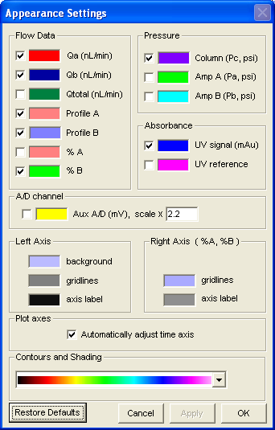

Returns:
TRUE, if the Eksigent Appearance Menu is displayed,
FALSE, otherwise.

ShowDiagnosticsMenu([in] ChannelNumber as Byte ) As Boolean

This routine will display the Hardware Diagnostics menu which allows the user to run several tests, calibrations and reset hours-of-use timers.

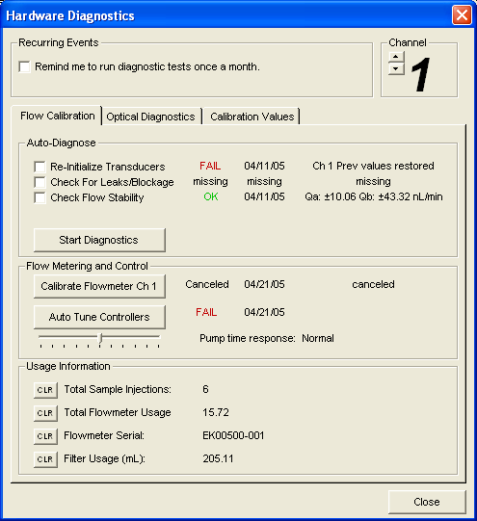

Returns:
TRUE, if an Eksigent Diagnostic Menu is displayed,
FALSE, otherwise.

ShowMethodMenu([in] ChannelNumber as Byte,
[in] FullPathName as String ) As Boolean

This routine will display the Method Settings screens which allow the user to create or edit LC methods.

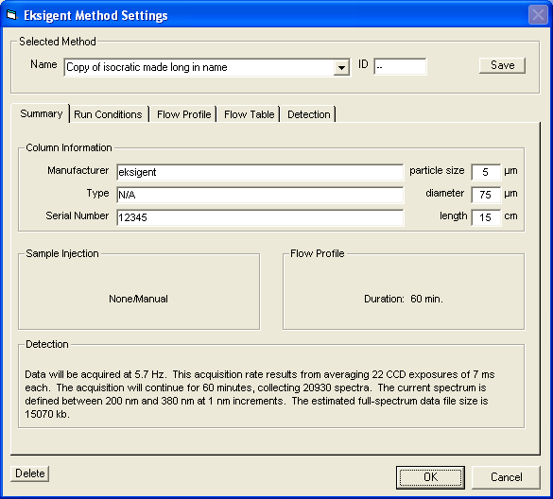

Returns:
TRUE, if the Eksigent Method Menu is displayed,
FALSE, otherwise.

ShowMobilePhaseMenu( [in] ChannelNumber as Byte ) As Boolean

This routine will display the Mobile Phase screen which allow the user to reset the loop-volumes for the mobile phases, and document any modifiers added to the mobile phase.

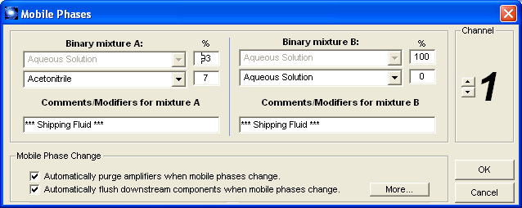

Returns:
TRUE, if the Eksigent Mobile Phases Menu is displayed,
FALSE, otherwise.

ShowRunListMenu( ) As Boolean

This routine will display the Run Manager/Sample List Settings screen. Note: External programs should NOT use this screen for creating and running combinations of methods.

Returns:
TRUE, if the Eksigent Run List Menu is displayed,
FALSE, otherwise.

Currently not supported.

ShowAboutBoxMenu( ) As Boolean



Returns:
TRUE, if the Eksigent AboutBox Menu is displayed,
FALSE, otherwise.

ShowHelpMenu( )

This routine will display the Eksigent Help Menu. Note: External programs should not call these screens as the help system is specific to the Eksigent software and will not match external control software.

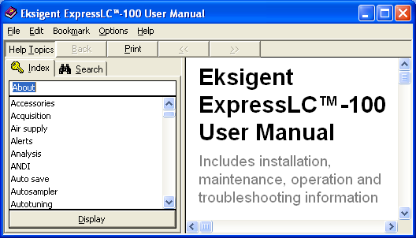

Returns:
TRUE, if the Eksigent Help Menu is displayed,
FALSE, otherwise.

ShowPeakParkMenu( [in] ChannelNumber as Byte )

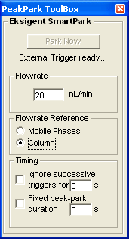

Returns:
TRUE, if the Eksigent Peak Parking Menu is displayed,
FALSE, otherwise.

ShowAlertsMenu( )

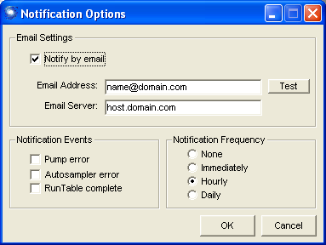

Returns:
TRUE, if the Eksigent Alerts Menu is displayed,
FALSE, otherwise.
ShowInstrumentConfigMenu( ) As Boolean

This routine will display the Instrument Configuration screen.
Note: This form is REQUIRED for proper pump operation and maintenance.

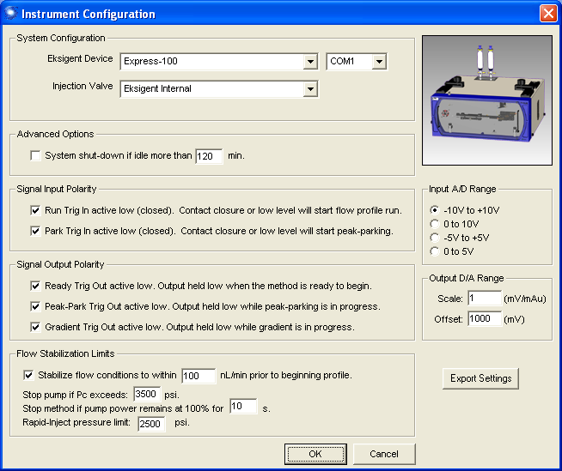

Returns:
TRUE, if the Eksigent Instrument Config Menu is displayed,
FALSE, otherwise.

ShowMainWindow( ) As Boolean

This routine will display the main screen of the Eksigent software. NOTE: This is the entire Eksigent software system. External run-managers should NOT call this routine unless they plan to let the Eksigent software control things.

Returns:
TRUE, if the Eksigent Main Window is displayed,
FALSE, otherwise.
ShowAdvancedSettings( ) as Boolean

Note: External Run Managers should NOT use this screen.
This routine will display the Advanced System Settings screen

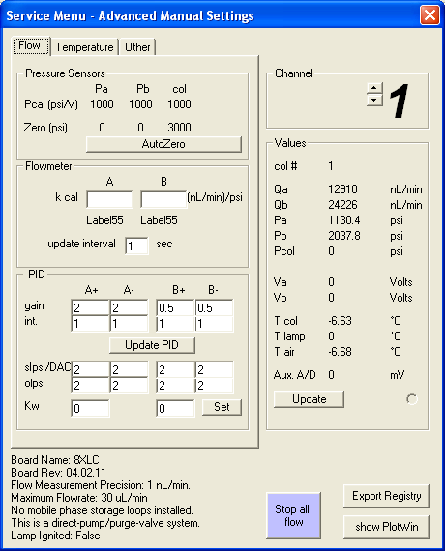

Returns:
TRUE, if the Advanced Menu is displayed
FALSE, otherwise.

ShowDirectControlMenu( [in] ChannelNumber as Byte ) As Boolean

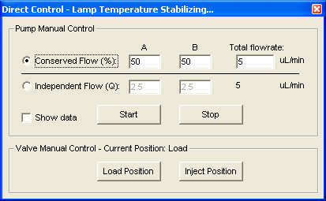

Returns:
TRUE, if the Direct Control Menu is displayed
FALSE, otherwise.

GetVersion( ) As String

Returns a string containing the version of the EXE (i.e. “1.96a”)

SelectChannel( [in] ChannelNumber as Byte )

Allows the run manager to set the current instrument column channel for multi-channel devices. The default value is channel 1.

Public Property Get COMInterface( ) As COM_Driver

Public Property Let COMInterface( indata As COM_Driver )

SetStatus( [in] ChannelNumber as Byte, [in] NewStatus as Integer ) As Boolean

This routine provides a way to override the pump state. Use at your own risk.

ResumeMethod( [in] ChannelNumber as Byte )

Call this routine to come out of Peak Parking mode.

StartFlush( [in] ChannelNumber as Byte, Qa as Single, Qb as Single ) As Boolean

This routine is equivalent to constant flow rate direct control.

Automation Method Description for COM_Driver

ReadCurrentPressures( [in] ChannelNumber as Byte,
[out] Pa, Pb, Pc, Pd as Single)

This routine returns the calculated pressure values in PSI for up to 4 locations in the pump. All 4 variables must be passed even if the simpler pumps only have 3 transducers. The return values take into account the zero and calibration values.

ReadCurrentPower( [in] ChannelNumber as Byte,
[out] PowerA, PowerB as Single)

This routine returns the percentage-power (0-100) currently being sent to each of the 2 pumps in a channel.

ReadCurrentTemperature( [in] ChannelNumber ) as Single

This routine returns the current temperature of the channel in degrees Centigrade. If the Eksigent instrument is a pump-only system, the temperature between the pressure transducers is returned. If the instrument includes a UV detector, the temperature of the column is returned.

Automation Method Description for EksigentInterface2

ShutDown( ) As Boolean

Returns:
TRUE, if an instrument was shutdown,
FALSE, otherwise.

IMPORTANT: This command must be called if your are using EksigentInterface before the external run Manager exits. The successful shutdown of the instrument and storage of configuration files can be adversely affected if this procedure is ignored.

SetConfigSettings( [in] ByRef Config As Variant ) As Boolean

This routine sets the device configuration parameters. It takes a variant parameter holding a 32-element array of strings in the form shown below.

Dim arr(32) As String
arr(0) = "FirmwareID=" & FirmwareID
arr(1) = "FirmwareID_minor=" & FirmwareID_minor
arr(2) = "EksigentSystem=" & EksigentSystem
arr(3) = "ValveType=" & ValveType
arr(4) = "Controller_COMport=" & Controller_COMport
arr(5) = "ShutDownIdleFlag=" & CStr(ShutDownIdleFlag)
arr(6) = "ShutDownIdleTime=" & ShutDownIdleTime
arr(7) = "TRIGpolarity(0)=" & CStr(TRIGpolarity(0))
arr(8) = "TRIGpolarity(1)=" & CStr(TRIGpolarity(1))
arr(9) = "TRIGpolarity(2)=" & CStr(TRIGpolarity(2))
arr(10) = "TRIGpolarity(3)=" & CStr(TRIGpolarity(3))
arr(11) = "TRIGpolarity(4)=" & CStr(TRIGpolarity(4))
arr(12) = "AD24_RANGE_BYTE=" & AD24_RANGE_BYTE
arr(13) = "FLOWSTABILIZEFLAG=" & CStr(FLOWSTABILIZEFLAG)
arr(14) = "StableFlowError=" & StableFlowError
arr(15) = "Plimit=" & Plimit
arr(16) = "Plimit_RapidInject=" & Plimit_RapidInject
arr(17) = "overpower_counter_limit=" & overpower_counter_limit
arr(18) = "Col_N=" & Col_N
arr(19) = "lSystemTypes=" & lSystemTypesStr
arr(20) = "COMPorts=" & COMPortsStr
arr(21) = "TotalChannels=" & TotalChannels
arr(22) = "Max_Flowrate(1)=" & Max_Flowrate(1)
arr(23) = "Max_Flowrate(2)=" & Max_Flowrate(2)
arr(24) = "Max_Flowrate(3)=" & Max_Flowrate(3)
arr(25) = "Max_Flowrate(4)=" & Max_Flowrate(4)
arr(26) = "Max_Flowrate(5)=" & Max_Flowrate(5)
arr(27) = "Max_Flowrate(6)=" & Max_Flowrate(6)
arr(28) = "Max_Flowrate(7)=" & Max_Flowrate(7)
arr(29) = "Max_Flowrate(8)=" & Max_Flowrate(8)
arr(30) = "UpdateInterval=" & dt_UpdateInterval
arr(31) = "DA_Offset=" & DA_Offset
arr(32) = "DA_Scale=" & DA_Scale

Config = arr
GetConfigSettings( [out] ByRef Config As Variant ) As Boolean

This routine returns a 32-element array of strings (shown in the form noted for SetConfigSettings) in the variant parameter passed in. This array of strings contains the device configuration settings.

SetDefaultConfigSettings( )

This routine sets the Eksigent device configuration settings to their default values.

ShowHelp( )

This routine shows the Eksigent device help.

DownloadMethodSettings( [in] colnum As Byte,
[in] ByRef Settings As Variant,
[in] nTriggerType As Long ) As Boolean

This routine takes a variant parameter holding an array of strings with NUM_METHOD_ITEMS + MAX_QA_PROFILE_NUMPTS + MAX_QA_PROFILE_NUMPTS + MAX_EVENT_NUM elements in the form shown below.

Public Const NUM_METHOD_ITEMS = 48
Public Const MAX_QA_PROFILE_NUMPTS = 32
Public Const MAX_QB_PROFILE_NUMPTS = 32
Public Const MAX_EVENT_NUM = 32

ReDim arr(NUM_METHOD_ITEMS + MAX_QA_PROFILE_NUMPTS + MAX_QA_PROFILE_NUMPTS + MAX_EVENT_NUM) As String

With MethodStruct

' "[GENERAL]"
arr(0) = "filename=" & .filename
arr(1) = "company_method_name=" & .company_method_name
arr(2) = "company_method_id=" & .company_method_id
' "[DETECTOR]"
arr(3) = "IntegrationTime=" & .IntegrationTime
arr(4) = "Averages=" & .averages
arr(5) = "DetectorAcqRate=" & .DetectAcqRate
arr(6) = "Boxcarwav=" & .Boxcarwav
arr(7) = "lambda_min=" & .lambda_min
arr(8) = "lambda_max=" & .lambda_max
arr(9) = "lambda_bin=" & .lambda_bin
arr(10) = "wbin1=" & .wbin1
arr(11) = "wbin2=" & .wbin2
arr(12) = "woffbin1=" & .woffbin1
arr(13) = "woffbin2=" & .woffbin2
arr(14) = "woffzero=" & .woffzero
arr(15) = "plottype=" & .plottype
arr(16) = "ref_src=" & .ref_src
arr(17) = "ntimes=" & .ntimes
' "[FLOW_PROFILE]"
arr(18) = "Qa_Profile_numpts=" & .Qa_Profile_numpts
For i = 1 To MAX_QA_PROFILE_NUMPTS
arr(18 + i) = .Time_A(i) & "," & .Qa_Profile(i)
Next
arr(19 + MAX_QA_PROFILE_NUMPTS) = "Qb_Profile_numpts=" & .Qb_Profile_numpts
For i = 1 To MAX_QB_PROFILE_NUMPTS
arr(19 + MAX_QA_PROFILE_NUMPTS + i) = .Time_B(i) & "," & .Qb_Profile(i)
Next
arr(20 + MAX_QA_PROFILE_NUMPTS + MAX_QB_PROFILE_NUMPTS) = "maxruntime=" & .maxruntime
arr(21 + MAX_QA_PROFILE_NUMPTS + MAX_QB_PROFILE_NUMPTS) = "Qfixed=" & .Qfixed
arr(22 + MAX_QA_PROFILE_NUMPTS + MAX_QB_PROFILE_NUMPTS) = "mixture_fraction_mode=" & CStr(.PROFILEMETHOD_MIXFRAC)
' "[CONDITIONS]"
arr(23 + MAX_QA_PROFILE_NUMPTS + MAX_QB_PROFILE_NUMPTS) = "PreRunFlushTime=" & CStr(.PreRunFlushTime)
arr(24 + MAX_QA_PROFILE_NUMPTS + MAX_QB_PROFILE_NUMPTS) = "PreRunFlush%=" & CStr(.PreRunFlushMult)
arr(25 + MAX_QA_PROFILE_NUMPTS + MAX_QB_PROFILE_NUMPTS) = "PostRunFlushTime=" & CStr(.PostRunFlushTime)
arr(26 + MAX_QA_PROFILE_NUMPTS + MAX_QB_PROFILE_NUMPTS) = "PostRunFlush%=" & CStr(.PostRunFlushMult)
arr(27 + MAX_QA_PROFILE_NUMPTS + MAX_QB_PROFILE_NUMPTS) = "PreRunFlushFlag=" & CStr(.PreRunFlushFlag)
arr(28 + MAX_QA_PROFILE_NUMPTS + MAX_QB_PROFILE_NUMPTS) = "PostRunFlushFlag=" & CStr(.PostRunFlushFlag)
arr(29 + MAX_QA_PROFILE_NUMPTS + MAX_QB_PROFILE_NUMPTS) = "TemperatureControlFlag=" & CStr(.TemperatureControlFlag)
arr(30 + MAX_QA_PROFILE_NUMPTS + MAX_QB_PROFILE_NUMPTS) = "Column_Set_Temperature=" & CStr(.Column_Set_Temperature)
arr(31 + MAX_QA_PROFILE_NUMPTS + MAX_QB_PROFILE_NUMPTS) = "InjectFlowPercent=" & .InjectFlowPercent
arr(32 + MAX_QA_PROFILE_NUMPTS + MAX_QB_PROFILE_NUMPTS) = "InjectionVolume=" & .InjectionVolume
arr(33 + MAX_QA_PROFILE_NUMPTS + MAX_QB_PROFILE_NUMPTS) = "InjectionMethod=" & .InjectionMethod
' "[COLUMN INFO]"
arr(34 + MAX_QA_PROFILE_NUMPTS + MAX_QB_PROFILE_NUMPTS) = "col_manufacturer=" & .col_manufacturer
arr(35 + MAX_QA_PROFILE_NUMPTS + MAX_QB_PROFILE_NUMPTS) = "col_type=" & .col_type
arr(36 + MAX_QA_PROFILE_NUMPTS + MAX_QB_PROFILE_NUMPTS) = "col_serialnum=" & .col_serialnum
arr(37 + MAX_QA_PROFILE_NUMPTS + MAX_QB_PROFILE_NUMPTS) = "col_length=" & .col_length
arr(38 + MAX_QA_PROFILE_NUMPTS + MAX_QB_PROFILE_NUMPTS) = "col_pt_size=" & .col_pt_size
arr(39 + MAX_QA_PROFILE_NUMPTS + MAX_QB_PROFILE_NUMPTS) = "col_diameter=" & .col_diameter
' "[EVENTS]"
arr(40 + MAX_QA_PROFILE_NUMPTS + MAX_QB_PROFILE_NUMPTS) = "meth_numevents=" & .meth_numevents
For i = 1 To MAX_EVENT_NUM
arr(40 + MAX_QA_PROFILE_NUMPTS + MAX_QB_PROFILE_NUMPTS + i) = .meth_time(i) & "," & .meth_event(i) & "," & .meth_param(i)
Next

arr(41 + MAX_QA_PROFILE_NUMPTS + MAX_QB_PROFILE_NUMPTS + MAX_EVENT_NUM) = "TotalChannels=" & TotalChannels
arr(42 + MAX_QA_PROFILE_NUMPTS + MAX_QB_PROFILE_NUMPTS + MAX_EVENT_NUM) = "FirmwareID=" & FirmwareID
arr(43 + MAX_QA_PROFILE_NUMPTS + MAX_QB_PROFILE_NUMPTS + MAX_EVENT_NUM) = "INJECTIONVALVE=" & INJECTIONVALVE
arr(44 + MAX_QA_PROFILE_NUMPTS + MAX_QB_PROFILE_NUMPTS + MAX_EVENT_NUM) = "UVDETECTOR=" & CStr(UVDETECTOR)
arr(45 + MAX_QA_PROFILE_NUMPTS + MAX_QB_PROFILE_NUMPTS + MAX_EVENT_NUM) = "LAM_MAX=" & LAM_MAX
arr(46 + MAX_QA_PROFILE_NUMPTS + MAX_QB_PROFILE_NUMPTS + MAX_EVENT_NUM) = "LAM_MIN=" & LAM_MIN
arr(47 + MAX_QA_PROFILE_NUMPTS + MAX_QB_PROFILE_NUMPTS + MAX_EVENT_NUM) = "nd=" & nd
arr(48 + MAX_QA_PROFILE_NUMPTS + MAX_QB_PROFILE_NUMPTS + MAX_EVENT_NUM) = "MAX_FLOWRATE=" & MAX_FLOWRATE
End With

Settings = arr

The user defined type METHOD_TYPE is shown below.

Public Type METHOD_TYPE
Filename As String
company_method_name As String
company_method_id As String
DetectAcqRate As Single 'detector acquisition rate in Hz
Totalpoints As Long
IntegrationTime As Integer
Averages As Integer
Boxcarwav As Single 'remove in next version of methodeditor
lambda_min As Single 'min lambda of spectrum in nm
lambda_max As Single 'max lambda of spectrum in nm
lambda_bin As Single 'width of spectral bin now fixed at 1
wbin1 As Single 'start of peak bin (Toolbox field)
wbin2 As Single 'end of peak bin (Toolbox field)
woffbin1 As Single 'start of offpeak bin (Toolbox field)
woffbin2 As Single 'end of offpeak bin (Toolbox field)
woffzero As Integer 'flag for forcing zero at offpeak bin
ref_src As Integer 'reference source used for abs, trans calcs
ntimes As Integer '# of acq’ns to average in ref, bkg meas
plottype As Integer 'Plot type (absorb=0, trans=1, det.counts=2)
maxruntime As Single 'duration of flow profile
PROFILEMETHOD_MIXFRAC As Boolean
Qfixed As Integer
Qa_Profile_numpts As Integer
Qb_Profile_numpts As Integer
Qa_Profile(1 To 32) As Single '0 - 10000 nL/min (+-.15 nL/min) (.0015%)
Qb_Profile(1 To 32) As Single
Time_A(1 To 32) As Long 'note:this is in seconds
Time_B(1 To 32) As Long
PreRunFlushTime As Long
PostRunFlushTime As Long
PreRunFlushMult As Single
PostRunFlushMult As Single
PostRunFlushFlag As Boolean
PreRunFlushFlag As Boolean
TemperatureControlFlag As Boolean
Column_Set_Temperature As Single
InjectionMethod As Integer
InjectFlowPercent As Single
InjectionVolume As Single
col_manufacturer As String
col_type As String
col_serialnum As String
col_length As String
col_diameter As String
col_pt_size As String
meth_numevents As Integer
meth_event(1 To 32) As Long
meth_time(1 To 32) As Long
meth_param(1 To 32) As String
End Type

nTriggerType can be one of two values:
0 - start when ready
1 - wait for trigger

UploadMethodSettings( [in] colnum As Byte,
[out] ByRef Settings As Variant ) As Boolean

This routine returns the method settings in a variant passed in. The form of the variant returned is an array of strings with NUM_METHOD_ITEMS + MAX_QA_PROFILE_NUMPTS + MAX_QA_PROFILE_NUMPTS + MAX_EVENT_NUM elements. See DownloadMethodSettings for the form of the strings.

InitializeDeviceForRun( [in] colnum As Byte ) As Boolean

This routine initializes the device and should be called before a run.

GetChromTraceData( [in] colnum As Byte,
[in] nTraceNumber As Long,
[out] ByRef nNumPoints As Long,
[out] ByRef vSecData As Variant,
[out] ByRef vPtData As Variant ) As Boolean

This routine returns True if it succeeds, False otherwise.

Everytime it is called it returns in nNumPoints the number of chromatogram trace points recorded since the Method run began for the trace number entered in nTraceNumber.

vSecData is a variant that contains an array of singles (floats) that represents the time in seconds for each trace point recorded since the Method run began. The number of array elements returned are nNumPoints.

vPtData is a variant that contains an array of longs representing the absorbance points recorded since the Method run began. The number of array elements returned are nNumPoints.
GetAuxTraceData( [in] colnum As Byte,
[in] nTraceNumber As Long,
[out] ByRef nNumPoints As Long,
[out] ByRef vSecData As Variant,
[out] ByRef vPtData As Variant ) As Boolean

This routine returns True if it succeeds, False otherwise.

Everytime it is called it returns in nNumPoints the number of auxilary trace points recorded since the Method run began for the auxilary trace number entered in nTraceNumber.

vSecData is a variant that contains an array of singles (floats) that represents the time in seconds for each aux trace point recorded since the Method run began. The number of array elements returned are nNumPoints.

vPtData is a variant that contains an array of singles representing the auxiliary trace points recorded since the Method run began. The number of array elements returned are nNumPoints.

For nTraceNumber = 1 – vPtData contains Qa trace data
For nTraceNumber = 2 – vPtData contains Qb trace data
For nTraceNumber = 3 – vPtData contains AuxAD trace data
For nTraceNumber = 4 – vPtData contains Pc trace data

AcquisitionIsComplete( [in] colnum As Byte ) As Boolean

This routine indicates whether or not the detector acquisition is in progress for colnum. If False, then the acquisition is still in progress. If True, the acquistion is no longer in progress, most probably indicating acquisition is completed.

GetStatus( [in] colnum As Byte ) As Long

Returns the state of the pumps for the provided channel.

Caution:
The channels will change state in a logical manner to affect control of the Instrument. The instrument does not wait until queried to change state. If the methodology used to implement an external Run Manager requires forced state changes, it may be necessary to include this logic within a wrapper between the run manager and the Eksigent interface to prevent a run from stalling, or otherwise behaving incorrectly.

Please see GetStatus in the previous EksigentInterface section for descriptions of all the valid status values.
StartRun( [in] colnum As Byte ) As Boolean

Starts running the Method loaded through the call to PrepareForRun().

StopRun( [in] colnum As Byte ) As Boolean

This will cancel the run. It can be given before StartRun to prevent the run from starting at all, or at any time during the run. The instrument will close all files and go to the READYTODOWNLOAD, PREFLUSH, or POSTFLUSH status.

ExtendRun( [in] colnum As Byte,
[in] dExtendtime As Double) As Boolean

This routine extends a Method run. dExtendtime is in seconds.

GetDeviceStatus( [in] colnum As Byte,
[out] ByRef Status As Variant ) As Boolean

This routine returns the device status in the variant passed in. The variant holds a user defined type StatusUDT.

Public Type StatusUDT
CaptionsOnly As Boolean
values(0 To 14) As Long
T As Single
Qa As Single
Qb As Single
Pa As Single
Pb As Single
PnodeA As Single
PnodeB As Single
PowA As Single
PowB As Single
PumpStatusStr As String
PumpStatusColor As Long
DeviceStatusStr As String
DeviceStatusColor As Long
End Type

GetStatusLog( [in] colnum As Byte,
[out] ByRef Log As Variant ) As Boolean

This routine returns True if log information is available, else it returns False.
An array of log strings is returned in the variant passed in.
GetSpectra( [in] colnum As Byte,
[out] ByRef NumPoints As Long,
[out] ByRef TimePoints() As Single,
[out] ByRef DataPoints() As Single ) As Boolean

This routine returns the spectra points since the run began.

Direct Control OCX

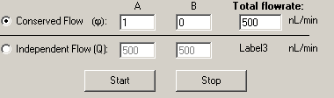

Public Sub InitializeOCX()

Important: This call is required prior to first use of the direct control.

Configuration Menu OCX

This control provides a menu for configuring an Eksigent device.

Public Sub InitializeOCX( )

Important: This call is required prior to first use of the configuration menu.

Public Function GetConfigSettings( [out] ByRef Config As Variant) As Boolean

This routine returns a 32-element array of strings (shown in the form noted for SetConfigSettings in the EksigentInterface2 section) in the variant parameter passed in. This array of strings contains the device configuration settings shown in the OCX control.

Public Function SetConfigSettings( [in] ByRef Config As Variant) As Boolean

This routine sets the device configuration parameters in the OCX control. It takes a variant parameter holding a 32-element array of strings in the form shown for SetConfigSettings in the EksigentInterface2 section.

Method Editor OCX

This control provides a UI for editing methods for Eksigent devices.

Public Sub MethodEditorInit()

Make this the first routine you call for the Method Editor OCX.

Public Sub UpdateAllRelatedFields(IgnoreChanges As Boolean)

Call this function after calling SetMethodSettings( ) to update the controls in the Method Editor OCX. If IgnoreChanges is True, MethodChanged will not be updated when the new values are entered into the controls.
Public Function ValidateMethodSettings() As Boolean

This function is currently unimplemented and always returns True.

Public Function IsMethodChanged() As Boolean

Returns True if a method property has changed in the OCX control, False otherwise.

Public Sub SetMethodChanged(bChanged As Boolean)

Use this routine to force a “method changed” state on the OCX control. Usually used to reset the control to unchanged (bChanged = False.)

Property Get maxruntime() As Single

Gets the maxruntime property.

Property Get PreRunFlushTime() As Long

Gets the PreRunFlushTime property.

Property Get DetectAcqRate() As Single

Gets the DetectAcqRate property.

Property Get lambda_min() As Single

Gets the lambda_min property.

Property Get lambda_max() As Single

Gets the lambda_max property.

Property Get lambda_bin() As Single

Gets the lambda_bin property.

Public Sub LockInterface(bLock As Boolean)

Use this routine to enable (bLock = False) or disable (block = True) the tab control in the Method Editor OCX control.

Public Function GetDefaultMethodSettings(ByRef Settings As Variant, ByRef Name As String) As Boolean

This routine returns the default method settings in a variant passed in. The form of the variant returned is an array of strings with NUM_METHOD_ITEMS + MAX_QA_PROFILE_NUMPTS + MAX_QA_PROFILE_NUMPTS + MAX_EVENT_NUM elements. See DownloadMethodSettings in EksigentInterface2 for the form of the strings.

The Name parameter is ignored.

Public Function GetMethodSettings(ByRef Settings As Variant, ByRef Name As String) As Boolean

This routine returns the method settings in a variant passed in. The form of the variant returned is an array of strings with NUM_METHOD_ITEMS + MAX_QA_PROFILE_NUMPTS + MAX_QA_PROFILE_NUMPTS + MAX_EVENT_NUM elements. See DownloadMethodSettings in EksigentInterface2 for the form of the strings.

The Name parameter is ignored.

Public Function SetMethodSettings(ByRef Settings As Variant, ByRef Name As String) As Boolean

This routine takes a variant parameter holding an array of strings with NUM_METHOD_ITEMS + MAX_QA_PROFILE_NUMPTS + MAX_QA_PROFILE_NUMPTS + MAX_EVENT_NUM elements. See DownloadMethodSettings in EksigentInterface2 for the form of the strings.

The Name parameter is ignored.

Public Sub DisableMethodControls(Disable As Boolean)

The routine disables input to the OCX control when the parameter Disable is set to True. Setting Disable to False reenables the input.

Public Sub UVDetectorInit(UVFlag As Boolean)

Use this routine to tell the Method Editor OCX whether or not to show the UVDetector tab. If UVFlag is True then the UVDetector tab will be shown.

Registering Eksigent Controls
The eksigent software must be installed and registered on the computer you are using for both development and the end application.

Referencing Controls with Visual Basic

Start Visual Basic and select Project->References from the pull-down menu. Scroll through the list to find:

[] EksigentNanoLC

Check both box’s and click Ok.

On the Component Palette, right click and choose “Components”. This will bring up a “Components” box that lets you add controls. Scroll through the list to find:

[] Direct Control
[] EK_ConfigMenu
[] EK_StatusBar
[] EKMethodEditorOCX

Check the boxes you want and click Ok.

Up to 4 new widgets will appear on the Component Pallet. Put the mouse over each and the tool-tip should say: “EksigentDirectControl”, “EksigentConfigMenu”, “EksigentStatusBar”, and “ctlMethodEditor”. You can now insert these OCX controls onto your own form.

Referencing Controls with Visual C++

Start Visual C and go to an empty spot on a form. Right-Click and choose “Insert ActiveX Control”.

Using the Eksigent Controls – Visual Basic Example

In your form_load() routine, add these lines:

Call EksigentDirectControl1.InitializeOCX()

The controls should now act like any other control.

To use the Eksigent Interface for pump control, declare variables like this:

Private EKdevice As EksigentInterface
Private WithEvents EKCOM as COM Driver

In the form_load() routine, add these lines:

Set EKdevice = CreateObject("eksigentNanolc.eksigentinterface")
Call EKdevice.Initialize

'Link our EKCOM variable to events from the COM interface
Set EKCOM = EKdevice.COMInterface CreateObject("EksigentNanoLC.COM_Driver")

You can now call routines like this:

EKDevice.Initialize()
EKDevice.GetStatus (1)
EKDevice.ShowMethodMenu(…)
EKDevice.PrepareForRun(…)
EKDevice.StartRun(1)
EKDevice.StopRun(1)

And don’t forget that when you exit your program, you should run:

EKDevice.ShutDown()

The Deployment utility should now package the Eksigent files in your project and take care of registering them as a part of your installation routine.

Removing the Eksigent Controls

On Win32 systems, you cannot simply delete the OCX and DLL files to move or remove them. You must first un-register them, then delete/move the files. If you delete the files first, you cannot un-register them.

Use the following commands from a cmd prompt to cleanly remove the Eksigent controls from your development system:

cd <the directory where the files exist>
unregtlib eksigent_chiplc.dll
unregsvr32 /u DirectControl.ocx
unregsvr32 /u EksigentStatusBar.ocx
unregsvr32 /u EKMethodEditorOCX.ocx
unregsvr32 /u EksigentConfigMenu.ocx
unregsvr32 /u EksigentMethodEditor.dll

You can now delete the files. If you move them to a different directory, use the commands described above to register them in their new location.

The Deployment utility that you use for your program will perform these commands as a part of it’s standard UnInstall function for your customers.

