**LIQUID Installation and Operation**

**By Jennifer E. Kyle**

([Jennifer.Kyle@pnnl.gov](mailto:Jennifer.Kyle@pnnl.gov))

**November 2016**

**Pacific Northwest National laboratory**

1. Click on the links below and download the associated files
   1. NET 4.5.1: <http://www.microsoft.com/en-us/download/details.aspx?id=40773>
   2. Thermo MS File Reader:  download and install the MSFileReader by creating an account at <https://thermo.flexnetoperations.com/control/thmo/login>, then logging in and choosing "Utility Software". Select MS File Reader 3.1 SP2 , then download MSFileReader_x64.exe
2. You will need to have xcalibur installed on your computer or MSConvert to create mzML files (LIQUID accepts .raw or .mzML files) of your MS/MS data files
   1. <http://proteowizard.sourceforge.net/downloads.shtml> (Windows 64-bit installer(no T2D support)). This contains the msconvert program.
3. In the folder containing LIQUID program files, open “LIQUID.exe”
4. You will see the following:

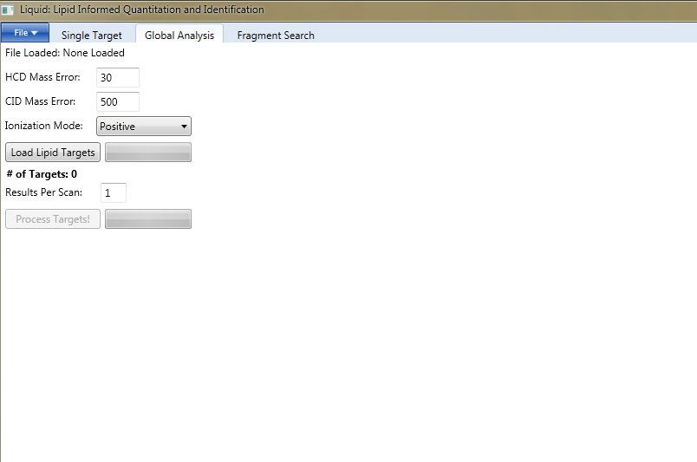

1. Select Global Analysis tab for untargeted lipidomics

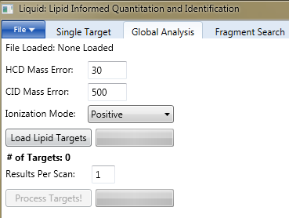

1. Click on ‘File’ and find and insert your LC-MS/MS data file

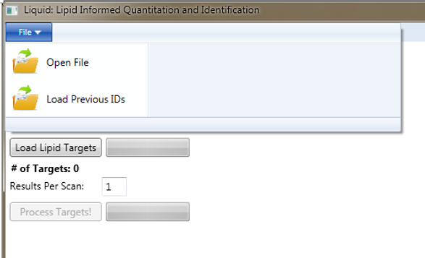

1. When the file is loaded the file name will appear

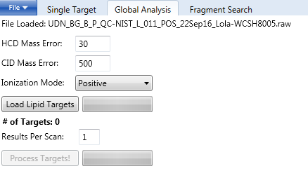

1. If required, change the HCD and CID mass error
2. Select the appropriate ionization mode from the drop down menu (this needs to match the LC-MS/MS data file and also the associated target list must be uploaded)

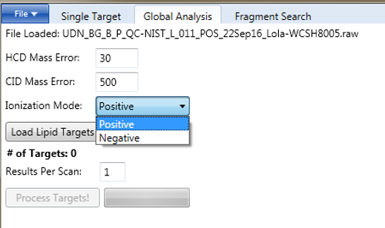

1. Click on “Load Lipid Targets” to load the global target file(s)



*There are separate global target files for samples analyzed in positive ionization and negative ionization. You can upload the one appropriate to your data or upload both if you will be analyzed data from both ionization modes. Once uploaded, the number of targets will be shown.

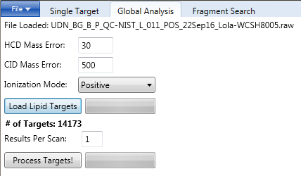

1. Select the number of results (lipid identifications) you want per ms/ms scan. If you select ‘1’ the highest scored match will be shown.



1. Click “Process Targets”
   1. Data will appear when the file has been processed (typically 60 seconds, about 10 sec after initial processing)

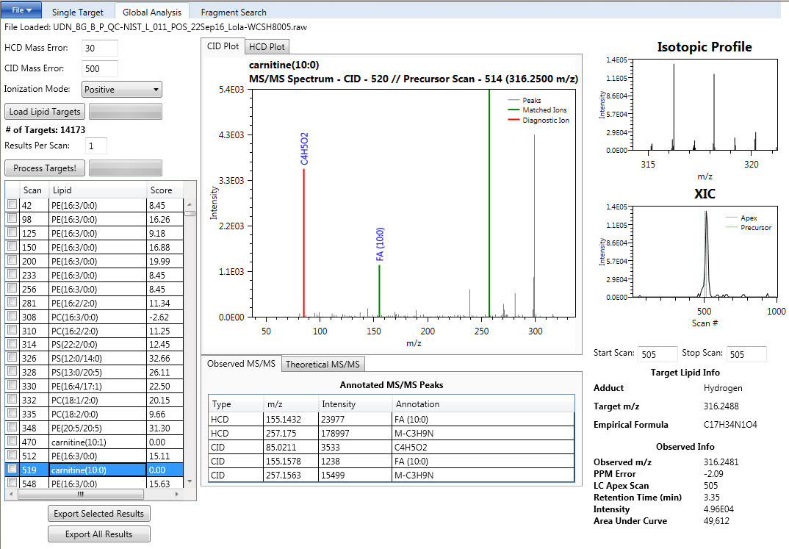

1. To organize the results table, click on ‘Lipid’ then hold shift on your keyboard and click on ‘Scan’

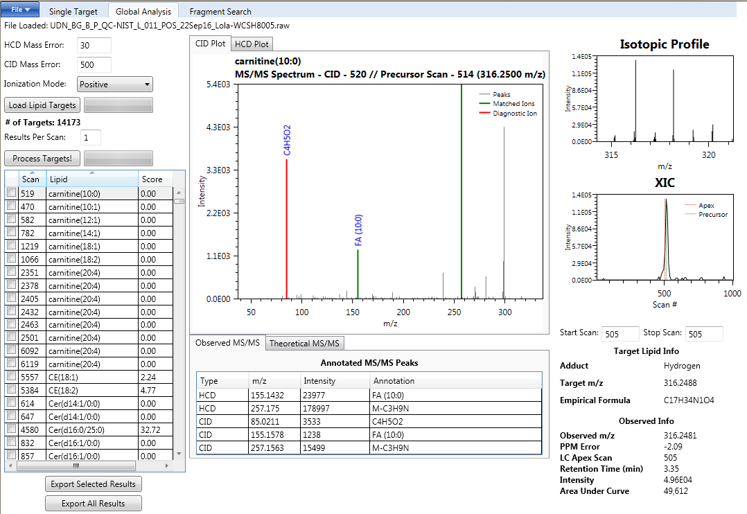

1. Start analyzing data and validating the candidate identifications. Most of the results listed in the table are incorrect (will be improved shortly) but what is correct and incorrect is usually easily deciphered. Example, DG(16:0/18:1):

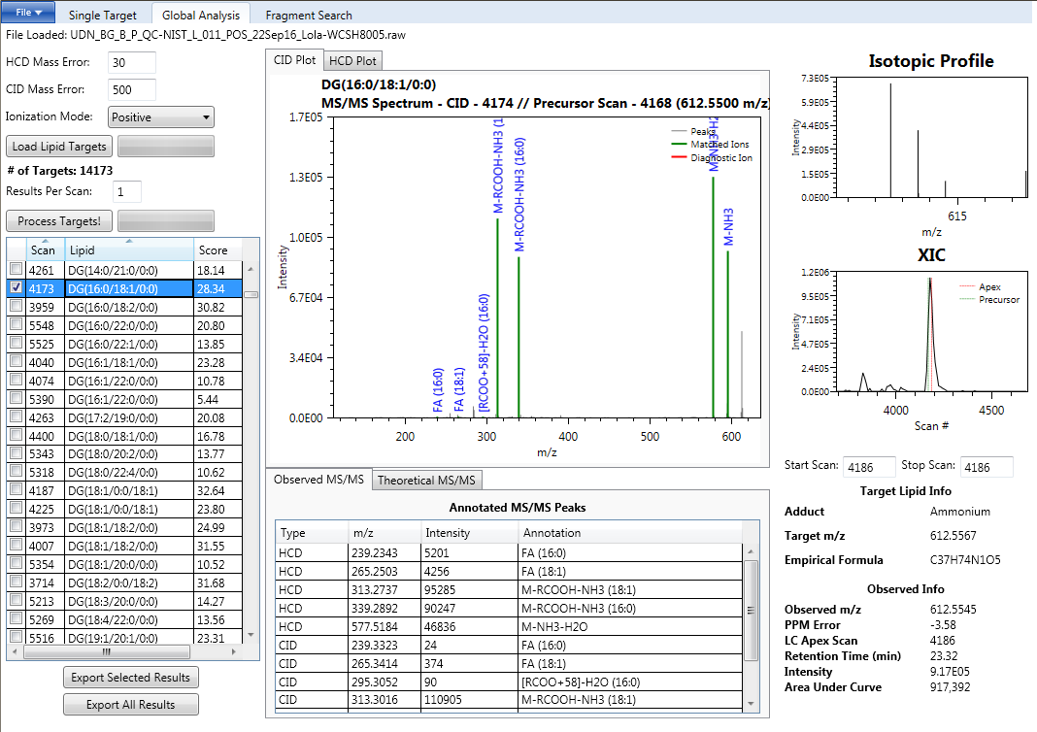

1. Another example (PC(14:0/16:0) and quick preview on making an identification
   1. MS/MS fragments that match the identification are highlighted. Red = diagnostic ion (if applicable) and green = other matched fragments (e.g. fatty acids). Gray = not matched. You can look at your MS/MS data in both HCD and CID (if applicable) and you can also see what fragments the software is looking for (Theoretical MS/MS tab) and a list of what was observed with associated annotation (Observed MS/MS). The isotopic profile for the associated empirical formula is shown. The MS level XIC is also shown. The red line in the XIC is where the software thinks the peak apex is located (this will give you the associated peak intensity value) and the green line in the XIC shows where the precursor scan is located. The PPM error and retention time (RT) is also provided to add another line of evidence that goes towards making a confident identification.

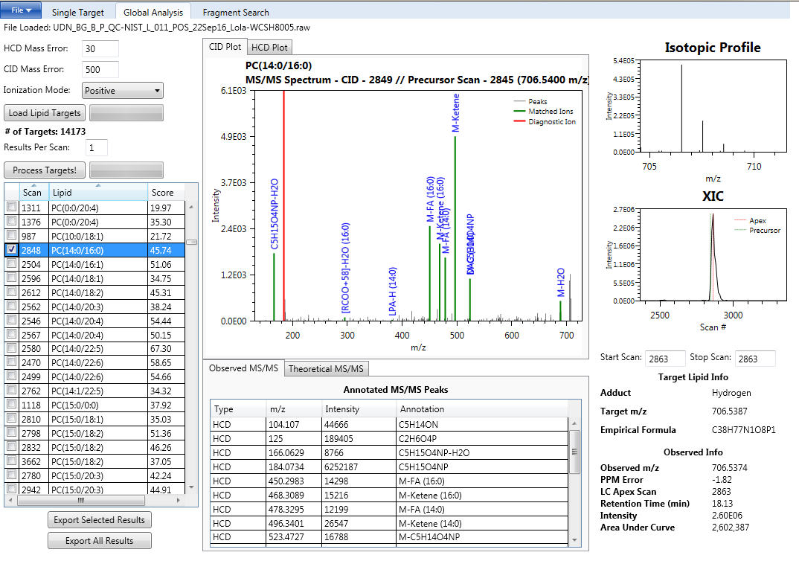

1. Once all of the confident identifications have been selected, click “ Export Selected Results”



1. To reload previously exported results, reprocess the raw file then go to “File” and click “Load Previous IDs”

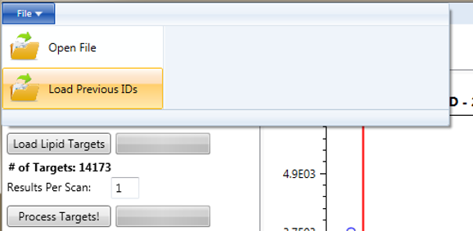

1. Once loaded organize the output chart (see Step 13) for the selected lipids to be checked

