**LIQUID Installation and Operation**

**By Jennifer E. Kyle**

([Jennifer.Kyle@pnnl.gov](mailto:Jennifer.Kyle@pnnl.gov))

**February 2019**

**Pacific Northwest National laboratory  
https://github.com/PNNL-Comp-Mass-Spec/LIQUID**

1. Requires Microsoft .NET Framework 4.6.2 or newer:
   1. https://www.microsoft.com/en-us/download/details.aspx?id=53344
2. LIQUID can read MS/MS data from Thermo Raw files or from .mzML files. A useful tool for creating .mzML files is MSConvert, which is part of ProteoWizard
   1. <http://proteowizard.sourceforge.net/download.html>
   2. Windows 64-bit installer (able to convert vendor files except T2D).
3. In the folder containing LIQUID program files, double click "LIQUID.exe"
4. You will see the following:

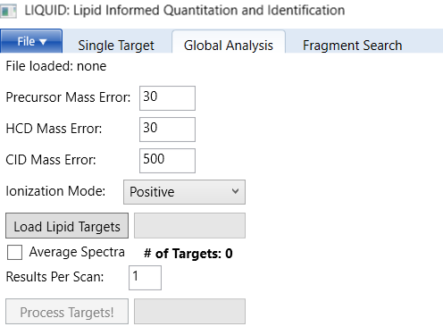

1. Select the Global Analysis tab for untargeted lipidomics
2. Click on "File" and select your LC-MS/MS data file

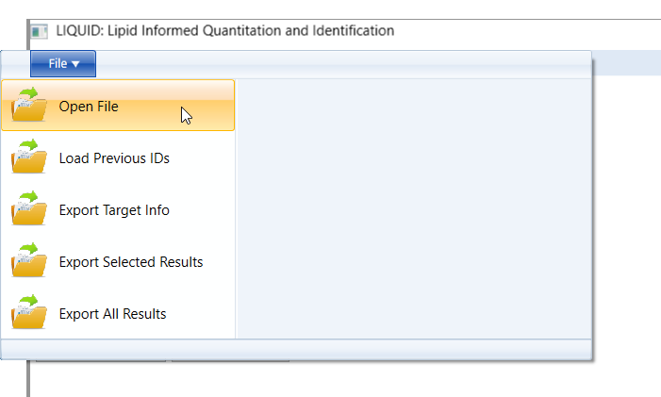

1. The file will be indexed, creating a .pbf file in the same directory as the input file. Index progress is shown via the "Caching data" message. Once indexing finishes, the path to the file is visible.

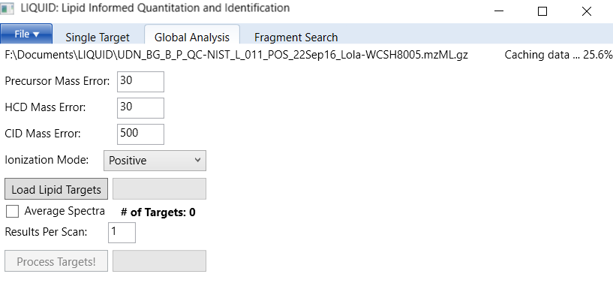

1. If required, change the HCD and CID mass errors (in ppm)
2. Select the appropriate ionization mode from the drop down menu (this needs to match the LC‑MS/MS data file and also the associated target list that will be chosen)

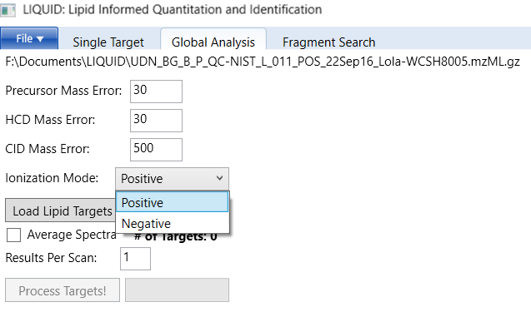

1. Click on "Load Lipid Targets" to load the global target file(s)

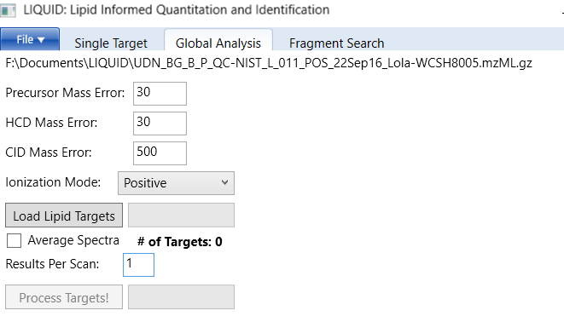

* There are separate global target files for samples analyzed in positive ionization and negative ionization.
* You can select the one appropriate to your data or select both if you need to analyze data from both ionization modes.
* Once uploaded, the number of targets will be shown.

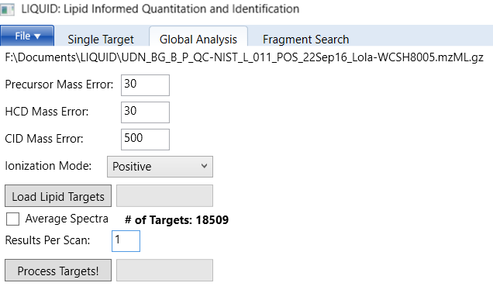

1. Select the number of results (lipid identifications) you want reported per MS/MS scan.   
   If you select "1" the highest scored match will be shown.
2. Click "Process Targets"
   1. A progress bar is shown to indicate processing progress.
3. After the search complete, search results are shown at the right, a mass spectrum is visible in the middle, and additional plots are shown at the right.
   1. Higher scores mean a higher confidence result

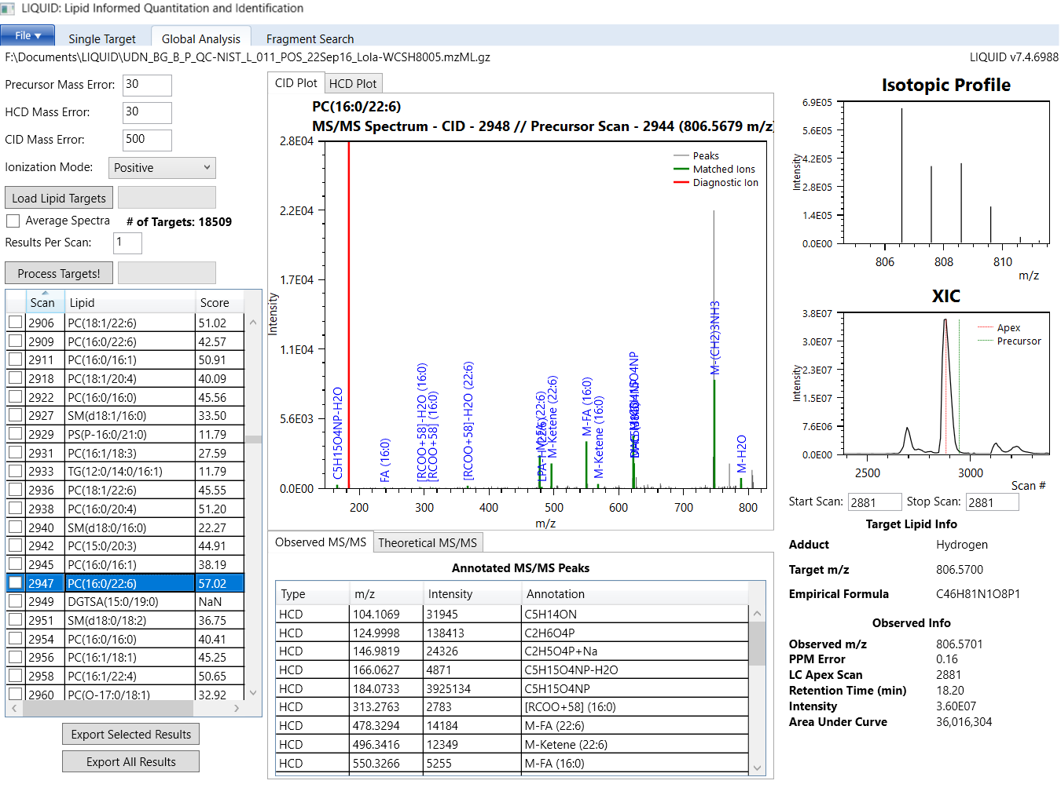

1. To sort the results by lipid, and then by scan, left click "Lipid", then shift left click "Scan"

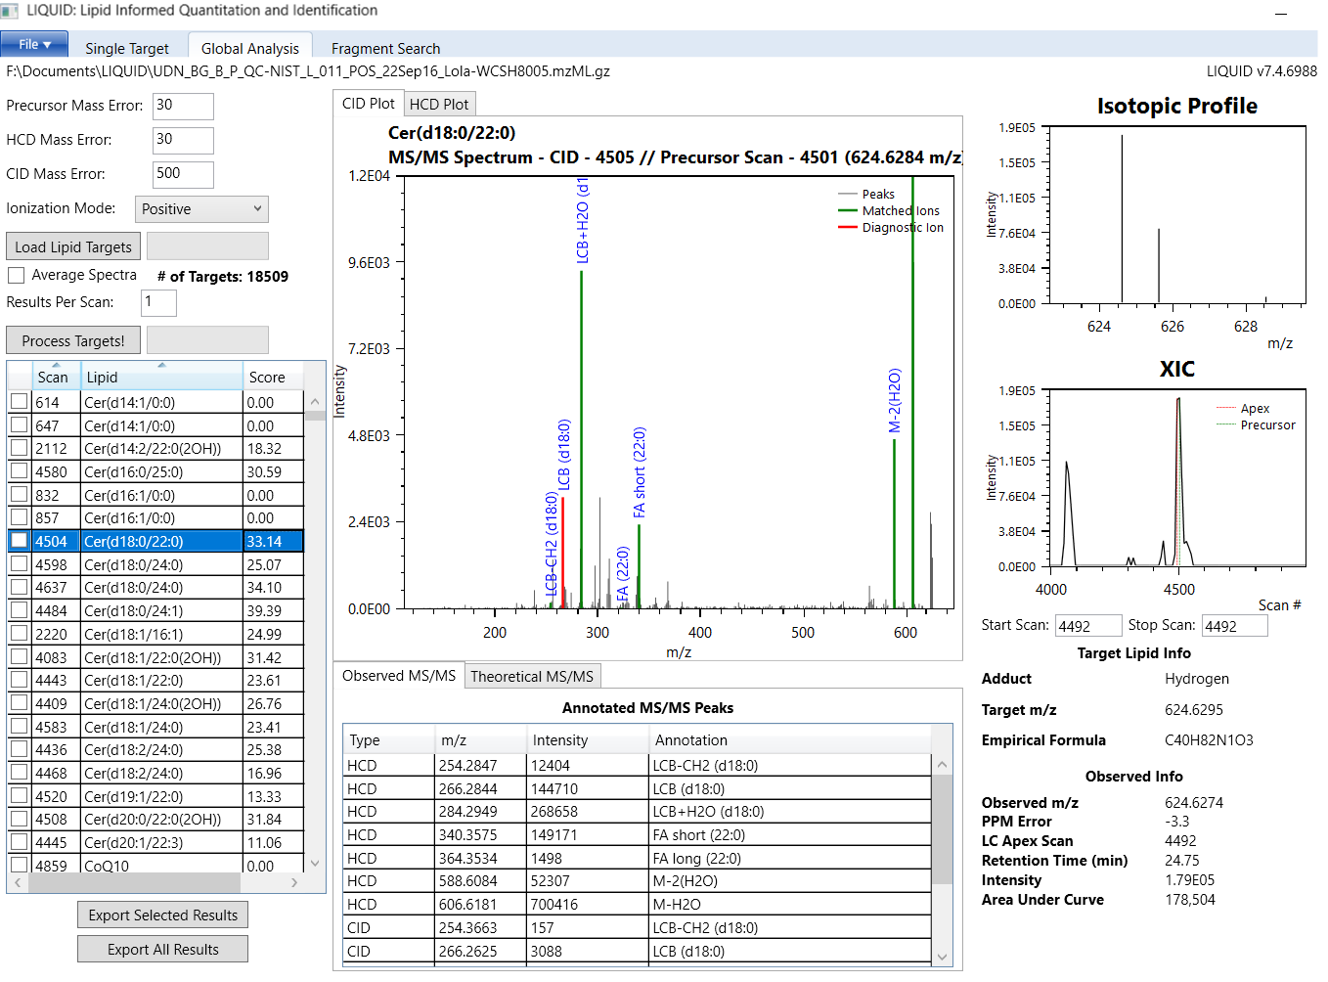

1. Start analyzing the results and validating the candidate identifications. Most of the results listed in the table are incorrect but what is correct and incorrect is usually easily deciphered. For example, DG(16:0/18:1):

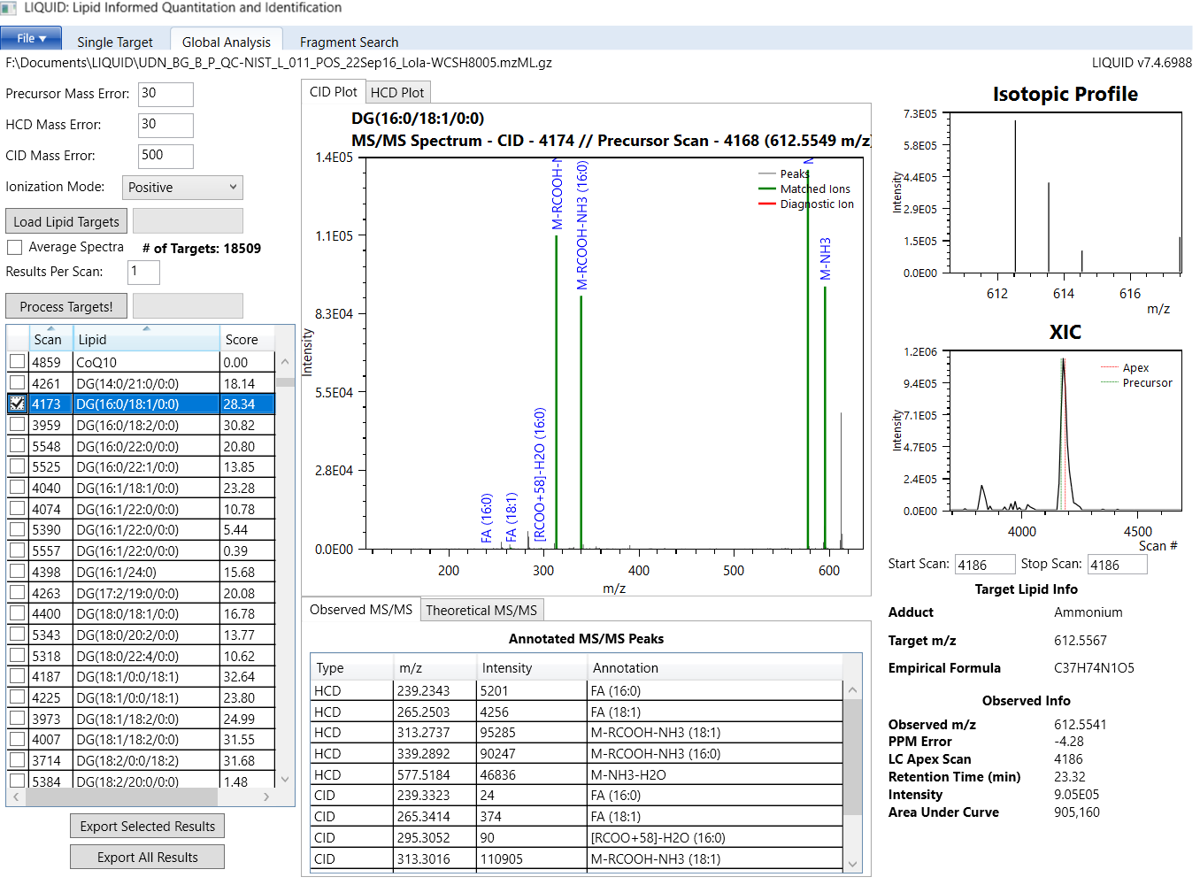

1. Another good example is PC(14:0/16:0)

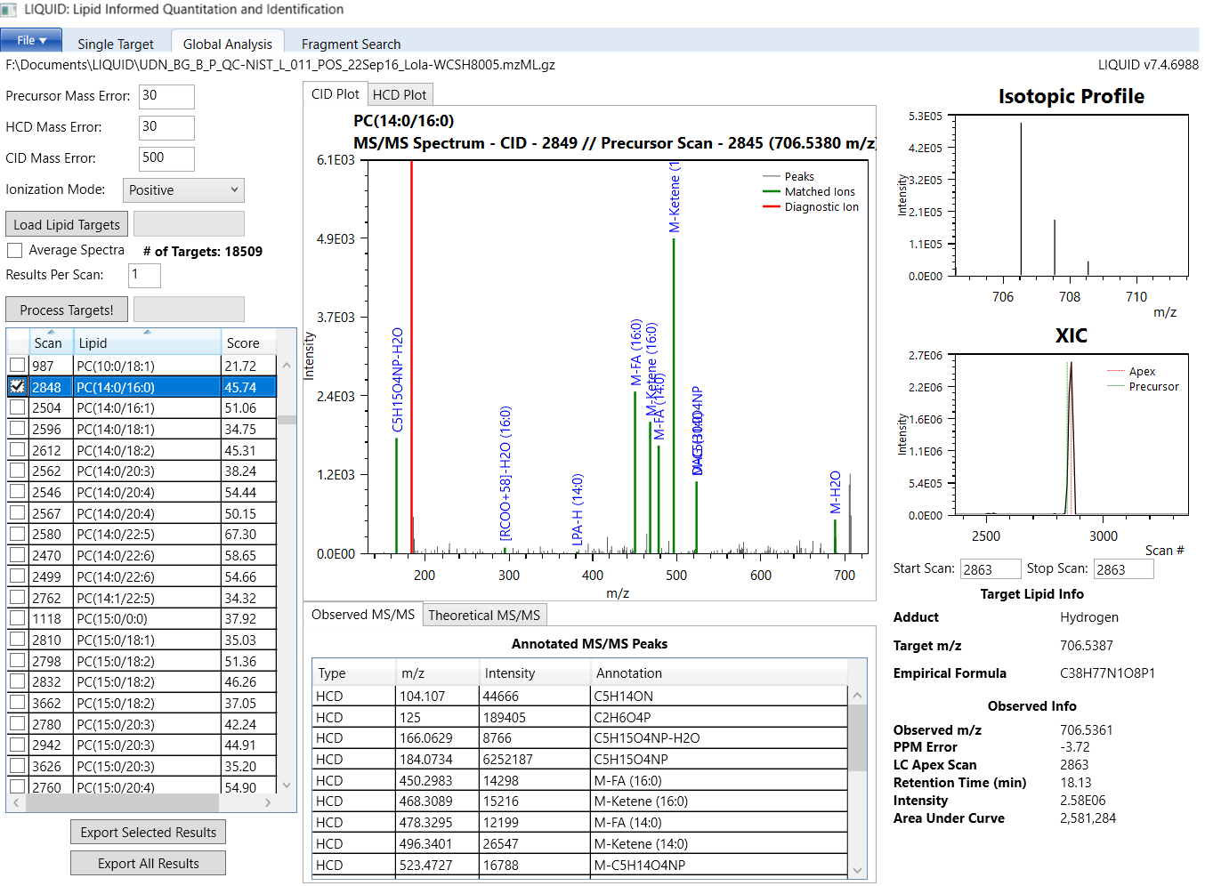

1. Explanation of the window layout
   1. MS/MS fragments that match the identification are highlighted.
      1. Red = diagnostic ion (if applicable)
      2. Green = other matched fragments (e.g. fatty acids).
      3. Gray = not matched.
   2. Plot Controls:
      1. Zoom into the plot by dragging with your middle mouse button
         1. If you don't have a middle mouse button (or you re-mapped it to double click), use Ctrl+Alt+Left Click to zoom in
      2. Zoom out by double clicking the middle mouse button   
         (or double Ctrl+Alt+Left Click)
      3. Slide the chart left and right (pan) using the right mouse button
   3. You can look at your MS/MS data in both HCD and CID (if applicable)
   4. The "Theoretical MS/MS" tab shows which fragments the software is looking for
   5. The "Observed MS/MS" tab lists the annotations associated with observed ions
   6. The isotopic profile reflects the associated empirical formula for the candidate ID.
   7. The MS level XIC shows the extracted ion chromatogram of the precursor m/z.
      1. The red line in the XIC is where the software thinks the peak apex is located   
         (the associated peak intensity value is based on this apex)
      2. The green line in the XIC shows where the precursor scan is located.
   8. The PPM error and retention time (RT) are also provided to add another line of evidence that goes towards making a confident identification.
2. Once all of the confident identifications have been selected, click "Export Selected Results" below the results grid, or from the File menu



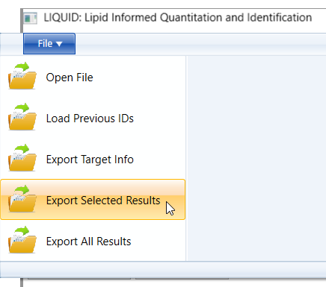

1. To reload previously exported results, you must first re-process the raw or .mzML file then select "File", "Load Previous IDs"

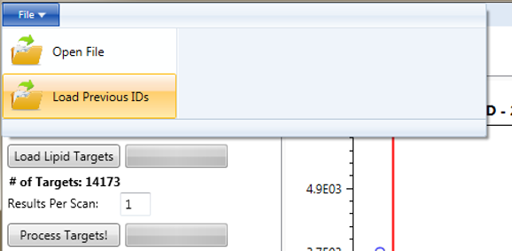

1. Optionally re-sort the results by Lipid, then Scan

