where P is pressure (dynes/cm²), d_{p} is the diameter of the packing particles (cm), ε (epsilon) is interparticle porosity, r is the column radius (cm), η (eta) is viscosity (poise), and L is column length (cm)

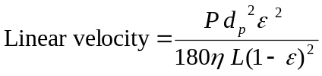
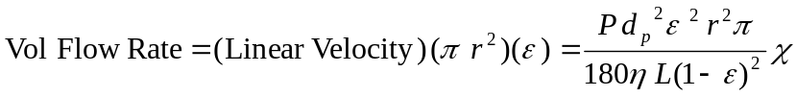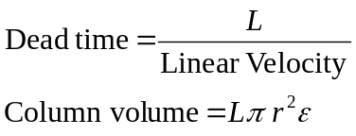

where P is pressure (dynes/cm²), d_{p} is the diameter of the packing particles (cm), r is the column radius (cm), η (eta) is viscosity (poise), and L is column length (cm)

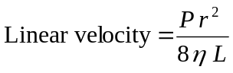
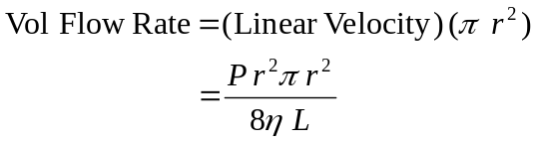

The theoretical amount of extra-column broadening that results from flow in open tubes is computed using the concept of plate height, H = σ_{L}²/L, where σ_{L}² is the spatial variance of the peak (cm²) and L is open tube length (cm). However, it is more useful to think in terms of temporal variance, σ_{t}² (sec²), which relates to spatial variance by σ_{L}²/u² = σ_{t}² where u is linear velocity (cm/sec):

H = A + B + C A = 0 and B = 0 in open tubes
C = d_{c}² u / (96 Dm)
D_{m} = diffusion coefficient of analyte = 10⁻⁶

H = d_{c}² u / (96 D_{m}) = σ_{L}²/L
d_{c}² u L / (96 D_{m}) = σ_{L}² Substituting σ_{L}²/u² = σ_{t}² and σ_{L}² = σ_{t}² u²
d_{c}² u L / (96 D_{m}) = σ_{t}² u² Solving for σ_{t}²
σ_{t}² = d_{c}² L / (96 D_{m} u)

The width at the base of a peak is 4σ_{t} so a 30 second wide peak would have σ_{t} = 7.5 seconds and σ_{t}² = 56 sec².

