Bioinformatics, YYYY, 0–0
doi: 10.1093/bioinformatics/xxxxx
Advance Access Publication Date: DD Month YYYY
Manuscript Category

Structural Bioinformatics
PIXiE: An Algorithm for Automated Ion Mobility Drift Time Extraction and Collision Cross Section Calculation using Global Data Association
Jian Ma¹, Xing Zhang¹, Yehia M. Ibrahim¹, Ryan S. Renslow¹, Dennis G. Thomas¹, Samuel H. Payne¹, Matthew E. Monroe¹, Richard D. Smith, Justin G. Teeguarden^{1,2}, Erin S Baker^{1,*} and Thomas O. Metz^{1,*}
¹Biological Sciences Division, Pacific Northwest National Laboratory, Richland, WA 99352, ²Department of Environmental and Molecular Toxicology, Oregon State University, Corvallis, OR 93771
*To whom correspondence should be addressed.
Associate Editor: XXXXXXX
Received on XXXXX; revised on XXXXX; accepted on XXXXX
Abstract
Motivation: We introduce an algorithm, the PNNL Ion Mobility Cross Section Extractor (PIXiE) to automatically extract drift times for molecules measured by ion mobility spectrometry-mass spectrometry (IMS-MS) and to compute their associated collision cross sections (CCSs). The primary application presented for this algorithm is the extraction of information necessary to create a reference library containing accurate masses, drift times and CCSs for use in high throughput IMS-MS-based metabolomics analyses. It could also be applied for use in IMS-MS analyses of other molecules.
Results: We demonstrate the utility of this approach by automatically extracting drift times and calculating the associated CCSs for a set of 31 small molecules, including 19 xenobiotic molecules, and 12 related exogenous or endogenous metabolites. The PIXiE-generated CCS values were identical to those calculated by hand.
Availability: PIXiE is an open-source tool, freely available on Github. The documentation and source code of the software can be found at https://github.com/PNNL-Comp-Mass-Spec/PIXiE and the source code of the backend workflow library used by PIXiE can be found at https://github.com/PNNL-Comp-Mass-Spec/IMS-Informed-Library.
Contact: erin.baker@pnnl.gov and thomas.metz@pnnl.gov
Supplementary information: Supplementary materials are available at Bioinformatics online.

Introduction
The field of metabolomics has made great strides since the explorations by Pauling and Robinson [1-3] and its conceptualization as an official ‘omics’ by Nicholson [4]. Many approaches and analytical platforms exist for collecting metabolomics data; although medium and low throughput methods based upon gas chromatography (GC) and liquid chromatography (LC) coupled with mass spectrometry (MS), as well as nuclear magnetic resonance (NMR) spectroscopy, still dominate most applications. Similarly, many algorithms and software packages are also available for manipulating data throughout the associated informatics pipelines. These informatics tools are used for identification and alignment of features across multiple analyses [5-7], normalization of metabolite abundance information [8, 9], and matching experimental metabolite characteristics to reference libraries of spectra, retention times, or chemical shifts, constructed from authentic chemical standards [10-12]. However, a National Academy of Sciences report calling for the complete characterization of both endogenous and exogenous chemicals in human exposures has initiated a transformation in metabolomics [13, 14]. As the demand for increased coverage of the metabolome and exposome increases, there remains a need for measurements that provide much higher throughput while still maintaining high sensitivity.
Ion mobility spectrometry (IMS) is a rapid gas-phase separation technique that is easily combined with MS for high throughput multi-dimensional separations [15, 16]. In an IMS separation, ions are subject to an electric field while traveling through a buffer gas and separate quickly based on ion shape and size, e.g. compact species drift faster than those with extended structures [15, 17]. By measuring IMS arrival times, it is possible to derive a molecule’s collisional cross section, which characterizes its chemical structure and can increase the specificity of metabolite identifications, particularly when combined with accurate mass measurement and other information. Herein, we report an approach for automatically extracting drift times for metabolites analyzed by drift tube IMS-MS (DT-IMS-MS) and for subsequently calculating their collision cross sections (CCSs). To obtain the most accurate CCS measurements, DT-IMS-MS analyses were performed at multiple electric fields. Given a list of empirical formulae for target molecules of interest, our algorithm analyzes the IMS-MS data for each target ion and extracts the arrival times at the peak centroids for each IMS electric field. These arrival times are then utilized to calculate the CCS for each ion. When candidate ions are indistinguishable using mass information alone, the algorithm calculates and tracks CCSs for all candidate ions throughout the experiment through the implementation of a unique, global data association approach inspired from multi-object tracking in video sequences [27, 28]. The resulting algorithm and software (PIXiE; PNNL Ion Mobility Cross Section Extractor) supports the extraction of drift times, molecular CCSs and accurate mass data for the rapid construction of reference libraries of metabolites and related molecules to be used in high throughput IMS-MS-based metabolomics studies.

METHODS

3.1 Overview: CCS Calculations from IMS Data
Reference libraries for high throughput identification of molecules ideally contain two or more orthogonal metrics of identification, such as accurate mass, isotopic signature, LC elution time, NMR spectra, MS/MS spectra, or IMS CCS [18]. These criteria adhere to the recommendations [19] of the Metabolomics Society’s Metabolomics Standards Initiative for highest confidence in metabolite identification [20]. Methods for determining IMS CCSs are well established. In the experiments detailed in this manuscript, CCSs were determined by collecting ion arrival time distributions (ATDs) at n different electric fields. The arrival time, t_{A}, of a particular ion was extracted from the apex of the ATD peak using Eqn 1.

 | 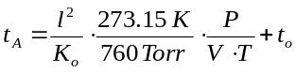 | (1)
The expression for t_{A} is an equation for a straight line (y = mx + b) where the slope of the line is inversely proportional to the reduced mobility of the ion (K_{o}), and the y-intercept is equal to the time outside the IMS drift cell (t_{o}). t_{A} is also a function of drift voltage (V, in volts), temperature (T, in kelvins), pressure (P, in torr) and the physical length of the drift tube (l, in meters). To acquire the CCS, K_{o} must be calculated for each ion and to attain K_{o}, t_{A} is extracted from the center of the ATD peak and plotted against P/(TV). Plots of t_{A} versus p/(TV) are highly linear with R² values of at least 0.9999. The mobility of an ion is dependent on the number of collisions it encounters with the buffer gas. By measuring the mobility of an ion, information about the ion’s shape and size, or in other words CCS, can be determined. The relationship between the mobility of an ion and its CCS has been derived in detail using kinetic theory [21] and is given by Eqn 2.
 | 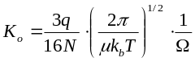 | (2)
where q is the ion charge in Joules, N is the buffer gas density,  is the reduced mass of the collision partners, kb is Boltzmann’s constant, and is the momentum transfer collision integral, which describes the collision between the ion and the buffer gas atoms and gives direct information about the conformation of the ion traveling through the drift cell. To reduce errors in the experimental evaluation of , multiple measurements are made on each system studied.
Automated processing of IMS-MS data is required to support high throughput creation of metabolite reference libraries, which would otherwise involve extensive manual data analysis. There are challenges associated with automated extraction of CCS from consecutively run IMS data. Given a known empirical formula, detection of an IMS-MS peak at the expected m/z of a target ion can correspond to three distinct possibilities: 1) the peak corresponds to the target ion; 2) the peak corresponds to a co-drifting compound that is indistinguishable from the target ion using m/z; and 3) the peak does not correspond to an ion but instead is a result of noise. Further, to determine the link between observed and expected ions, as well as to identify and remove noise, peaks need to be detected and tracked across multiple electrical fields in multi-field DT-IMS-MS experiments. We formulated this last challenge as a global data association problem, and refer to each of the potential solutions for the global data association problem as an association hypothesis. To solve the global association problem, PIXiE creates the association hypotheses set based on analyses of peak diffusion profiles across electric fields. From the association hypotheses set, PIXiE then selects the optimal association hypothesis as the final solution to the global data association problem. The following sections describe the details of each step of the algorithm in the order they are implemented (Fig. 1) in PIXiE.

3.2 Data Collection and Formatting
CCS calculations are performed at n different electric fields (in our case, 5 fields ranging from 16.3 V/cm to 18.7 V/cm). Data from multiple IMS-MS analyses at different electric fields were assembled into a single unified ion mobility file (UIMF) [22] for further analysis.

3.3 Target Molecule List
To start an analysis on a given UIMF file, PIXiE requires a target list file consisting of known empirical formulae for molecules of interest. PIXiE extracts CCSs for all molecular conformers, isobars or dimers of target molecules that can be separated by IMS.

3.4 Peak Identification, Scoring and Filtering
PIXiE performs electric field grouping, multidimensional peak extraction [23], scoring, and filtering (Fig. 1). These steps detect candidate peak(s) for each target ion and remove those that do not have sufficient peak quality for further analysis or whose isotopic distribution(s) do not match that of the target empirical formula. These steps are described briefly below.

3.4.1 Electric Field Grouping
For the experiments performed, chemical standards were analyzed over five electric fields with data collected over 5 min of direct injection (1 electric field/minute). All IMS-MS data were then stored in a single UIMF file [22]. The first step in processing the data in PIXiE is to bin the IMS-MS spectra according to the electric field at which the spectrum was collected. Spectra sharing the same electric field were averaged to enhance the signal to noise ratio.

3.4.2 Multidimensional Peak Extraction
IMS-MS features characterized by m/z, drift time, and intensity were extracted from the raw data using a modified version of the LC-IMS-MS Feature Finder [23]. The original implementation of the feature finder modeled a peak in two dimensions on an intensity map with LC retention time and IMS drift time as x and y axes, respectively. We modified this algorithm to extract 2-D peaks from an intensity map with m/z and drift time as x and y axes, respectively. In order to increase computational performance, the peak detector was applied only to the 2-D intensity area within a ±250 ppm mass window surrounding the expected m/z of the target molecule. Filtering of co-drifting compounds based on measured m/z is implicitly done in the global data association step, as ions with measured mass closer to expected produce a higher a posterior probability. A second mass measurement error threshold of ±15 ppm was applied as part of the post-filtering process after the global data association step.

3.4.3 Peak Scoring and Filtering
For peak apex extraction and subsequent comparison of diffusion profiles, peaks are characterized according to the following: base peak intensity, m/z at the base peak apex, drift time at the base peak apex, the base peak width in m/z, and the base peak width in drift time expressed as full width at half maximum. In addition, a peak shape score and an isotopic distribution score [24] are calculated to further characterize the quality of the peak and the proximity of the peak to the ideal isotopic distribution of the target molecule.
The peak shape score is calculated by quantifying how closely the IMS peak diffusion profile matches the expected Gaussian distribution using the Jaque-Bera Statistical Test [25]. Peak shapes deviating significantly from the expected Gaussian distribution are likely to be instrumental or computational artifacts.
The isotopic distribution score is calculated by quantifying the similarity between the theoretical [26] and observed isotopic distribution for each target molecule. The angle between the theoretical and the observed isotopic distribution vectors, whose value is normalized to 1, is used as an isotopic matching score (Eqn. 3). The angle scoring method is preferred to conventional methods (e.g. Euclidean distance or Pearson correlation) for quantifying differences between expected and observed isotopic signatures when differences are large. This attribute is useful for filtering of peaks with a very low probability of being associated with target ions in the preprocessing step.
 | 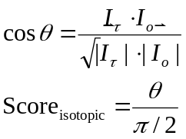 | (3)

Note that to avoid excluding peaks of low intensity, peak filtering in the preprocessing step does not involve filtering based on intensity.

3.5 Global Data Association
Following the preprocessing steps, the global data association step further removes peaks that are artifacts and determines the link between observed peaks and target molecules, if detected.
PIXiE makes the following assumptions for this step.

- Dimers, conformers and isobaric species of the target ion(s), are indistinguishable in the m/z dimension, and CCSs will be extracted for those ions, if detected.

- Even under varying electric field, some aspects of the 2-D diffusion profiles of a given ion remain the same. The ion cloud distribution is largely determined by the initial spread as the ion bundle enters the IMS drift tube and by any further diffusion that occurs in the drift tube [27]. As a result, the peak profile for a given molecule will broaden predictably as the total voltage drop increases [17]. The peak profile in m/z dimension remains constant despite the changing electric field.

- Peaks apices corresponding to the same ion at different electric fields, if detected, are subject to kinetic theory and can thus be modeled using the Mason-Schamp equation (Eqn. 1).

To solve the global ion association problem, we implemented a K-shortest path scheme to identify potential association hypotheses constrained by the above assumptions. Next, in the association hypotheses set identified by the K-shortest path algorithm, we adapted Bayesian statistics and used maximum a posterior estimation (MAP) [27, 28] to test association hypotheses against observed peaks and to ultimately select the optimal association hypothesis.

3.5.1 K-shortest path for hypothesis space reduction
If an ion is detected at more than one electric field, an “ion path” defining the ion’s presence at different electric fields is formed. When large numbers of peaks are observed in the targeted m/z space, e.g., due to low signal to noise ratio or high number of conformers/co-drifting compounds, the number of possible ion paths that can be formed becomes large enough that the subsequent MAP becomes computationally expensive.
To reduce the computational complexity of the MAP calculation, we introduced K-shortest path [28] to select the k most likely ion paths across the different electric fields. First, we defined an ion transition graph G as a weighted and directed graph, where the vertices are the set of all the peaks observed in the targeted m/z window X = {x₁, x₂, x₃…x_{i}…x_{n}} in all electric fields, and edges are inserted for every peak in a given electric field to all peaks in the adjacent electric fields (Fig. 1.c). Next, the weight of an edge is defined as the negative log of the matching score corresponding to the diffusion profile matching probability of a pair of peaks in adjacent electric fields (Eqn. 4). Additionally, two non-peak vertices are added to the graph as source and sink. A hypothetical ion path T_{k} is thus defined as a path in G from the source to the sink (Fig 1.b). Notably, the shorter an ion path is, the more consistent in terms of diffusion profiles are the peaks associated with the path according to Eqn. 5. Finding K shortest path in the ion transition graph is thus equivalent to finding K ion paths T_{k} with the most consistent peak diffusion profiles.

(4)

 | 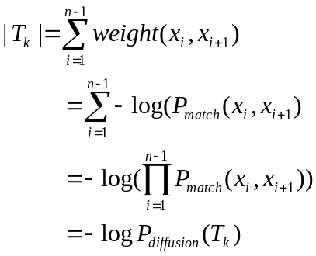 | (5)

We solve the K-shortest paths problem from G using the Hoffman-Pavlet algorithm [29] to acquire the K most likely hypothetical ion paths. Subject to the computing resources available, the number K can range from hundreds to thousands in case the association result does not converge. The K hypothetical ion paths (T_{k}) would then be combined to form association hypotheses of the data. The next step is to evaluate the association hypotheses using the MAP approach and determine the optimal association of peaks across electric fields.

3.4.3 A posteriori probability of association hypothesis
Let X continue to be the set of all peaks observed in the targeted m/z window X = {x1, x2, x3…xi…xn} in all electric fields, and let T be the association hypothesis represented by T = {Tk }, where Tk ∩ Tl = Ø. Then the optimal association hypothesis is one that maximizes its probability given the peaks observed.
 | 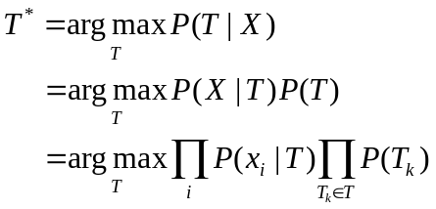 | (6)
According to Eqn. 6, to find the association hypothesis with the highest a posteriori probability, P(T_{k}) and P(x_{i} | T) need to be modeled as a function of individual peak profiles, relationships of peaks to ion paths, and the probability of a peak to not reject the association hypothesis.
We model the probability of ion path P(T_{k}) again, based on assumptions 2 and 3: the ion path T_{k} is more likely to be real if 1) the peak responses within share similar diffusion profiles and 2) the arrival time and electric field pairs of the peak comply with the kinetic theory described in Eqn. 1. P(T_{k}) is thus defined in Supplemental Eqn. 2 (Supplemental 1) as the weighted geometric mean of the correlation of determination value of the least squares fit line (R²) and the diffusion profile matching the probability for all the observations of an ion (including conformers), which is the P_{diffusion} used in the K shortest path ion tracking step (Eqn. 5).
For Pr(x_{i} | T) we implemented a simplified likelihood model as shown in Supplemental Eqn. 3 (Supplemental 1). If the peak x_{i} is on one of the paths T_{k}, we evaluate the arrival time error between the observed peak and what the path T_{k} predicts. The error corresponds to the degree to which the peak is rejecting hypothetical ion path T_{k} as a valid ion path. When the peak x_{i} is not on the ion path T_{k}, Pr(x_{i} | T) is then evaluated to δ, the probability of a peak within the target m/z to be an artifact or an interference, which is a constant that could be tuned based on the noise level of the data.

3.4.4 Diffusion profile matching
Both the weight calculation of the ion transition graph and computing Pr(T_{k}) requires computation of the matching probability of base peak diffusion profiles of two peaks measured at different electric fields. We characterize the distance between diffusion profiles of two ions with the following parameters: Δmzc, Δmzw, Δmzl, Δdtc, Δdtw, Δdtl, which correspond to the differences in m/z at peak apex, m/z full width at half maximum, percentage of peak intensities on the lower m/z side of the peak apex, drift time value at peak apex, drift time full width at half maximum, and percentage of peak intensities on the lower drift time side of the peak apex, respectively. By calculating the geometric mean of these 6 parameters weighted according to their impact to the diffusion profile matching, we can obtain a score that favors peaks sharing similar diffusion profiles. This matching score can then be normalized to 1 to model Pmatch(x_{i,} x_{i+1}) (Supplemental 1, Supplemental Eqn. 1).

3.4.5 CCS calculation
CCS is calculated for all ion paths in the optimized association hypothesis using the least squares fit of Eqn. 1 to obtain mobility. Mobility can then be converted to CCS using Eqn. 2.
In addition to the linear simple least squares typically used to calculate ion mobility, PIXiE offers an option to use iteratively reweighted least squares as an alternative, with bisquare weight [30] to account for numerical and instrumental errors in determining the apex of arrival time distribution, which if occurring at peaks at the max or min electric fields could contribute substantial error to the final CCS extracted (Supplemental 1, Part 2).

3.4.6 Post-filtering
Although the isotopic filtering and global data association is able to filter out various kinds of artifacts and identify co-drifting compounds, these steps cannot identify the remaining ions as conformers or dimers of the target ion. The identifications might be clear for a simple sample of known composition (e.g. an authentic chemical standard in solution). However, in the case of data from complex samples (e.g. blood plasma), it is still possible that a co-drifting compound could pass the isotopic filter and global association step and have its CCS extracted. The next step is to use discretional thresholds on multiple scores generated in various steps of the algorithm, such as the isotopic similarity score, mass error in ppm, or the a posteriori probability to further identify any remaining co-drifting chemicals. For example, users can establish thresholds such as a mass measurement error ≤ 10 ppm, or an a posteriori probability > 0.7. To aid this process, PIXiE generates an analysis database for each batch of analyses performed so that users can easily adjust various parameter thresholds for post-filtering through database queries, while viewing the results generated from the optimal association hypothesis.

RESULTS
4.1 An automated tool for DT-IMS CCS calculation.
We developed PIXiE as an open source, C# software toolkit that automates extraction of drift times and calculation of CCSs for molecules measured across multiple electric fields in DT-IMS-MS. PIXiE implements the preprocessing steps and global data association algorithm described in Fig. 1.
The primary application for PIXiE is in the construction of a reference library containing accurate mass and CCS data for metabolites and other small molecules. To further automate data analysis for an arbitrary amount of targets in a given amount of data, we developed a parallel batch processor. The user can schedule searches for multiple targets for a set of DT-IMS-MS data, and the batch processor will run multiple analysis processes, aggregating the results to a single SQLite database consisting of relational tables such as chemical targets, data files, analyses, detected ions and peaks. This database can later be queried directly for quality control, post-processing or visualization purposes. Results after post processing can then be exported to an accurate mass and CCS library. Intensive testing of PIXiE on data from DT-IMS-MS analyses of 472 small molecules in mixed and standard datasets with 5 different IMS electric fields shows that on a windows server with 8-core Intel Xeon X5560 CPU with 2.8 GHz and 25 GB of RAM, PIXiE required 2 – 5 seconds to analyze 1 adduct variant of a target molecule with the max k in k-shortest path set to 3000. The processing time of PIXiE scales linearly with the number of CCS analyses needed.

4.2 Peak extraction and filtering
To test the peak extraction and filtering, we inspected analyses of 31 randomly selected molecules within the 472 molecule dataset. As an example, the analysis record from calculating the CCS of permethrin (PubChem CID 40326), a pyrethroid insecticide, is shown in Table 1. The empirical formula of the target molecule, C₂₁H₂₀Cl₂O₃, was set in PIXiE to form the corresponding sodiated and protonated adduct ions. Taking the sodiated permethrin ion analysis as an example, the corresponding target m/z is 413.069. PIXiE first grouped the DT-IMS-MS data frames into 5 electric fields (1-5, in order) [1-32], [33-65], [66-97], [98-130] and [131-160], with 1450.18, 1400.14, 1350.12, 1300.12 and 1250.19 V drift tube voltage, respectively. After averaging the IMS data within the initial m/z window of 413.069 ± 15 ppm, the peak detector found 5, 5, 4, 5, and 5 peaks in electric fields 1 through 5, respectively. No candidate peaks were removed by peak shape or isotopic profile filtering. Next, the global data association step was applied and the optimal association hypothesis was found consisting of 3 detected ions. The PIXiE result from peak filtering and peak extraction matches visual inspection of the raw data (Fig. 2). Such peak extraction and filtering information is logged for each optimal association hypothesis to ensure the provenance of PIXiE CCS calculations. Besides the analysis log file, each CCS extracted by PIXiE can be traced to the optimal association hypothesis used. PIXiE visualizes each optimal association as shown in Fig. 2.b. The optimal association hypothesis plot shows all observed peaks as scatter points according to their arrival time, the value of P/(T•V), and peak intensity.
Table 1. Peak statistics averaged across electric fields for the sodiated form of permetherin and the filter thresholds used in preprocessing.
Criteria | Value or Criteria
Criteria | Expected | Measured
 | Target detection 1
Intensity Score | > 0.8 | 0.9718
Peak Shape Score | > 0.8 | 0.8851
Isotopic Distribution Score | > 0.8 | 0.9840
Mass Error Score | < 15 ppm | 7 ppm
T₀ | / | 5.4201 ms
R² | / | 0.9996
P(T) | / | 0.95
Cross Section (Å²) | / | 191.3175
 | Target detection 2
Intensity Score | > 0.8 | 0.9869
Peak Shape Score | > 0.8 | 0.9370
Isotopic Distribution Score | > 0.8 | 0.9889
Mass Error Score | < 15 ppm | 7 ppm
T₀ | / | 6.3855 ms
R² | / | 0.9995
P(T) | / | 0.92
Cross Section (Å²) | N/A | 191.3175
 | Target detection 3
Intensity Score | > 0.8 | 0.8929
Peake Shape Score | > 0.8 | 0.8990
Isotopic Distribution Score | > 0.8 | 0.9912
Mass Error Score | < 15 ppm | 7 ppm
T₀ | / | 8.3613 ms
R² | / | 0.9996
P(T) | / | 0.93
Cross Section (Å²) | N/A | 258.4848

4.3 Validation of PIXiE extracted CCSs
To verify the accuracy of PIXiE extracted CCSs, we performed a side by side comparison of PIXiE results with those from manual calculations using Eqn. 1 and Eqn. 2. The comparison was performed for 16 ions from 12 common metabolites. The spreadsheets used for hand analyses can be found in Supplemental S3). Table 2 shows that PIXiE CCS results are nearly identical with those resulting from hand calculation. Additional comparisons with literature and predicted CCS values were performed for these metabolites (Supplemental 1, Supplemental Table S1).
Table 2. Comparison of manually calculated and PIXiE determined CCSs for 11 metabolites.
Metabolite | Adduct | PIXiE  CCS (Å²) | Manual  CCS (Å²)
adenosine | [M+H] | 166.1 | 166.1
adenosine | [M+Na] | 165.1 | 165.1
choline | [M+] | 119.0 | 119.0
cytidine | [M-H] | 156.2 | 156.2
D-tryptophan | [M-H] | 159.1 | 159.5
epinephrine | [M+H] | 243.3 | 242.2
folic Acid | [M+H] | 198.6 | 198.6
folic Acid | [M+Na] | 207.0 | 206.9
folic Acid | [M-H] | 198.9 | 199.0
fructose-1-6-diphosphate | [M-H] | 156.2 | 156.3
glucosamine-6-phosphate | [M+H] | 153.2 | 153.2
glucosamine-6-phosphate | [M+Na] | 172.0 | 172.0
glucosamine-6-phosphate | [M-H] | 155.9 | 155.4
NAD | [M-H] | 219.0 | 219.0
sucrose | [M+Na] | 176.7 | 176.7
taurine | [M+Na] | 148.4 | 148.0
UDP-galactose | [M-H] | 210.6 | 210.7

4.4 Algorithm robustness
To evaluate the robustness of PIXiE’s determination of optimal association hypotheses, we tested the algorithm on datasets containing multiple conformers/dimers. As many as 5 conformers and/or dimers were detected in a single target analysis, and all CCSs were extracted correctly (Supplemental 2). We have not yet encountered a case in analyses of authentic reference materials where the data are too complex for PIXiE to determine a reasonable optimal association hypothesis.

4.5 Limitations
As discussed in 3.46. Even though PIXiE could reliably locate ions in the data that match the mass and isotopic pattern specified by the target, and determine CCS of those ions. PIXiE alone does not offer absolute identification of ions in relation to the target, nor can PIXiE draw a line between conformers and dimers. To use for library construction purposes sample purity has to be ensured to provide the principle basis for ion identification. Library building is best conducted using conservative parameters (e.g., low mass error threshold, high isotopic score threshold, to limit the probability of mis-association of peaks with target molecules. Furthermore, some form of dimer rejection algorithm is needed to prevent dimers from entering the library.
The accuracy of PIXiE CCS calculation can be limited by certain types of error. First, slight variations in gas temperature can undermine the assumption that ion mobility is constant for different electric fields [17]. Second, as the slope calculation through Eqn.1 usually uses simple least squares, the CCS value obtained is vulnerable to error in high leverage data points. In an effort to mitigate these potential sources of error, PIXiE offers options to alter some steps used in the traditional calculation of CCS (Eqn. 1) such as using the temperature of each individual electric field instead of the average temperature across the experiment, as well as the option to use iteratively reweighted least squares instead of simple least squares in slope calculations. The justifications and effects of those optional variants of the traditional multi-field CCS calculation methods are discussed in Supplemental 1.

Conclusion
The use of CCS as a metric for confident identification of metabolites and other small molecules in metabolomics studies has high potential. However, the difficulty of implementing automated data analysis has limited the throughput of multi-electric field DT-IMS-MS CCS extraction. To address these challenges, we have developed PIXiE, the first automated tool for reliably extracting CCSs from multi-electric field DT-IMS-MS data. Using the global data association algorithm, PIXiE is able to track target ions in the presence of co-drifting ions representing conformers and/or chemical and electronic noise. The optimal association hypothesis distills ions from the collected DT-IMS-MS data having m/z consistent with the target molecule, isotopic profiles similar to the expected isotopic profile of the target, and peak responses across electric fields that comply with ion kinetic theory [17]. Most importantly, CCSs can be easily calculated for each of the ions distilled based on the known arrival times of the ions in the different electric fields. Drift times can then be documented using the measured arrival time and subtracting the time an ion spent outside the drift tube, which is independently evaluated for each ion at the least squares step. For applications where multi-electric field DT-IMS-MS measurements are performed, PIXiE increases the throughput of CCS extraction to levels on par with other methods.
Funding
This research was supported by the Laboratory Directed Research and Development (LDRD) program at the Pacific Northwest National Laboratory (PNNL) and is a contribution of the Global Forensic Chemical Exposure Assessment for the Environmental Exposome project. The work was also supported by the National Institute of Environmental Health Sciences of the NIH (R01ES022190). Portions of this research utilized capabilities developed by the Department of Energy Office of Biological and Environmental Research Genome Sciences Program under the Pan-omics Program. IMS-MS analyses were performed in the Environmental Molecular Sciences Laboratory, a national scientific user facility sponsored by the U.S. Department of Energy (DOE) Office of Biological and Environmental Research and located at PNNL. A portion of the research described in this paper is part of the Microbes in Transition Initiative at PNNL, conducted under the LDRD program. We thank Martha Barr-Sanchez for her assistance in determining chemical adduct structures for prediction of CCS values. PNNL is a multi-program national laboratory operated by Battelle for the DOE under Contract DE-AC05-76RLO 1830.

The authors declare no conflict of interest
References
1. Pauling, L., et al., Quantitative analysis of urine vapor and breath by gas-liquid partition chromatography. Proc Natl Acad Sci U S A, 1971. 68(10): p. 2374-6.
2. Robinson, A.B., et al., An apparatus for the quantitative analysis of volatile compounds in urine. J Chromatogr, 1973. 85(1): p. 19-29.
3. Robinson, A.B., F.C. Westall, and G.W. Ellison, Multiple sclerosis: urinary amine measurement for orthomolecular diagnosis. Life Sci, 1974. 14(9): p. 1747-53.
4. Nicholson, J.K., J.C. Lindon, and E. Holmes, 'Metabonomics': understanding the metabolic responses of living systems to pathophysiological stimuli via multivariate statistical analysis of biological NMR spectroscopic data. Xenobiotica, 1999. 29(11): p. 1181-9.
5. LaMarche, B.L., et al., MultiAlign: a multiple LC-MS analysis tool for targeted omics analysis. BMC Bioinformatics, 2013. 14: p. 49.
6. Pluskal, T., et al., MZmine 2: modular framework for processing, visualizing, and analyzing mass spectrometry-based molecular profile data. BMC Bioinformatics, 2010. 11: p. 395.
7. Smith, C.A., et al., XCMS: processing mass spectrometry data for metabolite profiling using nonlinear peak alignment, matching, and identification. Anal Chem, 2006. 78(3): p. 779-87.
8. Xia, J., et al., MetaboAnalyst 3.0-making metabolomics more meaningful. Nucleic Acids Res, 2015. 43(W1): p. W251-7.
9. Polpitiya, A.D., et al., DAnTE: a statistical tool for quantitative analysis of -omics data. Bioinformatics, 2008. 24(13): p. 1556-8.
10. Gerlich, M. and S. Neumann, MetFusion: integration of compound identification strategies. J Mass Spectrom, 2013. 48(3): p. 291-8.
11. Kind, T., et al., LipidBlast in silico tandem mass spectrometry database for lipid identification. Nat Methods, 2013. 10(8): p. 755-8.
12. Weljie, A.M., et al., Targeted profiling: quantitative analysis of 1H NMR metabolomics data. Anal Chem, 2006. 78(13): p. 4430-42.
13. Council, N.R., Exposure Science in the 21st Century: A Vision and a Strategy. 2012, Washington, DC: The National Academies Press. 196.
14. Soltow, Q.A., et al., High-performance metabolic profiling with dual chromatography-Fourier-transform mass spectrometry (DC-FTMS) for study of the exposome. Metabolomics, 2011. 9(1): p. 132-143.
15. Guevremont, R., et al., Combined Ion Mobility/Time-of-Flight Mass Spectrometry Study of Electrospray-Generated Ions. Anal Chem, 1997. 69(19): p. 3959-65.
16. Steiner, W.E., et al., Electrospray ionization with ambient pressure ion mobility separation and mass analysis by orthogonal time-of-flight mass spectrometry. Rapid Commun Mass Spectrom, 2001. 15(23): p. 2221-6.
17. Mason, E.A. and E.W. McDaniel, Transport properties of ions in gases. 1988, New York: Wiley.
18. Lapthorn, C., F. Pullen, and B.Z. Chowdhry, Ion mobility spectrometry-mass spectrometry (IMS-MS) of small molecules: separating and assigning structures to ions. Mass Spectrom Rev, 2013. 32(1): p. 43-71.
19. Sumner, L.W., et al., Proposed minimum reporting standards for chemical analysis Chemical Analysis Working Group (CAWG) Metabolomics Standards Initiative (MSI). Metabolomics : Official journal of the Metabolomic Society, 2007. 3(3): p. 211-221.
20. Castle, A.L., et al., Metabolomics Standards Workshop and the development of international standards for reporting metabolomics experimental results. Briefings in Bioinformatics, 2006. 7(2): p. 159-165.
21. Mason, E.A., H.W. Schamp, and C.P. University of Maryland, Mobility of Gaseous Ions in Weak Electric Fields. 1958: United States Air Force, Office of Scientific Research.
22. Shah, A.R., et al., An efficient data format for mass spectrometry-based proteomics. Journal of the American Society for Mass Spectrometry, 2010: p. 1784-1788.
23. Crowell, K.L., et al., LC-IMS-MS Feature Finder: detecting multidimensional liquid chromatography, ion mobility and mass spectrometry features in complex datasets. Bioinformatics, 2013: p. 2804-2805.
24. Ghavidel, F.Z., et al., The use of the isotopic distribution as a complementary quality metric to assess tandem mass spectra results. J Proteomics, 2014. 98: p. 150-8.
25. Jarque, B.A., Efficient tests for normality, heteroskedasticity and serial independence of regression residuals: Monte Carlo evidence, in Economics Letter 7. 1981. p. 313 – 318.
26. Jaitly, N., et al., Decon2LS: An open-source software package for automated processing and visualization of high resolution mass spectrometry. BMC Bioinformatics, 2009: p. 10:87.
27. Siems, W.F., et al., Measuring the Resolving Power of Ion Mobility Spectrometers. Analytical Chemistry, 1994. 66(23): p. 4195-4201.
28. Berclaz, J., et al., Multiple Object Tracking using K-Shortest Paths Optimization. IEEE TRANSACTIONS ON PATTERN ANALYSIS AND MACHINE INTELLIGENCE 2011: p. 1806-1819.
29. Hoffman, W. and R. Pavley, A Method for the Solution of the Nth Best Path Problem. Journal of the ACM (JACM), 1959: p. 506-514
30. Wolke, R. and H. Schwetlick, Iteratively Reweighted Least Squares: Algorithms, Convergence Analysis, and Numerical Comparisons. SIAM Journal on Scientific and Statistical Computing, 1988. 9(5): p. 907-921.

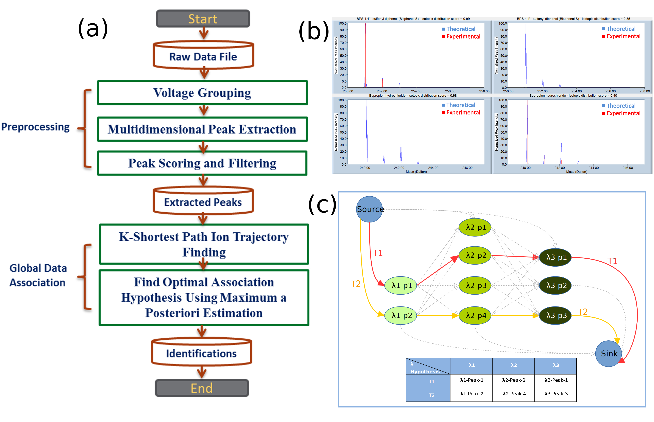
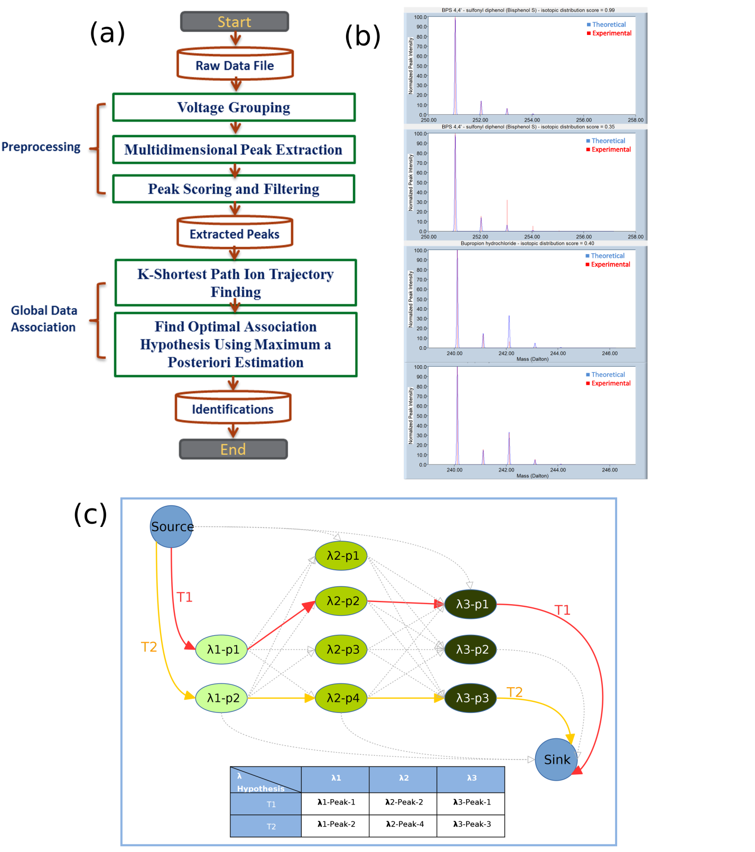
Figure 1: (a) Steps of the mobility extraction algorithm. The preprocessing step starts after voltage grouping to extract and filter peaks. After filtering, the algorithm uses K-shortest path and maximum a posteriori probability estimation to solve the global data association problem and process the peaks into mobility information of conformer ions; (b) Application of isotopic score for improved chemical identification. In the example shown, the software extracted 2 candidate conformers for bisphenol S (sufonyl diphenol) when given a low isotopic score threshold in the preprocessing step. When the isotopic score threshold is raised, the latter conformer is removed due to its low isotopic score; (c) The ion transition graph G. Each path from source to sink represents a potential association of peak responses of an ion across various electric fields.
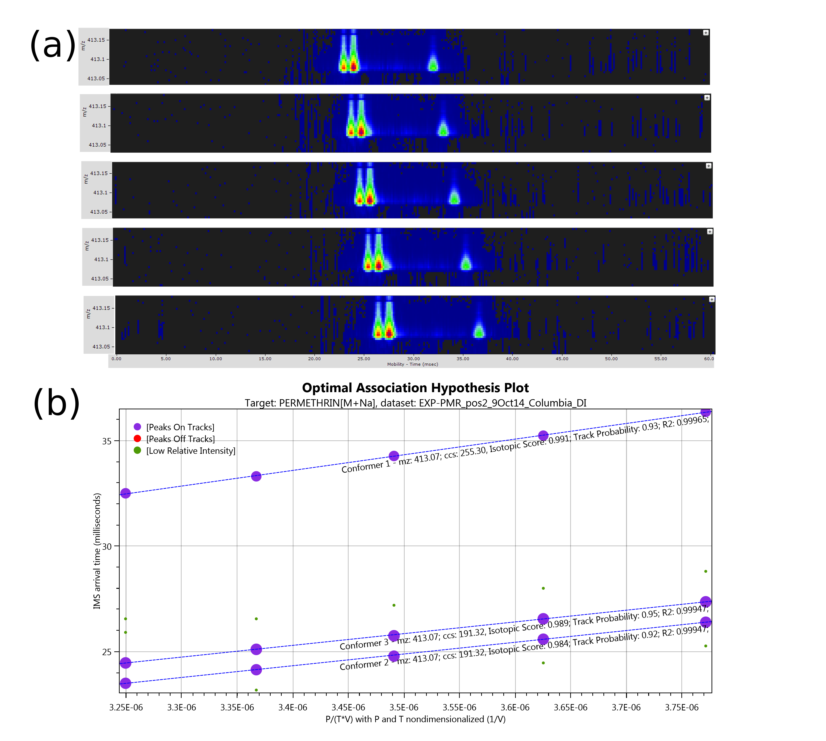
Figure 2: (a) Sodiated Permethrin ions sample data at m/z of around 413.0659 Dalton. As the drift tube electric field decreases, arrival time of the ions increases. (b) Ions were tracked by PIXIE using global data association. The optimal association hypothesis consisted of 3 ion paths, whose feature merits are shown in Table.2. This association hypothesis had an a posteriori probability of 0.7606, higher than all other association hypotheses, and was thus chosen to explain the observed peaks. Other peaks failed to meet the criteria for identification of the target ion and were thus registered as artifacts. Based on the optimal association hypothesis, 3 detections were reported around the target m/z with CCS of 191 Å^2, 191 Å^2 and 255 Å^2, which could correspond to permethrin and a dimer.

