Iteratively reweighted least squares

3. The iteratively reweighted least squares option
Using the simple linear least squares, the uncertainty of drift time measurement in high-leverage peaks could contribute an unproportioned amount of overall measurement uncertainty in collision cross section, e.g., 1 TOF pulse of drift time error at the highest electric field could contribute ~10 Å^2 of error collision cross section. The linearly reweighted least squares method reduces the probability for drastic collision cross section deviation by distribute each electric field’s contribution to the final CCS result evenly. This option is recommended for data with low or irregular number of electric fields.
To evaluate the impact of iteratively reweighted least squares on the calculation of collision cross section, we compared the collision cross section values that PIXiE generates to computationally predicted values. With iteratively reweighted least squares turned off, the predicted and PIXiE generated collision cross section values had a correlation coefficient of 0.967, while turning on iteratively reweighted least squares improved the coefficient to 0.974. The average percentage error between predicted and experimental values was 5.2%. Turning on iteratively reweighted least squares reduces the average percentage error to 4.5%. A detailed correlation is plotted in Fig. 3, and the frequency plot of the percentage difference is shown in Fig. 4. The error frequency plot shows that 33% of the CCS values PIXiE extracted are within 1% error of the predicted values. As a result, we conclude that turning on the iteratively reweighted least squares option reduces both the systematic bias and measurement uncertainties.
In addition, the calculation of collision cross section from multi-electric field DT-IMS-MS measurements can be subject to uncertainty due to simple least squares fit.

PIXiE also implements an iteratively reweighted least squares to mitigate measurement error
With the iteratively reweighted least squares option turned off, the collision cross section determined by PIXiE converge to values obtained by manual multi-electric field DT-IMS-MS collision cross section extraction, as shown by the results for 12 common metabolites in Table. 3.

The traditionally manually intensive multi-electric field DT-IMS-MS collision cross section extraction is known as a method with the least systematic bias[31], aside from calibration intensive methods such as when using a single electric field and internal calibrant(s), or methods based on traveling wave IMS[32].
- IRLS equalize weights of different voltage groups, which is a desirable attribute intrinsically for any kind of parameter estimation. So in theory it should improve both accuracy and precision, the scale of which depends on types of error present.
- IRLS especially acts as a countermeasure to numerical and measurement errors in drift time/temperature/pressure measurements in high leverage voltage groups. Without IRLS, 1 TOF error in Dt detection could result in large amount of CCS discrepancy.

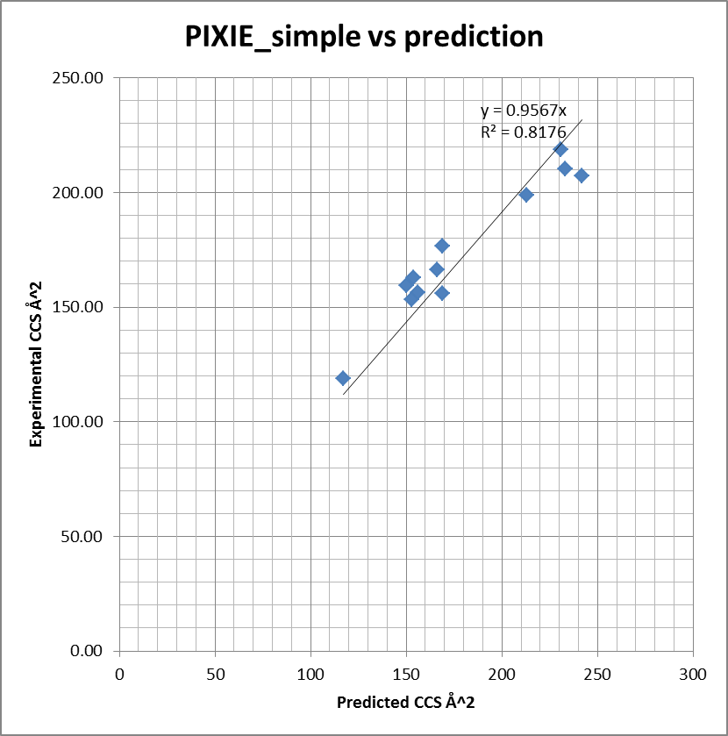 | 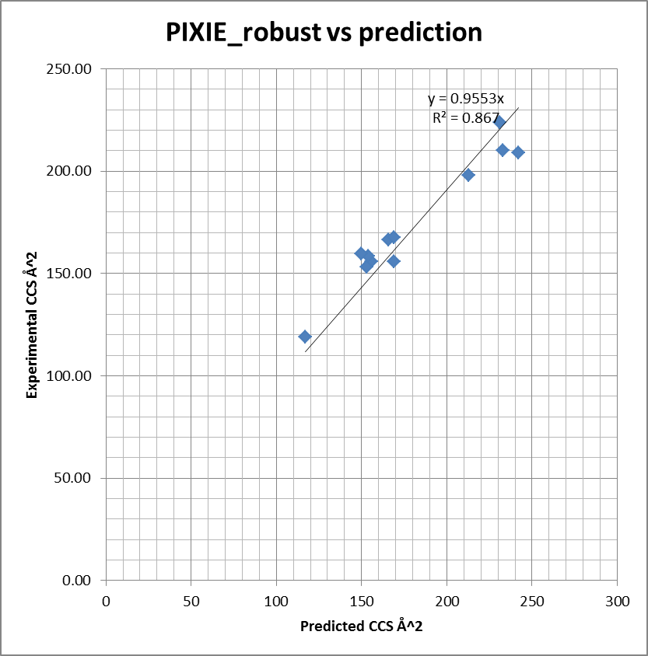
Figure 3. (a) Correlation plot of PIXiE CCS vs NWChem prediction with iteratively reweighted least squares option off. (b) Correlation plot of PIXiE CCS vs NWChem prediction with iteratively reweighted least squares option on

Table 3. PIXiE with iteratively reweighted least squares vs PIXiE with simple least squares vs NWChem prediction vs literature prediction
Chemical | adduct | PIXIE CCS Robust | PIXIE CCS Simple | NWCHEM PREDICT | LITERATURE PREDICT | Additional detected conformers
Adenosine | [M+H] | 166.49 | 166.13 | 163.50 | 166 | 1 conformer, CCS = 157
Adenosine | [M+H] | 156.95 | 157.04
Adenosine | [M+Na] | 167.73 | 165.11
Choline | [APCI] | 119.14 | 118.96 |  | 117
Cytidine | [M-H] | 155.87 | 156.17 | 160.87 | 156
D-Tryptophan | [M-H] | 158.69 | 162.73 |  | 154
FolicAcid | [M+H] | 201.96 | 198.77 |  |  | 1 conformer, CCS = 207
FolicAcid | [M+Na] | 209.09 | 207.13 | 227.86 | 242
FolicAcid | [M-H] | 198.09 | 198.63 |  | 213
Fructose-1-6-diphosphate | [M-H] | 155.85 | 155.97 | 165.95 | 169
Glucosamine-6-phosphate | [M+H] | 153.10 | 153.23 | 146.51 | 153 | 4 conformers, CCS = 156, 165, 187, 201
Glucosamine-6-phosphate | [M+Na] | 171.99 | 171.99
Glucosamine-6-phosphate | [M-H] | 159.73 | 159.54 |  | 150
NAD | [M-H] | 223.93 | 218.62 |  | 231 | 1 conformer, CCS = 176
Sucrose | [M+Na] | 167.46 | 176.65 | 169.57 | 169
UDP-Galactose | [M-H] | 210.27 | 210.27 |  | 233

